Supplementary Materials
Methods
PFAI was measured quantitatively using CoronaryDoc (v6.11, Shukun (Beijing) Network Technology Co., Ltd.), automatedly tracking adipose tissue within a radial distance from the outer vessel wall equal to the diameter and around the 40mm length range proximal of left anterior descending artery (LAD) and left circumflex artery (LCX) and the 10 mm to 50 mm length segment proximal to the right coronary artery (RCA) (CT attenuation range between -190 HU and -30HU) [1-3].
Plaque characteristics and composition were automatically analyzed by the CoronaryDoc (v6.11, Shukun (Beijing) Network Technology Co., Ltd.) based on the Society of Cardiovascular Computed Tomography guidelines [4]. Plaque volume fraction was defined as (plaque volume/vessel volume) * 100%. For the analysis of plaque composition, the classification was grouped into four components: lipid (-30 to 30 HU), fibro-lipid (31 to 130 HU), fibrous (131 to 350 HU), and calcified components (exceeding 350 HU) [5]. Patients with stenosis more than 50% (LAD, LCX and RCA) or 30% (left main coronary artery) were classified as having significant stenosis [6].
The calculation of CT-FFR was performed using the automatic quantification software FFR Doc(v6.11, Shukun (Beijing) Network Technology Co., Ltd.), which integrates a reduced-order computational approach with machine learning modifications [7, 8]. The coronary artery calcium score was calculated nonenhanced CT images using the CoronaryDoc (v6.11, Shukun (Beijing) Network Technology Co., Ltd.) based on Agatston method [9].

Table S1. The Scanning and Reconstruction Protocols of Coronary CT Angiography.
 |  | Lightspeed VCT, GE Healthcare | Brilliance iCT; Philips Healthcare |  | Somatom Definition Flash, Siemens Healthcare
 | ECG-gating | Retro | Pro | Retro | Pro | Retro
CT parameters | Detector collimation (mm) | 40 × 0.625 | 128 × 0.625 |  | 128 × 0.625
 | Pitch | 0.2 | \ | 0.18 | \ | 0.17-0.38  (depending on HR)
 | Gantry rotation time (ms) | 0.35 | 0.27 |  | 0.28 or 0.33 (depending on HR)
 | Tube voltage (kV) | 120 | 120 |  | 80–120 (depending on the patient's BMI)
 | Tube-current-time product (mAs/rotation) | 100–450 (depending on the patient's BMI) | 180–360 (depending on the patient's BMI) | 500–800 (depending on the patient's BMI) | 100–500 (depending on the patient's BMI)
 | HR control with β-blocker | > 70/min | > 70/min |  | > 90/min
 | Scan range | 1 cm below the tracheal bifurcation-heart base | 1 cm below the tracheal bifurcation-heart base |  | 1 cm below the tracheal bifurcation-heart base
Contrast agent | Flow rate (mL/s) | 4-5 | 4-5 |  | 4-5
 | Bolus volume (mL) | 1-1.1/kg | 1-1.1/kg |  | 1-1.1/kg
 | Saline flush (mL) | 30 | 30 |  | 30
 | Scan delay | test-bolus (aortic root at level of left main coronary, peak+4s) | bolus-tracking (descending aorta or left ventricle threshold 150 HU) |  | bolus-tracking (descending aorta or left ventricle threshold 100 HU)
Image reconstruction | Slice thickness (mm) | 0.625 | 0.9 |  | 0.6
 | Increment (mm) | 0.625 | 0.45 |  | 0.3
 | Reconstruction kernal | standard | Xres standard |  | I26f medium-smooth ASA
 | ECG-gated restruction | HR ≥ 70/min: during late systole [40%–50%] in 5% increments, and 75%;  HR < 70/min: late diastole [70%–80%] in 5% increments, and 45% | late diastole [70%–80%]) in 5% increments | HR ≥ 70/min: during late systole [40%–50%] in 5% increments, and 75%;  HR < 70/min: late diastole [70%–80%] in 5% increments, and 45% | the best diastolic and systolic phases were automatically detected by the Cardio Best Phase technique + 45% and 75%
Before examination, heart rate was controlled with oral administration of 25–75 mg beta-blocker. During scanning, the contrast agent [Iopamidol (370 mg/dL, PilotFree, Shanghai, China) or Iopromide (370 mg/dL, Müllerstrasse, Berlin, Germany)] was intravenously injected through a 18–20 gauge needle into the right antecubital vein. ECG = electrocardiogram; CT = computed tomography; Retro = retrospective gating; Pro = prospective gating; HR = heart rate; BMI = body mass index.

References
1. Dong X, Li N, Zhu C, Wang Y, Shi K, Pan H, Wang S, Shi Z, Geng Y, Wang W et al: Diagnosis of coronary artery disease in patients with type 2 diabetes mellitus based on computed tomography and pericoronary adipose tissue radiomics: a retrospective cross-sectional study. Cardiovasc Diabetol 2023, 22(1):14.
2. Nie JY, Chen WX, Wu QD: Relationship Analysis Between Pericoronary Fat Attenuation Index and Parameters of Single Plaque. J Comput Assist Tomogr 2024, 48(4):647-651.
3. Antonopoulos AS, Sanna F, Sabharwal N, Thomas S, Oikonomou EK, Herdman L, Margaritis M, Shirodaria C, Kampoli AM, Akoumianakis I et al: Detecting human coronary inflammation by imaging perivascular fat. Sci Transl Med 2017, 9(398).
4. Zhang CJ, Xia D, Zheng C, Wei J, Cui Y, Qu Y, Liao F: Automatic Identification of Coronary Arteries in Coronary Computed Tomographic Angiography. IEEE Access 2020, 8:65566-65572.
5. Jing M, Xi H, Wang Y, Zhu H, Sun Q, Zhang Y, Ren W, Xu Z, Deng L, Zhang B et al: Association between Pericoronary Fat Attenuation Index Values and Plaque Composition Volume Fraction Measured by Coronary Computed Tomography Angiography. Acad Radiol 2024, 31(9):3579-3589.
6. Yu Y, Ding X, Yu L, Dai X, Wang Y, Zhang J: Increased coronary pericoronary adipose tissue attenuation in diabetic patients compared to non-diabetic controls: A propensity score matching analysis. J Cardiovasc Comput Tomogr 2022, 16(4):327-335.
7. Yu M, Lu Z, Shen C, Yan J, Wang Y, Lu B, Zhang J: The best predictor of ischemic coronary stenosis: subtended myocardial volume, machine learning-based FFR(CT), or high-risk plaque features? Eur Radiol 2019, 29(7):3647-3657.
8. Zhang LJ, Tang C, Xu P, Guo B, Zhou F, Xue Y, Zhang J, Zheng M, Xu L, Hou Y et al: Coronary Computed Tomography Angiography-derived Fractional Flow Reserve: An Expert Consensus Document of Chinese Society of Radiology. J Thorac Imaging 2022, 37(6):385-400.
9. Xu J, Chen L, Wu X, Li C, Ai G, Liu Y, Tian B, Guo D, Fang Z: Do plaque-related factors affect the diagnostic performance of an artificial intelligence coronary-assisted diagnosis system? Comparison with invasive coronary angiography. Eur Radiol 2022, 32(3):1866-1878.

Table S2. The baseline characteristics stratified by kilovolt peak
Characteristics | Kilovolt peak |  | P value
Characteristics | <100 kv  n=71 | ≥100 kv  n=373 | P value
Demographics
Age, age | 72.9 (9.9) | 70.3 (9.5) | 0.036
Female, n (%) | 30 (42.3) | 112 (30.0) | 0.059
Smoking, n (%) | 9 (16.1) | 69 (21.2) | 0.488
BMI, kg/m² | 21.0 (2.7) | 24.3 (3.1) | <0.001
Comorbidities
Hypertension, n (%) | 55 (78.6) | 287 (77.6) | 0.977
Congestive Heart failure, n (%) | 10 (14.3) | 54 (14.5) | >0.999
Diabetes mellitus, n (%) | 29 (40.8) | 165 (44.5) | 0.664
Hyperlipemia, n (%) | 41 (65.1) | 235 (68.9) | 0.650
Anemia, n (%) | 35 (52.2) | 174 (48.3) | 0.650
Atrial Fibrillation, n (%) | 6 (8.6) | 26 (7.0) | 0.837
Dialysis, n (%) | 4 (5.6) | 28 (7.5) | 0.757
Laboratory findings
WBC, 10^{^9}/L | 7.2 [6.0, 8.9] | 7.2 [6.1, 8.3] | 0.763
NEUT, 10^{^9}/L | 4.9 (2.6) | 4.9 (2.3) | 0.798
Hemoglobin, g/L | 122.9 (18.5) | 125.3 (21.5) | 0.393
FIB, g/L | 3.9 (1.1) | 4.2 (1.1) | 0.103
HbA1c, % | 6.6 (2.1) | 6.5 (1.2) | 0.560
CHOL, mmol/L | 4.7 (1.4) | 4.4 (1.2) | 0.199
LDLC, mmol/L | 3.0 (1.1) | 2.7 (0.9) | 0.016
HDLC, mmol/L | 1.1 (0.3) | 1.0 (0.2) | 0.053
TG, mmol/L | 1.8 (1.3) | 1.9 (1.6) | 0.778
eGFR, mL/min/1.73m² | 46.2 (13.0) | 44.1 (15.1) | 0.260
eGFR ≤30 mL/min/1.73m², n (%) | 8 (11.3) | 59 (15.8) | 0.423
LVEF, % | 58.7 (14.0) | 58.7 (12.1) | 0.987
CCTA features
LM significant stenosis, n (%) | 13 (18.6) | 64 (18.8) | >0.999
LAD significant stenosis, n (%) | 56 (80.0) | 292 (85.6) | 0.313
LCX significant stenosis, n (%) | 17 (24.3) | 108 (31.7) | 0.280
RCA significant stenosis, n (%) | 48 (68.6) | 246 (72.4) | 0.621
LAD FFR | 0.6 (0.1) | 0.5 (0.1) | 0.001
LCX FFR | 0.7 (0.1) | 0.7 (0.2) | 0.001
RCA FFR | 0.7 (0.2) | 0.6 (0.2) | 0.026
LAD FAI, HU | -87.1 (9.0) | -79.5 (9.0) | <0.001
LCX FAI, HU | -85.2 (7.9) | -77.5 (8.4) | <0.001
RCA FAI, HU | -85.8 (10.4) | -78.5 (9.9) | <0.001
Total plaque volume, mm³ | 143.7 (111.0) | 222.2 (168.1) | <0.001
Lipid plaque volume, mm³ | 4.6 (5.7) | 16.4 (17.3) | <0.001
Lipid fibrous plaque volume, mm³ | 21.1 (20.1) | 70.3 (63.6) | <0.001
Fibrous plaque volume, mm³ | 31.5 (27.7) | 65.6 (59.5) | <0.001
Calcium plaque volume, mm³ | 86.5 (95.2) | 70.0 (82.7) | 0.151
CAC scores | 308.6 [67.3, 668.4] | 280.2 [85.7, 694.1] | 0.981
ICA features
PCI, n (%) | 58 (81.7) | 284 (76.1) | 0.387
SYNTAX score | 23.0 (12.2) | 20.8 (12.4) | 0.198
Medication
RAASi, n (%) | 46 (67.6) | 249 (68.4) | >0.999
Statins, n (%) | 65 (95.6) | 336 (92.3) | 0.480
β-blockers, n (%) | 50 (73.5) | 270 (74.2) | >0.999
Antiplatelet, n (%) | 65 (95.6) | 357 (98.1) | 0.416
Abbreviations: CAC: Coronary Artery Calcium; ICA: Invasive Coronary Angiography; CCTA: Coronary Computed Tomography Angiography; CHOL: Total Cholesterol; eGFR: Estimated Glomerular Filtration Rate; FFR: Fractional Flow Reserve; FIB: Fibrinogen; HbA1c: Hemoglobin A1c; HDL-C: High-Density Lipoprotein Cholesterol; LAD: Left Anterior Descending Artery; LCX: Left Circumflex Artery; LDL-C: Low-Density Lipoprotein Cholesterol; NEUT: Neutrophil; PCI: Percutaneous Coronary Intervention; pFAI: Pericoronary Fat Attenuation Index; RAASi: Renin-Angiotensin-Aldosterone System Inhibitors; RCA: Right Coronary Artery; SD: Standard Deviation; TG: Triglyceride; WBC: White Blood Cells

Table S3. Univariate and multivariate analyses for MACEs
Variable | Univariate |  | Multivariate  (LAD-pFAI) |  | Multivariate  (LCX-pFAI) |  | Multivariate  (RCA-pFAI)
Variable | HR (95%CI) | P | HR (95%CI) | P | HR (95%CI) | P | HR (95%CI) | P
LAD-pFAI (>-81.0 vs ≤-81.0 HU) | 1.50 (0.99–2.28) | 0.055 | 1.65 (1.02-2.66) | 0.042
LCX-pFAI (>-78.8 vs ≤-78.8 HU) | 2.05 (1.34–3.15) | 0.001 |  |  | 2.06 (1.23-3.45) | 0.006
RCA-pFAI (>-79.4 vs ≤-79.4 HU) | 1.76 (1.16–2.68) | 0.008 |  |  |  |  | 1.71 (1.07-2.74) | 0.025
Age | 1.01 (0.99–1.03) | 0.518 | 1.00 (0.97-1.02) | 0.852 | 1.01 (0.98-1.03) | 0.558 | 1.01 (0.98-1.03) | 0.609
Female vs male | 0.79 (0.50–1.25) | 0.314 | 1.23 (0.69-2.17) | 0.484 | 1.00 (0.58-1.72) | 0.996 | 0.95 (0.55-1.62) | 0.840
LAD stenosis | 1.25 (0.66–2.35) | 0.498 | 0.76 (0.38-1.52) | 0.439
LCX stenosis | 1.17 (0.74–1.85) | 0.493 |  |  | 0.78 (0.46-1.31) | 0.343
RCA stenosis | 1.39 (0.83–2.32) | 0.206 |  |  |  |  | 0.92 (0.53-1.60) | 0.779
PCI | 0.65 (0.41–1.02) | 0.061 | 0.79 (0.47-1.33) | 0.380 | 0.80 (0.48-1.36) | 0.414 | 0.77 (0.46-1.31) | 0.336
Kvp (<100 kv vs ≥100kv) | 0.66 (0.38–1.12) | 0.122 | 0.49 (0.27-0.89) | 0.020 | 0.35 (0.19-0.65) | 0.001 | 0.53 (0.30-0.94) | 0.030
Diabetes mellitus | 1.26 (0.83–1.92) | 0.270 | 1.42 (0.86-2.34) | 0.173 | 1.13 (0.69-1.85) | 0.632 | 1.16 (0.72-1.87) | 0.539
Hypertension | 1.08 (0.65–1.82) | 0.765 | 1.45 (0.75-2.82) | 0.270 | 1.20 (0.64-2.26) | 0.566 | 1.35 (0.72-2.5) | 0.347
Congestive heart failure | 2.81 (1.73–4.55) | <0.001 | 2.75 (1.56-4.83) | <0.001 | 2.89 (1.64-5.09) | <0.001 | 4.00 (2.27-7.03) | <0.001
eGFR | 0.98 (0.96–0.99) | <0.001 | 0.99 (0.98-1.01) | 0.460 | 0.99 (0.97-1.00) | 0.140 | 0.99 (0.97-1.00) | 0.049
RAASi | 0.73 (0.47–1.15) | 0.179 | 0.79 (0.48-1.31) | 0.356 | 0.77 (0.48-1.25) | 0.292 | 1.08 (0.65-1.80) | 0.758
Smoke | 0.98 (0.69–1.4) | 0.914
Atrial fibrillation | 1.56 (0.78–3.11) | 0.206
Hyperlipidemia | 0.99 (0.62–1.6) | 0.971
White blood cell | 0.98 (0.93–1.05) | 0.609
Neutrophil | 1.01 (0.93–1.11) | 0.811
Hemoglobin | 0.99 (0.98–1.00) | 0.017
Fibrinogen | 1.11 (0.92–1.33) | 0.279
HbA1c | 1.19 (1.02–1.37) | 0.023
CHOL | 1.04 (0.87–1.25) | 0.665
LDLC | 1.11 (0.87–1.41) | 0.401
HDLC | 1.30 (0.58–2.93) | 0.530
TG | 0.92 (0.76–1.11) | 0.402
LAD FFR | 0.33 (0.07–1.63) | 0.173
LCX FFR | 0.41 (0.10–1.7) | 0.219
RCA FFR | 0.16 (0.04–0.66) | 0.011
Total plaque volume | 1.00 (1.00–1.00) | 0.016
Lipid plaque volume | 1.00 (0.99–1.02) | 0.864
Lipid fibrous plaque volume | 1.00 (1.00–1.01) | 0.094
Fibrous plaque volume | 1.00 (1.00–1.01) | 0.104
Calcium plaque volume | 1.00 (1.00–1.00) | 0.029
CAC scores | 1.00 (1.00–1.00) | 0.180
SYNTAX_score | 1.01 (1.00–1.03) | 0.095
Statins | 1.01 (0.32–3.22) | 0.991
β-blockers | 0.65 (0.41–1.04) | 0.073
Antiplatelet | 0.67 (0.16–2.71) | 0.570
Abbreviations: CAC: Coronary Artery Calcium; CHOL: Total Cholesterol; eGFR: Estimated Glomerular Filtration Rate; FFR: Fractional Flow Reserve; HbA1c: Hemoglobin A1c; HDL-C: High-Density Lipoprotein Cholesterol; Kvp: Kilovolt Peak; LAD: Left Anterior Descending Artery; LCX: Left Circumflex Artery; LDL-C: Low-Density Lipoprotein Cholesterol; NEUT: Neutrophil; PCI: Percutaneous Coronary Intervention; pFAI: Pericoronary Fat Attenuation Index; RAASi: Renin-Angiotensin-Aldosterone System Inhibitors; RCA: Right Coronary Artery; TG: Triglyceride; WBC: White Blood Cells

Table S3. Cox proportional regression of continuous pFAI and MACEs and cardiovascular and all-cause mortality.
 | HR (95% CI) | P value
MACE
LAD-pFAI | 1.04 (1.02–1.07) | 0.001
LCX-pFAI | 1.03 (1.01–1.06) | 0.017
RCA-pFAI | 1.04 (1.02–1.07) | <0.001
Cardiovascular mortality
LAD-pFAI | 1.07 (1.04–1.1) | <0.001
LCX-pFAI | 1.06 (1.03–1.09) | <0.001
RCA-pFAI | 1.06 (1.03–1.09) | <0.001
All-cause mortality
LAD-pFAI | 1.05 (1.03–1.07) | <0.001
LCX-pFAI | 1.05 (1.02–1.07) | <0.001
RCA-pFAI | 1.04 (1.02–1.06) | <0.001
Adjusted for age, sex, kilovolt peak ≥100 kV, diabetes mellitus, hypertension, congestive heart failure, estimated glomerular filtration rate, significant stenosis of the corresponding coronary artery, percutaneous coronary intervention, and renin‒angiotensin‒aldosterone system inhibitors.
Abbreviations: LAD, left anterior descending coronary artery; LCX, left circumflex artery; RCA, right coronary artery; pFAI, pericoronary fat attenuation index.
Table S4. Subgroup analysis stratified by CKD stages and CAC scores
 | CKD stage 3  (n=377) | CKD stage 4–5  (n=67) | P for interaction | CAC scores <283  (n=202) | CAC scores ≥283  (n=201) | P for interaction
 | HR (95% CI) | HR (95% CI) | P for interaction | HR (95% CI) | HR (95% CI) | P for interaction
MACE
LAD-pFAI (>-81.0 vs ≤-81.0 HU) | 1.76 (1.01–3.05) | 2.36 (0.54–10.23) | 0.689 | 1.23 (0.54–2.82) | 1.77 (0.90–3.50) | 0.369
LCX-pFAI (>-78.8 vs ≤-78.8 HU) | 1.90 (1.07–3.35) | 3.20 (0.71–14.37) | 0.717 | 2.29 (1.01–5.19) | 1.64 (0.8–3.36) | 0.810
RCA-pFAI (>-79.4 vs ≤-79.4 HU) | 1.52 (0.90–2.56) | 1.96 (0.50–7.77) | 0.435 | 1.88 (0.88–4.00) | 1.70 (0.85–3.38) | 0.584
Cardiovascular mortality
LAD-pFAI (>-81.0 vs ≤-81.0 HU) | 3.15 (1.58–6.26) | 2.72 (0.55–13.53) | 0.909 | 2.17 (0.79–5.93) | 3.13 (1.30–7.56) | 0.679
LCX-pFAI (>-78.8 vs ≤-78.8 HU) | 2.58 (1.29–5.14) | 4.66 (0.85–25.64) | 0.424 | 2.00 (0.81–4.95) | 2.26 (0.86–5.94) | 0.864
RCA-pFAI (>-79.4 vs ≤-79.4 HU) | 1.76 (0.92–3.33) | 6.08 (0.83–44.8) | 0.240 | 1.78 (0.75–4.20) | 2.50 (1.07–5.87) | 0.774
All-cause mortality
LAD-pFAI (>-81.0 vs ≤-81.0 HU) | 2.47 (1.53–4.01) | 1.93 (0.56–6.67) | 0.981 | 2.31 (1.13–4.73) | 2.36 (1.26–4.42) | 0.851
LCX-pFAI (>-78.8 vs ≤-78.8 HU) | 1.80 (1.10–2.92) | 2.18 (0.62–7.73) | 0.233 | 1.70 (0.87–3.32) | 2.15 (1.13–4.09) | 0.612
RCA-pFAI (>-79.4 vs ≤-79.4 HU) | 1.67 (1.05–2.63) | 1.79 (0.57–5.6) | 0.310 | 1.86 (0.99–3.50) | 2.03 (1.14–3.61) | 0.901
Adjusted for age, sex, kilovolt peak ≥100 kV, diabetes mellitus, hypertension, congestive heart failure, significant stenosis of the corresponding coronary artery, percutaneous coronary intervention, estimated glomerular filtration rate, and renin‒angiotensin‒aldosterone system inhibitors.
Abbreviations: CAC: Coronary Artery Calcium; CI: Confidence interval; CKD: Chronic Kidney Disease; HR: Hazards Ratio; LAD: Left Anterior Descending Artery; LCX: Left Circumflex Artery; pFAI: Pericoronary Fat Attenuation Index; RCA: Right Coronary Artery
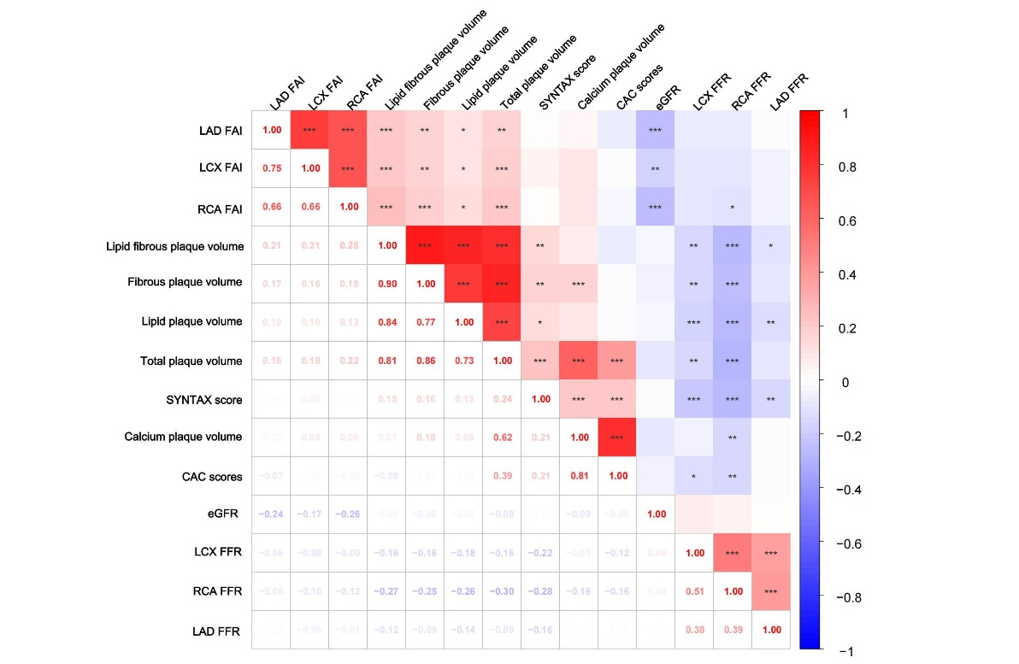
Figure S1. Pearson correlation of CCTA-derived parameters, SYNTAX score and eGFR
*P <0.05, **P<0.01, ***P<0.001
CCTA: Coronary Computed Tomography Angiography; eGFR: Estimated Glomerular Filtration Rate; FFR: Fractional Flow Reserve; LAD: Left Anterior Descending Artery; LCX: Left Circumflex Artery; FAI: Pericoronary Fat Attenuation Index; RCA: Right Coronary Artery;

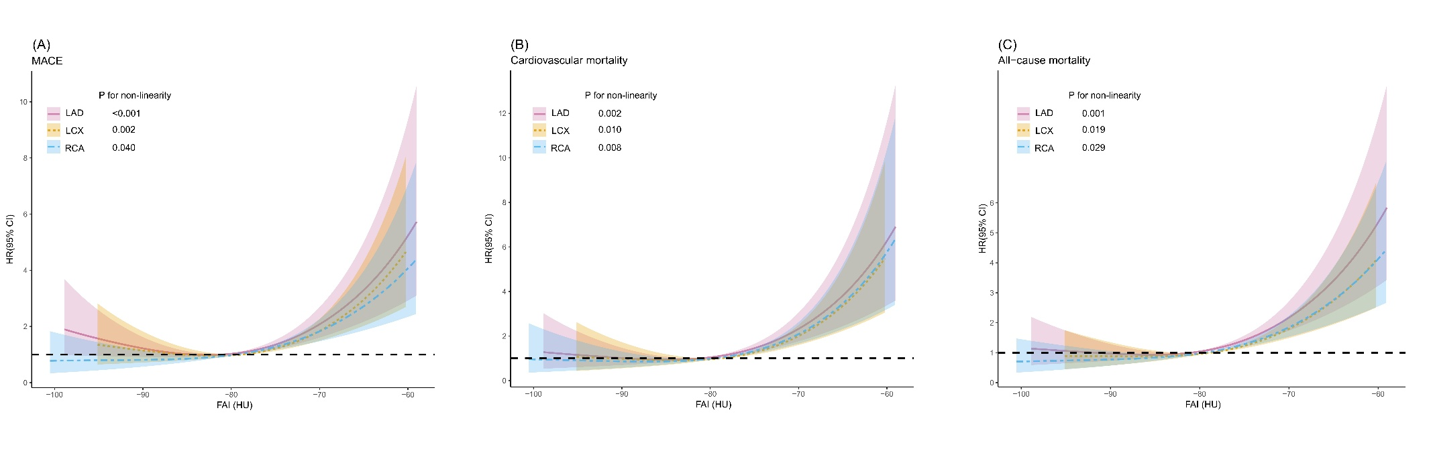
Figure S2. Unadjusted restricted cubic spline curve of pFAI and MACEs and cardiovascular and all-cause mortality
The graph depicts the adjusted HR (95% CI) for MACE (A), cardiovascular (B) and all-cause mortality (C) across varying levels of pFAI. The curves corresponding to different coronary arteries are color-coded: pink solid line for the LAD, yellow dotted line for the LCX, and blue dashed line for the RCA.
CI: confidence interval; LAD: left anterior descending; LCX: left circumflex artery; HR: hazard ratio; MACE: major adverse cardiovascular events; pFAI: pericoronary fat attenuation index; RCA: right coronary artery

