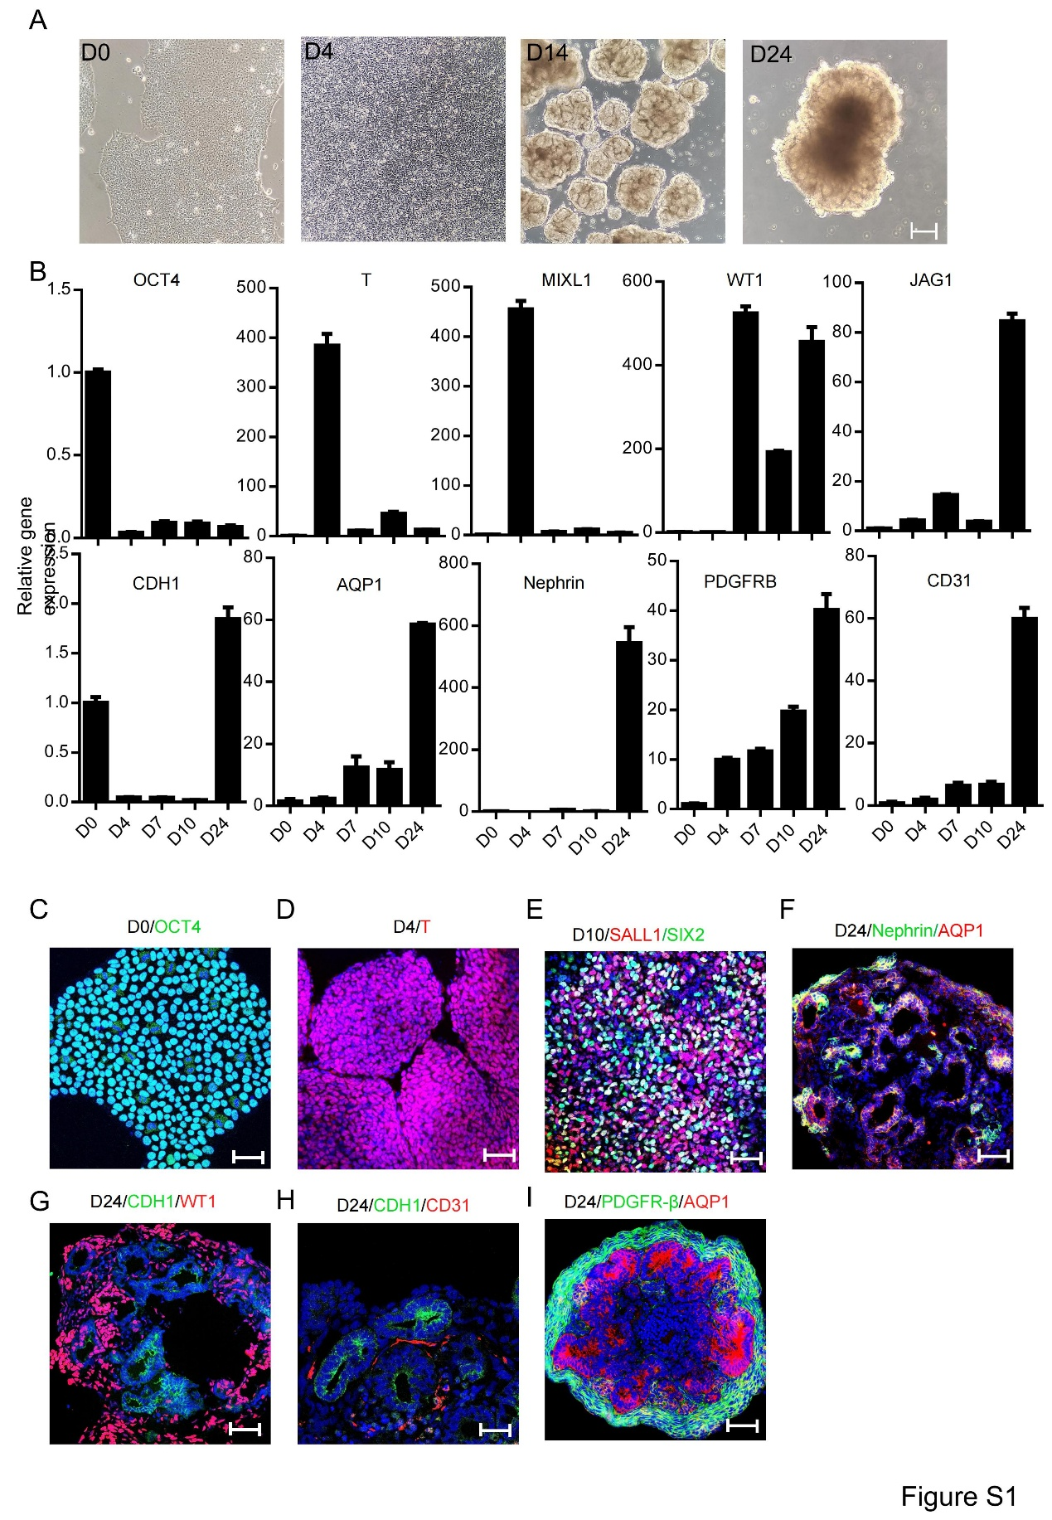
Figure S1. Kidney organoids derived from hPSCs.
(A) Bright field images showing the induced differentiation of human induced pluripotent stem cells (hPSCs) into kidney organoids. Scale bar = 100 µm, magnification = 100×, (B) Expression of specific marker genes at each stage of differentiation induction, SOX2 marks pluripotent stem cells, T (Brachyury) and MIXL denote primitive streak cells, WT1 is a marker for nephrogenic intermediate mesoderm, JAG1 is expressed in middle tubules, CDH1 in distal tubules, and AQP1 in proximal tubules. NPHS1 is a marker for podocytes, PDGFR-β for mesangial cells, and CD31 for vascular endothelial cells, (C) Immunofluorescent detection of the specific marker protein T (red) for primitive streak cells. Scale bar = 50 µm, magnification = 200×, (D) Immunofluorescent detection of the specific marker proteins SIX2 (red) and SALL1 (green) for nephron progenitor cells. Scale bar = 50 µm, magnification = 200×, (F) Immunofluorescent detection of the specific marker proteins Nephrin (green) for podocytes and AQP1 (red) for proximal tubules. Scale bar = 50 µm, magnification = 200×, (G) Immunofluorescent detection of the specific marker proteins CDH1 (green) for distal tubules and WT1 (red) for podocytes. Scale bar = 50 µm, magnification = 200×, (H) Immunofluorescent detection of the specific marker proteins CDH1 (green) for distal tubules and CD31 (red) for endothelial cells. Scale bar = 50 µm, magnification = 200×, (I) Immunofluorescent detection of the specific marker proteins PDGFR-β (green) for mesangial cells and AQP1 (red) for proximal tubules. Scale bar = 50 µm, magnification = 200×.

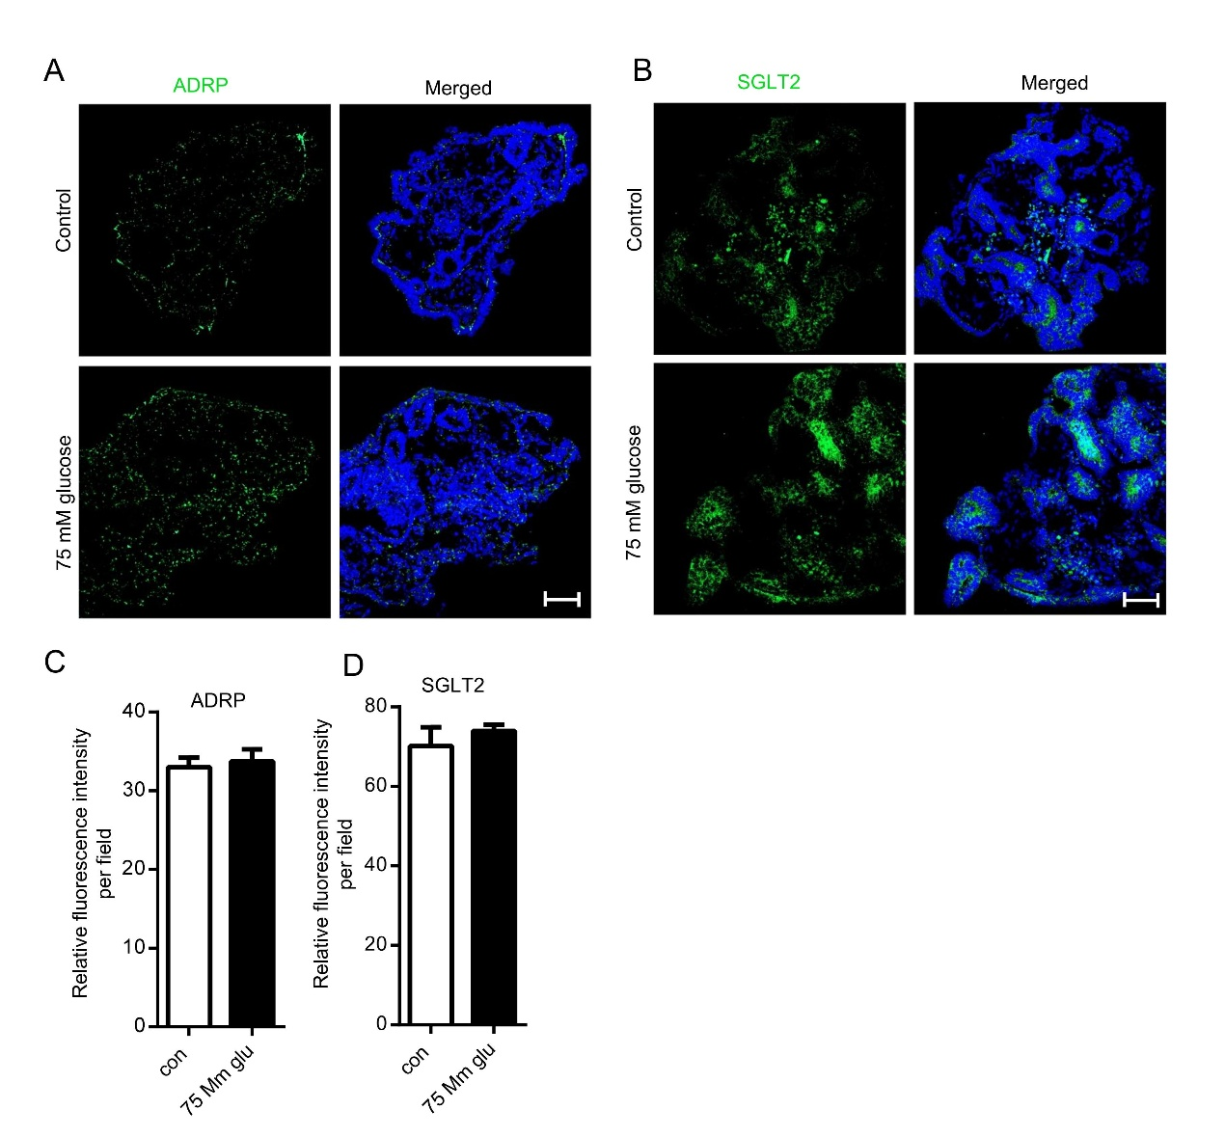
Figure S2. High glucose-induced 24-hour changes of glucolipid metabolism in kidney organoids, related to Figure 1.
(A) Expression of ADRP in kidney organoids after 24 hours of intervention, detected by immunofluorescence (ADRP labeled in green), scale bar = 50 µm, magnification = 200×, (B) Expression of SGLT2 protein in kidney organoids after 24 hours of intervention, detected by immunofluorescence (SGLT2 labeled in green), scale bar = 50 µm, magnification = 200×. (C) Statistical graph of the average fluorescence intensity of ADRP, n = 4, (D) Statistical graph of the average fluorescence intensity of SGLT2, n = 4.

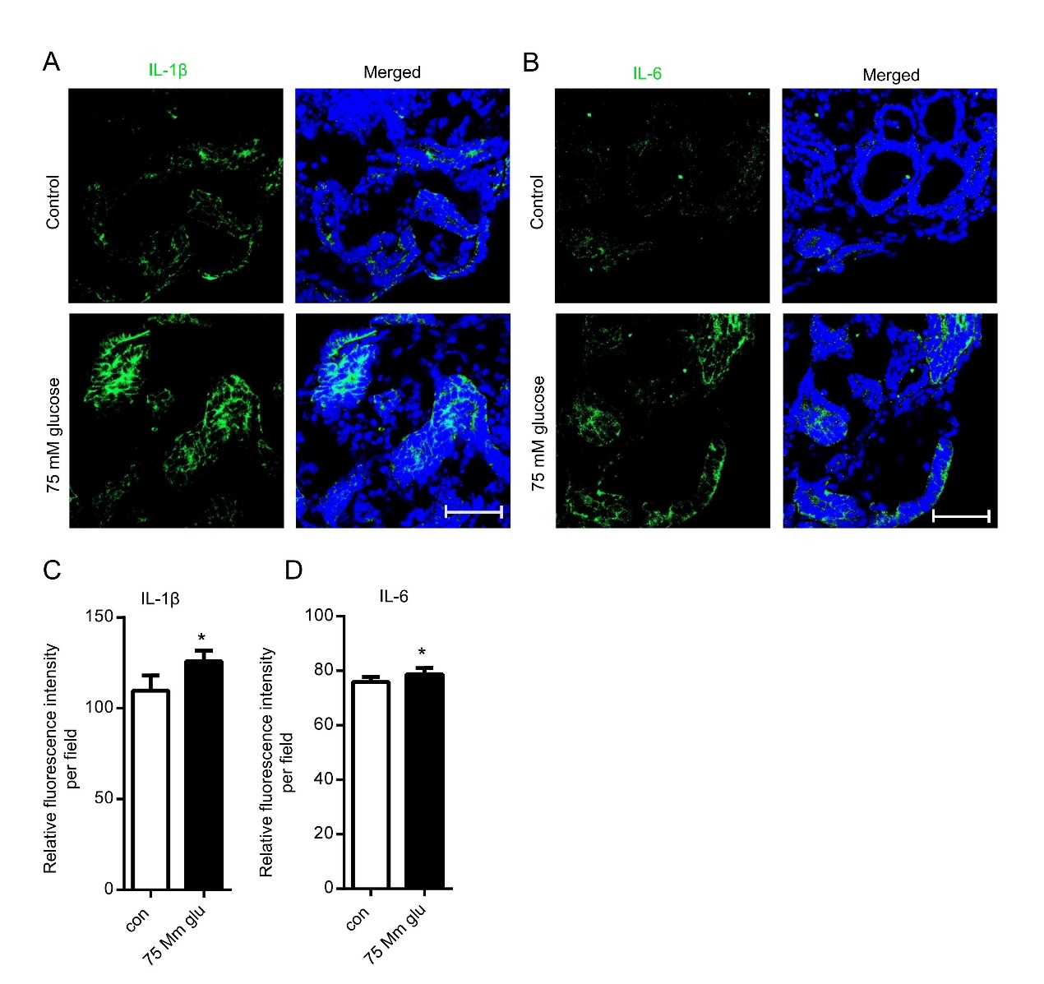
Figure S3. High glucose treated 24-hour upregulates inflammatory levels of kidney organoids, related to Figure 2.
(A) Immunofluorescence detection of IL-1β protein expression (marked in green) in kidney organoids 24 hours post-intervention, scale bar = 20 µm, magnification = 400×. (B) Immunofluorescence detection of IL-6 protein expression in kidney organoids 24 hours post-intervention (IL-6 labeled in green), scale bar = 20 µm, magnification = 400×. (C) Statistical analysis of the average fluorescence intensity for IL-1β, *P < 0.05, n = 4, (D) Statistical analysis of the average fluorescence intensity for IL-6, *P < 0.05, n = 4.

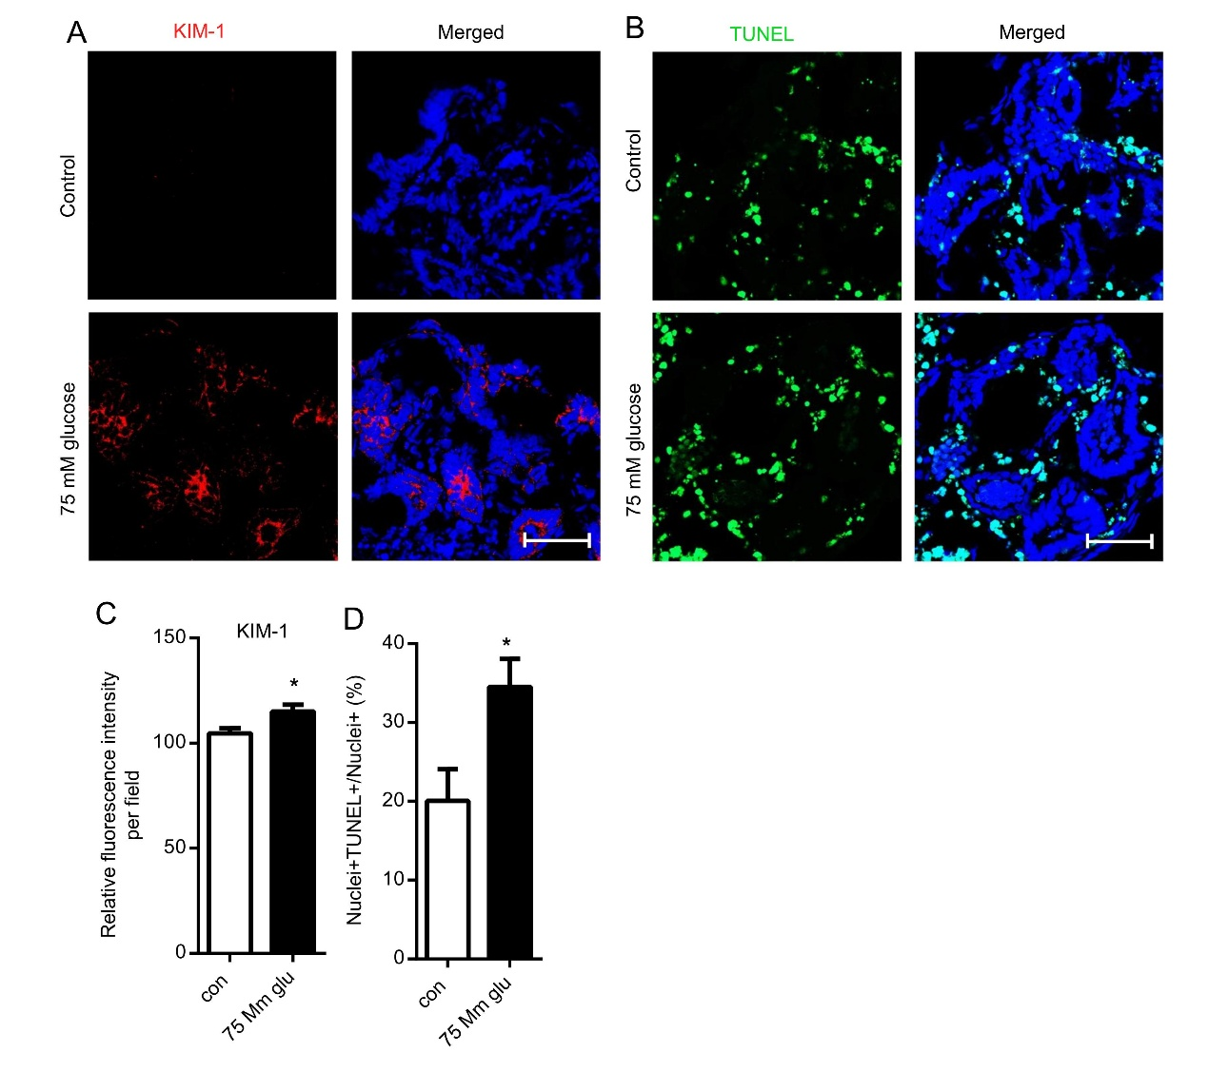
Figure S4. Cell damage and apoptosis in high glucose treated 24-hour kidney organoids, related to Figure 3
(A) Expression of KIM-1 in kidney organoids, detected by immunofluorescence (KIM-1 labeled in red), scale bar = 20 µm, magnification = 400×. (B) TUNEL staining to detect cell apoptosis in kidney organoids, apoptotic cells labeled in green, scale bar = 20 µm, magnification = 400×, (C) Statistical graph of the average fluorescence intensity of KIM-1, *P < 0.05, n = 4. (D) Nuclei+TUNEL+/Nuclei+ (%), *P < 0.05, n = 4

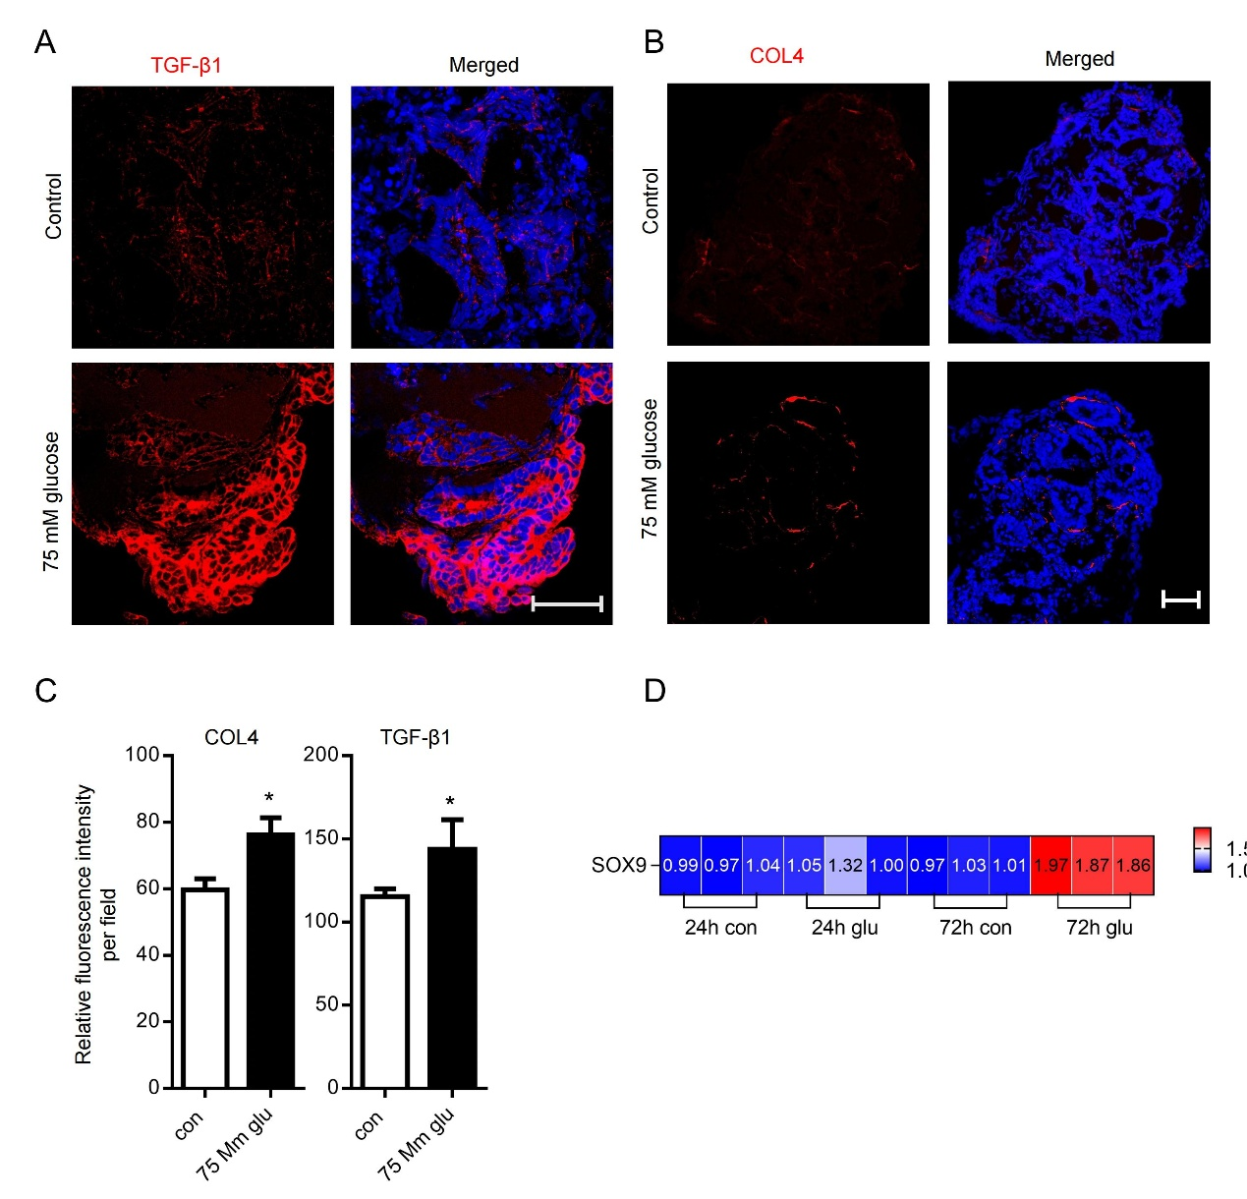
Figure S5. High glucose treated 24-hour increases kidney organoid fibrosis.
(A) Immunofluorescence detection of TGF-β1 protein expression (marked in red) in kidney organoids 24 hours after intervention. Scale bar = 20 µm, magnification = 400×, (B) Immunofluorescence detection of COL4 (red) protein expression in kidney organoids 24 hours after intervention. Scale bar = 50 µm, magnification = 200×, (C) Statistical analysis of the average fluorescence intensity of TGF-β1,COL4 and Fibronectin, *P < 0.05, n = 4, (D) mRNA expression levels of SOX9 in kidney organoids, n = 3.

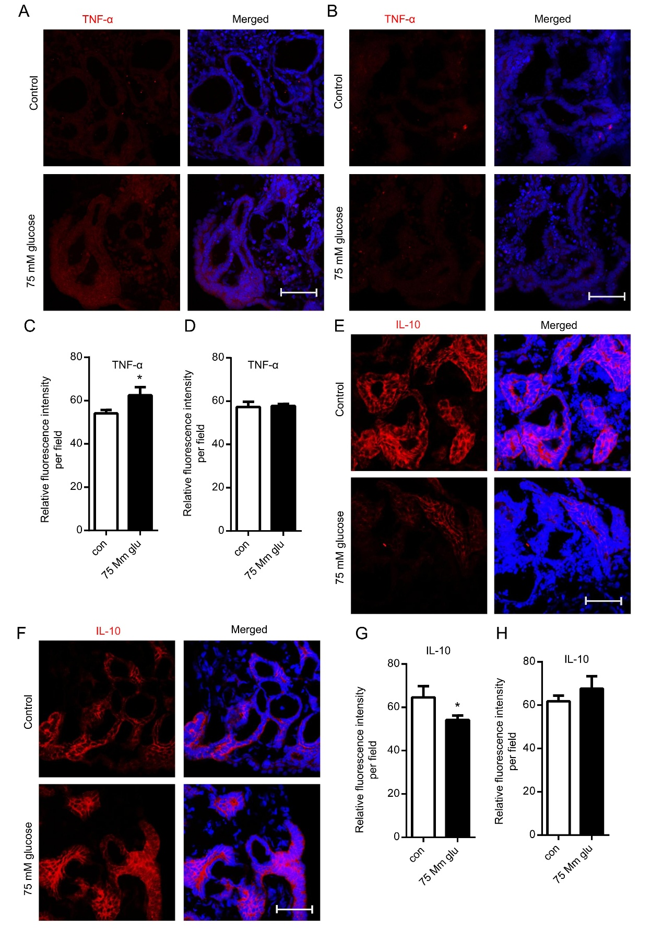
Figure S6. High glucose upregulates inflammatory (TNF-α) factor and anti-inflammatory (IL-10) levels factor of kidney organoids
(A) Immunofluorescence detection of TNF- α protein expression (marked in red) in kidney organoids 24 hours post-intervention, scale bar = 20 µm, magnification = 400×. (B) Immunofluorescence detection of TNF- α protein expression in kidney organoids 72 hours post-intervention (IL-6 labeled in red), scale bar = 20 µm, magnification = 400×, (C) Statistical analysis of the average fluorescence intensity for TNF- α of kidney organoids 24 hours post-intervention, *P < 0.05, n = 4, (D) Statistical analysis of the average fluorescence intensity for TNF- α of kidney organoids 72 hours post-intervention, *P < 0.05, n = 4, (E) Immunofluorescence detection of IL-10 protein expression in kidney organoids 24 hours post-intervention (IL-10 labeled in red), scale bar = 20 µm, magnification = 400×, (F) Immunofluorescence detection of IL-10 protein expression in kidney organoids 72 hours post-intervention (IL-10 labeled in red), scale bar = 20 µm, magnification = 400×, (G) Statistical analysis of the average fluorescence intensity for IL-10 of kidney organoids 24 hours post-intervention, *P < 0.05, n = 4, (H) Statistical analysis of the average fluorescence intensity for IL-10 of kidney organoids 72 hours post-intervention, *P < 0.05, n = 4.

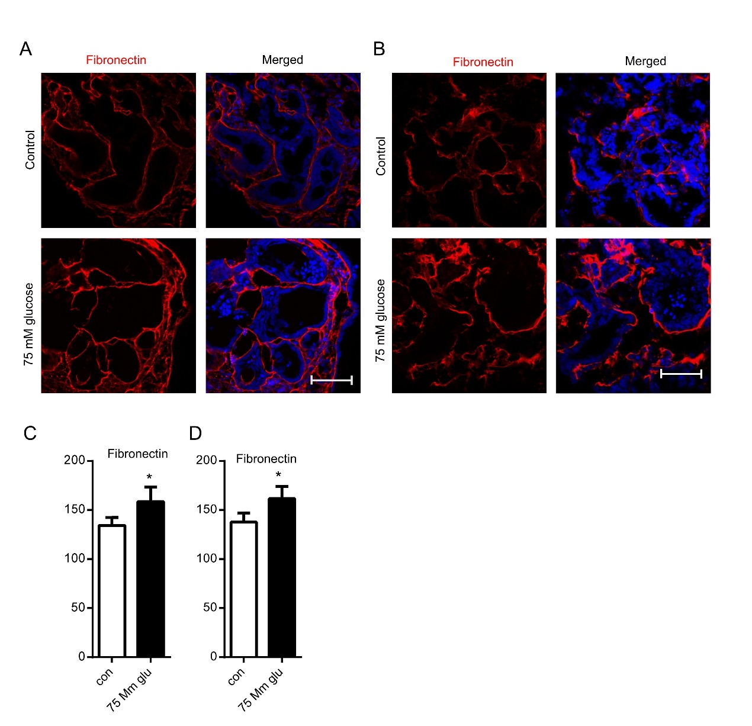
Figure S7. High glucose increases kidney organoid fibrosis (Fibronectin).
(A) Immunofluorescence detection of Fibronectin protein expression in kidney organoids 24 hours after intervention. Scale bar = 20 µm, magnification = 400×, (B) Immunofluorescence detection of Fibronectin protein expression in kidney organoids 72 hours after intervention. Scale bar = 20 µm, magnification = 400×, (C) Statistical analysis of the average fluorescence intensity for Fibronectin of kidney organoids 24 hours post-intervention, *P < 0.05, n = 4, (D) Statistical analysis of the average fluorescence intensity for Fibronectin of kidney organoids 72 hours post-intervention, *P < 0.05, n = 4.

