Supplemental Material

Methods
Search Strategy and Eligibility Criteria
Identified articles were imported to Covidence, and duplicates were removed. Four reviewers (X.L., K.Y.P., H.Le., and H.Li.) participated in the screening process. Titles/abstracts and full text of each article were independently screened by 2 reviewers and any discrepancies were resolved by the third reviewer. Detailed search terms listed by database are in Supplemental Table 1.

Data Extraction and Quality Assessment
Five reviewers (X.L., K.Y.P., H.Le., H.Li., and T.D.) independently performed data extraction onto a Microsoft Excel spreadsheet (version 16.86; Microsoft Corp., Redmond, WA, USA), and 2 reviewers (N.C. and C.W.) were referred to in the case of disagreement. Data extraction was completed utilizing a standardized form, which included the following variables for each study, where available: author, publication year, title, trial number if the study was a randomized controlled trial (RCT), study setting/country, disease state(s), study design, number of participants, participants’ demographic characteristics (age and gender), description of intervention/comparator, reported renal outcomes with units of measurement, estimated glomerular filtration rate (eGFR) measurement methods, time point measured, baseline eGFR, baseline biomarkers of proteinuria, and funding source.
Three investigators (X.L., K.Y.P., and H.Li.) independently assessed the quality of studies at the study level. Any discrepancies were resolved with discussions and consensus. The risk of bias (RoB) was assessed using the Revised Cochrane RoB tool for randomized trials (RoB 2) and graded as “Low” or “High” risk of bias or “Some Concerns” [86]. The Risk of Bias in Non-randomized Studies of Interventions (ROBINS-I) tool was used for observational cohort studies (OCSs), and they were graded as “Low,” “Moderate,” “Serious,” or “Critical” RoB [87].

Results
Secondary Renal Outcomes
Proteinuria
For urine protein to creatinine ratio (UPCR), the percentage change at 24 weeks showed a reduction of 15.7% (95% confidence interval [CI] –41.2 to 9.8; I² 85.2%), continuing to 96 weeks with a reduction of 28.6% (95% CI –38.5 to –18.7; I² 0%) in tenofovir alafenamide (TAF) compared to tenofovir disoproxil fumarate (TDF). For urine albumin to creatinine ratio (UACR), the reduction at 24 weeks was 10.5% (95% CI –25.0 to 4.0), and at 96 weeks, it was 21.7% reduction (95% CI –31.3 to –12.1; I² 65.5%) in TAF versus TDF. Urine retinol-binding protein to creatinine ratio (RBPCR) showed a significant decrease in TAF at 48 weeks with –35.6% (95% CI –43.5 to –27.7; I² 68.4%), continuing to 96 weeks with –47.3% (95% CI –70.0 to –24.6; I² 70.1%), and reaching –50.8% (95% CI –90.0 to –11.5; I² 60.2%) at 144 weeks, compared to TDF. Lastly, for beta-2 microglobulin to creatinine ratio (β₂MCR), compared to TDF, reductions were seen in TAF at 24 weeks with –18.7% (95% CI –33.1 to –4.3), continuing to 96 weeks with –59.1% (95% CI –85.5 to –32.7; I² 64.7%), and sustaining –56.5% (95% CI –85.5 to –27.5; I² 30.9%) at 144 weeks.
The absolute value changes further supported these findings, consistently showing significant reductions at each follow-up interval. For UPCR, the absolute value change showed a reduction of 10.4 mg/g at 24 weeks (95% CI –20.4 to –0.4; I² 60.6%), 12.9 mg/g at 48 weeks (95% CI –16.4 to –9.3; I² 57.8%), 14.1 mg/g at 96 weeks (95% CI –19.1 to –9.1; I² 0%), and 15.7 mg/g at 144 weeks (95% CI –25.1 to –6.4) in TAF compared to TDF. UACR showed a decrease in TAF at Week 24 with –0.8 mg/g (95% CI –3.2 to 1.5), Week 48 with –0.9 mg/g (95% CI –1.2 to –0.6; I² 63.0%), and Week 96 with –1.3 mg/g (95% CI –1.9 to –0.6; I² 72.1%), compared to TDF. For RBPCR, the significant reduction in TAF at 48 weeks was 36.9 µg/g (95% CI –45.4 to –28.3; I² 71.2%), and was 45.5 µg/g at 96 weeks (95% CI –65.8 to –25.2; I² 62.7%), reaching 38.9 µg/g at week 144 (95% CI –57.1 to –20.7; I² 4.8%), compared to TDF. Compared to TDF, β₂MCR showed a significant decrease in TAF at 24 weeks with –0.9 µg/g (95% CI –1.6 to –0.2), at 48 weeks with –50.9 µg/g (95% CI –69.0, –32.7; I² 93.1%), at 96 weeks with -66.9 µg/g (95% CI –100.5 to –33.4; I² 71.8%), and at 144 weeks with –56.1 µg/g (95% CI –90.8 to –21.3; I² 48.2%).
Sensitivity Analyses
Findings from sensitivity analyses were robust and consistent with the primary meta-analyses. TAF was significantly more favorable than TDF in eGFR change after excluding 4 studies with small sample size (pooled effect size of remaining studies: 2.48 mL/min; 95% CI 1.05 to 3.92; I² 95.4%), after excluding 8 studies not based on the Cockcroft—Gault (CG) equation (pooled effect size of remaining studies: 3.07 mL/min; 95% CI l.69 to 4.46; I² 93.4%), and after excluding 4 OCSs (pooled effect size of remaining studies: 2.16 mL/min; 95% CI 0.81 to 3.52; I² 94.8%). After sensitivity analyses by excluding 3 small-sized studies (pooled effect size of remaining studies: –0.02 mg/dL; 95% CI –0.03 to –0.01; I² 94.0%) and 2 OCS (pooled effect size of remaining studies: –0.02 mg/dL; 95% CI –0.03 to –0.01; I² 89.2%), TAF was also significantly more favorable in SCr change compared to TDF. A summary of sensitivity analyses is displayed in Table S7.

References
1. Flemyng E, Dwan K, Moore TH, Page MJ, Higgins JP. Risk of bias 2 in Cochrane reviews: a phased approach for the introduction of new methodology. Cochrane Database Syst Rev. 2020;10:ED000148.
2. Sterne JAC, Hernán MA, McAleenan A, Reeves BC, Higgins JPT. Chapter 25: Assessing risk of bias in a non-randomized study. In: Higgins JPT, Thomas J, Chandler J, Cumpston M, Li T, Page MJ, Welch VA, editors. Cochrane Handbook for Systematic Reviews of Interventions Version 6.5. The Cochrane Collaboration, 2024. https://training.cochrane.org/handbook/current/chapter-25. Accessed 22 Nov 2024.

Supplemental Table 1. Search terms

PubMed
No. | Search Query
#1 | HIV infections [MeSH]
#2 | HIV [MeSH]
#3 | hepatitis b [MeSH]
#4 | "Pre-Exposure Prophylaxis"[Mesh]
#5 | #1 OR #2 OR #3 OR #4
#6 | HIV [Title/Abstract]
#7 | HIV/AIDS [Title/Abstract]
#8 | "human immunodeficiency virus*"[Title/Abstract]
#9 | "human immune deficiency virus*"[Title/Abstract]
#10 | "human immuno-deficiency virus*"[Title/Abstract]
#11 | "human immune-deficiency virus*"[Title/Abstract]
#12 | "acquired immunodeficiency syndrome"[Title/Abstract]
#13 | "acquired immune deficiency syndrome"[Title/Abstract]
#14 | "acquired immuno-deficiency syndrome"[Title/Abstract]
#15 | "acquired immune-deficiency syndrome"[Title/Abstract]
#16 | HBV [Title/Abstract]
#17 | hepatitis b [Title/Abstract]
#18 | CHB [Title/Abstract]
#19 | "pre-exposure prophylaxis"[Title/Abstract]
#20 | "PrEP"[Title/Abstract]
#21 | "Prophylaxis, Pre-Exposure" [Title/Abstract]
#22 | #6 OR #7 OR #8 OR #9 OR #10 OR #11 OR #12 OR #13 OR #14 OR #15 OR #16 OR #17 OR #18 OR #19 OR #20 OR #21
#23 | #5 OR #22
#24 | tenofovir [MeSH]
#25 | tenofovir [Title/Abstract]
#26 | TFV [Title/Abstract]
#27 | 9-(2-Phosphonomethoxypropyl)adenine [Title/Abstract]
#28 | TDF [Title/Abstract]
#29 | TAF [Title/Abstract]
#30 | viread [Title/Abstract]
#31 | vemlidy [Title/Abstract]
#32 | descovy [Title/Abstract]
#33 | truvada [Title/Abstract]
#34 | #25 OR #26 OR #27 OR #28 OR #29 OR #30 OR #31 OR #32 OR #33
#35 | #24 OR #34
#36 | #23 AND #35
#37 | #23 AND #35 (filters: humans)
#38 | review [Publication Type]
#39 | systematic review [Publication Type]
#40 | #38 OR #39
#41 | #37 NOT #40
#42 | #37 NOT #40 (filter: from 2017/12/4 - 2025/05/31)
#43 | #37 NOT #40 (filter: from 2015/11/5 - 2025/05/31)
EMBASE
No. | Query
#1 | 'human immunodeficiency virus'/exp
#2 | 'human immunodeficiency virus infection'/exp
#3 | 'hepatitis b virus'/exp
#4 | 'hepatitis b'/exp
#5 | 'pre-exposure prophylaxis'/exp
#6 | 'hiv':ti,ab,kw
#7 | 'human immunodeficiency virus':ti,ab,kw
#8 | 'human immune deficiency virus':ti,ab,kw
#9 | 'human immuno-deficiency virus':ti,ab,kw
#10 | 'human immune-deficiency virus':ti,ab,kw
#11 | 'acquired immunodeficiency syndromes':ti,ab,kw
#12 | 'acquired immune deficiency syndrome':ti,ab,kw
#13 | 'acquired immuno-deficiency syndrome':ti,ab,kw
#14 | 'acquired immune-deficiency syndrome':ti,ab,kw
#15 | 'hiv/aids':ti,ab,kw
#16 | 'hbv':ti,ab,kw
#17 | 'hepatitis b':ti,ab,kw
#18 | 'chb':ti,ab,kw
#19 | 'pre-exposure prophylaxis':ti,ab,kw
#20 | 'PrEP':ti,ab,kw
#21 | #1 OR #2 OR #3 OR #4 OR #5
#22 | #6 OR #7 OR #8 OR #9 OR #10 OR #11 OR #12 OR #13 OR #14 OR #15 OR #16 OR #17 OR #18 OR #19 OR #20
#23 | #21 OR #22
#24 | 'tenofovir'/exp
#25 | 'tenofovir':ti,ab,kw
#26 | 'tfv':ti,ab,kw
#27 | 'viread':ti,ab,kw
#28 | 'vemlidy':ti,ab,kw
#29 | 'truvada ':ti,ab,kw
#30 | 'descovy ':ti,ab,kw
#31 | 'TDF':ti,ab,kw
#32 | 'TAF':ti,ab,kw
#33 | '9-(2-Phosphonomethoxypropyl)adenine':ti,ab,kw
#34 | #25 OR #26 OR #27 OR #28 OR #29 OR #30 OR #31 OR #32 OR #33
#35 | #24 OR #34
#36 | #23 AND #35
#37 | #23 AND #35 AND [embase]/lim
#38 | #23 AND #35 AND [embase]/lim AND [humans]/lim
#39 | #23 AND #35 AND [embase]/lim AND [humans]/lim NOT ([conference abstract]/lim OR [conference paper]/lim OR [conference review]/lim OR [editorial]/lim OR [erratum]/lim OR [letter]/lim OR [note]/lim OR [review]/lim OR [cochrane review]/lim OR [systematic review]/lim OR [meta analysis]/lim)
#40 | #23 AND #35 AND [embase]/lim AND [humans]/lim NOT ([conference abstract]/lim OR [conference paper]/lim OR [conference review]/lim OR [editorial]/lim OR [erratum]/lim OR [letter]/lim OR [note]/lim OR [review]/lim OR [cochrane review]/lim OR [systematic review]/lim OR [meta analysis]/lim) AND [04-12-2017]/sd NOT [31-05-2025]/sd
#41 | #23 AND #35 AND [embase]/lim AND [humans]/lim NOT ([conference abstract]/lim OR [conference paper]/lim OR [conference review]/lim OR [editorial]/lim OR [erratum]/lim OR [letter]/lim OR [note]/lim OR [review]/lim OR [cochrane review]/lim OR [systematic review]/lim OR [meta analysis]/lim) AND [05-11-2015]/sd NOT [31-05-2025]/sd
Web of Science
No. | Query
#1 | AB=(“HIV” OR “human immunodeficiency virus” OR “human immune deficiency virus” OR “human immuno-deficiency virus” OR “human immune-deficiency virus” OR “acquired immunodeficiency syndromes” OR “acquired immune deficiency syndrome” OR “acquired immuno-deficiency syndrome” OR “acquired immune-deficiency syndrome” OR HIV/AIDS OR “HBV” OR “hepatitis B” OR “CHB” OR “Pre-Exposure Prophylaxis” OR “Pre Exposure Prophylaxis” “PrEP”)
#2 | TI=(“HIV” OR “human immunodeficiency virus” OR “human immune deficiency virus” OR “human immuno-deficiency virus” OR “human immune-deficiency virus” OR “acquired immunodeficiency syndromes” OR “acquired immune deficiency syndrome” OR “acquired immuno-deficiency syndrome” OR “acquired immune-deficiency syndrome” OR HIV/AIDS OR “HBV” OR “hepatitis B" OR “CHB” OR “Pre-Exposure Prophylaxis” OR “Pre Exposure Prophylaxis” “PrEP”)
#3 | AK=(“HIV” OR “human immunodeficiency virus” OR “human immune deficiency virus” OR “human immuno-deficiency virus” OR “human immune-deficiency virus” OR “acquired immunodeficiency syndromes” OR “acquired immune deficiency syndrome” OR “acquired immuno-deficiency syndrome” OR “acquired immune-deficiency syndrome” OR HIV/AIDS OR “HBV” OR “hepatitis B" OR “CHB” OR “Pre-Exposure Prophylaxis” OR “Pre Exposure Prophylaxis” “PrEP”)
#4 | #1 OR #2 OR #3
#5 | AB=(“tenofovir” OR “TFV” OR “Viread” OR "Vemlidy" OR “TAF” OR “TDF” OR “9-(2-Phosphonomethoxypropyl)adenine” OR “Descovy” OR “Truvada”)
#6 | TI=(“tenofovir” OR “TFV” OR “Viread” OR "Vemlidy" OR “TAF” OR “TDF” OR “9-(2-Phosphonomethoxypropyl)adenine” OR “Descovy” OR “Truvada”)
#7 | AK=(“tenofovir” OR “TFV” OR “Viread” OR "Vemlidy" OR “TAF” OR “TDF” OR “9-(2-Phosphonomethoxypropyl)adenine” OR “Descovy” OR “Truvada”)
#8 | #5 OR #6 OR #7
#9 | DT=(Article)
#10 | DOP=(2017-12-04/2025-05-31)
#11 | DOP=(2015-11-05/2025-05-31)
#12 | #4 AND #8 AND #9 AND #10
#13 | #4 AND #8 AND #9 AND #11
The Cochrane Trial Registry
No. | Query
#1 | (“HIV” OR “human immunodeficiency virus” OR “human immune deficiency virus” OR “human immuno-deficiency virus” OR “human immune-deficiency virus” OR “acquired immunodeficiency syndromes” OR “acquired immune deficiency syndrome” OR “acquired immuno-deficiency syndrome” OR “acquired immune-deficiency syndrome” OR “AIDS” OR “HBV” OR “hepatitis B” OR “CHB” OR “Pre-Exposure Prophylaxis” OR “Pre Exposure Prophylaxis” “PrEP”):ti,ab,kw
#2 | (tenofovir OR “TFV” OR “Viread” OR "Vemlidy" OR “TAF” OR “TDF” OR “descovy” OR “truvada”):ti,ab,kw
#3 | #1 AND #2
#4 | #1 AND #2 Filter (2017-12-04/2025-05-31)
#5 | #1 AND #2 Filter (2015-11-05/2025-05-31)

Supplemental Table 2. Baseline characteristics for included articles
Author, year | Clinical trial registration number | Registration date | Study design | Total size | Sample size  TAF | Sample size TDF | Age, y TAF | Age, y TDF | Sex,male %TAF | Sex,  male %  TDF |  | Baseline eGFR, TAF |  | Baseline eGFR, TDF |  | Study duration for renal outcome |  | Patient population |  | Drug exposure | Switch or not |  | TAF regimens, dose |  | TDF regimens, dose |  |  | Boosted regimens in TAF, % | Boosted regimens in TDF, % | Funding | Country/  Region
Sax 2014 | NCT01497899 | 2011/11/28 | Phase 2, RCT, DB, paralleled | 170 | 112 | 58 | 34 | 38 | 96 | 98 |  | 115 mL/min |  | 113 mL/min |  | 48 weeks |  | HIV-1 |  | Naïve | Not switch |  | E/C/F/TAF,  10 mg |  | E/C/F/TDF, 300 mg |  |  | Boosted, 100% (cobicistat) | Boosted, 100% (cobicistat) | Gilead Sciences | USA
Mills 2015 | NCT01565850 | 2012/04 | Phase 2, RCT, DB, paralleled | 153 | 103 | 50 | 31 | 36 | 92 | 94 |  | 116 mL/min |  | 109.6 mL/min |  | 48 weeks |  | HIV-1 |  | Naïve | Not switch |  | D/C/F/TAF,  10 mg |  | D + C + F/TDF, 300 mg |  |  | Boosted, 100% (cobicistat) | Boosted, 100% (cobicistat) | Gilead Sciences | USA
Hodder 2018 | NCT01705574 | 2012/10/24 | Phase 3, RCT, OL, paralleled | 212 | 159 | 53 | 36 | 36 | 0 | 0 |  | 103.2  mL/min |  | 100.8  mL/min |  | 48 weeks |  | HIV-1 |  | Experienced | Switch |  | E/C/F/TAF,  10 mg |  | A + Ri + F/TDF 300 mg |  |  | Boosted, 100% (cobicistat) | Boosted, 100% (ritonavir) | Gilead Sciences | North America, Europe, Thailand, Uganda
Eron 2019 | NCT02269917 | 2015/03 | Phase 3, RCT, OL, paralleled | 1141 | 763 | 378 | 46 | 45 | 82 | 83 |  | 104.2 mL/min/1.73 m² |  | 103.3  mL/min/1.73 m² |  | 48 weeks |  | HIV-1 |  | Experienced | Switch |  | D/C/F/TAF,  10 mg |  | bPI + F/TDF, NA |  |  | Boosted, 100% (cobicistat) | Boosted, 100% (PI) | Janssen Sciences | North America, Europe
Maggiolo 2019 | NCT02616783 | 2015/12/22 | Phase 3, RCT, OL, paralleled | 166 | 110 | 56 | 65 | 66 | 87 | 91 |  | 80 mL/min |  | 80 mL/min |  | 48 weeks |  | HIV-1 |  | Experienced | Switch |  | E/C/F/TAF,  10 mg |  | 3rd agent + (3TC-containing backbone [maximum 2 NRTIs] or F)/TDF, NA |  |  | Boosted, 100% (cobicistat) | Boosted, NA | Gilead Sciences | Belgium, France, Italy, Spain, UK
Kityo 2019 | NCT02652624 | 2016/02/19 | Phase 3, RCT, OL, paralleled | 470 | 234 | 236 | 39 | 40 | 0 | 0 |  | 99.6 mL/min |  | 102.0 mL/min |  | 48 weeks |  | HIV-1 |  | Experienced | Switch |  | B/F/TAF,  25 mg |  | E/C/F/TDF, N/A; or A + Ri + F/TDF, NA |  |  | Unboosted | Boosted, 48% (cobicistat or ritonavir) | Gilead Sciences | North America, Russian Federation, Thailand, Uganda
Gane 2018 | NCT02862548 | 2016/09/16 | Phase 2, RCT, OL, paralleled | 51 | 26 | 25 | 58 | 62 | 62 | 88 |  | 52.3 mL/min/1.73 m² |  | 52.4 mL/min/1.73 m² |  | 48 weeks |  | HBV |  | Experienced | Switch |  | TAF, 25 mg |  | TDF alone or in combination, N/A |  |  | Unboosted | Unboosted | Gilead Sciences | New Zealand
Lamper  tico 2020 | NCT02979613 | 2016/12/29 | Phase 3, RCT, DB, paralleled | 488 | 243 | 245 | 51 | 51 | 74 | 68 |  | 90.9 mL/min |  | 90.3 mL/min |  | 48 weeks |  | HBV |  | Experienced | Switch |  | TAF, 25 mg |  | TDF, 300 mg |  |  | Unboosted | Unboosted | Gilead Sciences | Hong Kong, South Korea, Taiwan, Canada, Italy, Spain, UK, USA
Hou 2021 | NCT02836249, NCT02836236 | 2016/06/19 | Phase 3, RCT, DB, paralleled | 334 | 227 | 107 | 38 | 40 | 71 | 77 |  | 113 mL/min |  | 113 mL/min |  | 144 weeks |  | HBV |  | Experienced | Not switch |  | TAF, 25 mg |  | TDF, 300 mg |  |  | Unboosted | Unboosted | Gilead Sciences | China
Byun 2022 | NCT03241641 | 2017/10/26 | Phase 4, RCT, OL, paralleled | 174 | 87 | 87 | 56.4 | 53.3 | 77 | 84 |  | 89 mL/min |  | 97 mL/min |  | 48 weeks |  | HBV |  | Experienced | Switch |  | TAF, 25 mg |  | TDF, 300 mg |  |  | Unboosted | Unboosted | Gilead Sciences and national research institutions in South Korea | South Korea
Li 2023 | NCT03547908 | 2018/05/30 | Phase 3, RCT, DB, paralleled | 243 | 121 | 122 | 31 | 32 | 93 | 98 |  | 106.8 mL/min |  | 104.7 mL/min |  | 96 weeks |  | HIV-1/HBV coinfection |  | Naïve | Not switch |  | B/F/TAF,  25 mg |  | Do/F/TDF, 300 mg |  |  | Unboosted | Unboosted | Gilead Sciences | Asia, USA, Dominican Republic, Spain
Buti 2016 | NCT01940341 | 2013/09/12 | Phase 3, RCT, DB, paralleled | 425 | 285 | 140 | 45 | 48 | 61 | 61 |  | 104.7 mL/min |  | 100.3 mL/min |  | 48 weeks |  | HBV |  | Mixed | Not switch |  | TAF, 25 mg |  | TDF, 300 mg |  |  | Unboosted | Unboosted | Gilead Sciences | North America, Europe, Oceania, Asia
Chan 2016 | NCT01940471 | 2013/09/11 | Phase 3, RCT, DB, paralleled | 873 | 581 | 292 | 38 | 38 | 64 | 65 |  | 113.7 mL/min |  | 112.5 mL/min |  | 48 weeks |  | HBV |  | Mixed | Not switch |  | TAF, 25 mg |  | TDF, 300 mg |  |  | Unboosted | Unboosted | Gilead Sciences | North America, Europe, Oceania, Asia
Agarwal 2018 | NCT01940341, NCT01940471 | 2013/09/12 &2013/09/11 | Phase 3, RCT, DB, paralleled | 1298 | 866 | 432 | 40 | 41 | 63 | 64 |  | 106 mL/min |  | 105 mL/min |  | 96 weeks |  | HBV |  | Mixed | Not switch |  | TAF, 25 mg |  | TDF, 300 mg |  |  | Unboosted | Unboosted | Gilead Sciences | North America, Europe, Oceania, Asia
Pan 2021 | NCT01940341, NCT01940471 | 2013/09/12 & 2013/09/11 | Phase 3, RCT, DB, paralleled | 1298 | 866 | 432 | 40 | 41 | 63 | 64 |  | 107 mL/min |  | 103 mL/min |  | 48 weeks |  | HBV |  | Mixed | Not switch |  | TAF, 25 mg |  | TDF, 300 mg |  |  | Unboosted | Unboosted | Gilead Sciences | North America, Europe, Oceania, Asia
Sax 2015 | NCT01780506, NCT01797445 | 2012/12/26& 2013/03/12 | Phase 3, RCT, DB, paralleled | 1733 | 866 | 867 | 33 | 35 | 85 | 85 |  | 117 mL/min |  | 114 mL/min |  | 48 weeks |  | HIV-1 |  | Naïve | Not switch |  | E/C/F/TAF,  10 mg |  | E/C/F/TDF, 300 mg |  |  | Boosted, 100% (cobicistat) | Boosted, 100% (cobicistat) | Gilead Sciences | 1) North America, Europe, Australia, Japan, Thailand and 2) North America, Europe, Mexico
Wohl 2016 | NCT01780506, NCT01797445 | 2012/12/26& 2013/03/12 | Phase 3, RCT, DB, paralleled | 1733 | 866 | 867 | 33 | 35 | 85 | 85 |  | 117 mL/min |  | 114 mL/min |  | 96 weeks |  | HIV-1 |  | Naïve | Not switch |  | E/C/F/TAF,  10 mg |  | E/C/F/TDF, 300 mg |  |  | Boosted, 100% (cobicistat) | Boosted, 100% (cobicistat) | Gilead Sciences | 1) North America, Europe, Australia, Japan, Thailand and 2) North America, Europe, Mexico
Arribas 2017 | NCT01780506, NCT01797445 | 2012/12/26& 2013/03/12 | Phase 3, RCT, DB, paralleled | 1733 | 866 | 867 | 33 | 35 | 85 | 85 |  | 117 mL/min |  | 114 mL/min |  | 144 weeks |  | HIV-1 |  | Naïve | Not switch |  | E/C/F/TAF,  10 mg |  | E/C/F/TDF, 300 mg |  |  | Boosted, 100% (cobicistat) | Boosted, 100% (cobicistat) | Gilead Sciences | 1) North America, Europe, Australia, Japan, Thailand and 2) North America, Europe, Mexico
Gallant 2016 | NCT02121795 | 2014/05/06 | Phase 3, RCT, DB, paralleled | 663 | 333 | 330 | 48 | 49 | 86 | 84 |  | 99.4 mL/min |  | 100.2 mL/min |  | 48 weeks |  | HIV-1 |  | Experienced | Switch |  | F/TAF, 10 mg or 25 mg + 3rd agent |  | F/TDF, 200 mg or 300 mg + 3rd agent |  |  | Boosted, 47% | Boosted, 45% | Gilead Sciences | North America, Europe
Raffi 2017 | NCT02121795 | 2014/05/06 | Phase 3, RCT, DB, paralleled | 663 | 333 | 330 | 48 | 49 | 86 | 84 |  | 99.4 mL/min |  | 100.2 mL/min |  | 96 weeks |  | HIV-1 |  | Experienced | Switch |  | F/TAF,  10 mg or 25 mg + 3rd agent |  | F/TDF, 200 mg or 300 mg + 3rd agent |  |  | Boosted, 47% (PI) | Boosted, 45% (PI) | Gilead Sciences | North America, Europe
DeJesus 2017 | NCT02345226 | 2015/01/26 | Phase 3, RCT, DB, paralleled | 875 | 438 | 437 | 49 | 48 | 85 | 89 |  | 110.4 mL/min |  | 107.6 mL/min |  | 48 weeks |  | HIV-1 |  | Experienced | Switch |  | R/F/TAF,  25 mg |  | Ef/F/TDF,  300 mg |  |  | Unboosted | Unboosted | Gilead Sciences | North America, Europe
Hagins 2018a | NCT02345252 | 2015/01/26 | Phase 3,RCT, OL, paralleled | 630 | 316 | 314 | 46 | 44 | 87 | 92 |  |  | 105.7 mL/min | 107.7 mL/min | 96 weeks |  | HIV-1 |  | Experienced |  |  | Switch |  | R/F/TAF,  25 mg |  | R/F/TDF,  300 mg |  | Unboosted, NA | Unboosted, NA | Gilead Sciences | North America, Europe, Australia, Thailand
Hagins 2018b | NCT02345226 | 2015/01/26 | Phase 3, RCT, DB, paralleled | 875 | 438 | 437 | 49 | 48 | 85 | 89 |  | 110.4 mL/min |  | 107.6 mL/min |  | 96 weeks |  | HIV-1 |  | Experienced | Switch |  | R/F/TAF,  25 mg |  | Ef/F/TDF,  300 mg |  |  | Unboosted | Unboosted | Gilead Sciences | North America, Europe
Mills 2016 | NCT01815736 | 2013/03/27 | Phase 3, RCT, OL, paralleled | 1436 | 959 | 477 | 41 | 40 | 89 | 90 |  | 105.7 mL/min |  | 107.7 mL/min |  | 48 weeks |  | HIV-1 |  | Experienced | Switch |  | E/C/F/TAF,  10 mg |  | E/C/F/TDF, 300 mg; Ef/F/TDF,  300 mg; C + A + F/TDF,  300 mg; or Ri + A + F/TDF, 300 mg |  |  | Boosted, 100% (cobicistat) | Boosted, 73.8% (cobicistat or ritonavir) | Gilead Sciences | North America, Europe, Australia, Thailand
Orkin 2017 | NCT02345252 | 2015/01/26 | Phase 3, RCT, OL, paralleled | 630 | 316 | 314 | 46 | 44 | 87 | 92 |  | 103.5 mL/min |  | 99.7 mL/min |  | 48 weeks |  | HIV-1 |  | Experienced | Switch |  | R/F/TAF,  25 mg |  | R/F/TDF,  300 mg |  |  | Unboosted | Unboosted | Gilead Sciences | North America, Europe, Australia, Thailand
Dejesus 2018 | NCT01815736 | 2013/03/27 | Phase 3, RCT, OL, paralleled | 1436 | 959 | 477 | 41 | 40 | 89 | 90 |  | 105.7 mL/min |  | 107.7 mL/min |  | 96 weeks |  | HIV-1 |  | Experienced | Switch |  | E/C/F/TAF,  10 mg |  | E/C/F/TDF, 300 mg; Ef/F/TDF,  300 mg; C + A + F/TDF,  300 mg; or Ri + A + F/TDF, 300 mg |  |  | Boosted, 100% (cobicistat) | Boosted, 73.8% (cobicistat or ritonavir) | Gilead Sciences | North America, Europe, Australia, Thailand
Hermansson 2019 | NCT01815736 | 2013/03/27 | Phase 3, RCT, OL, paralleled | 1436 | 959 | 477 | 41 | 40 | 89 | 90 |  | 105.7 mL/min |  | 107.7 mL/min |  | 84 weeks |  | HIV-1 |  | Experienced | Switch |  | E/C/F/TAF,  10 mg |  | E/C/F/TDF, 300 mg |  |  | Boosted, 100% (cobicistat) | Boosted, 42% (cobicistat or ritonavir) | Gilead Sciences | North America, Europe, Australia, Thailand
Eron 2018 | NCT02431247 | 2015/07/06 | Phase 3, RCT, DB, paralleled | 725 | 362 | 363 | 34 | 34 | 88 | 89 |  | 119.3 mL/min |  | 118.4 mL/min |  | 48 weeks |  | HIV-1 |  | Naïve | Not switch |  | D/C/F/TAF,  10 mg |  | D/C + F/TDF, 300mg |  |  | Boosted, 100% (cobicistat) | Boosted, 100% (cobicistat) | Janssen Sciences | North America, Europe
Orkin 2020 | NCT02431247 |  | Phase 3, RCT, DB, paralleled | 725 | 362 | 363 | 34 | 34 | 88 | 89 |  | 119.3 mL/min |  | 118.4 mL/min |  | 48 weeks |  | HIV-1 |  | Naïve | Not switch |  | D/C/F/TAF,  10 mg |  | D/C + F/TDF, 300mg |  |  | Boosted, 100% (cobicistat) | Boosted, 100% (cobicistat) | Janssen Sciences | North America, Europe
Lockman 2021a | NCT03048422 | 2018/01/19 | Phase 3, RCT, OL, paralleled | 643 | 217 | 215 | 26.8 | 26 | 0 | 0 |  | 192.1 mL/min |  | 186.6 mL/min |  | 48  weeks |  | HIV-1 |  | Naive | Not  switch |  | F/Do/TAF,  25mg |  | F/Do/TDF, 300mg |  |  | Unboosted | Unboosted | National Institute of Allergy and Infectious Diseases | North America, South America, South Africa, South Asia
Lockman 2021b | NCT03048422 | 2018/01/19 | Phase 3, RCT, OL, paralleled | 643 | 217 | 211 | 26.8 | 26.6 | 0 | 0 |  | 192.1 mL/min |  | 182.6 mL/min |  | 48  weeks |  | HIV-1 |  | Naïve | Not  switch |  | F/Do/TAF, 25mg |  | F/Ef/TDF, 300mg |  |  | Unboosted | Unboosted | National Institute of Allergy and Infectious Diseases | North America, South America, South Africa, South Asia
Venter 2019a | NCT03122262 | 2017/01/16 | Phase 3, RCT, OL, paralleled | 702 | 351 | 351 | 33 | 32 | 39 | 41 |  | NA |  | NA |  | 48 weeks |  | HIV-1 |  | Naïve | Not switch |  | F/Do/TAF,  25 mg |  | F/Do/TDF, 300 mg |  |  | Unboosted | Unboosted | ViiV Healthcare and national research institutions in the USA and South Africa | South Africa
Venter 2019b | NCT03122262 | 2017/01/16 | Phase 3, RCT, OL, paralleled | 702 | 351 | 351 | 33 | 32 | 39 | 43 |  | NA |  | NA |  | 48 weeks |  | HIV-1 |  | Naïve | Not switch |  | F/Do/TAF,  25 mg |  | F/Ef/TDF,  300 mg |  |  | Unboosted | Unboosted | ViiV Healthcare and national research institutions in the US and South Africa | South Africa
Venter 2020a | NCT03122262 | 2017/01/16 | Phase 3, RCT, OL, paralleled | 702 | 351 | 351 | 33 | 32 | 39 | 41 |  | NA |  | NA |  | 96 weeks |  | HIV-1 |  | Naïve | Not switch |  | F/Do/TAF,  25 mg |  | F/Do/TDF, 300 mg |  |  | Unboosted | Unboosted | ViiV Healthcare and national research institutions in the US and South Africa | South Africa
Venter 2020b | NCT03122262 | 2017/01/26 | Phase 3, RCT, OL, paralleled | 702 | 351 | 351 | 33 | 32 | 39 | 43 |  | NA |  | NA |  | 96 weeks |  | HIV-1 |  | Naïve | Not switch |  | F/Do/TAF,  25 mg |  | F/Ef/TDF,  300 mg |  |  | Unboosted | Unboosted | ViiV Healthcare and national research institutions in the US and South Africa | South Africa
Mayer 2020 | NCT02842086 | 2016/09/02 | Phase 3, RCT, DB, paralleled | 5387 | 2694 | 2693 | 34 | 34 | 100 | 100 |  | 123 mL/min |  | 121 mL/min |  | 48 weeks |  | PrEP |  | Experienced | Not switch |  | F/TAF, 25 mg |  | F/TDF, 300 mg |  |  | Unboosted | Unboosted | Gilead Sciences | North America, Europe
Ogbuagu 2021 | NCT02842086 | 2016/09/02 | Phase 3, RCT, DB, paralleled | 5387 | 2694 | 2693 | 34 | 34 | 100 | 100 |  | 123 mL/min |  | 121 mL/min |  | 96 weeks |  | PrEP |  | Experienced | Not switch |  | F/TAF, 25 mg |  | F/TDF, 300 mg |  |  | Unboosted | Unboosted | Gilead Sciences | North America, Europe
Wang  2024 | ChiCTR2000038711 | 2020/09/29 | RCT, OL, paralleled | 295 | 146 | 149 | 31 | 32 | 100 | 100 | NA |  |  | NA |  | 48 weeks |  | HIV-1 |  | Naïve | Not switch |  | B/F/TAF, NA |  |  |  | EFV/3TC/TDF, NA | Unboosted | Unboosted | Gilead Sciences | China
Zhang 2024 | ChiCTR2100051605 | 2021/09/28 | Phase 3, RCT, DB, paralleled | 762 | 381 | 381 | 34.4 | 34.2 | 97.1 | 97.1 | NA |  |  | NA |  | 48 weeks |  | HIV-1 |  | Experienced | Switch |  | E/C/F/TAF, 10 mg |  |  |  | ANV/3TC/TDF, 150 mg | Boosted, 100% (cobicistat) | Unboosted | Jiangsu Aidea Pharmaceutical | China
Jeong 2022 | - | Unreported | OCS, retrospective | 210 | 70 | 140 | 50 | 51 | 63 | 69 |  | NA |  | NA |  | 48 weeks |  | HBV |  | Naïve | Not switch |  | TAF, NA |  | TDF, NA |  |  | Unboosted | Unboosted | Not specified | South Korea
Kim 2022 | - | Unreported | OCS, retrospective | 887 | 270 | 617 | 48 | 50 | 50 | 61 |  | 99  mL/min/1.73 m² |  | 98  mL/min/1.73 m² |  | 48 weeks |  | HBV |  | Naïve | Not switch |  | TAF, NA |  | TDF, NA |  |  | Unboosted | Unboosted | Not specified | South Korea
Rivera 2023 | - | Unreported | OCS, retrospective | 528 | 118 | 410 | 44.86 | 38 | 99.2 | 97.3 | 99.44  mL/kg/m² |  |  | 86.07  mL/kg/m² |  | 72 weeks |  | PrEP |  | Experienced | Switch |  | TAF based therapy |  |  |  | TDF based therapy | Unboosted | Unboosted | Not specified | United States
Zhang 2024a/b/c | NCT03920618 | 2019/02/21 | OCS, prospective, OL | 112 | 59 | 53 | 43.5 | 39 | 86.36 | 93.18 | 114.32  mL/min/1.73 m² |  |  | 115.45  mL/min/1.73 m² |  | 48/ 96/ 144 weeks |  | HBV |  | Naïve | Not switch |  | TAF, 25 mg |  |  |  | TDF, 300 mg | Unboosted | Unboosted | the Natural Science Foundation of China | China
Wu 2024 | KY-2024-003-001 | Unreported | OCS, retrospective | 125 | 36 | 89 | NA | NA | 69.4 | 68.5 | 113.52 mL/min/1.73 m² |  |  | 114.26  mL/min/1.73 m² |  | 48 weeks |  | HBV |  | Naïve | Not switch |  | TAF, NA |  |  |  | TDF, NA | Unboosted | Unboosted | Not specified | China
3TC, lamivudine; A, atazanavir; ANV, ainuovirine; B, bictegravir; bPI, boosted protease inhibitor; C, cobicistat; D, darunavir; DB, double-blind; Do, dolutegravir; E, elvitegravir; Ef, efavirenz; F, emtricitabine; HBV, hepatitis B virus; NA, not available; NRTI, nucleoside reverse transcriptase inhibitor; OCS, observational cohort study; OL, open-label; PrEP, pre-exposure prophylaxis; PI, proteasome inhibitor; R, rilpivirine; RCT, randomized controlled trial; Ri, ritonavir; TAF, tenofovir alafenamide; TDF, tenofovir disoproxil fumarate.

Supplemental Table 3. Quality assessment showing A) traffic light plot for RoB 2, B) traffic light plot for ROBINS-I, and C) GRADE summary of included studies
A) RoB 2

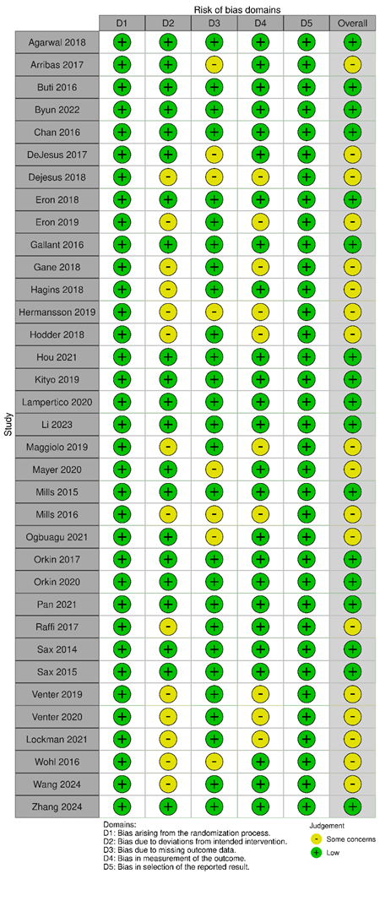
B) ROBINS-I
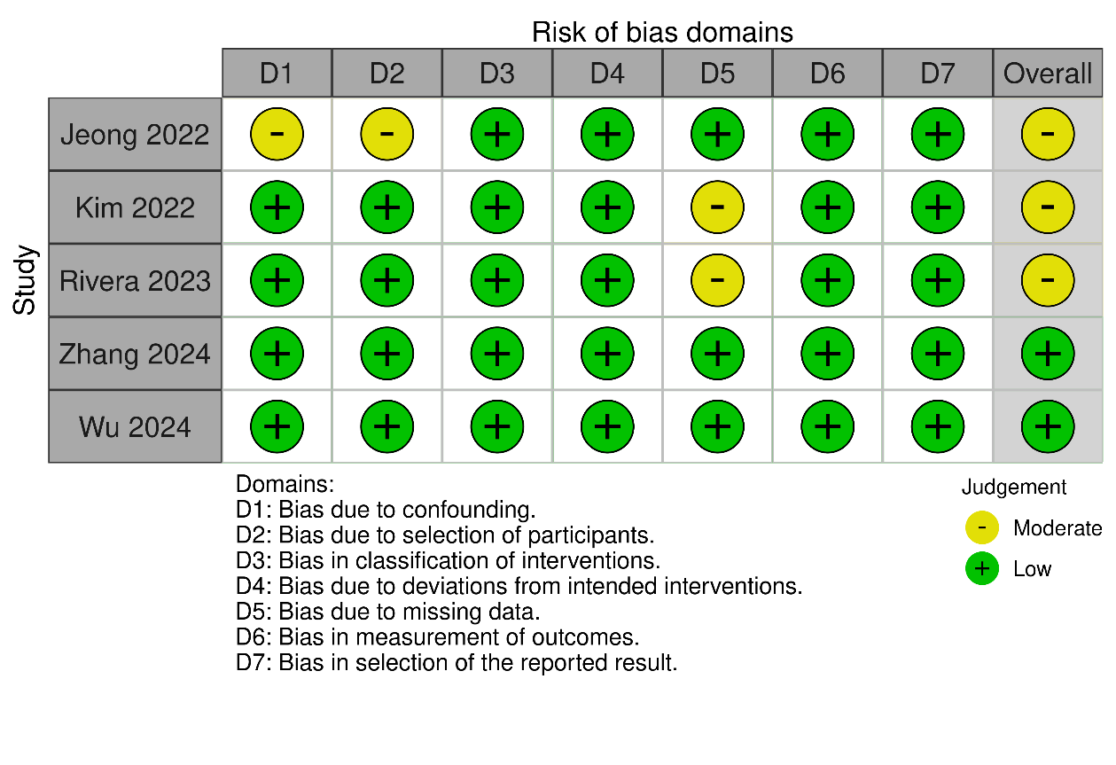

C) GRADE summary
Certainty assessment |  |  |  |  |  |  | Summary of findings |  | Certainty | Importance
No. of studies | Study design | RoBª | Inconsistency^{b} | Indirectness^{c} | Imprecision^{d} | Publication bias^{e} | Effect size (unit) | 95% CI | Certainty | Importance
Absolute value change in eGFR (follow-up: range 24 weeks to 144 weeks)
33 | 29 randomized trials,  4 observational cohort studies | Not serious | Serious | Not serious | Not serious | Undetected | 2.23 mL/min | 0.98 to  3.48 | ⨁⨁⨁◯  MODERATE | IMPORTANT
Absolute value change in SCr (follow-up: range 24 weeks to 144 weeks)
24 | 22 randomized trials,  2 observational cohort study | Not serious | Very serious | Not serious | Not serious | Detected | –0.02  mg/dL | –0.03 to  –0.01 | ⨁◯◯◯  VERY LOW | IMPORTANT
Percentage change in UPCR (follow-up: range 24 weeks to 144 weeks)
13 | Randomized trials | Not serious | Serious | Not serious | Not serious | Detected | –21.27% | –26.73 to  –15.8 | ⨁⨁◯◯  LOW | CRITICAL
Absolute value change in UPCR (follow-up: range 24 weeks to 144 weeks)
13 | Randomized trials | Not serious | Not serious | Not serious | Not serious | Detected | –12.90 mg/g | –15.57 to  –10.23 | ⨁⨁⨁◯  MODERATE | CRITICAL
Percentage change in UACR (follow-up: range 24 weeks to 96 weeks)
16 | Randomized trials | Not serious | Not serious | Not serious | Not serious | Detected | –15.13% | –19.13 to  –11.14 | ⨁⨁⨁◯  MODERATE | CRITICAL
Absolute value change in UACR (follow-up: range 24 weeks to 96 weeks)
16 | Randomized trials | Not serious | Not serious | Not serious | Not serious | Detected | –0.94 mg/g | –1.19 to  –0.68 | ⨁⨁⨁◯  MODERATE | CRITICAL
Percentage change in RBPCR (follow-up: range 48 weeks to 144 weeks)
18 | Randomized trials | Not serious | Not serious | Not serious | Not serious | Detected | –37.68% | –44.66 to  –30.70 | ⨁⨁⨁◯  MODERATE | CRITICAL
Absolute value change in RBPCR (follow-up: range 48 weeks to 144 weeks)
18 | Randomized trials | Not serious | Not  serious | Not serious | Not serious | Detected | –38.07 µg/g | –45.11 to  –31.04 | ⨁⨁⨁◯  MODERATE | CRITICAL
Percentage change in β₂MCR (follow-up: range 24 weeks to 144 weeks)
19 | Randomized trials | Not serious | Not serious | Not serious | Not serious | Detected | –45.77% | –53.36 to  –38.17 | ⨁⨁⨁◯  MODERATE | CRITICAL
Absolute value change in β₂MCR (follow-up: range 24 weeks to 144 weeks)
19 | Randomized trials | Not serious | Very serious | Not serious | Not serious | Detected | –31.34 µg/g | –36.91 to  –25.77 | ⨁◯◯◯  VERY LOW | CRITICAL
β₂MCR, urine β2 microglobulin to creatinine ratio; CI, confidence interval; eGFR, estimated glomerular filtration rate; GRADE, Grading of Recommendations, Assessment, Development, and Evaluation; RBPCR, urine retinol-binding protein to creatinine ratio; RoB 2, revised Cochrane risk of bias tool for randomized trials; ROBINS-I, Risk Of Bias in Non-randomized Studies-Interventions; SCr, serum creatinine; UACR, urine albumin to creatinine ratio; UPCR, urine protein to creatinine ratio.
Note:
High certainty: further research is very unlikely to change our confidence in the estimate of effect.
Moderate certainty: further research is likely to have an important impact on our confidence in the estimate of effect and may change the estimate.
Low certainty: further research is very likely to have an important impact on our confidence in the estimate of effect and is likely to change the estimate.
Very low certainty: we are very uncertain about the estimate.
ªRoB was assessed using the ROBINS-I tool for observational cohort studies and RoB 2 tool for randomized trials
^{b}Inconsistency was evaluated based on I² statistic in primary analyses for each outcome of interest
^{c}Indirectness was based on whether the evidence answered directly the research question and whether any indirectness of available evidence may have been serious enough to downgrade the quality of evidence for this outcome
^{d}Imprecision was evaluated based on whether 95% CI of effect size included the value of no effect “0” or not
^{e}Publication bias was assessed by funnel plot and Egger’s test

Supplemental Table 4. Subgroup analysis of eGFR change from baseline (for studies using CG formula only)
 |  | No. of participants
Subgroup analyses | No. of studies | TAF | TDF | Effect size (95% CI) | I², %
By disease state
HBV | 7 | 4040 | 3447 | 3.55 (2.68 to 4.42) | 0
HIV-1 | 15 | 6404 | 6352 | 2.88 (0.98 to 4.77) | 94.72
PrEP | 1 | 2694 | 2693 | 4.40 (2.18 to 6.62) | -
HIV-1/HBV coinfection | 1 | 121 | 122 | 2.10 (–1.09 to 5.29) | -
By duration
Week 48 | 16 | 6798 | 6489 | 2.98 (1.25 to 4.71) | 94.23
Week 96 | 6 | 5494 | 5311 | 2.91 (–0.42 to 6.24) | 90.79
Week 144 | 2 | 967 | 814 | 4.25 (1.04 to 7.46) | 49.16
By disease state and duration
HIV-1 and Week 48 | 11 | 3851 | 3581 | 2.71 (0.50 to 4.93) | 95.20
HIV-1 and Week 96 | 3 | 1813 | 2064 | 2.34 (–4.36 to 9.04) | 94.89
HIV-1 and Week 144 | 1 | 740 | 707 | 6.10 (2.47 to 9.73) | -
PrEP and Week 96 | 1 | 2694 | 2693 | 4.40 (2.18 to 6.62) | -
HBV and Week 48 | 5 | 2947 | 2908 | 3.64 (2.63 to 4.64) | 0
HBV and Week 96 | 1 | 866 | 432 | 3.60 (1.46 to 5.74) | -
HBV and Week 144 | 1 | 227 | 107 | 2.80 (–0.04 to 5.64) | -
HIV-1/HBV coinfection and Week 96 | 1 | 121 | 122 | 2.10 (–1.09 to 5.29) | -
By baseline eGFR (either ≤90 mL/min in each arm or not)
≤90 mL/min | 2 | 190 | 139 | 0.17 (–6.39 to 6.72) | 82.62
>90 mL/min | 22 | 13,069 | 12,475 | 3.33 (1.88 to 4.78) | 93.88
By previous exposure (HIV-1 only)
Naïve | 8 | 3348 | 3949 | 4.32 (1.21 to 7.44) | 92.00
Experienced | 7 | 3056 | 2403 | 1.94 (–1.23 to 5.11) | 95.45
CI, confidence interval; eGFR, estimated glomerular filtration rate; HBV, hepatitis B virus; PrEP, pre-exposure prophylaxis; TAF, tenofovir alafenamide; TDF, tenofovir disoproxil fumarate.

Supplemental Table 5. Subgroup analysis of eGFR change from baseline (for studies using CKD-EPI formula only)
 |  | No. of participants
Subgroup analyses | No. of studies | TAF | TDF | Effect size (95% CI) | I², %
By disease state
HBV | 1 | 52 | 47 | 0.46 (–2.43 to 3.35) | 0
HIV-1 | 3 | 1465 | 1096 | 3.56 (–0.70 to 7.83) | 94.94
PrEP | 1 | 118 | 410 | 4.37 (–0.51 to 9.25) | -
By duration
Week 24 | 1 | 26 | 25 | 0.26 (–3.19 to 3.71) | -
Week 48 | 4 | 1491 | 1118 | 3.07 (–0.63 to 6.77) | 92.45
Week 72 | 1 | 118 | 410 | 4.37 (–0.51 to 9.25) | -
By disease state and duration
HIV-1 and Week 48 | 3 | 1465 | 1096 | 3.56 (–0.70 to 7.83) | 94.94
PrEP and Week 72 | 1 | 118 | 410 | 4.37 (–0.51 to 9.25) | -
HBV and Week 24 | 1 | 26 | 25 | 0.26 (–3.19 to 3.71) | -
HBV and Week 48 | 1 | 26 | 22 | 0.92 (–4.36 to 6.20) | -
By baseline eGFR (either ≤90 mL/min in each arm or not)ª
≤90 mL/min | 2 | 170 | 457 | 1.47 (–1.01 to 3.96) | 0
>90 mL/min | 2 | 1084 | 715 | 1.59 (–1.83 to 5.02) | 90.72
By previous exposure (HIV-1 only)
Naïve | 1 | 362 | 363 | 3.40 (1.69 to 5.11) | -
Experienced | 2 | 1103 | 733 | 3.70 (–3.86 to 11.27) | 97.27
CI, confidence interval; eGFR, estimated glomerular filtration rate; HBV, hepatitis B virus; PrEP, pre-exposure prophylaxis; SCr, serum creatinine; TAF, tenofovir alafenamide; TDF, tenofovir disoproxil fumarate.
ªOne study that did not report the baseline eGFR values was removed from this subgroup analysis.

Supplementary Table 6. Subgroup analysis of SCr change from baseline
Subgroup analyses | No. of studies | No. of participants |  | Effect size (95% CI) | I², %
Subgroup analyses | No. of studies | TAF | TDF | Effect size (95% CI) | I², %
By disease state
HBV | 9 | 2543 | 1622 | –0.02 (–0.04 to 0.00) | 89.88
HIV-1 | 13 | 5251 | 4772 | –0.01 (–0.03 to 0.01) | 91.59
PrEP | 2 | 4565 | 4587 | –0.01 (–0.02 to –0.01) | 61.41
By duration
Week 24 | 1 | 26 | 25 | 0.00 (–0.09 to 0.08) | -
Week 48 | 18 | 7439 | 6933 | –0.02 (–0.03 to –0.01) | 93.77
Week 84 | 1 | 272 | 144 | –0.04 (–0.07 to –0.01) | -
Week 96 | 5 | 4351 | 3440 | –0.02 (–0.03 to 0.00) | 77.13
Week 144 | 2 | 271 | 151 | –0.01 (–0.03 to 0.01) | 0
By disease state and duration
HIV-1 and Week 48 | 10 | 3732 | 3594 | –0.01 (–0.04 to 0.02) | 92.68
HIV-1 and Week 84 | 1 | 272 | 144 | –0.04 (–0.07 to –0.01) | -
HIV-1 and Week 96 | 2 | 1247 | 746 | 0.00 (–0.10 to 0.09) | 78.14
PrEP and Week 48 | 1 | 2371 | 2369 | –0.02 (–0.02 to –0.01) | -
PrEP and Week 96 | 1 | 2194 | 2218 | –0.01 (–0.02 to 0.00) | -
HBV and Week 24 | 1 | 26 | 25 | 0.00 (–0.09 to 0.08) | -
HBV and Week 48 | 7 | 1336 | 970 | –0.02 (–0.05 to 0.00) | 93.79
HBV and Week 96 | 2 | 910 | 476 | –0.02 (–0.03 to –0.01) | 0
HBV and Week 144 | 2 | 271 | 151 | –0.01 (–0.03 to 0.01) | 0
By previous exposure (HIV-1 only)
Naïve | 7 | 2244 | 2910 | –0.01 (–0.04 to 0.01) | 77.89
Experienced | 6 | 3007 | 1862 | –0.01 (–0.05 to 0.02) | 95.64
By difference in booster distribution between groups (HIV-1 only)
≥0.1 | 5 | 2674 | 1532 | –0.01 (–0.05 to 0.03) | 96.40
<0.1 | 8 | 2577 | 3240 | –0.02 (–0.04 to 0.00) | 75.71
CI, confidence interval; HBV, hepatitis B virus; PrEP, pre-exposure prophylaxis; SCr, serum creatinine; TAF, tenofovir alafenamide; TDF, tenofovir disoproxil fumarate.

Supplemental Table 7. Summary of sensitivity analyses

Sensitivity analyses | No. of studies | Effect size | 95% CI | I², %
eGFR
Primary analysis (DL methods) | 33 | 2.23 | 0.98 to 3.48 | 94.06
Using a fixed-effects model | 33 | 0.06 | –0.02 to 0.15 | 94.06
Excluding studies with high/serious RoB | - | - | - | -
Excluding studies with small sample size | 28 | 2.48 | 1.05 to 3.92 | 95.43
Excluding studies not based on Cockcroft–Gaultª | 25 | 3.07 | 1.69 to 4.46 | 93.44
Excluding studies not based on CKD-EPI | 6 | 2.80 | –0.06 to 5.66 | 88.00
Excluding observational cohort studies | 29 | 2.16 | 0.81 to 3.52 | 94.79
SCr
Primary analysis (DL methods) | 24 | –0.02 | –0.03 to –0.01 | 92.19
Using a fixed-effects model | 24 | 0.00 | 0.00 to 0.00 | 92.19
Excluding studies with high/serious RoB | - | - | - | -
Excluding studies with small sample size | 21 | –0.02 | –0.03 to –0.01 | 93.94
Excluding observational cohort studies | 22 | –0.02 | –0.03 to –0.01 | 89.19
Excluding studies with pregnant women | 23 | -0.02 | –0.03 to –0.01 | 92.44
CI, confidence interval; CKD-EPI, Chronic Kidney Disease Epidemiology Collaboration; DL, DerSimonian–Laird; eGFR, estimated glomerular filtration rate; MDRD, modification in diet of renal disease; RoB, risk of bias; SCr, serum creatinine.
ªOf the 5 excluded studies, 3 used the CKD-EPI formula, 1 used the MDRD formula, and 1 did not have a clear definition of the formula used.

Supplemental Figure 1. Study selection flow diagram
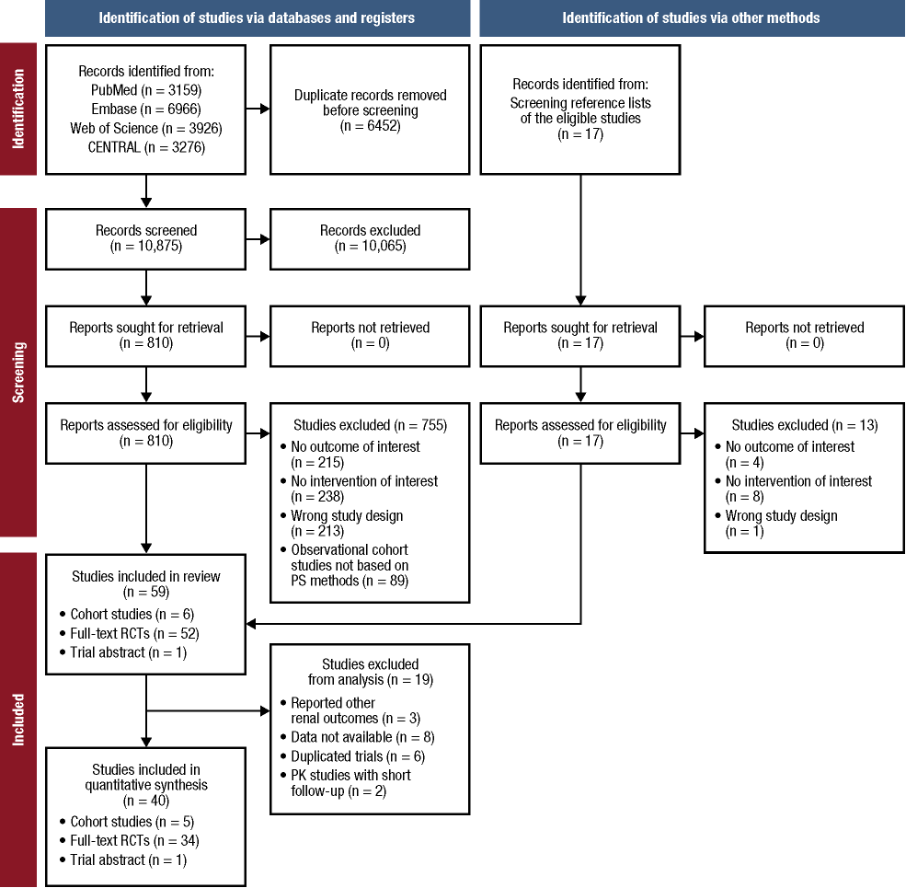

CENTRAL, Cochrane Central Register of Controlled Trials; PS, propensity score; RCT, randomized controlled trial.

Supplemental Figure 2. Forest plots of eGFR change from baseline for exploring heterogeneity by A) removing 8 studies that were not based on Cockcroft–Gault and B) removing 6 studies due to introduced bias by baseline eGFR, pregnancy, and serum creatinine inhibition effects by imbalanced use of dolutegravir and rilpivirine

A)

B)

CI, confidence interval; eGFR, estimated glomerular filtration rate; MD, mean difference; SD, standard deviation; TAF, tenofovir alafenamide; TDF, tenofovir disoproxil fumarate.
The x-axis represents the MD of eGFR change from baseline (measured in mL/min) between TAF and TDF. The y-axis represents the line of null effect. A null effect, or value of 0, indicates no difference between TAF and TDF for eGFR change from baseline. The right side of the null effect line indicates a favor toward TAF, and the left side of the null effect line indicates a favor toward TDF.

Supplemental Figure 3. Publication bias and small-study effect assessment for eGFR

A) Funnel plot
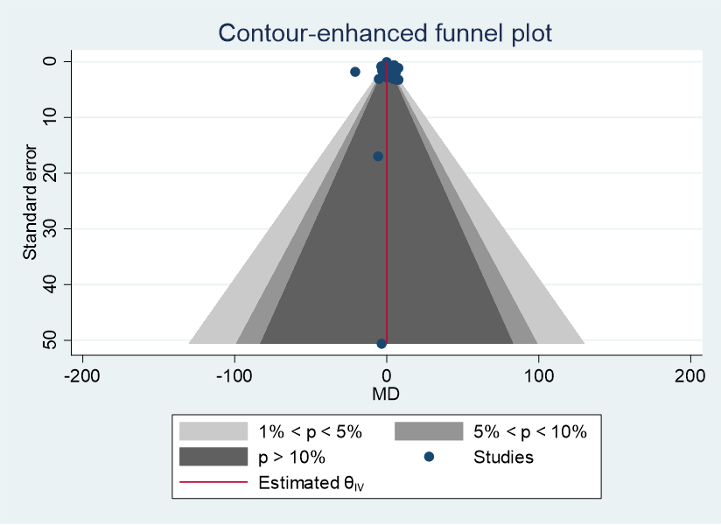

B) Egger’s test
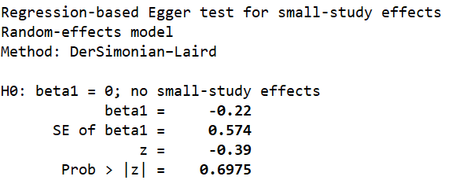

eGFR, estimated glomerular filtration rate.

Supplemental Figure 4. Forest plot of SCr change from baseline for exploring heterogeneity, removing 6 studies that were not consistent with others by visual inspection
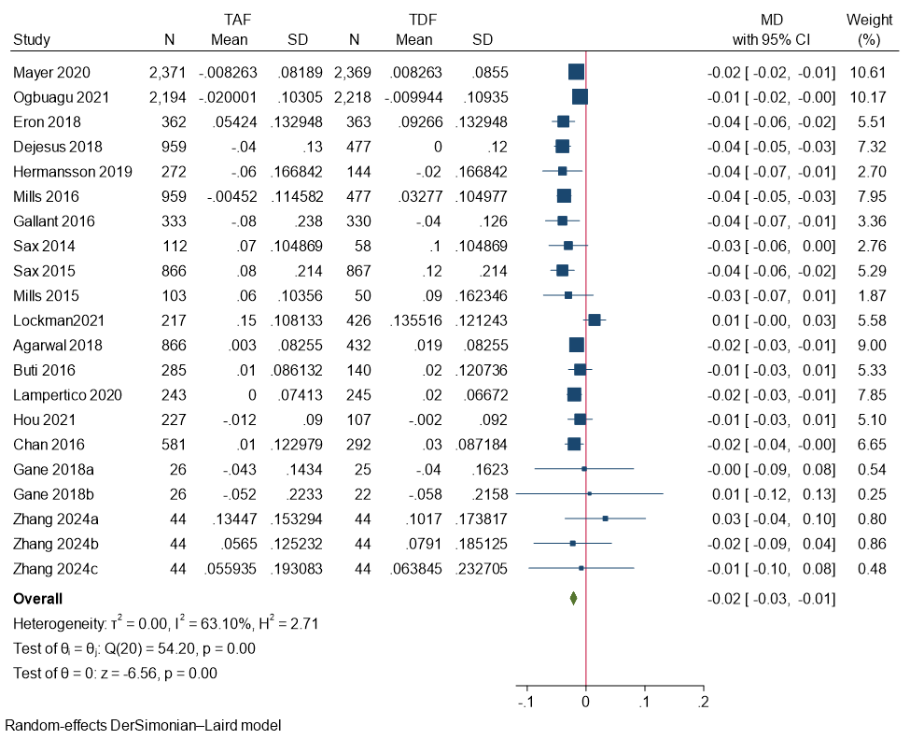

CI, confidence interval; MD, mean difference; PrEP, pre-exposure prophylaxis; SCr, serum creatinine; SD, standard deviation; TAF, tenofovir alafenamide; TDF, tenofovir disoproxil fumarate.
The x-axis represents the MD of SCr change from baseline (measured in mg/dL) between TAF and TDF. The y-axis represents the line of null effect. A null effect, or value of 0, indicates no difference between TAF and TDF for serum creatinine change from baseline. The right side of the null effect line indicates a favor toward TDF, and the left side of the null effect line indicates a favor toward TAF.

Supplemental Figure 5. Publication bias and small-study effect assessment for SCr

A) Funnel plot
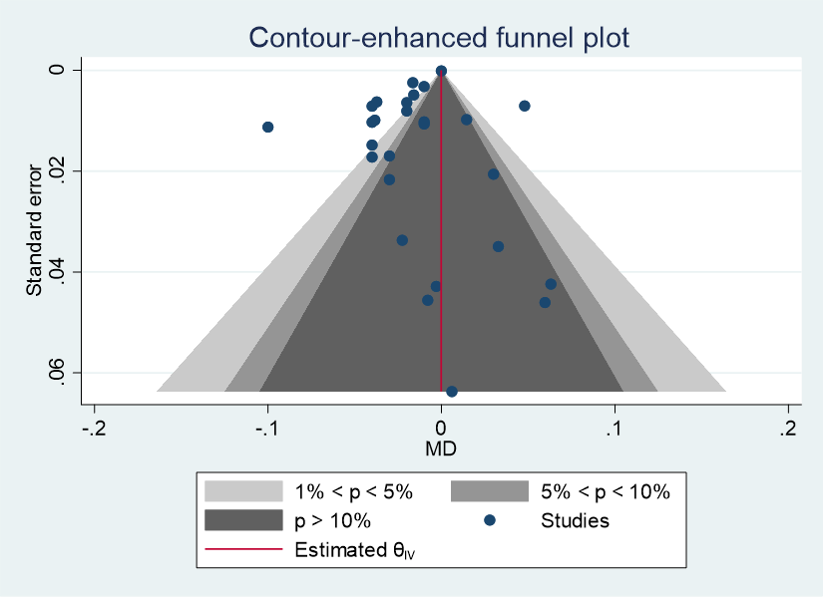

B) Egger’s test
SCr, serum creatinine.

Supplemental Figure 6. Forest plots of UPCR (percentage change and absolute value change from baseline) by follow-up duration

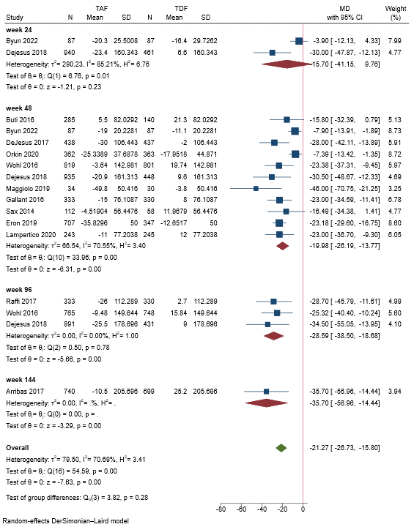 | 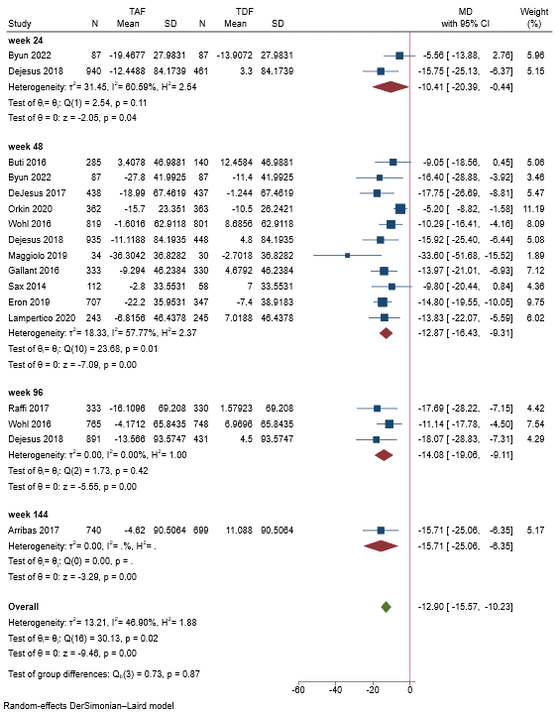
CI, confidence interval; MD, mean difference; SD, standard deviation; TAF, tenofovir alafenamide; TDF, tenofovir disoproxil fumarate; UPCR, urine protein to creatinine ratio.
The x-axis represents the MD of UPCR change from baseline (absolute value change measured in mg/g) between TAF and TDF. The y-axis represents the line of null effect. A null effect, or value of 0, indicates no difference between TAF and TDF for UPCR change from baseline. The right side of the null effect line indicates a favor toward TDF, and the left side of the null effect line indicates a favor toward TAF.

Supplemental Figure 7. Forest plots of UACR (percentage change and absolute value change from baseline) by follow-up duration
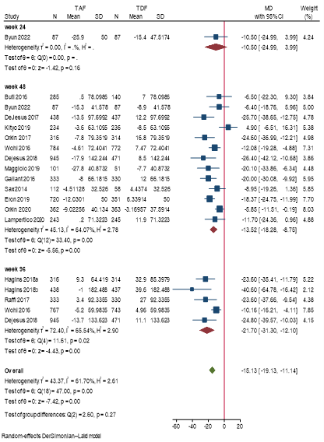

CI, confidence interval; MD, mean difference; SD, standard deviation; TAF, tenofovir alafenamide; TDF, tenofovir disoproxil fumarate; UACR, urine albumin to creatinine ratio.
The x-axis represents the mean difference of UACR change from baseline (absolute value change measured in mg/g) between TAF and TDF. The y axis represents the line of null effect. A null effect, or value of 0, indicates no difference between TAF and TDF for UACR change from baseline. The right side of the null effect line indicates a favor toward TDF, and the left side of the null effect line indicates a favor toward TAF.

Supplemental Figure 8. Forest plots of RBPCR (percentage change and absolute value change from baseline) by follow-up duration

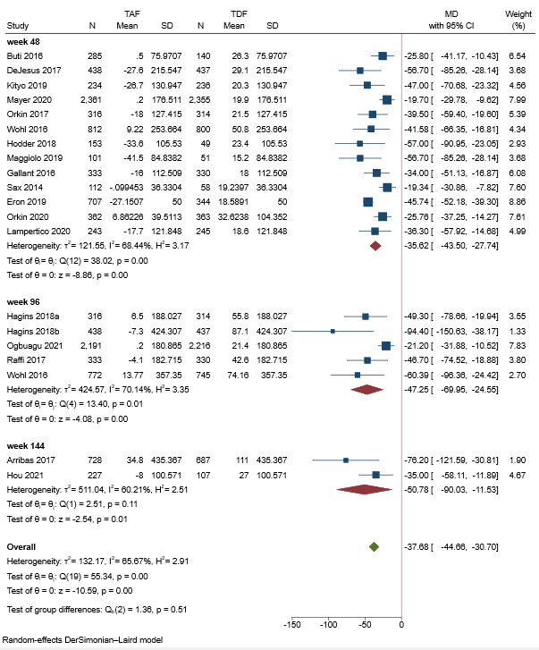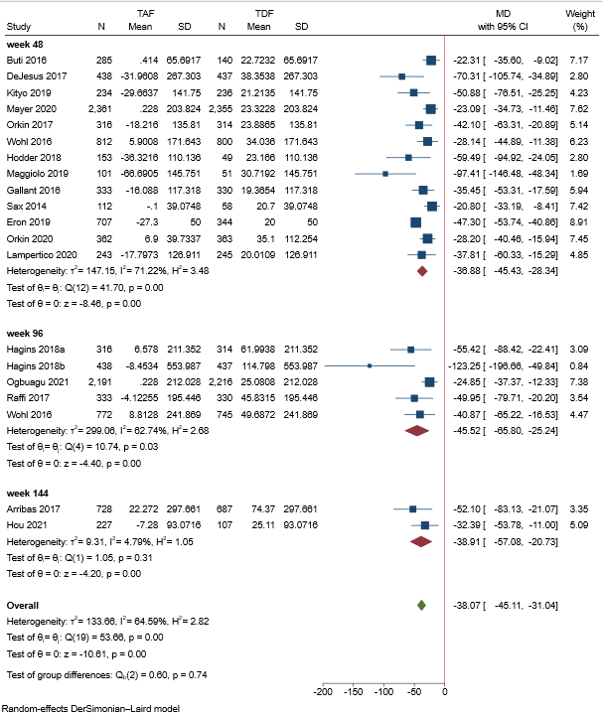

CI, confidence interval; MD, mean difference; RBPCR, urine retinol-binding protein to creatinine ratio; SD, standard deviation; TAF, tenofovir alafenamide; TDF, tenofovir disoproxil fumarate.
The x-axis represents the MD of RBPCR change from baseline (absolute value change measured in µg/g) between TAF and TDF. The y axis represents the line of null effect. A null effect, or value of 0, indicates no difference between TAF and TDF for RBPCR change from baseline. The right side of the null effect line indicates a favor toward TDF, and the left side of the null effect line indicates a favor toward TAF.

Supplemental Figure 9. Forest plots of β₂MCR (percentage change and absolute value change from baseline) by follow-up duration

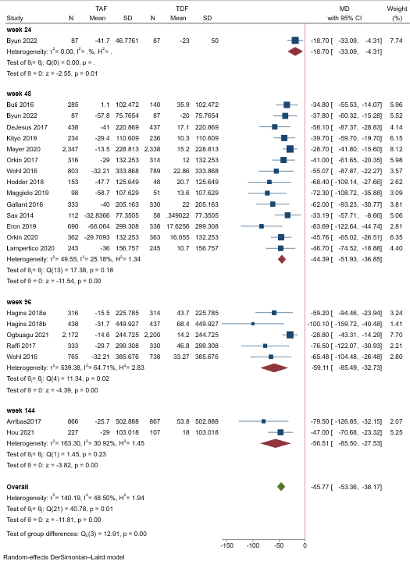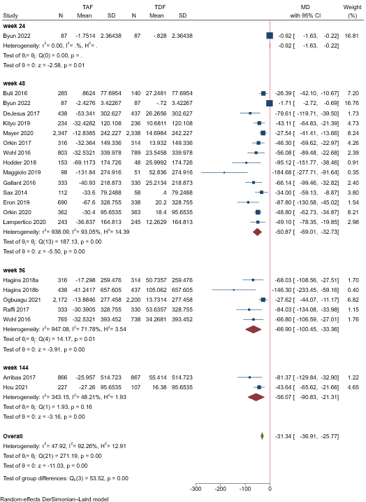
β₂MCR, urine beta-2 microglobulin to creatinine ratio; CI, confidence interval; MD, mean difference; SD, standard deviation; TAF, tenofovir alafenamide; TDF, tenofovir disoproxil fumarate.
The x-axis represents the MD of β₂MCR change from baseline (absolute value change measured in µg/g) between TAF and TDF. The y axis represents the line of null effect. A null effect, or value of 0, indicates no difference between TAF and TDF for β₂MCR change from baseline. The right side of the null effect line indicates a favor toward TDF, and the left side of the null effect line indicates a favor toward TAF.

Supplemental Figure 10. Forest plots of proteinuria change for exploring heterogeneity

A) UPCR (percentage change from baseline) with follow-up duration of 48 weeks

B) β2MCR (absolute change from baseline) with follow-up duration of 48 weeks

β₂MCR, urine beta-2 microglobulin to creatinine ratio; CI, confidence interval; MD, mean difference; SD, standard deviation; TAF, tenofovir alafenamide; TDF, tenofovir disoproxil fumarate; UPCR, urine protein to creatinine ratio.
The x-axis represents the MD of UPCR (mg/g) or β₂MCR (µg/g) change from baseline between TAF and TDF. The y axis represents the line of null effect. A null effect, or value of 0, indicates no difference between TAF and TDF for UPCR or β₂MCR change from baseline. The right side of the null effect line indicates a favor toward TDF, and the left side of the null effect line indicates a favor toward TAF.

Supplemental Figure 11. Publication bias and small-study effect assessment for proteinuria biomarkers A) UPCR, B) UACR, C) RBPCR, and D) β₂MCR. Funnel plots show percentage change in the left-hand panels and absolute change in the right-hand panels. Egger’s tests results are shown below the funnel plots.

A)
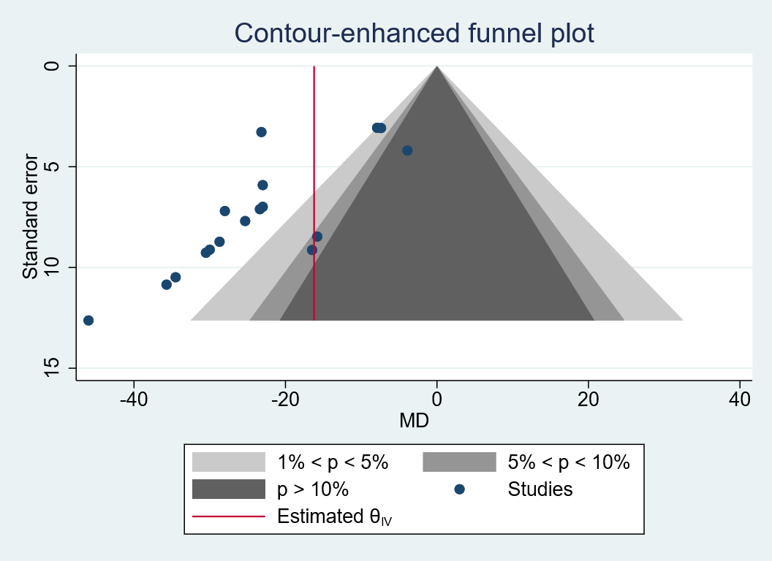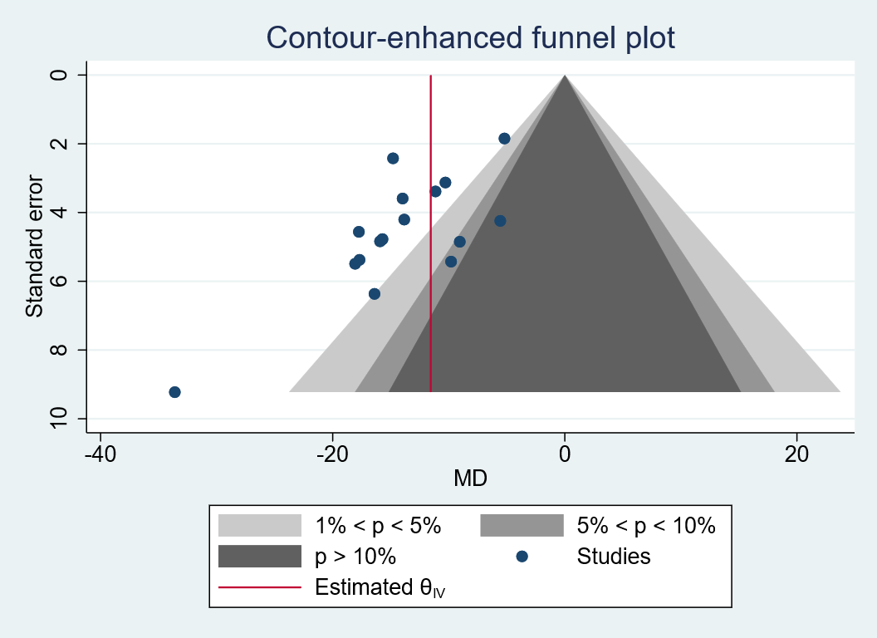
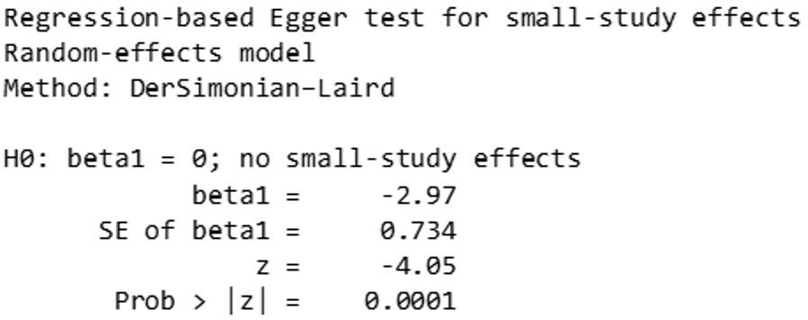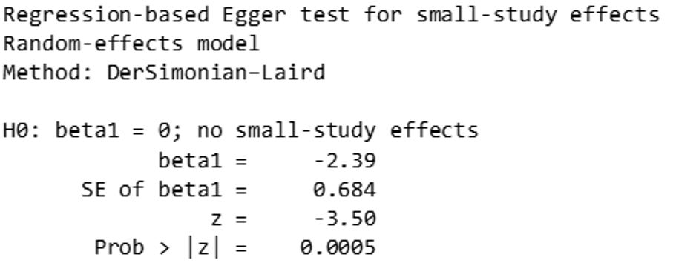

B)

C)
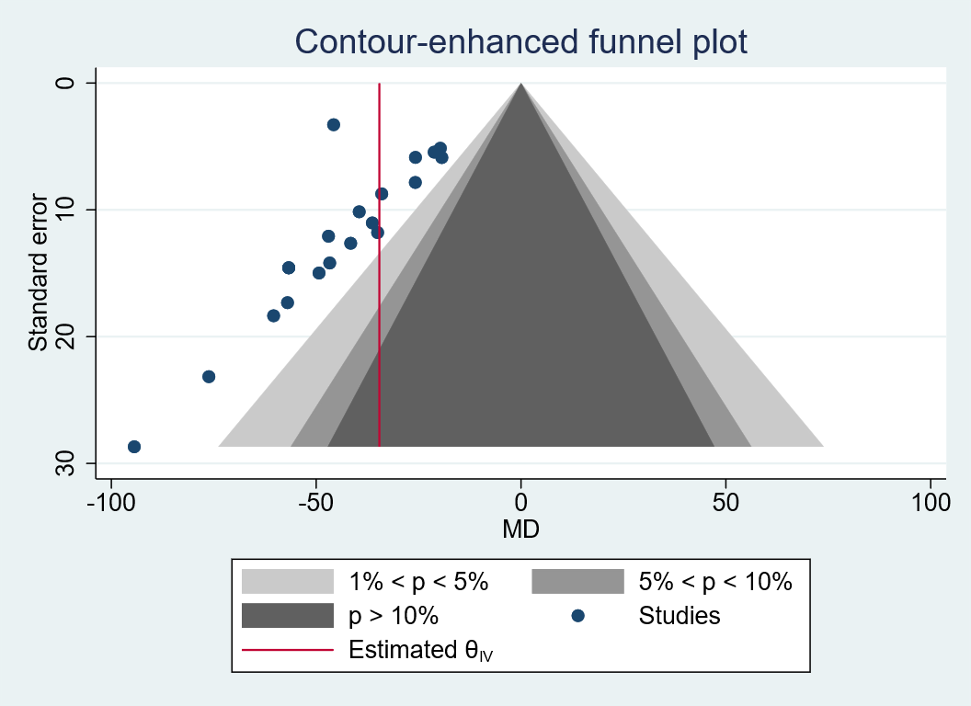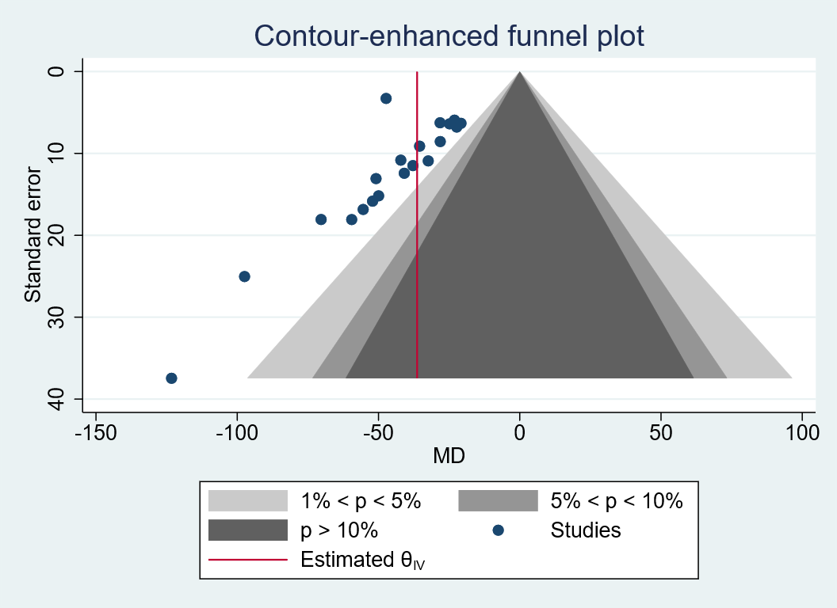

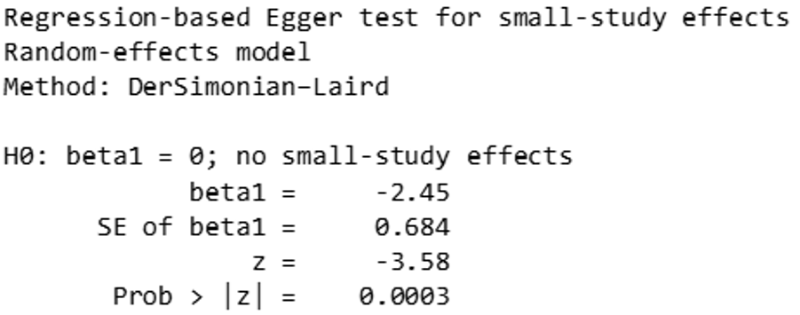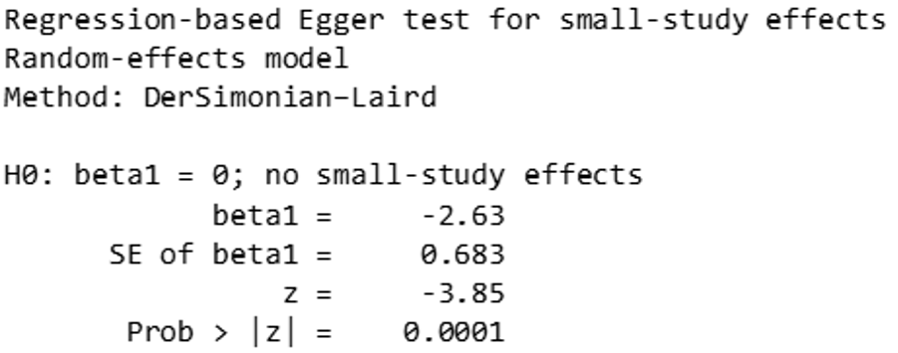

D)
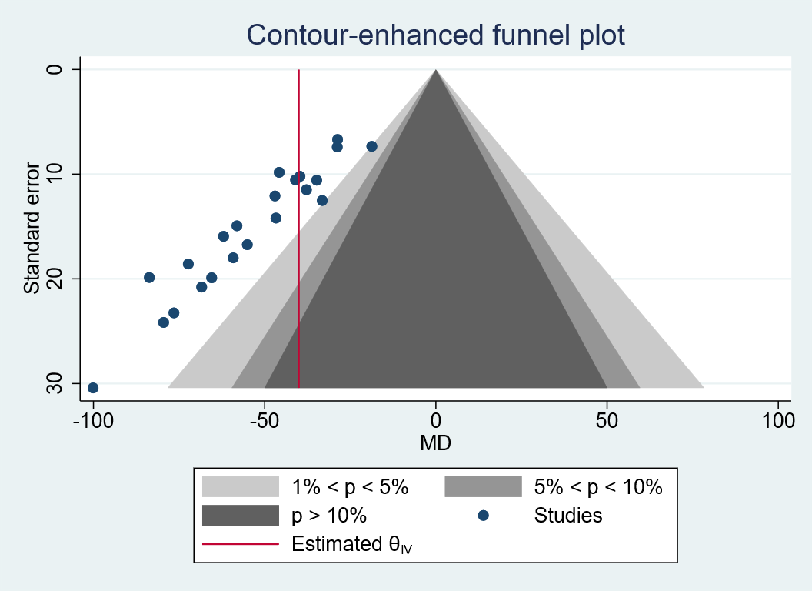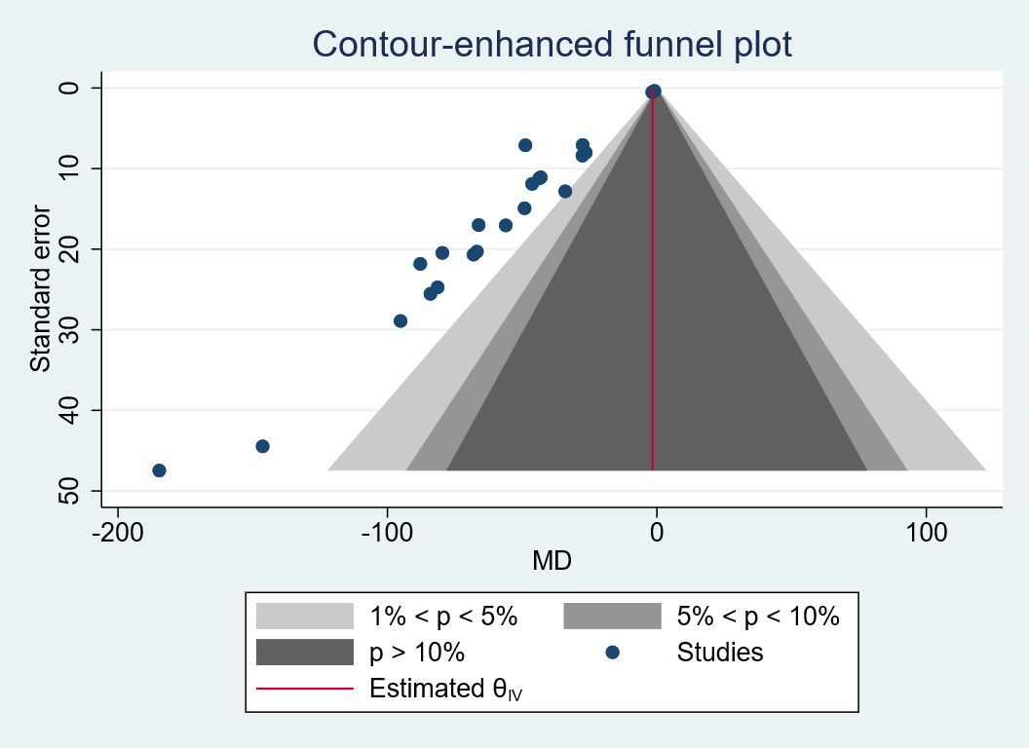

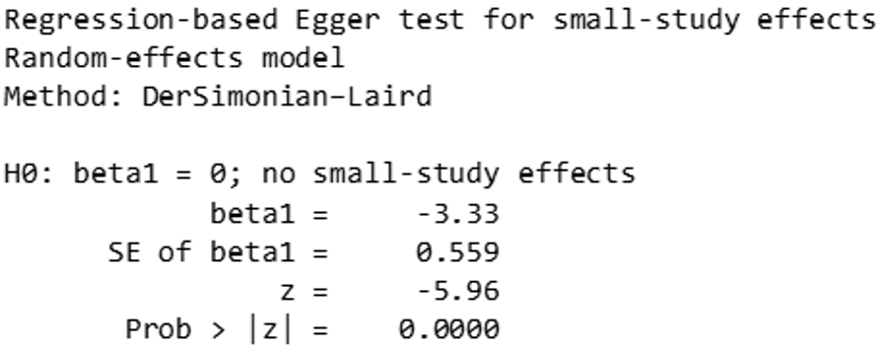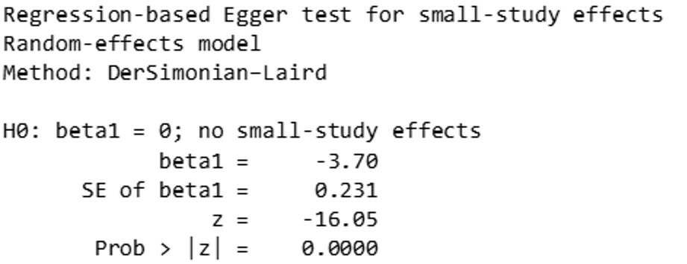
β₂MCR, urine beta-2 microglobulin to creatinine ratio; RBPCR, urine retinol-binding protein to creatinine ratio; UACR, urine albumin to creatinine ratio; UPCR, urine protein to creatinine ratio.

