Supplemental Data – Document 1 Map Figures

Figure 1. CKD 4&5 Undecided aggregate journey map

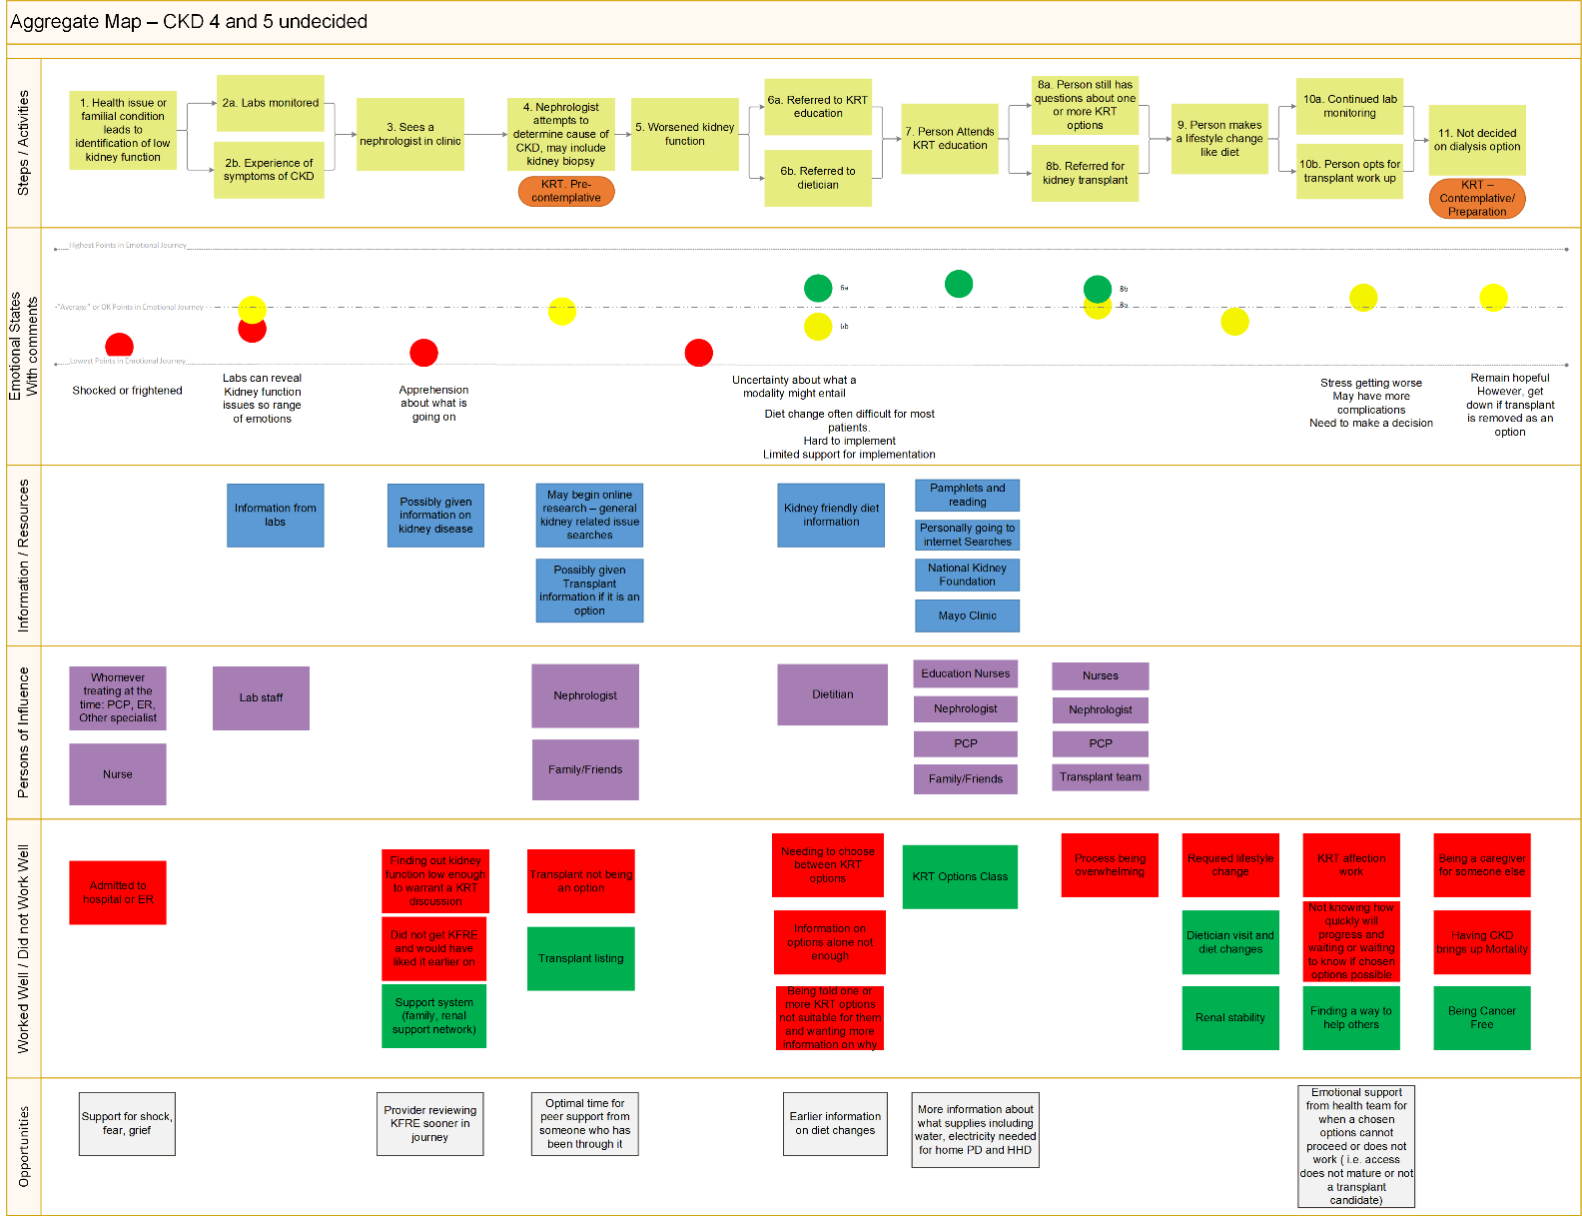

Legend: Phase – depicts the diagnosis, education, decision and treatment phases at the top, yellow boxes - steps or actions in the process that the person takes, orange ovals - indicate stage of behavioural change in terms of readiness to make a kidney replacement therapy options decision, blue boxes – resources used in decision-making, purple boxes people helpful, green boxes – what worked well in the process, what did not work well in the process, grey boxes – suggestions for improvement or interventions. Circles pertain to the emotional map. Red is a negative emotion; green is positive and yellow is neutral.

Figure 2. CKD 4 Decided aggregate journey map
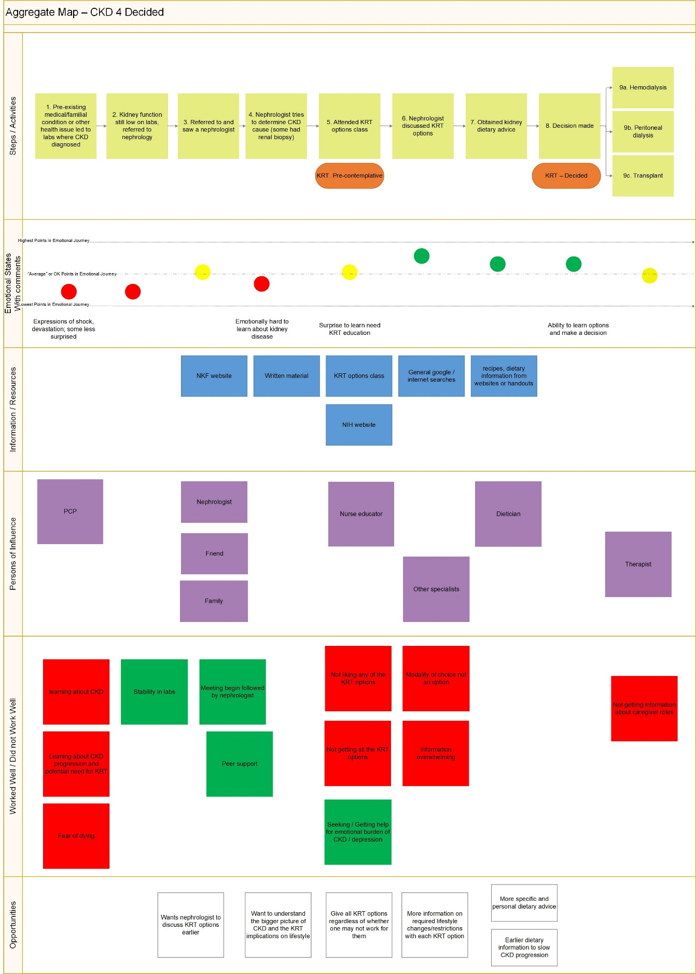

Legend: Phase – depicts the diagnosis, education, decision and treatment phases at the top, yellow boxes - steps or actions in the process that the person takes, orange ovals - indicate stage of behavioural change in terms of readiness to make a kidney replacement therapy options decision, blue boxes – resources used in decision-making, purple boxes people helpful, green boxes – what worked well in the process, what did not work well in the process, grey boxes – suggestions for improvement or interventions. Circles pertain to the emotional map. Red is a negative emotion; green is positive and yellow is neutral.

Figure 3. Unplanned hospital start dialysis group aggregate journey map

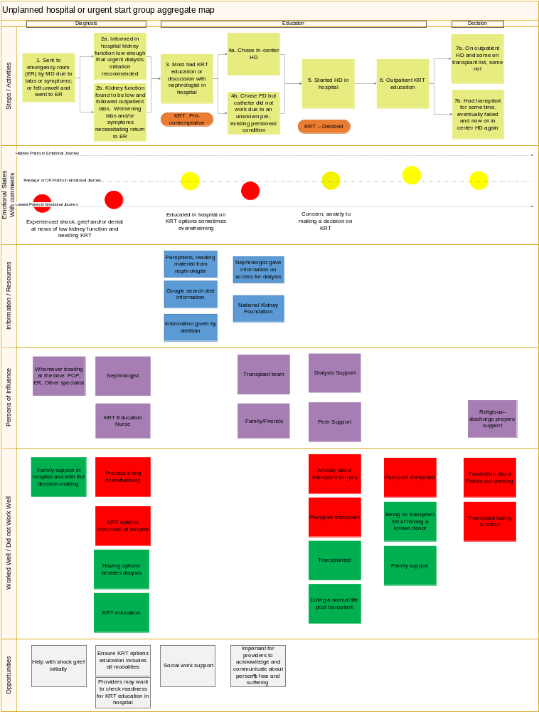

Legend: Phase – depicts the diagnosis, education, decision and treatment phases at the top, yellow boxes - steps or actions in the process that the person takes, orange ovals - indicate stage of behavioural change in terms of readiness to make a kidney replacement therapy options decision, blue boxes – resources used in decision-making, purple boxes people helpful, green boxes – what worked well in the process, what did not work well in the process, grey boxes – suggestions for improvement or interventions. Circles pertain to the emotional map. Red is a negative emotion; green is positive and yellow is neutral.

Figure 4. Post transplant CKD group aggregate journey map

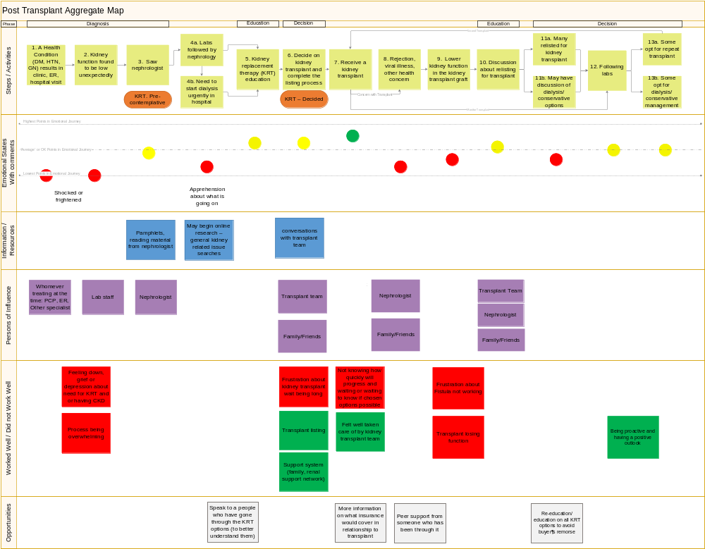

Legend: yellow boxes - Phase – depicts the diagnosis, education, decision and treatment phases at the top, steps or actions in the process that the person takes, orange ovals - indicate stage of behavioural change in terms of readiness to make a kidney replacement therapy options decision, blue boxes – resources used in decision-making, purple boxes people helpful, green boxes – what worked well in the process, what did not work well in the process, grey boxes – suggestions for improvement or interventions. Circles pertain to the emotional map. Red is a negative emotion; green is positive and yellow is neutral.

