Supplementary Table S1: Baseline characteristics for patients stratified by PIV index quartiles.
 |  | PIV_4group
 | Overall  N = 1,164 | G1  N = 291 | G2  N = 291 | G3  N = 291 | G4  N = 291 | p-value
PIV index range |  | 9.97 to 218 | 218 to 445 | 445 to 1110 | 1110 to 23100
PIV | 455 (218, 1,115) | 131 (96, 162) | 325 (263, 383) | 720 (552, 864) | 2,618 (1,848, 4,451) | <0.001
SII | 858 (491, 1,917) | 323 (247, 429) | 634 (528, 772) | 1,100 (901, 1,524) | 3,240 (2,371, 4,914) | <0.001
NLR | 4 (2, 8) | 2 (1, 2) | 3 (2, 3) | 5 (3, 7) | 14 (9, 21) | <0.001
Age（years） | 65 (56, 73) | 64 (56, 71) | 64 (55, 72) | 66 (58, 75) | 66 (56, 76) | 0.011
Gender(Woman) | 467 (40.1%) | 142 (48.8%) | 124 (42.6%) | 117 (40.2%) | 84 (28.9%) | <0.001
BMI(kg/m2) | 22.0 (20.0, 24.4) | 22.0 (20.0, 24.6) | 22.2 (20.3, 24.6) | 21.9 (19.8, 24.2) | 22.2 (19.9, 24.0) | 0.513
Smoking history | 222 (19.1%) | 47 (16.2%) | 53 (18.2%) | 63 (21.6%) | 59 (20.3%) | 0.351
Preoperative medical history
Hypertension | 267 (22.9%) | 54 (18.6%) | 60 (20.6%) | 67 (23.0%) | 86 (29.6%) | 0.010
AF | 19 (1.6%) | 3 (1.0%) | 4 (1.4%) | 6 (2.1%) | 6 (2.1%) | 0.735
COPD | 103 (8.8%) | 21 (7.2%) | 20 (6.9%) | 30 (10.3%) | 32 (11.0%) | 0.187
MI | 60 (5.2%) | 11 (3.8%) | 17 (5.8%) | 11 (3.8%) | 21 (7.2%) | 0.167
PVD | 96 (8.2%) | 13 (4.5%) | 15 (5.2%) | 20 (6.9%) | 48 (16.5%) | <0.001
Stroke | 75 (6.4%) | 6 (2.1%) | 12 (4.1%) | 20 (6.9%) | 37 (12.7%) | <0.001
CHD | 30 (2.6%) | 2 (0.7%) | 10 (3.4%) | 8 (2.7%) | 10 (3.4%) | 0.117
Diabetes | 114 (9.8%) | 22 (7.6%) | 24 (8.2%) | 31 (10.7%) | 37 (12.7%) | 0.140
Preoperative medications
Statins | 102 (8.8%) | 22 (7.6%) | 29 (10.0%) | 27 (9.3%) | 24 (8.2%) | 0.742
Hypertension medication | 285 (24.5%) | 55 (18.9%) | 67 (23.0%) | 79 (27.1%) | 84 (28.9%) | 0.025
Anti diabetic drugs | 141 (12.1%) | 31 (10.7%) | 25 (8.6%) | 42 (14.4%) | 43 (14.8%) | 0.061
Preoperative Lab Results
Cre | 80 (67, 93) | 80 (70, 91) | 82 (67, 93) | 80 (67, 94) | 78 (61, 97) | 0.544
Hb | 128 (111, 140) | 129 (117, 139) | 131 (114, 142) | 124 (110, 138) | 124 (103, 141) | 0.013
Glu | 5.49 (4.70, 7.14) | 5.02 (4.56, 5.59) | 5.27 (4.53, 6.15) | 5.47 (4.62, 6.96) | 7.48 (5.88, 9.84) | <0.001
TG | 1.17 (0.82, 1.62) | 1.18 (0.82, 1.69) | 1.26 (0.90, 1.73) | 1.15 (0.86, 1.52) | 1.04 (0.72, 1.50) | <0.001
Anesthesia information
ASA classification
I | 2 (0.2%) | 2 (0.7%) | 0 (0.0%) | 0 (0.0%) | 0 (0.0%)
II | 80 (6.9%) | 27 (9.3%) | 29 (10.0%) | 19 (6.5%) | 5 (1.7%)
III | 698 (60.0%) | 203 (69.8%) | 207 (71.1%) | 168 (57.7%) | 120 (41.2%)
IV | 374 (32.1%) | 58 (19.9%) | 55 (18.9%) | 102 (35.1%) | 159 (54.6%)
V | 10 (0.9%) | 1 (0.3%) | 0 (0.0%) | 2 (0.7%) | 7 (2.4%)
Surgical types |  |  |  |  |  | <0.001
Other | 82 (7.0%) | 6 (2.1%) | 9 (3.1%) | 23 (7.9%) | 44 (15.1%)
Thoracic surgery | 229 (19.7%) | 78 (26.8%) | 65 (22.3%) | 66 (22.7%) | 20 (6.9%)
Nonthoracic major surgery | 853 (73.3%) | 207 (71.1%) | 217 (74.6%) | 202 (69.4%) | 227 (78.0%)
Emergency surgery | 299 (25.7%) | 15 (5.2%) | 30 (10.3%) | 74 (25.4%) | 180 (61.9%) | <0.001
Duration of anesthesia (mins) | 195 (130, 265) | 220 (160, 285) | 215 (150, 275) | 195 (125, 265) | 150 (100, 210) | <0.001
MAP<60mmHg duration (mins) | 0 (0, 10) | 0 (0, 10) | 0 (0, 10) | 0 (0, 10) | 5 (0, 10) | 0.072
Total infusion volume（ml） | 1,750 (1,000, 2,250) | 2,000 (1,500, 2,250) | 2,000 (1,500, 2,500) | 1,750 (1,000, 2,500) | 1,500 (1,000, 2,000) | <0.001
Erythrocyte | 67 (5.8%) | 16 (5.5%) | 11 (3.8%) | 17 (5.8%) | 23 (7.9%) | 0.203
Plasm | 28 (2.4%) | 7 (2.4%) | 1 (0.3%) | 6 (2.1%) | 14 (4.8%) | 0.006
Blood loss(ml) | 30 (18, 100) | 50 (20, 100) | 50 (20, 100) | 30 (15, 80) | 20 (10, 100) | <0.001
Urine output(ml) | 300 (200, 500) | 300 (200, 500) | 300 (210, 500) | 300 (200, 500) | 267 (200, 400) | <0.001
Intraoperative medication
Type of vasopressor |  |  |  |  |  | 0.134
DA | 394 (33.8%) | 96 (33.0%) | 112 (38.5%) | 103 (35.4%) | 83 (28.5%)
E | 27 (2.3%) | 11 (3.8%) | 5 (1.7%) | 4 (1.4%) | 7 (2.4%)
NE | 25 (2.1%) | 6 (2.1%) | 3 (1.0%) | 7 (2.4%) | 9 (3.1%)
PE | 355 (30.5%) | 87 (29.9%) | 91 (31.3%) | 93 (32.0%) | 84 (28.9%)
Diuretics | 34 (2.9%) | 6 (2.1%) | 12 (4.1%) | 8 (2.7%) | 8 (2.7%) | 0.512
Postoperative results
Scr highest within 2 days | 73 (60, 92) | 70 (60, 86) | 73 (60, 88) | 72 (59, 93) | 81 (63, 104) | <0.001
Scr highest within 7 days | 77 (64, 97) | 73 (63, 88) | 76 (64, 94) | 77 (64, 96) | 82 (65, 113) | <0.001
AKI | 98 (8.4%) | 10 (3.4%) | 16 (5.5%) | 23 (7.9%) | 49 (16.8%) | <0.001
Continious variables were presented as median [quartile].Categorical variables were presented as n (proportion).Abbreviations:AKI: Acute Kidney Injury;PIV: Pan-Immune-Inflammation Value;SII: Systemic Immune-Inflammation Index;NLR: Neutrophil-to-Lymphocyte Ratio;Cre: Creatinine;DA: Dopamine;E: Epinephrine;NE: Norepinephrine;PE: Phenylephrine;TG: triglyceride; BMI: Body Mass Index; CHF: Congestive Heart Failure; AF: Atrial fibrillation; MI: myocardial ischemia; COPD: Chronic Obstructive Pulmonary Disease; PVD: ASA: American Society of Anesthesiologist;

Supplementary Table S2. AUC values and 95% confidence intervals of preoperative inflammatory markers for predicting AKI
Predictor | AUC (95% CI) | p-value
PIV | 0.691 (0.633–0.749)
SII | 0.654 (0.593–0.714)
NLR | 0.648 (0.587–0.710)
PIV vs SII |  | <0.001
PIV vs NLR |  | 0.002
P-values were calculated using DeLong’s test to compare AUCs.

Supplementary Table S3.Patient demographics and baseline characteristics
Characteristic | Cohort |  | p-value
Characteristic | Training Cohort  N = 815 | Internal Test Cohort  N = 349 | p-value
PIV, n (%) |  |  | 0.243
≥ 1916 | 154 (18.9%) | 56 (16.0%)
< 1916 | 660 (81.1%) | 293 (84.0%)
SII, n (%) |  |  | 0.146
≥ 2738 | 126 (15.5%) | 66 (18.9%)
< 2738 | 689 (84.5%) | 283 (81.1%)
NLR, n (%) |  |  | 0.584
≥ 9 | 175 (21.5%) | 80 (22.9%)
< 9 | 640 (78.5%) | 269 (77.1%)
Age, n (%) |  |  | 0.919
≥ 69 | 308 (37.8%) | 133 (38.1%)
< 69 | 507 (62.2%) | 216 (61.9%)
Gender, n (%) |  |  | 0.792
Man | 486 (59.6%) | 211 (60.5%)
Woman | 329 (40.4%) | 138 (39.5%)
Smoking history, n (%) |  |  | 0.815
No | 661 (81.1%) | 281 (80.5%)
Yes | 154 (18.9%) | 68 (19.5%)
hypertension, n (%) |  |  | 0.452
No | 633 (77.7%) | 264 (75.6%)
Yes | 182 (22.3%) | 85 (24.4%)
stroke, n (%) |  |  | 0.894
No | 763 (93.6%) | 326 (93.4%)
Yes | 52 (6.4%) | 23 (6.6%)
PVD, n (%) |  |  | 0.379
No | 744 (91.3%) | 324 (92.8%)
Yes | 71 (8.7%) | 25 (7.2%)
Hypertension medication, n (%) |  |  | 0.499
No | 620 (76.1%) | 259 (74.2%)
Yes | 195 (23.9%) | 90 (25.8%)
Anti diabetic drugs, n (%) |  |  | 0.655
No | 714 (87.6%) | 309 (88.5%)
Yes | 101 (12.4%) | 40 (11.5%)
Diuretics, n (%) |  |  | 0.111
No | 787 (96.6%) | 343 (98.3%)
Yes | 28 (3.4%) | 6 (1.7%)
Glu, n (%) |  |  | 0.885
≥ 5.8 | 347 (42.6%) | 147 (42.1%)
< 5.8 | 468 (57.4%) | 202 (57.9%)
Hb, n (%) |  |  | 0.182
≥ 126 | 430 (52.8%) | 199 (57.0%)
< 126 | 385 (47.2%) | 150 (43.0%)
Emergency, n (%) |  |  | 0.408
No | 600 (73.6%) | 265 (75.9%)
Yes | 215 (26.4%) | 84 (24.1%)
MAP<60mmHg duration, n (%) |  |  | 0.054
≥ 5 | 384 (47.1%) | 143 (41.0%)
< 5 | 431 (52.9%) | 206 (59.0%)
Pearson's Chi-squared test

Supplementary Table S4.The coefficients of Lasso regression analysis
variable | Coefficient
(Intercept) | -1.7698888
PIV | -0.8848454
SII | 0.0000000
NLR | 0.0000000
Age | 0.0000000
Gender | 0.0000000
hypertension | 0.0000000
Smoking history | 0.0000000
Stroke history | 0.0000000
Hypertension medication | 0.0000000
Anti diabetic drugs | 0.0000000
Diuretic | 0.0000000
Hb | 0.0000000
Glu | 0.0000000
MAP<60mmHg duration (mins) | 0.0000000
Emergency | 0.2887917
ASA classification | 0.0000000

Supplementary Table S5. Results of Multivariate Logistic regression for Training Cohort
Characteristic | N | Event N | OR | 95% CI | p-value
PIV
≥ 1916 | 154 | 36 | — | —
< 1916 | 660 | 36 | 0.27 | 0.16, 0.48 | <0.001
Emergency
No | 600 | 33 | — | —
Yes | 214 | 39 | 2.27 | 1.30, 3.96 | 0.004
Abbreviations: CI = Confidence Interval, OR = Odds Ratio

Supplementary Figure S3
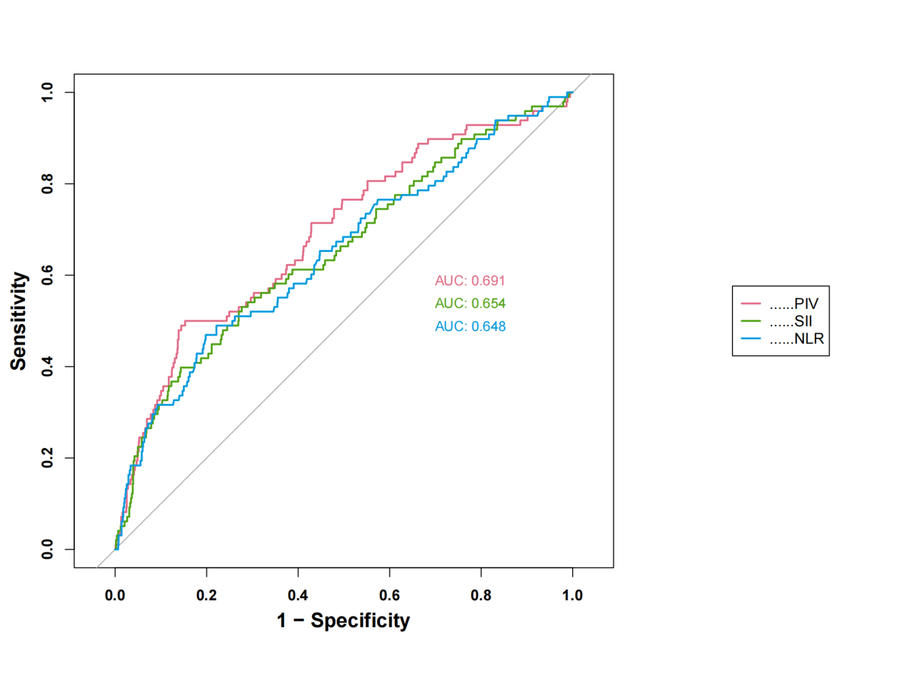
AUC: area under the curve; The optimal cut-off value for PIV was 1,916, with a sensitivity of 50% and a specificity of 84.7%.

Supplementary Figure S4：Lasso coefficient path plot
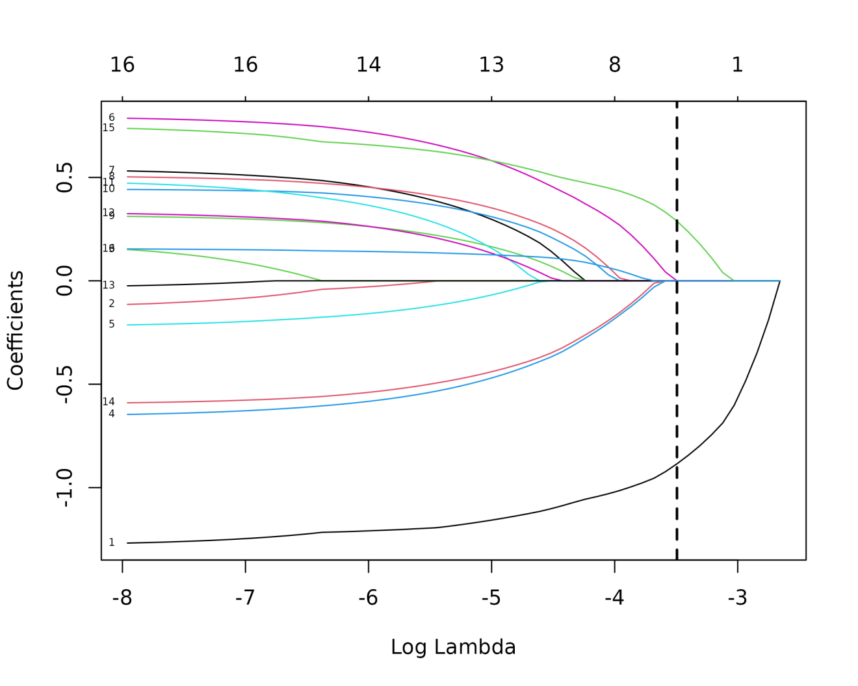
Figure S4. Plot of the Lasso regression coefficient profiles (λ = 0.0303850475902138)

Supplementary Figure S5:10-fold cross-validation curve
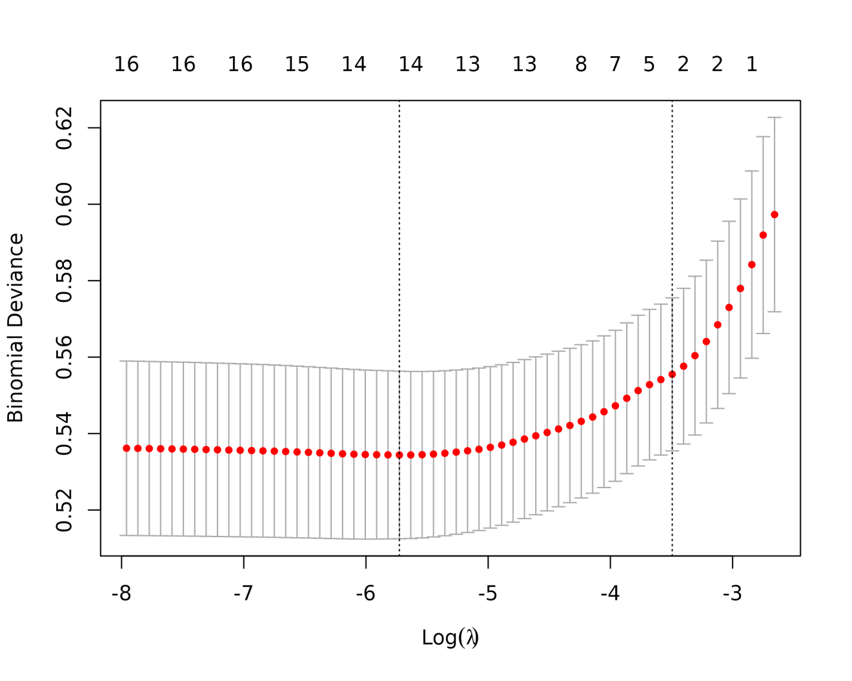
Figure S5. 10-fold cross-validation was applied to select the most suitable feature using the Lasso regression model. (λ = 0.0303850475902138)

Supplementary Figure S6:Calibration curve based on the training set
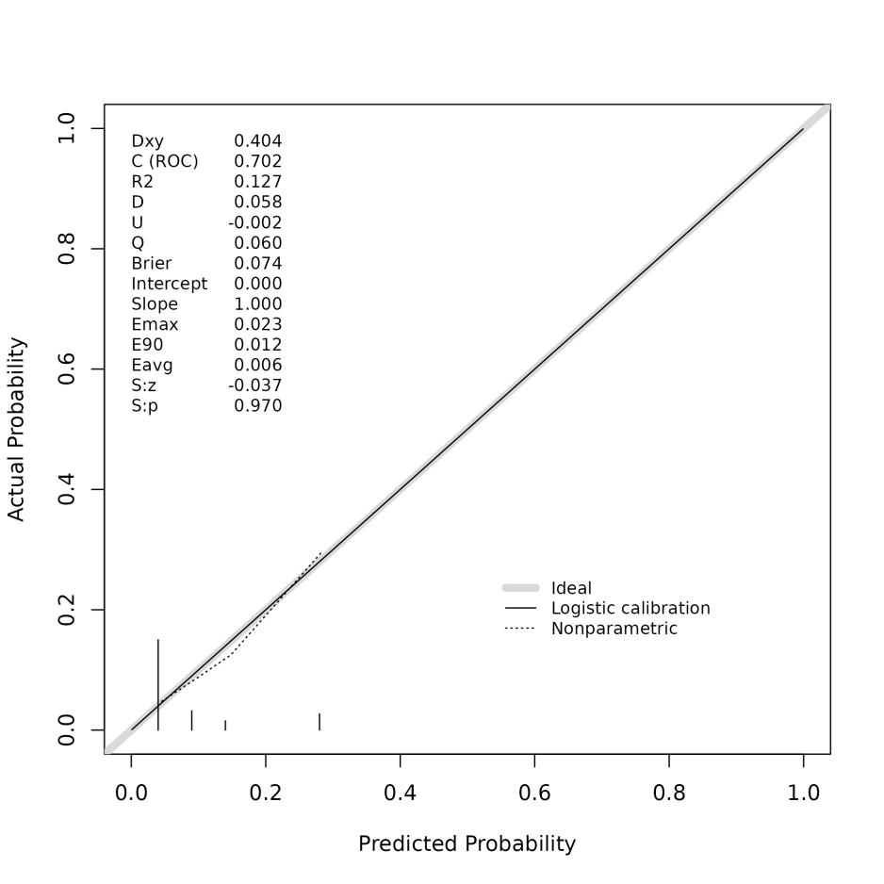

Supplementary Figure S7:Calibration curve based on internal validation set
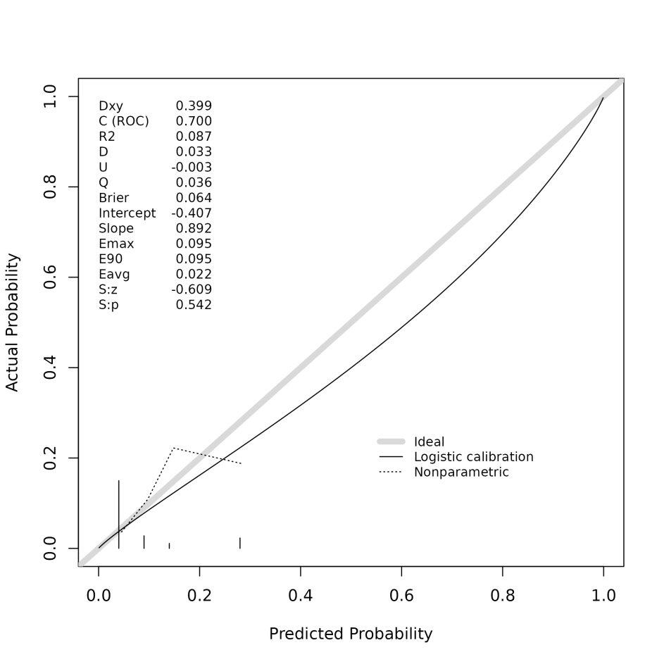

Supplementary Figure S8:DCA curve based on the training set
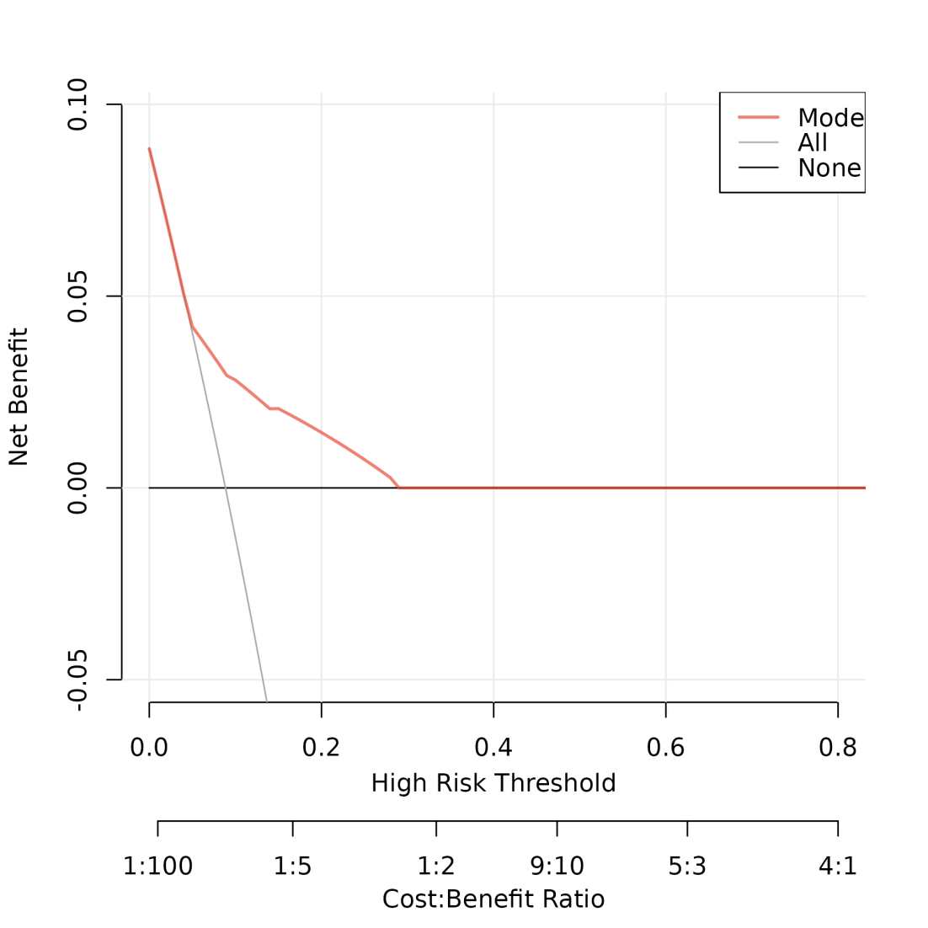

Supplementary Figure S9:DCA curve based on internal validation set
