Additional File 2 – Word Clouds relating to the six emergent themes
Theme 1- Improving the RENAL Screen?
An example word cloud display of the combined responses to Q16:
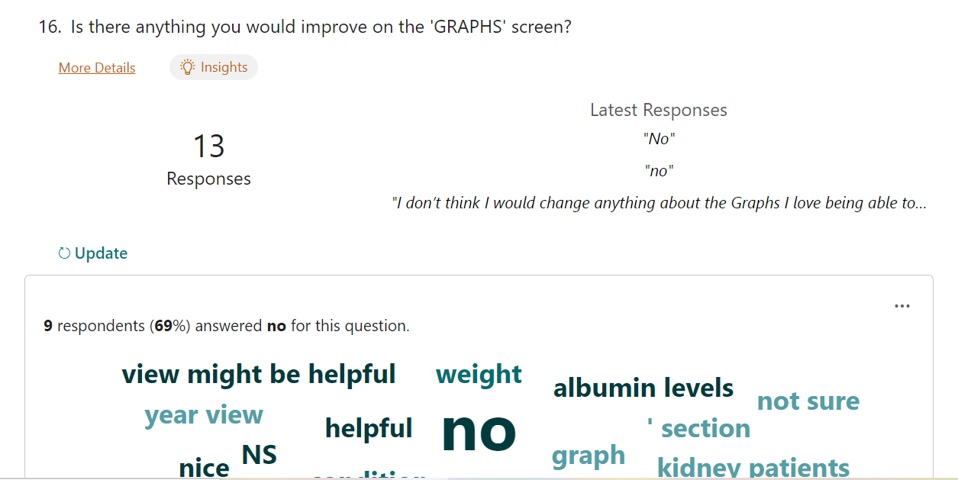

Word cloud relating to suggested improvements to the App:

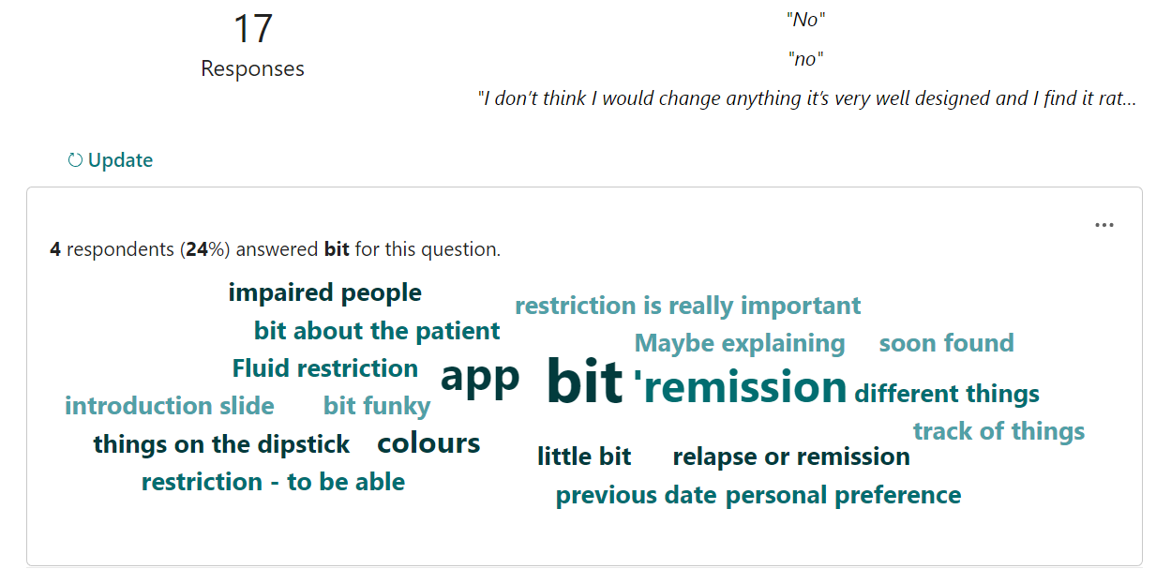
Theme 2: Improving the ADD APPOINTMENT screen
Word cloud relating to suggested improvements to the ADD APPOINTMENT section of the App:

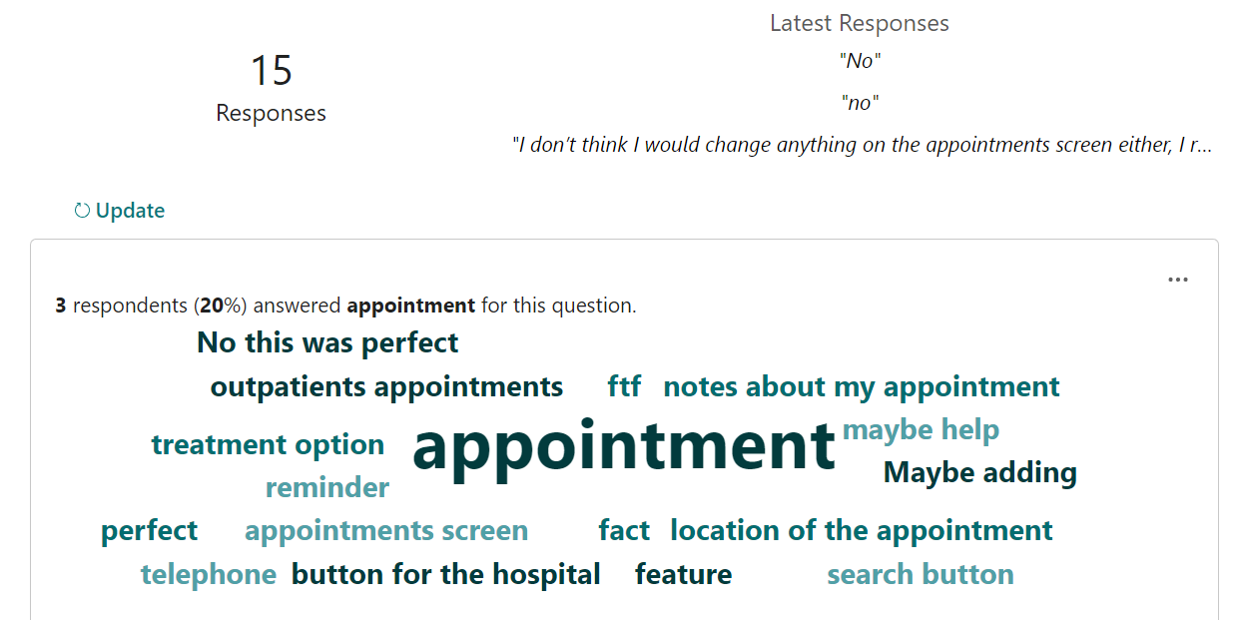

Theme 3: Improvement of the GRAPHS screen

Word cloud relating to the possibility of improvements to the GRAPHS screen section of the App:
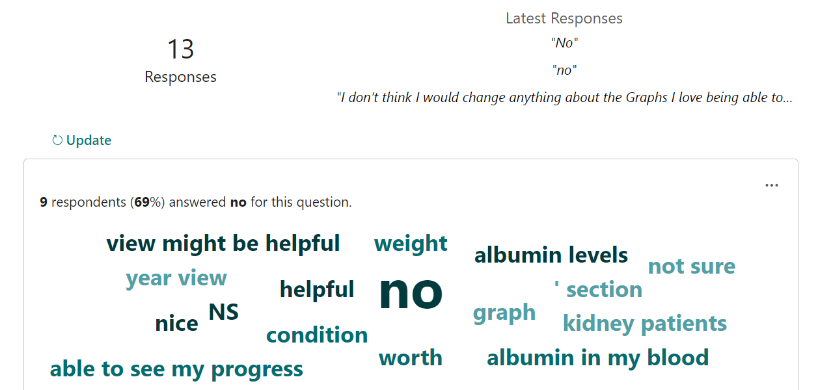

Theme 4: Improving the ADD A READING screen

Word cloud relating to suggested improvements to the ADD A READING screen section of the App:

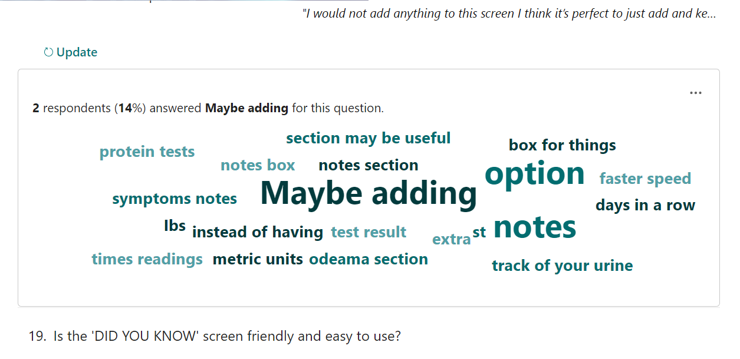

Theme 5: Improving the DID YOU KNOW screen
Word cloud relating to suggested improvements to the DID YOU KNOW screen section of the App:

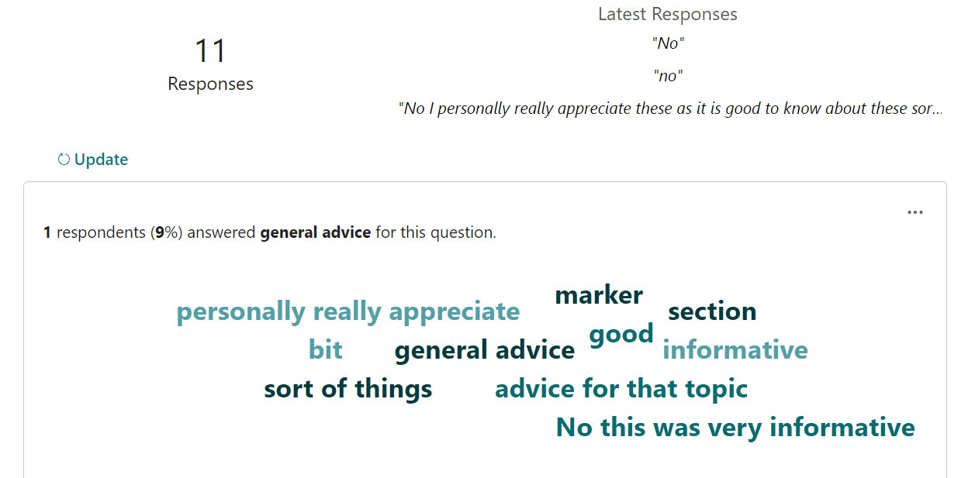

Theme 6: Further comments
Word cloud relating to suggested improvements to the FURTHER COMMENTS AND ANY PROBLEMS screen section of the App:

