Appendix1.Original Dialysis Symptom Index Scale
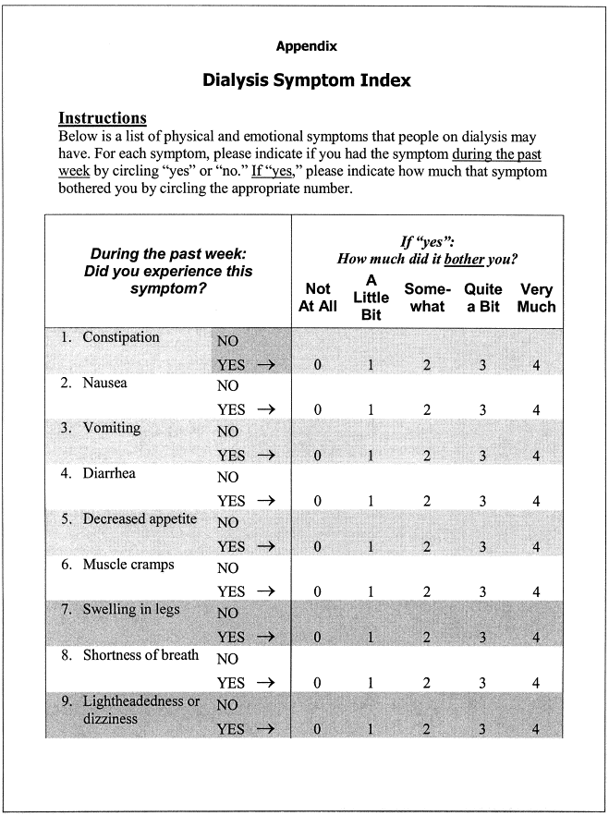
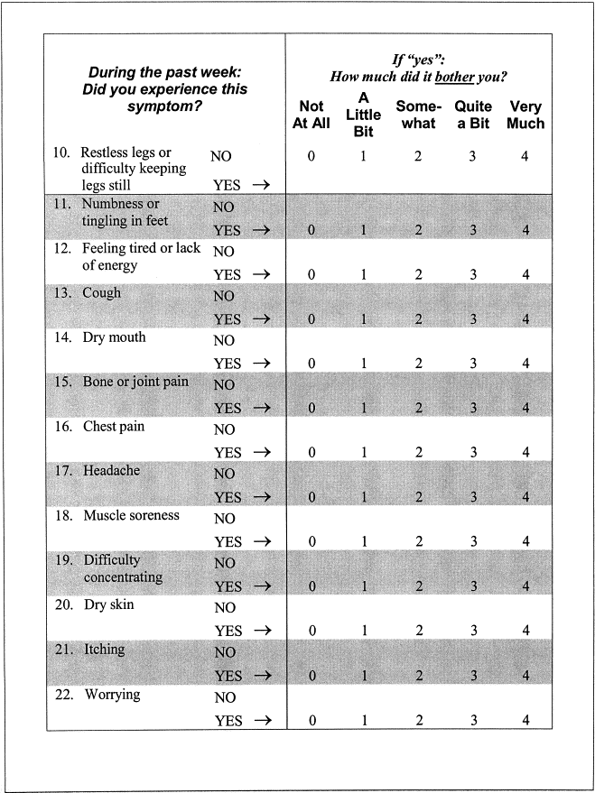
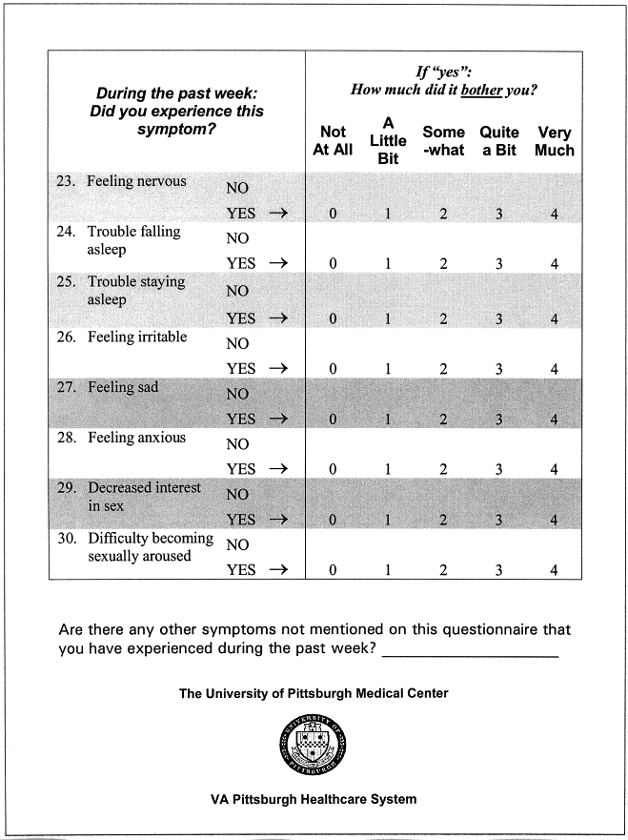

Appendix2.Revised Dialysis Symptom Index Scale (Chinese version)
在过去的一周内，您有没有出现下列症状？ | 没有 | 如果有，它通常多久出现一次？ |  |  |  | 如果有，他通常有多严重？ |  |  |  | 如果有，它对您造成多少烦恼？
在过去的一周内，您有没有出现下列症状？ | 没有 | 极少 | 有时 | 频繁 | 几乎持续 | 轻微 | 中度 | 重度 | 极重度 | 完全没有 | 少许 | 一些 | 较多 | 很多
1.便秘 |  | 1 | 2 | 3 | 4 | 1 | 2 | 3 | 4 | 1 | 2 | 3 | 4 | 5
2.恶心 |  | 1 | 2 | 3 | 4 | 1 | 2 | 3 | 4 | 1 | 2 | 3 | 4 | 5
3.呕吐 |  | 1 | 2 | 3 | 4 | 1 | 2 | 3 | 4 | 1 | 2 | 3 | 4 | 5
4.腹泻 |  | 1 | 2 | 3 | 4 | 1 | 2 | 3 | 4 | 1 | 2 | 3 | 4 | 5
5.食欲下降 |  | 1 | 2 | 3 | 4 | 1 | 2 | 3 | 4 | 1 | 2 | 3 | 4 | 5
6.肌肉痉挛 |  | 1 | 2 | 3 | 4 | 1 | 2 | 3 | 4 | 1 | 2 | 3 | 4 | 5
7.下肢肿胀 |  | 1 | 2 | 3 | 4 | 1 | 2 | 3 | 4 | 1 | 2 | 3 | 4 | 5
8.呼吸短促 |  | 1 | 2 | 3 | 4 | 1 | 2 | 3 | 4 | 1 | 2 | 3 | 4 | 5
9.头晕 |  | 1 | 2 | 3 | 4 | 1 | 2 | 3 | 4 | 1 | 2 | 3 | 4 | 5
10.很难让腿静止不动 |  | 1 | 2 | 3 | 4 | 1 | 2 | 3 | 4 | 1 | 2 | 3 | 4 | 5
11.足部麻木或刺痛 |  | 1 | 2 | 3 | 4 | 1 | 2 | 3 | 4 | 1 | 2 | 3 | 4 | 5
12.疲劳或乏力 |  | 1 | 2 | 3 | 4 | 1 | 2 | 3 | 4 | 1 | 2 | 3 | 4 | 5
13.咳嗽 |  | 1 | 2 | 3 | 4 | 1 | 2 | 3 | 4 | 1 | 2 | 3 | 4 | 5
14.口干 |  | 1 | 2 | 3 | 4 | 1 | 2 | 3 | 4 | 1 | 2 | 3 | 4 | 5
15.骨或关节痛 |  | 1 | 2 | 3 | 4 | 1 | 2 | 3 | 4 | 1 | 2 | 3 | 4 | 5
16.胸痛 |  | 1 | 2 | 3 | 4 | 1 | 2 | 3 | 4 | 1 | 2 | 3 | 4 | 5
17.头痛 |  | 1 | 2 | 3 | 4 | 1 | 2 | 3 | 4 | 1 | 2 | 3 | 4 | 5
18.肌肉痛 |  | 1 | 2 | 3 | 4 | 1 | 2 | 3 | 4 | 1 | 2 | 3 | 4 | 5
19.难以集中注意力 |  | 1 | 2 | 3 | 4 | 1 | 2 | 3 | 4 | 1 | 2 | 3 | 4 | 5
20.皮肤干燥 |  | 1 | 2 | 3 | 4 | 1 | 2 | 3 | 4 | 1 | 2 | 3 | 4 | 5
21.瘙痒 |  | 1 | 2 | 3 | 4 | 1 | 2 | 3 | 4 | 1 | 2 | 3 | 4 | 5
22.忧虑 |  | 1 | 2 | 3 | 4 | 1 | 2 | 3 | 4 | 1 | 2 | 3 | 4 | 5
23.紧张 |  | 1 | 2 | 3 | 4 | 1 | 2 | 3 | 4 | 1 | 2 | 3 | 4 | 5
24.入睡困难 |  | 1 | 2 | 3 | 4 | 1 | 2 | 3 | 4 | 1 | 2 | 3 | 4 | 5
25.易醒 |  | 1 | 2 | 3 | 4 | 1 | 2 | 3 | 4 | 1 | 2 | 3 | 4 | 5
26.易怒 |  | 1 | 2 | 3 | 4 | 1 | 2 | 3 | 4 | 1 | 2 | 3 | 4 | 5
27.伤心 |  | 1 | 2 | 3 | 4 | 1 | 2 | 3 | 4 | 1 | 2 | 3 | 4 | 5
28.焦虑 |  | 1 | 2 | 3 | 4 | 1 | 2 | 3 | 4 | 1 | 2 | 3 | 4 | 5
29.性欲减退 |  | 1 | 2 | 3 | 4 | 1 | 2 | 3 | 4 | 1 | 2 | 3 | 4 | 5
30.性冲动困难 |  | 1 | 2 | 3 | 4 | 1 | 2 | 3 | 4 | 1 | 2 | 3 | 4 | 5
在过去一周内，您是否还有其他未在本问卷中提及的症状？___

Appendix3.Revised Dialysis Symptom Index Scale (English translated version)
During the past week: Did you experience this symptom? | none | If “yes”:How often does it usually occur? |  |  |  | If 'yes': How severe is it usually? |  |  |  | If “yes”: How much did it bother you ?
During the past week: Did you experience this symptom? | none | Very rare | sometimes | frequent | Almost continuous | mild | moderate | severe | Very severe | Not at all | A little bit | Some-what | Quit a bit | Very much
1.Constipation |  | 1 | 2 | 3 | 4 | 1 | 2 | 3 | 4 | 1 | 2 | 3 | 4 | 5
2. Nausea |  | 1 | 2 | 3 | 4 | 1 | 2 | 3 | 4 | 1 | 2 | 3 | 4 | 5
3. Vomiting |  | 1 | 2 | 3 | 4 | 1 | 2 | 3 | 4 | 1 | 2 | 3 | 4 | 5
4. Diarrhea |  | 1 | 2 | 3 | 4 | 1 | 2 | 3 | 4 | 1 | 2 | 3 | 4 | 5
5. Decreased Appetite |  | 1 | 2 | 3 | 4 | 1 | 2 | 3 | 4 | 1 | 2 | 3 | 4 | 5
6. Muscle cramps |  | 1 | 2 | 3 | 4 | 1 | 2 | 3 | 4 | 1 | 2 | 3 | 4 | 5
7. Swelling in legs |  | 1 | 2 | 3 | 4 | 1 | 2 | 3 | 4 | 1 | 2 | 3 | 4 | 5
8. Shortness of breath |  | 1 | 2 | 3 | 4 | 1 | 2 | 3 | 4 | 1 | 2 | 3 | 4 | 5
9. Dizziness |  | 1 | 2 | 3 | 4 | 1 | 2 | 3 | 4 | 1 | 2 | 3 | 4 | 5
10. Restless legs |  | 1 | 2 | 3 | 4 | 1 | 2 | 3 | 4 | 1 | 2 | 3 | 4 | 5
11. Numbness in the feet |  | 1 | 2 | 3 | 4 | 1 | 2 | 3 | 4 | 1 | 2 | 3 | 4 | 5
12. Fatigue |  | 1 | 2 | 3 | 4 | 1 | 2 | 3 | 4 | 1 | 2 | 3 | 4 | 5
13. Cough |  | 1 | 2 | 3 | 4 | 1 | 2 | 3 | 4 | 1 | 2 | 3 | 4 | 5
14. Dry mouth |  | 1 | 2 | 3 | 4 | 1 | 2 | 3 | 4 | 1 | 2 | 3 | 4 | 5
15. Joint pain |  | 1 | 2 | 3 | 4 | 1 | 2 | 3 | 4 | 1 | 2 | 3 | 4 | 5
16. Chest pain |  | 1 | 2 | 3 | 4 | 1 | 2 | 3 | 4 | 1 | 2 | 3 | 4 | 5
17.Headache |  | 1 | 2 | 3 | 4 | 1 | 2 | 3 | 4 | 1 | 2 | 3 | 4 | 5
18.Muscle soreness |  | 1 | 2 | 3 | 4 | 1 | 2 | 3 | 4 | 1 | 2 | 3 | 4 | 5
19.Difficulty concentrating |  | 1 | 2 | 3 | 4 | 1 | 2 | 3 | 4 | 1 | 2 | 3 | 4 | 5
20.Dry skin |  | 1 | 2 | 3 | 4 | 1 | 2 | 3 | 4 | 1 | 2 | 3 | 4 | 5
21. Itching |  | 1 | 2 | 3 | 4 | 1 | 2 | 3 | 4 | 1 | 2 | 3 | 4 | 5
22. Worrying |  | 1 | 2 | 3 | 4 | 1 | 2 | 3 | 4 | 1 | 2 | 3 | 4 | 5
23. Nervousness |  | 1 | 2 | 3 | 4 | 1 | 2 | 3 | 4 | 1 | 2 | 3 | 4 | 5
24. Trouble falling asleep |  | 1 | 2 | 3 | 4 | 1 | 2 | 3 | 4 | 1 | 2 | 3 | 4 | 5
25. Trouble staying asleep |  | 1 | 2 | 3 | 4 | 1 | 2 | 3 | 4 | 1 | 2 | 3 | 4 | 5
26. Feeling irritable |  | 1 | 2 | 3 | 4 | 1 | 2 | 3 | 4 | 1 | 2 | 3 | 4 | 5
27. Feeling sad |  | 1 | 2 | 3 | 4 | 1 | 2 | 3 | 4 | 1 | 2 | 3 | 4 | 5
28. Anxiety |  | 1 | 2 | 3 | 4 | 1 | 2 | 3 | 4 | 1 | 2 | 3 | 4 | 5
29. Decreased interest in sex |  | 1 | 2 | 3 | 4 | 1 | 2 | 3 | 4 | 1 | 2 | 3 | 4 | 5
30. Difficulty becoming sexually aroused |  | 1 | 2 | 3 | 4 | 1 | 2 | 3 | 4 | 1 | 2 | 3 | 4 | 5
Are there any other symptoms not mentioned on this questionnaire that you have experienced during the past week? _______________________

Complete explanation of the modified dialysis symptom index (Modified DSI)
1. Original tool source
The Dialysis Symptom Index (DSI) was developed by Weisbord et al. in 2004, consisting of 30 symptom items (25 physical symptoms, 5 psychological symptoms), assessing the distress caused by symptoms over the past 7 days (see appendix 1).
2. Explanation of the modified version
The Chinese version of the modified DSI adopted in this study was revised by Hao Yanhua (2016) in her master's thesis. It remains consistent with the original scale in terms of symptoms, comprising 30 symptom items (25 physical symptoms and 5 psychological symptoms) to assess the distress caused by symptoms over the past 7 days. The modifications include: adding dimensions: the original DSI only assessed the level of symptom distress; the revised version added two additional dimensions (frequency and severity) to more comprehensively evaluate the symptom burden. localization: all symptom descriptions were verified through back-translation to ensure semantic equivalence. (The Chinese version of the modified DSI is in Appendix 2, and the English version is in Appendix 3)
3. Scoring method and calculation details: incidence selection: the patient first answers "Did this symptom occur in the past 7 days?" (yes/no); if the answer is "yes," continue to evaluate three dimensions:
4. Calculation of individual symptom score:
Individual symptom score = (frequency + severity score + distress score) × presence of the symptom
5. Total Score Calculation:
DSI Total Score = Σ(Scores for each symptom), range 0-390 points
• 0 points: No symptoms
• Maximum score 390: All 30 symptoms are "Persistent, extremely severe" and "Extremely distressing", 30×1×(4+4+5)=390
6. Psychometric characteristics
Scale-level content validity index, S-CVI and item-level content validity index, I-CVI are both 1; the total Cronbach's α coefficient of the scale is 0.983, and the Cronbach's α coefficients of each subscale dimension are 0.943 for frequency of occurrence, 0.948 for severity, and 0.959 for distress, indicating that the adapted scale has good internal consistency.

Supplementary Table 1. Post-hoc Pairwise Comparison Results of Significant Categorical Variables (Bonferroni-corrected)
Variables | Pairwise Comparison | Test Statistic | Raw p-value | Corrected p-value^a | Significance
Residence | low vs. moderate | 14.749 | 0.003 | 0.009 | *
 | low vs. high | 42.127 | 0.001 | 0.003 | *
 | moderate vs. hight | 24.376 | 0.001 | 0.003 | *
Education level | low vs. moderate | 17.586 | 0.001 | 0.003 | *
 | low vs. high | 10.53 | 0.015 | 0.045 | *
 | moderate vs. hight | 4.026 | 0.259 | 0.777 | ns
Cohabitant | low vs. moderate | 7.069 | 0.07 | 0.21 | ns
 | low vs. high | 7.418 | 0.06 | 0.18 | ns
 | moderate vs. hight | 11.461 | 0.009 | 0.027 | *
Family relationship | low vs. moderate | 0.525 | 0.469 | 1.407 | ns
 | low vs. high | 11 | 0.001 | 0.003 | *
 | moderate vs. hight | 8.81 | 0.003 | 0.009 | *
Monthly income (yuan) | low vs. moderate | 13.307 | 0.004 | 0.012 | *
 | low vs. high | 26.023 | 0.001 | 0.003 | *
 | moderate vs. hight | 10.837 | 0.013 | 0.039 | *

Note：^a Corrected p-values were calculated using Bonferroni correction: Corrected p-value = Raw p-value × 3 (3 pairwise comparisons for each variable).
Indicates statistical significance after correction (corrected p < 0.05); ns = not significant (corrected p ≥ 0.05).

Supplementary Table 2 Weight matrix of edges in the GLASSO network for the total sample.
 | S1 | S2 | S3 | S4 | S5 | S6 | S7 | S8 | S9 | S10 | S11 | S12 | S13 | S14 | S15 | S16 | S17 | S18 | S19 | S20 | S21 | S22 | S23 | S24 | S25 | S26 | S27 | S28 | S29 | S30
S1 | 0.00
S2 | 0.000 | 0.000
S3 | 0.000 | 0.662 | 0.000
S4 | 0.073 | 0.000 | 0.102 | 0.000
S5 | 0.049 | 0.000 | 0.000 | 0.060 | 0.000
S6 | 0.000 | 0.110 | 0.032 | 0.056 | 0.000 | 0.000
S7 | 0.000 | 0.020 | 0.027 | 0.077 | 0.078 | 0.132 | 0.000
S8 | 0.115 | 0.000 | 0.080 | 0.057 | 0.072 | 0.000 | 0.148 | 0.000
S9 | 0.080 | 0.045 | 0.000 | 0.000 | 0.000 | 0.012 | 0.000 | 0.095 | 0.000
S10 | 0.000 | 0.000 | 0.063 | 0.009 | 0.000 | 0.000 | 0.000 | 0.122 | 0.081 | 0.000
S11 | 0.057 | 0.000 | 0.000 | 0.028 | 0.000 | -0.061 | 0.150 | 0.103 | 0.021 | 0.000 | 0.000
S12 | 0.019 | 0.000 | 0.017 | 0.000 | 0.161 | 0.000 | 0.000 | 0.000 | 0.000 | 0.029 | 0.052 | 0.000
S13 | 0.005 | 0.022 | 0.000 | 0.000 | -0.021 | 0.190 | 0.000 | 0.000 | 0.123 | 0.000 | 0.040 | 0.000 | 0.000
S14 | 0.100 | 0.000 | -0.002 | 0.000 | 0.034 | 0.208 | 0.000 | -0.043 | 0.000 | 0.000 | -0.025 | 0.067 | 0.058 | 0.000
S15 | 0.084 | 0.000 | 0.000 | 0.086 | 0.000 | 0.000 | 0.011 | 0.000 | 0.113 | 0.014 | 0.173 | 0.000 | 0.017 | 0.059 | 0.000
S16 | 0.000 | 0.000 | 0.000 | 0.227 | 0.000 | 0.000 | 0.126 | 0.216 | 0.000 | 0.022 | 0.000 | 0.000 | 0.054 | 0.000 | 0.055 | 0.000
S17 | 0.000 | 0.054 | 0.084 | 0.138 | 0.000 | 0.058 | 0.000 | 0.000 | 0.268 | 0.000 | 0.087 | 0.000 | 0.000 | 0.000 | 0.036 | 0.131 | 0.000
S18 | 0.000 | 0.000 | 0.030 | 0.054 | 0.000 | 0.064 | 0.073 | 0.000 | 0.000 | 0.213 | 0.000 | 0.000 | 0.000 | -0.004 | 0.155 | 0.243 | 0.077 | 0.000
S19 | 0.000 | 0.000 | 0.000 | 0.000 | 0.000 | 0.022 | 0.000 | 0.000 | 0.010 | 0.000 | 0.000 | 0.000 | 0.078 | 0.000 | 0.000 | 0.000 | 0.180 | 0.154 | 0.000
S20 | 0.000 | 0.000 | -0.029 | 0.000 | 0.059 | 0.005 | 0.000 | 0.000 | -0.019 | 0.000 | -0.026 | 0.000 | 0.000 | 0.180 | 0.034 | 0.000 | 0.000 | 0.024 | 0.000 | 0.000
S21 | 0.000 | 0.000 | 0.000 | 0.000 | 0.014 | 0.000 | 0.000 | 0.000 | 0.000 | 0.000 | 0.000 | 0.037 | 0.000 | 0.000 | 0.000 | -0.015 | 0.068 | 0.000 | 0.061 | 0.601 | 0.000
S22 | 0.019 | 0.030 | 0.000 | 0.006 | 0.014 | 0.007 | 0.000 | 0.091 | 0.000 | 0.000 | 0.079 | 0.000 | 0.000 | 0.031 | 0.000 | 0.000 | 0.000 | 0.000 | 0.087 | -0.004 | 0.000 | 0.000
S23 | 0.012 | 0.000 | 0.000 | 0.000 | 0.028 | 0.000 | 0.000 | 0.020 | 0.000 | 0.000 | 0.000 | 0.000 | 0.089 | 0.000 | 0.000 | 0.044 | 0.000 | 0.109 | 0.161 | 0.028 | -0.039 | 0.270 | 0.000
S24 | 0.097 | 0.000 | 0.000 | -0.025 | 0.077 | -0.007 | -0.057 | 0.000 | 0.000 | 0.000 | 0.049 | 0.017 | 0.000 | 0.000 | 0.000 | 0.000 | 0.000 | 0.000 | 0.016 | 0.000 | 0.061 | 0.000 | 0.000 | 0.000
S25 | -0.108 | 0.000 | 0.000 | 0.000 | 0.034 | 0.000 | 0.000 | 0.000 | 0.000 | 0.107 | 0.000 | 0.036 | -0.001 | -0.014 | 0.000 | -0.003 | -0.022 | 0.000 | 0.000 | 0.000 | 0.023 | 0.000 | -0.009 | 0.574 | 0.000
S26 | 0.029 | 0.000 | 0.000 | 0.000 | 0.000 | 0.000 | 0.000 | 0.000 | 0.050 | 0.000 | 0.026 | 0.000 | 0.089 | 0.000 | 0.000 | 0.000 | 0.000 | 0.000 | 0.119 | 0.000 | 0.030 | 0.000 | 0.104 | 0.001 | 0.116 | 0.000
S27 | 0.000 | 0.000 | 0.013 | 0.000 | 0.022 | 0.000 | 0.119 | 0.000 | 0.016 | 0.178 | 0.070 | 0.028 | 0.000 | 0.000 | 0.000 | 0.089 | 0.000 | 0.125 | 0.000 | 0.000 | 0.006 | 0.155 | 0.103 | 0.000 | 0.009 | 0.177 | 0.000
S28 | 0.040 | 0.000 | -0.019 | 0.000 | 0.045 | 0.000 | 0.000 | 0.000 | 0.054 | 0.000 | 0.000 | 0.000 | 0.000 | 0.121 | 0.000 | 0.000 | 0.000 | 0.000 | 0.036 | 0.000 | 0.000 | 0.217 | 0.000 | 0.000 | 0.000 | 0.232 | 0.156 | 0.000
S29 | 0.000 | 0.000 | 0.000 | 0.000 | 0.000 | 0.000 | 0.000 | 0.000 | 0.000 | 0.034 | -0.017 | -0.027 | 0.000 | 0.048 | 0.000 | 0.000 | -0.009 | 0.000 | 0.000 | 0.000 | -0.016 | 0.000 | 0.000 | -0.035 | 0.047 | 0.000 | 0.000 | 0.076 | 0.000
S30 | 0.053 | 0.044 | 0.000 | 0.000 | 0.000 | 0.000 | -0.024 | 0.000 | 0.000 | 0.022 | -0.005 | 0.000 | 0.000 | 0.000 | 0.024 | -0.017 | 0.000 | 0.000 | 0.000 | -0.003 | -0.028 | 0.035 | 0.000 | 0.000 | 0.006 | 0.000 | 0.000 | 0.040 | 0.882 | 0.00
Note: Symptoms were ordered by strength centrality (z-scored). S1; Constipation, S2; Nausea, S3; Vomiting, S4; Diarrhea, S5; Decreased Appetite, S6; Muscle cramps, S7; Swelling in legs, S8; Shortness of breath, S9; Dizziness, S10; Restless legs, S11; Numbness in the feet, S12; Fatigue, S13; Cough, S14; Dry mouth, S15; Joint pain, S16; Chest pain, S17; Headache, S18; Muscle pain, S19; Difficulty concentrating, S20; Dry skin, S21; Itching, S22; Worry, S23; Nervousness, S24; Trouble falling asleep, S25; Trouble staying asleep, S26; Feeling irritable, S27; Feeling sad, S28; Anxiety, S29; Decreased interest in sex, S30; Difficulty becoming sexually aroused.

Supplementary Table 3 Standardized Strength Centrality Index (z-scores) for Each Symptom Node in the Total Sample and Three Subgroup Networks
 | Total network | Low stigma group | Moderate stigma group | High stigma group
1.Constipation | -0.495 | -0.795 | -0.846 | -1.388
2. Nausea | -0.208 | 0.080 | 0.728 | -0.461
3. Vomiting | 0.834 | 0.657 | 0.391 | 0.921
4. Diarrhea | -0.144 | 0.819 | 0.096 | 0.299
5. Decreased Appetite | -1.514 | -1.248 | -1.730 | 0.114
6. Muscle cramps | -0.336 | 0.520 | -1.173 | -1.030
7. Swelling in legs | 0.117 | 0.910 | 0.318 | -0.515
8. Shortness of breath | 0.836 | 0.689 | 1.346 | -0.054
9. Dizziness | -0.212 | -0.360 | 0.195 | 0.362
10. Restless legs | -0.760 | 0.176 | -0.393 | -1.095
11. Numbness in the feet | 0.281 | -1.591 | -0.231 | 0.091
12. Fatigue | -3.184 | -2.716 | -2.975 | -0.962
13. Cough | -1.399 | -1.765 | -0.547 | -1.153
14. Dry mouth | -0.167 | -0.535 | -0.753 | -0.801
15. Joint pain | -0.967 | -0.625 | 0.242 | -0.572
16. Chest pain | 1.321 | 1.671 | 0.876 | 1.284
17.Headache | 1.142 | 0.323 | 0.823 | 2.061
18.Muscle soreness | 1.807 | 1.664 | 1.740 | 1.616
19.Difficulty concentrating | -0.574 | -0.094 | 0.162 | -0.070
20.Dry skin | -0.059 | -0.448 | -0.441 | -0.762
21. Itching | -0.130 | 0.234 | -0.882 | -0.728
22. Worry | 0.143 | 0.272 | 0.621 | 1.543
23. Nervousness | -0.032 | 0.059 | 0.234 | 1.054
24. Trouble falling asleep | -0.039 | -0.837 | -0.654 | -0.926
25. Trouble staying asleep | 0.516 | 0.379 | -0.525 | -0.818
26. Feeling irritable | -0.287 | 0.156 | -0.258 | -0.402
27. Feeling sad | 1.463 | 1.633 | 1.881 | 1.944
28. Anxiety | 0.078 | -0.253 | 0.644 | 0.232
29. Decreased interest in sex | 1.001 | 0.249 | 0.410 | -0.716
30. Difficulty becoming sexually aroused | 0.969 | 0.777 | 0.699 | 0.931

Supplementary Figure1. latent profile of stigma

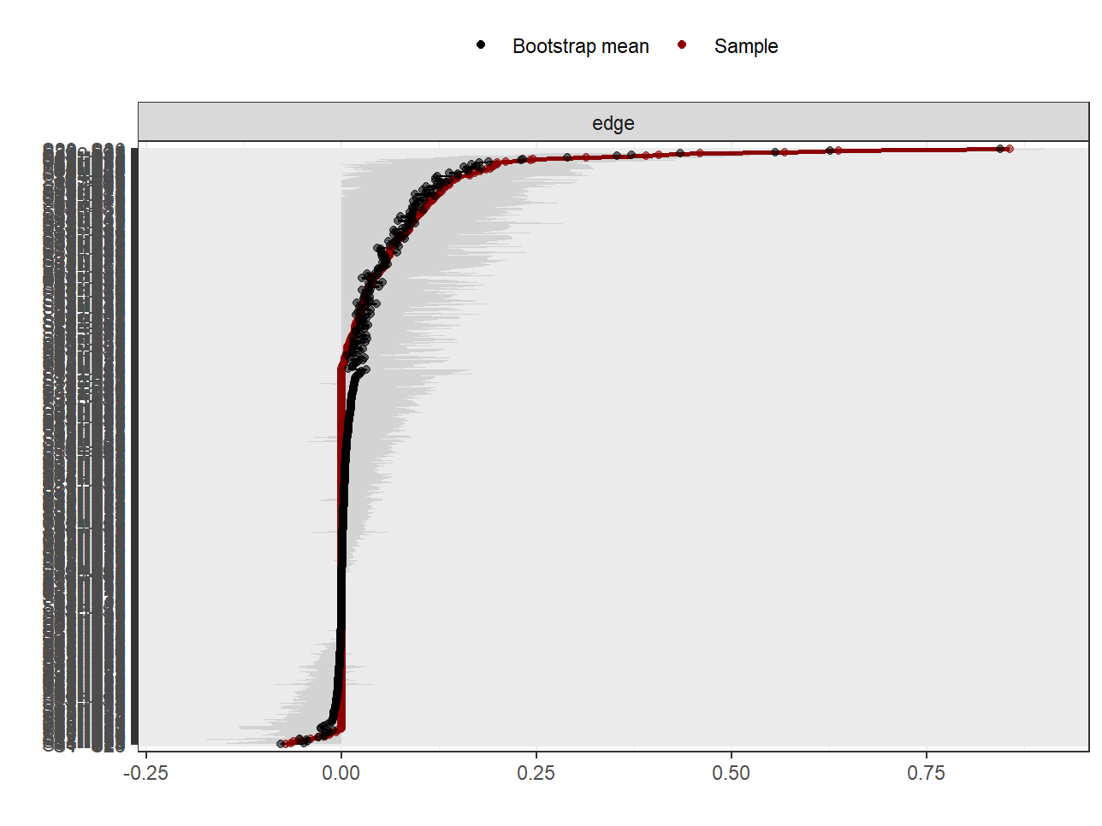
Supplementary Figure 2. Bootstrap analysis results for edge weights of low stigma group
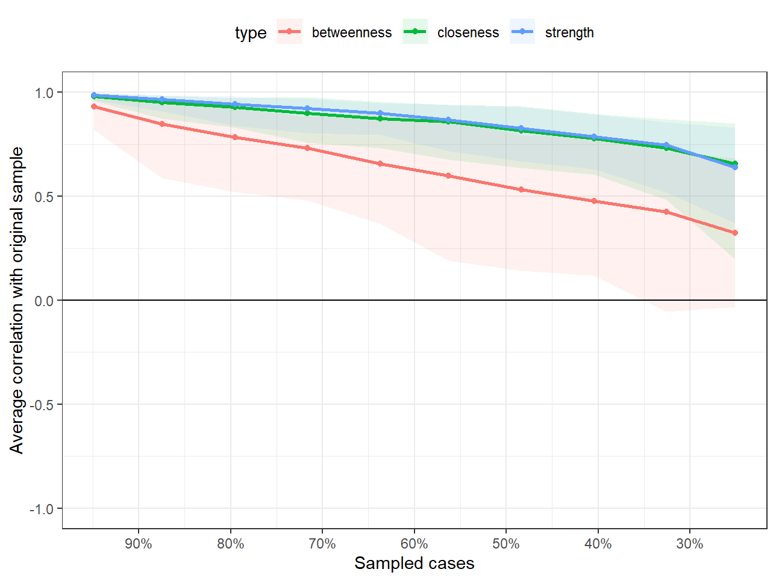
Supplementary Figure 3. Correlation stability analysis of the symptom network in low stigma group
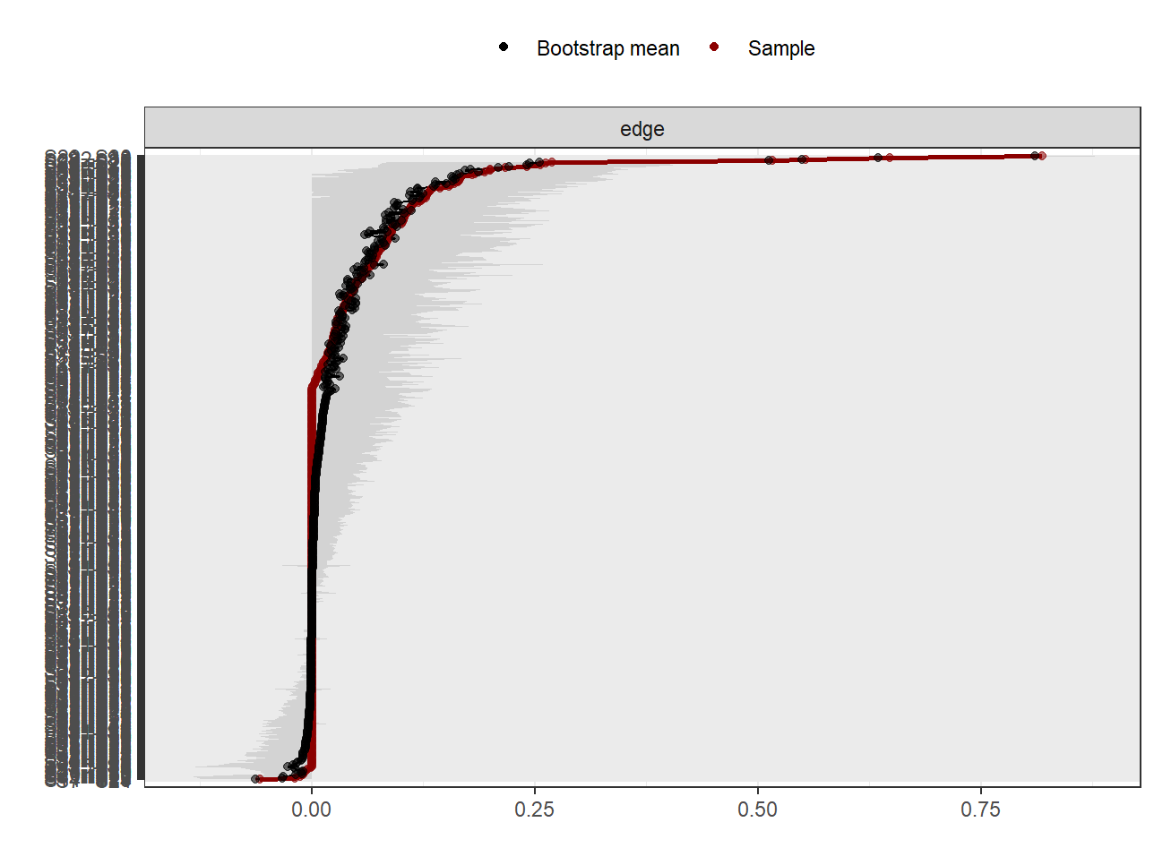
Supplementary Figure 4. Bootstrap analysis results for edge weights of moderate stigma group
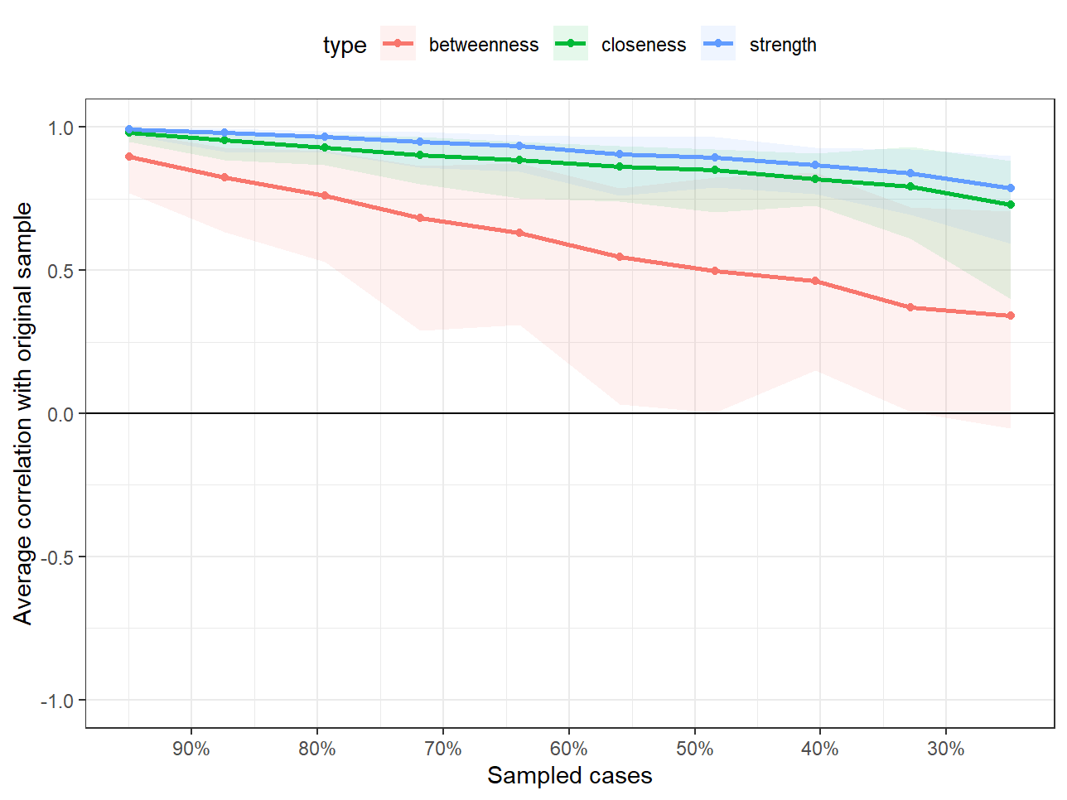
Supplementary Figure 5. Correlation stability analysis of the symptom network in moderate stigma group

