Parameters | native T₁ mapping | DWI | T₂* mapping
Imaging planes | Coronal | Coronal | Coronal
Sequence | MOLLI | RESOLVE | mFFE
TR (ms) | 546.6 | 2200 | 447
TE (ms) | 1.1 | 67 | 6 (initial), 4 (interval), 9 echoes*
Slice thickness (mm) | 5 | 5 | 5
Slice gap (mm) | 1 | 0 | 1
FOV (mm × mm) | 290 × 290 | 320 × 160 | 360 × 270
Matrix | 144 × 144 | 160 × 120 | 160 × 128
Flip angle | 35° | - | -
b-value (s/mm²) | - | 0, 900 | -
Spatial resolution (mm³) | 2 × 2 × 5 | 2 × 2 × 5 | 1.4 × 1.4 × 5
Initial TI (ms) | 284 | - | -
TI interval (ms) | 80 | - | -
Breath-hold | 10 s per time | - | 20 s per time
Suppl Table 1. Renal multimodal magnetic resonance imaging acquisition details
DWI, diffusion-weighted imaging; MOLLI, modified Look-Locker inversion; RESOLVE, readout segmentation of long variable echo-trains; mFFE, multi-echo fast field echo; TR, repetition time; TE, echo time; FOV, field of view; TI, inversion time; * Initial TE: 6 ms; TE interval: 4 ms; total of 9 echoes (from 6 ms to 38 ms)

Suppl Table 2. Cross-validation results of other machine learning classification models (except for XGBoost) for identifying the presence of renal fibrosis (RF 1 vs. RF 2 and RF 3)
Model | Dataset | Fold 1 |  |  | Fold 2 |  |  | Fold 3 |  |  | Mean
Model | Dataset | AUC | ACC |  | AUC | ACC |  | AUC | ACC |  | AUC | ACC
LR | Training | 0.897 | 0.822 |  | 0.933 | 0.792 |  | 0.885 | 0.833 |  | 0.905 | 0.816
LR | Test | 0.936 | 0.922 |  | 0.809 | 0.745 |  | 0.875 | 0.800 |  | 0.873 | 0.822
NB | Training | 0.862 | 0.802 |  | 0.917 | 0.792 |  | 0.882 | 0.833 |  | 0.887 | 0.809
NB | Test | 0.955 | 0.922 |  | 0.822 | 0.725 |  | 0.862 | 0.760 |  | 0.880 | 0.802
Linear-SVM | Training | 0.592 | 0.564 |  | 0.880 | 0.782 |  | 0.873 | 0.765 |  | 0.782 | 0.704
Linear-SVM | Test | 0.608 | 0.471 |  | 0.736 | 0.725 |  | 0.881 | 0.840 |  | 0.742 | 0.679
Poly-SVM | Training | 0.758 | 0.703 |  | 0.844 | 0.772 |  | 0.776 | 0.784 |  | 0.793 | 0.753
Poly-SVM | Test | 0.873 | 0.804 |  | 0.712 | 0.706 |  | 0.775 | 0.700 |  | 0.787 | 0.737
Sigmoid-SVM | Training | 0.749 | 0.703 |  | 0.811 | 0.713 |  | 0.808 | 0.784 |  | 0.789 | 0.733
Sigmoid-SVM | Test | 0.859 | 0.784 |  | 0.778 | 0.706 |  | 0.780 | 0.740 |  | 0.806 | 0.743
Rbf-SVM | Training | 0.739 | 0.723 |  | 0.841 | 0.723 |  | 0.779 | 0.696 |  | 0.786 | 0.714
Rbf-SVM | Test | 0.861 | 0.804 |  | 0.707 | 0.706 |  | 0.759 | 0.740 |  | 0.776 | 0.750
DT | Training | 0.957 | 0.802 |  | 0.973 | 0.891 |  | 0.954 | 0.863 |  | 0.961 | 0.852
DT | Test | 0.847 | 0.784 |  | 0.896 | 0.784 |  | 0.812 | 0.880 |  | 0.852 | 0.816
RF | Training | 0.964 | 0.891 |  | 0.981 | 0.921 |  | 0.956 | 0.892 |  | 0.967 | 0.901
RF | Test | 0.909 | 0.843 |  | 0.888 | 0.725 |  | 0.902 | 0.760 |  | 0.900 | 0.776
ExtraTree | Training | 0.902 | 0.802 |  | 0.956 | 0.871 |  | 0.915 | 0.863 |  | 0.924 | 0.845
ExtraTree | Test | 0.956 | 0.882 |  | 0.821 | 0.765 |  | 0.902 | 0.920 |  | 0.893 | 0.856
AdaBoost | Training | 0.972 | 0.911 |  | 0.991 | 0.911 |  | 0.976 | 0.922 |  | 0.980 | 0.915
AdaBoost | Test | 0.874 | 0.765 |  | 0.886 | 0.824 |  | 0.782 | 0.880 |  | 0.847 | 0.823
MLP | Training | 0.654 | 0.545 |  | 0.669 | 0.554 |  | 0.606 | 0.490 |  | 0.643 | 0.530
MLP | Test | 0.634 | 0.569 |  | 0.604 | 0.549 |  | 0.702 | 0.640 |  | 0.647 | 0.586
GBM | Training | 0.984 | 0.911 |  | 0.991 | 0.950 |  | 0.978 | 0.931 |  | 0.984 | 0.931
GBM | Test | 0.886 | 0.784 |  | 0.876 | 0.745 |  | 0.881 | 0.900 |  | 0.881 | 0.810
LightGBM | Training | 0.949 | 0.822 |  | 0.973 | 0.911 |  | 0.943 | 0.873 |  | 0.955 | 0.869
LightGBM | Test | 0.930 | 0.784 |  | 0.891 | 0.784 |  | 0.894 | 0.720 |  | 0.905 | 0.763
ACC, accuracy; AUC, area under the curve; LR, logistic regression; NB, naive bayes, SVM, support vector machine; DT, decision tree; RF, random forest; ExtraTree, extremely randomized trees; MLP, multi-layer perceptron; GBM, gradient boosting machines

Suppl Table 3. Cross-validation results of other machine learning classification models (except for ExtraTree) for identifying the severity of renal fibrosis (RF 2 vs. RF 3)
Model | Dataset | Fold 1 |  |  | Fold 2 |  |  | Fold 3 |  |  | Mean
Model | Dataset | AUC | ACC |  | AUC | ACC |  | AUC | ACC |  | AUC | ACC
LR | Training | 0.886 | 0.846 |  | 0.856 | 0.772 |  | 0.871 | 0.785 |  | 0.871 | 0.801
LR | Test | 0.855 | 0.800 |  | 0.895 | 0.795 |  | 0.834 | 0.744 |  | 0.861 | 0.780
NB | Training | 0.905 | 0.859 |  | 0.880 | 0.810 |  | 0.892 | 0.823 |  | 0.892 | 0.831
NB | Test | 0.867 | 0.825 |  | 0.944 | 0.897 |  | 0.851 | 0.846 |  | 0.887 | 0.856
Linear-SVM | Training | 0.830 | 0.731 |  | 0.797 | 0.747 |  | 0.581 | 0.696 |  | 0.736 | 0.725
Linear-SVM | Test | 0.805 | 0.775 |  | 0.741 | 0.641 |  | 0.673 | 0.718 |  | 0.740 | 0.711
Poly-SVM | Training | 0.812 | 0.795 |  | 0.823 | 0.759 |  | 0.816 | 0.797 |  | 0.817 | 0.784
Poly-SVM | Test | 0.802 | 0.800 |  | 0.707 | 0.795 |  | 0.812 | 0.769 |  | 0.774 | 0.788
Sigmoid-SVM | Training | 0.761 | 0.692 |  | 0.796 | 0.734 |  | 0.757 | 0.684 |  | 0.771 | 0.703
Sigmoid-SVM | Test | 0.769 | 0.775 |  | 0.728 | 0.641 |  | 0.791 | 0.718 |  | 0.763 | 0.711
Rbf-SVM | Training | 0.819 | 0.795 |  | 0.822 | 0.785 |  | 0.822 | 0.810 |  | 0.821 | 0.797
Rbf-SVM | Test | 0.787 | 0.800 |  | 0.796 | 0.846 |  | 0.812 | 0.769 |  | 0.798 | 0.805
DT | Training | 0.953 | 0.910 |  | 0.954 | 0.873 |  | 0.959 | 0.899 |  | 0.955 | 0.894
DT | Test | 0.803 | 0.800 |  | 0.844 | 0.821 |  | 0.844 | 0.821 |  | 0.830 | 0.814
RF | Training | 0.967 | 0.923 |  | 0.964 | 0.911 |  | 0.974 | 0.924 |  | 0.968 | 0.919
RF | Test | 0.828 | 0.775 |  | 0.866 | 0.872 |  | 0.882 | 0.872 |  | 0.859 | 0.840
XGBoost | Training | 0.983 | 0.936 |  | 0.986 | 0.937 |  | 0.984 | 0.937 |  | 0.984 | 0.937
XGBoost | Test | 0.840 | 0.800 |  | 0.872 | 0.821 |  | 0.899 | 0.846 |  | 0.870 | 0.822
AdaBoost | Training | 0.985 | 0.923 |  | 0.975 | 0.911 |  | 0.976 | 0.911 |  | 0.979 | 0.915
AdaBoost | Test | 0.861 | 0.800 |  | 0.861 | 0.795 |  | 0.844 | 0.769 |  | 0.855 | 0.788
MLP | Training | 0.727 | 0.782 |  | 0.759 | 0.759 |  | 0.758 | 0.772 |  | 0.748 | 0.771
MLP | Test | 0.714 | 0.750 |  | 0.802 | 0.744 |  | 0.677 | 0.769 |  | 0.731 | 0.754
GBM | Training | 0.980 | 0.949 |  | 0.979 | 0.911 |  | 0.988 | 0.962 |  | 0.982 | 0.941
GBM | Test | 0.799 | 0.775 |  | 0.910 | 0.821 |  | 0.871 | 0.821 |  | 0.860 | 0.806
LightGBM | Training | 0.938 | 0.846 |  | 0.933 | 0.848 |  | 0.935 | 0.823 |  | 0.935 | 0.839
LightGBM | Test | 0.847 | 0.800 |  | 0.906 | 0.872 |  | 0.875 | 0.821 |  | 0.876 | 0.831
ACC, accuracy; AUC, area under the curve; LR, logistic regression; NB, naive bayes, SVM, support vector machine; DT, decision tree; RF, random forest; XGBoost, eXtreme gradient boosting; MLP, multi-layer perceptron; GBM, gradient boosting machines

Suppl Table 4. Bootstrap-based AUC comparison between the optimal model (XGBoost) with other classifiers for RF presence (RF 1 vs. RF 2 and RF 3)

Model 1 | Model 2 | Data Type | AUC(Model 1) | AUC(XGBoost) | Delta AUC (M1−XGB) | 95% CI (bootstrap) | Bootstrap P-Value
LR | XGBoost | test | 0.9364 | 0.9114 | +0.0250 | [ -0.005, +0.055 ] | 0.10
NB | XGBoost | test | 0.9545 | 0.9114 | +0.0432 | [ +0.010, +0.076 ] | 0.01
linear_SVM | XGBoost | test | 0.6080 | 0.9114 | -0.3034 | [ -0.370, -0.235 ] | <0.001
poly_SVM | XGBoost | test | 0.8727 | 0.9114 | -0.0386 | [ -0.080, +0.003 ] | 0.07
sigmoid_SVM | XGBoost | test | 0.8591 | 0.9114 | -0.0523 | [ -0.095, -0.010 ] | 0.02
rbf_SVM | XGBoost | test | 0.8614 | 0.9114 | -0.0500 | [ -0.092, -0.008 ] | 0.02
DT | XGBoost | test | 0.8466 | 0.9114 | -0.0648 | [ -0.112, -0.018 ] | 0.01
Random Forest | XGBoost | test | 0.9091 | 0.9114 | -0.0023 | [ -0.030, +0.026 ] | 0.88
ExtraTree | XGBoost | test | 0.9557 | 0.9114 | +0.0443 | [ +0.012, +0.077 ] | 0.01
AdaBoost | XGBoost | test | 0.8739 | 0.9114 | -0.0375 | [ -0.078, +0.003 ] | 0.07
MLP | XGBoost | test | 0.6341 | 0.9114 | -0.2773 | [ -0.345, -0.210 ] | <0.001
GBM | XGBoost | test | 0.8864 | 0.9114 | -0.0250 | [ -0.065, +0.015 ] | 0.22
LightGBM | XGBoost | test | 0.9295 | 0.9114 | +0.0182 | [ -0.012, +0.049 ] | 0.24
LR, logistic regression; NB, naive bayes, SVM, support vector machine; DT, decision tree; MLP, multi-layer perceptron; GBM, gradient boosting machines; AUC, area under the curve; CI, confidence interval

Suppl Table 5. Bootstrap-based AUC comparison between the optimal model (ExtraTree) with other classifiers for RF severity (RF 2 vs. RF 3)

Model 1 | Model 2 | Data Type | AUC(Model 1) | AUC(XGBoost) | Delta AUC (M1−XGB) | 95% CI (bootstrap) | Bootstrap  P-Value
LR | ExtraTree | test | 0.8546 | 0.8396 | +0.0150 | [ -0.012, +0.042 ] | 0.27
NB | ExtraTree | test | 0.8672 | 0.8396 | +0.0276 | [ +0.001, +0.054 ] | 0.04
linear_SVM | ExtraTree | test | 0.8045 | 0.8396 | -0.0351 | [ -0.069, -0.001 ] | 0.04
poly_SVM | ExtraTree | test | 0.8020 | 0.8396 | -0.0376 | [ -0.072, -0.003 ] | 0.03
sigmoid_SVM | ExtraTree | test | 0.7694 | 0.8396 | -0.0702 | [ -0.108, -0.032 ] | <0.001
rbf_SVM | ExtraTree | test | 0.7870 | 0.8396 | -0.0526 | [ -0.089, -0.016 ] | 0.005
DT | ExtraTree | test | 0.8033 | 0.8396 | -0.0363 | [ -0.071, -0.002 ] | 0.04
RF | ExtraTree | test | 0.8283 | 0.8396 | -0.0113 | [ -0.041, +0.018 ] | 0.45
XGBoost | ExtraTree | test | 0.8521 | 0.8396 | +0.0125 | [ -0.014, +0.039 ] | 0.36
AdaBoost | ExtraTree | test | 0.8609 | 0.8396 | +0.0213 | [ -0.006, +0.048 ] | 0.13
MLP | ExtraTree | test | 0.7143 | 0.8396 | -0.1253 | [ -0.171, -0.080 ] | <0.001
GBM | ExtraTree | test | 0.7995 | 0.8396 | -0.0401 | [ -0.075, -0.005 ] | 0.02
LightGBM | ExtraTree | test | 0.8471 | 0.8396 | +0.0075 | [ -0.019, +0.034 ] | 0.58
LR, logistic regression; NB, naive bayes, SVM, support vector machine; DT, decision tree; MLP, multi-layer perceptron; GBM, gradient boosting machines; AUC, area under the curve; CI, confidence interval
Suppl Table 6. Detailed class-wise and training-set performance of ablated model variants
Source | Dataset | Class | ACC | AUC | Sen | Spe | NPV | PPV | F1
MM-MNetV2-MLP | train | 0 | 0.792 | 0.902 | 0.913 | 0.756 | 0.967 | 0.525 | 0.667
MM-MNetV2-MLP | train | 1 | 0.703 | 0.766 | 0.864 | 0.579 | 0.846 | 0.613 | 0.717
MM-MNetV2-MLP | train | 2 | 0.772 | 0.873 | 0.882 | 0.716 | 0.923 | 0.612 | 0.723
MM-MNetV2-MLP | test | 0 | 0.706 | 0.777 | 0.909 | 0.65 | 0.963 | 0.417 | 0.571
MM-MNetV2-MLP | test | 1 | 0.608 | 0.588 | 0.76 | 0.462 | 0.667 | 0.576 | 0.655
MM-MNetV2-MLP | test | 2 | 0.667 | 0.657 | 0.733 | 0.639 | 0.852 | 0.458 | 0.564
MM-MNetV2-Trans | train | 0 | 0.901 | 0.941 | 0.783 | 0.936 | 0.936 | 0.783 | 0.783
MM-MNetV2-Trans | train | 1 | 0.634 | 0.572 | 0.909 | 0.421 | 0.857 | 0.548 | 0.684
MM-MNetV2-Trans | train | 2 | 0.802 | 0.847 | 1 | 0.701 | 1 | 0.63 | 0.773
MM-MNetV2-Trans | test | 0 | 0.686 | 0.727 | 0.727 | 0.675 | 0.9 | 0.381 | 0.5
MM-MNetV2-Trans | test | 1 | 0.549 | 0.512 | 0.96 | 0.154 | 0.8 | 0.522 | 0.676
MM-MNetV2-Trans | test | 2 | 0.588 | 0.541 | 0.667 | 0.556 | 0.8 | 0.385 | 0.488
MM-MNetV2SE-MLP | train | 0 | 0.861 | 0.943 | 0.957 | 0.833 | 0.985 | 0.629 | 0.759
MM-MNetV2SE-MLP | train | 1 | 0.792 | 0.881 | 0.705 | 0.86 | 0.79 | 0.795 | 0.747
MM-MNetV2SE-MLP | train | 2 | 0.891 | 0.958 | 0.971 | 0.851 | 0.983 | 0.767 | 0.857
MM-MNetV2SE-MLP | test | 0 | 0.725 | 0.745 | 0.727 | 0.725 | 0.906 | 0.421 | 0.533
MM-MNetV2SE-MLP | test | 1 | 0.569 | 0.511 | 0.32 | 0.808 | 0.553 | 0.615 | 0.421
MM-MNetV2SE-MLP | test | 2 | 0.647 | 0.656 | 0.733 | 0.611 | 0.846 | 0.44 | 0.55
MobileNetV2-SE | train | 0 | 0.891 | 0.934 | 0.826 | 0.91 | 0.947 | 0.731 | 0.776
MobileNetV2-SE | train | 1 | 0.851 | 0.883 | 0.932 | 0.789 | 0.938 | 0.774 | 0.845
MobileNetV2-SE | train | 2 | 0.871 | 0.925 | 0.765 | 0.925 | 0.886 | 0.839 | 0.8
MobileNetV2-SE | test | 0 | 0.882 | 0.93 | 0.818 | 0.9 | 0.947 | 0.692 | 0.75
MobileNetV2-SE | test | 1 | 0.784 | 0.827 | 0.72 | 0.846 | 0.759 | 0.818 | 0.766
MobileNetV2-SE | test | 2 | 0.863 | 0.882 | 0.8 | 0.889 | 0.914 | 0.75 | 0.774
MM-MNetV2-Trans, MobileNetV2 (without SE) + Transformer fusion; MM-MNetV2SE-MLP, MobileNetV2 + SE + simple fusion + MLP head (no Transformer); MM-MNetV2-MLP, MobileNetV2 (without SE) + simple fusion + MLP head (no Transformer); MobileNetV2-SE (Full model), complete model; Class 0, RF 1, no RF (0% fibrosis); Class 1, RF 2, mild RF (≤25% fibrosis); Class 2, RF 3, moderate to severe RF (>25% fibrosis); AUC, area under the curve; SEN, sensitivity; SPE, specificity; ACC, accuracy; PPV, positive predictive value; NPV, negative predictive value

Suppl Table 7. Related Studies on Imaging-Based Assessment of CKD
Study  （year） | Population | Imaging Modality | Modeling  Strategy | Task | Key Limitation
Wei et al.  (iScience,2024) | CKD | Native T₁ Mapping | Radiomics+ML | RF grading | Single-modality MRI
Hua et al.  (Eur Radiol, 2023) | CKD | T1WI, ADC | SVM-based ML | RF grading | Conventional ML
Mao et al.  (Insights Into Imaging, 2023) | CKD | T2WI | ML | CKD staging | Single sequence
Wang et al.  (Frontiers Endocrinol, 2023) | Diabetic nephropathy | Multiparametric MRI | ML | RF severity | Radiomic features; no end-to-end DL
Chen et al.  (J Nephrol, 2023) | CKD | Ultrasound | ML | RF severity | Ultrasound-based
CKD，chronic kidney disease；ML，machine learning；RF，renal fibrosis；DL，deep learning.

Suppl Figure 1. Spearman rank correlation of DL-sign values before and after probability calibration

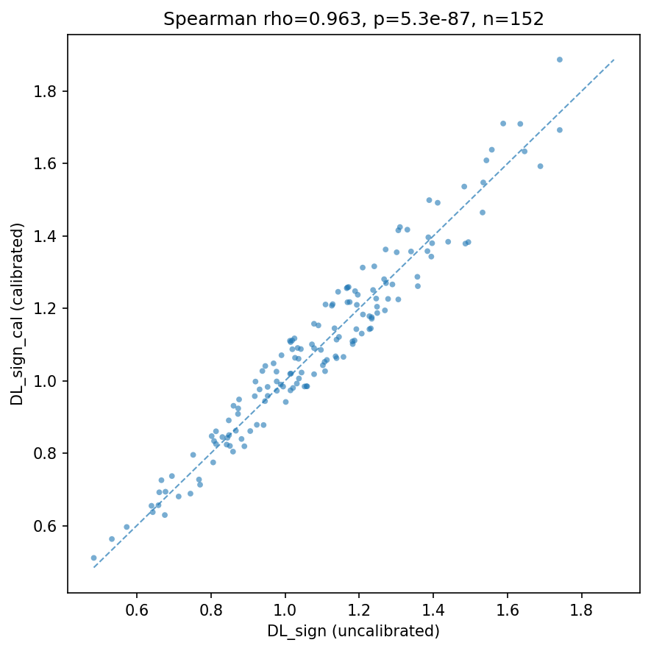
The calculation results show a Spearman rank correlation coefficient of 0.963 between DL-sign (uncalibrated) and DL-sign-cal (temperature calibrated), with a p-value of approximately 5.3 × 10⁻⁸⁷. This indicates a strong correlation and extremely high consistency in ranking. The correlation scatter plot is shown above, demonstrating a very high level of agreement between the DL-sign before and after calibration at the sample level

Suppl Figure 2

Suppl Figure 3

Sample-Size Sufficiency Evaluation Using Performance-Sample Size Curves
Suppl Figure 2：Both the training set and test set AUCs tended to stabilize after reaching a certain sample size: For the "presence/absence of fibrosis" model, the test set AUC stabilized in the range of approximately 0.86-0.89 when the sample size reached approximately 100-110 cases, also exhibiting a convergence trend. Suppl Figure 3：For the "mild vs. moderate-severe fibrosis" model, the test set AUC gradually stabilized above approximately 0.85 after the sample size increased to approximately 80-90 cases, shifting from earlier fluctuations. Subsequently, further increases in sample size yielded limited improvements in AUC.
AUC, area under the curve.

Others:
We have publicly released the experimental workflow code for the PIxelmedAI platform via a link:
https://github.com/410312774/PixelMedAI/tree/main/note2-%E6%B7%B1%E5%BA%A6%E5%AD%A6%E4%B9%A0%E5%88%86%E7%B1%BB/Mob_Se

