Supplemental Table 1. A list of ICD 10 codes used in this study.

ICD 10 codes
N17 (Acute renal failure)
N17.0 (Acute renal failure with tubular necrosis)
N17.1 (Acute renal failure with acute cortical necrosis)
N17.2 (Acute renal failure with medullary necrosis)
N17.8 (Other acute renal failure)
N17.9 (Acute renal failure, unspecified)
N18 (Chronic renal failure)
N18.0 (End-stage renal disease)
N18.1 (Chronic kidney disease, stage 1)
N18.2 (Chronic kidney disease, stage 2)
N18.3 (Chronic kidney disease, stage 3)
N18.4 (Chronic kidney disease, stage 4)
N18.5 (Chronic kidney disease, stage 5)
N18.8 (Other chronic renal failure)
N18.9 (Chronic renal failure, unspecified)
N19 (Unspecified renal failure)

Supplemental Table 2. Age-adjusted mortality rate per 100,000 from renal failure in the US overall and by gender.

Year | Female |  |  | Male |  |  | Overall
Year | AAMR | 95% CI  Lower | 95% CI  Upper | AAMR | 95% CI  Lower | 95% CI  Upper | AAMR | 95% CI  Lower | 95% CI  Upper
1999 | 16.61 | 16.37 | 16.86 | 24.70 | 24.31 | 25.09 | 19.57 | 19.36 | 19.78
2000 | 17.31 | 17.06 | 17.56 | 25.45 | 25.06 | 25.84 | 20.31 | 20.10 | 20.52
2001 | 18.19 | 17.93 | 18.44 | 26.58 | 26.19 | 26.97 | 21.23 | 21.02 | 21.44
2002 | 18.48 | 18.23 | 18.73 | 27.23 | 26.83 | 27.62 | 21.71 | 21.50 | 21.92
2003 | 18.87 | 18.61 | 19.12 | 27.58 | 27.19 | 27.97 | 22.14 | 21.93 | 22.35
2004 | 18.76 | 18.51 | 19.02 | 26.84 | 26.46 | 27.22 | 21.84 | 21.63 | 22.05
2005 | 18.80 | 18.55 | 19.05 | 27.15 | 26.78 | 27.53 | 21.97 | 21.76 | 22.18
2006 | 18.59 | 18.35 | 18.84 | 26.82 | 26.45 | 27.19 | 21.77 | 21.57 | 21.98
2007 | 18.30 | 18.05 | 18.54 | 26.11 | 25.75 | 26.47 | 21.32 | 21.12 | 21.52
2008 | 18.17 | 17.93 | 18.41 | 25.91 | 25.56 | 26.26 | 21.22 | 21.02 | 21.42
2009 | 17.86 | 17.62 | 18.10 | 25.34 | 24.99 | 25.68 | 20.81 | 20.61 | 21.00
2010 | 17.61 | 17.38 | 17.85 | 25.41 | 25.07 | 25.76 | 20.68 | 20.49 | 20.88
2011 | 17.26 | 17.04 | 17.49 | 25.01 | 24.67 | 25.34 | 20.34 | 20.15 | 20.53
2012 | 16.95 | 16.72 | 17.18 | 24.34 | 24.02 | 24.66 | 19.91 | 19.73 | 20.10
2013 | 17.15 | 16.93 | 17.38 | 24.37 | 24.05 | 24.69 | 20.05 | 19.87 | 20.23
2014 | 16.87 | 16.64 | 17.09 | 24.57 | 24.26 | 24.89 | 20.00 | 19.82 | 20.19
2015 | 17.10 | 16.88 | 17.32 | 24.78 | 24.47 | 25.09 | 20.28 | 20.10 | 20.46
2016 | 16.94 | 16.72 | 17.16 | 24.15 | 23.85 | 24.46 | 19.94 | 19.77 | 20.12
2017 | 16.77 | 16.56 | 16.99 | 23.74 | 23.44 | 24.03 | 19.67 | 19.49 | 19.84
2018 | 16.28 | 16.07 | 16.49 | 23.91 | 23.61 | 24.20 | 19.51 | 19.34 | 19.68
2019 | 16.21 | 16.01 | 16.42 | 23.16 | 22.88 | 23.45 | 19.18 | 19.01 | 19.35
2020 | 16.17 | 15.97 | 16.38 | 23.20 | 22.91 | 23.48 | 19.22 | 19.05 | 19.39
2021 | 17.16 | 16.94 | 17.37 | 24.92 | 24.62 | 25.22 | 20.49 | 20.32 | 20.67
2022 | 17.58 | 17.37 | 17.80 | 25.22 | 24.92 | 25.51 | 20.82 | 20.64 | 20.99

AAMR: age-adjusted mortality rate (per 100,000)
95% CI Lower: lower bound of 95% confidence interval
95% CI Upper: upper bound of 95% confidence interval

Confidence intervals are from Centers for Disease Control and Prevention Wide-ranging Online Data for Epidemiologic Research (CDC WONDER) data.

Supplemental Table 3. Joinpoint analysis data for renal failure mortality trends in the US overall and by gender.

Cohort | Segment | Years | APC | 95% CI  Lower | 95% CI  Upper
Female | 1 | 1999-2003 | 3.1052* | 1.96 | 4.51
Female | 2 | 2003-2020 | -0.9583* | -1.11 | -0.84
Female | 3 | 2020-2022 | 4.8585* | 2.47 | 6.08
Female | Average | 1999-2022 | 0.2329* | 0.07 | 0.39
Male | 1 | 1999-2002 | 3.6211* | 1.89 | 6.49
Male | 2 | 2002-2020 | -0.9287* | -1.07 | -0.82
Male | 3 | 2020-2022 | 4.8787* | 2.50 | 6.19
Male | Average | 1999-2022 | 0.15 | -0.01 | 0.31
Overall | 1 | 1999-2003 | 3.1661* | 2.16 | 4.35
Overall | 2 | 2003-2012 | -1.1093* | -2.01 | -0.83
Overall | 3 | 2012-2020 | -0.53 | -0.91 | 0.17
Overall | 4 | 2020-2022 | 4.1130* | 2.06 | 5.28
Overall | Average | 1999-2022 | 0.2732* | 0.14 | 0.41

APC: annual percent change
95% CI Lower: lower bound of 95% confidence interval
95% CI Upper: upper bound of 95% confidence interval
*: statistically significant difference from 0 at p < 0.05 level

Supplemental Table 4. Age-adjusted mortality rate per 100,000 from renal failure in the US by race.

Year | Hispanic or  Latino |  |  |  | NH American Indian or  Alaska Native |  |  |  | NH Black or  African American |  |  |  | NH White
Year | AAMR | 95% CI  Lower | 95% CI  Upper | AAMR |  | 95% CI  Lower | 95% CI  Upper | AAMR |  | 95% CI  Lower | 95% CI  Upper | AAMR |  | 95% CI  Lower | 95% CI  Upper
1999 | 17.94 | 16.98 | 18.89 | 25.39 |  | 21.46 | 29.32 | 43.31 |  | 42.24 | 44.39 | 17.17 |  | 16.96 | 17.38
2000 | 17.75 | 16.83 | 18.67 | 25.23 |  | 21.57 | 28.89 | 43.84 |  | 42.77 | 44.91 | 18.07 |  | 17.85 | 18.28
2001 | 18.78 | 17.86 | 19.70 | 26.07 |  | 22.39 | 29.75 | 45.71 |  | 44.62 | 46.79 | 18.88 |  | 18.67 | 19.10
2002 | 18.12 | 17.24 | 19.00 | 24.12 |  | 20.60 | 27.64 | 46.16 |  | 45.07 | 47.24 | 19.42 |  | 19.20 | 19.64
2003 | 19.81 | 18.91 | 20.71 | 29.06 |  | 25.12 | 33.01 | 47.65 |  | 46.56 | 48.74 | 19.71 |  | 19.49 | 19.93
2004 | 18.84 | 18.00 | 19.69 | 26.00 |  | 22.37 | 29.63 | 46.35 |  | 45.28 | 47.41 | 19.53 |  | 19.31 | 19.75
2005 | 19.02 | 18.19 | 19.85 | 27.89 |  | 24.17 | 31.61 | 46.50 |  | 45.44 | 47.55 | 19.71 |  | 19.49 | 19.92
2006 | 19.84 | 19.02 | 20.67 | 26.21 |  | 22.77 | 29.66 | 46.32 |  | 45.27 | 47.36 | 19.39 |  | 19.17 | 19.60
2007 | 18.89 | 18.11 | 19.68 | 27.49 |  | 23.94 | 31.04 | 43.78 |  | 42.78 | 44.78 | 19.16 |  | 18.95 | 19.37
2008 | 19.16 | 18.40 | 19.93 | 30.04 |  | 26.41 | 33.68 | 42.99 |  | 42.01 | 43.97 | 19.08 |  | 18.87 | 19.29
2009 | 19.07 | 18.33 | 19.81 | 24.40 |  | 21.24 | 27.57 | 42.41 |  | 41.45 | 43.38 | 18.63 |  | 18.42 | 18.83
2010 | 19.31 | 18.57 | 20.04 | 27.01 |  | 23.63 | 30.38 | 40.87 |  | 39.94 | 41.81 | 18.69 |  | 18.48 | 18.90
2011 | 17.03 | 16.36 | 17.69 | 24.12 |  | 21.05 | 27.19 | 40.50 |  | 39.58 | 41.42 | 18.56 |  | 18.35 | 18.76
2012 | 17.09 | 16.45 | 17.74 | 23.72 |  | 20.73 | 26.70 | 39.43 |  | 38.54 | 40.32 | 18.10 |  | 17.90 | 18.30
2013 | 16.78 | 16.16 | 17.40 | 22.34 |  | 19.59 | 25.10 | 39.33 |  | 38.45 | 40.20 | 18.31 |  | 18.11 | 18.51
2014 | 16.83 | 16.22 | 17.43 | 23.97 |  | 21.18 | 26.77 | 38.45 |  | 37.60 | 39.30 | 18.25 |  | 18.06 | 18.45
2015 | 17.25 | 16.66 | 17.84 | 24.26 |  | 21.53 | 27.00 | 39.85 |  | 38.99 | 40.70 | 18.41 |  | 18.21 | 18.60
2016 | 17.30 | 16.72 | 17.88 | 23.36 |  | 20.75 | 25.97 | 39.16 |  | 38.33 | 39.99 | 18.08 |  | 17.88 | 18.27
2017 | 17.10 | 16.54 | 17.66 | 21.33 |  | 18.91 | 23.75 | 39.18 |  | 38.37 | 40.00 | 17.71 |  | 17.52 | 17.90
2018 | 17.63 | 17.08 | 18.19 | 21.53 |  | 19.15 | 23.91 | 38.92 |  | 38.12 | 39.72 | 17.47 |  | 17.29 | 17.66
2019 | 17.82 | 17.27 | 18.36 | 23.88 |  | 21.41 | 26.34 | 38.10 |  | 37.32 | 38.88 | 17.12 |  | 16.94 | 17.30
2020 | 17.60 | 17.08 | 18.13 | 21.89 |  | 19.59 | 24.18 | 39.69 |  | 38.91 | 40.48 | 16.88 |  | 16.70 | 17.06
2021 | 18.63 | 18.09 | 19.17 | 24.36 |  | 21.84 | 26.89 | 40.18 |  | 39.38 | 40.99 | 18.54 |  | 18.34 | 18.73
2022 | 18.84 | 18.31 | 19.37 | 25.80 |  | 23.28 | 28.31 | 40.85 |  | 40.05 | 41.64 | 18.80 |  | 18.61 | 19.00

AAMR: age-adjusted mortality rate (per 100,000)
NH: non-Hispanic
95% CI Lower: lower bound of 95% confidence interval
95% CI Upper: upper bound of 95% confidence interval

Confidence intervals are from Centers for Disease Control and Prevention Wide-ranging Online Data for Epidemiologic Research (CDC WONDER) data.

Supplemental Table 5. Joinpoint analysis data for renal failure mortality trends in the US by race.

Cohort | Segment | Years | APC | 95% CI  Lower | 95% CI  Upper
Hispanic or Latino | 1 | 1999-2009 | 0.6181* | 0.04 | 1.72
Hispanic or Latino | 2 | 2009-2013 | -3.9863* | -6.36 | -1.77
Hispanic or Latino | 3 | 2013-2022 | 1.3350* | 0.77 | 2.41
Hispanic or Latino | Average | 1999-2022 | 0.08 | -0.10 | 0.39
NH American Indian or Alaska Native | 1 | 1999-2007 | 1.15 | -0.65 | 8.97
NH American Indian or Alaska Native | 2 | 2007-2018 | -2.2358* | -8.99 | -1.21
NH American Indian or Alaska Native | 3 | 2018-2022 | 4.16 | -0.12 | 11.95
NH American Indian or Alaska Native | Average | 1999-2022 | 0.03 | -0.56 | 0.91
NH Black or African American | 1 | 1999-2003 | 2.7594* | 1.60 | 4.10
NH Black or African American | 2 | 2003-2012 | -2.1264* | -2.91 | -1.77
NH Black or African American | 3 | 2012-2019 | -0.31 | -1.52 | 0.24
NH Black or African American | 4 | 2019-2022 | 1.9178* | 0.55 | 3.67
NH Black or African American | Average | 1999-2022 | -0.2156* | -0.35 | -0.07
NH White | 1 | 1999-2003 | 3.3518* | 2.07 | 5.15
NH White | 2 | 2003-2020 | -0.8441* | -1.04 | -0.71
NH White | 3 | 2020-2022 | 5.1322* | 2.06 | 6.63
NH White | Average | 1999-2022 | 0.3828* | 0.18 | 0.57

APC: annual percent change
NH: non-Hispanic
95% CI Lower: lower bound of 95% confidence interval
95% CI Upper: upper bound of 95% confidence interval
*: statistically significant difference from 0 at p < 0.05 level
Supplemental Table 6. Age-adjusted mortality rate per 100,000 from renal failure in the US by census region.

Year | Midwest |  |  | Northeast |  |  | South |  |  | West
Year | AAMR | 95% CI  Lower | 95% CI  Upper | AAMR | 95% CI  Lower | 95% CI  Upper | AAMR | 95% CI  Lower | 95% CI  Upper | AAMR | 95% CI  Lower | 95% CI  Upper
1999 | 21.55 | 21.11 | 21.99 | 21.90 | 21.42 | 22.37 | 20.63 | 20.28 | 20.99 | 12.61 | 12.23 | 12.98
2000 | 22.92 | 22.46 | 23.37 | 22.91 | 22.43 | 23.40 | 21.74 | 21.38 | 22.11 | 11.68 | 11.32 | 12.04
2001 | 23.60 | 23.15 | 24.06 | 23.19 | 22.70 | 23.67 | 23.33 | 22.95 | 23.70 | 12.60 | 12.24 | 12.97
2002 | 24.63 | 24.16 | 25.09 | 23.93 | 23.44 | 24.41 | 23.55 | 23.17 | 23.92 | 12.53 | 12.17 | 12.89
2003 | 24.69 | 24.23 | 25.15 | 23.92 | 23.44 | 24.40 | 24.58 | 24.20 | 24.96 | 12.94 | 12.58 | 13.30
2004 | 23.81 | 23.36 | 24.26 | 23.56 | 23.08 | 24.03 | 24.34 | 23.97 | 24.72 | 13.27 | 12.91 | 13.63
2005 | 23.86 | 23.41 | 24.31 | 23.52 | 23.05 | 23.99 | 24.73 | 24.36 | 25.10 | 13.41 | 13.05 | 13.77
2006 | 23.14 | 22.70 | 23.58 | 22.82 | 22.36 | 23.29 | 25.01 | 24.64 | 25.38 | 13.42 | 13.06 | 13.77
2007 | 22.36 | 21.93 | 22.79 | 21.88 | 21.42 | 22.33 | 25.14 | 24.77 | 25.51 | 12.93 | 12.58 | 13.27
2008 | 22.54 | 22.11 | 22.97 | 21.72 | 21.27 | 22.17 | 25.02 | 24.66 | 25.38 | 12.51 | 12.17 | 12.84
2009 | 22.28 | 21.85 | 22.70 | 20.83 | 20.39 | 21.26 | 24.74 | 24.38 | 25.10 | 12.26 | 11.93 | 12.59
2010 | 22.48 | 22.06 | 22.91 | 20.03 | 19.61 | 20.46 | 24.87 | 24.51 | 25.22 | 12.05 | 11.73 | 12.37
2011 | 22.58 | 22.16 | 23.00 | 20.21 | 19.78 | 20.63 | 23.94 | 23.60 | 24.29 | 11.80 | 11.49 | 12.11
2012 | 22.25 | 21.83 | 22.66 | 19.37 | 18.96 | 19.79 | 23.46 | 23.12 | 23.80 | 11.79 | 11.48 | 12.10
2013 | 22.26 | 21.85 | 22.67 | 19.13 | 18.73 | 19.54 | 23.96 | 23.62 | 24.29 | 11.73 | 11.42 | 12.03
2014 | 22.68 | 22.27 | 23.09 | 18.91 | 18.51 | 19.31 | 23.58 | 23.26 | 23.91 | 12.00 | 11.69 | 12.30
2015 | 23.01 | 22.59 | 23.42 | 19.39 | 18.99 | 19.80 | 23.50 | 23.18 | 23.82 | 12.70 | 12.39 | 13.01
2016 | 22.33 | 21.92 | 22.73 | 18.85 | 18.45 | 19.25 | 23.23 | 22.91 | 23.54 | 12.76 | 12.46 | 13.06
2017 | 22.16 | 21.76 | 22.56 | 18.52 | 18.13 | 18.91 | 22.78 | 22.47 | 23.09 | 12.84 | 12.54 | 13.14
2018 | 22.03 | 21.64 | 22.43 | 18.79 | 18.40 | 19.18 | 22.41 | 22.11 | 22.72 | 12.54 | 12.25 | 12.83
2019 | 21.34 | 20.95 | 21.72 | 19.18 | 18.79 | 19.57 | 21.62 | 21.32 | 21.91 | 12.82 | 12.53 | 13.12
2020 | 21.56 | 21.17 | 21.94 | 18.76 | 18.38 | 19.15 | 21.55 | 21.26 | 21.85 | 13.10 | 12.81 | 13.39
2021 | 22.40 | 22.00 | 22.80 | 19.46 | 19.06 | 19.85 | 23.32 | 23.01 | 23.62 | 14.61 | 14.29 | 14.92
2022 | 23.64 | 23.24 | 24.05 | 19.80 | 19.41 | 20.19 | 23.22 | 22.93 | 23.52 | 14.78 | 14.47 | 15.09

AAMR: age-adjusted mortality rate (per 100,000)
95% CI Lower: lower bound of 95% confidence interval
95% CI Upper: upper bound of 95% confidence interval

Confidence intervals are from Centers for Disease Control and Prevention Wide-ranging Online Data for Epidemiologic Research (CDC WONDER) data.
Supplemental Table 7. Joinpoint analysis data for renal failure mortality trends in the US by census region.

Cohort | Segment | Years | APC | 95% CI  Lower | 95% CI  Upper
Midwest | 1 | 1999-2002 | 4.6826* | 3.06 | 6.15
Midwest | 2 | 2002-2008 | -1.7993* | -2.91 | -1.31
Midwest | 3 | 2008-2015 | 0.25 | -0.11 | 1.72
Midwest | 4 | 2015-2020 | -1.1877* | -2.69 | -0.67
Midwest | 5 | 2020-2022 | 5.0976* | 2.88 | 6.54
Midwest | Average | 1999-2022 | 0.3735* | 0.22 | 0.52
Northeast | 1 | 1999-2003 | 2.3780* | 1.15 | 4.04
Northeast | 2 | 2003-2013 | -2.4276* | -3.64 | -1.59
Northeast | 3 | 2013-2020 | -0.12 | -3.68 | 0.61
Northeast | 4 | 2020-2022 | 2.6290* | 0.01 | 4.18
Northeast | Average | 1999-2022 | -0.4703* | -0.68 | -0.29
South | 1 | 1999-2001 | 6.8054* | 3.67 | 9.38
South | 2 | 2001-2007 | 1.3383* | 0.14 | 2.04
South | 3 | 2007-2020 | -1.1298* | -1.54 | -0.94
South | 4 | 2020-2022 | 3.6277* | 0.95 | 5.12
South | Average | 1999-2022 | 0.5887* | 0.39 | 0.78
West | 1 | 1999-2006 | 1.4219* | 0.51 | 2.97
West | 2 | 2006-2011 | -2.7786* | -5.35 | -1.03
West | 3 | 2011-2020 | 1.41 | -0.53 | 2.17
West | 4 | 2020-2022 | 6.6532* | 2.36 | 8.88
West | Average | 1999-2022 | 0.9277* | 0.65 | 1.19

APC: annual percent change
95% CI Lower: lower bound of 95% confidence interval
95% CI Upper: upper bound of 95% confidence interval
*: statistically significant difference from 0 at p < 0.05 level
Supplemental Table 8. Age-adjusted mortality rate per 100,000 from renal failure in the US by age groups.

Year | Young Adult |  |  | Middle Aged |  |  | Elderly
Year | AAMR | 95% CI  Lower | 95% CI  Upper | AAMR | 95% CI  Lower | 95% CI  Upper | AAMR | 95% CI  Lower | 95% CI  Upper
1999 | 1.09 | 1.02 | 1.16 | 6.96 | 6.75 | 7.17 | 85.32 | 84.35 | 86.30
2000 | 1.15 | 1.07 | 1.22 | 7.46 | 7.25 | 7.68 | 88.11 | 87.13 | 89.10
2001 | 1.10 | 1.03 | 1.17 | 7.76 | 7.55 | 7.98 | 92.40 | 91.40 | 93.40
2002 | 1.15 | 1.07 | 1.22 | 7.78 | 7.57 | 7.99 | 94.71 | 93.70 | 95.72
2003 | 1.25 | 1.17 | 1.32 | 8.18 | 7.97 | 8.39 | 95.98 | 94.97 | 96.99
2004 | 1.25 | 1.18 | 1.33 | 8.14 | 7.93 | 8.35 | 94.50 | 93.50 | 95.50
2005 | 1.19 | 1.12 | 1.27 | 7.94 | 7.74 | 8.14 | 95.67 | 94.68 | 96.66
2006 | 1.20 | 1.13 | 1.27 | 8.22 | 8.02 | 8.42 | 94.13 | 93.15 | 95.10
2007 | 1.15 | 1.07 | 1.22 | 7.90 | 7.71 | 8.10 | 92.50 | 91.54 | 93.46
2008 | 1.20 | 1.12 | 1.28 | 8.00 | 7.81 | 8.19 | 91.67 | 90.72 | 92.61
2009 | 1.31 | 1.23 | 1.39 | 7.93 | 7.73 | 8.12 | 89.44 | 88.51 | 90.37
2010 | 1.10 | 1.03 | 1.17 | 7.86 | 7.67 | 8.05 | 89.41 | 88.49 | 90.33
2011 | 1.10 | 1.03 | 1.17 | 7.44 | 7.26 | 7.62 | 88.42 | 87.51 | 89.32
2012 | 1.05 | 0.97 | 1.12 | 7.55 | 7.36 | 7.73 | 86.16 | 85.28 | 87.04
2013 | 1.09 | 1.02 | 1.16 | 7.60 | 7.42 | 7.79 | 86.65 | 85.78 | 87.52
2014 | 1.10 | 1.03 | 1.17 | 7.66 | 7.48 | 7.85 | 86.29 | 85.43 | 87.15
2015 | 1.15 | 1.07 | 1.22 | 8.06 | 7.87 | 8.25 | 86.90 | 86.04 | 87.75
2016 | 1.25 | 1.18 | 1.33 | 8.24 | 8.05 | 8.43 | 84.61 | 83.78 | 85.44
2017 | 1.10 | 1.03 | 1.17 | 8.32 | 8.13 | 8.51 | 83.41 | 82.60 | 84.23
2018 | 1.21 | 1.13 | 1.29 | 8.44 | 8.25 | 8.63 | 82.14 | 81.34 | 82.93
2019 | 1.25 | 1.18 | 1.33 | 8.58 | 8.39 | 8.78 | 80.08 | 79.30 | 80.86
2020 | 1.41 | 1.33 | 1.49 | 9.12 | 8.92 | 9.32 | 78.99 | 78.23 | 79.75
2021 | 1.56 | 1.48 | 1.65 | 9.38 | 9.18 | 9.58 | 84.68 | 83.87 | 85.49
2022 | 1.57 | 1.49 | 1.66 | 10.04 | 9.82 | 10.25 | 85.17 | 84.39 | 85.95

AAMR: age-adjusted mortality rate (per 100,000)
95% CI Lower: lower bound of 95% confidence interval
95% CI Upper: upper bound of 95% confidence interval

Confidence intervals are from Centers for Disease Control and Prevention Wide-ranging Online Data for Epidemiologic Research (CDC WONDER) data.

Supplemental Table 9. Joinpoint analysis data for renal failure mortality trends in the US by age.

Cohort | Segment | Years | APC | 95% CI  Lower | 95% CI  Upper
Young Adult | 1 | 1999-2017 | -0.17 | -1.13 | 0.43
Young Adult | 2 | 2017-2022 | 7.0039* | 3.57 | 15.45
Young Adult | Average | 1999-2022 | 1.3450* | 0.82 | 1.83
Middle Aged | 1 | 1999-2003 | 3.7953* | 2.07 | 6.82
Middle Aged | 2 | 2003-2013 | -0.8178* | -2.36 | -0.05
Middle Aged | 3 | 2013-2019 | 2.27 | -1.94 | 3.17
Middle Aged | 4 | 2019-2022 | 4.7668* | 2.77 | 7.21
Middle Aged | Average | 1999-2022 | 1.4937* | 1.28 | 1.77
Elderly | 1 | 1999-2003 | 3.0167* | 1.81 | 4.56
Elderly | 2 | 2003-2020 | -1.0901* | -1.28 | -0.97
Elderly | 3 | 2020-2022 | 3.4598* | 0.72 | 4.71
Elderly | Average | 1999-2022 | 0.00 | -0.17 | 0.17

APC: annual percent change
95% CI Lower: lower bound of 95% confidence interval
95% CI Upper: upper bound of 95% confidence interval
*: statistically significant difference from 0 at p < 0.05 level

Supplemental Table 10. Overall age-adjusted mortality rate per 100,000 from renal failure in the US from the Underlying Cause-of-Death and Multiple Cause-of-Death databases.

Year | Multiple Cause-of-Death |  |  | Underlying Cause-of-Death
Year | AAMR | 95% CI  Lower | 95% CI  Upper | AAMR | 95% CI  Lower | 95% CI  Upper
1999 | 103.60 | 103.12 | 104.07 | 19.57 | 19.36 | 19.78
2000 | 107.82 | 107.34 | 108.30 | 20.31 | 20.1 | 20.52
2001 | 110.39 | 109.91 | 110.87 | 21.23 | 21.02 | 21.44
2002 | 112.01 | 111.52 | 112.49 | 21.71 | 21.5 | 21.92
2003 | 113.00 | 112.52 | 113.48 | 22.14 | 21.93 | 22.35
2004 | 111.62 | 111.14 | 112.09 | 21.84 | 21.63 | 22.05
2005 | 112.22 | 111.75 | 112.69 | 21.97 | 21.76 | 22.18
2006 | 108.21 | 107.75 | 108.67 | 21.77 | 21.57 | 21.98
2007 | 105.13 | 104.68 | 105.58 | 21.32 | 21.12 | 21.52
2008 | 101.59 | 101.16 | 102.03 | 21.22 | 21.02 | 21.42
2009 | 97.89 | 97.46 | 98.31 | 20.81 | 20.61 | 21.0
2010 | 95.55 | 95.13 | 95.97 | 20.68 | 20.49 | 20.88
2011 | 116.33 | 115.87 | 116.78 | 20.34 | 20.15 | 20.53
2012 | 114.14 | 113.69 | 114.59 | 19.91 | 19.73 | 20.10
2013 | 80.77 | 80.40 | 81.14 | 20.05 | 19.87 | 20.23
2014 | 78.69 | 78.33 | 79.05 | 20.0 | 19.82 | 20.19
2015 | 79.16 | 78.80 | 79.52 | 20.28 | 20.1 | 20.46
2016 | 77.59 | 77.24 | 77.94 | 19.94 | 19.77 | 20.12
2017 | 77.51 | 77.16 | 77.86 | 19.67 | 19.49 | 19.84
2018 | 77.06 | 76.72 | 77.40 | 19.51 | 19.34 | 19.68
2019 | 76.19 | 75.85 | 76.53 | 19.18 | 19.01 | 19.35
2020 | 90.48 | 90.11 | 90.84 | 19.22 | 19.05 | 19.39
2021 | 107.22 | 106.81 | 107.62 | 20.49 | 20.32 | 20.67
2022 | 101.47 | 101.09 | 101.85 | 20.82 | 20.64 | 20.99

AAMR: age-adjusted mortality rate (per 100,000)
95% CI Lower: lower bound of 95% confidence interval
95% CI Upper: upper bound of 95% confidence interval

Confidence intervals are from Centers for Disease Control and Prevention Wide-ranging Online Data for Epidemiologic Research (CDC WONDER) data.

Supplemental Table 11. Joinpoint analysis data for overall renal failure mortality trends in the US from the multiple cause of death and underlying cause of death databases.

Database | Segment | Years | APC | 95% CI  Lower | 95% CI  Upper
Multiple Cause-of-Death | 1 | 1999-2012 | -0.2707 | -6.2916 | 9.082
Multiple Cause-of-Death | 2 | 2012-2015 | -11.386 | -14.834 | 5.7147
Multiple Cause-of-Death | 3 | 2015-2019 | 2.3583 | -16.7905 | 11.4454
Multiple Cause-of-Death | 4 | 2019-2022 | 10.3007* | 1.3658 | 22.2624
Multiple Cause-of-Death | Average | 1999-2022 | -0.0457 | -0.9214 | -0.7408
Underlying Cause-of-Death | 1 | 1999-2003 | 3.1661* | 2.16 | 4.35
Underlying Cause-of-Death | 2 | 2003-2012 | -1.1093* | -2.01 | -0.83
Underlying Cause-of-Death | 3 | 2012-2020 | -0.53 | -0.91 | 0.17
Underlying Cause-of-Death | 4 | 2020-2022 | 4.1130* | 2.06 | 5.28
Underlying Cause-of-Death | Average | 1999-2022 | 0.2732* | 0.14 | 0.41

APC: annual percent change
95% CI Lower: lower bound of 95% confidence interval
95% CI Upper: upper bound of 95% confidence interval
*: statistically significant difference from 0 at p < 0.05 level

Supplemental Table 12. Age-adjusted mortality rate per 100,000 from renal failure in the US by diagnosis code.

Year | N17 — Acute Renal Failure |  |  | N18 — Chronic Renal Failure |  |  | N19 — Unspecified Renal Failure
Year | AAMR | 95% CI  Lower | 95% CI  Upper | AAMR | 95% CI  Lower | 95% CI  Upper | AAMR | 95% CI  Lower | 95% CI  Upper
1999 | 2.67 | 2.60 | 2.75 | 7.88 | 7.75 | 8.02 | 9.00 | 8.86 | 9.14
2000 | 2.88 | 2.80 | 2.96 | 8.06 | 7.93 | 8.19 | 9.34 | 9.20 | 9.48
2001 | 2.99 | 2.91 | 3.07 | 8.59 | 8.46 | 8.73 | 9.65 | 9.51 | 9.79
2002 | 3.27 | 3.19 | 3.36 | 8.83 | 8.69 | 8.96 | 9.59 | 9.45 | 9.74
2003 | 3.51 | 3.42 | 3.59 | 9.28 | 9.15 | 9.42 | 9.36 | 9.22 | 9.50
2004 | 3.62 | 3.53 | 3.70 | 9.24 | 9.10 | 9.38 | 8.97 | 8.84 | 9.11
2005 | 3.86 | 3.78 | 3.95 | 9.26 | 9.13 | 9.40 | 8.87 | 8.74 | 9.00
2006 | 3.80 | 3.72 | 3.89 | 9.55 | 9.42 | 9.69 | 8.39 | 8.27 | 8.52
2007 | 3.88 | 3.80 | 3.97 | 9.30 | 9.16 | 9.43 | 8.16 | 8.04 | 8.29
2008 | 4.33 | 4.24 | 4.42 | 9.34 | 9.21 | 9.48 | 7.56 | 7.45 | 7.68
2009 | 4.38 | 4.29 | 4.47 | 9.39 | 9.26 | 9.52 | 7.04 | 6.93 | 7.16
2010 | 4.41 | 4.32 | 4.50 | 9.60 | 9.46 | 9.73 | 6.70 | 6.59 | 6.81
2011 | 3.81 | 3.73 | 3.90 | 10.70 | 10.57 | 10.84 | 5.83 | 5.73 | 5.94
2012 | 3.52 | 3.44 | 3.59 | 11.00 | 10.86 | 11.14 | 5.38 | 5.28 | 5.48
2013 | 3.49 | 3.41 | 3.57 | 11.38 | 11.24 | 11.52 | 5.19 | 5.09 | 5.28
2014 | 3.52 | 3.45 | 3.60 | 11.77 | 11.63 | 11.91 | 4.70 | 4.61 | 4.79
2015 | 3.50 | 3.42 | 3.57 | 12.60 | 12.46 | 12.74 | 4.22 | 4.14 | 4.31
2016 | 3.33 | 3.25 | 3.40 | 13.04 | 12.89 | 13.18 | 3.58 | 3.51 | 3.66
2017 | 3.17 | 3.10 | 3.24 | 13.23 | 13.09 | 13.37 | 3.30 | 3.23 | 3.38
2018 | 3.10 | 3.04 | 3.17 | 13.49 | 13.34 | 13.63 | 2.95 | 2.88 | 3.01
2019 | 2.84 | 2.77 | 2.90 | 13.67 | 13.52 | 13.81 | 2.70 | 2.64 | 2.76
2020 | 3.05 | 2.98 | 3.11 | 13.75 | 13.61 | 13.90 | 2.35 | 2.29 | 2.41
2021 | 3.80 | 3.73 | 3.88 | 14.36 | 14.21 | 14.51 | 2.33 | 2.27 | 2.39
2022 | 4.61 | 4.52 | 4.69 | 14.20 | 14.06 | 14.34 | 2.03 | 1.98 | 2.09

AAMR: age-adjusted mortality rate (per 100,000)
95% CI Lower: lower bound of 95% confidence interval
95% CI Upper: upper bound of 95% confidence interval

Confidence intervals are from Centers for Disease Control and Prevention Wide-ranging Online Data for Epidemiologic Research (CDC WONDER) data.

Supplemental Table 13. Joinpoint analysis data for renal failure mortality trends in the US by diagnosis code.

Cohort | Segment | Years | APC | 95% CI  Lower | 95% CI  Upper
N17 — Acute renal failure | 1 | 1999-2009 | 4.9046* | 2.4622 | 8.2102
N17 — Acute renal failure | 2 | 2009-2012 | -6.9613 | -8.886 | 6.848
N17 — Acute renal failure | 3 | 2012-2020 | -2.4515 | -3.8482 | 0.269
N17 — Acute renal failure | 4 | 2020-2022 | 25.1431* | 18.3367 | 29.8348
N17 — Acute renal failure | Average | 1999-2022 | 2.2527* | 1.8437 | 2.7158
N18 — Chronic renal failure | 1 | 1999-2003 | 4.264* | 2.9525 | 6.6067
N18 — Chronic renal failure | 2 | 2003-2009 | 0.3365 | -1.197 | 1.06
N18 — Chronic renal failure | 3 | 2009-2016 | 4.7753* | 4.2503 | 5.5817
N18 — Chronic renal failure | 4 | 2016-2022 | 1.4757* | 0.881 | 1.9573
N18 — Chronic renal failure | Average | 1999-2022 | 2.6502* | 2.5044 | 2.8228
N19 — Unspecified renal failure | 1 | 1999-2001 | 4.4431* | 0.3534 | 8.7106
N19 — Unspecified renal failure | 2 | 2001-2007 | -2.8516* | -5.4908 | -2.0209
N19 — Unspecified renal failure | 3 | 2007-2013 | -7.7162* | -9.1493 | -5.3365
N19 — Unspecified renal failure | 4 | 2013-2022 | -9.929* | -14.0957 | -9.0982
N19 — Unspecified renal failure | Average | 1999-2022 | -6.3527 | -6.8594 | -6.0677

APC: annual percent change
95% CI Lower: lower bound of 95% confidence interval
95% CI Upper: upper bound of 95% confidence interval
*: statistically significant difference from 0 at p < 0.05 level
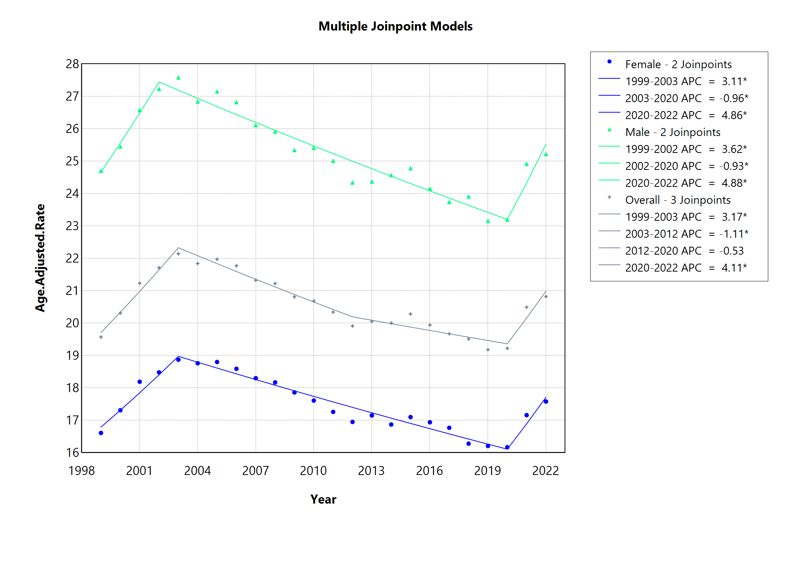
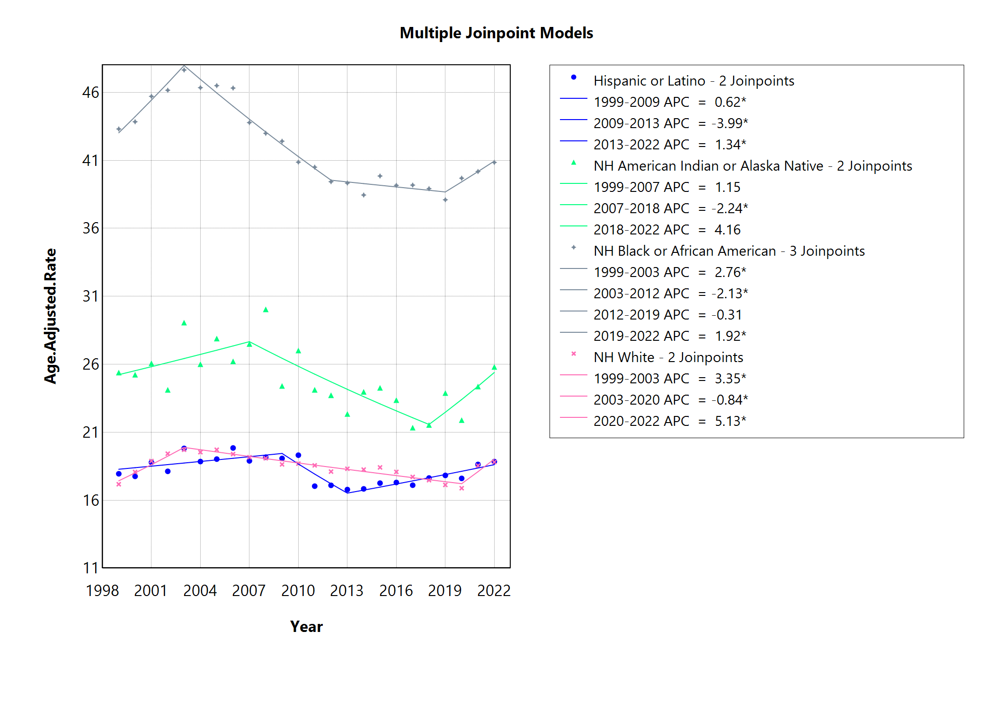
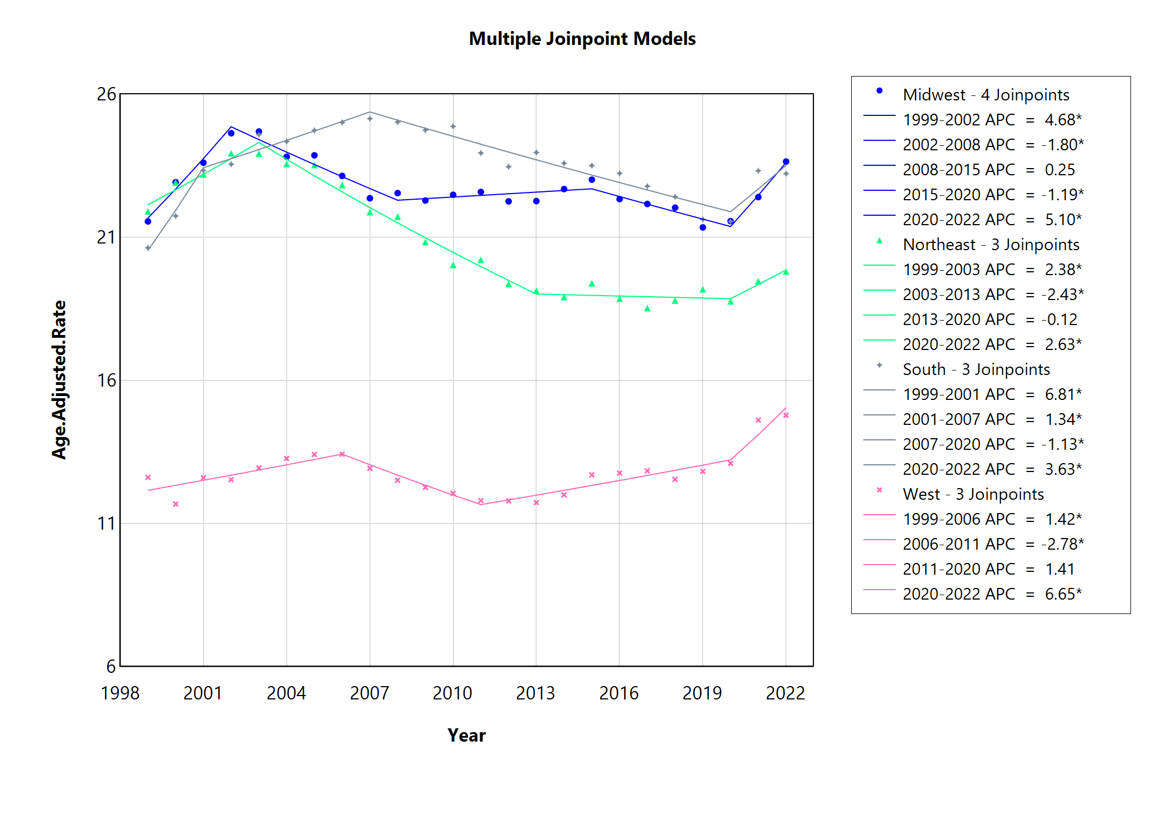
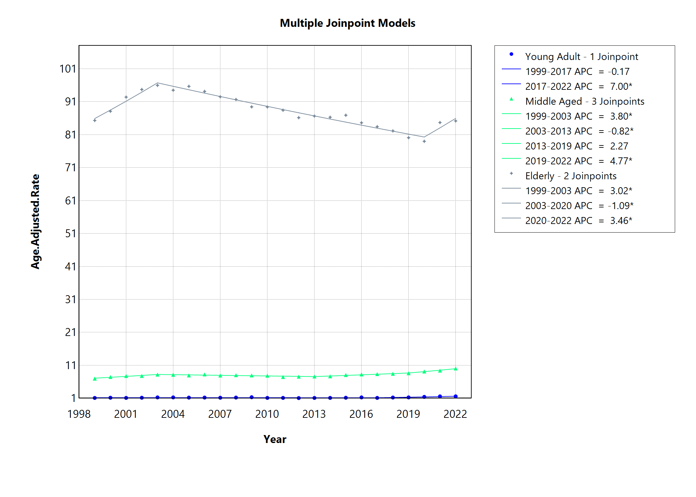
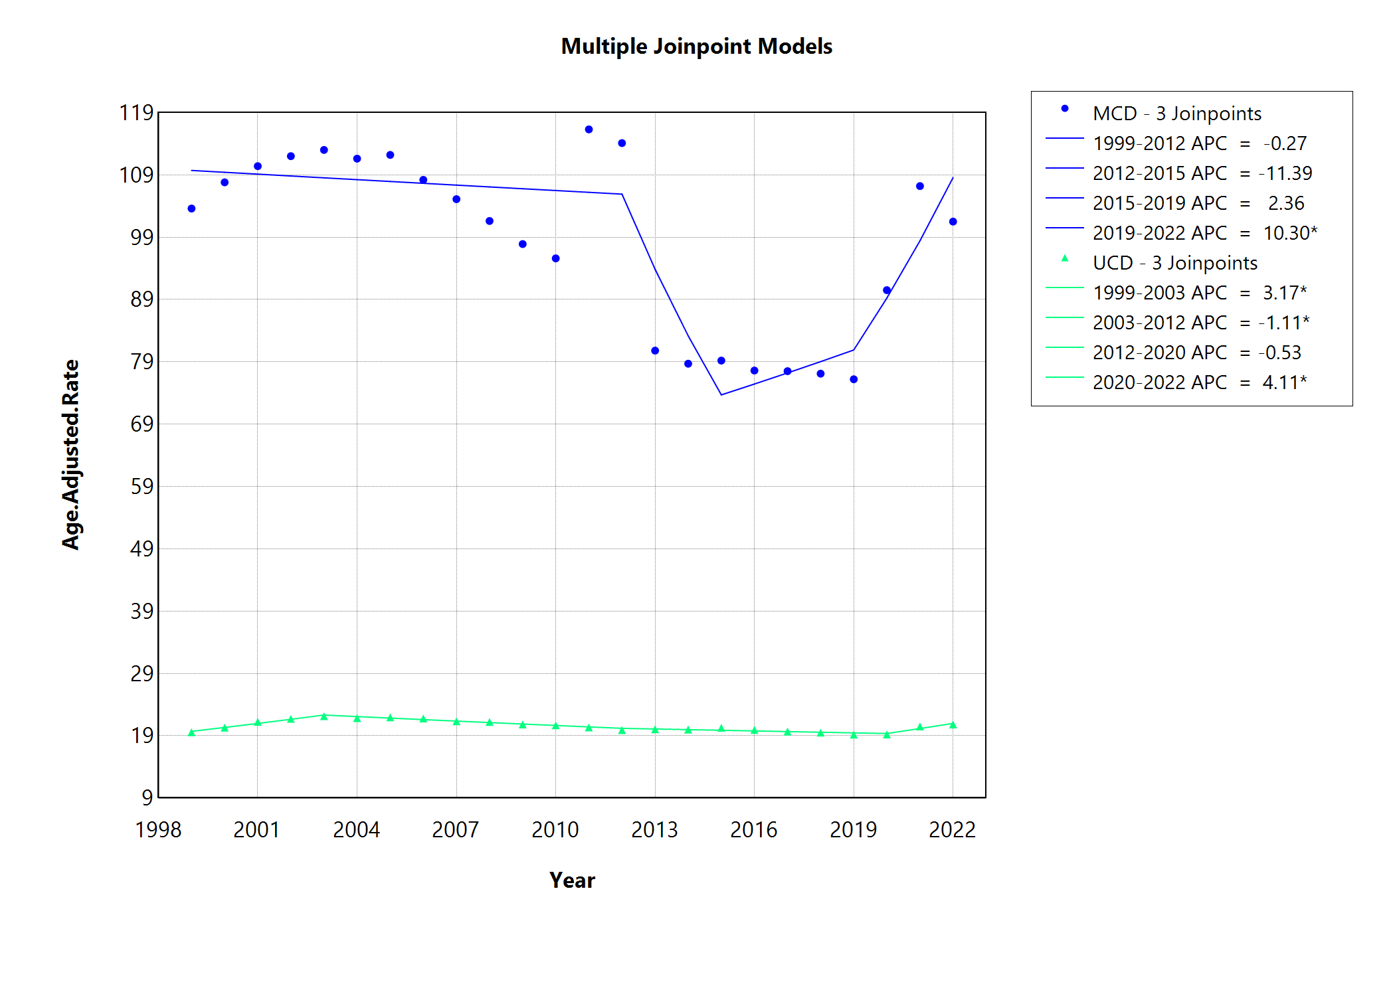
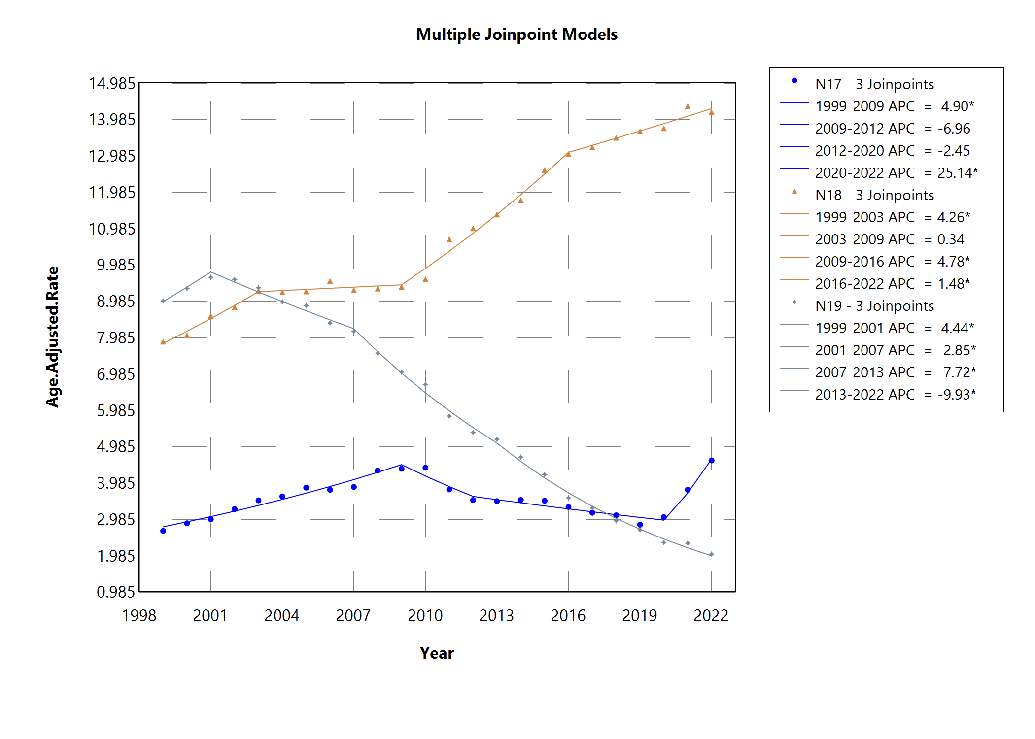
Supplemental Fig. 1. Joinpoint output showing age-adjusted mortality rate per 100,000 from renal failure overall and by gender. APC
= annual percent change, * = significantly different from 0 with p < 0.05.

Supplemental Fig. 2. Joinpoint output showing age-adjusted mortality rate per 100,000 from renal failure by race. NH = non-Hispanic, APC = annual percent change, * = significantly different from 0 with p < 0.05.

Supplemental Fig. 3. Joinpoint output showing Age-adjusted mortality rate (AAMR) per 100,000 from renal failure by census region. APC = annual percent change, * = significantly different from 0 with p < 0.05.

Supplemental Fig. 4. Joinpoint output showing age-adjusted mortality rate per 100,000 from renal failure by age group. Elderly are age > 65 years, Middle Aged are age 45-64 years, Young Adults are age 25-44 years. APC = annual percent change, * = significantly different from 0 with p < 0.05.

Supplemental Fig. 5. Joinpoint output showing Age-adjusted mortality rate (AAMR) per 100,000 from renal failure from similar CDC WONDER databases. MCD = Multiple Cause-of-Death, UCD = Underlying Cause-of-Death. APC = annual percent change, * = significantly different from 0 with p < 0.05.

Supplemental Fig. 6. Joinpoint output showing Age-adjusted mortality rate (AAMR) per 100,000 from renal failure by diagnosis code. N17 = acute renal failure, N18 = chronic renal failure, N19 = unspecified renal failure. APC = annual percent change, * = significantly different from 0 with p < 0.05.

