Supplementary Material
Supplementary Table 1. Attainment of the proteinuria reduction target
Group | Time(mo) | Target indicators |  | Ideal indicators
 |  | Number of patients (n) | Proportion (%） | Number of patients (n) | Proportion (%）
<3 years | 6 | 8 | 72.73% | 6 | 54.55%
 | 12 | 9 | 81.82% | 8 | 72.73%
≥3 years | 6 | 0 | 0.00% | 0 | 0.00%
 | 12 | 1 | 12.50% | 0 | 0.00%

Supplementary Table 2. Individual Patient Prior Treatment History
Patient ID | Group | GC | CYC | LEF | HCQ | CNI | MMF | TW | RASi/Supportive
1 | <3 yr | + | – | – | – | – | – | + | –
2 | <3 yr | + | – | – | + | – | – | – | –
3 | <3 yr | + | – | + | – | – | – | – | –
4 | <3 yr | + | – | + | – | – | – | – | –
5 | <3 yr | + | – | – | + | – | – | – | –
13 | <3 yr | + | – | – | + | – | – | – | –
15 | <3 yr | + | – | – | – | – | – | – | –
16 | <3 yr | + | – | – | – | – | – | – | + (ARB)
17 | <3 yr | + | – | – | + | – | – | – | + (dapagliflozin)
18 | <3 yr | + | – | – | – | – | – | – | + (sacubitril/valsartan)
19 | <3 yr | + | – | – | – | – | – | – | + (olmesartan)
6 | ≥3 yr | + | + | – | – | – | – | – | –
7 | ≥3 yr | + | + | + | – | – | – | – | + (ARB)
8 | ≥3 yr | – | – | – | – | + | – | – | –
9 | ≥3 yr | + | – | – | – | + | – | – | –
10 | ≥3 yr | + | + | – | – | – | – | – | –
11 | ≥3 yr | + | + | – | – | – | – | – | + (valsartan + dapagliflozin)
12 | ≥3 yr | + | – | + | – | – | – | – | + (benazepril)
14 | ≥3 yr | + | + | – | – | – | + | + | –

Supplementary Table 3. Individual Patient Urinary RBC Data (Semiquantitative Grading)
Patient ID | Group | Baseline | Month 1 | Month 2 | Month 3 | Month 4 | Month 5 | Month 6 | Month 9 | Month 12
1 | <3 yr | + | ± | ± | – | – | – | – | – | –
2 | <3 yr | ++++ | + | ++++ | + | ++ | ++ | ++++ | – | ++
3 | <3 yr | ± | ++ | ++ | + | – | ± | + | – | ±
4 | <3 yr | – | – | – | – | – | ± | – | – | –
5 | <3 yr | ++ | +++ | ++ | ++ | ++ | ++ | ++ | ++ | ±
6 | ≥3 yr | + | + | + | + | – | – | + | + | +
7 | ≥3 yr | ++++ | ++++ | – | – | +++ | – | ++ | – | ++
8 | ≥3 yr | ++++ | ++ | +++ | ++ | ++ | ± | ++ | ++ | ++
9 | ≥3 yr | – | – | ++ | – | – | ++ | – | ± | ±
10 | ≥3 yr | ± | + | ± | ± | ± | ± | ± | – | –
11 | ≥3 yr | – | – | – | – | – | – | – | – | –
12 | ≥3 yr | – | ++ | ++ | – | ++ | ++ | ± | – | –
13 | <3 yr | ++ | ++++ | + | ++++ | – | – | + | ± | –
14 | ≥3 yr | + | + | + | + | – | – | + | + | +
15 | <3 yr | ++++ | ++ | +++ | ++ | ++ | ± | ++ | ++ | ++
16 | <3 yr | +++ | + | – | ++ | ± | – | ++ | ++ | ++
17 | <3 yr | ++++ | ++ | ++++ | +++ | – | – | + | ++ | ++
18 | <3 yr | +++ | ++ | – | – | ++++ | ++++ | ++ | ++ | ++
19 | <3 yr | + | + | – | + | – | ± | ± | – | –
Note: – (<1 RBC/HPF, negative), ± (1–4 RBC/HPF, trace), + (5–9 RBC/HPF, mild), ++ (10–29 RBC/HPF, moderate), +++ (30–99 RBC/HPF, severe), ++++ (≥100 RBC/HPF or innumerable). Empty cells (–in the time point columns) indicate missing data at that time point. Original records included range values and descriptive terms (e.g.“RBC occasional”,“RBC full field”); the grading was applied for descriptive purposes only, and no statistical analysis was performed due to the semiquantitative nature of the data.

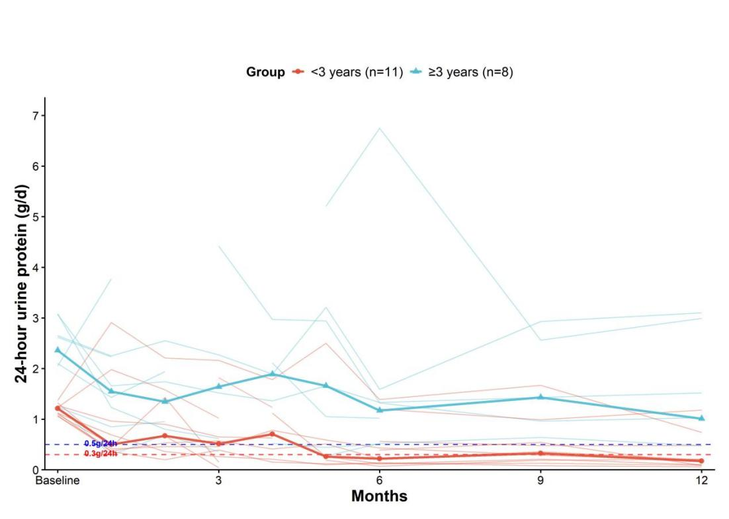
Supplementary Figure 1. Individual trajectory of 24-hour urinary protein changes

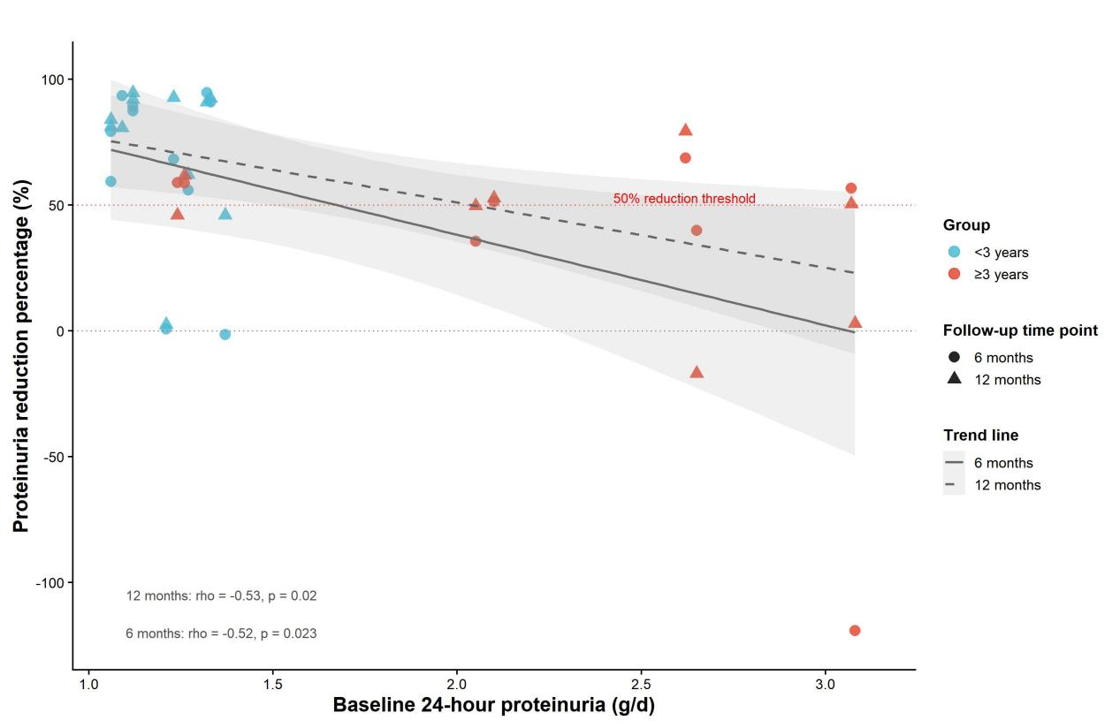
Supplementary Figure 2. Exploratory correlation between baseline 24-hour proteinuria and percent reduction in proteinuria at 12 months

