Exercise modality and dose effects on renal function in non–dialysis chronic kidney disease: a Bayesian model-based network meta-analysis

1. Supplementary File 1: Search strategy 2
1.1 Table S1. The search strategy for the PubMed database (506) 2
1.2 Table S2. The search strategy for the Cochrane database (3837) 2
1.3 Table S3. The search strategy for the Embase database (435) 3
1.4 Table S4. The search strategy for the Web of Science database (885) 4
1.5 Table S5. The search strategy for the EBSCO database (133) 5
1.6 Table S6. The search strategy for the CNKI database (167) 5
2. Supplementary File 2: Key assumptions of Network Meta-Analysis 6
2.1 Connectivity 6
2.2 Consistency 6
2.3 Transitivity 7
3. Supplementary File 3: Non-linear functions and models fit comparison 7
4. Supplementary File 4: Demographic characteristics of included studies 10
5. Supplementary File 5: Quality Assessment 15
6. Supplementary File 6: Dose-response relationships 17
6.1 Modality-specific dose–response relationships estimated by the Bayesian B-spline model 17
6.2 Comparison between the B-spline and Emax models 17
7. References 18

1. Supplementary File 1: Search strategy

1.1 Table S1. The search strategy for the PubMed database (506)
 | Search strategy | Results
#1 | "Renal Insufficiency, Chronic"[Mesh] | 145297
#2 | Search: (((((chronic kidney disease*[Title/Abstract]) OR (chronic renal disease*[Title/Abstract])) OR (chronic kidney insufficienc*[Title/Abstract])) OR (chronic renal insufficienc*[Title/Abstract])) OR (chronic kidney failure*[Title/Abstract])) OR (chronic renal failure*[Title/Abstract]) | 124955
#3 | #1 OR #2 | 205322
#4 | ((((((((((((("Exercise"[Mesh]) OR "Endurance Training"[Mesh]) OR "Yoga"[Mesh]) OR "Walking"[Mesh]) OR "Resistance Training"[Mesh]) OR "Exercise Therapy"[Mesh]) OR "Physical Education and Training"[Mesh]) OR "Physical Fitness"[Mesh]) OR "Running"[Mesh]) OR "Jogging"[Mesh]) OR "Swimming"[Mesh]) OR "Qigong"[Mesh]) OR "Tai Ji"[Mesh]) OR "Bicycling"[Mesh] | 388366
#5 | (((((((((((((((((((((((((Exercis*[Title/Abstract]) OR (Exerciz*[Title/Abstract])) OR (Endurance Training[Title/Abstract])) OR (High-Intensity Interval Training[Title/Abstract])) OR (Resistance Training[Title/Abstract])) OR (Strength Training[Title/Abstract])) OR (Physical[Title/Abstract])) OR (Running[Title/Abstract])) OR (Jogging[Title/Abstract])) OR (Swimming[Title/Abstract])) OR (Walk*[Title/Abstract])) OR (Gymnastics[Title/Abstract])) OR (Yoga[Title/Abstract])) OR (Qigong[Title/Abstract])) OR (Tai ji[Title/Abstract])) OR (tai-chi[Title/Abstract])) OR (tai chi[Title/Abstract])) OR (cycling[Title/Abstract])) OR (bicycling[Title/Abstract])) OR (qi gong[Title/Abstract])) OR (wuqinxi[Title/Abstract])) OR (baduanjin[Title/Abstract])) OR (liuzijue[Title/Abstract])) OR (yijinjing[Title/Abstract])) OR (pilate*[Title/Abstract])) OR (Traditional Chinese Exercises[Title/Abstract]) | 1620978
#6 | #4 OR #5 | 1703844
#7 | "Randomized Controlled Trial" [Publication Type] | 634477
#8 | #3 AND #6 AND #7 | 506

1.2 Table S2. The search strategy for the Cochrane database (3837)
 | Search strategy | Results
#1 | MeSH descriptor: [Renal Insufficiency, Chronic] explode all trees | 9988
#2 | (chronic kidney disease):ti,ab,kw OR (chronic renal disease):ti,ab,kw OR (chronic kidney insufficienc):ti,ab,kw OR (chronic renal insufficienc):ti,ab,kw OR (chronic kidney failure):ti,ab,kw | 25383
#3 | #1 OR #2 | 25594
#4 | MeSH descriptor: [Exercise] explode all trees | 40295
#5 | MeSH descriptor: [Endurance Training] explode all trees | 220
#6 | MeSH descriptor: [Yoga] explode all trees | 1253
#7 | MeSH descriptor: [Walking] explode all trees | 8462
#8 | MeSH descriptor: [Resistance Training] explode all trees | 6041
#9 | MeSH descriptor: [Exercise Therapy] explode all trees | 22989
#10 | MeSH descriptor: [Physical Education and Training] explode all trees | 1916
#11 | MeSH descriptor: [Physical Fitness] explode all trees | 5079
#12 | MeSH descriptor: [Running] explode all trees | 2936
#13 | MeSH descriptor: [Jogging] explode all trees | 72
#14 | MeSH descriptor: [Swimming] explode all trees | 660
#15 | MeSH descriptor: [Qigong] explode all trees | 176
#16 | MeSH descriptor: [Tai Ji] explode all trees | 599
#17 | MeSH descriptor: [Bicycling] explode all trees | 2180
#18 | (Exercis*):ti,ab,kw OR (Exerciz*):ti,ab,kw OR (Endurance Training):ti,ab,kw OR (High-Intensity Interval Training):ti,ab,kw OR (Resistance Training):ti,ab,kw | 166249
#19 | (Strength Training):ti,ab,kw OR (Physical):ti,ab,kw OR (Running):ti,ab,kw OR (Jogging):ti,ab,kw OR (Swimming):ti,ab,kw | 221812
#20 | (Walk*):ti,ab,kw OR (Gymnastics):ti,ab,kw OR (Qigong):ti,ab,kw OR (Tai ji):ti,ab,kw OR (tai-chi):ti,ab,kw | 51182
#21 | (tai chi):ti,ab,kw OR (cycling):ti,ab,kw OR (bicycling):ti,ab,kw OR (qi gong):ti,ab,kw OR (wuqinxi):ti,ab,kw | 86413
#22 | (baduanjin):ti,ab,kw OR (liuzijue):ti,ab,kw OR (yijinjing):ti,ab,kw OR (pilate*):ti,ab,kw OR (Traditional Chinese Exercises):ti,ab,kw | 2787
#23 | #4 OR #5 OR #6 OR #7 OR #8 OR #9 OR #10 OR #11 OR #12 OR #13 OR #14 OR #15 OR #16 OR #17 OR #18 OR #19 OR #20 OR #21 OR #22 | 388439
#24 | #3 AND #23 | 3874
#25 | Controlled Trials | 3837

1.3 Table S3. The search strategy for the Embase database (435)
 | Search strategy | Results
#1 | 'chronic kidney failure'/exp | 254067
#2 | 'chronic kidney disease*':ti,ab,kw OR 'chronic renal disease*':ti,ab,kw OR 'chronic kidney insufficienc*':ti,ab,kw OR 'chronic renal insufficienc*':ti,ab,kw OR 'chronic kidney failure*':ti,ab,kw OR 'chronic renal failure*':ti,ab,kw | 203282
#3 | #1 OR #2 | 295841
#4 | 'exercise'/exp OR 'endurance training'/exp OR 'yoga'/exp OR 'walking'/exp OR 'resistance training'/exp OR 'physical education'/exp OR 'fitness'/exp OR 'running'/exp OR 'jogging'/exp OR 'swimming'/exp OR 'qigong'/exp OR 'tai chi'/exp OR 'cycling'/exp | 787443
#5 | exercis*:ti,ab,kw OR exerciz*:ti,ab,kw OR 'endurance training':ti,ab,kw OR 'high-intensity interval training':ti,ab,kw OR 'resistance training':ti,ab,kw OR 'strength training':ti,ab,kw OR physical:ti,ab,kw OR running:ti,ab,kw OR jogging:ti,ab,kw OR swimming:ti,ab,kw OR walk*:ti,ab,kw OR gymnastics:ti,ab,kw OR 'pranayama':ti,ab,kw OR qigong:ti,ab,kw OR 'tai ji':ti,ab,kw OR 'tai chi':ti,ab,kw OR cycling:ti,ab,kw OR bicycling:ti,ab,kw OR 'qi gong':ti,ab,kw OR wuqinxi:ti,ab,kw OR baduanjin:ti,ab,kw OR liuzijue:ti,ab,kw OR yijinjing:ti,ab,kw OR pilate*:ti,ab,kw OR 'traditional chinese exercises':ti,ab,kw | 2187512
#6 | #4 OR #5 | 2378767
#7 | 'randomized controlled trial':ti,ab,kw OR rct:ti,ab,kw | 270422
#8 | #3 AND #6 AND #7 | 435

1.4 Table S4. The search strategy for the Web of Science database (885)
 | Search strategy | Results
#1 | chronic kidney disease* (Topic) or chronic renal disease* (Topic) or chronic kidney insufficienc* (Topic) or chronic renal insufficienc* (Topic) or chronic kidney failure* (Topic) or chronic renal failure* (Topic) | 179733
#2 | Exerciz* (Topic) or Endurance Training (Topic) or Exercis* (Topic) or High-Intensity Interval Training (Topic) or Resistance Training (Topic) or Strength Training (Topic) or Physical (Topic) or Running (Topic) or Jogging (Topic) or Swimming (Topic) or Walk* (Topic) or Gymnastics (Topic) or Yoga (Topic) or Qigong (Topic) or Tai ji (Topic) or tai-chi (Topic) or tai chi (Topic) or cycling (Topic) or bicycling (Topic) or qi gong (Topic) or wuqinxi (Topic) or baduanjin (Topic) or liuzijue (Topic) or yijinjing (Topic) or pilate* (Topic) or Traditional Chinese Exercises (Topic) | 4540683
#3 | Randomized Controlled Trial (Topic) or RCT (Topic) | 597078
#4 | #1 AND #2 AND #3 | 885

1.5 Table S5. The search strategy for the EBSCO database (133)
 | Search strategy | Results
#1 | SU chronic kidney disease* OR SU chronic renal disease* OR SU chronic kidney insufficienc* OR SU chronic renal insufficienc* OR SU chronic kidney failure* OR SU chronic renal failure* | 345855
#2 | SU Exercis* OR SU Exerciz* OR SU Endurance Training OR SU High-Intensity Interval Training OR SU Resistance Training OR SU Strength Training OR SU Physical OR SU Running OR SU Jogging OR SU Swimming OR SU Walk* OR SU Gymnastics | 2671564
#3 | SU Yoga OR SU Qigong OR SU Tai ji OR SU tai-chi OR SU tai chi OR SU cycling OR SU bicycling OR SU qi gong OR SU wuqinxi OR SU baduanjin OR SU liuzijue | 113623
#4 | SU yijinjing OR SU pilate* OR SU Traditional Chinese Exercises | 3065
#5 | #2 OR #3 OR #4 | 2671570
#6 | SU Randomized Controlled Trial OR SU RCT | 584796
#7 | #1 AND #5 AND #6 | 133

1.6 Table S6. The search strategy for the CNKI database (167)
 | Search strategy | Results
#1 | ( SU %= 'chronic kidney disease' OR SU %= 'chronic renal insufficiency' OR SU %= 'chronic renal dysfunction' ) AND( SU %= 'exercise' OR SU %= 'training' OR SU %= 'aerobic exercise' OR SU %= 'resistance exercise' OR SU %= 'stretching exercise' OR SU %= 'high-intensity interval training' OR SU %= 'running' OR SU %= 'jogging' OR SU %= 'yoga' OR SU %= 'swimming' OR SU %= 'walking' OR SU %= 'qigong' OR SU %= 'baduanjin' OR SU %= 'wuqinxi' OR SU %= 'tai chi' OR SU %= 'yijinjing' OR SU %= 'lizijue' OR SU %= 'traditional Chinese exercise' OR SU %= 'pilates') | 167
Note: The original search was conducted in Chinese databases using equivalent Chinese keywords; all corresponding English terms shown here were translated solely for transparency and readability, without altering the original search logic or result

2. Supplementary File 2: Key assumptions of Network Meta-Analysis

2.1 Connectivity
Network connectivity was visually examined at both the treatment and agent levels, and no evidence of disconnection was observed in either network (Figure S1).
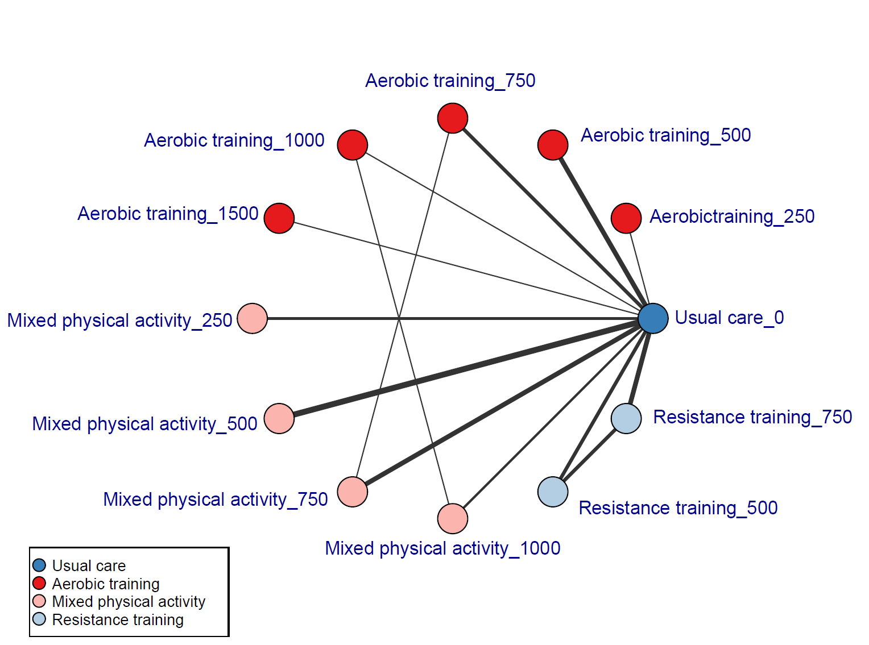
Figure S1. Network diagram of exercise interventions at different weekly doses.

2.2 Consistency
Model fit was compared between the consistency model and the unrelated mean effects (UME) model. The Deviance Information Criterion (DIC), residual deviance, and the effective number of parameters (pD) were comparable between the two models (DIC = 84.69 vs. 86.08; ΔDIC = 1.39). Based on the commonly accepted criterion (ΔDIC < 5), the consistency assumption was deemed valid, indicating strong agreement between direct and indirect evidence (Table S7 and Figure S2).
Table S7. Consistent and UME models fit comparison
Model | pD | Residual deviance | DIC | SD
Consistent | 36.94 | 47.74 | 84.69 | 0.36
UME | 36.83 | 49.24 | 86.08 | 0.42
Note. pD: effective number of parameters; DIC: Deviance Information Criterion; SD: standard deviation; UME: unrelated mean effects.
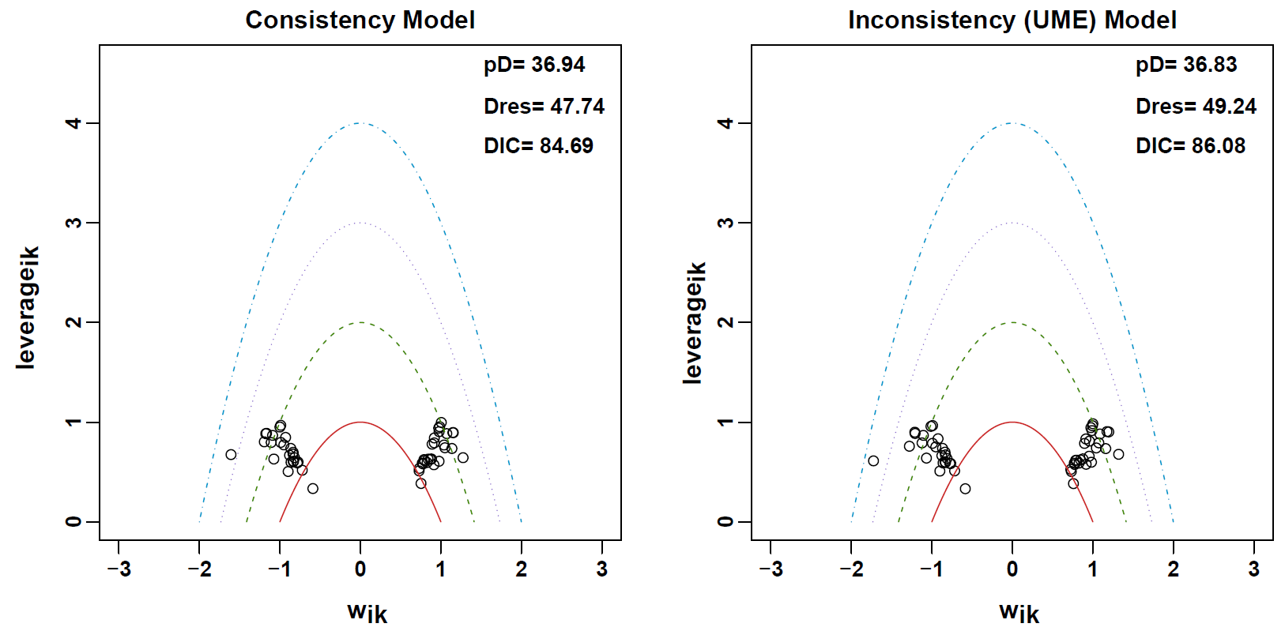
Figure S2. Consistency assessment between the consistency and UME models

2.3 Transitivity
Transitivity was evaluated at the treatment level using the MBNMA node-splitting method, which contrasts posterior distributions derived from direct and indirect sources of evidence. Figure S3 presents the node-splitting posterior density plots, displaying direct (solid) and indirect (dashed) evidence for each treatment comparison. The pronounced overlap between these distributions supports the assumption of good transitivity across the network.
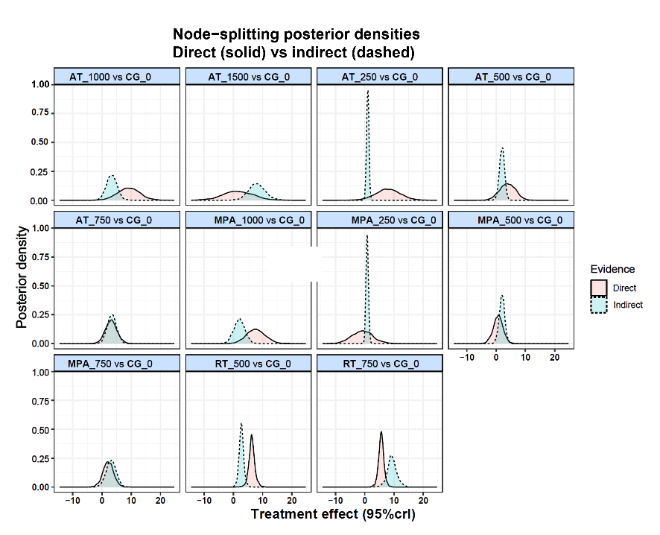
Figure S3. Node-splitting analysis (density plot). AT: Aerobic Training; CG: control group; MPA: Mixed Physical Activity; RE: Resistance Training.

3. Supplementary File 3: Non-linear functions and models fit comparison
To identify the most appropriate functional form for the non-linear association between exercise dose and eGFR, we first plotted the observed effects across exercise types and dose levels (Figure S4). We then performed a split network meta-analysis (Split NMA), treating each dose as a separate intervention under a random-effects model, to visualize dose-specific effects relative to control for exploratory purposes (Figure S5).
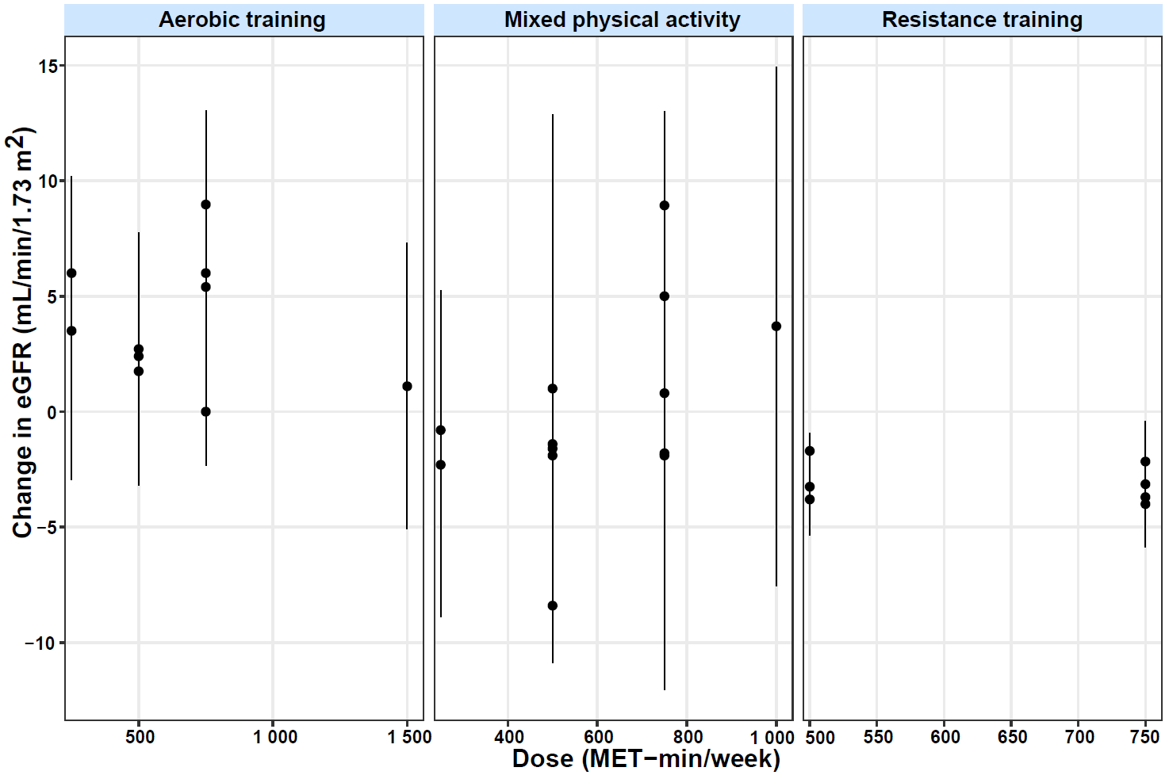
Figure S4. Observed dose–response relationships across exercise types.
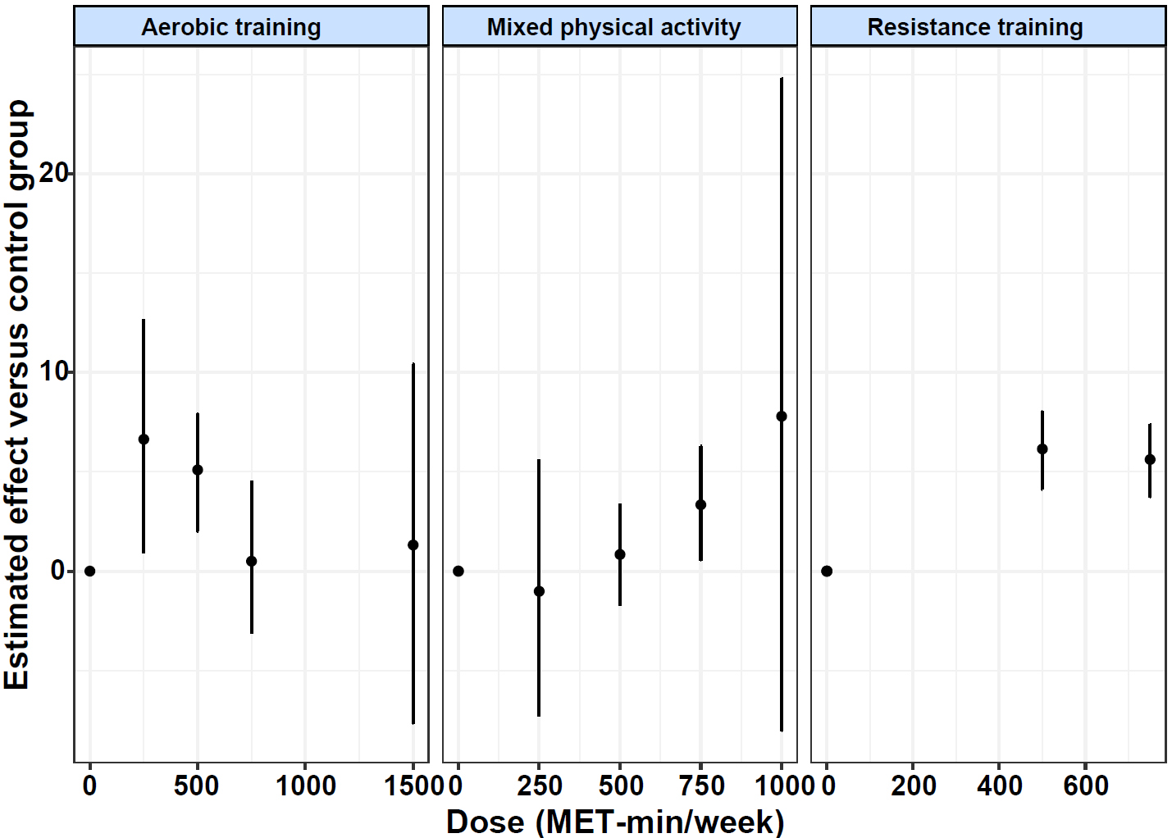
Figure S5. Split network meta-analysis treating each dose as a distinct intervention.
Guided by these preliminary patterns, we fitted Emax, restricted cubic spline (RCS), quadratic, and B-spline models within an MBNMA framework. Model performance was evaluated using the deviance information criterion (DIC), effective number of parameters (pD), and residual deviance (Table S8). The Emax model yielded the lowest DIC (89.14), reflecting the optimal balance between fit and model complexity. Deviance diagnostics (Figure S6) further supported adequate model calibration, with most posterior mean residuals close to 1.
Table S8. Comparison of non-linear functions for dose–response modelling
Model | DIC | pD | ResDev | Rank
Emax | 89.14 | 36.97 | 52.18 | 1
Quadratic | 90.50 | 39.94 | 50.56 | 2
B-spline | 91.70 | 40.19 | 51.51 | 3
Restricted cubic splines (RCS) | 92.99 | 41.45 | 51.54 | 4
Note: DIC: Deviance Information Criterion; pD: Number of estimated parameters; ResDev: Residual Deviance.
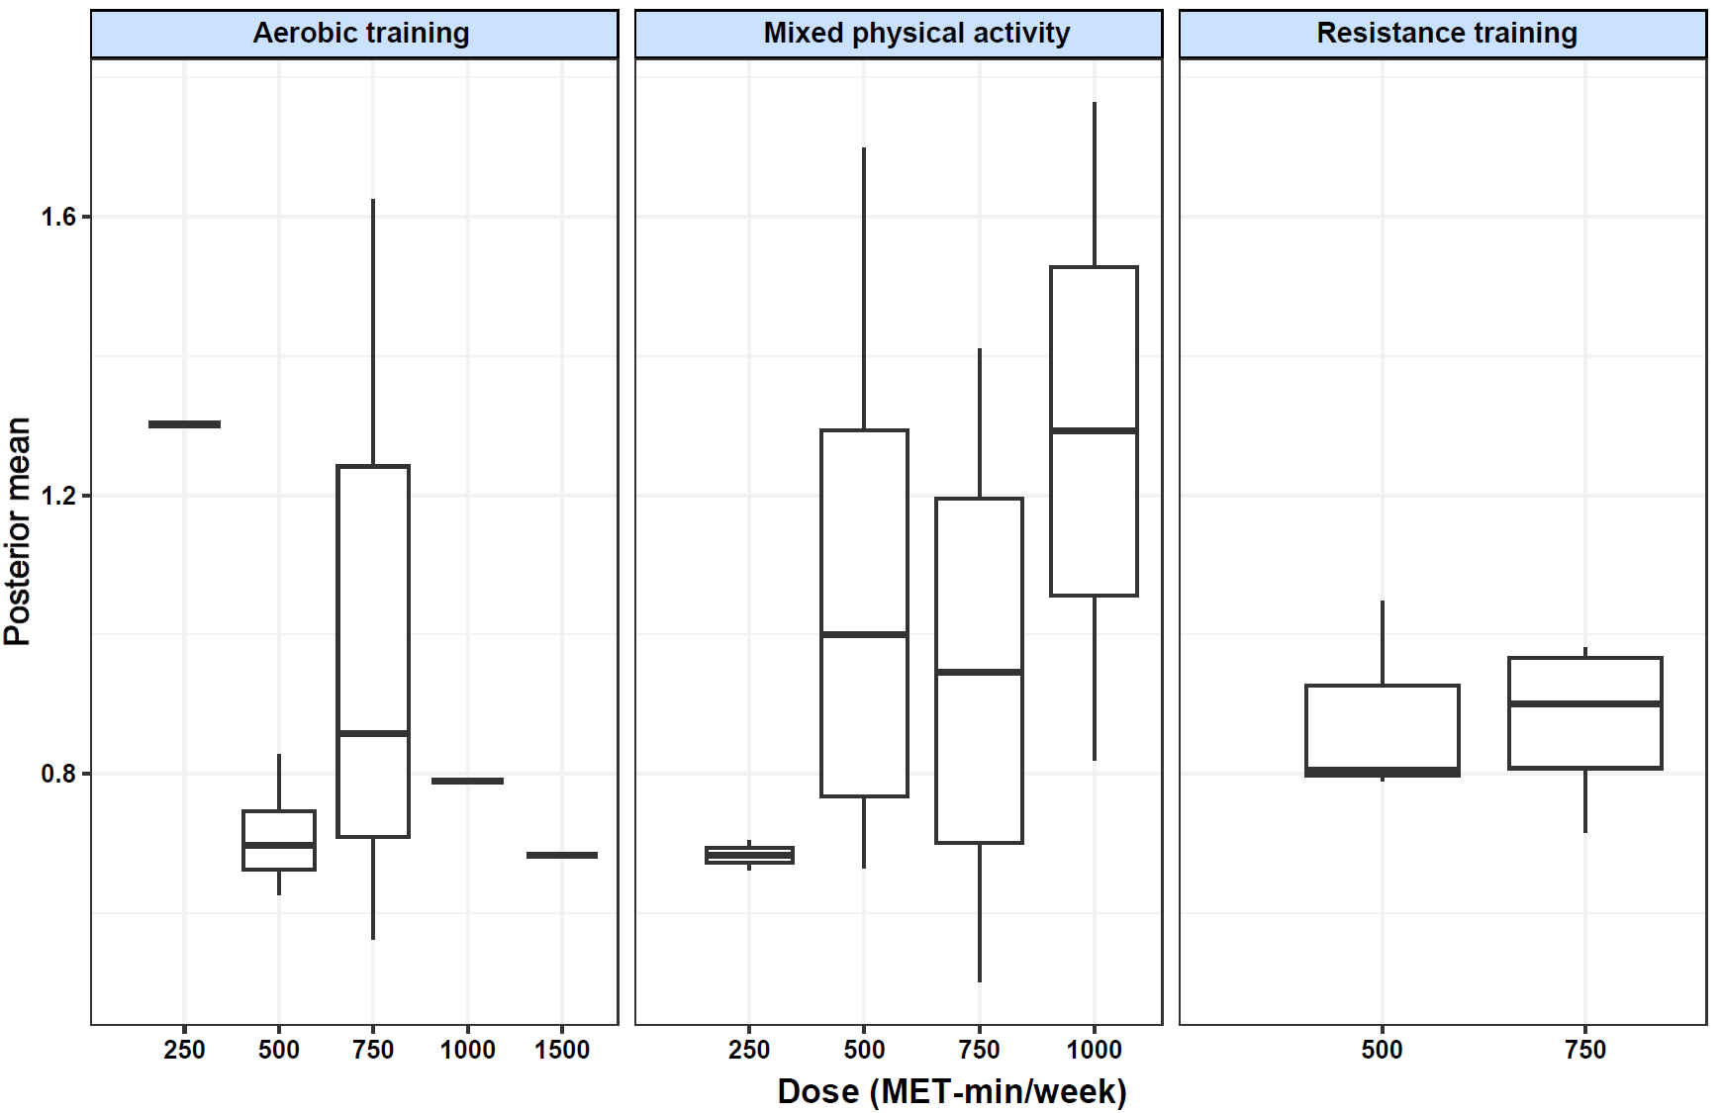
Figure S6. Deviance diagnostic plots (Emax model).

4. Supplementary File 4: Demographic characteristics of included studies
Table S9. Demographic characteristics of included studies
Author (Year) | Sample size(n) | % Female | Mean Age (SD or Range) | CKD Stage | Comorbidities | Treatment Type | Frequency | Session Duration (min) | Total Duration (weeks) | Control Type | Dose (MET-min/week) | Supervision | progressive
Headley et al. (2012)(1) | 21 | - | IG:57.5 ± 11.5  CG:52.5 ± 10.6 | 2-4 | Diabetic nephropathy, Hypertensive nephrosclerosis | Aerobic + resistance exercise | 3 | 60-75 | 48 | usual care | 620.6 | YES | YES
Howden et al. (2013)(2) | 83 | IG:33%  CG:42% | IG:60.2±9.7  CG:62.0±8.4 | 3–4 | Diabetes, Renovascular | Aerobic + resistance exercise | 2-3 | 35-45 | 52 | usual care | 450 | Partially supervised | YES
Baria et al. (2014)(3) | 29 | 0 | IG1:52.1 ± 11.4  IG2:50.8 ± 7.7  CG:53.4 ± 9.6 | 3–4 | Overweight, Diabetes | Walking | 3 | 40-70 | 12 | usual care | 480 | IG1: YES  IG2: Partially supervised | YES
Shi et al. (2014)(4) | 21 | 33.3% | 69.4 ± 7.7 | 3 | Cardiovascular Diseases | Tai Chi | 3-5 | 30 | 12 | usual care | 360 | Partially supervised | NO
Aoike et al. (2015)(5) | 29 | IG:36%  CG:34% | IG:55.9 ± 7.7  CG:54.3 ± 8.7 | 3–4 | Overweight, Diabetes | Walking | 3 | 40-50 | 12 | usual care | 308 | Partially supervised | YES
Greenwood et al. (2015)(6) | 20 | IG:25%  CG:10% | IG:53.8 ± 13.5  CG:53.3 ± 12.9 | 3–4 | Hypertensive nephrosclerosis | Aerobic + resistance exercise | 3 | 30-50 | 52 | usual care | 1080 | Partially supervised | YES
Howden et al. (2015)(7) | 83 | IG:33%  CG:42% | IG:60.2 ± 9.7  CG:62.0 ± 8.4 | 3–4 | Diabetes, Glomerulonephritis | Aerobic + resistance exercise | 3 | 50 | 52 | usual care | 645 | Partially supervised | YES
Craenenbroeck et al. (2015)(8) | 48 | IG:42%  CG:48% | IG:51.5± 11.8  CG:54.7 ± 14.1 | 3–4 | Diabetes | Cycling | 28 | 10 | 12 | usual care | 1869 | Partially supervised | NO
Leehey et al. (2016)(9) | 36 | 0 | IG:65.4±8.7  CG:66.6±7.5 | 2-4 | Obese, Diabetic | Aerobic + resistance exercise | 3 | 30-90 | 52 | usual care | 845 | Partially supervised | YES
Feng et al. (2016)(10) | 87 | IG1:51.7%  IG2:44.8%  CG:48.3% | IG1:48.50±3.51  IG2:48.21±3.62  CG:48.00±3.62 | 2-3 | Hypertension, Coronary heart disease | IG1: Cycling  IG2: Aerobic + resistance exercise | 3 | 30-45 | 12 | usual care | IG1:612  IG2:699 | YES | YES
Miele et al. (2017)(11) | 51 | IG:36%  CG:33.3% | IG:58.0 ± 8.0  CG:57.1 ± 9.0 | 3 | Hypertension, Diabetes | General aerobic training | 3 | 15-55 | 16 | usual care | 825 | YES | YES
Small et al. (2017)(12) | 136 | IG:41.7%  CG:45.3% | IG:60.5 ± 14.2  CG:63.5 ± 9.7 | 3–4 | Diabetes, Overweight | Aerobic + resistance exercise | 5-7 | 50-60 | 52 | usual care | 542 | Partially supervised | YES
Aoike et al. (2018)(13) | 50 | IG1:30.8%  IG2:33.3%  CG:33.3% | IG1:56.3 ± 7.9  IG2:56.0 ± 8.3  CG:54.3 ± 8.7 | 3–4 | Hypertensive, Diabetic | Walking | 3 | 40-60 | 24 | usual care | 581 | IG1: YES  IG2: Partially supervised | YES
Barcellos et al. (2018)(14) | 150 | IG:64.5% CG:62.2% | IG:65.0 ± 10.5  CG:65.1 ± 11.2 | 2-4 | Hypertensive | Aerobic + resistance exercise | 3 | 60 | 16 | usual care | 442.5 | YES | YES
Beetham et al. (2018)(15) | 163 | IG:40.5% CG:39.7% | IG:60.5 ± 10.5  CG:63.5 ± 7.0 | 3–4 | Obese, Diabetic | Aerobic + resistance exercise | 2-3 | 35-45 | 52 | usual care | 450 | Partially supervised | YES
Feng et al. (2018)(16) | 60 | IG1:50%  IG2:45%  CG:45% | IG1:47.5±5.6  IG2:51.6±6.1  CG:49.2±6.3 | 2-3 | Hypertension, Coronary heart disease | IG1: Cycling  IG2: Aerobic + resistance exercise | 3 | 30-55 | 12 | usual care | IG1:432  IG2:642 | YES | YES
Kirkman et al. (2019)(17) | 49 | IG:33.3% CG:25% | IG:55 ± 13  CG:62 ± 9 | 3-5 | Diabetic | Mixed aerobic exercises | 3 | 45 | 12 | usual care | 787 | YES | YES
Correa et al. (2021)(18) | 141 | IG1:36.7%  IG2:40%  CG:33.3% | IG1:58 ± 9  IG2:60 ± 8  CG:57 ± 6 | 2 | Hypertension | IG1: Multi-exercise resistance training  IG2: Multi-exercise resistance training with blood flow restriction | 3 | 45-60 | 24 | usual care | IG1:675  IG2:450 | YES | YES
Correa et al. (2021)(19) | 141 | IG1:34.3%  IG2:28.6%  CG:31.4% | IG1:58± 6  IG2:58± 7  CG:58± 5 | 2 | Diabetic，Hypertension | IG1: Multi-exercise resistance training  IG2: Multi-exercise resistance training with blood flow restriction | 3 | 45-60 | 24 | usual care | IG1:675  IG2:450 | YES | YES
Deus et al. (2021)(20) | 141 | IG1:34.3%  IG2:28.6%  CG:31.4% | IG1:58.09 ± 6.26  IG2:58.06 ± 6.47  CG:57.60 ± 5.22 | 2 | Overweight | IG1: Multi-exercise resistance training  IG2: Multi-exercise resistance training with blood flow restriction | 3 | 60 | 24 | usual care | IG1:675  IG2:450 | YES | YES
Otobe et al. (2021)(21) | 60 | IG:55.6%  CG:26.9% | IG:78.4±6.4  CG:78.1±7.4 | 3-4 | Hypertension, Dyslipidemia | Aerobic + resistance + balance Exercise | 3 | 60 | 24 | usual care | 208.5 | Partially supervised | NO
Araujo et al. (2023)(22) | 38 | 38.7% | IG:57.94 ±  2.74  CG:58.07 ± 5.22 | 2 | Osteopenia | Multi-exercise resistance training | 3-4 | 30-60 | 22 | usual care | 851 | YES | YES
Weiner et al. (2023)(23) | 99 | IG:31%CG:20% | IG:67.9 ± 7.7  CG:68.1 ± 8.8 | 3-4 | Obesity, Diabetes, Hypertension | Aerobic + resistance exercise | 3 | 40-60 | 52 | usual care | 785 | Partially supervised | YES
Kimura et al. (2024)(24) | 46 | IG:39.1%  CG:30.4% | IG:61.5 ± 11.2  CG:58.9 ± 14.5 | 2-3 | Diabetic | Aerobic + resistance exercise | 5 | 10-30 | 24 | usual care | 332.5 | Partially supervised | YES
Gomes et al. (2017)(25) | 45 | IG:29.2%  CG:33.3% | IG:55.9 ± 8.0  CG:54.3 ± 8.7 | 3-4 | Overweight, Hypertension | Walking | 3 | 30-50 | 24 | usual care | 607.5 | Partially supervised | YES

5. Supplementary File 5: Quality Assessment
This table summarizes the certainty of evidence and risk-of-bias assessments for the effects of different exercise modalities on estimated glomerular filtration rate (eGFR) in patients with non-dialysis chronic kidney disease. The evaluation was conducted following the GRADE (Grading of Recommendations, Assessment, Development and Evaluation) framework, which considers study limitations, inconsistency, indirectness, imprecision, and other factors affecting evidence quality.
Table S10. GRADE summary of evidence for the effect of different exercise modalities on eGFR in non-dialysis chronic kidney disease.
Certainty assessment |  |  |  |  |  | № of patients |  | Effect | Certainty
№ of studies | Risk of bias | Inconsistency | Indirectness | Imprecision | Other considerations | [Exercise] | Conventional treatment | Absolute  (95% CI) | Certainty
AT (10) | serious | not serious | not serious | not serious | none | 201 | 170 | 3.66  (1.25 to 6.03) | ⨁⨁⨁◯  Moderate
MPA (13) | serious | not serious | not serious | serious | none | 431 | 421 | 1.76  (0.33 to 3.79) | ⨁⨁◯◯  Low
RT (4) | serious | not serious | not serious | not serious | none | 216 | 116 | 5.77  (3.27 to 8.25) | ⨁⨁⨁◯  Moderate
Note: Certainty of evidence was assessed using the GRADE framework. AT = aerobic training; MPA = mixed physical activity; RT = resistance training.

6. Supplementary File 6: Dose-response relationships

6.1 Modality-specific dose–response relationships estimated by the Bayesian B-spline model
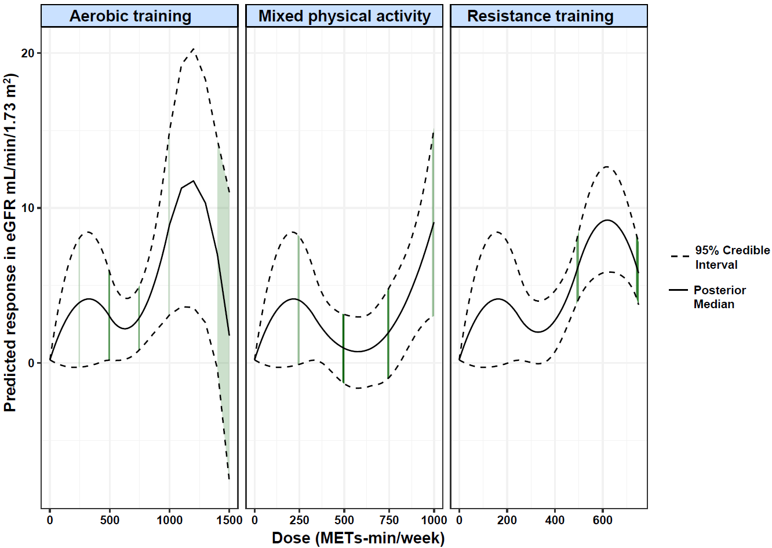
This supplementary section presents additional dose–response analyses conducted using the Bayesian B-spline model to validate and extend the findings of the primary Emax-based results. By providing a more flexible, data-driven estimation framework, the B-spline model helps visualize non-linear response patterns across different exercise modalities and supports the robustness of the main conclusions.
Figure S7. Dose–response relationships between exercise modalities and changes in estimated glomerular filtration rate (eGFR) among patients with non-dialysis chronic kidney disease. The figure shows the predicted response in eGFR (mL/min/1.73 m²) across different weekly exercise doses (METs-min/week) for three exercise modalities: aerobic training, mixed physical activity, and resistance training. The solid black line represents the posterior median estimate, and the dashed lines indicate the 95% credible intervals derived from the Bayesian dose–response network meta-analysis.

6.2 Comparison between the B-spline and Emax models
This supplementary analysis compared the dose–response estimates derived from the Bayesian B-spline and Emax models to verify the robustness of the findings. The Emax model was selected as the primary analysis because it achieved the lowest Deviance Information Criterion (DIC), indicating superior model fit and parsimony. The B-spline model, characterized by greater flexibility, was employed as a complementary validation to examine potential non-linear dose–response patterns. As shown in Table S8, both models produced broadly consistent trends, with aerobic and resistance training showing the largest predicted improvements in eGFR at moderate-to-high doses. Minor variations in the estimated effective ranges and peak doses reflect differences in model smoothing rather than substantive inconsistencies.
Table S11. Comparison of effective dose ranges, peak doses, and peak responses estimated by the Bayesian B-spline and Emax models across different exercise modalities
Model | Type | Effective Dose Range | Peak Dose | Median Peak Response | 95% CrI (Peak Response)
B-Spline | Aerobic training | 767.13 - 1353.79 | 1199.0 | 11.8 | 3.57 - 20.25
B-Spline | Mixed physical activity | 856.61 - 998.33 | 998.33 | 8.99 | 3.02 – 15.02
B-Spline | Resistance training | 410.67 - 747.49 | 622.07 | 9.23 | 5.86 – 12.64
Emax | Aerobic training | 250.84 - 1500 | 1500 | 3.98 | 1.73 - 6.38
Emax | Resistance training | 501.67 - 1500 | 747.49 | 6.1 | 4.24 - 7.95
Note: The table summarizes dose–response parameters estimated by the Bayesian B-spline and Emax models across different exercise modalities. Effective range represents the interval of exercise dose (METs-min/week) associated with a significant improvement in eGFR. Peak dose denotes the dose corresponding to the maximal predicted response, and the 95% credible interval (CrI) reflects the uncertainty around the posterior estimates.

7. References
1. Headley S, Germain M, Milch C, Pescatello L, Coughlin MA, Nindl BC, et al. Exercise training improves HR responses and VO2peak in predialysis kidney patients. Med Sci Sports Exerc. 2012;44(12):2392–9.
2. Howden EJ, Leano R, Petchey W, Coombes JS, Isbel NM, Marwick TH. Effects of exercise and lifestyle intervention on cardiovascular function in CKD. Clin J Am Soc Nephrol. 2013;8(9):1494–501..
3. Baria F, Kamimura MA, Aoike DT, Ammirati A, Leister Rocha M, de Mello MT, et al. Randomized controlled trial to evaluate the impact of aerobic exercise on visceral fat in overweight chronic kidney disease patients. Nephrol Dial Transplant. 2014;29(4):857–64.
4. Shi ZM, Wen HP, Liu FR, Yao CX. The effects of Tai Chi on the renal and cardiac functions of patients with chronic kidney and cardiovascular diseases. J Phys Ther Sci. 2014;26(11):1733–6.
5. Aoike DT, Baria F, Kamimura MA, Ammirati A, de Mello MT, Cuppari L. Impact of home-based aerobic exercise on the physical capacity of overweight patients with chronic kidney disease. Int Urol Nephrol. 2015;47(2):359–67.
6. Greenwood SA, Koufaki P, Mercer TH, MacLaughlin HL, Rush R, Lindup H, et al. Effect of exercise training on estimated GFR, vascular health, and cardiorespiratory fitness in patients with CKD: a pilot randomized controlled trial. Am J Kidney Dis. 2015;65(3):425–34.
7. Howden EJ, Coombes JS, Strand H, Douglas B, Campbell KL, Isbel NM. Exercise training in CKD: efficacy, adherence, and safety. Am J Kidney Dis. 2015;65(4):583–91.
8. Van Craenenbroeck AH, Van Craenenbroeck EM, Van Ackeren K, Vrints CJ, Conraads VM, Verpooten GA, et al. Effect of moderate aerobic exercise training on endothelial function and arterial stiffness in CKD stages 3–4: a randomized controlled trial. Am J Kidney Dis. 2015;66(2):285–96.
9. Leehey DJ, Collins E, Kramer HJ, Cooper C, Butler J, McBurney C, et al. Structured exercise in obese diabetic patients with chronic kidney disease: a randomized controlled trial. Am J Nephrol. 2016;44(1):54–62.
10. Feng L, Min C, Zun W, Peng J, Lei W. The effects of exercises of different types on renal function and the risk factors associated with cardiovascular disease in patients with chronic kidney disease. Chin J Rehabil Med. 2016;31(11):1234–8.
11. Miele EM, Headley SAE, Germain M, Joubert J, Herrick S, Milch C, et al. High-density lipoprotein particle pattern and overall lipid responses to a short-term moderate-intensity aerobic exercise training intervention in patients with chronic kidney disease. Clin Kidney J. 2017;10(4):524–31.
12. Small DM, Beetham KS, Howden EJ, Briskey DR, Johnson DW, Isbel NM, et al. Effects of exercise and lifestyle intervention on oxidative stress in chronic kidney disease. Redox Rep. 2017;22(3):127–36.
13. Aoike DT, Baria F, Kamimura MA, Ammirati A, Cuppari L. Home-based versus center-based aerobic exercise on cardiopulmonary performance, physical function, quality of life and quality of sleep of overweight patients with chronic kidney disease. Clin Exp Nephrol. 2018;22(1):87–98.
14. Barcellos FC, Del Vecchio FB, Reges A, Mielke G, Santos IS, Umpierre D, et al. Exercise in patients with hypertension and chronic kidney disease: a randomized controlled trial. J Hum Hypertens. 2018;32(6):397–407.
15. Beetham KS, Howden EJ, Isbel NM, Coombes JS. Agreement between cystatin C- and creatinine-based eGFR estimates after a 12-month exercise intervention in patients with chronic kidney disease. BMC Nephrol. 2018;19(1):366.
16. Feng L, Wenjing H, Gang O, Peng J, Zun W, Lei W, et al. Effects of different types of exercise on motor function in patients with chronic kidney disease. Chin J Rehabil Theory Pract. 2018;24(2):208–13.
17. Kirkman DL, Ramick MG, Muth BJ, Stock JM, Pohlig RT, Townsend RR, et al. Effects of aerobic exercise on vascular function in nondialysis chronic kidney disease: a randomized controlled trial. Am J Physiol Renal Physiol. 2019;316(5):F898–905.
18. Corrêa HL, Neves RVP, Deus LA, Maia BCH, Maya AT, Tzanno-Martins C, et al. Low-load resistance training with blood flow restriction prevent renal function decline: the role of the redox balance, angiotensin 1-7 and vasopressin. Physiol Behav. 2021;230:113295.
19. Corrêa HL, Neves RVP, Deus LA, Souza MK, Haro AS, Costa F, et al. Blood flow restriction training blunts chronic kidney disease progression in humans. Med Sci Sports Exerc. 2021;53(2):249–57.
20. de Deus LA, Neves RVP, Corrêa HL, Reis AL, Honorato FS, Silva VL, et al. Improving the prognosis of renal patients: the effects of blood flow-restricted resistance training on redox balance and cardiac autonomic function. Exp Physiol. 2021;106(4):1099–1109.
21. Otobe Y, Yamada M, Hiraki K, Onari S, Taki Y, Sumi H, et al. Physical exercise improves cognitive function in older adults with stage 3–4 chronic kidney disease: a randomized controlled trial. Am J Nephrol. 2021;52(12):929–39.
22. de Araujo TB, de Luca Correa H, de Deus LA, Neves RVP, Reis AL, Honorato FS, et al. The effects of home-based progressive resistance training in chronic kidney disease patients. Exp Gerontol. 2023;171:112030.
23. Weiner DE, Liu CK, Miao S, Fielding R, Katzel LI, Giffuni J, et al. Effect of long-term exercise training on physical performance and cardiorespiratory function in adults with CKD: a randomized controlled trial. Am J Kidney Dis. 2023;81(1):59–66.
24. Kimura T, Washida N, Ohtsuki S, Sugita K, Hosoya K, Uchiyama K. A multicenter randomized controlled trial to investigate potential effects of exercise therapy on renal function stratified by renal disorders and renal pathology: beneficial or harmful effect in immunoglobulin A nephropathy. Clin Exp Nephrol. 2024;28(6):539–46.
25. Gomes TS, Aoike DT, Baria F, Graciolli FG, Moyses RMA, Cuppari L. Effect of aerobic exercise on markers of bone metabolism of overweight and obese patients with chronic kidney disease. J Ren Nutr. 2017;27(5):364–71.

