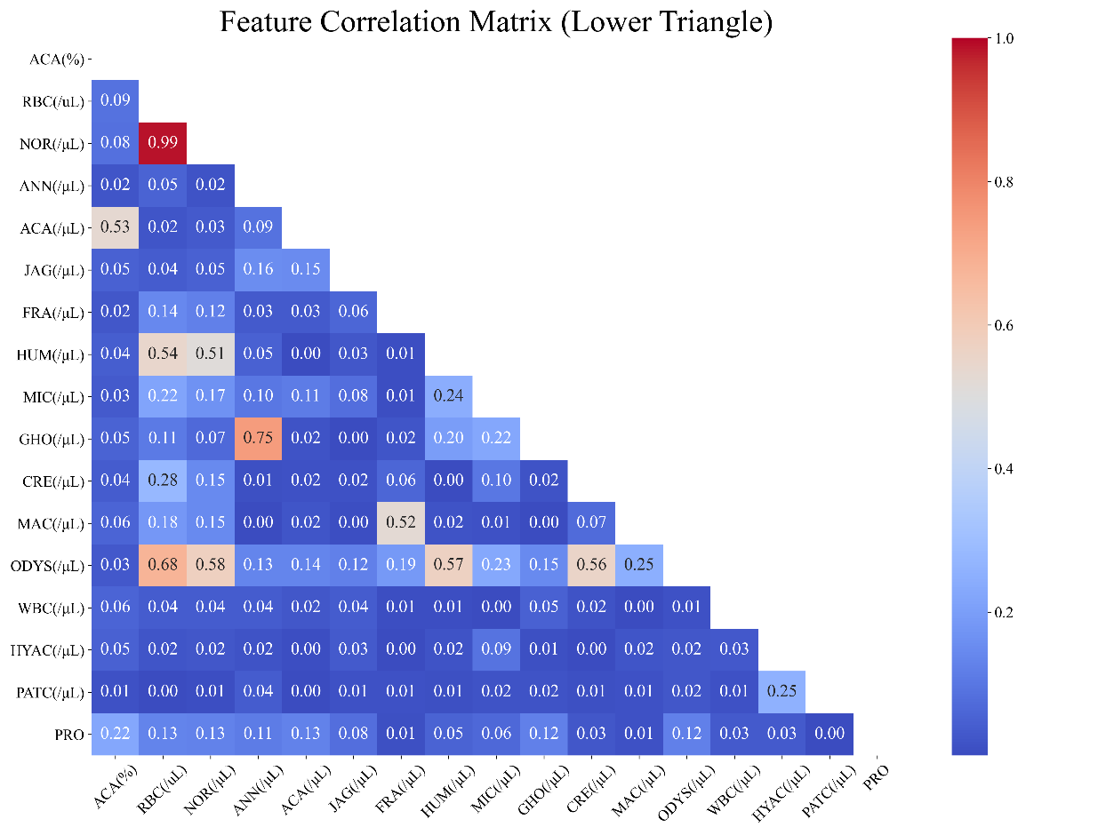
Supplementary Figure 1: Seventeen features related to GH were identified through a correlation coefficient matrix
GH, glomerular hematuria.

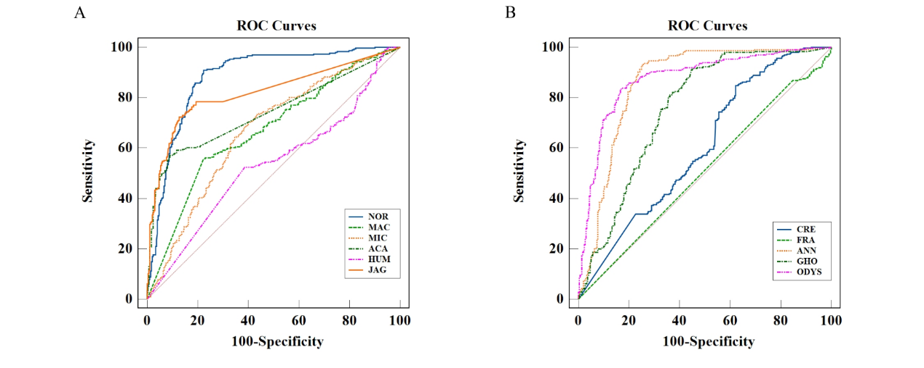
Supplementary Figure 2: ROC curves obtained with RBC subclassification parameters. NOR, normocytes; MIC, microcytes; JAG, jagged RBCs; MAC, macrocytes; FRA, fragmented RBCs; HUM, humped spherocytes; ACA, acanthocytes; CRE, crenocytes; ANN, annular RBCs; GHO, ghost RBCs; ODYS, other dysmorphic RBCs.

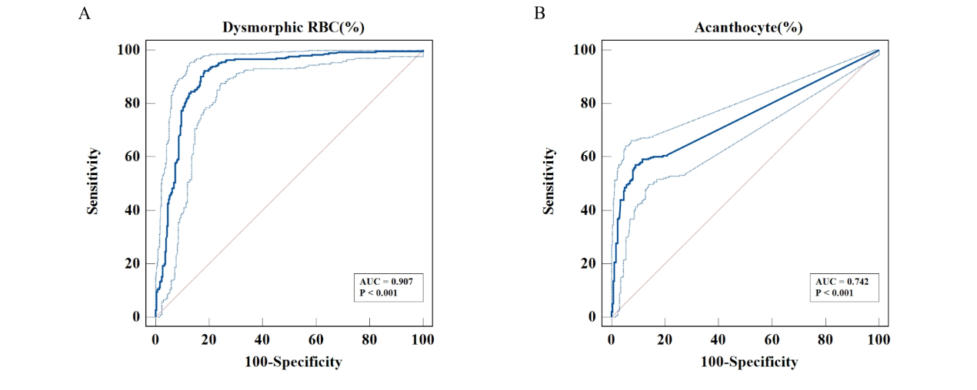
Supplementary Figure 3: ROC curves obtained with dysmorphic RBC (%) and acanthocyte (%). A. Receiver operating for predict GH patients in the dysmorphic RBC (%). B. Receiver operating for predict GH patients in the acanthocyte (%).
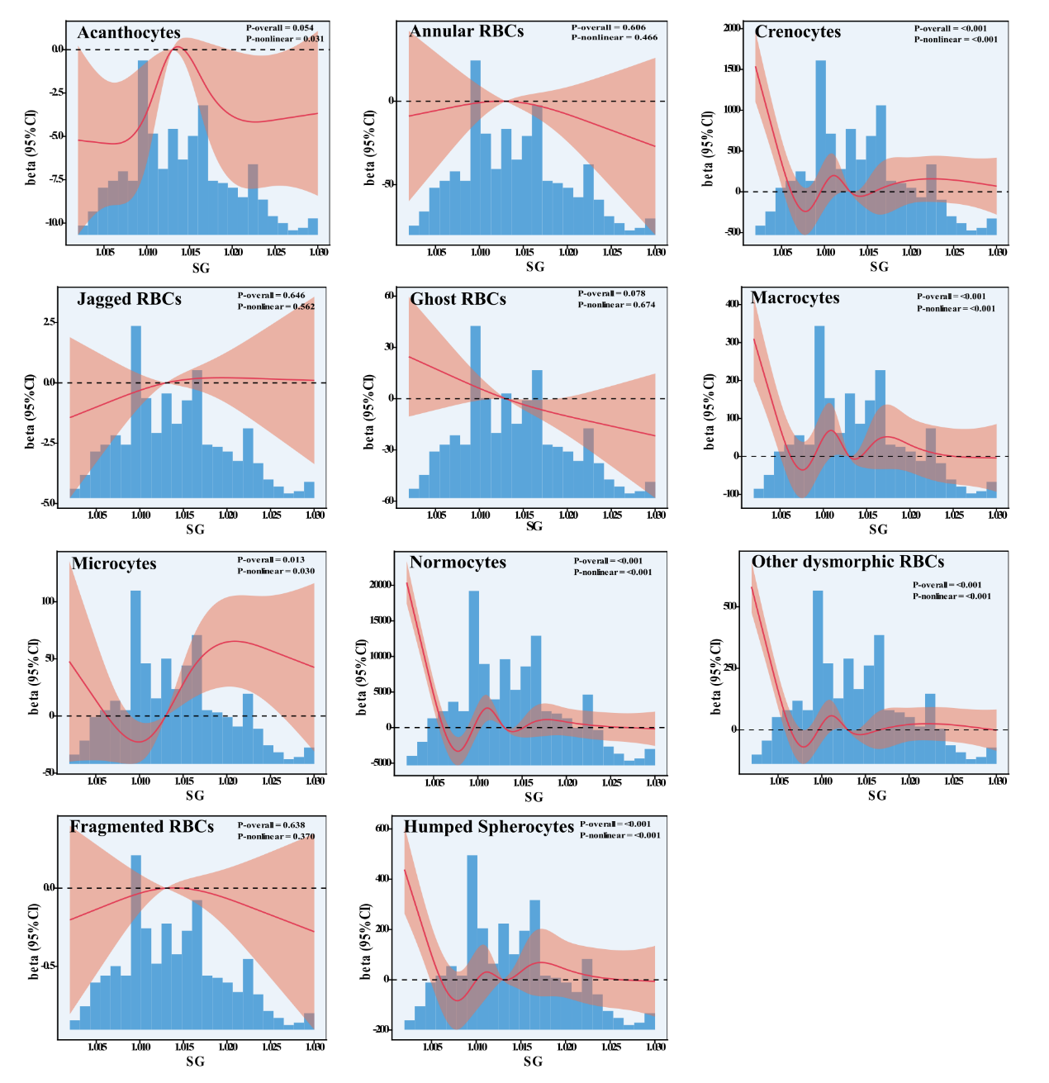
Supplementary Figure 4: Relationship between SG and various RBC morphological types.

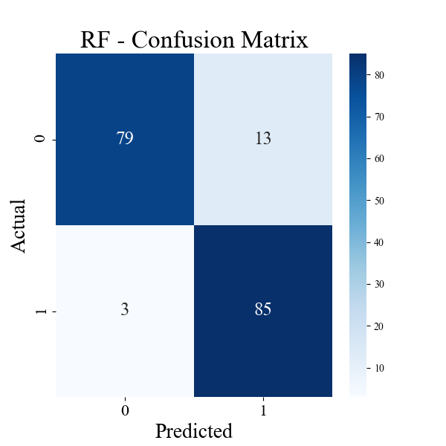
Supplementary Figure 5: Confusion matrix of the RF models for predict GN in the validation set. RF, random forest; GH, glomerular hematuria.

Supplementary Table 1: Diagnostic process for 25 cases of GH identified through clinical diagnosis.
Clinical diagnosis | Disease Diagnosis Process
ANCA-related nephritis | Patients diagnosed with ANCA-associated vasculitis exhibit renal involvement manifestations:  1) Active hematuria is common, predominantly microscopic hematuria with visible red blood cell casts, often accompanied by proteinuria;  2) Renal function impairment is frequent, with over half presenting as rapidly progressive glomerulonephritis.
Purpura nephritis | Extrarenal manifestations such as cutaneous purpura in allergic purpura; Clinical manifestations of renal impairment, such as hematuria (gross or microscopic), proteinuria (24-hour urine protein >150mg), hypertension, renal insufficiency, etc.
Latent glomerulonephritis | Clinical presentation includes glomerular hematuria (microscopic, predominantly with dysmorphic red blood cells) and/or proteinuria (<1g/24h).
Chronic renal failure | Diagnosis based on history (chronic kidney disease >3 months), renal function tests (decreased GFR), and relevant clinical manifestations (metabolic disorders, clinical symptoms).
Nephritic syndrome (acute nephritic syndrome and chronic nephritic syndrome) | Acute nephritic syndrome: Clinical manifestations (acute onset of hematuria, proteinuria, edema, hypertension), renal dysfunction, immunological tests (serum C3, serum anti-streptolysin “O”).  Chronic nephritic syndrome: Clinical manifestations (persistent hematuria, proteinuria, edema, hypertension with slow progression), declining renal function; history >3 months.
Nephrotic syndrome | Diagnostic criteria: Urinary protein >3.5g/day; plasma albumin <30g/L; edema; elevated blood lipids.
ANCA, Anti-neutrophil cytoplasmic antibody.

Supplementary Table 2: EU 8600 parameter in GH and NGH patients in the training set and validation set.
Parameter | Training set |  |  | Validation set
Parameter | GH  Median (IQR) | NGH  Median (IQR) | P | GH  Median (IQR) | NGH  Median (IQR) | P
Acanthocytes (%) | 0.59 (0.00-2.00) | 0.00(0.00-0.00) | <0.001 | 0.25(0.00-2.00) | 0.00(0.00-0.00) |  | <0.001
Normocytes (/μL) | 8.60(2.30-28.25) | 232.20(59.30-1311.45) | <0.001 | 10.00(3.48-29.00) | 197.75(36.25-1215.65) |  | <0.001
Annular RBCs (/μL) | 19.55(9.06-38.40) | 5.50(1.30-28.50) | <0.001 | 18.30(8.05-53.15) | 4.50(0.83-22.38) |  | <0.001
Acanthocytes (/μL) | 0.45(0.00-1.70) | 0.00(0.00-0.00) | <0.001 | 0.30(0.00-1.65) | 0.00(0.00-0.00) |  | <0.001
Jagged RBCs (/μL) | 1.40(0.30-4.20) | 0.00(0.00-0.30) | <0.001 | 1.62(0.30-4.62) | 0.00(0.00-0.30) |  | <0.001
Fragmented RBCs (/μL) | 0.00(0.00-0.00) | 0.00(0.00-0.00) | 0.336 | 0.00(0.00-0.00) | 0.00(0.00-0.00) |  | 0.782
Humped Spherocytes (/μL) | 0.00(0.00-0.00) | 0.80(1.00-7.00) | <0.001 | 0.00(0.00-0.03) | 0.30(0.00-3.48) |  | 0.202
Microcytes (/μL) | 7.80(2.50-21.60) | 14.00(4.90-42.10) | <0.001 | 11.26(3.43-28.74) | 10.05(3.33-58.00) |  | 0.900
Ghost RBCs (/μL) | 5.62(2.50-14.35) | 7.20(1.40-23.90) | 0.713 | 5.30(2.30-12.20) | 2.90(1.20-10.25) |  | 0.030
Crenocytes(/μL) | 0.30(0.00-1.70) | 3.10(0.30-23.30) | <0.001 | 0.41(0.00-1.10) | 3.55(0.30-47.18) |  | <0.001
Macrocytes (/μL) | 0.00(0.00-0.00) | 3.00(0.30-26.65) | <0.001 | 0.00(0.00-0.95) | 4.60(0.30-19.48) |  | <0.001
Other dysmorphic RBCs (/μL) | 18.17(10.17-43.74) | 23.50(7.20-70.40) | 0.461 | 18.00(9.22-59.40) | 23.80(7.90-60.99) |  | 0.920
WBCs (/μL) | 6.85(3.60-18.48) | 82.42(19.40-344.29) | <0.001 | 7.90(4.23-18.60) | 52.40(14.40-257.80) |  | <0.001
Hyaline Casts(/μL) | 0.20(0.00-0.93) | 0.00(0.00-0.00) | <0.001 | 0.50(0.00-1.20) | 0.00(0.00-0.00) |  | <0.001
Pathological Casts (/μL) | 0.00(0.00-0.50) | 0.00(0.00-0.00) | <0.001 | 0.20(0.00-1.00) | 0.00(0.00-0.00) |  | <0.001
Urinary dipstick results  of protein, n (%) |  |  | 0.101 |  |  |  | 0.042
Negative | 28(13.46) | 71(33.97) |  | 7(7.95) | 31(33.70)
± | 11(5.29) | 17(8.13) |  | 7(7.95) | 9(9.78)
1+ | 63(30.29) | 69(33.01) |  | 22(25.00) | 26(28.26)
2+ | 64(30.77) | 42(20.10) |  | 31(35.23) | 23(25.00)
3+ | 42(20.19) | 10(4.78) |  | 21(23.86) | 3(3.26)
Non-normally distributed variables are summarized as median (Q1–Q3, interquartile range). The median value of fragmented RBCs was zero in both the GH and NGH, with extremely low concentrations in urine, thus, the statistical results are not considered reliable for reference. GH, glomerular hematuria; NGH, non-glomerular hematuria; IQR, interquartile range; RBC, red blood cell. WBC, white blood cell.

Supplementary Table 3: False positive sample parameter characteristics.
 | Ture Positive | False Positive | P
Number, n | 273 | 56
Acanthocytes (/μL) | 0.6(0.0-1.7) | 0.0(0.0-0.6) | <0.001
Jagged RBCs (/μL) | 1.7(0.3-4.9) | 0.3(0.0-1.1) | <0.001

Supplementary Table 4: Compare the performance differences of various ML algorithms using validation set.
ML | ROC AUC |  | P
LR vs NB | 0.936(0.899-0.965) | 0.912(0.862-0.953) | <0.001
LR vs KNN | 0.936(0.899-0.965) | 0.923(0.879-0.961) | <0.001
LR vs SVM | 0.936(0.899-0.965) | 0.916(0.873-0.953) | <0.001
LR vs RF | 0.936(0.899-0.965) | 0.960(0.930-0.986) | <0.001
LR vs MLP | 0.936(0.899-0.965) | 0.961(0.928-0.986) | <0.001
LR vs AdaBoost | 0.936(0.899-0.965) | 0.967(0.944-0.989) | <0.001
LR vs GBDT | 0.936(0.899-0.965) | 0.968(0.944-0.987) | <0.001
LR vs ANN | 0.936(0.899-0.965) | 0.956(0.923-0.980) | <0.001
NB vs KNN | 0.912(0.862-0.953) | 0.923(0.879-0.961) | <0.001
NB vs SVM | 0.912(0.862-0.953) | 0.916(0.873-0.953) | 0.026
NB vs RF | 0.912(0.862-0.953) | 0.960(0.930-0.986) | <0.001
NB vs MLP | 0.912(0.862-0.953) | 0.961(0.873-0.953) | <0.001
NB vs AdaBoost | 0.912(0.862-0.953) | 0.967(0.944-0.989) | <0.001
NB vs GBDT | 0.912(0.862-0.953) | 0.968(0.944-0.987) | <0.001
NB vs ANN | 0.912(0.862-0.953) | 0.956(0.923-0.980) | <0.001
KNN vs SVM | 0.923(0.879-0.961) | 0.916(0.873-0.953) | <0.001
KNN vs RF | 0.923(0.879-0.961) | 0.960(0.930-0.986) | <0.001
KNN vs MLP | 0.923(0.879-0.961) | 0.961(0.928-0.986) | <0.001
KNN vs AdaBoost | 0.923(0.879-0.961) | 0.967(0.944-0.989) | <0.001
KNN vs GBDT | 0.923(0.879-0.961) | 0.968(0.944-0.987) | <0.001
KNN vs ANN | 0.923(0.879-0.961) | 0.956(0.923-0.980) | <0.001
SVM vs RF | 0.916(0.873-0.953) | 0.960(0.930-0.986) | <0.001
SVM vs MLP | 0.916(0.873-0.953) | 0.961(0.928-0.986) | <0.001
SVM vs AdaBoost | 0.916(0.873-0.953) | 0.967(0.944-0.989) | <0.001
SVM vs GBDT | 0.916(0.873-0.953) | 0.968(0.944-0.987) | <0.001
SVM vs ANN | 0.916(0.873-0.953) | 0.956(0.923-0.980) | <0.001
RF vs MLP | 0.960(0.930-0.986) | 0.961(0.928-0.986) | 0.779
RF vs AdaBoost | 0.960(0.930-0.986) | 0.967(0.944-0.989) | <0.001
RF vs GBDT | 0.960(0.930-0.986) | 0.968(0.944-0.987) | <0.001
RF vs ANN | 0.960(0.930-0.986) | 0.956(0.923-0.980) | <0.001
MLP vs AdaBoost | 0.961(0.928-0.986) | 0.967(0.944-0.989) | <0.001
MLP vs GBDT | 0.961(0.928-0.986) | 0.968(0.944-0.987) | <0.001
MLP vs ANN | 0.961(0.928-0.986) | 0.956(0.923-0.980) | <0.001
AdaBoost vs GBDT | 0.967(0.944-0.989) | 0.968(0.944-0.987) | <0.001
AdaBoost vs ANN | 0.967(0.944-0.989) | 0.956(0.923-0.980) | <0.001
GBDT vs ANN | 0.968(0.944-0.987) | 0.956(0.923-0.980) | <0.001
LR, logistic regression; NB, naïve bayes; KNN, k-nearest neighbor; SVM, support vector machines; RF, random forest; MLP, multi-layer perceptron; AdaBoost, adaptive boosting; GBDT, gradient boosting decision tree; ANN, artificial neural networks; AUC, area under the curve.

