B
A

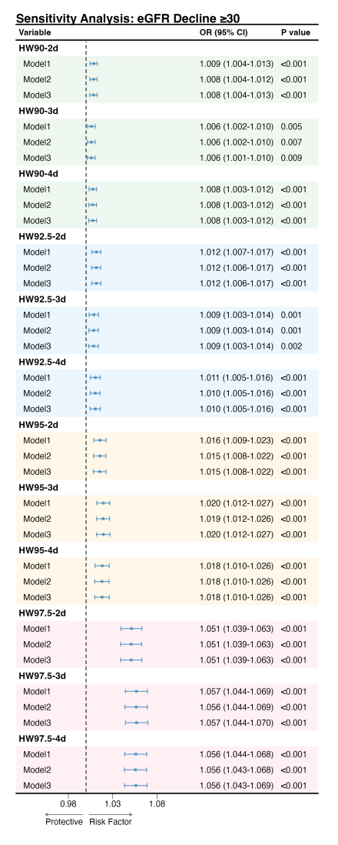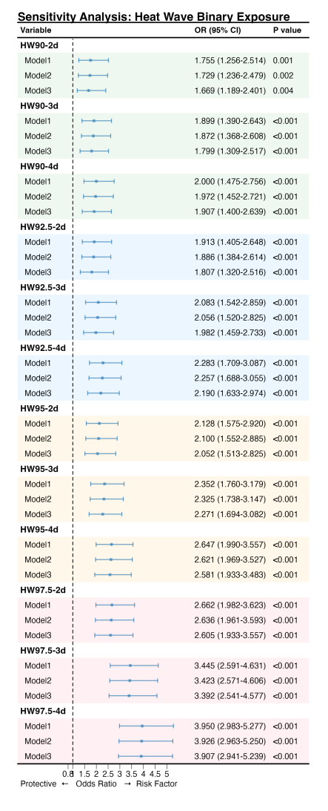

Fig.5：Sensitivity analysis of the association between heatwaves and risk of chronic kidney disease(CKD).(A)Sensitivity analysis of eGFR decline ≥30%;(B) Sensitivity analysis of heatwaves binary exposure

