Supplementary Material
Table S1. Antimicrobial Susceptibility by Pathogen ᵃ
Antibiotic | SOSA (n=76) | Enterococcus spp. (n=18) | S. aureus (n=38) | A. baumannii (n=4) | E. coli (n=10) | Enterobacter spp. (n=8) | K. pneumoniae (n=12) | P. aeruginosa (n=15)
Aminoglycosides
Amikacin | NR | IR | NR | 0/2 (0.0) | 10/10 (100.0) | 7/8 (87.5) | 7/11 (63.6) | NR
Gentamicin | 31/71 (43.7) | IR | 33/36 (91.7) | 1/3 (33.3) | 6/10 (60.0) | 7/8 (87.5) | 7/11 (63.6) | NR
Tobramycin | NR | IR | NR | 0/2 (0.0) | 3/8 (37.5) | 4/4 (100.0) | 2/5 (40.0) | 9/10 (90.0)
Beta-lactams
Amoxicillin-clavulanate | NR | NR | NR | IR | 3/8 (37.5) | IR | 5/10 (50.0) | IR
Ampicillin | NR | 4/16 (25.0) | NR | IR | 0/5 (0.0) | IR | 0/8 (0.0) | IR
Ampicillin-sulbactam | NR | NR | NR | 0/2 (0.0) | 1/6 (16.7) | IR | 1/4 (25.0) | IR
Aztreonam | IR | IR | IR | IR | 4/5 (80.0) | 1/3 (33.3) | 2/4 (50.0) | 4/6 (66.7)
Oxacillin | 8/74 (10.8) | IR | 16/37 (43.2) | IR | IR | IR | IR | IR
Piperacillin-tazobactam | NR | NR | NR | 0/1 (0.0) | 8/10 (80.0) | 5/7 (71.4) | 6/11 (54.5) | 9/15 (60.0)
Carbapenems
Ertapenem | NR | NR | NR | IR | 6/8 (75.0) | 4/4 (100.0) | 2/5 (40.0) | IR
Imipenem | NR | NR | NR | 1/4 (25.0) | 7/9 (77.8) | 8/8 (100.0) | 7/10 (70.0) | 14/15 (93.3)
Meropenem | NR | NR | NR | 1/4 (25.0) | 9/10 (90.0) | 8/8 (100.0) | 7/10 (70.0) | 14/15 (93.3)
Cephalosporins
Cefazolin | NR | IR | NR | IR | 2/3 (66.7) | IR | 1/1 (100.0) | IR
Cefepime | NR | IR | NR | 1/4 (25.0) | 5/8 (62.5) | 6/7 (85.7) | 6/10 (60.0) | 13/15 (86.7)
Cefotaxime | NR | IR | NR | 0/1 (0.0) | 2/2 (100.0) | NR | 1/3 (33.3) | IR
Ceftazidime | NR | IR | NR | 2/4 (50.0) | 5/6 (83.3) | 4/6 (66.7) | 5/9 (55.6) | 13/15 (86.7)
Ceftriaxone | NR | IR | NR | NT | 0/1 (0.0) | NR | 2/4 (50.0) | IR
Cefuroxime | NR | IR | NR | IR | 1/5 (20.0) | IR | 3/5 (60.0) | IR
Fluoroquinolones
Ciprofloxacin | 13/45 (28.9) | NR | 16/22 (72.7) | 0/2 (0.0) | 6/10 (60.0) | 7/7 (100.0) | 5/11 (45.5) | 13/15 (86.7)
Levofloxacin | 20/67 (29.9) | NR | 25/36 (69.4) | 1/3 (33.3) | 6/10 (60.0) | 5/5 (100.0) | 4/7 (57.1) | 9/10 (90.0)
Moxifloxacin | 21/52 (40.4) | NR | 20/30 (66.7) | NR | NR | NR | NR | NR
Glycopeptides
Teicoplanin | 58/64 (90.6) | 7/14 (50.0) | 33/34 (97.1) | IR | IR | IR | IR | IR
Vancomycin | 75/76 (98.7) | 11/18 (61.1) | 37/37 (100.0) | IR | IR | IR | IR | IR
Other
Linezolid | 71/71 (100.0) | 16/16 (100.0) | 35/36 (97.2) | IR | IR | IR | IR | IR
Minocycline | NT | NR | NT | NT | NR | NR | NR | NR
Rifampin | 26/29 (89.7) | NR | 16/17 (94.1) | NR | NR | NR | NR | NR
Tetracycline | 39/59 (66.1) | NR | 30/33 (90.9) | NR | 1/3 (33.3) | NT | NT | IR
Tigecycline^{e} | NR | NR | NR | NR | 7/8 (87.5) | 4/4 (100.0) | 5/7 (71.4) | IR
Trimethoprim-sulfamethoxazole | 53/76 (69.7) | IR | 33/37 (89.2) | 4/4 (100.0) | 3/9 (33.3) | 7/7 (100.0) | 6/11 (54.5) | IR
Abbreviations: SOSA, Staphylococci other than Staphylococcus aureus; TMP-SMX, trimethoprim-sulfamethoxazole.
a—Antimicrobial susceptibility data are presented at the isolate level; denominators are isolates tested, not patients. For polymicrobial episodes, organisms recovered from the same episode are reported separately, restricted to valid organism–antibiotic combinations per CLSI M100 interpretive guidance.
b—Values shown as: susceptible isolates / total tested (percentage susceptible).
c—NR, not recommended (no established CLSI M100 breakpoints for this organism–antibiotic combination at the time of testing).
d—NT, not tested (no isolates tested for that antibiotic-organism combination).
e—Tigecycline reported per EUCAST practice; not in CLSI M100 routine panels.
f—IR, intrinsically resistant (organism–antibiotic combinations with documented intrinsic resistance per CLSI M100 interpretive guidance). NR and IR categories were assigned according to CLSI M100 principles and organism–drug interpretive guidance; categorical susceptibility results reflect laboratory-reported interpretations at the time of testing, per the CLSI M100 standards in use during the corresponding period (2013–2024). Raw MICs were not consistently available for retrospective reinterpretation against a single contemporary CLSI breakpoint version; temporal changes in breakpoints over the study period may therefore have introduced classification heterogeneity.

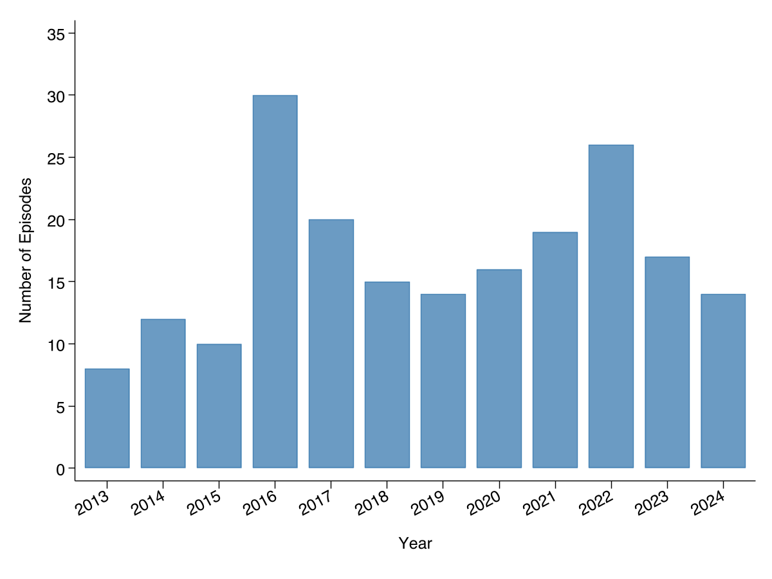
Figure S1. Bloodstream Infection Episodes Among Hemodialysis Patients by Year, 2013-2024. Each bar represents the number of first bloodstream infection episodes per patient (N = 201) identified in each calendar year. Episodes were defined using 14-day deduplication intervals. Data for 2024 include January through July only, as data extraction was precluded beyond this date due to transition to a new electronic medical record system.

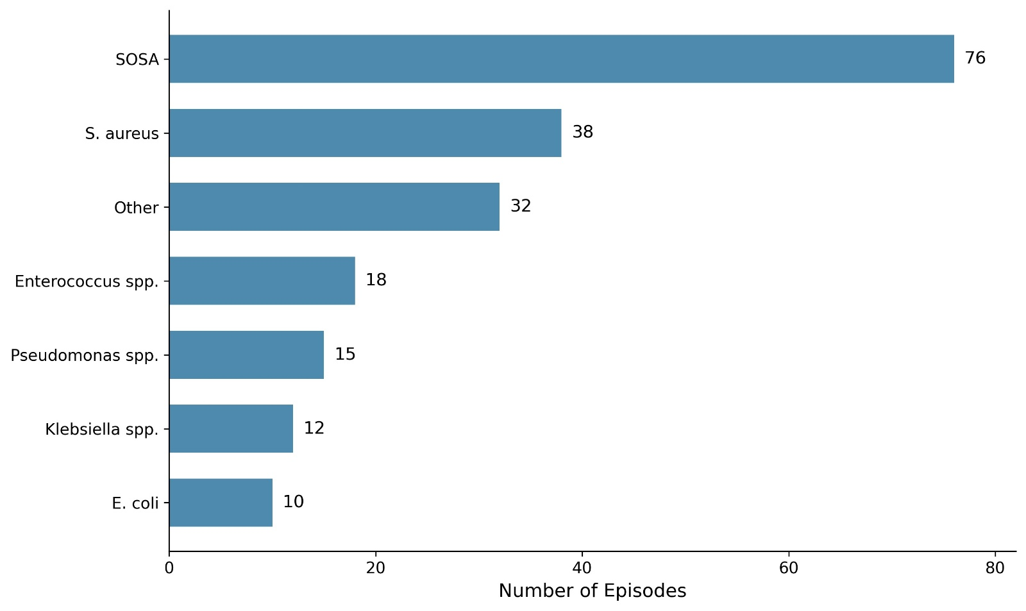
Figure S2. Distribution of Bloodstream Infection Pathogens Among Hemodialysis Patients. Horizontal bars represent the number of first bloodstream infection episodes per patient (N = 201) caused by each pathogen group. The top 6 organisms are shown individually; the remaining species are combined into the "Other" category (n = 32). SOSA indicates Staphylococci other than Staphylococcus aureus.

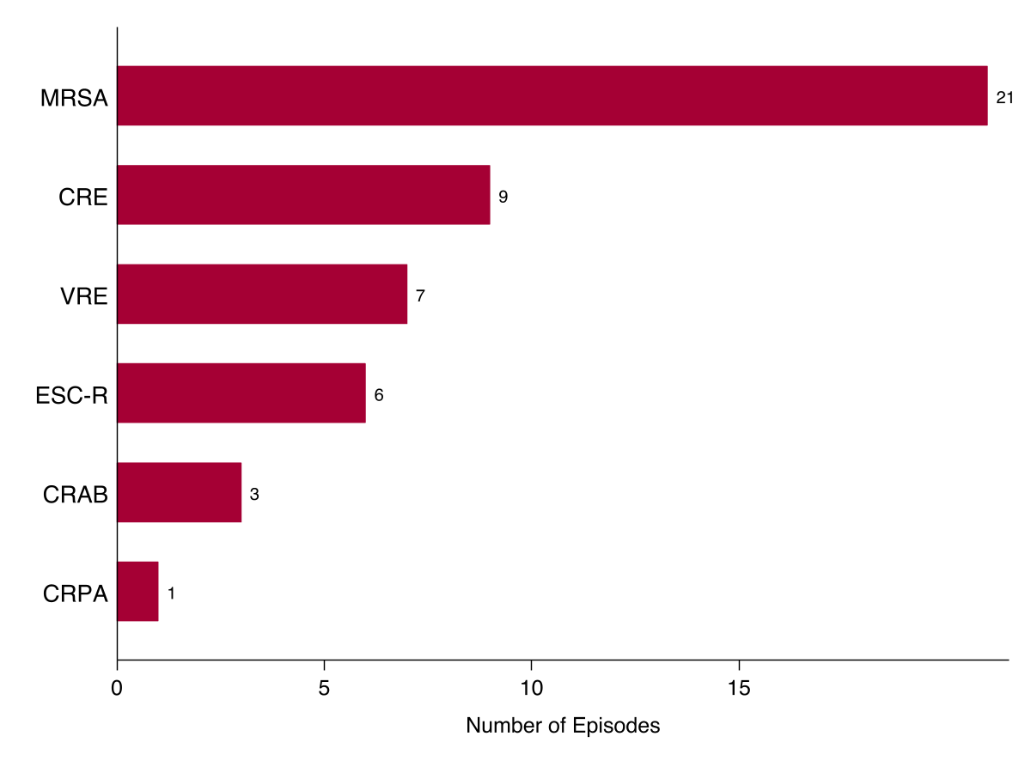
Figure S3. Multidrug-Resistant Phenotypes Among Bloodstream Infection Isolates in Hemodialysis Patients. Horizontal bars represent the number of first bloodstream infection isolates per patient (N = 201) harboring each multidrug-resistant phenotype. Phenotypes are not mutually exclusive; a single isolate may carry more than one resistance phenotype. MRSA indicates methicillin-resistant Staphylococcus aureus; CRE, carbapenem-resistant Enterobacterales; VRE, vancomycin-resistant Enterococcus; ESC-R, extended-spectrum cephalosporin-resistant Enterobacterales; CRAB, carbapenem-resistant Acinetobacter baumannii; CRPA, carbapenem-resistant Pseudomonas aeruginosa.

