Supplementary Appendix
Content | Page
Supplementary Table S1. Detailed search strategy for each database. | 2
Supplementary Table S2. The NOS assessment scale for the included cohort studies. | 3
Supplementary Figure S1. The ROB-2 tool assessment for the included RCTs. | 4
Supplementary Figure S2. Funnel plot analysis of 28-days mortality. | 5
Supplementary Figure S3. Trim-and-fill analysis plot of 28-days mortality. | 6
Supplementary Figure S4. Leave-one-out sensitivity analysis of 28-days mortality. | 7
Supplementary Figure S5. Leave-one-out sensitivity analysis of multi-organ dysfunction socre (MODS). | 8
Supplementary Figure S6. Leave-one-out sensitivity analysis of intensive care unit (ICU) stay. | 9

Supplementary Table S1. Detailed search strategy for each database.
Database | Search keywords | Filters | Results
PubMed | (("renal replacement therapy"[Mesh] OR "continuous renal replacement therapy"[tiab] OR CRRT[tiab] OR hemodialysis[tiab] OR haemodialysis[tiab] OR hemofiltration[tiab] OR haemofiltration[tiab] OR RRT[tiab]) AND ("acute kidney injury"[Mesh] OR AKI[tiab] OR "acute renal failure"[tiab] OR ARF[tiab] OR "acute kidney failure"[tiab]) AND ("sepsis"[Mesh] OR septic[tiab] OR sepsis[tiab] OR "septic shock"[tiab]) AND ("time factors"[Mesh] OR timing[tiab] OR early[tiab] OR late[tiab] OR initiation[tiab] OR "initiation time"[tiab] OR "start time"[tiab] OR delay[tiab])) | English language | N= 645
Scopus | TITLE-ABS-KEY ( ( "renal replacement therapy" OR "continuous renal replacement therapy" OR crrt OR rrt OR hemodialysis OR haemodialysis OR hemofiltration OR haemofiltration ) AND ( "acute kidney injury" OR aki OR "acute renal failure" OR arf ) AND ( sepsis OR septic OR "septic shock" ) AND ( timing OR early OR late OR initiation OR "initiation time" OR "start time" OR delay ) ) | English language | N= 1188
Web of Science | TS=((("renal replacement therapy" OR "continuous renal replacement therapy" OR CRRT OR RRT OR hemodialysis OR haemodialysis OR hemofiltration OR haemofiltration) AND ("acute kidney injury" OR AKI OR "acute renal failure" OR ARF) AND (sepsis OR septic OR "septic shock") AND (timing OR early OR late OR initiation OR "initiation time" OR "start time" OR delay))) | English language | N= 985
Cochrane CENTRAL | ("renal replacement therapy" OR "continuous renal replacement therapy" OR CRRT OR RRT OR hemodialysis OR haemodialysis OR hemofiltration OR haemofiltration) AND ("acute kidney injury" OR AKI OR "acute renal failure" OR ARF) AND (sepsis OR septic OR "septic shock") AND (timing OR early OR late OR initiation OR delay) | English language | N= 261

Supplementary Table S2. The NOS assessment scale for the included cohort studies.
ID | Cohort studies
ID | Selection |  |  |  | Comparability | Outcome |  |  | Quality Score
ID | Representativeness of the exposed cohort | Selection of the non-exposed cohort | Ascertainment of exposure | Demonstration that outcome of interest was not present at start of study | Comparability of cohorts on the basis of the design or analysis | Assessment of outcome | Was follow-up long enough for outcomes to occur | Adequacy of follow up of cohorts | Quality Score
Baek 2017 | * | * | * | * | ** | * | * | * | 9/9
Chon 2012 | * | * | * | * | * | * | * | * | 8/9
Oh 2012 | * | * | * | * | * | * | * |  | 7/9
Oh 2016 | * | * | * | * | * | * | * |  | 7/9
Shum 2013 | * | * | * | * | * | * | * |  | 7/9
Tian 2014 |  | * | * | * | * | * | * | * | 7/9
Xiao 2021 |  | * | * | * | * | * | * | * | 7/9
Yoon 2019 |  | * | * | * | * | * | * | * | 7/9
Julien 2025 | * | * | * | * | ** | * | * | * | 9/9
Lee 2024 | * | * | * | * | ** | * | * |  | 8/9
Li 2026 | * | * | * | * | ** | * | * |  | 8/9

Supplementary Figure S1. The ROB-2 tool assessment for the included RCTs.
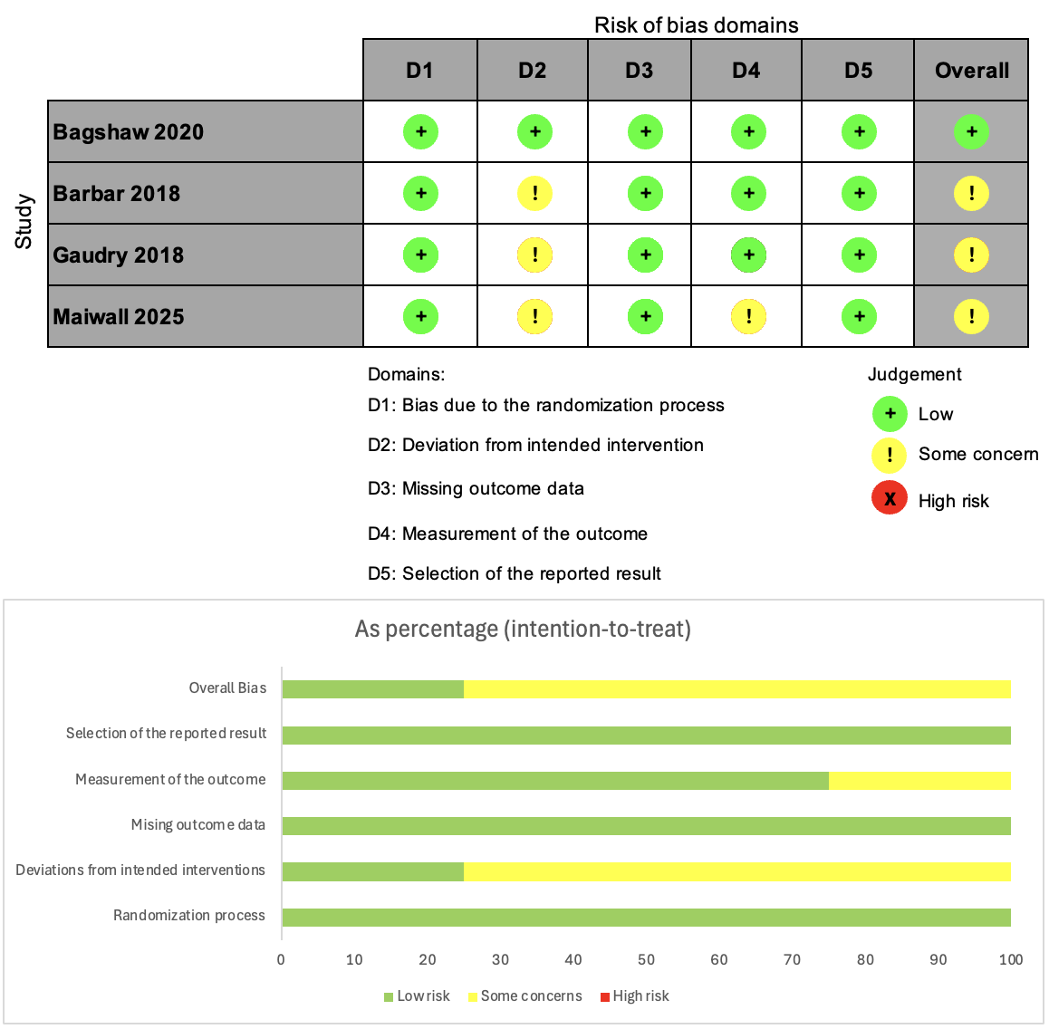

Supplementary Figure S2. Funnel plot analysis of 28-days mortality.
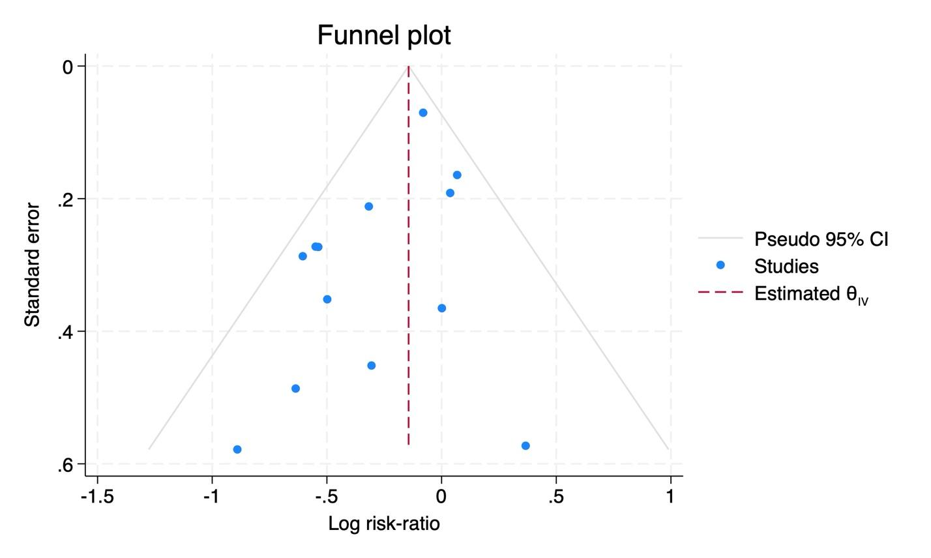

Supplementary Figure S3. Trim-and-fill analysis plot of 28-days mortality.
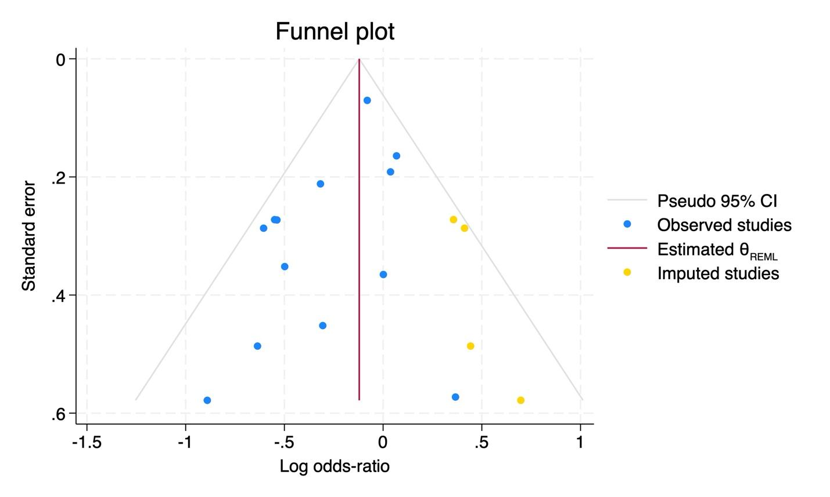

Supplementary Figure S4. Leave-one-out sensitivity analysis of 28-days mortality.
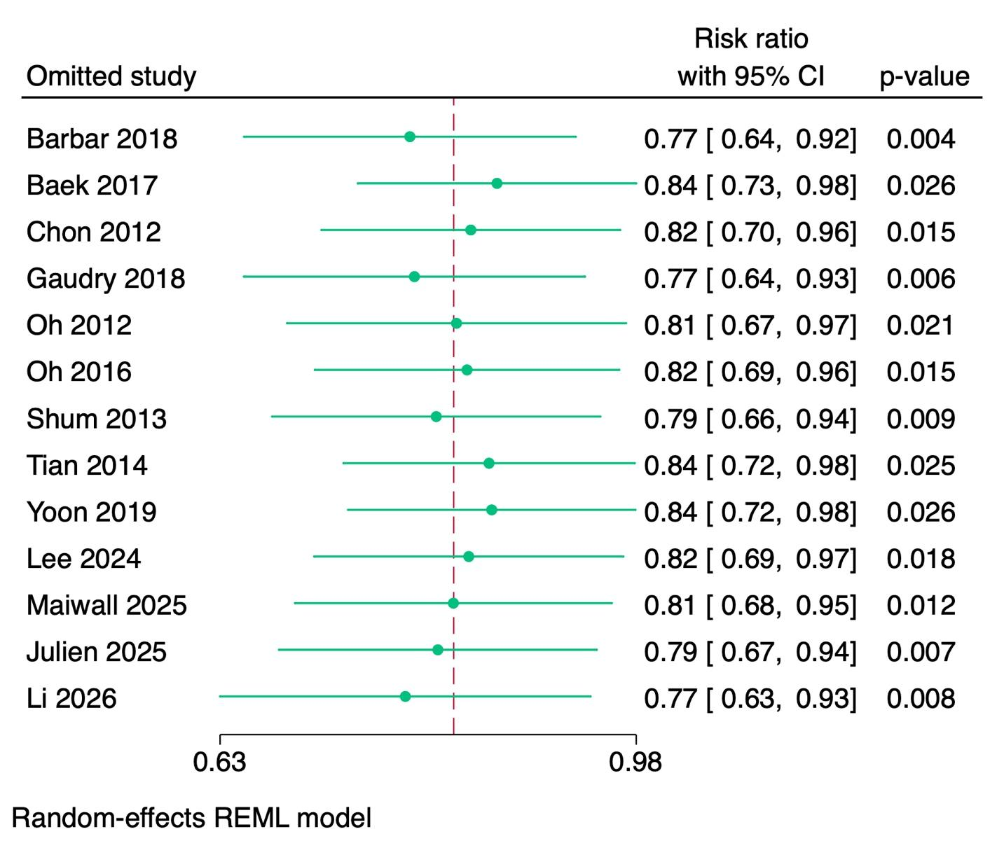

Supplementary Figure S5. Leave-one-out sensitivity analysis of multi-organ dysfunction socre (MODS).
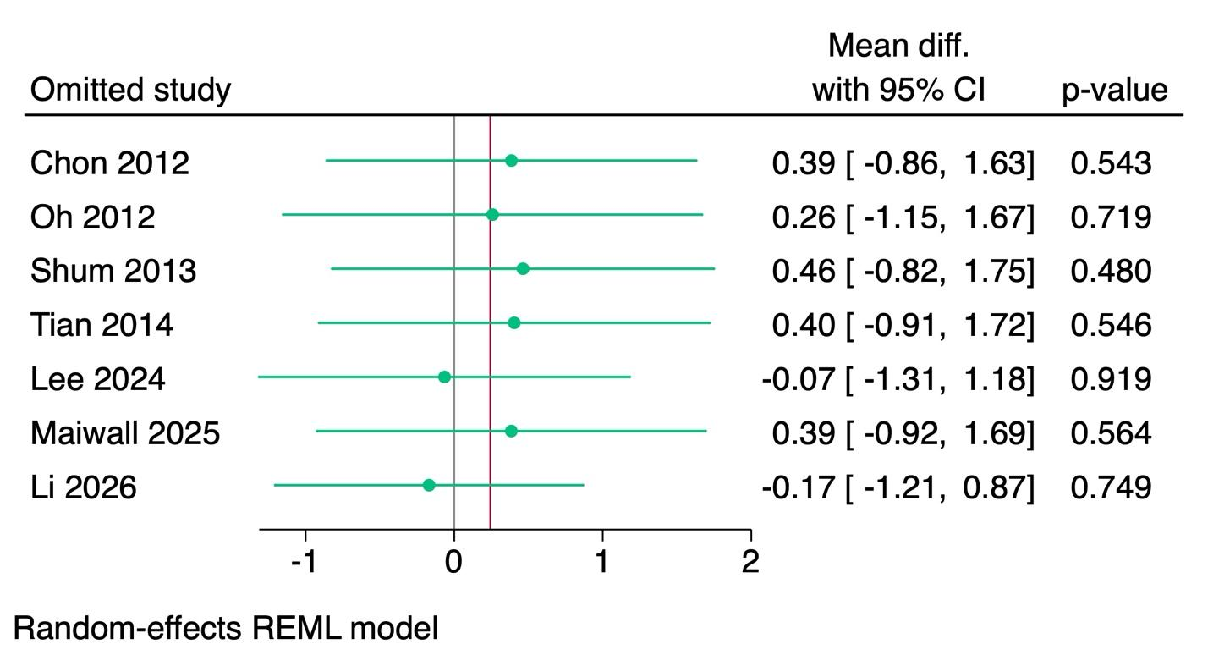

Supplementary Figure S6. Leave-one-out sensitivity analysis of intensive care unit (ICU) stay.
