Supplementary Table 1 The changes in laboratory test indicators after the injection of Obinutuzumab
 | Baseline  n=66 | 1m  n=62 | 2m  n=31 | 3m  n=43 | 6m  n=44 | 9m  n=38 | 12m  n=42 | 18m  n=30 | 24m  n=17 | 30m  n=8
aPLA2Rab* (RU/ml) | 55.4(18.4, 134.7) | 6.5(1.3,16.4) | 3.7(0.8,12.8) | 2.0(0.7,10.9) | 0.9(0.6, 2.5) | 1.7(0,6.1) | 1.0(0.6,5.0) | 1.4(0.7,4.6) | 0.9(0.6,1.4) | 0.7(0.6,1.3)
24h UP* (g/d) | 6.0(4.6, 9.5) | 4.7(3.2,7.4) | 4.0(2.5,6.1) | 4.3(2.2,6.5) | 2.0(1.0,4.3) | 2.2(0.6,4.0) | 1.0(0.5,3.7) | 1.4(0.3,4.3) | 0.7(0.4,3.4) | 1.0(0.2,3.5)
SCr (umol/L) | 74(59,90) | 73(63,88) | 77(59,101) | 73(65,91) | 77(68,86) | 79(67,89) | 78(69,98) | 92(70,110) | 88(65,133) | 91(70, 97)
eGFR (ml/min/1.73m²) | 93±27 | 93±26 | 90±29 | 92±22 | 92±24 | 86±27 | 84±27 | 79±27 | 72±32 | 77±29
Alb* (g/L) | 24.8±3.8 | 27.5±4.3 | 31.4±5.2 | 32.9±5.1 | 38.5±5.4 | 38.2±4.9 | 39.8±6.3 | 41.6±6.4 | 44.6±15.2 | 41.9±6.0
IgG** (g/L) | 5.99±2.47 | 6.76±2.67 | 7.93±3.17 | 6.85±1.95 | 9.62±3.17 | 9.58±3.49 | 10.37±3.29 | 10.84±2.87 | 12.26±8.03 | 9.86±3.14
B lym* (/uL) | 202(83,347) | 0(0,1) | 0(0,1) | 0(0,1) | 1(0,9) | 0(0,74) | 74(23,178) | 93(19,229) | 86(7,272) | 117(58,341)
Note: * Starting from the first month of follow-up, it was statistically significant compared with the baseline data (P < 0.05); Starting from the second month of follow-up, there was a statistical significance compared with the baseline data (P < 0.05).
Supplementary Table 2 Information on patients who have not achieved remission after Obinutuzumab treatment
Patient | Age and gender | Previous treatment | Dose of Obinutuzumab | Follow-up time | Baseline |  |  |  |  | Latest
 |  |  |  |  | aPLA2Rab  (RU/ml) | 24h UP  (g/d) | SCr  (umol/L) | Alb  (g/L) | B lym  (/uL) | aPLA2Rab  (RU/ml) | 24h UP  (g/d) | SCr  (umol/L) | Alb  (g/L) | B lym  (/uL)
Case 13 | 65/M | CsA+RTX | 2 | 21 | 815 | 9.4 | 58 | 22.7 | 84.7 | 6.5 | 3.7 | 73 | 34.4 | 78
Case 15 | 41/M | Pred+CTX/CNI/RTX | 3 | 23 | <2 | 3.5 | 76 | 28.7 | 23 | <2 | 5.8 | 81 | 36.0 | 201
Case 32 | 64/M | RTX | 1 | 21 | 2.4 | 15.4 | 241 | 29.1 | 6.44 | <2 | 3.2 | 218 | 36.0 | 33
Case 37 | 39/F |  | 1 | 9 | 99 | 5.2 | 47 | 27.9 | 306 | 2.9 | 5.1 | 61 | 43.2 | /
Case 41 | 51/M | RTX | 2 | 12 | 74 | 16.3 | 125 | 28.6 | 3.78 | <2 | 4.0 | 95 | 41.4 | 34
Case 59 | 58/M |  | 2 | 20 | 49 | 12.5 | 149 | 22.0 | 238 | <2 | 3.8 | 151 | 44.6 | /

Supplementary Table 3 Treatment information for relapsed patients
Patient | Age and gender | Immunosuppressive therapy in the previous 9 months before obinutuzumab | Dose of Obinutuzumab | Follow-up time  (M) | PR time (M) | Relapse time(M) | Baseline |  |  |  | Remission |  |  |  | Relapse
 |  |  |  |  |  |  | aPLA2Rab  (RU/ml) | 24h UP  (g/d) | Alb  (g/L) | B lym  (/uL) | aPLA2Rab  (RU/ml) | 24h UP  (g/d) | Alb  (g/L) | B lym  (/uL) | aPLA2Rab  (RU/ml) | 24h UP  (g/d) | Alb  (g/L) | B lym  (/uL)
Case 3 | 44/F |  | 1g | 20 | 1 | 18 | 122 | 10.0 | 29.1 | 165 | <2 | 0.1 | 44.0 | 0 | 3 | 4.2 | 33.6 | 224
Case 10 | 43/F | Pred+CTX | 2g | 36 | 4 | 17 | 165 | 3.4 | 24 | 214 | <2 | 0.8 | 43.4 | 0 | 28 | 4.4 | 39.1 | 378
Case 16 | 63/M | CsA | 2g | 26 | 9 | 21 | 54 | 9.4 | 25.6 | 280 | <2 | 1.9 | 40.7 | 0 | 23 | 7.2 | 35.3 | 346
Case 17 | 52/M |  | 1g
Case 21 | 38/M |  | 1g | 37 | 7 | 25 | 138 | 4.6 | 24.1 | 415 | <2 | 0.6 | 43.6 | 0 | 31 | 4.6 | 28.0 | 482
Case 63 | 61/M |  | 2g | 13 | 4 | 10 | 621 | 4.8 | 18.1 | 312 | <2 | 0.7 | 42.6 | 0 | 349 | 10.5 | 16.2 | 24.9

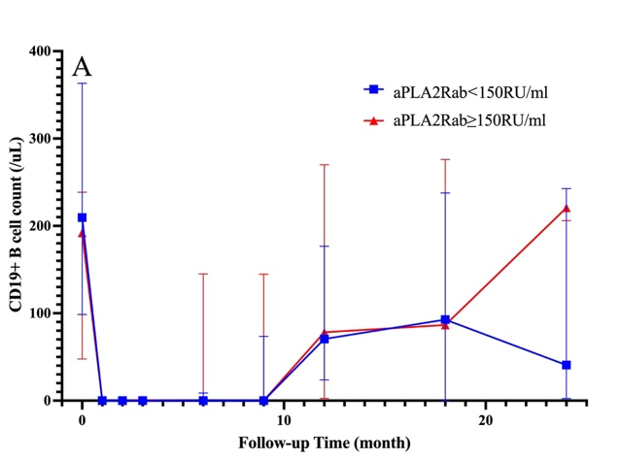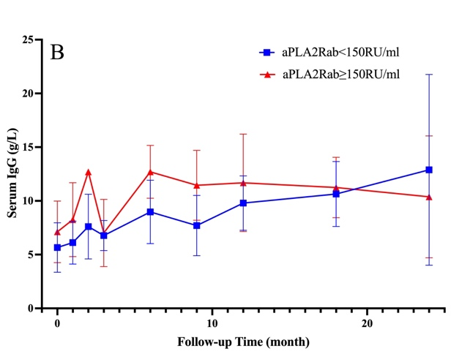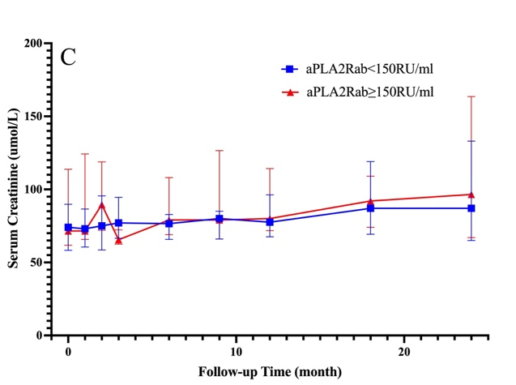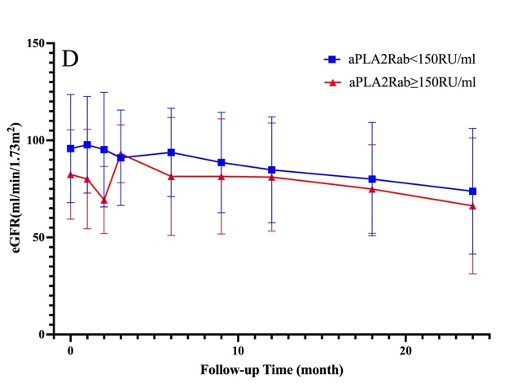

Supplementary Figure 1 Trend chart of B-cell count (A), blood IgG (B), serum creatinine (C), and eGFR (D) after treatment with Obinutuzumab.

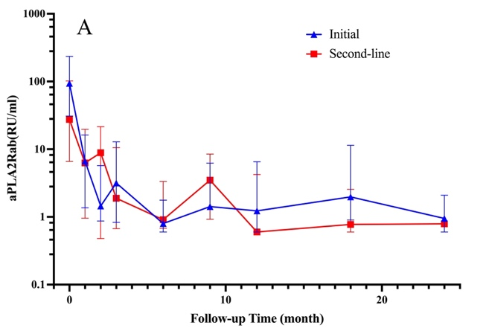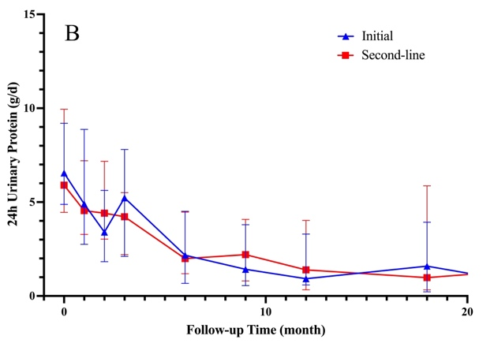
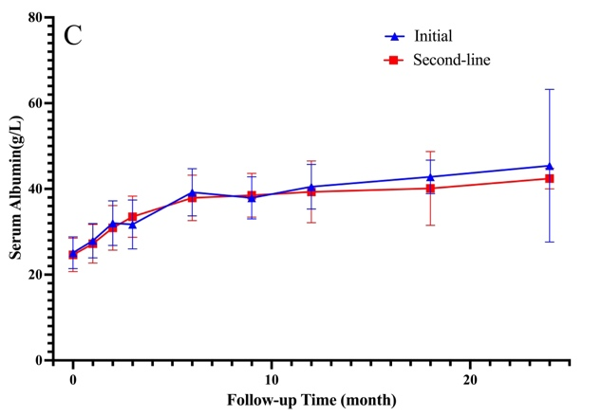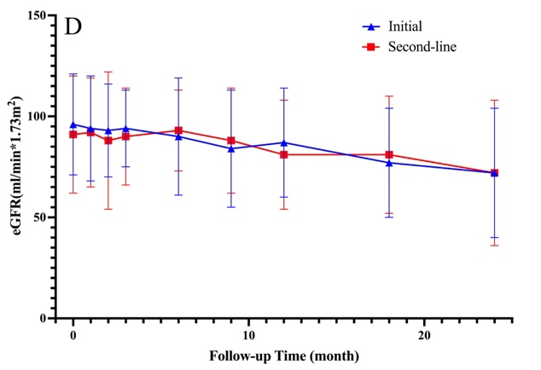
Supplementary Figure 2 Trend chart of aPLA2Rab (A), 24h urinary protein (B), serum albumin (C), and eGFR (D) after treatment with Obinutuzumab.

