Supplementary Figure 1. Risk-of-bias traffic-light plot for the three included RCTs (RoB-2 domain-level judgements).
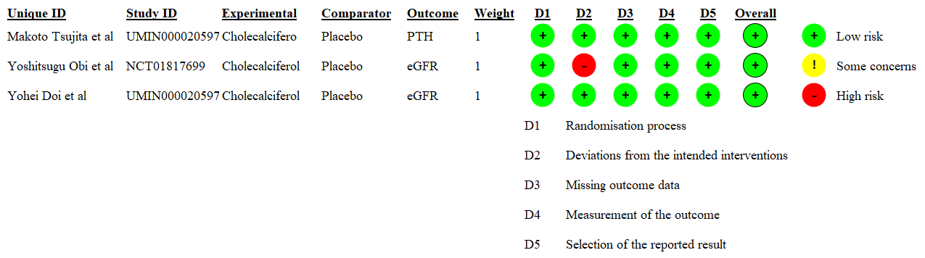

Supplementary Table 1. RoB-2 Domain-Level Judgements for Makoto Tsujita et al. (UMIN000020597)
Unique ID | Makoto Tsujita et al | Study ID | UMIN000020597 | Assessor | Yang and Wang
Ref or Label | DOI: 10.1002/jbmr.4469 | Aim | assignment to intervention (the 'intention-to-treat' effect)
Experimental | Cholecalcifero | Comparator | Placebo | Source | Journal article(s)
Outcome | PTH | Results | 95%CI, -25 to -3 | Weight | 1
Domain | Signalling question |  |  | Response | Comments
Bias arising from the randomization process | 1.1 Was the allocation sequence random? |  |  | Y | Participants were randomized using a computer-generated sequence at an allocation ratio of 1:1 to receive either cholecalciferol 4000 IU or a matching placebo daily from 1 to 12 months post-transplant, with a random block size of 8 and stratified by age (<50 or ≥50 years) and sex. None of the patients received active forms of vitamin D, or antiresorptive or anabolic agents for the prevention or treatment of osteoporosis throughout the study period.
Bias arising from the randomization process | 1.2 Was the allocation sequence concealed until participants were enrolled and assigned to interventions? |  |  | Y
Bias arising from the randomization process | 1.3 Did baseline differences between intervention groups suggest a problem with the randomization process? |  |  | N | Baseline characteristics were similar across the two treatment groups
Bias arising from the randomization process | Risk of bias judgement |  |  | Low
Bias due to deviations from intended interventions | 2.1.Were participants aware of their assigned intervention during the trial? |  |  | PN | Participants were randomized using a computer-generated  sequence at an allocation ratio of 1:1 to receive either cholecalciferol 4000 IU or a matching placebo daily from 1 to 12 months post-transplant, with a random block size of 8 and stratified by age (<50 or ≥50 years) and sex
Bias due to deviations from intended interventions | 2.2.Were carers and people delivering the interventions aware of participants' assigned intervention during the trial? |  |  | PN
Bias due to deviations from intended interventions | 2.3. If Y/PY/NI to 2.1 or 2.2: Were there deviations from the intended intervention that arose because of the experimental context? |  |  | NA
Bias due to deviations from intended interventions | 2.4 If Y/PY to 2.3: Were these deviations likely to have affected the outcome? |  |  | NA
Bias due to deviations from intended interventions | 2.5. If Y/PY/NI to 2.4: Were these deviations from intended intervention balanced between groups? |  |  | NA
Bias due to deviations from intended interventions | 2.6 Was an appropriate analysis used to estimate the effect of assignment to intervention? |  |  | Y | The effects of cholecalciferol versus placebo on whole PTH, TRACP-5b, BAP, and BMD levels were estimated by analysis of covariance (ANCOVA), adjusting for baseline values based on the full analysis set that included all  randomized participants who took the allocated drugs at least once.
Bias due to deviations from intended interventions | 2.7 If N/PN/NI to 2.6: Was there potential for a substantial impact (on the result) of the failure to analyse participants in the group to which they were randomized? |  |  | NA
Bias due to deviations from intended interventions | Risk of bias judgement |  |  | Low
Bias due to missing outcome data | 3.1 Were data for this outcome available for all, or nearly all, participants randomized? |  |  | Y | A total of 193 patients were randomized to either cholecalciferol (n = 96) or placebo (n = 97)
Bias due to missing outcome data | 3.2 If N/PN/NI to 3.1: Is there evidence that result was not biased by missing outcome data? |  |  | NA
Bias due to missing outcome data | 3.3 If N/PN to 3.2: Could missingness in the outcome depend on its true value? |  |  | NA
Bias due to missing outcome data | 3.4 If Y/PY/NI to 3.3: Is it likely that missingness in the outcome depended on its true value? |  |  | NA
Bias due to missing outcome data | Risk of bias judgement |  |  | Low
Bias in measurement of the outcome | 4.1 Was the method of measuring the outcome inappropriate? |  |  | N | To avoid arbitrary cut-points and preserve the statistical power, we used the multivariable fractional polynomial interaction approach to evaluate the interactions between continuous variables and treatment.
Bias in measurement of the outcome | 4.2 Could measurement or ascertainment of the outcome have differed between intervention groups? |  |  | N | To avoid arbitrary cut-points and preserve the statistical power, we used the multivariable fractional polynomial interaction approach to evaluate the interactions between continuous variables and treatment.
Bias in measurement of the outcome | 4.3 Were outcome assessors aware of the intervention received by study participants? |  |  | PY
Bias in measurement of the outcome | 4.4 If Y/PY/NI to 4.3: Could assessment of the outcome have been influenced by knowledge of intervention received? |  |  | N
Bias in measurement of the outcome | 4.5 If Y/PY/NI to 4.4: Is it likely that assessment of the outcome was influenced by knowledge of intervention received? |  |  | NA
Bias in measurement of the outcome | Risk of bias judgement |  |  | Low
Bias in selection of the reported result | 5.1 Were the data that produced this result analysed in accordance with a pre-specified analysis plan that was finalized before unblinded outcome data were available for analysis? |  |  | Y | This is a secondary endpoints study
Bias in selection of the reported result | 5.2 ... multiple eligible outcome measurements (e.g. scales, definitions, time points) within the outcome domain? |  |  | N
Bias in selection of the reported result | 5.3 ... multiple eligible analyses of the data? |  |  | N
Bias in selection of the reported result | Risk of bias judgement |  |  | Low
Overall bias | Risk of bias judgement |  |  | Low

Supplementary Table 2. RoB-2 Domain-Level Judgements for Yoshitsugu Obi et al. (NCT01817699)
Unique ID | Yoshitsugu Obi et al | Study ID | NCT01817699 | Assessor | Yang and Wang
Ref or Label | Transplant International 2021; 34: 1212–1225 | Aim | assignment to intervention (the 'intention-to-treat' effect)
Experimental | Cholecalciferol | Comparator | Placebo | Source | Journal article(s)
Outcome | eGFR | Results | i.e., -1.6±4.5 | Weight | 1
Domain | Signalling question |  |  | Response | Comments
Bias arising from the randomization process | 1.1 Was the allocation sequence random? |  |  | Y | Participants were randomly assigned in a 1:1 ratio to either a high or low hemoglobin target (i.e., ≥12.5 vs. <10.5 g/dl) and to either a cholecalciferol group or a control group by using an online-based block randomization program (block size: 8) with stratification by transplant date
Bias arising from the randomization process | 1.2 Was the allocation sequence concealed until participants were enrolled and assigned to interventions? |  |  | Y
Bias arising from the randomization process | 1.3 Did baseline differences between intervention groups suggest a problem with the randomization process? |  |  | N | The baseline characteristics including the levels of eGFR, hemoglobin, and serum 25(OH)D were similar across all groups
Bias arising from the randomization process | Risk of bias judgement |  |  | Low
Bias due to deviations from intended interventions | 2.1.Were participants aware of their assigned intervention during the trial? |  |  | Y | This was an open-label trial, and treatment allocation was not concealed from the patients and investigators
Bias due to deviations from intended interventions | 2.2.Were carers and people delivering the interventions aware of participants' assigned intervention during the trial? |  |  | Y
Bias due to deviations from intended interventions | 2.3. If Y/PY/NI to 2.1 or 2.2: Were there deviations from the intended intervention that arose because of the experimental context? |  |  | Y | Despite periodical monitoring and recommendations made by the central study team, the high hemoglobin target group showed lower mean levels (i.e., 11.4 g/dl) than originally planned with suboptimal dose of MPG-EPO
Bias due to deviations from intended interventions | 2.4 If Y/PY to 2.3: Were these deviations likely to have affected the outcome? |  |  | Y
Bias due to deviations from intended interventions | 2.5. If Y/PY/NI to 2.4: Were these deviations from intended intervention balanced between groups? |  |  | N
Bias due to deviations from intended interventions | 2.6 Was an appropriate analysis used to estimate the effect of assignment to intervention? |  |  | Y | All analyses were done by intention to treat.
Bias due to deviations from intended interventions | 2.7 If N/PN/NI to 2.6: Was there potential for a substantial impact (on the result) of the failure to analyse participants in the group to which they were randomized? |  |  | NA
Bias due to deviations from intended interventions | Risk of bias judgement |  |  | High
Bias due to missing outcome data | 3.1 Were data for this outcome available for all, or nearly all, participants randomized? |  |  | Y
Bias due to missing outcome data | 3.2 If N/PN/NI to 3.1: Is there evidence that result was not biased by missing outcome data? |  |  | NA
Bias due to missing outcome data | 3.3 If N/PN to 3.2: Could missingness in the outcome depend on its true value? |  |  | NA
Bias due to missing outcome data | 3.4 If Y/PY/NI to 3.3: Is it likely that missingness in the outcome depended on its true value? |  |  | NA
Bias due to missing outcome data | Risk of bias judgement |  |  | Low
Bias in measurement of the outcome | 4.1 Was the method of measuring the outcome inappropriate? |  |  | N
Bias in measurement of the outcome | 4.2 Could measurement or ascertainment of the outcome have differed between intervention groups? |  |  | N
Bias in measurement of the outcome | 4.3 Were outcome assessors aware of the intervention received by study participants? |  |  | Y
Bias in measurement of the outcome | 4.4 If Y/PY/NI to 4.3: Could assessment of the outcome have been influenced by knowledge of intervention received? |  |  | N
Bias in measurement of the outcome | 4.5 If Y/PY/NI to 4.4: Is it likely that assessment of the outcome was influenced by knowledge of intervention received? |  |  | NA
Bias in measurement of the outcome | Risk of bias judgement |  |  | Low
Bias in selection of the reported result | 5.1 Were the data that produced this result analysed in accordance with a pre-specified analysis plan that was finalized before unblinded outcome data were available for analysis? |  |  | Y
Bias in selection of the reported result | 5.2 ... multiple eligible outcome measurements (e.g. scales, definitions, time points) within the outcome domain? |  |  | N
Bias in selection of the reported result | 5.3 ... multiple eligible analyses of the data? |  |  | N
Bias in selection of the reported result | Risk of bias judgement |  |  | Low
Overall bias | Risk of bias judgement |  |  | Some concerns | Adherence to the hemoglobin targets was periodically evaluated by the central study team who made intervention recommendations

Suplementary Table 3. RoB-2 Domain-Level Judgements for Yohei Doi et al. (UMIN000020597)
Unique ID | Yohei Doi et al | Study ID | UMIN000020597 | Assessor | Yang and Wang
Ref or Label | Am J Transplant. 2021;00:1–12. | Aim | assignment to intervention (the 'intention-to-treat' effect)
Experimental | Cholecalciferol | Comparator | Placebo | Source | Journal article(s)
Outcome | eGFR | Results | 95% CI，−0.7 to 3.1 | Weight | 1
Domain | Signalling question |  |  | Response | Comments
Bias arising from the randomization process | 1.1 Was the allocation sequence random? |  |  | Y | With the use of a computer-generated random sequence
Bias arising from the randomization process | 1.2 Was the allocation sequence concealed until participants were enrolled and assigned to interventions? |  |  | Y | With the use of a computer-generated random sequence
Bias arising from the randomization process | 1.3 Did baseline differences between intervention groups suggest a problem with the randomization process? |  |  | N | Baseline characteristics were well balanced between groups, except for the u-LFABP creatinine ratio in the cholecalciferol group.
Bias arising from the randomization process | Risk of bias judgement |  |  | Low
Bias due to deviations from intended interventions | 2.1.Were participants aware of their assigned intervention during the trial? |  |  | N | Participants and investigators were masked to treatment allocation throughout the entire study.
Bias due to deviations from intended interventions | 2.2.Were carers and people delivering the interventions aware of participants' assigned intervention during the trial? |  |  | N
Bias due to deviations from intended interventions | 2.3. If Y/PY/NI to 2.1 or 2.2: Were there deviations from the intended intervention that arose because of the experimental context? |  |  | NA
Bias due to deviations from intended interventions | 2.4 If Y/PY to 2.3: Were these deviations likely to have affected the outcome? |  |  | NA
Bias due to deviations from intended interventions | 2.5. If Y/PY/NI to 2.4: Were these deviations from intended intervention balanced between groups? |  |  | NA
Bias due to deviations from intended interventions | 2.6 Was an appropriate analysis used to estimate the effect of assignment to intervention? |  |  | Y | Primary analysis: “ANCOVA with adjustment for baseline values was used … based on the modified intention-to-treat set which included all randomized patients who received the study drug at least once
Bias due to deviations from intended interventions | 2.7 If N/PN/NI to 2.6: Was there potential for a substantial impact (on the result) of the failure to analyse participants in the group to which they were randomized? |  |  | NA
Bias due to deviations from intended interventions | Risk of bias judgement |  |  | Low
Bias due to missing outcome data | 3.1 Were data for this outcome available for all, or nearly all, participants randomized? |  |  | Y
Bias due to missing outcome data | 3.2 If N/PN/NI to 3.1: Is there evidence that result was not biased by missing outcome data? |  |  | NA
Bias due to missing outcome data | 3.3 If N/PN to 3.2: Could missingness in the outcome depend on its true value? |  |  | NA
Bias due to missing outcome data | 3.4 If Y/PY/NI to 3.3: Is it likely that missingness in the outcome depended on its true value? |  |  | NA
Bias due to missing outcome data | Risk of bias judgement |  |  | Low
Bias in measurement of the outcome | 4.1 Was the method of measuring the outcome inappropriate? |  |  | N
Bias in measurement of the outcome | 4.2 Could measurement or ascertainment of the outcome have differed between intervention groups? |  |  | N | were measured using standard automated techniques
Bias in measurement of the outcome | 4.3 Were outcome assessors aware of the intervention received by study participants? |  |  | N | Participants and investigators were masked to treatment allocation throughout the entire study.
Bias in measurement of the outcome | 4.4 If Y/PY/NI to 4.3: Could assessment of the outcome have been influenced by knowledge of intervention received? |  |  | NA
Bias in measurement of the outcome | 4.5 If Y/PY/NI to 4.4: Is it likely that assessment of the outcome was influenced by knowledge of intervention received? |  |  | NA
Bias in measurement of the outcome | Risk of bias judgement |  |  | Low
Bias in selection of the reported result | 5.1 Were the data that produced this result analysed in accordance with a pre-specified analysis plan that was finalized before unblinded outcome data were available for analysis? |  |  | Y | An analysis of covariance (ANCOVA) with adjustment for baseline values was used in the primary endpoint analysis
Bias in selection of the reported result | 5.2 ... multiple eligible outcome measurements (e.g. scales, definitions, time points) within the outcome domain? |  |  | N
Bias in selection of the reported result | 5.3 ... multiple eligible analyses of the data? |  |  | N
Bias in selection of the reported result | Risk of bias judgement |  |  | Low
Overall bias | Risk of bias judgement |  |  | Low

Supplementary Table 4. ROBINS-I Risk-of-Bias Summary for the Six Included Observational Studies.
No | ID | Overall | Domain 1 | Domain 2 | Domain 3 | Domain 4 | Domain 5 | Domain 6 | Domain 7
K. Martin Wissing et al | Transplantation 2005;79: 108 –115 | Moderate | Moderate | Moderate | Low | Moderate | Low | Low | Low
Marie Courbebaisse et al | Kidney International (2009) 75, 646–651 | Moderate | Serious | Low | Low | Moderate | Low | Low | Low
Marie Courbebaisse et al | American Journal of Transplantation 23 (2023) 366–376 | Low | Moderate | Low | Low | Low | Low | Low | Low
Yuri Battaglia et al | Biomolecules 2023, 13, 629. | Low | Low | Low | Low | Low | Low | Low | Low
Shu-Meng Hu et al | Endocrine Connections (2022) 11, e220123 | Moderate | Serious | Moderate | Moderate | Low | Low | Low | Low

Supplementary Table 5. Vitamin D Level Definitions Used in Each Study.
Study | Year | Original definition of vitamin D status
K. Martin Wissing et al | 2005 | Not explicitly defined for deficiency/insufficiency; baseline 25(OH)D 19–24 ng/mL
Makoto Tsujita et al | 2022 | Deficiency: <20 ng/mL (96% of participants); sufficiency target: >30 ng/mL; used Endocrine Society criteria
Yoshitsugu Obi1 et al | 2021 | Not defined for deficiency; baseline 25(OH)D 14.5 ng/mL
Marie Courbebaisse1 et al | 2008 | Insufficiency: <30 ng/mL; treatment target: >30 ng/mL; used K/DOQI guidelines
Marie Courbebaisse1 et al | 2022 | Insufficiency: <30 ng/mL; inclusion criterion was <30 ng/mL
Yohei Doi et al | 2021 | Insufficiency according to Endocrine Society: <30 ng/mL; baseline median 10 ng/mL
Yuri Battaglia et al | 2023 | Insufficiency: <30 ng/mL; severe insufficiency: <20 ng/mL; deficiency: <10 ng/mL; baseline 25(OH)D 15 ng/mL in both groups
Shu-Meng Hu et al | 2022 | Sufficiency: >75 nmol/L (>30 ng/mL); deficiency: ≤75 nmol/L (≤30 ng/mL)

Supplementary Table 6. Additional characteristics of the included studies.
Study | Transplant vintage at enrollment | Donor type | Immunosuppressive regimen | Key exclusion criteria | Control of bisphosphonates, calcimimetics, active vitamin D
K. Martin Wissing et al | randomization and supplementation started end of first week after transplant | living donors 2/41 (5%) in Ca group, 5/38 (13%) in VitD group; remainder deceased donor | Induction: Thymoglobulin (high/intermediate risk) or basiliximab. Maintenance: Prednisolone (taper: 20→10→7.5→5 mg by month 3, withdrawal in low-risk at month 6); CNI (tacrolimus or cyclosporine) + MMF 2 g/d. Rejection: IV methylprednisolone. | Spontaneous hypercalcemia, hypocalcemia requiring active vitamin D, multi-organ transplant | Bisphosphonates/active D: excluded if active D needed; bisphosphonates not mentioned.
Makoto Tsujita et al | 1 month post-transplant | All living donors | Induction: risk-based. Maintenance: Prednisolone (start 60 mg → taper to 10 mg by week 3 → 5 mg by month 3); CNI + MMF or everolimus. Rejection: IV methylprednisolone. | hypercalcaemia (corrected Ca ≥11 mg/dL), eGFR <30 mL/min/1.73m² | not standardised or excluded – randomisation expected to balance.
Yoshitsugu Obi1 et al | median 8 years (IQR 5–12) | Not reported | CNI (tacrolimus 64%, cyclosporine 34%), MMF 80%, everolimus 23%, steroids 82%, azathioprine 5%, mizoribine 10%. No induction details. | Current nutritional vitamin D, hypercalcaemia (≥10.5 mg/dL), HIV, pregnancy | bisphosphonates: not explicitly controlled
Marie Courbebaisse1 et al | 3 months | Not reported | Maintenance: CNI (cyclosporine 28–47%, tacrolimus 65%) + steroids (mean dose at M3 ~10 mg/d, at M12 ~6–8 mg/d). Rejection rate ~20%. | Hypercalcaemia (≥2.70 mmol/L) | no mention of standardisation or exclusion. Control group received no bone-active medication.
Marie Courbebaisse1 et al | 12–48 months | Not reported | Steroids (60–63%), CNI (tacrolimus/cyclosporine), antimetabolites (MMF, azathioprine). No active vitamin D at inclusion. Diabetes excluded. | Diabetes, hypercalcaemia, hyperphosphataemia, severe renal dysfunction | Bisphosphonates/active D: allowed; randomisation balances.
Yohei Doi et al | 1 month post-transplant | All living donors | Prednisolone taper: 60 mg → 10 mg at week 3 → 5 mg at month 3. CNI + MMF or everolimus. | Nutritional vitamin D use, hypercalcaemia (≥11 mg/dL), eGFR <30 | bisphosphonates: not standardised – randomisation as main balancing method.
Yuri Battaglia et al | median 88 months | Not reported | Steroids (91%), cyclosporine (40%), tacrolimus (54%), MMF (64%), azathioprine (12%), mTORi (6–14%). | History of fractures, parathyroidectomy | Subgroup analysis by bisphosphonate/calcimimetic/active D use.
Shu-Meng Hu et al | 2 weeks (1–4) post-transplant | Not reported | Standard triple therapy: CNI (tacrolimus, target 5.95–7.11 ng/mL), MMF (AUC 45.7–70.9 mg·h/L), and steroids. No further induction details. | Parathyroidectomy, use of active vitamin D / cinacalcet / bisphosphonates | Multivariable regression adjusting for pre/post-transplant vitamin D supplementation, age, sex, dialysis vintage, etc.

Supplementary Table 7. Specific Search Strategies.
Database | Search Strategy
PubMed | ("Vitamin D"[MeSH Terms] OR "vitamin D"[Title/Abstract] OR "25-dihydroxyvitamin D"[Title/Abstract] OR "cholecalciferol"[Title/Abstract] OR "ergocalciferol"[Title/Abstract]) AND ("Kidney Transplantation"[MeSH Terms] OR "kidney transplantation"[Title/Abstract] OR "renal transplantation"[Title/Abstract] OR "kidney transplant"[Title/Abstract] OR "renal transplant"[Title/Abstract] OR "kidney graft"[Title/Abstract] OR "renal graft"[Title/Abstract])
EMBASE | ('vitamin d'/exp OR 'vitamin d':ti,ab OR '25-dihydroxyvitamin d':ti,ab OR 'cholecalciferol':ti,ab OR 'ergocalciferol':ti,ab) AND ('kidney transplantation'/exp OR 'kidney transplantation':ti,ab OR 'renal transplantation':ti,ab OR 'kidney transplant':ti,ab OR 'renal transplant':ti,ab OR 'kidney graft':ti,ab OR 'renal graft':ti,ab)
Web of Science | TS=("vitamin D" OR "25-dihydroxyvitamin D" OR "cholecalciferol" OR "ergocalciferol") AND TS=("kidney transplantation" OR "renal transplantation" OR "kidney transplant" OR "renal transplant" OR "kidney graft" OR "renal graft")

Supplementary Figure 2. Sensitivity analysis of the effect of vitamin D supplementation on post-transplant vitamin D Levels in kidney transplant recipients.
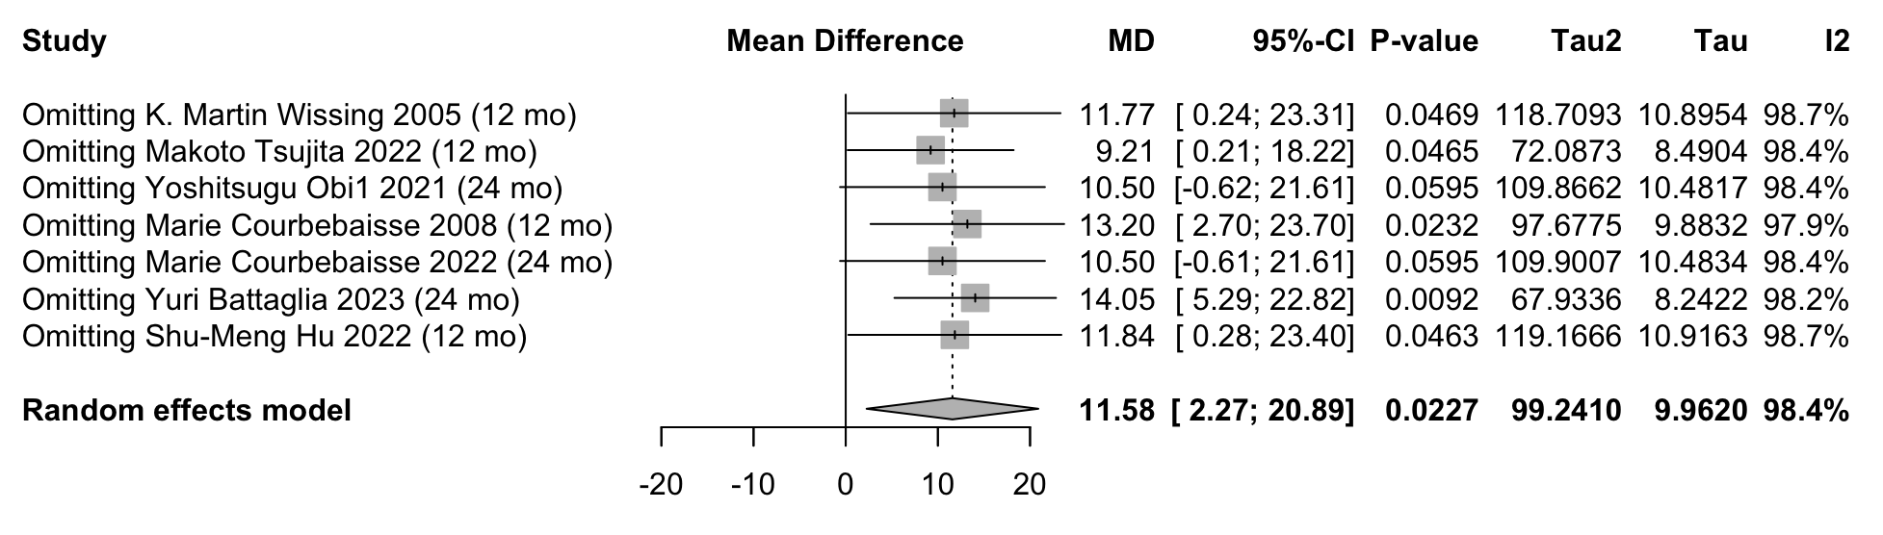

Supplementary Figure 3. Sensitivity analysis of the effect of vitamin D supplementation on post-transplant eGFR Levels in kidney transplant recipients.
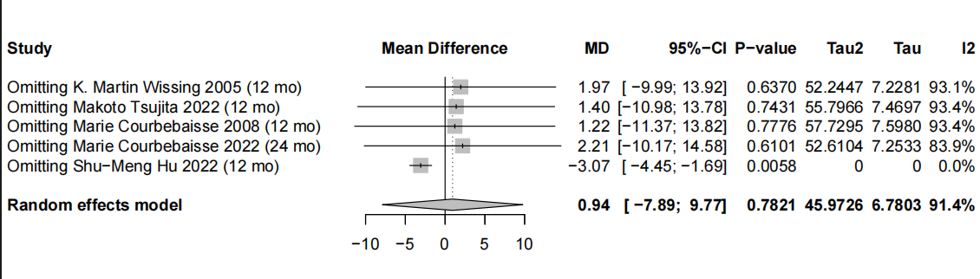

Supplementary Figure 4. Sensitivity analysis of the effect of vitamin D supplementation on post-transplant iPTH Levels in kidney transplant recipients.
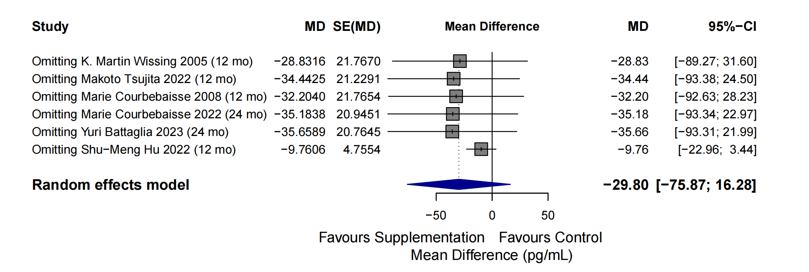
Supplementary Figure 5. Sensitivity analysis of the effect of vitamin D supplementation on post-transplant serum calcium levels in kidney transplant recipient.
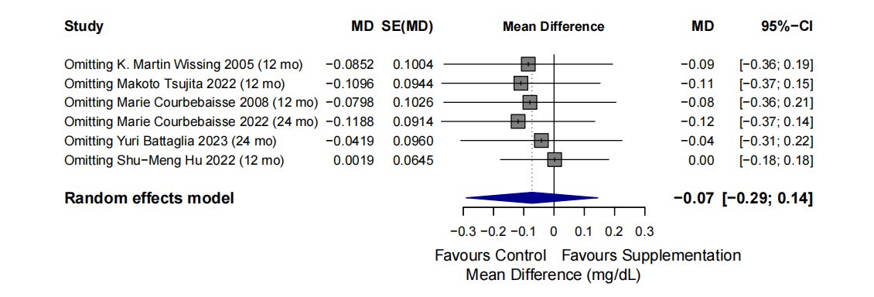

Supplementary Figure 6. Sensitivity analysis of the effect of vitamin D supplementation on post-transplant serum phosphorus levels in kidney transplant recipients.
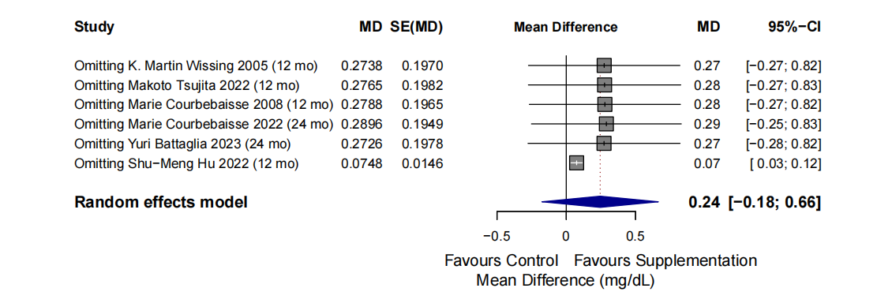
Supplementary Figure 7. Subgroup analysis of vitamin D supplementation on intact parathyroid hormone (PTH) stratified by the dose of vitamin D in kidney transplant recipients.
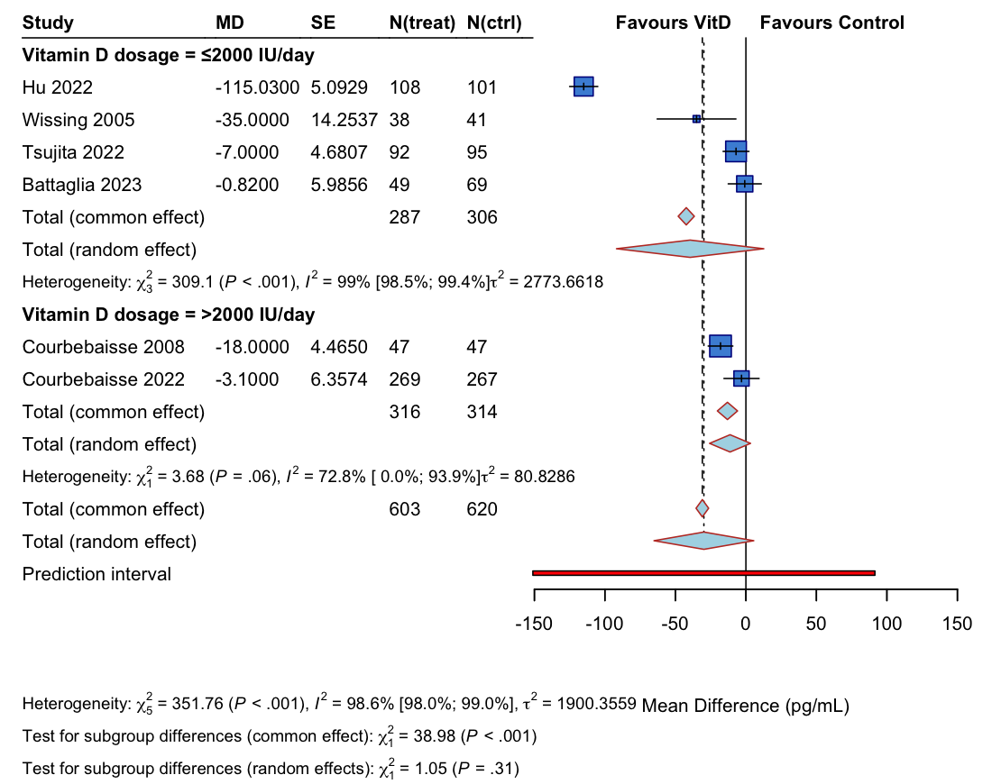

Supplementary Figure 8. Subgroup analysis of vitamin D supplementation on intact parathyroid hormone (PTH) stratified by duration of follow-up in kidney transplant recipients.
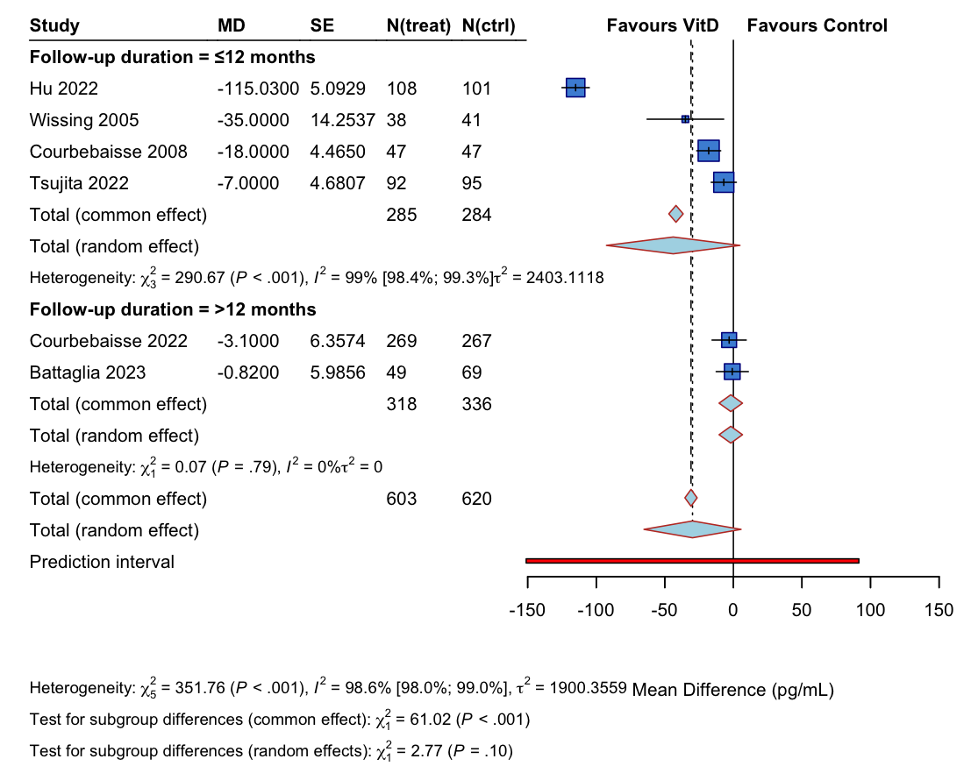

Supplementary Figure 9. Subgroup analysis of vitamin D supplementation on eGFR stratified by duration of follow-up in kidney transplant recipients.
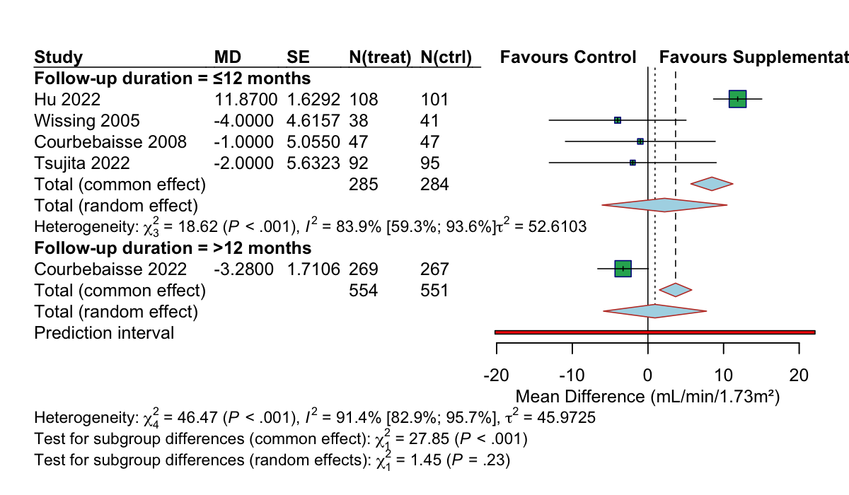
Supplementary Figure 10. Subgroup analysis of vitamin D supplementation on eGFR stratified by the dose of vitamin D in kidney transplant recipients.
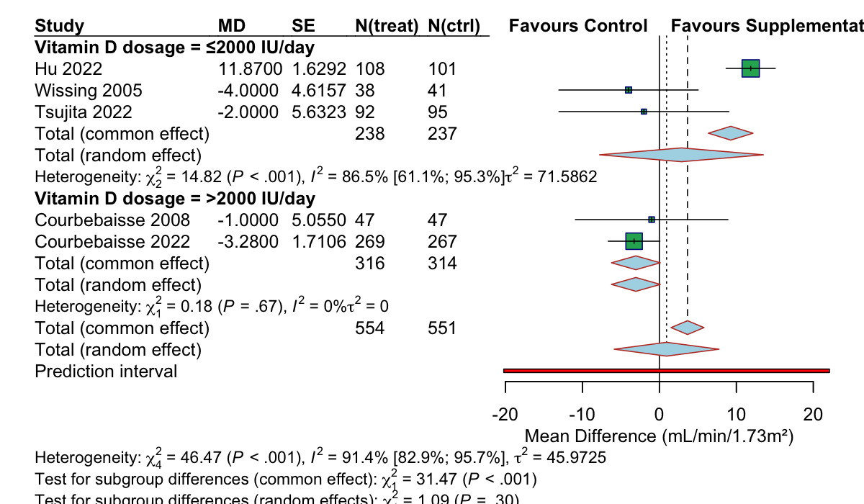

Supplementary Figure 11. Funnel plot assessing publication bias for the effect of vitamin D supplementation on 25(OH)D levels.
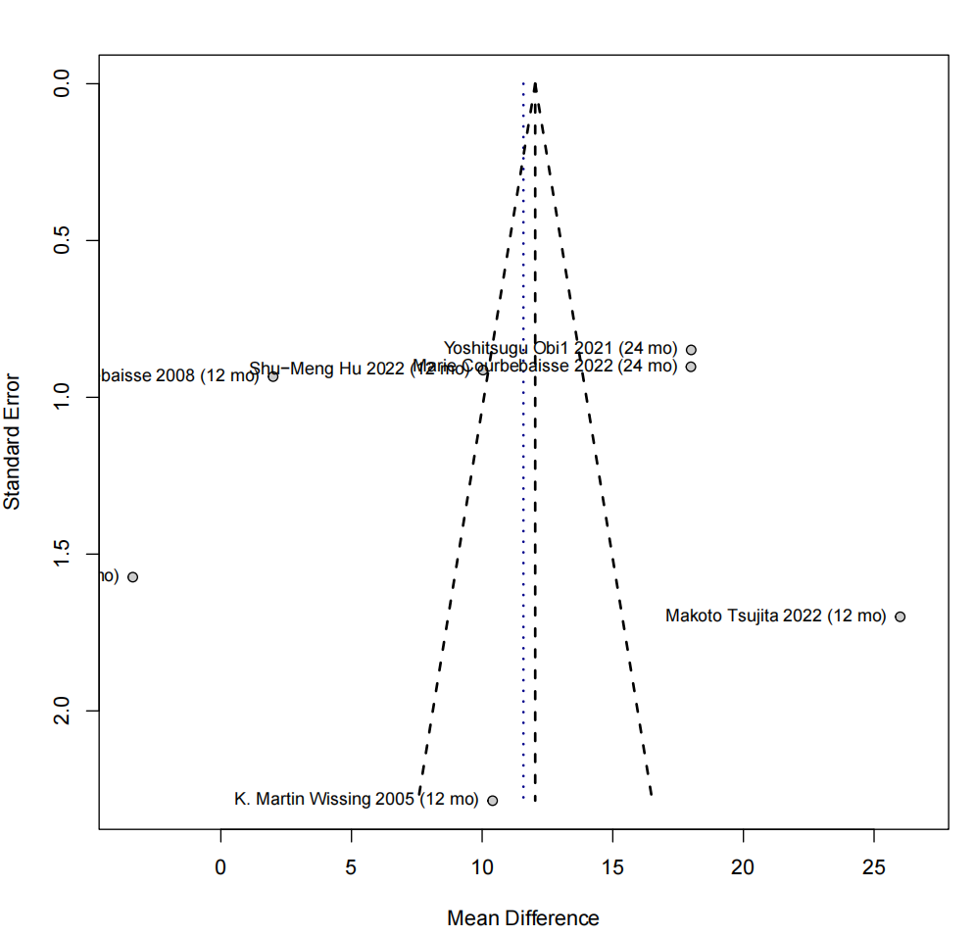

Supplementary Figure 12. Funnel plot assessing publication bias for the effect of vitamin D supplementation on PTH levels.
