Binomial Test
Variable | Level | Counts | Total | Proportion | p
Hypertension (0-no; 1-yes) | no | 41 | 112 | 0.366 | 0.006
 | yes | 71 | 112 | 0.634 | 0.006
Diabetes melilites (0-no; 1-yes) | no | 104 | 112 | 0.929 | < 0.001
 | yes | 8 | 112 | 0.071 | < 0.001
Table S1. Prevalence of associated conditions (diabetes and hypertension) among patients

Variable | Without hepatic enzymes elevation | With hepatic enzymes elevation
Age at treatment initiation, years | 45.69 ± 5.82 | 42.48 ± 10.53
Baseline eGFR, mL/min/1.73 m² | 73.62 ± 27.00 | 68.26 ± 26.73
Baseline TKV (VRT), mL | 1788 ± 1001 | 2561 ± 2189
Table S2. Baseline characteristics of patients with and without hepatic enzyme elevation

Descriptive Statistics
 | Daily urine output_1year
Valid | 44
Mean | 5212
Std. Deviation | 1812
Minimum | 5.500
Maximum | 8000
25th percentile | 4950
50th percentile | 5250
75th percentile | 6000
Table S3. Daily urine output after 1 year of treatment

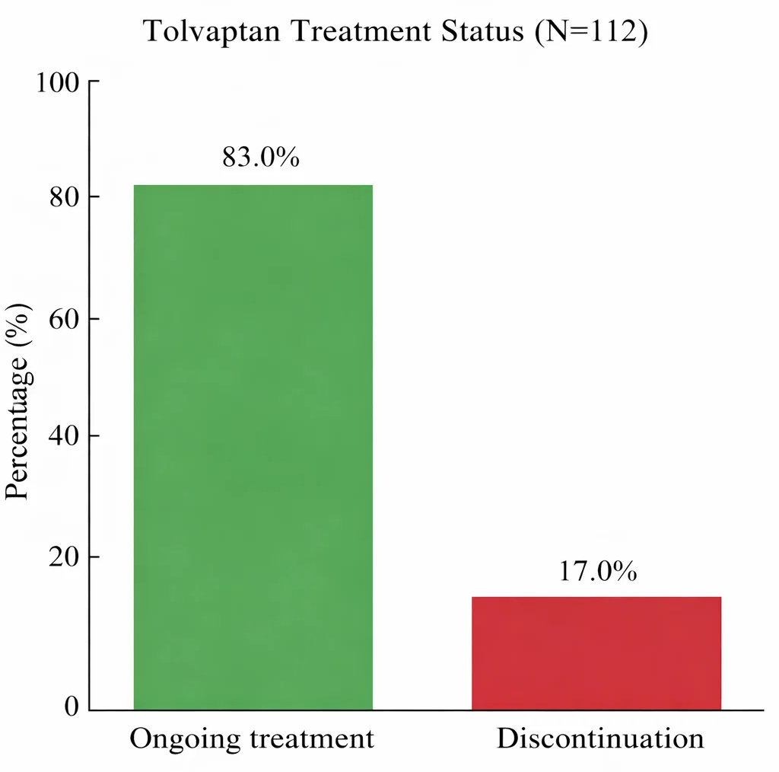

Figure 1. Tolvaptan treatment status

