Figure 1.Forest plot of the association between continuous serum phosphorus and CKD-associated pruritus.
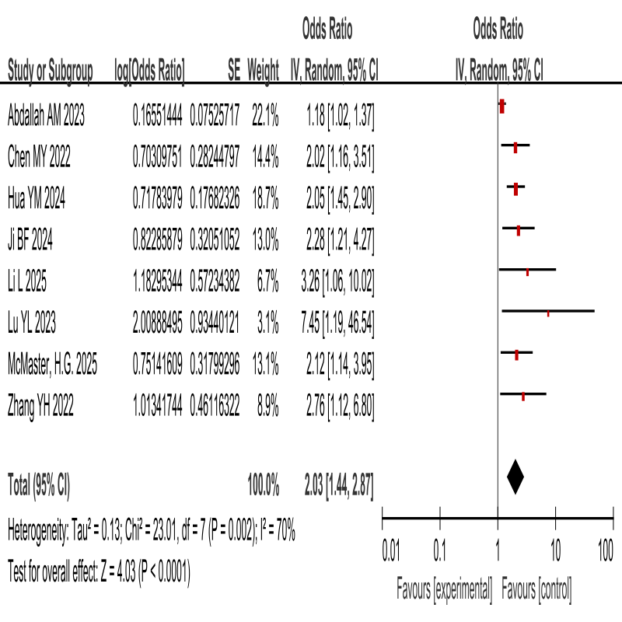Figure 2.Forest plot of the association between dichotomised serum phosphorus and CKD-associated pruritus.
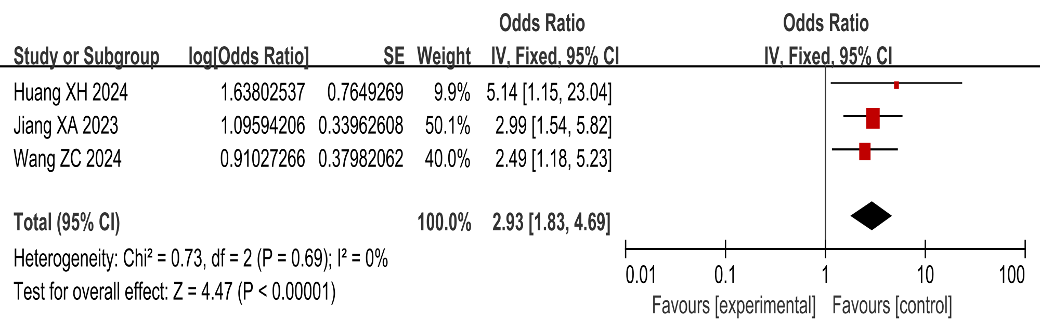
Figure 3.Forest plot of the association between continuous PTH/iPTH and CKD-associated pruritus.
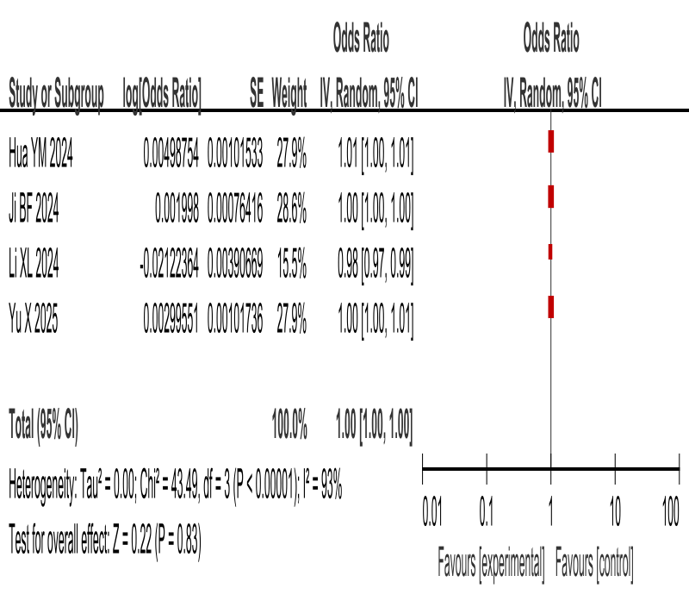
Figure 4.Forest plot of the association between dichotomised PTH/iPTH and CKD-associated pruritus.
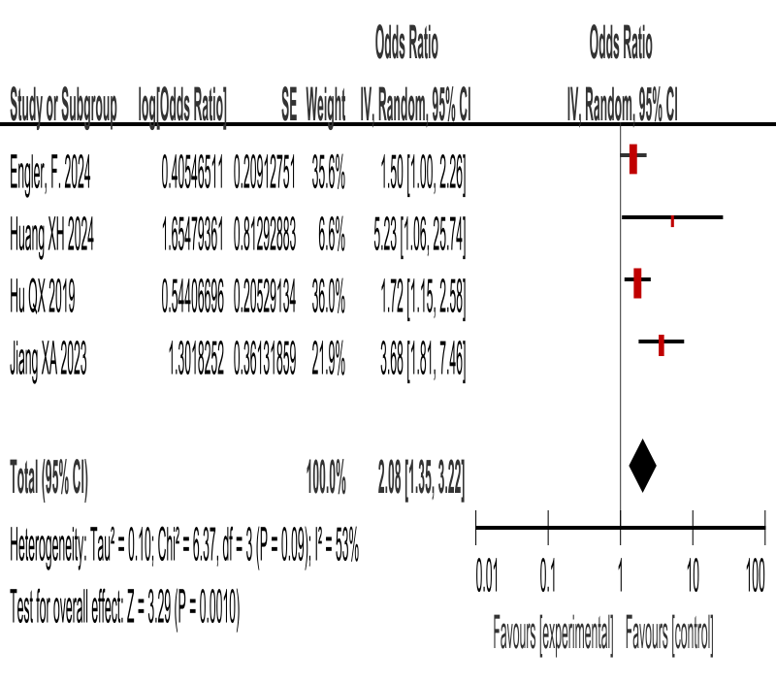
Figure 5.Forest plot of the association between continuous CRP/hs-CRP and CKD-associated pruritus.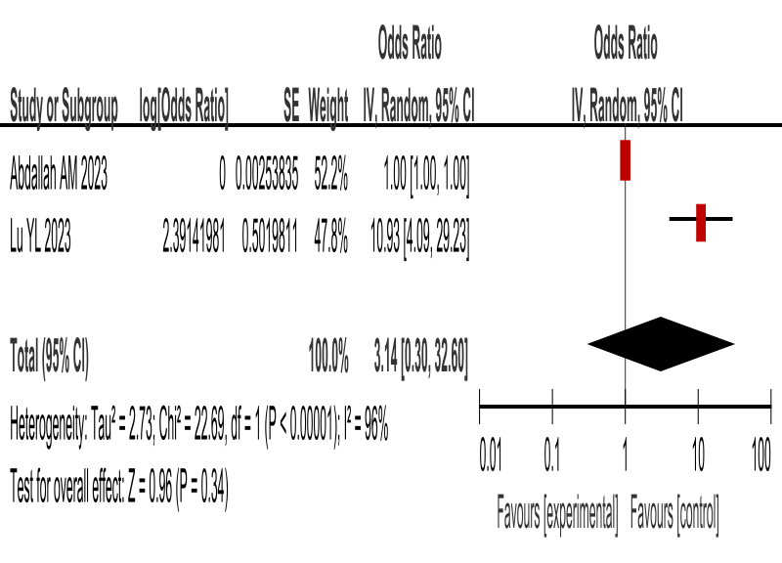
Figure 6.Forest plot of the association between dichotomised CRP/hs-CRP and CKD-associated pruritus.
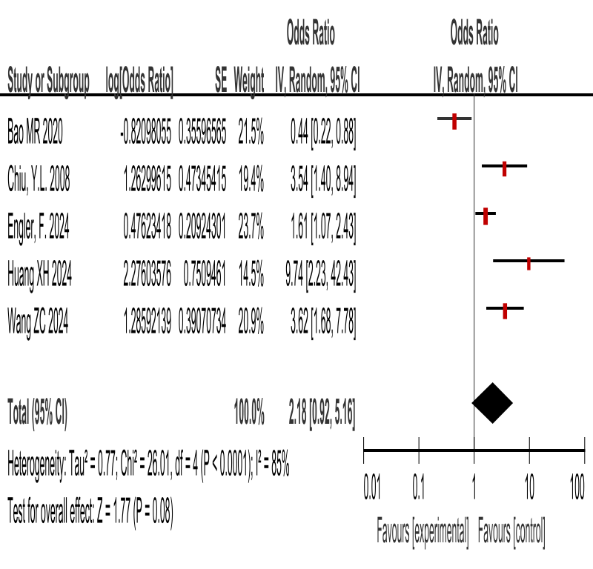
Figure 7.Forest plot of the association between dichotomised age and CKD-associated pruritus.
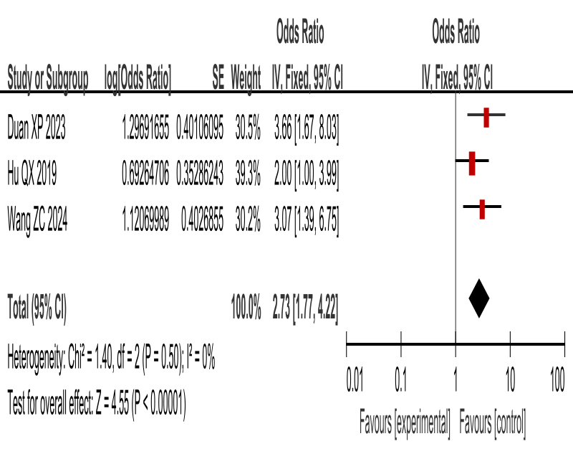
Figure 8.Forest plot of the association between continuous Dialysis vintage and CKD-associated pruritus.
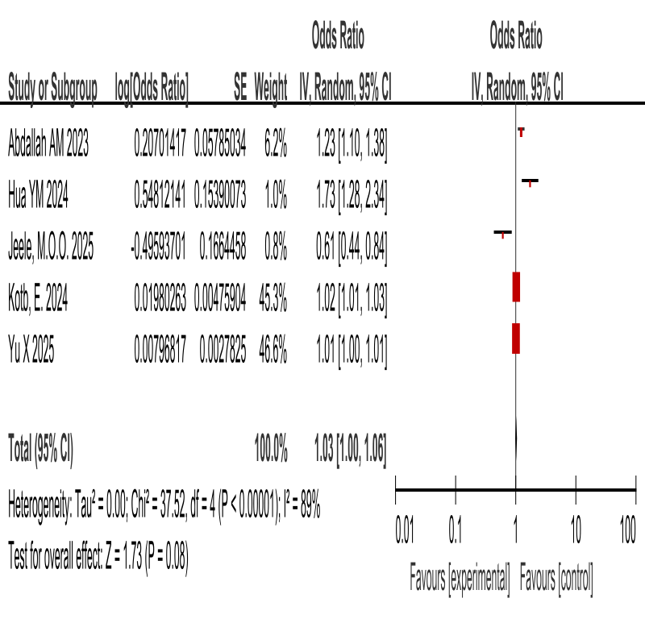
Figure 9.Forest plot of the association between dichotomised Dialysis vintage and CKD-associated pruritus.
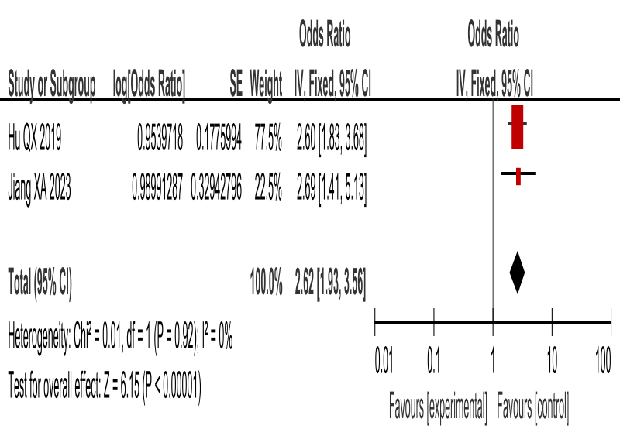
Figure 10.Forest plot of the association between continuous β₂-microglobulin and CKD-associated pruritus.
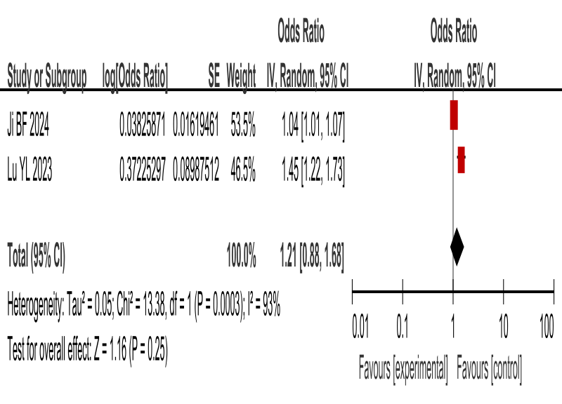
Figure 11.Forest plot of the association between dichotomised β₂-microglobulin and CKD-associated pruritus.
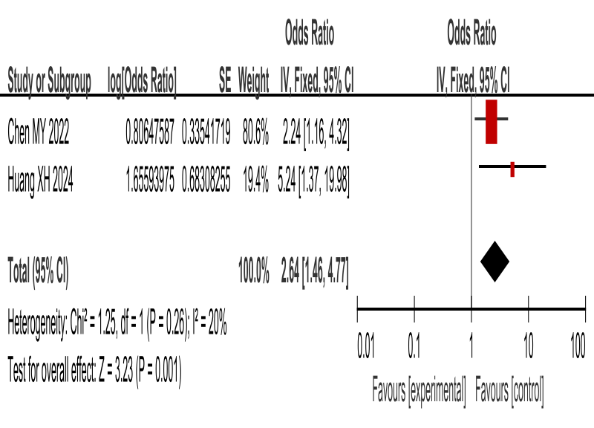
Figure 12.Forest plot of the association between continuous Serum calcium and CKD-associated pruritus.
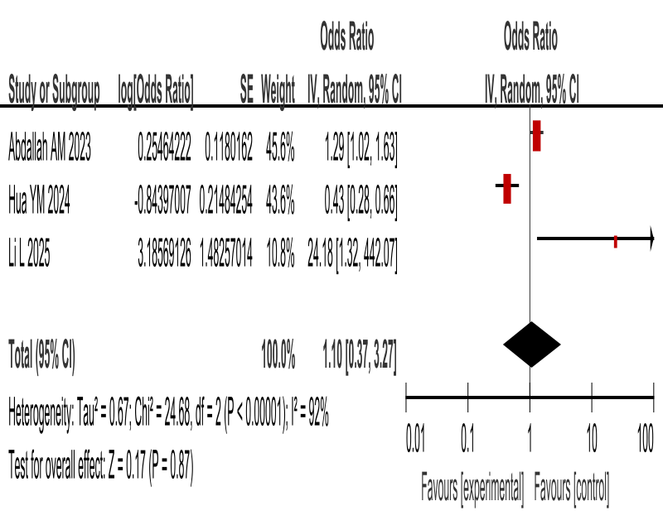
Figure 13.Forest plot of the association between continuous Albumin and CKD-associated pruritus.
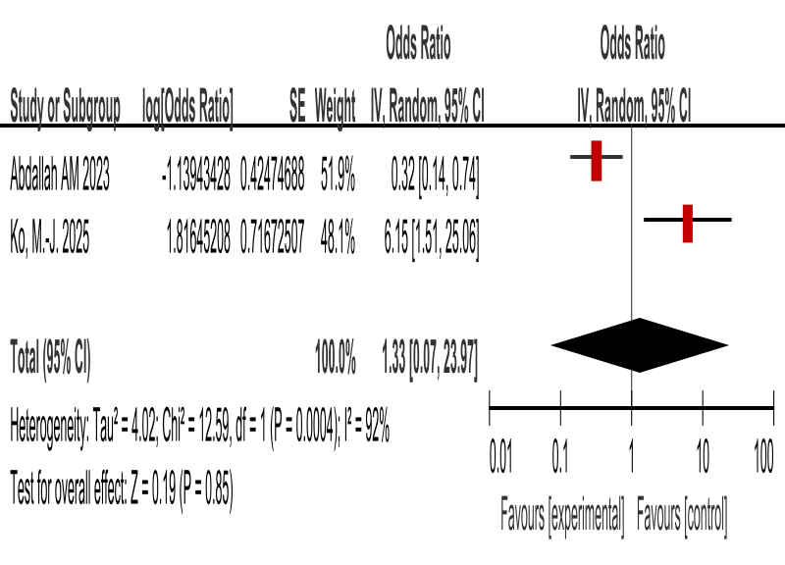
Figure 14.Forest plot of the association between dichotomised Depression and CKD-associated pruritus.
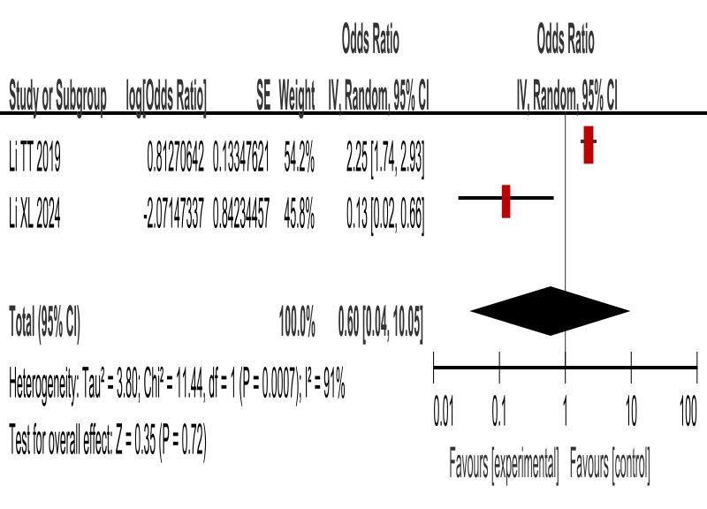
Figure 15.Forest plot of the association between continuous Body mass index(BMI) and CKD-associated pruritus.
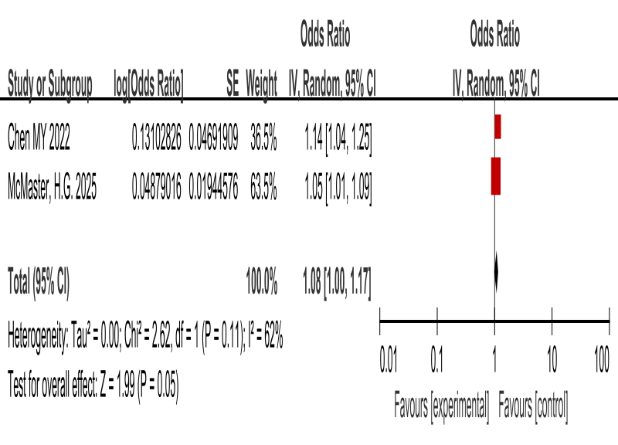
Figure 16.Forest plot of the association between dichotomised Smoking history and CKD-associated pruritus.
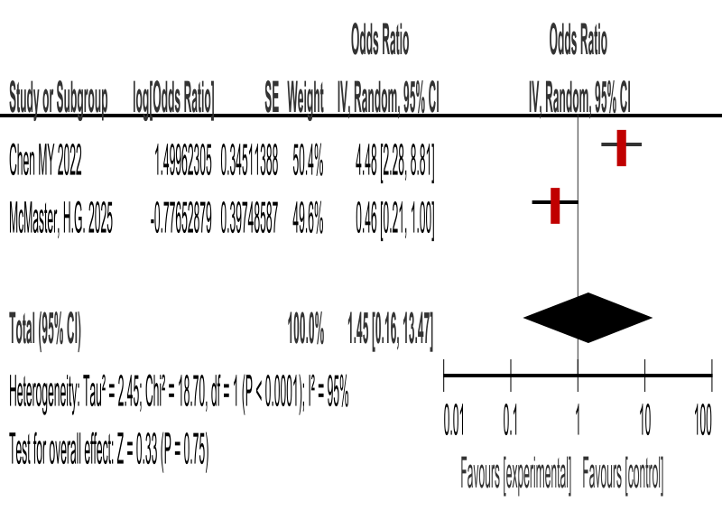
Figure 17.Forest plot of the association between dichotomised Diabetes mellitus and CKD-associated pruritus.
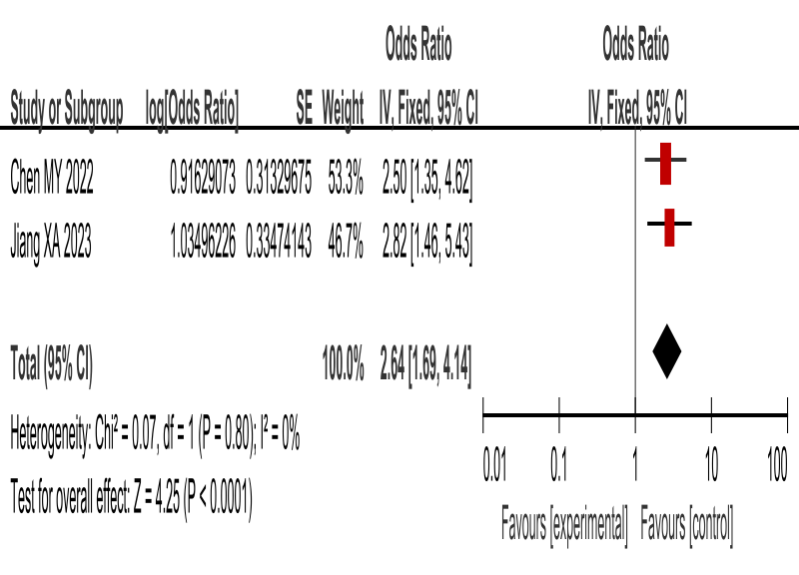
Figure 18.Forest plot of the association between continuous 25(OH)₂D₃ and CKD-associated pruritus.
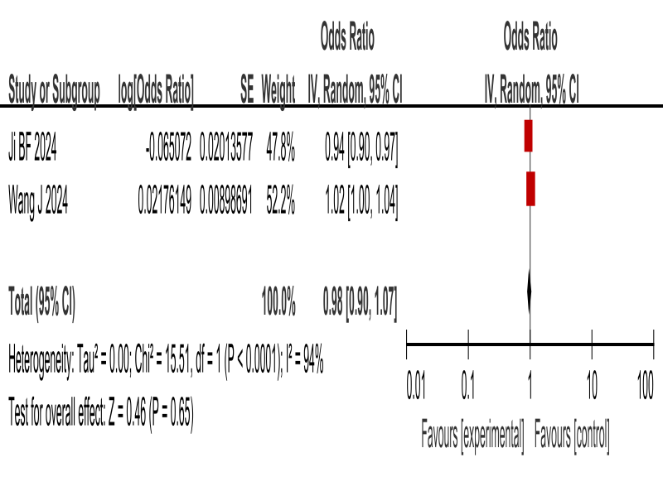
Figure 19.Forest plot of the association between continuous Sleep quality and CKD-associated pruritus.
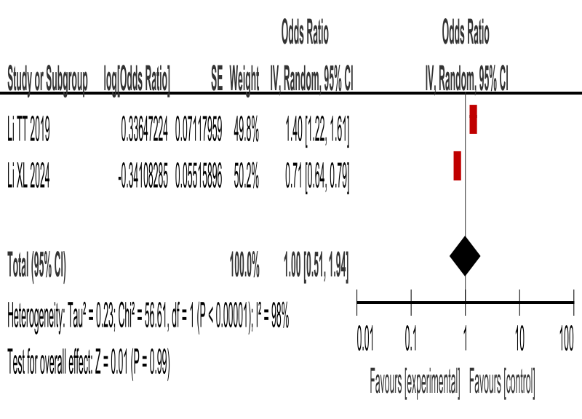
Figure 20.Forest plot of the association between dichotomised High-flux hemodialysis and CKD-associated pruritus.
