Supplement table 1. Association between admission serum phosphate levels and acute kidney injury non-recovery
Supplement table 2. Association between different admission serum phosphate categories and in hospital acute kidney injury occurrence
Supplement table 3. Association between different admission serum phosphate categories and occurrence of AKI 2-3 stage in the total patients and in patients with acute kidney injury
Supplement table 4. Association between different admission serum phosphate categories and in hospital mortality in the total patients and patients with acute kidney injury
Supplement table 5. Association between different admission serum phosphate categories and acute kidney injury non-recovery
Supplement table 6. Baseline characteristics after 1:5 propensity score matching
Supplement table 7. Test of interaction between admission serum phosphate and admission estimated glomerular filtration rate

Supplement figure 1. Association between admission serum phosphate level and in hospital acute kidney injury occurrence in patients with eGFR<30 ml/min/1.73 m² , eGFR 30-60 ml/min/1.73 m² ,eGFR 60-90 ml/min/1.73 m² , eGFR≥90 ml/min/1.73 m²
Supplement figure 2. Association between admission serum phosphate level and occurrence of AKI 2-3 stage in patients with eGFR<30 ml/min/1.73 m² , eGFR 30-60 ml/min/1.73 m² ,eGFR 60-90 ml/min/1.73 m² , eGFR≥90 ml/min/1.73 m²
Supplement figure 3. Association between admission serum phosphate level and in hospital mortality in patients with eGFR<30 ml/min/1.73 m² , eGFR 30-60 ml/min/1.73 m² ,eGFR 60-90 ml/min/1.73 m² , eGFR≥90 ml/min/1.73 m²
Supplement figure 4. Association between admission serum phosphate level and acute kidney injury non-recovery with eGFR<30 ml/min/1.73 m² , eGFR 30-60 ml/min/1.73 m² ,eGFR 60-90 ml/min/1.73 m² , eGFR≥90 ml/min/1.73 m²
Supplement figure 5. Association between admission serum phosphate level and in hospital acute kidney injury occurrence in patients without tubulointerstitial disease
Supplement figure 6. Association between admission serum phosphate level and occurrence of AKI 2-3 stage in patients without tubulointerstitial disease
Supplement figure 7. Association between admission serum phosphate level and in hospital mortality in patients without tubulointerstitial disease
Supplement figure 8. Association between admission serum phosphate level and acute kidney injury non-recovery in patients without tubulointerstitial disease

Supplement table 1. Association between admission serum phosphate levels and acute kidney injury non-recovery
Admission serum phosphate level(mmol/L) | Univariate analysis |  |  | Multivariate analysis
Admission serum phosphate level(mmol/L) | OR(95%CI) | P | P.adjust | OR(95%CI) | P | P.adjust
<0.81 | 1.12[0.91,1.40] | 0.291 | 1.000 | 1.48[1.18,1.87] | 0.001 | 0.006
0.81-<0.97 | 0.91[0.75,1.10] | 0.340 | 1.000 | 0.97[0.79,1.18] | 0.746 | 1.000
0.97-<1.13 | 1.05[0.91,1.23] | 0.486 | 1.000 | 1.07[0.92,1.26] | 0.383 | 1.000
1.13-<1.29 | REF | REF | REF | REF | REF | REF
1.29-<1.45 | 0.84[0.72,0.98] | 0.030 | 0.181 | 0.92[0.78,1.10] | 0.367 | 1.000
1.45-<1.78 | 0.58[0.48,0.70] | <0.001 | <0.001 | 0.73[0.59,0.89] | 0.002 | 0.011
≥1.78 | 0.27[0.17,0.40] | <0.001 | <0.001 | 0.59[0.37,0.92] | 0.022 | 0.130

Adjusted for heart failure, malignant solid tumor, eGFR, urea nitrogen, diuretic, aminoglycoside antibiotics, antifungal drugs, proton pump inhibitors (PPI), uric acid-lowering medication, contrast agent, lipid-lowering drugs, vasoactive drugs, β-lactam antibiotics.
OR: odds ratio, CI: confidence interval, REF: reference, eGFR: estimated glomerular filtration rate

Supplement table 2. Association between different admission serum phosphate categories and in hospital acute kidney injury occurrence
Admission serum phosphate level(mmol/L) | Univariate analysis |  |  | Multivariate analysis
Admission serum phosphate level(mmol/L) | OR (95%CI) | P | P.adjust | OR (95%CI) | P | P.adjust
<0.81 | 1.76 [1.58-1.97] | <0.001 | <0.001 | 1.32 [1.16-1.50] | <0.001 | <0.001
0.81-1.45 | REF | REF | REF | REF | REF | REF
>1.45 | 1.59[1.45-1.74] | <0.001 | <0.001 | 1.15 [1.03-1.27] | 0.011 | 0.021
Adjusted for age ,gender, surgery department, intensive care unit, hypertension, diabetes, heart failure, malignant solid tumor, cirrhosis or liver failure, cerebrovascular disease, eGFR , hemoglobin, platelet, urea nitrogen, total carbon dioxide, uric acid, albumin, blood glucose, international normalized ratio, diuretic, intra-aortic balloon pump(IABP), invasive ventilator, aminoglycoside antibiotics, glycopeptide antibiotics, antifungal drugs, glucocorticoid, immunosuppressants, lipid-lowering drugs, vasoactive drugs, β-lactam antibiotics
OR: odds ratio, CI: confidence interval, REF: reference, eGFR: estimated glomerular filtration rate

Supplement table 3. Association between different admission serum phosphate categories and occurrence of AKI 2-3 stage in the total patients and in patients with acute kidney injury
Admission serum phosphate (mmol/L) | Univariate analysis ª |  |  | Multivariate analysis ^{a,b} |  |  | Univariate analysis ^{c} |  |  | Multivariate analysis ^{c,d}
Admission serum phosphate (mmol/L) | OR (95%CI) | P | P.adjust | OR (95%CI) | P | P.adjust | OR (95%CI) | P | P.adjust | OR (95%CI) | P | P.adjust
<0.81 | 2.58[2.02,3.25] | <0.001 | <0.001 | 1.31[1.00,1.69] | 0.045 | 0.091 | 1.73[1.33,2.22] | <0.001 | <0.001 | 1.28[0.97,1.68] | 0.077 | 1.000
0.81-1.45 | REF | REF | REF | REF | REF | REF | REF | REF | REF | REF | REF | REF
>1.45 | 2.01[1.62,2.47] | <0.001 | <0.001 | 1.54[1.22,1.93] | <0.001 | <0.001 | 1.43[1.14,1.78] | 0.002 | 0.004 | 1.35[1.06,1.71] | 0.014 | 0.226
ªIn total patients, ^{c} in patients with AKI
^{b}Adjusted for surgery department, intensive care unit, hypertension, heart failure, cirrhosis or liver failure, hemoglobin, urea nitrogen, uric acid, albumin, angiotensin receptor blockers/angiotensin-converting enzyme inhibitors (ARB/ACEI), diuretic, non-steroidal anti-inflammatory drugs (NSAIDs), intra-aortic balloon pump(IABP), invasive ventilator, glycopeptide antibiotics, antifungal drugs, uric acid-lowering medication, lipid-lowering drugs, vasoactive drugs, β-lactam antibiotics.
^{d}Adjusted for intensive care unit, heart failure, cirrhosis or liver failure, urea nitrogen, albumin, Angiotensin Receptor Blockers/ Angiotensin-Converting Enzyme Inhibitors (ARB/ACEI), diuretic, invasive ventilator, glycopeptide antibiotics, antifungal drugs, uric acid-lowering medication, glucocorticoid, vasoactive drugs, lipid-lowering drugs.
OR: odds ratio, CI: confidence interval, REF: reference

Supplement table 4. Association between different admission serum phosphate categories and in hospital mortality in the total patients and patients with acute kidney injury
Admission serum phosphate (mmol/L) | Univariate analysis ª |  |  | Multivariate analysis ^{a,b} |  |  | Univariate analysis ^{c} |  |  | Multivariate analysis ^{c,d}
Admission serum phosphate (mmol/L) | OR (95%CI) | P | P.adjust | OR (95%CI) | P | P.adjust | OR (95%CI) | P | P.adjust | OR (95%CI) | P | P.adjust
<0.81 | 6.19[5.13,7.43] | <0.001 | <0.001 | 1.92[1.52,2.41] | <0.001 | <0.001 | 3.85[2.99,4.94] | <0.001 | <0.001 | 1.67[1.24,2.23] | 0.001 | 0.001
0.81-1.45 | REF | REF | REF | REF | REF | REF | REF | REF | REF | REF | REF | REF
>1.45 | 1.69[1.32,2.13] | <0.001 | <0.001 | 1.29[0.96,1.71] | 0.088 | 0.175 | 1.01[0.73,1.38] | 0.927 | 1.000 | 0.91[0.62,1.29] | 0.592 | 1.000

ªIn total patients, ^{c} in patients with AKI
^{b}Adjusted for age, surgery department, intensive care unit, diabetes, heart failure, malignant solid tumor, chronic lung disease, cirrhosis or liver failure, cerebrovascular disease, eGFR, urea nitrogen, uric acid, albumin, blood glucose, Angiotensin Receptor Blockers/ Angiotensin-Converting Enzyme Inhibitors(ARB/ACEI), diuretic, non-steroidal anti-inflammatory drugs (NSAIDs), intra-aortic balloon pump(IABP), glycopeptide antibiotics, antifungal drugs, proton pump inhibitors, glucocorticoid, contrast agent, vasoactive drugs,β-lactam antibiotics.
^{d}Adjusted for age, surgery department, hypertension, heart failure, chronic lung disease, cirrhosis or liver failure, cerebrovascular disease, eGFR, white blood cell, urea nitrogen, albumin, Angiotensin Receptor Blockers/ Angiotensin-Converting Enzyme Inhibitors (ARB/ACEI), diuretic, non-steroidal anti-inflammatory drugs (NSAIDs), glycopeptide antibiotics, antifungal drugs, antiviral drugs, proton pump inhibitors (PPI), glucocorticoid, contrast agent, vasoactive drugs, β-lactam antibiotics.
OR: odds ratio, CI: confidence interval, REF: reference, AKI: acute kidney injury, eGFR: estimated glomerular filtration rate

Supplement table 5. Association between different admission serum phosphate categories and acute kidney injury non-recovery

Admission serum phosphate level(mmol/L) | Univariate analysis |  |  | Multivariate analysis
Admission serum phosphate level(mmol/L) | OR (95%CI) | P | P.adjust | OR (95%CI) | P | P.adjust
<0.81 | 1.17 [0.96-1.43] | 0.128 | 0.257 | 1.49 [1.20-1.85] | <0.001 | 0.001
0.81-1.45 | REF | REF | REF | REF | REF | REF
>1.45 | 0.52[0.44-0.61] | <0.001 | <0.001 | 0.69 [0.58-0.83] | <0.001 | <0.001

Adjusted for heart failure, malignant solid tumor, eGFR, uric acid, urea nitrogen, diuretic, aminoglycoside antibiotics, antifungal drugs, proton pump inhibitors (PPI), uric acid-lowering medication, contrast agent, lipid-lowering drugs, vasoactive drugs, β-lactam antibiotics.
OR: odds ratio, CI: confidence interval, REF: reference, eGFR: estimated glomerular filtration rate

Supplement table 6. Baseline characteristics after 1:5 propensity score matching

 | P | SMD
Age | 0.776 | 0.004
Male | 0.094 | 0.024
Surgery department | 0.216 | 0.018
Intensive care unit | <0.001 | 0.050

Supplement table 7. Test of interaction between admission serum phosphate and admission estimated glomerular filtration rate
Item | Univariate analysis |  | Multivariate analysis
Item | OR(95%CI) | P | OR(95%CI) | P
AKI occurence
Serum phosphate:eGFR | 0.993[0.993,0.994] | <0.001 | 0.997[0.996,0.998]ª | <0.001
AKI 2-3 stage
Serum phosphate:eGFR | 0.995[0.993,0.997] | <0.001 | 1.002[0.999,1.004]^{b} | 0.179
In-hospital mortality
Serum phosphate:eGFR | 0.983[0.981,0.986] | <0.001 | 0.993[0.990,0.997]^{c} | <0.001
AKI non-recovery
Serum phosphate:eGFR | 1.008[1.007,1.010] | <0.001 | 1.004[1.003,1.006]^{d} | <0.001
a:adjusted for age, gender, surgery department, intensive care unit, hypertension, diabetes, heart failure, malignant solid tumor, cirrhosis or liver failure, cerebrovascular disease, hemoglobin, platelet, urea nitrogen, total carbon dioxide, uric acid, albumin, blood glucose, international normalized ratio, diuretic, intra-aortic balloon pump(IABP), invasive ventilator, aminoglycoside antibiotics, glycopeptide antibiotics, antifungal drugs, glucocorticoid, immunosuppressants, lipid-lowering drugs, vasoactive drugs,β-lactam antibiotics.
b: adjusted for surgery department, intensive care unit, hypertension, heart failure, cirrhosis or liver failure, hemoglobin, urea nitrogen, uric acid, albumin, angiotensin receptor blockers/angiotensin-converting enzyme inhibitors(ARB/ACEI), diuretic, non-steroidal anti-inflammatory drugs (NSAIDs), intra-aortic balloon pump (IABP), invasive ventilator, glycopeptide antibiotics, antifungal drugs, uric acid-lowering medication, lipid-lowering drugs, vasoactive drugs, β-lactam antibiotics.
c: Adjusted for age, surgery department, intensive care unit, diabetes, heart failure, malignant solid tumor, chronic lung disease, cirrhosis or liver failure, cerebrovascular disease, urea nitrogen, uric acid, albumin, blood glucose, Angiotensin Receptor Blockers/ Angiotensin-Converting Enzyme Inhibitors(ARB/ACEI), diuretic, non-steroidal anti-inflammatory drugs (NSAIDs), intra-aortic balloon pump(IABP), glycopeptide antibiotics, antifungal drugs, proton pump inhibitors, glucocorticoid, contrast agent, vasoactive drugs,β-lactam antibiotics.
d: adjusted for heart failure, malignant solid tumor, urea nitrogen, diuretic, aminoglycoside antibiotics, antifungal drugs, proton pump inhibitors (PPI), uric acid-lowering medication, contrast agent, lipid-lowering drugs, vasoactive drugs, β-lactam antibiotics.

Supplement figure 1. Association between admission serum phosphate level and in hospital acute kidney injury occurrence in patients with eGFR<30 ml/min/1.73 m² , eGFR 30-60 ml/min/1.73 m² ,eGFR 60-90 ml/min/1.73 m² , eGFR≥90 ml/min/1.73 m²

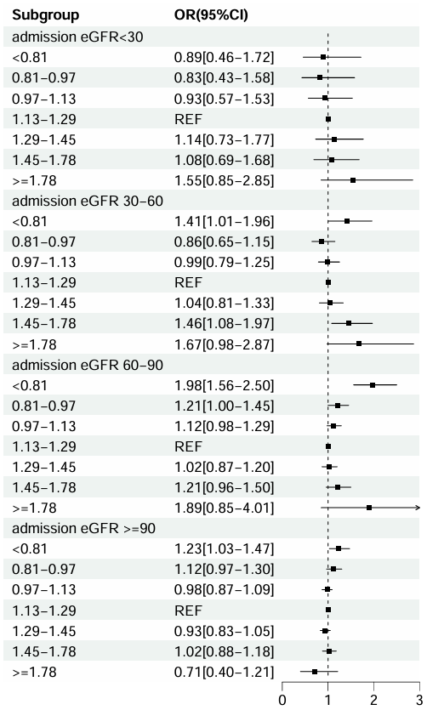
Adjusted for age, gender, surgery department, intensive care unit, hypertension, diabetes, heart failure, malignant solid tumor, cirrhosis or liver failure, cerebrovascular disease, eGFR, hemoglobin, platelet, urea nitrogen, total carbon dioxide, uric acid, albumin, blood glucose, international normalized ratio, diuretic, intra-aortic balloon pump(IABP), invasive ventilator, aminoglycoside antibiotics, glycopeptide antibiotics, antifungal drugs, glucocorticoid, immunosuppressants, lipid-lowering drugs, vasoactive drugs,β-lactam antibiotics.
OR: odds ratio, CI: confidence interval, eGFR: estimated glomerular filtration rate, REF: reference

Supplement figure 2. Association between admission serum phosphate level and occurrence of AKI 2-3 stage in patients with eGFR<30 ml/min/1.73 m² , eGFR 30-60 ml/min/1.73 m² ,eGFR 60-90 ml/min/1.73 m² , eGFR≥90 ml/min/1.73 m²
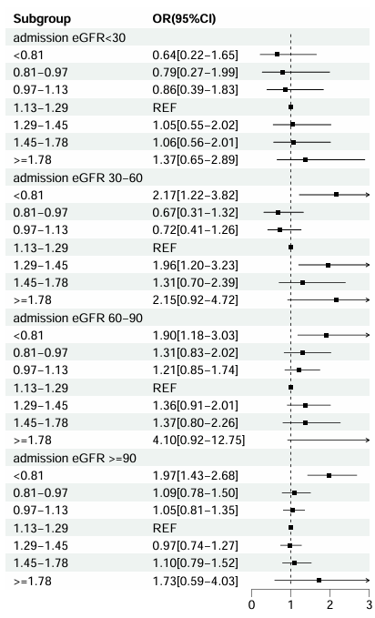
Adjusted for platelet, urea nitrogen, uric acid, diuretic, non-steroidal anti-inflammatory drugs (NSAIDs), intra-aortic balloon pump(IABP), invasive ventilator, glycopeptide antibiotics, vasoactive drugs,β-lactam antibiotics.

OR: odds ratio, CI: confidence interval, eGFR: estimated glomerular filtration rate, REF: reference

Supplement figure 3. Association between admission serum phosphate level and in hospital mortality in patients with eGFR<30 ml/min/1.73 m², eGFR 30-60 ml/min/1.73 m², eGFR 60-90 ml/min/1.73 m², eGFR≥90 ml/min/1.73 m²
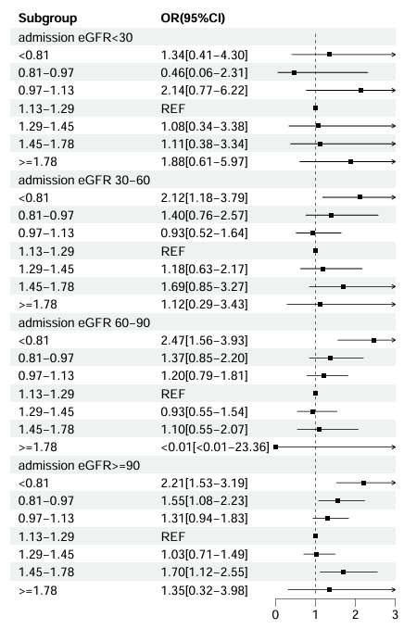
Adjusted for age, heart failure, chronic lung disease, cirrhosis or liver failure, white blood cell, platelet, urea nitrogen, albumin, blood glucose, international normalized ratio (INR), diuretic, non-steroidal anti-inflammatory drugs (NSAIDs), glycopeptide antibiotics, antifungal drugs, proton pump inhibitors, glucocorticoid, vasoactive drugs, β-lactam antibiotics.
OR: odds ratio, CI: confidence interval, eGFR: estimated glomerular filtration rate, REF: reference

Supplement figure 4. Association between admission serum phosphate level and acute kidney injury non-recovery with eGFR<30 ml/min/1.73 m² , eGFR 30-60 ml/min/1.73 m² ,eGFR 60-90 ml/min/1.73 m² , eGFR≥90 ml/min/1.73 m²
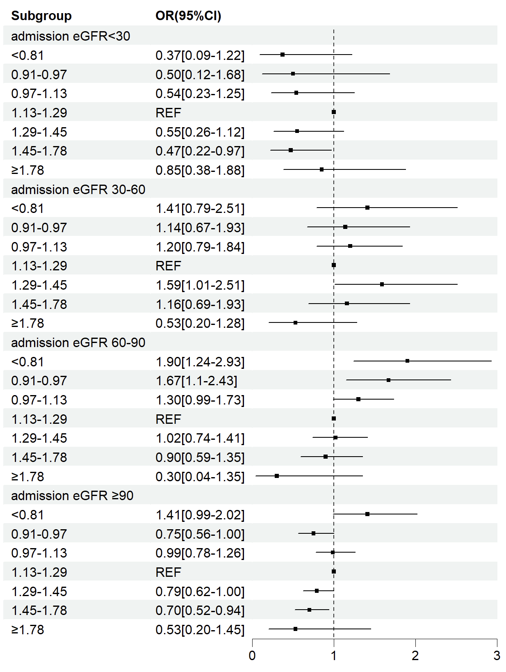
eGFR<30 ml/min/1.73 m²: Adjusted for age, malignant solid tumor, glycopeptide antibiotics
eGFR 30-60 ml/min/1.73 m²: Adjusted for age, intensive care unit, albumin, blood glucose
eGFR 60-90 ml/min/1.73 m²: Adjusted for age, coronary heart disease, malignant solid tumor, hemoglobin, diuretic, nonsteroidal anti-inflammatory drugs, invasive ventilator, aminoglycoside antibiotics, contrast agent, β-lactam antibiotics
eGFR≥90 ml/min/1.73 m²: Adjusted for male, malignant solid tumor, uric acid, international normalized ratio, diuretic, glycopeptide antibiotics, proton pump inhibitors, contrast agent, β-lactam antibiotics
OR: odds ratio, CI: confidence interval, eGFR: estimated glomerular filtration rate, REF: reference

Supplement figure 5. Association between admission serum phosphate level and in hospital acute kidney injury occurrence in patients without tubulointerstitial disease
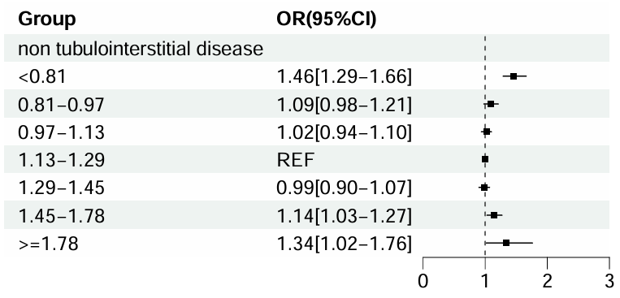
Adjusted for age, gender, surgery department, intensive care unit, hypertension, diabetes, heart failure, malignant solid tumor, cirrhosis or liver failure, cerebrovascular disease, eGFR, hemoglobin, platelet, urea nitrogen, total carbon dioxide, uric acid, albumin, blood glucose, international normalized ratio, diuretic, intra-aortic balloon pump(IABP), invasive ventilator, aminoglycoside antibiotics, glycopeptide antibiotics, antifungal drugs, glucocorticoid, immunosuppressants, lipid-lowering drugs, vasoactive drugs,β-lactam antibiotics.
OR: odds ratio, CI: confidence interval, REF: reference

Supplement figure 6. Association between admission serum phosphate level and occurrence of AKI 2-3 stage in patients without tubulointerstitial disease
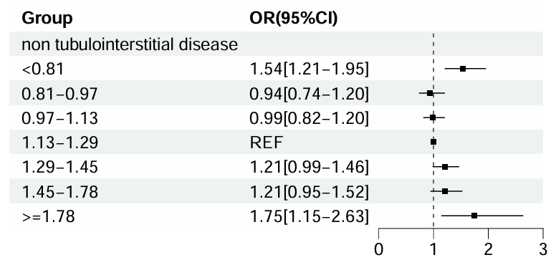
Adjusted for surgery department, intensive care unit, hypertension, heart failure, cirrhosis or liver failure, hemoglobin, urea nitrogen, uric acid, albumin, angiotensin receptor blockers/angiotensin-converting enzyme inhibitors (ARB/ACEI), diuretic, non-steroidal anti-inflammatory drugs (NSAIDs), intra-aortic balloon pump (IABP), invasive ventilator, glycopeptide antibiotics, antifungal drugs, uric acid-lowering medication, lipid-lowering drugs, vasoactive drugs, β-lactam antibiotics.
OR: odds ratio, CI: confidence interval, REF: reference, AKI: acute kidney injury, eGFR: estimated glomerular filtration rate

Supplement figure 7. Association between admission serum phosphate level and in hospital mortality in patients without tubulointerstitial disease
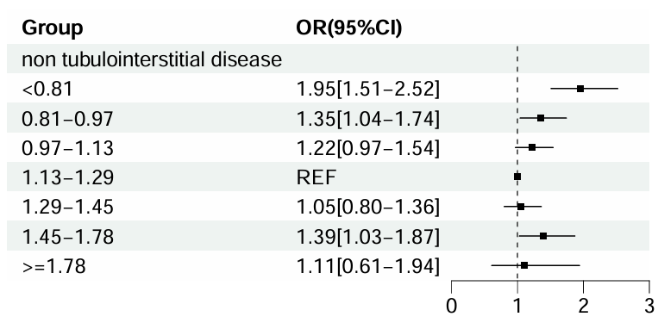
Adjusted for age, surgery department, intensive care unit, diabetes, heart failure, malignant solid tumor, chronic lung disease, cirrhosis or liver failure, cerebrovascular disease, eGFR, urea nitrogen, uric acid, albumin, blood glucose, Angiotensin Receptor Blockers/ Angiotensin-Converting Enzyme Inhibitors(ARB/ACEI), diuretic, non-steroidal anti-inflammatory drugs (NSAIDs), intra-aortic balloon pump(IABP), glycopeptide antibiotics, antifungal drugs, proton pump inhibitors, glucocorticoid, contrast agent, vasoactive drugs,β-lactam antibiotics.
OR: odds ratio, CI: confidence interval, REF: reference, eGFR: estimated glomerular filtration rate

Supplement figure 8. Association between admission serum phosphate level and acute kidney injury non-recovery in patients without tubulointerstitial disease
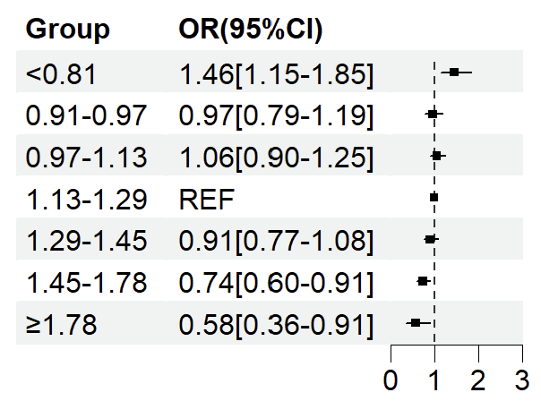
Adjusted for heart failure, malignant solid tumor, eGFR, urea nitrogen, diuretic, aminoglycoside antibiotics, antifungal drugs, proton pump inhibitors (PPI), uric acid-lowering medication, lipid-lowering drugs, contrast agent, vasoactive drugs, β-lactam antibiotics.
OR: odds ratio, CI: confidence interval, REF: reference

