Supplementary Table S1. Baseline characteristics of the maintenance hemodialysis patients
 | Regular health-check | Clinically indicated | p-value
Patient, ^{c} n(%) | 159(78) | 46(22)
Dialysis vintage, ^{b} months | 44.0(20.0,72.0) | 42.5(23.5,83.3) | 0.928
Age, ª years | 57.5±15.3 | 60.8±11.5 | 0.120
Gender, M/F | 92/67 | 29/17 | 0.529
BMI, ª kg/m² | 22.3±4.0 | 22.2±3.5 | 0.973
Kt/V | 1.5±0.3 | 1.5±0.3 | 0.948
Hypertension, ^{c} n(%) | 145(91.2) | 42(91.3) | 1.000
Diabetes, ^{c} n(%) | 61(38.4) | 18(39.1) | 0.925
Calcium-free phosphate binders, ^{c} n(%) | 74(46.5) | 24(52.2) | 0.501
Calcium-based phosphate binders, ^{c} n(%) | 11(6.9) | 4(8.7) | 0.748
Active vitamin D3, ^{c} n(%) | 45(28.3) | 15(32.6) | 0.572
Hemoglobin, ª g/dl | 10.9±1.7 | 10.9±1.8 | 0.787
hs-CRP, ^{b} mg/l | 1.5(0.4,4.6) | 1.3(0.1,6.9) | 0.666
Total protein, ª g/dl | 6.4±0.6 | 6.5±0.6 | 0.491
Albumin, ª g/dl | 3.8±0.5 | 3.7±0.4 | 0.514
Creatinine, ª mg/dl | 9.2±3.3 | 9.4±3.4 | 0.769
Uric acid, ª mg/dl | 5.9±1.8 | 5.9±1.9 | 0.885
Urea, ª mg/dl | 123.2±45.1 | 116.6±39.1 | 0.343
Corrected calcium, ª mg/dl | 9.5±0.8 | 9.4±0.7 | 0.289
Phosphorus, ª mg/dl | 5.2±1.5 | 5.3±1.7 | 0.762
Magnesium, ª mg/dl | 2.4±0.3 | 2.4±0.4 | 0.492
Glucose, ^{b} mg/dl | 104.9(86.4,142.6) | 99.4(83.5,155.7) | 0.973
Total cholesterol, ª mg/dl | 148.1±44.9 | 144.6±39.1 | 0.629
Triglyceride, ^{b} mg/dl | 127.5(91.2,202.8) | 142.6(85.0,227.6) | 0.699
LDL-C, ª mg/dl | 81.9±30.5 | 83.5±28.6 | 0.751
HDL-C, ª mg/dl | 38.7±13.9 | 36.0±12.0 | 0.227
Alkaline phosphatase, ^{b} U/l | 89.0(67.0,115.0) | 86.0(63.8,127.0) | 0.966
iPTH, ^{b} pg/ml | 197.6(92.6,380.4) | 145.3(78.0,402.5) | 0.423
AoACS | 191(0,631) | 293(15,1039) | 0.255

BMI body mass index; hs-CRP hypersensitive C-reactive protein; LDL-C low-density lipoprotein cholesterol; HDL-C high-density lipoprotein cholesterol; iPTH intact parathyroid hormone.
ª Data are presented as mean ± SD for normally distributed continuous variables.
^{b} median (IQR) for non-normally distributed continuous variables.
^{c} n (%) for categorical variables.
* p < 0.05
Supplementary Table S2. Aortic arch calcification voxel counts and volumes by CT attenuation ranges
HU Range | Voxel Count (n) | Calcium Volume (mm³)
130–199 | 703 | 1522.80
200–299 | 597 | 1293.19
300–399 | 325 | 704.00
≥400 | 412 | 892.46

Supplementary Table S3. Variance inflation factors (VIFs) for multivariable Cox models
Model type | Predictor variable | VIF value
Cardiovascular mortality | Age | 1.71
Cardiovascular mortality | Diabetes | 1.16
Cardiovascular mortality | Creatinine | 1.25
Cardiovascular mortality | Log(AoACS+1) | 1.37
All-cause mortality | Age | 1.88
All-cause mortality | Diabetes | 1.40
All-cause mortality | Creatinine | 1.86
All-cause mortality | Urea | 1.57
All-cause mortality | Alkaline phosphatase | 1.07
All-cause mortality | Albumin | 1.15
All-cause mortality | Glucose | 1.31
All-cause mortality | Active vitamin D3 | 1.07
All-cause mortality | Log(AoACS+1) | 1.47
Note: All covariates entered into each multivariable Cox model are listed, corresponding exactly to the variables with adjusted estimates in Tables 2 and 3. VIFs were calculated using the complete covariate set of each final model. Variables with p < 0.05 in univariate Cox analysis were entered simultaneously (enter method). All VIFs were < 2, indicating no significant multicollinearity.
Supplementary Table S4a. Discrimination metrics (C-index) for cardiovascular death
Endpoint | Base model  C-index (95 % CI) | Base + log(AoACS+1) model  C-index (95 % CI) | ΔC-index
Cardiovascular death | 0.784 (0.702–0.866) | 0.804 (0.728–0.880) | +0.020
Notes:
Base model includes age, diabetes, and serum creatinine.
Base + log(AoACS+1) model includes the base model covariates plus the log-transformed aortic arch calcification score.
ΔC-index represents the change in C-index after adding log(AoACS+1) to the base model.

Supplementary Table S4b. Discrimination metrics (C-index) for all-cause death
Endpoint | Base model  C-index (95 % CI) | Base + log(AoACS+1) model  C-index (95 % CI) | ΔC-index
All-cause death | 0.806 (0.755–0.857) | 0.820 (0.773–0.867) | +0.014
Notes:
Base model includes age, diabetes, and serum creatinine, albumin, urea, fasting glucose, alkaline phosphatase, prescription of active vitamin D3.
Base + log(AoACS+1) model includes the base model covariates plus the log-transformed aortic arch calcification score.
ΔC-index represents the change in C-index after adding log(AoACS+1) to the base model.

Supplementary Table S4c. Reclassification metrics (NRI and IDI) for cardiovascular and all-cause mortality
Endpoint | Continuous NRI (95 % CI) | p | IDI (95 % CI) | p
Cardiovascular death | 0.106 (-0.368–0.312) | 0.651 | 0.003 (-0.006–0.038) | 0.486
All-cause death | 0.255 (-0.040–0.431) | 0.070 | 0.046 (0.003–0.117) | 0.038
Notes:
Base model for cardiovascular death includes age, diabetes, and serum creatinine.
Base model for all-cause death includes age, diabetes, and serum creatinine, albumin, urea, fasting glucose, alkaline phosphatase, prescription of active vitamin D3.
Base + log(AoACS+1) model includes the base model covariates plus the log-transformed aortic arch calcification score

Supplementary Methods – AoACS Calculation on MANGO 4.1
- Import axial non-contrast DICOM images into MANGO 4.1.
- Set the threshold to 130–199 HU (Toolbox → Set Explicit Value Range).
- Manually outline the aortic arch ROI (the calcified component of the aortic arch) on every slice within the previously defined anatomical boundaries (Toolbox → Paint Mode).
- Repeat steps 2–3 for 200–299 HU, 300–399 HU, and ≥ 400 HU, re-delineating the identical anatomical region of the aortic arch on each occasion.
- Record the calcified volume (Analysis → ROI Statistics → Volume → Size, mm³); convert to area by dividing by the 5 mm slice thickness.
- Multiply each volume-derived area by its density factor (1, 2, 3 or 4) and sum the four products to obtain the AoACS.
Note on AoACS calculation
AoACS is calculated in two mathematically equivalent ways:
• slice-by-slice summation of (area × density factor); or
• summation of the four partial scores obtained by integrating the calcified areas within each attenuation window multiplied by the respective density factors (1–4). Both methods yield identical result.

Reconstruction parameters
Images were reconstructed using a standard soft-tissue kernel (B) with a field of view (FOV) of 350 mm and matrix size of 512 × 512. The reconstruction slice thickness was 5 mm with 5 mm interval (no overlap), using iDose 3. Pitch was 0.938.

Minimum detection threshold
A minimum threshold of 130 HU was applied. Given that this study used non-gated chest CT with 5 mm slice thickness, the aortic arch has a large diameter and calcified plaques are typically continuous and voluminous. The 130 HU threshold is sufficient to distinguish calcification from surrounding soft tissue; therefore, no additional minimum lesion area or cluster size threshold was specified. This differs from coronary artery Agatston scoring, where a minimum lesion area of ≥1 mm² is typically required due to the small target vessel size and susceptibility to artifacts and noise.

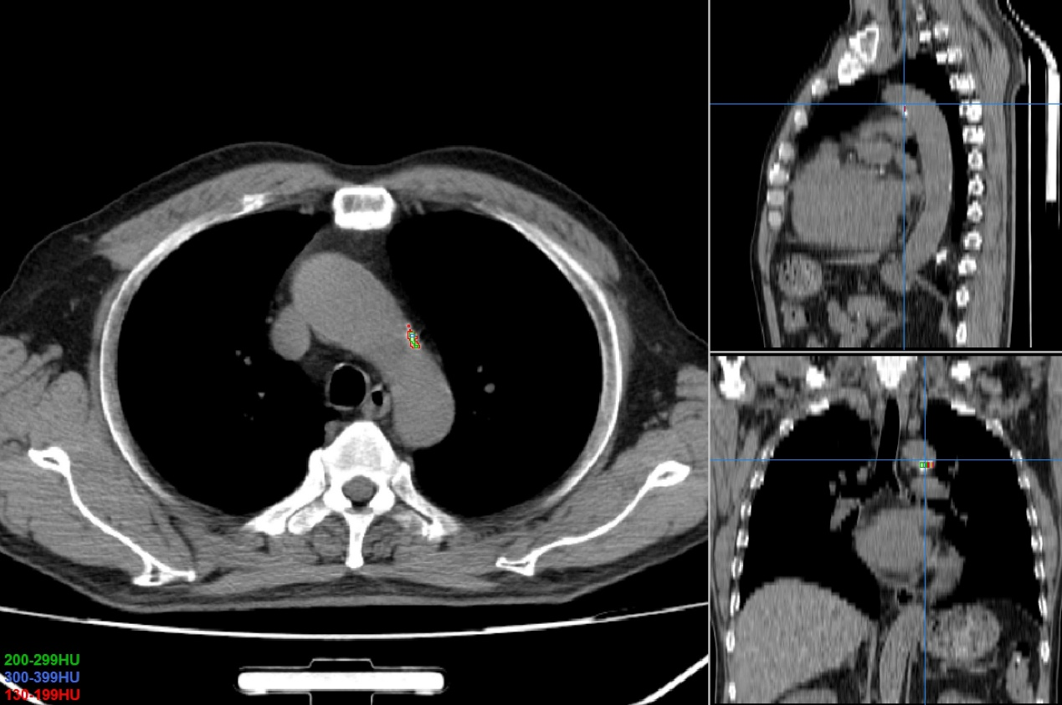
(A)

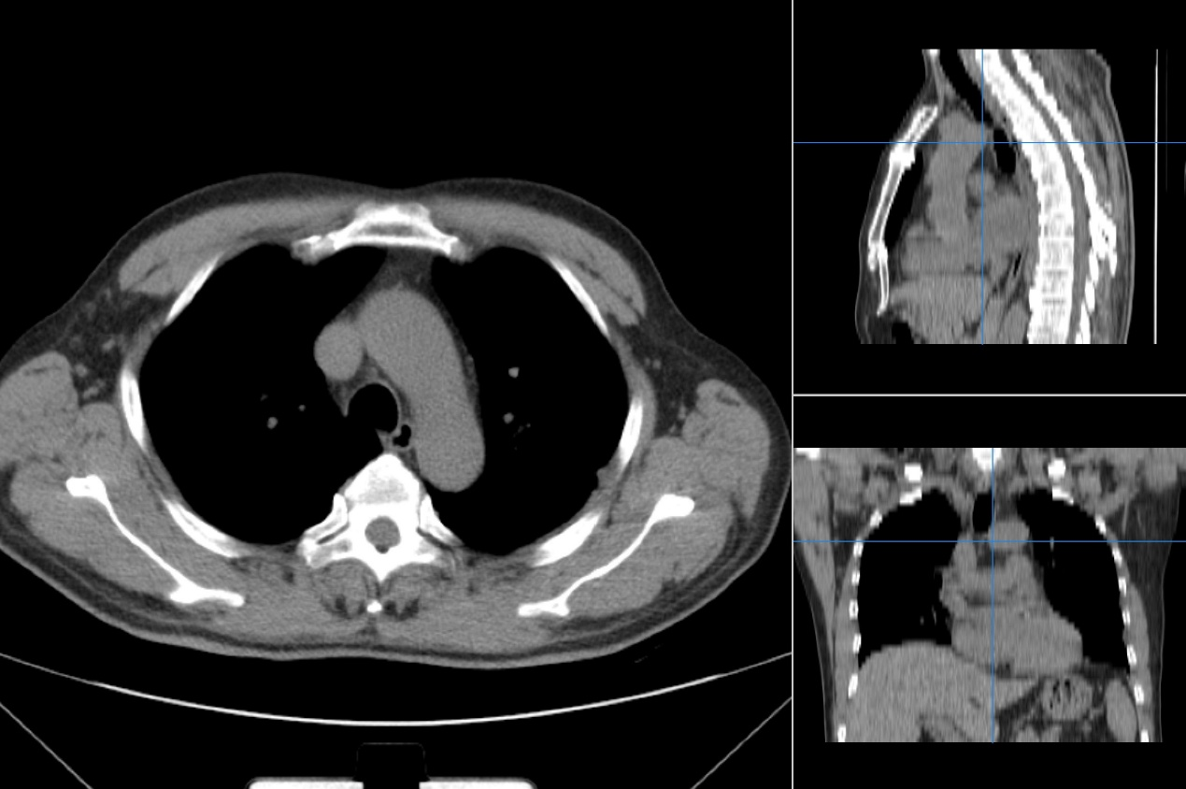
(B)

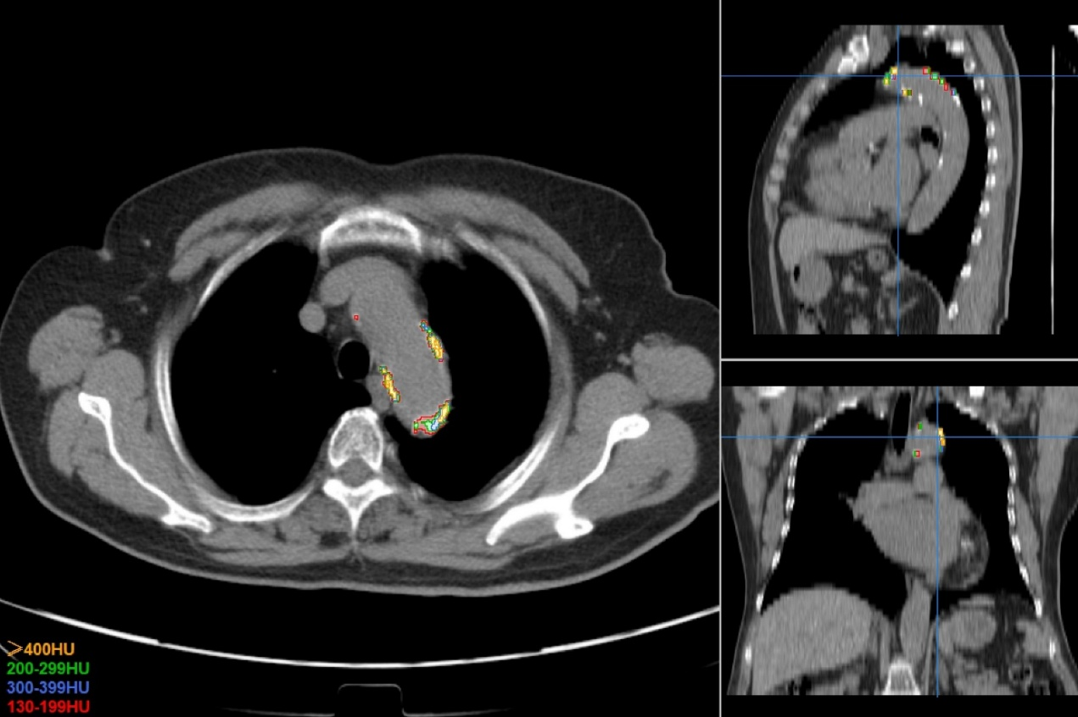
(C)

Supplementary Figure S1. Representative non-contrast chest CT images of the aortic arch illustrating the AoACS grading system. (A) Grade 0: No visible calcification (AoACS = 0). (B) Grade 1: Mild calcification with focal hyperdense plaques (AoACS < 491, below median). (C) Grade 2: Severe calcification with extensive, dense calcified plaques (AoACS ≥ 491, above median).

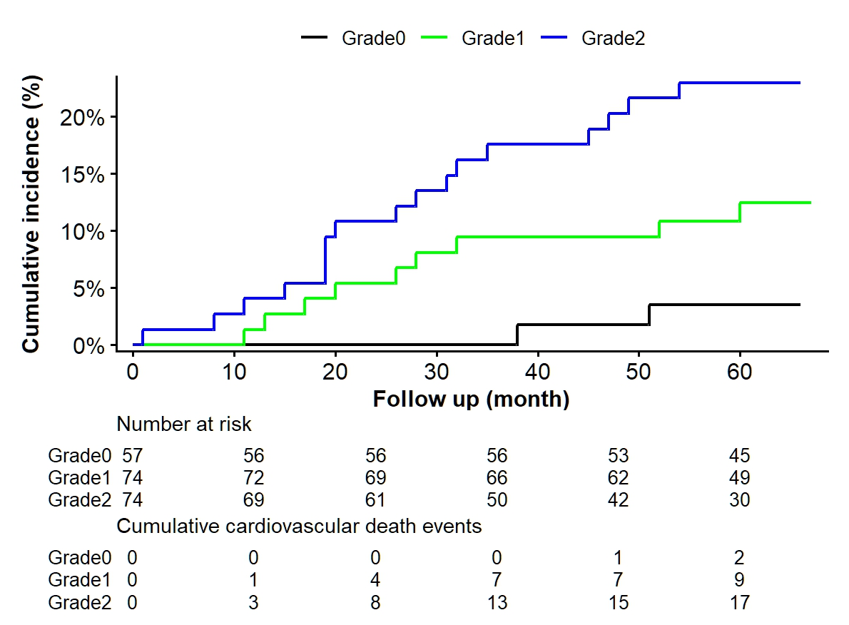
Supplementary Figure S2. Cumulative incidence functions for cardiovascular mortality by AoACS groups. Gray's test, p = 0.0045.

