Additional File 2
Figures
Additional File 2 Figure 1. Lesion numbers at Weeks 24 and 48
New active lesions (sum of Gd+ plus non-enhancing new or newly-enlarging T2 hyperintense) compared to baseline
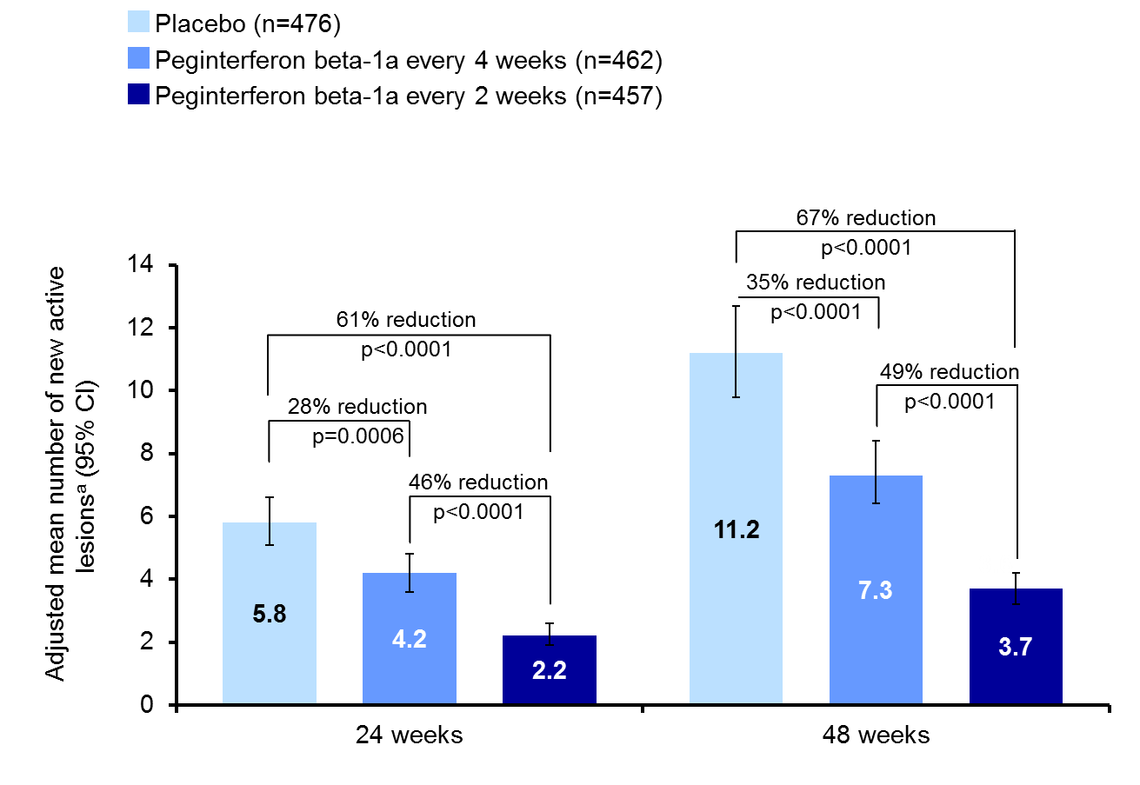
ªBased on mean number of new lesions. Negative binomial regression analysis, adjusted for baseline number of Gd+ lesions. The data for 48 weeks has been published previously [10]. CI = confidence interval.

Additional File 2 Figure 2. MRI-NEDA proportions
- Baseline to Week 48
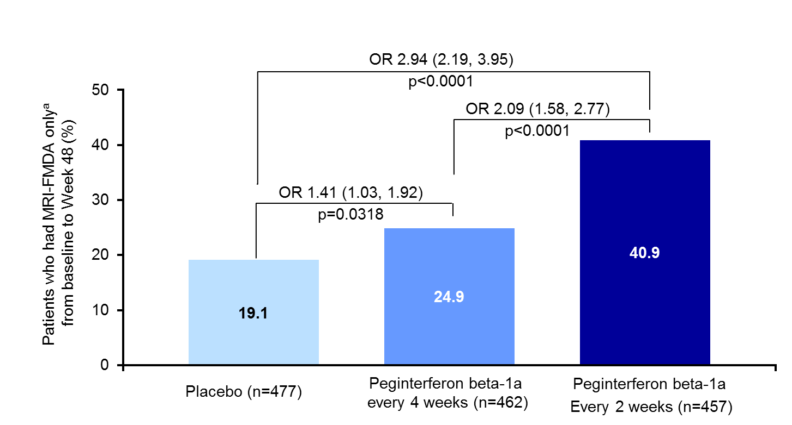
- Baseline to Week 24
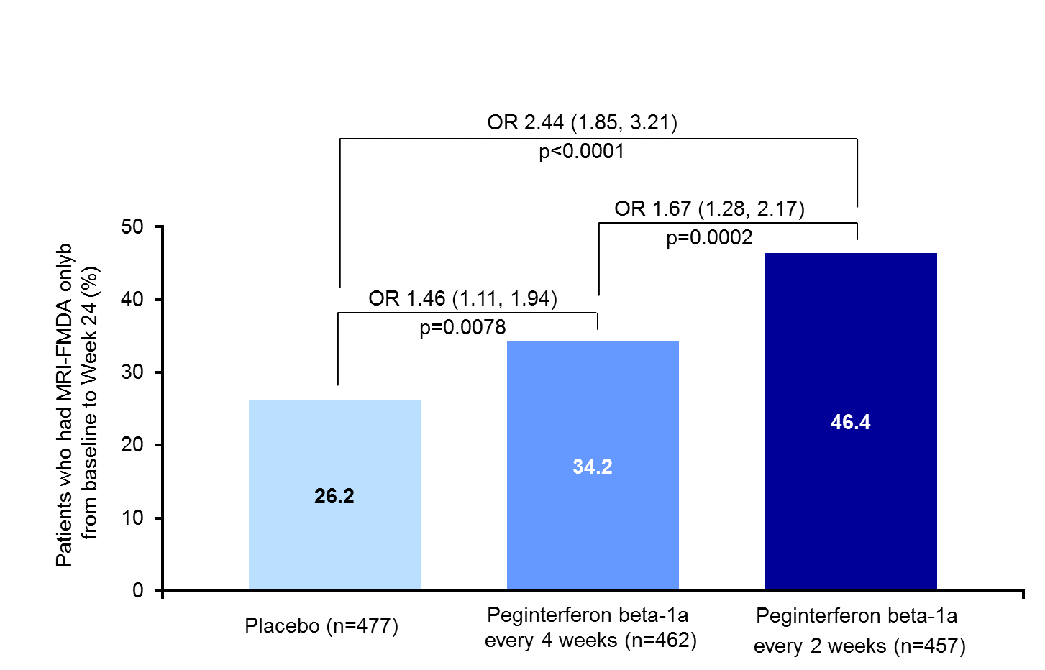

- Weeks 24−48
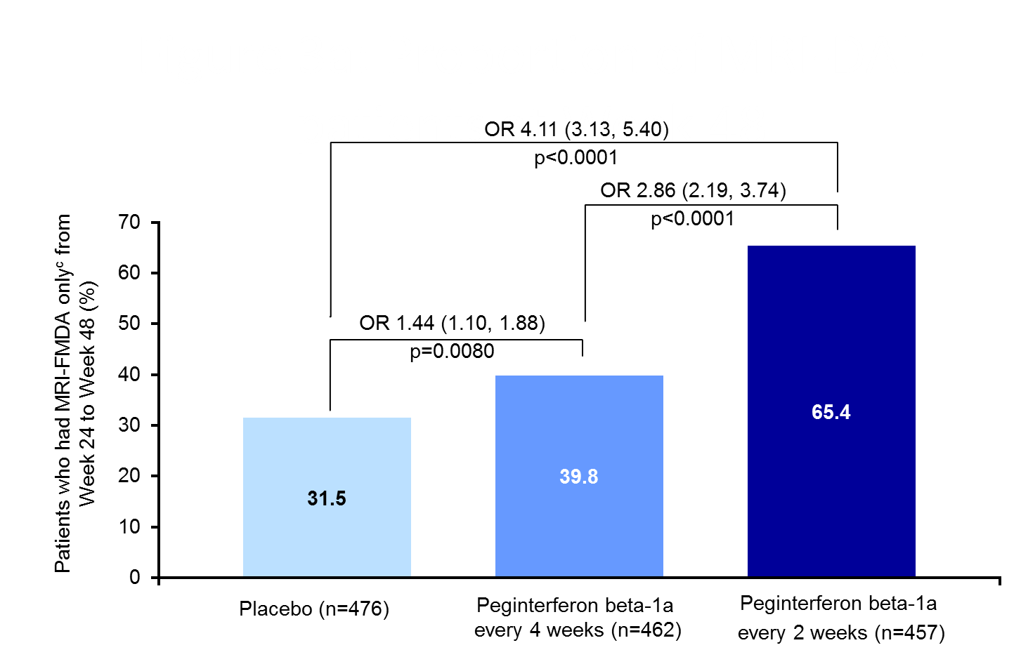
ORs are shown with 95% confidence intervals in parentheses. ªDefined as no gadolinium-enhancing lesions at Week 24 and Week 48 and no new or newly-enlarging T2 lesions compared with baseline at Week 48. ^{b}Defined as no gadolinium-enhancing lesions at Week 24 and no new or newly-enlarging T2 lesions at Week 24 compared with baseline; ^{c}Defined as no gadolinium-enhancing lesions at Week 48 and no new or newly-enlarging T2 lesions at Week 48 compared with Week 24 or the closest previous visit before Week 48. Data from patients with complete MRI results during the time interval were used. NEDA=No evidence of disease activity; MRI = magnetic resonance imaging; OR = odds ratio.

Additional File 2 Figure 3. Clinical-NEDA proportions
- Baseline to Week 48
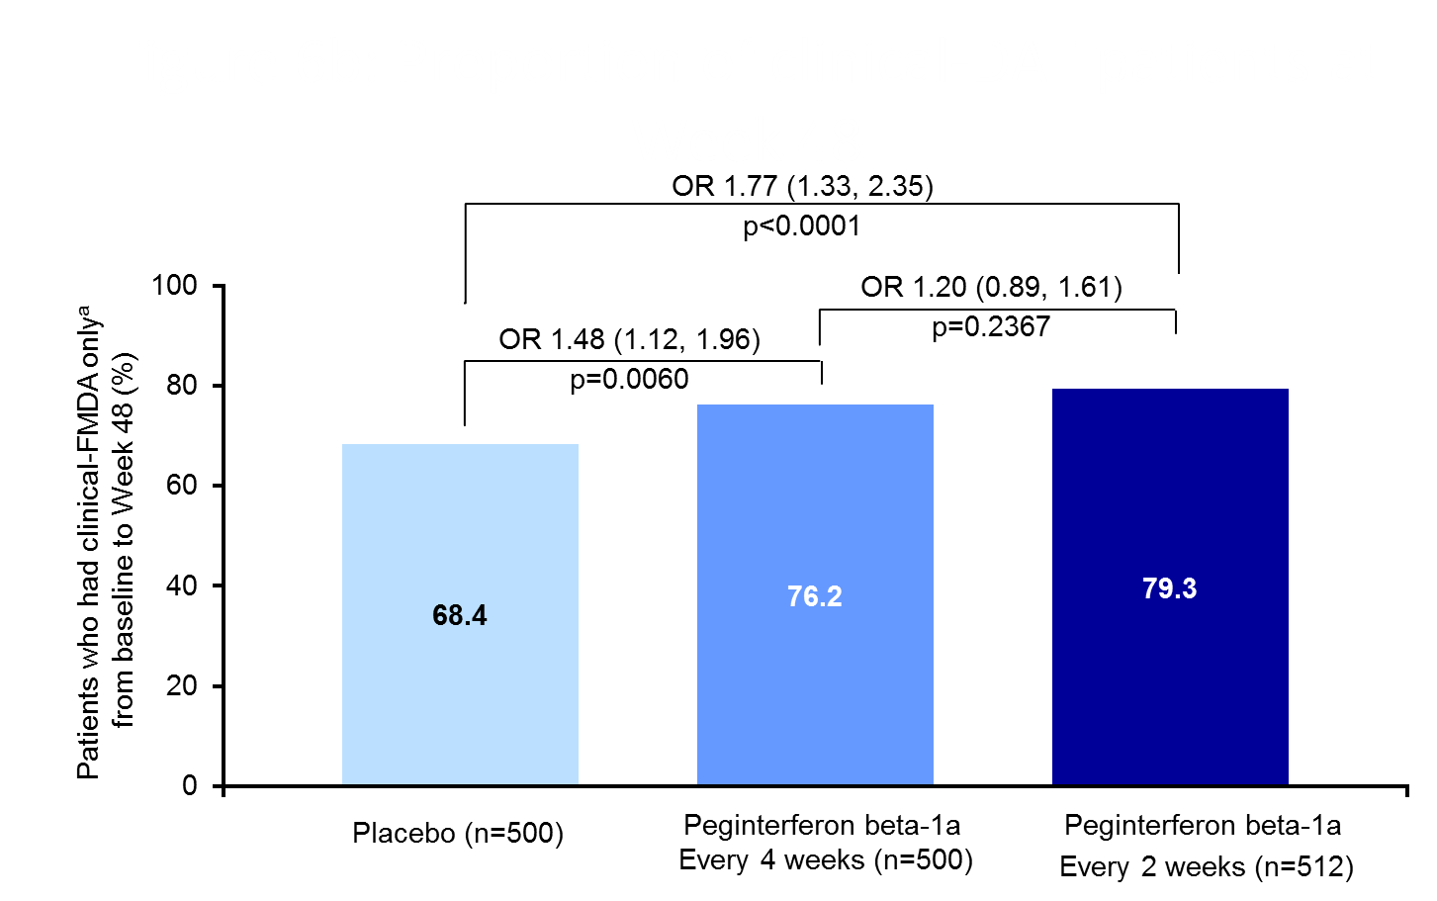

- Baseline to Week 24
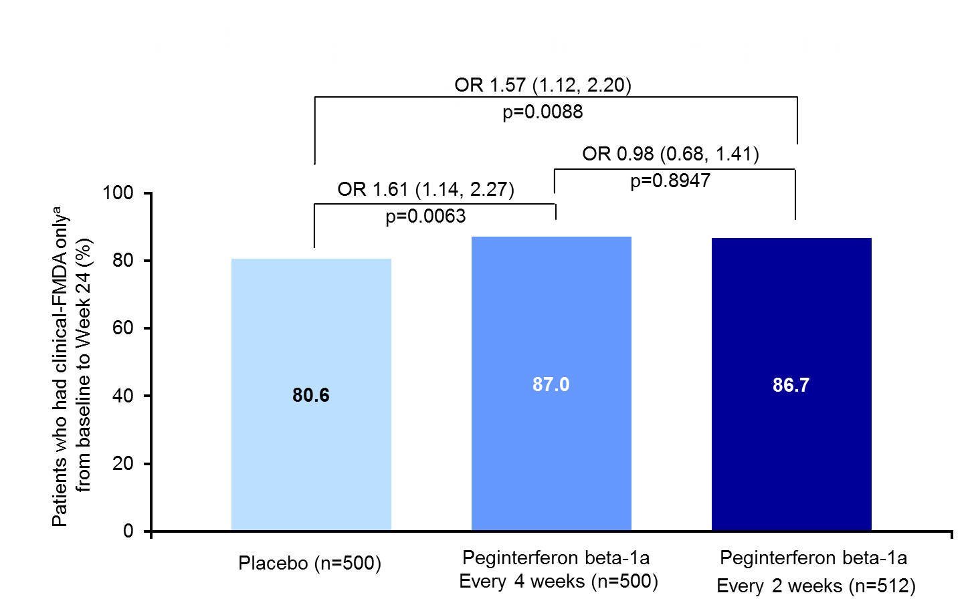
- Weeks 24−48
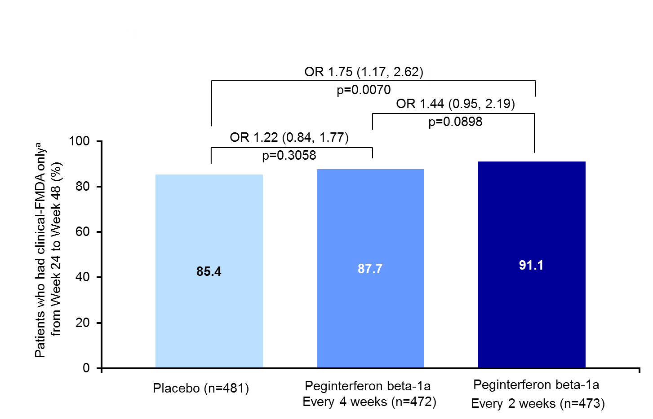
ORs are shown with 95% confidence intervals in parentheses. ªDefined as no relapses and no onset of 12-week confirmed disability progression over the interval specified. NEDA = No evidence of disease activity; OR = odds ratio.

