Supplementary Material

Figure S1. Prevalences of the single item scores

Table S1. UWDRS and GAS for WD Tier 2 (sub)scores depending on gender, KFR, and liver cirrhosis

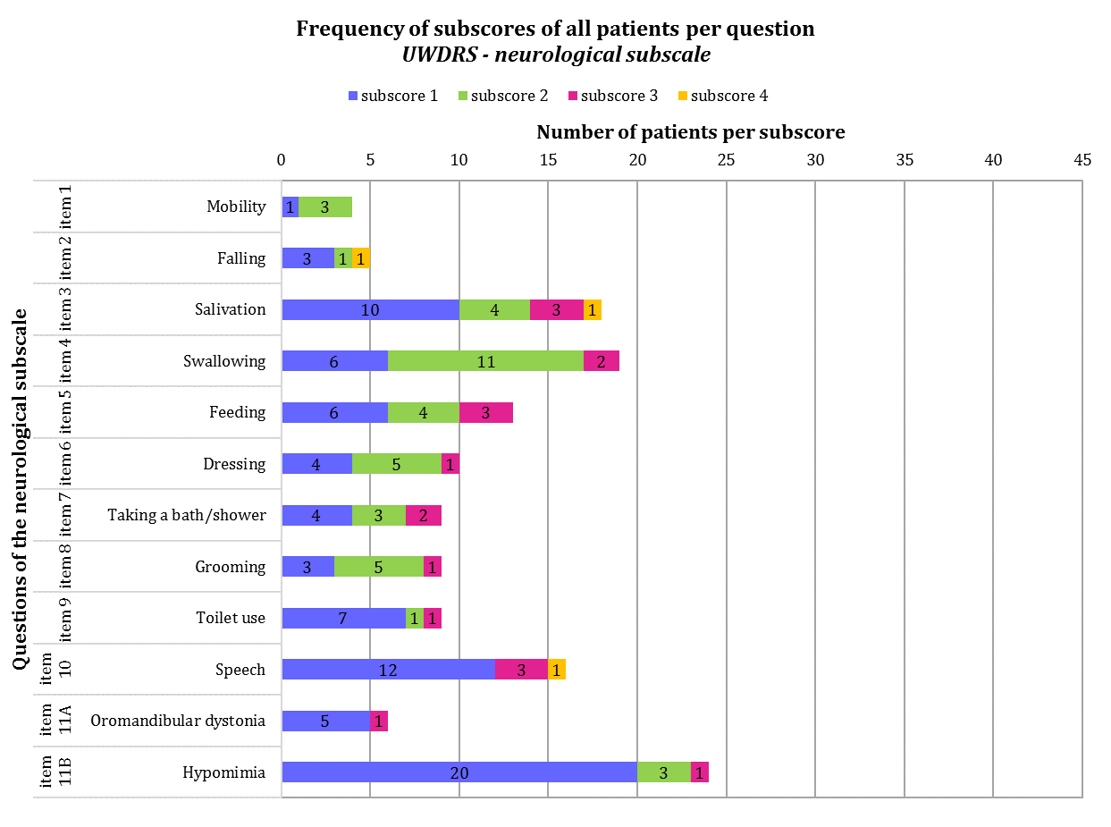
Single-item total score correlation | Cronbach’s α for omitted item
0.68 | 0.96
0.49 | 0.96
0.45 | 0.96
0.50 | 0.96
0.77 | 0.96
0.84 | 0.96
0.74 | 0.96
0.85 | 0.96
0.81 | 0.96
0.62 | 0.96
0.35 | 0.96
0.57 | 0.96

Single-item total score correlation | Cronbach‘s α for omitted item
0.55 | 0.96
0.45 | 0.96
-0.02 | 0.96
-0.02 | 0.96
0.41 | 0.96
0.33 | 0.96
0.48 | 0.96
0.51 | 0.96
- | -
- | -
0.81 | 0.96
0.78 | 0.96
0.69 | 0.96
0.70 | 0.96

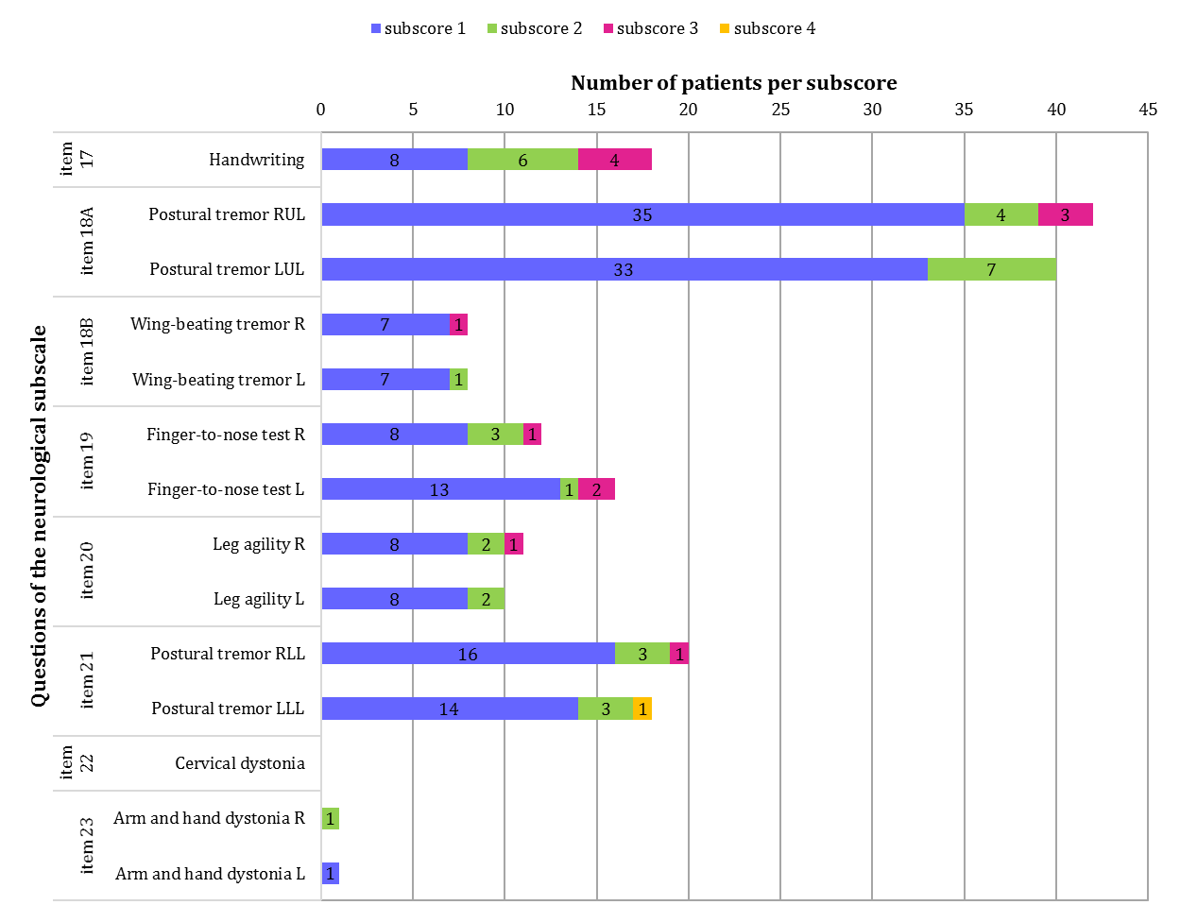
Single-item total score correlation | Cronbach‘s α for omitted item
0.83 | 0.96
0.55 | 0.96
0.38 | 0.96
0.49 | 0.96
0.63 | 0.96
0.66 | 0.96
0.65 | 0.96
0.55 | 0.96
0.68 | 0.96
0.62 | 0.96
0.61 | 0.96
- | -
0.24 | 0.96
0.25 | 0.96

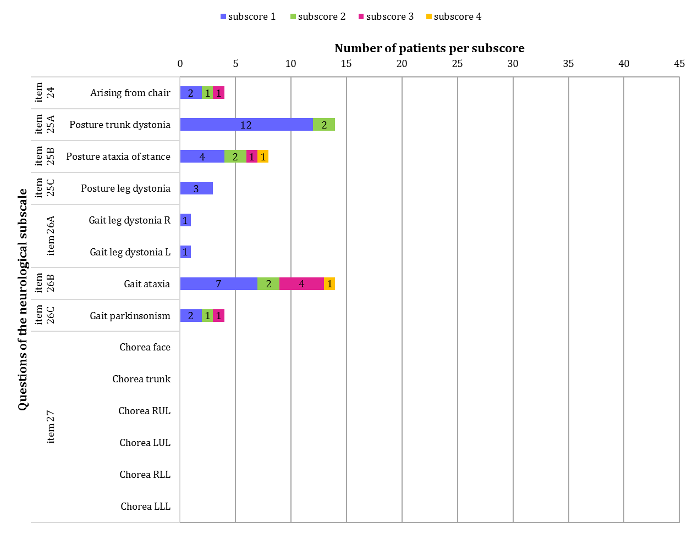
Single-item total score correlation | Cronbach‘s α for omitted item
0.63 | 0.96
0.57 | 0.96
0.76 | 0.96
0.68 | 0.96
0.29 | 0.96
0.29 | 0.96
0.81 | 0.96
0.71 | 0.96
- | -
- | -
- | -
- | -
- | -
- | -

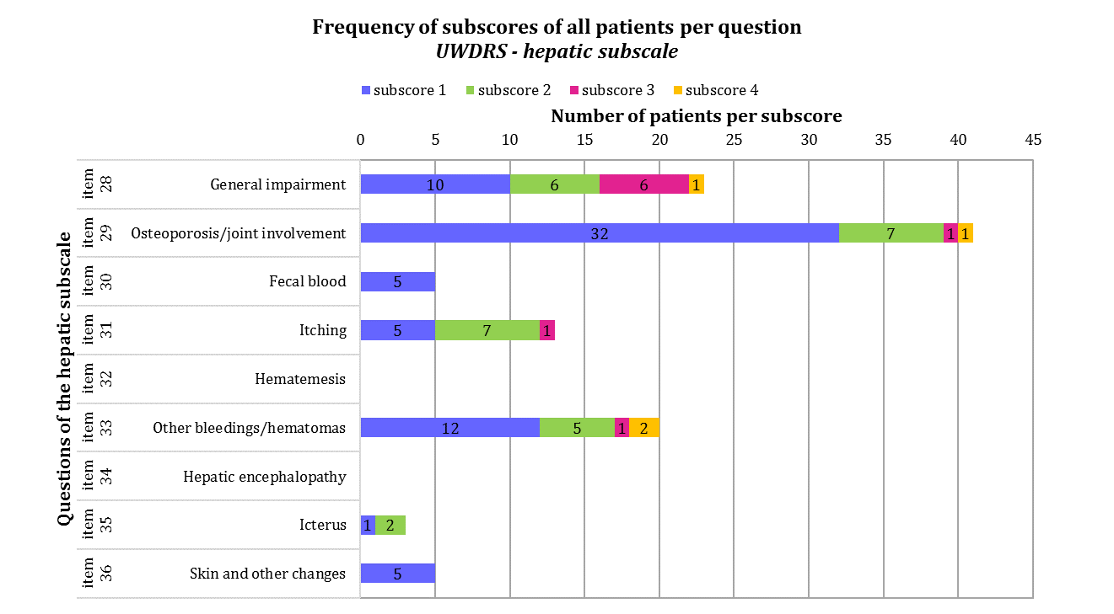
Single-item total score correlation | Cronbach‘s α for omitted item
0.41 | 0.62
0.35 | 0.62
0.14 | 0.66*
0.52 | 0.56
- | -
0.49 | 0.57
- | -
0.39 | 0.62
0.49 | 0.62

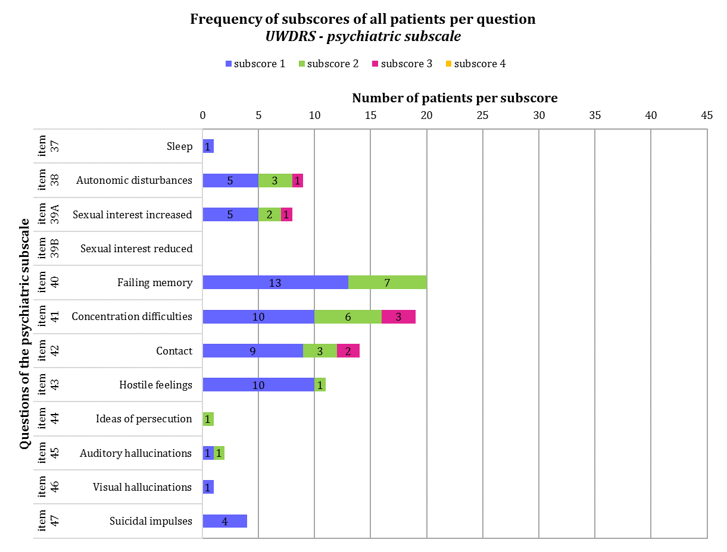
Single-item total score correlation | Cronbach‘s α for omitted item
0.35 | 0.83
0.54 | 0.82
0.31 | 0.84*
- | -
0.59 | 0.82
0.58 | 0.82
0.55 | 0.82
0.36 | 0.83
0.71 | 0.82
0.65 | 0.82
0.73 | 0.83
0.65 | 0.82

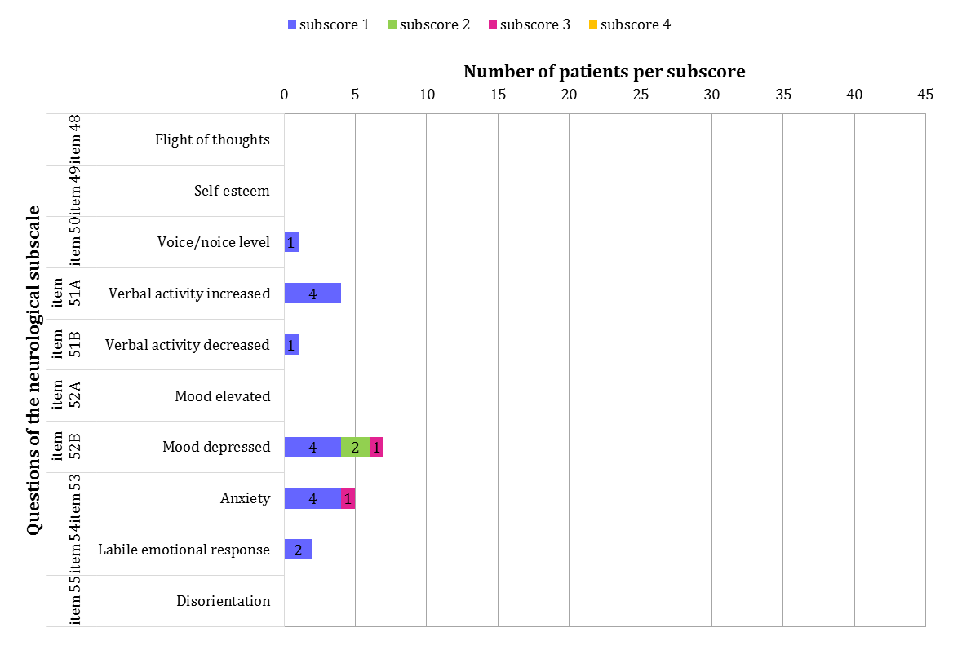
Single-item total score correlation | Cronbach‘s α for omitted item
- | -
- | -
0.27 | 0.84*
0.10 | 0.94*
- | -
0.62 | 0.84*
0.62 | 0.82
0.49 | 0.83
- | -

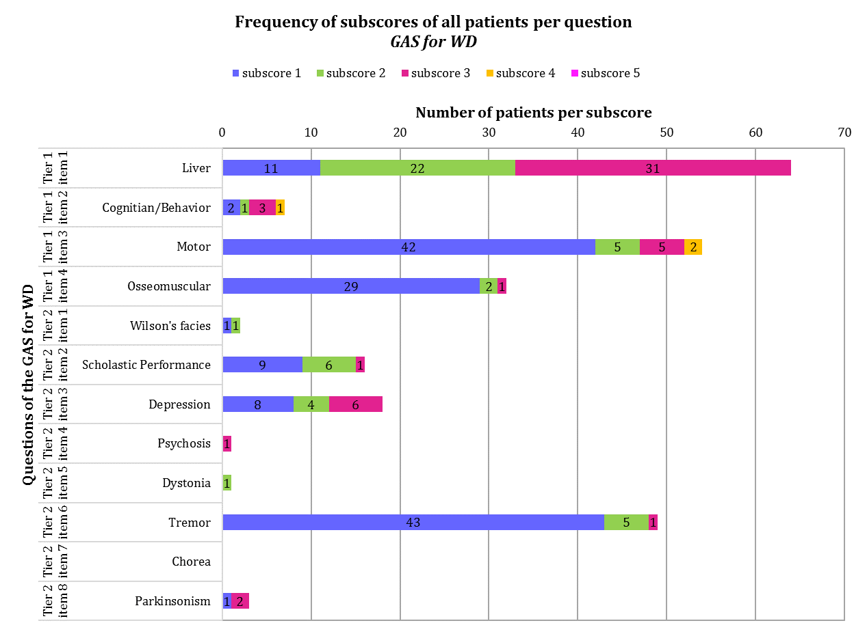
Single-item total score correlation | Cronbach‘s α for omitted item
0.48 | 0.82
0.65 | 0.79
0.57 | 0.80
0.26 | 0.82
0.45 | 0.82
0.29 | 0.82
- | -
0.41 | 0.81

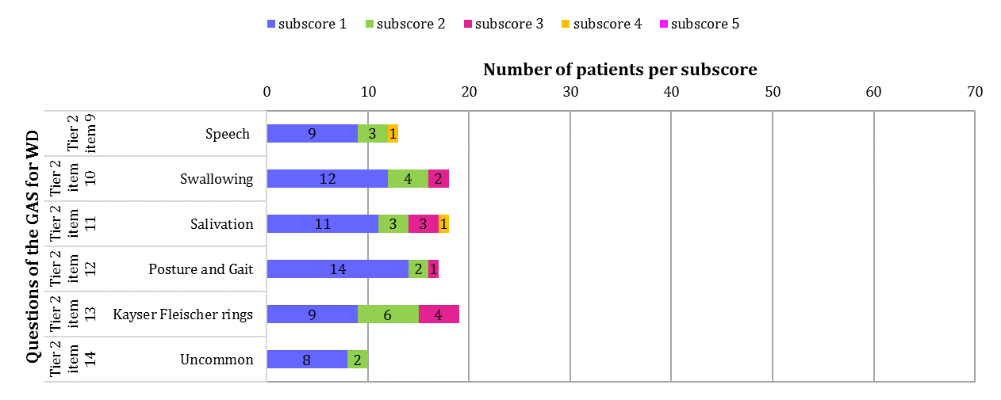
Single-item total score correlation | Cronbach‘s α for omitted item
0.66 | 0.79
0.73 | 0.79
0.62 | 0.80
0.51 | 0.81
0.22 | 0.84*
0.45 | 0.81

Table S1. UWDRS and GAS for WD Tier 2 (sub)scores depending on gender, KFR, and liver cirrhosis
 | Total score  median (range) |  | P value
 | Gender
UWDRS total score  UWDRS neurological subscore  UWDRS hepatic subscore  UWDRS psychiatric subscore  GAS for WD Tier 2 score | Female  10 (0-97)  5 (0-66)  3 (0-13)  1 (0-26)  3 (0-17) | Male  9.5 (1-76)  5 (1-74)  1 (0-8)  1 (0-9)  2.5 (0-24) | 0.844  0.598  0.004*  0.562  0.775
 | KFR at assessment
UWDRS total score  UWDRS neurological subscore  UWDRS hepatic subscore  UWDRS psychiatric subscore  GAS for WD Tier 2 score | Yes  20 (2-55)  11 (1-49)  2 (0-6)  2 (0-7)  4 (2-24) | No  8.5 (0-97)  4 (0-74)  1.5 (0-13)  1 (0-26)  1.5 (0-17) | 0.016*  0.004*  0.763  0.453  <0.001*
 | Liver cirrhosis at the time of diagnosis
UWDRS total score  UWDRS neurological subscore  UWDRS hepatic subscore  UWDRS psychiatric subscore  GAS for WD Tier 2 score | Yes  14 (0-55)  7 (0-49)  4 (0-13)  3 (0-12)  3 (0-24) | No  9 (1-97)  5 (1-74)  1 (0-7)  1 (0-26)  2.5 (0-17) | 0.198  0.422  0.078  0.136  0.702
*, P value statistically significant

