Supplementary Information
- FDG-PET normalization
Intensity normalization was based on comparing the patient group to a healthy control (HC) group. 75 healthy controls were incorporated into the analysis. Detailed demographic information of the HC group is shown in Table 1.
Table 1 Demographic information of healthy controls
Group | HC
Number of subjects | 75
Gender (M/F) | 45/30
Baseline age (mean±std) | 76.26±5.13
Baseline MMSE (mean±std) | 28.91±1.18
Baseline ADAS-cog (mean±std) | 10.47±4.27
MMSE, Mini-mental State Examination; ADAS-cog, Alzheimer’s disease Assessment Scale-Cognitive section.
- The reference cluster results in FDG-PET normalization
In baseline, the reference clusters mainly distributed in Precuneus, Limbic Lobe, Parietal Lobe, Cuneus and Posterior Cingulate. In the second time point, 6th month after baseline, the reference clusters mainly located in Precuneus, Parietal Lobe, Limbic Lobe, Posterior Cingulate, and Occipital Lobe. For the third time point, 12th month after baseline, the reference clusters mainly located in Precuneus, Limbic Lobe, Posterior Cingulate, Occipital Lobe, and Cuneus. In the 18th month after baseline, the third time point, the reference clusters mainly distributed in Precuneus, Limbic Lobe, Parietal Lobe, Posterior Cingulate, Occipital Lobe, and Cingulate Gyrus. Visualization of the reference clusters of difference time points is shown in Figure 1.
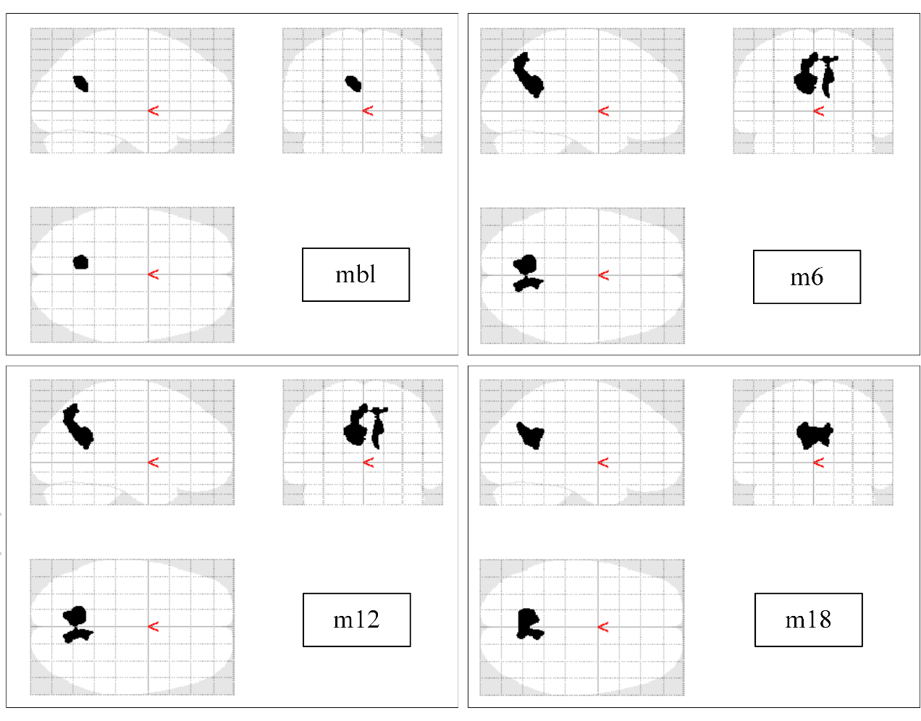
Figure 1. Mask for normalization in different time point of scan. mbl, month of baseline. m6, 6th month after baseline. m12, 12th month after baseline. m18, 18th month after baseline.
- LASSO based classification results
Table 2. Comparison of the classification performance in static features
Feature | ACC(%) | SEN(%) | SPE(%) | AUC
Static_mbl | 65.82 | 54.55 | 73.91 | 0.6462
Static_m6 | 70.89 | 57.58 | 80.43 | 0.7358
Static_m12 | 75.94 | 60.61 | 86.96 | 0.7596
Static_m18 | 72.15 | 60.61 | 80.43 | 0.7115
Static_all | 70.89 | 63.64 | 76.09 | 0.6607
ACC, classification accuracy. SEN, classification sensitivity. SPE, classification specificity. AUC, Area Under Curve. Static_mbl, static feature obtained in the baseline. Static_m6, static feature obtained in the 6th month after baseline. Static_m12, static feature obtained in the 12th month after baseline. Static_m18, static feature obtained in the 18th month after baseline. Static_all, combining all the static features.

Table 3. Comparison of the classification performance in dynamic features
Feature | ACC(%) | SEN(%) | SPE(%) | AUC
Dynamic_1 | 87.34 | 93.94 | 82.61 | 0.9302
Dynamic_2 | 70.89 | 54.55 | 82.61 | 0.7401
Dynamic_3 | 81.01 | 69.70 | 89.13 | 0.8047
R1 | 60.76 | 9.09 | 97.83 | 0.5440
R2 | 64.56 | 21.21 | 97.83 | 0.6173
R3 | 63.29 | 12.12 | 1 | 0.5738
Dynamic_all | 84.81 | 96.97 | 76.09 | 0.9275
ACC, classification accuracy. SEN, classification sensitivity. SPE, classification specificity. AUC, Area Under Curve. Dynamic_1, dynamic feature calculated with Static_mbl and Static_m6 in table 2. Dynamic_2, dynamic feature calculated with Static_mbl and Static_m12. Dynamic_3, dynamic feature calculated with Static_mbl and Static_m18. R1, metabolic change rate in the 6th month after baseline. R2, metabolic change rate in the 12th month after baseline; R3, metabolic change rate in the 18th month after baseline. Dynamic_all, combining all the dynamic features.

