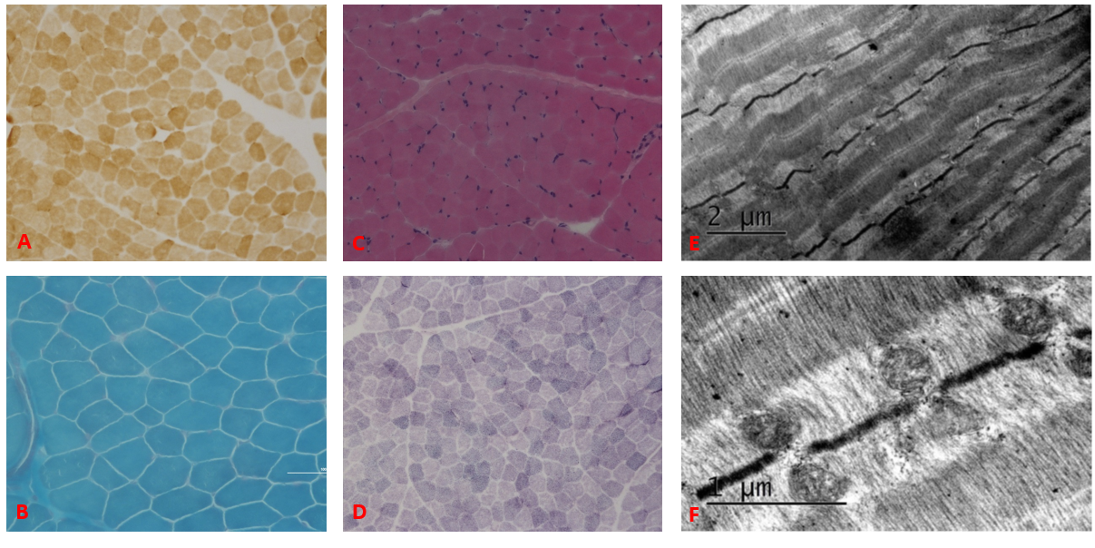
Supplementary data 1 Muscle biopsy. A–D Skeletal muscle sections from the patient were stained with COX (A), HE(B), MGT2 (C) and SDH (D) to visualize mitochondria. E-F Electron microscopy findings.

