Supplementary tables and figures for:

Prevalence and profile of nocturnal disturbances in Chinese patients with advanced-stage Parkinson’s disease: a cross-sectional epidemiology study
Guiying He et al.
Corresponding author:
Shengdi Chen
Address: Department of Neurology, Rui Jin Hospital Affiliated to Shanghai Jiao Tong University School of Medicine, Shanghai 200025, China
Tel: +86 21-6445-4473
Email: chensd@rjh.com.cn

Supplementary Figure 1. Study sites
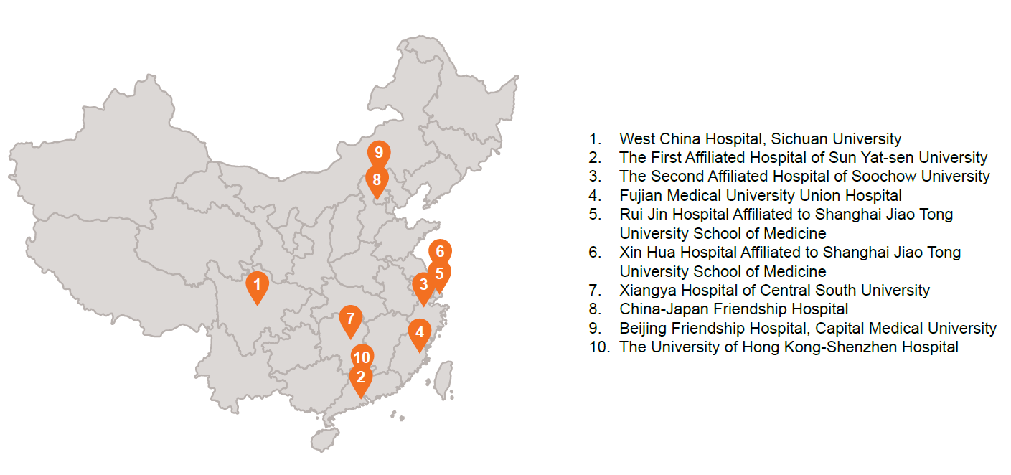

Supplementary Figure 2. Patient disposition
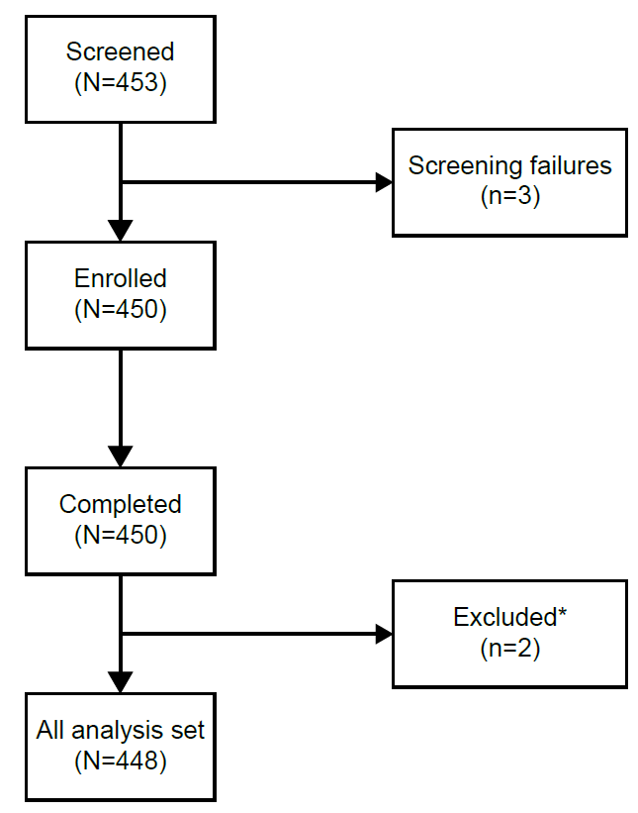

*Two patients were excluded from the all analysis set for not meeting inclusion criteria for analysis. These patients did not use levodopa monotherapy or adjunctive therapy before enrolment to the study.

Supplementary Table 1. Item scores for PDSS-2
 | With ND  (n=317) | Without ND  (n=130) | Total  (N=448)
Overall, did you sleep well?
Median (min., max.) | 2 (0, 4) | 1 (0, 4) | 2 (0, 4)
p-value |  |  | p<0.001
Difficulty falling asleep each night
Median (min., max.) | 2 (0, 4) | 0 (0, 4) | 1 (0, 4)
p-value |  |  | p<0.001
Difficulty staying asleep
Median (min., max.) | 3 (0, 4) | 1 (0, 4) | 3 (0, 4)
p-value |  |  | p<0.001
Restlessness leg/arm disrupt sleep
Median (min., max.) | 2 (0, 4) | 0 (0, 4) | 1 (0, 4)
p-value |  |  | p<0.001
Urge to move leg/arm disrupt sleep
Median (min., max.) | 2 (0, 4) | 0 (0, 4) | 1 (0, 4)
p-value |  |  | p<0.001
Distressing dreams at night
Median (min., max.) | 2 (0, 4) | 0 (0, 4) | 1 (0, 4)
p-value |  |  | p<0.001
Distressing hallucination at night
Median (min., max.) | 0 (0, 4) | 0 (0, 3) | 0 (0, 4)
p-value |  |  | p<0.001
Get up at night to pass urine
Median (min., max.) | 4 (0, 4) | 3 (0, 4) | 4 (0, 4)
p-value |  |  | p<0.001
Uncomfortable due to immobility
Median (min., max.) | 3 (0, 4) | 0 (0, 4) | 2 (0, 4)
p-value |  |  | p<0.001
Pain arms/legs woke you
Median (min., max.) | 1 (0, 4) | 0 (0, 2) | 0 (0, 4)
p-value |  |  | p<0.001
Muscle cramps arm/leg woke you
Median (min., max.) | 1 (0, 4) | 0 (0, 2) | 1 (0, 4)
p-value |  |  | p<0.001
Wake early-painful posture arm/leg
Median (min., max.) | 1 (0, 4) | 0 (0, 2) | 0 (0, 4)
p-value |  |  | p<0.001
On waking, experience tremor
Median (min., max.) | 1 (0, 4) | 0 (0, 4) | 0 (0, 4)
p-value |  |  | p<0.001
Feel tired/sleepy after waking
Median (min., max.) | 2 (0, 4) | 0 (0, 4) | 1 (0, 4)
p-value |  |  | p<0.001
Wake up-snore/difficult breathing
Median (min., max.) | 0 (0, 4) | 0 (0, 4) | 0 (0, 4)
p-value |  |  | p<0.001
A single patient was excluded in both of with/without ND group due to missing one item of PDSS-2 score. The ANCOVA model was used for the analysis of individual PDSS-2 item scores with ND status, sex (female vs male), and H&Y stage (Stage IV vs Stage III vs Stage IIS vs Stage II) included as fixed factors, and age, disease duration as continuous covariates. ANCOVA, analysis of covariance; H&Y, Modified Hoehn & Yahr; max., maximum; min., minimum; ND, nocturnal disturbance; PD, Parkinson’s disease; PDSS-2, Parkinson’s Disease Sleep Scale 2nd version.

Supplementary Table 2. Linear regression of PDQ-39 total score
Covariate | Estimated regression coefficient (95% CI) | p-value
ND status | 13.83 (11.08, 16.59) | <0.001
Age | -0.07 (-0.20, 0.06) | 0.308
Sex | 2.73 (0.27, 5.18) | 0.029
Disease stage of PD | 4.30 (2.93, 5.68) | <0.001
Disease duration, years | 0.22 (-0.07, 0.51) | 0.143
Average time of awake “off” per day, hours | 0.91 (0.45, 1.37) | <0.001
The impact of the ND status on the PDQ-39 total score was assessed by a multivariate linear model with age, sex, disease duration, disease stage, average time of awake time adjusted. The estimated regression coefficient for age, H&Y stage (Stage II = 1, Stage IIS = 2, Stage III = 3, Stage IV = 4), disease duration, and average time of awake time are calculated to compare the pairwise difference in 1 higher unit change. The estimated regression coefficient of sex is calculated with male as the reference level. The estimated regression coefficient of ND status is calculated with without ND as the reference level.
CI, confidence interval; H&Y, Modified Hoehn & Yahr; ND, nocturnal disturbance; PD, Parkinson’s disease; PDQ-39, Parkinson’s Disease Questionnaire-39.

