SUPPLEMENTAL MATERIAL
Supplementary 1. Methodology details: secondary outcomes definition, study risk of bias and confidence in the evidence assessments 4
Secondary outcome definitions 4
Study risk of bias assessment 4
Confidence in the evidence from network meta-analysis assessments 4
Within-study bias 4
Indirectness 5
Imprecision, heterogeneity, and incoherence 5
Supplementary 2. Characteristics of included studies table (N=57) 7
References 14
Supplementary 3. Risk of bias summary table 17
References 35
Supplementary 4. Table of ongoing studies (last update December 2020) 36
Supplementary 5. Network plots of evidence for secondary outcomes 37
Ischemic stroke 37
Ischemic stroke or transient ischemic attack 38
Cardiovascular event 39
Hemorrhagic stroke 40
Intracranial haemorrhage 41
Major bleeding 42
Supplementary 6. Results of the pairwise meta-analyses for primary and secondary outcomes 43
All strokes 43
All-cause mortality 49
Ischemic stroke 55
Ischemic stroke or transient ischemic attack 60
Cardiovascular event 62
Hemorrhagic stroke 68
Intracranial haemorrhage 72
Major bleeding 76
Supplementary 7. Assessment of the confidence in the network estimates by outcome 83
All strokes 83
All-cause mortality 87
Ischemic stroke 90
Cardiovascular event 93
Hemorrhagic stroke 96
Intracranial haemorrhage 99
Major bleeding 102
Supplementary 8. SUCRA, probability to be the best and mean rank by outcome 105
All strokes 105
All-cause mortality 105
Ischemic stroke 106
Cardiovascular event 107
Hemorrhagic stroke 107
Intracranial haemorrhage 108
Major bleeding 108
Supplementary 9. Results from the assessment of incoherence by using global and local (side-split method) approaches for primary and secondary outcomes 110
All strokes 110
All-cause mortality 111
Ischemic stroke 112
Cardiovascular event 113
Hemorrhagic stroke 114
Intracranial haemorrhage 115
Major bleeding 116
Supplementary 10. Comparison-adjusted funnel plot for a network of interventions by outcome 118
All strokes 118
All-cause mortality 119
Ischemic stroke 120
Cardiovascular event 121
Hemorrhagic stroke 122
Intracranial haemorrhage 123
Major bleeding 124
Reference 124

Supplementary 1. Methodology details: secondary outcomes definition, study risk of bias and confidence in the evidence assessments

Secondary outcome definitions
- cardiovascular event: any sudden death, fatal or non-fatal acute coronary syndrome, stroke, intracranial hemorrhage, or pulmonary embolism
- hemorrhagic stroke: an acute extravasation of blood into and around the brain parenchyma (intracerebral hemorrhage and subarachnoid hemorrhage, excluding subdural hematoma and epidural hematoma)
- intracranial hemorrhage: includes hemorrhagic stroke, subdural hematoma and epidural hematoma
- major bleeding: including all symptomatic intracranial hemorrhage, any fatal bleeding, or any bleeding requiring hospital admission (i.e. for transfusion of unit of red-blood cells) or leaving significantly disability (with persistent sequelae).

Study risk of bias assessment
The following domains of bias were considered: selection (random sequence generation, allocation concealment), performance (blinding of participants and personnel), detection (blinding of outcome assessment), attrition (incomplete outcome data), and selective outcome reporting. We explicitly judged the risk of bias in each criterion as ’low’, ’high’, or ’unclear’. We evaluated incomplete outcome data as having a low risk of bias when the numbers and reasons for dropouts were balanced (i.e., in the absence of a significant difference) between arms. Our assessment of methodological quality included published trial protocols when available. Finally, for each study, we explicitly also judged the overall risk of bias as follows: we considered allocation concealment, blinding of participants and personnel, and incomplete outcome data to classify each study as having low risk of bias when we judged all of the selected criteria as having low risk of bias; high risk of bias when we judged at least one criterion among those selected as having high risk of bias; and moderate risk of bias in the remaining cases.

Confidence in the evidence from network meta-analysis assessments
We assessed the following items: within-study bias, indirectness, imprecision, heterogeneity, incoherence and reporting bias. For each item, we judged whether we had no concerns, some concerns, or major concerns. By considering the judgments from all items, we derived an overall confidence rating for each comparison. We assessed the confidence in the network estimates as at very low, low, moderate, or high confidence. We used the web application CINeMA (https://cinema.ispm.unibe.ch/) and derived the judgment for each item and the overall confidence rating for each network estimate as described by Papakonstantinou and colleagues.¹

Within-study bias
The assessment of the within-study bias is showed in the risk of bias bar chart. The chart is automatically generated in CINeMA by using the overall study risk of bias (see Supplementary 3) and the study contribution matrix (i.e., how much each direct evidence contributes to each the network estimate) also calculated in CINeMA. Each bar shows how much studies at low risk of bias (green), moderate (yellow) or high risk of bias (red) contribute in percentage to the network estimate. We used the “majority risk of bias” to summarize risk of bias across contributions for each network estimate and derive the judgment for within-study bias.

Indirectness
We used the “majority” criterion to assess the indirectness and summarized it with bar charts. We assigned low risk for indirectness to all included studies and hence we judged all comparisons as with “no concerns” for indirectness (indirectness bar chart not reported).

Imprecision, heterogeneity, and incoherence
For the assessment of imprecision, heterogeneity, and incoherence we considered an odds ratio of 0.90 as clinically important for all-cause mortality and of 0.80 for other outcomes and followed the CINeMA criteria.¹ We assessed the level of concern as reported in the figure below²:
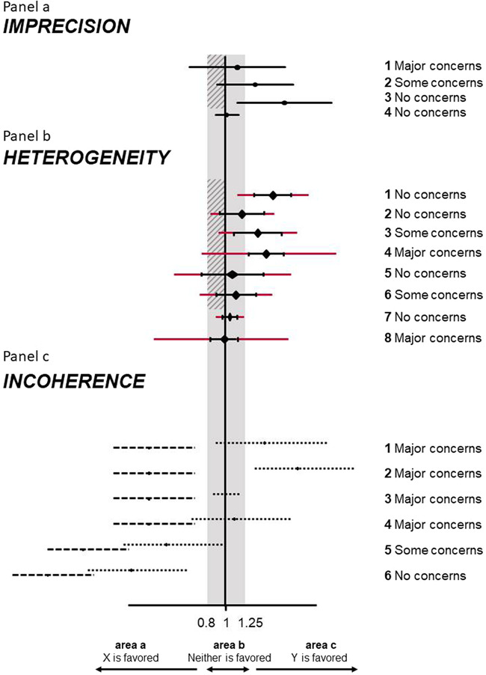
Legend: Illustration of rules to assess imprecision (a), heterogeneity (b), and incoherence (c) in CINeMA. We assume several fictional scenarios for the odds ratio from NMA comparing interventions X and Y. The clinically important effects were set at 0.8 and 1.25 ( = 1/0.8). The gray areas represent values that favor neither of the competing interventions. The shaded interval represents the interval between the null effect and clinically important size of effect. Black horizontal lines indicate confidence intervals and red extensions indicate prediction intervals of NMA relative treatment effects. Dotted lines represent direct and dashed lines represent indirect confidence intervals. Judgments are the same for cases symmetrical to those illustrated. NMA, network meta-analysis
For judging the confidence in the estimates for imprecision and for heterogeneity, odds ratio with relative 95% confidence interval and prediction intervals are reported in the forest plots below.
The judgments of the confidence in the estimates for incoherence are based on the results from the design-by-treatment interaction test and side-splitting test (see Supplementary 9).
Reporting bias
The comparison-adjusted funnel plots by outcome are reported in Supplementary 9. For each outcome, we judged all estimates as undetected.
Confidence rating
We rated:
- high confidence if no concerns in all the above-mentioned domains
- moderate confidence if at least a “some concerns” but no “major concerns”
- low confidence if one major concerns
- very low confidence if more than one major concerns

References
¹Papakonstantinou T, Nikolakopoulou A, Higgins JPT, Egger M, Salanti G. CINeMA: Software for semiautomated assessment of the confidence in the results of network meta-analysis. Campbell Systematic Reviews. 2020;16:e1080.
²Campbell Systematic Reviews, Volume: 16, Issue: 1, First published: 11 March 2020, DOI: (10.1002/cl2.1080)

Supplementary 2. Characteristics of included studies table (N=57)

Study | Year, Country | Index event (n pts random) | Follow up | NI at entry | Non-CE only | TR | Age (mean, y) | Males (%) | Intervention(s) | Control
THALES* ¹ | 2020, global | Ischemic stroke or TIA (11016) | 2 mo | Yes | No | ≤24 h | 65 | 39 | Ticagrelor (180 mg  loading dose followed by 90 mg twice daily) + aspirin (300 to 325 mg on day 1 followed by 75 to 100 mg daily) | Aspirin (300 to 325 mg on day 1 followed by 75 to 100 mg daily)
Khazaei^{§2} | 2019, Iran | Ischemic stroke or TIA (54) | 3 mo | Optional | Yes | NR | 67 | 63 | Aspirin 80 mg/day + Clopidogrel 75 mg/day | Aspirin 80 mg/day
PICASSO study³ | 2018, Asia | Ischemic stroke or TIA (1534) | Median 1.9 y | Yes | Yes | <180 days | 66 | 62 | Cilostazol 100 mg twice daily | Aspirin 100 mg daily
POINT trial⁴ | 2018, global | Ischemic stroke or TIA (4881) | 3 mo | Yes | Yes | ≤12 h | NR (median 65) | 55 | Clopidogrel 75 mg daily + Aspirin ranged from 50 mg to 325 mg daily - Median 81 mg | Aspirin (50 to 325 mg daily) - Median 81 mg
MAESTRO Study⁵ | 2017, Korea | Ischemic stroke (795) | Median 2.7 y | Yes | Yes | ≤1 mo | 61 | 68 | Triflusal 300 mg twice per day | Clopidogrel 75 mg once daily
COMPRESS*⁶ | 2016, Korea | Ischemic stroke (358) | 1 mo | Yes | Yes | ≤48 h | 66 | 64 | Clopidogrel 75 mg once daily + Aspirin 100 mg | Aspirin 100 mg once daily
SOCRATES Study⁷ | 2016, global | Ischemic stroke or TIA (13199) | 3 mo | Yes | No | ≤24 h | 66 | 59 | Ticagrelor 90 mg twice daily | Aspirin 100 mg daily
CATHARSIS⁸ | 2015, Japan | Ischemic stroke (165) | mean  2 y | Yes | Yes | 2 wk - 6 mo | 68 | 66 | Cilostazol 200 mg daily + Aspirin 100 mg daily | Aspirin 100 mg daily
Wang⁹ | 2015, China | Ischemic stroke (570) | 1 mo | Yes | Yes | <48 h | 70 | 55 | Clopidogrel 75 mg + Aspirin 200 mg daily | Aspirin 200 mg daily
Yi*¹⁰ | 2014, China | Ischemic stroke (574) | 1 mo | Yes | Yes | ≤48 h | 70 | 55 | 200 mg aspirin and 75 mg clopidogrel daily | Aspirin 200 mg/day for 30 days
CHANCE trial¹¹ | 2013, China | Ischemic stroke or TIA (5170) | 3 mo | Yes | Yes | ≤24 h | NR (median 62) | 66 | Clopidogrel 300 mg day 1 followed by 75 mg daily for 90 days + Aspirin 75 mg to 300 mg day 1, followed by 75 mg daily for the first 21 days | Aspirin 75 mg to 300 mg day 1, followed by 75 mg daily
ECLIPse Study¹² | 2013, Korea | Ischemic stroke (203) | 3 mo | Yes | Yes | ≤1 wk | 65 | 75 | Cilostazol 100 mg twice daily + Aspirin 100 mg daily | Aspirin 100 mg daily
TIMI 50 trial¹³ | 2013, global | Ischemic stroke (4883) | 3 y | NR | Yes | 2 wk - 12 mo | 65 | 67 | Vorapaxar 2.5 mg daily added to standard antiplatelet therapy | Placebo added to standard antiplatelet therapy
Nakamura^{§14} | 2012, Japan | Ischemic stroke (76) | 6 mo | Yes | Yes | ≤48 h | 67 | 74 | Cilostazol 100 mg twice + Aspirin 100 mg daily | Aspirin 100 mg daily
Shinohara^{§15} | 2012, Japan | Ischemic stroke (90) | 2 mo | Yes | Yes | 2 wk - 1 year | 65 | 77 | Vorapaxar 1 mg daily+ Aspirin 75 or 150 mg per day; Vorapaxar 2.5 mg daily+ Aspirin 7 ranging between 75 and 150 mg per day; | Aspirin (75 - 150 mg daily
SPS3 (Secondary Prevention of Small Subcortical Strokes)¹⁶ | 2012, global | Ischemic stroke or TIA (3020) | Mean 3.4 y | Yes | Yes | ≤6 mo | 63 | 63 | Clopidogrel 75 mg + Aspirin 325 mg daily | Aspirin 325 mg daily
CAIST trial¹⁷ | 2011, Korea | Ischemic stroke (458) | 3 mo | Yes | Yes | ≤48 hours | 63 | 61 | Cilostazol 200 mg daily | Aspirin 300 mg daily
CHARISMA Study¹⁸ | 2011, global | Ischemic stroke or TIA (4320) | median 25 mo | NR | No | ≤5 years | 65 | 63 | Clopidogrel 75 mg/day+Aspirin 100 mg daily | Aspirin 100 mg daily
JASAP Study¹⁹ | 2011, Japan | Ischemic stroke (1295) | 24 mo | Yes | Yes | 1wk - 6 mo | 66 | 72 | Dypiridamole 200 mg + Aspirin 25 mg twice daily | Aspirin 81 mg once daily
PERFORM study²⁰ | 2011, global | Ischemic stroke or TIA (19120) | Mean 28.3 mo | Yes | Yes | 48 h – 3 mo (stroke); 8 days (TIA) | 67 | 63 | Terutroban 30 mg daily | Aspirin 100 mg daily
TOSS-2²¹ | 2011, Asia | Ischemic stroke (457) | 7 mo | Yes | Yes | ≤2 wk | 65 | 51 | cilostazol 100 mg twice a day + aspirin 75-150 mg once daily | clopidogrel 75 mg daily + aspirin 75-150 mg once daily
CSPS-2²² | 2010, Japan | Ischemic stroke or TIA (2757) | Mean 29 mo | Yes | Yes | ≤26 wk | 63 | 72 | Cilostazol 100 mg twice daily | Aspirin 81 mg once daily
Guo^{§23} | 2009, China | Ischemic stroke (68) | 12 mo | Yes | Yes | 1 - 6 mo | 61 | 35 | Cilostazol 100 mg twice daily | Aspirin 100 mg daily
Uchiyama²⁴ | 2009, Japan | Ischemic stroke (1869) | 12 mo | Yes | No | >8 days | 64 | 71 | Clopidogrel 75 mg once daily | Ticlopidine 200 mg once daily
CASISP study²⁵ | 2008, China | Ischemic stroke (720) | 12-18 mo | Yes | Yes | 1 - 6 mo | 60 | 69 | Cilostazol 200 mg/day | Aspirin 100 mg daily
Fukuuchi²⁶ | 2008, Japan | Ischemic stroke (1151) | 12 mo | Yes | Yes | >8 days | 65 | 73 | Clopidogrel 75 mg once daily | Ticlopidine 200 mg once daily
PRoFESS²⁷ | 2008, global | Ischemic stroke or TIA (20332) | Mean 2.5 y | Yes | Yes | ≤4 mo | 66 | 64 | Aspirin 25 mg + Dipyridamole 200 mg twice daily | Clopidogrel 75 mg daily
ESPRIT²⁸ | 2006, global | Ischemic stroke or TIA (2739) | Mean 3.5 y | Yes | Yes | ≤6 mo | 63 | 65 | Aspirin (30-325 mg daily) +dipyridamole 200mg daily | Aspirin (30-325 mg daily) - Median dose 75 mg
CARESS trial*²⁹ | 2005, Europe | Ischemic stroke or TIA (107) | 7 days | Yes | Yes | ≤3 mo | 65 | 69 | Day 1: Clopidogrel 300 mg daily; From day 2 to day 7 Clopidogrel 75 mg + Aspirin 75 mg daily | From day 1 to day 7Aspirin 75 mg once a day
Chairangsarit^{§30} | 2005, Thailand | Ischemic stroke (38) | 6 mo | Yes | Yes | ≤48 h | 64 | 53 | Aspirin 300 mg daily+ dipyridamole 75 mg three times per day | Aspirin 300 mg daily
MATCH³¹ | 2004, global | Ischemic stroke or TIA (7599) | 18 mo | Yes | Yes | ≤3 mo | 66 | 63 | 75 mg Aspirin once daily+ 75 mg Clopidogrel once daily | 75 mg Clopidogrel once daily
TAPIRSS Study³² | 2004, Argentina | Ischemic stroke or TIA (431) | Mean 1.6 y | Yes | Yes | < 6 mo | 65 | 68 | Triflusal 600 mg daily | Aspirin 325 mg daily
AAASPS (Aspirin and Ticlopidine for prevention of recurrent stroke in black pts)³³ | 2003, USA | Ischemic stroke (1809) | Mean 1.5 y | Yes | Yes | 1 wk - 3 mo | 61 | 46 | Ticlopidine 250 mg twice a day | Aspirin 325 mg twice a day
TACIP study³⁴ | 2003, Spain  Portugal | Ischemic stroke or TIA (2113) | Mean 30.1 mo | Yes | Yes | ≤6 mo | 65 | 66 | Triflusal 600 mg daily | Aspirin 325 mg daily
TOPALS study³⁵ | 2003, Japan | Ischemic stroke or TIA (276) | Mean 1.59 y | NR | Yes | 1 - 6 mo (3 mo for TIA) | 67 | 65 | Ticlopidine 200 mg daily | Ticlopidine 100 mg + Aspirin 81 mg daily
Gotoh³⁶ | 2000, Japan | Ischemic stroke (1095) | At least 12 mo | Yes | Yes | 1 - 6 mo | 65 | 66 | Cilostazol 100 mg twice daily | Placebo
Grotemeyer³⁷ | 2000, Germany | Ischemic stroke (563) | 24 mo | Yes | Yes | 8 - 16 wk | 58 | 68 | Piracetam 1600 mg three times daily | Aspirin 200 mg three times daily
CAST* (Chinese Acute Stroke Trial)³⁸ | 1997, China | Ischemic stroke (21106) | 1 mo | Yes | No | ≤48 h | 63 | 63 | Aspirin 160 mg once daily | Placebo
TISS (Ticlopidine Indobufen Stroke Study)³⁹ | 1997, Italy | Ischemic stroke or TIA (1632) | 12 mo | Yes | No | ≤1 mo | 65 | 63 | Ticlopidine 250 mg once or twice daily | Indobufen 200 mg once or twice daily
CAPRIE⁴⁰ | 1996, global | Ischemic stroke or TIA (6431) | Mean 1.9 mo | Yes | Yes | 1 wk - 6 mo | 65 | 64 | Clopidogrel 75mg once daily | Aspirin 325 mg once daily
European Stroke Prevention Study 2⁴¹ | 1996, Europe | Ischemic stroke or TIA (6602) | 2 y | Optional | No | ≤3 mo | 67 | 58 | Aspirin 25 mg twice a day; Dipyidamole 200 mg twice a day; Aspirin 25 mg+Dipyridamole 200mg twice a day | Placebo
JETS-1⁴² | 1995, Japan | TIA (227) | 3-6 mo | Yes | No | ≤12 wk | 61 | 69 | Satigrel 1 mg twice daily; Satigrel 2 mg twice daily | Aspirin 81 mg four time daily
MAST-I*⁴³ | 1995, Europe | Ischemic stroke (309) | 10 days | Yes | No | ≤6 h | NR | 53 | Aspirin 300 mg daily | No treatment
Smirne^{#44} | 1994, Italy | TIA (183) | 6 mo | Yes | Yes | ≤3 mo | 66 | 58 | Triflusal 600 mg daily | Aspirin 300 mg daily
EAFT Study⁴⁵ | 1993, Europe/  Israel | Ischemic stroke or TIA (782) | Mean 2.3 y | Yes | No | < 3 mo | 73 | 56 | Aspirin 300 mg daily | Placebo
De Falco*^{§46} | 1991, Italy | Ischemic stroke or TIA (87) | 15 mo | Optional | No | 1 - 4 wk | 64 | 67 | Picodamide 600 mg die | Aspirin 300 mg die
SALT Study⁴⁷ | 1991, Sweden | Ischemic stroke or TIA (1360) | Median 32 mo | Optional (recommended for minor stroke) | Yes | <3 mo | 67 | NR | Aspirin 75 mg daily | Placebo
UK-TIA Study⁴⁸ | 1991, UK | Ischemic stroke or TIA (2436) | At least 12 mo, mean 4 y | Optional | Yes | NR | 60 | 73 | Aspirin 600 mg twice daily; Aspirin 300 mg once daily | Placebo
CATS (Canadian American Ticlopidine study)⁴⁹ | 1989, North America | Ischemic stroke or TIA  (1053) | 3 y (mean 2 y) | Yes | Yes | 1 wk - 4 mo | 65 | 62 | Ticlopidine 125 mg twice a day | Placebo
Ticlopidine Aspirin Stroke Study⁵⁰ | 1989, North America | Ischemic stroke or TIA (3069) | 2-6 y | No | No | ≤3 mo | 63 | 65 | Ticlopidine 250 mg twice a day | Aspirin 650 mg twice a day
ESPS Study⁵¹ | 1987, Europe | Ischemic stroke or TIA (2500) | 24 mo | Optional | No | ≤3 mo | 63 | 58 | Dypiridamole 75 mg + Aspirin 330 mg 3 times daily | Placebo
Swedish Cooperative Study⁵² | 1987, Sweden | Ischemic stroke (505) | 2 y | Yes | No | 1-3 wk | 68 | 62 | Aspirin 1.5 g/day | Placebo
Persantine Aspirin Trial⁵³ | 1985, North America | Ischemic stroke (890) | Median 25 mo | NR | No | ≤3 mo | 63 | 67 | Aspirin 325 mg+ Dypiridamole 75 mg 4 times daily | Aspirin 325 mg 4 times daily
Tohgi⁵⁴ | 1984, Japan | TIA (340) | 12 mo | NR | No | ≤3 mo | NR | NR | Ticlpidine 100 mg twice | Aspirin 500 mg once
AICLA study⁵⁵ | 1983, France | Ischemic stroke or TIA (604) | 3 y | No | Yes | ≤1 year | 63 | 70 | Aspirin 330 mg 3 times daily; Dypiridamole 75 mg + Aspirin 330 mg 3 times daily | Placebo
Danish Cooperative study⁵⁶ | 1983, Denmark | TIA (203) | Mean 25 mo | No | No | ≤1 mo | 59 | 73 | Aspirin 500 mg twice daily | Placebo
The Canadian Cooperative Study⁵⁷ | 1978, Canada | Ischemic stroke (585) | Mean 26 mo | Optional | No | ≤3 mo | NR | 69 | Sulfinpirazone 200 mg, Aspirin 325 mg, Sulfinpirazone 200 mg+Aspirin 325 mg 4 times daily | Placebo
CE, cardio-embolic, h: hours; mo: months; NI: neuroimaging; NR: not reported; pts: patients;TIA, transient ischemic attack; TR: Time from first ischemic event to randomization; y: year; wk: weeks;
*All studies had a treatment duration of 1 month or longer but CAST, CARESS, COMPRESS, MAST-I, Yi 2014, THALES Study (Treatment duration <1month); De Falco (NR)
§total sample size <100 participants, excluded from the statistical analysis
#no data on the pre-defined selected outcomes, excluded from the statistical analysis

References
- Johnston SC, Amarenco P, Denison H, et al. Ticagrelor and aspirin or aspirin alone in acute ischemic stroke or TIA. N Engl J Med 2020;383:207-17. Doi: 10.1056/NEJMoa1916870.
- Khazaei M, Ghasemian F, Mazdeh M, Taheri M, Ghafouri-Fard S. Comparison of administration of clopidogrel with aspirin versus aspirin alone in prevention of secondary stroke after transient ischemic attack. Clin Transl Med. 2019;8(1):6. doi: 10.1186/s40169-019-0223-z.
- Kim BJ, Lee EJ, Kwon SU, et al.; PICASSO investigators. Prevention of cardiovascular events in Asian patients with ischaemic stroke at high risk of cerebral haemorrhage (PICASSO): a multicentre, randomised controlled trial. Lancet Neurol. 2018;17(6):509-518. doi: 10.1016/S1474-4422(18)30128-5.
- Johnston SC, Easton JD, Farrant M, et al; Clinical Research Collaboration, Neurological Emergencies Treatment Trials Network, and the POINT Investigators. Clopidogrel and Aspirin in Acute Ischemic Stroke and High-Risk TIA. N Engl J Med. 2018;379(3):215-225. doi: 10.1056/NEJMoa1800410.
- Lee JH, Hwang YH, Lee KO, et al. Effects of Triflusal and Clopidogrel on the Secondary Prevention of Stroke Based on Cytochrome P450 2C19 Genotyping. J Stroke. 2017;19(3):356-364. doi: 10.5853/jos.2017.01249.
- Hong KS, Lee SH, Kim EG, et al; COMPRESS Investigators. Recurrent Ischemic Lesions After Acute Atherothrombotic Stroke: Clopidogrel Plus Aspirin Versus Aspirin Alone. Stroke. 2016;47(9):2323-30. doi: 10.1161/STROKEAHA.115.012293.
- Johnston SC, Amarenco P, Albers GW, et al.; SOCRATES Steering Committee and Investigators. Ticagrelor versus Aspirin in Acute Stroke or Transient Ischemic Attack. N Engl J Med. 2016;375(1):35-43. doi: 10.1056/NEJMoa1603060.
- Uchiyama S, Sakai N, Toi S, et al.; CATHARSIS Study Group. Final Results of Cilostazol-Aspirin Therapy against Recurrent Stroke with Intracranial Artery Stenosis (CATHARSIS). Cerebrovasc Dis Extra. 2015;5(1):1-13. doi: 10.1159/000369610.
- Wang C, Yi X, Zhang B, Liao D, Lin J, Chi L. Clopidogrel plus aspirin prevents early neurologic deterioration and improves 6-month outcome in patients with acute large artery atherosclerosis stroke. Clin Appl Thromb Hemost. 2015;21(5):453-61.
- Yi X, Lin J, Wang C, Zhang B, Chi W. A comparative study of dual versus monoantiplatelet therapy in patients with acute large-artery atherosclerosis stroke. J Stroke Cerebrovasc Dis. 2014;23(7):1975-81. doi: 10.1016/j.jstrokecerebrovasdis.2014.01.022.
- Wang Y, Wang Y, Zhao X, et al.; for the CHANCE Investigators. Clopidogrel with Aspirin in Acute Minor Stroke or Transient Ischemic Attack. N Engl J Med 2013;369:11-19. DOI: 10.1056/NEJMoa1215340.
- Han SW, Lee SS, Kim SH, et al. Effect of cilostazol in acute lacunar infarction based on pulsatility index of transcranial Doppler (ECLIPse): a multicenter, randomized, double-blind, placebo-controlled trial. Eur Neurol. 2013;69(1):33-40. doi: 10.1159/000338247.
- Morrow DA, Alberts MJ, Mohr JP, et al.; Thrombin Receptor Antagonist in Secondary Prevention of Atherothrombotic Ischemic Events–TIMI 50 Steering Committee and Investigators. Efficacy and safety of vorapaxar in patients with prior ischemic stroke. Stroke. 2013;44(3):691-8. doi: 10.1161/STROKEAHA.111.000433.
- Nakamura T, Tsuruta S, Uchiyama S. Cilostazol combined with aspirin prevents early neurological deterioration in patients with acute ischemic stroke: a pilot study. J Neurol Sci. 2012;313(1-2):22-6. doi: 10.1016/j.jns.2011.09.038.
- Shinohara Y, Goto S, Doi M, Jensen P. Safety of the novel protease-activated receptor-1 antagonist vorapaxar in Japanese patients with a history of ischemic stroke. J Stroke Cerebrovasc Dis. 2012;21(4):318-24. doi: 10.1016/j.jstrokecerebrovasdis.2010.09.005.
- SPS3 Investigators, Benavente OR, Hart RG, McClure LA, Szychowski JM, Coffey CS, Pearce LA. Effects of clopidogrel added to aspirin in patients with recent lacunar stroke. N Engl J Med. 2012;367(9):817-25. doi: 10.1056/NEJMoa1204133.
- Lee YS, Bae HJ, Kang DW, et al. Cilostazol in Acute Ischemic Stroke Treatment (CAIST Trial): a randomized double-blind non-inferiority trial. Cerebrovasc Dis. 2011;32(1):65-71. doi: 10.1159/000327036.
- Hankey GJ, Johnston SC, Easton JD, et al.; CHARISMA trial investigators. Effect of clopidogrel plus ASA vs. ASA early after TIA and ischaemic stroke: a substudy of the CHARISMA trial. Int J Stroke. 2011;6(1):3-9. doi: 10.1111/j.1747-4949.2010.00535.x.
- Uchiyama S, Ikeda Y, Urano Y, Horie Y, Yamaguchi T. The Japanese aggrenox (extended-release dipyridamole plus aspirin) stroke prevention versus aspirin programme (JASAP) study: a randomized, double-blind, controlled trial. Cerebrovasc Dis. 2011;31(6):601-13. doi: 10.1159/000327035.
- Bousser MG, Amarenco P, Chamorro A, et al.; PERFORM Study Investigators. Terutroban versus aspirin in patients with cerebral ischaemic events (PERFORM): a randomised, double-blind, parallel-group trial. Lancet. 2011;377(9782):2013-22. doi: 10.1016/S0140-6736(11)60600-4.
- Kwon SU, Hong KS, Kang DW, et al. Efficacy and safety of combination antiplatelet therapies in patients with symptomatic intracranial atherosclerotic stenosis. Stroke. 2011;42(10):2883-90. doi: 10.1161/STROKEAHA.110.609370.
- Shinohara Y, Katayama Y, Uchiyama S, et al.; for the CSPS 2 group. Cilostazol for prevention of secondary stroke (CSPS 2): an aspirin-controlled, double-blind, randomised non-inferiority trial Lancet Neurol 2010; 9: 959–68.
- Guo JJ, Xu E, Lin QY, Zeng GL, Xie HF. Effect of cilostazol on cerebral arteries in secondary prevention of ischemic stroke. Neurosci Bull. 2009;25(6):383-90. doi: 10.1007/s12264-009-6192-2.
- Uchiyama S, Fukuuchi Y, Yamaguchi T. The safety and efficacy of clopidogrel versus ticlopidine in Japanese stroke patients: combined results of two Phase III, multicenter, randomized clinical trials. J Neurol. 2009;256(6):888-97. doi: 10.1007/s00415-009-5035-4.
- Huang Y, Cheng Y, Wu J, et al. Cilostazol versus Aspirin for Secondary Ischaemic Stroke Prevention cooperation investigators. Cilostazol as an alternative to aspirin after ischaemic stroke: a randomised, double-blind, pilot study. Lancet Neurol. 2008;7(6):494-9. doi: 10.1016/S1474-4422(08)70094-2.
- Fukuuchi Y, Tohgi H, Okudera T, Ikeda Y, Miyanaga Y, Uchiyama S, Hirano M, Shinohara Y, Matsumoto M, Yamaguchi T. A randomized, double-blind study comparing the safety and efficacy of clopidogrel versus ticlopidine in Japanese patients with noncardioembolic cerebral infarction. Cerebrovasc Dis. 2008;25(1-2):40-9.
- Sacco RL, Diener HC, Yusuf S, et al.; for the PRoFESS Study Group. Aspirin and Extended-Release Dipyridamole versus Clopidogrel for Recurrent Stroke N Engl J Med 2008;359:1238-51.
- ESPRIT Study Group, Halkes PH, van Gijn J, Kappelle LJ, Koudstaal PJ, Algra A. Aspirin plus dipyridamole versus aspirin alone after cerebral ischaemia of arterial origin (ESPRIT): randomised controlled trial. Lancet. 2006;367(9523):1665-73. doi: 10.1016/S0140-6736(06)68734-5.
- Markus HS, Droste DW, Kaps M, et al. Dual antiplatelet therapy with clopidogrel and aspirin in symptomatic carotid stenosis evaluated using doppler embolic signal detection: the Clopidogrel and Aspirin for Reduction of Emboli in Symptomatic Carotid Stenosis (CARESS) trial. Circulation. 2005;111(17):2233-40. doi: 10.1161/01.CIR.0000163561.90680.1C.
- Chairangsarit P, Sithinamsuwan P, Niyasom S, Udommongkol C, Nidhinandana S, Suwantamee J. Comparison between aspirin combined with dipyridamole versus aspirin alone within 48 hours after ischemic stroke event for prevention of recurrent stroke and improvement of neurological function: a preliminary study. J Med Assoc Thai. 2005;88 Suppl 3:S148-54.
- Diener HC, Bogousslavsky J, Brass LM, Cimminiello C, Csiba L, Kaste M, Leys D, Matias-Guiu J, Rupprecht HJ; MATCH investigators. Aspirin and clopidogrel compared with clopidogrel alone after recent ischaemic stroke or transient ischaemic attack in high-risk patients (MATCH): randomised, double-blind, placebo-controlled trial. Lancet. 2004 Jul 24-30;364(9431):331-7. doi: 10.1016/S0140-6736(04)16721-4.
- Culebras A, Rotta-Escalante R, Vila J, Domínguez R, Abiusi G, Famulari A, Rey R, Bauso-Tosselli L, Gori H, Ferrari J, Reich E; TAPIRSS investigators. Triflusal vs aspirin for prevention of cerebral infarction: a randomized stroke study. Neurology. 2004;62(7):1073-80. doi: 10.1212/01.wnl.0000113757.34662.aa.
- Gorelick PB, Richardson D, Kelly M, et al.; African American Antiplatelet Stroke Prevention Study Investigators. Aspirin and ticlopidine for prevention of recurrent stroke in black patients: a randomized trial. JAMA. 2003;289(22):2947-57. doi: 10.1001/jama.289.22.2947.
- Matías-Guiu J, Ferro JM, Alvarez-Sabín J, et al.; TACIP Investigators. Comparison of triflusal and aspirin for prevention of vascular events in patients after cerebral infarction: the TACIP Study: a randomized, double-blind, multicenter trial. Stroke. 2003;34(4):840-8. doi: 10.1161/01.STR.0000063141.24491.50.
- Ito E, Takahashi A, Yamamoto H, Kuzuhara S, Uchiyama S, Nakajima M; Tokai Panaldine Aspirin Long-Term Study (TOPALS). Ticlopidine alone versus ticlopidine plus aspirin for preventing recurrent stroke. Intern Med. 2003;42(9):793-9. doi: 10.2169/internalmedicine.42.793.
- Gotoh F, Tohgi H, Hirai S, et al. Cilostazol stroke prevention study: A placebo-controlled double-blind trial for secondary prevention of cerebral infarction. J Stroke Cerebrovasc Dis. 2000;9(4):147-57. doi: 10.1053/jscd.2000.7216.
- Grotemeyer KH, Evers S, Fischer M, Husstedt IW. Piracetam versus acetylsalicylic acid in secondary stroke prophylaxis. A double-blind, randomized, parallel group, 2 year follow-up study. J Neurol Sci. 2000;181(1-2):65-72. doi: 10.1016/s0022-510x(00)00410-x.
- CAST: randomised placebo-controlled trial of early aspirin use in 20,000 patients with acute ischaemic stroke. CAST (Chinese Acute Stroke Trial) Collaborative Group. Lancet. 1997;349(9066):1641-9.
- Bergamasco B, Benna P, Carolei A, Rasura M, Rudelli G, Fieschi C. A randomized trial comparing ticlopidine hydrochloride with indobufen for the prevention of stroke in high-risk patients (TISS Study). Ticlopidine Indobufen Stroke Study. Funct Neurol. 1997;12(1):33-43.
- CAPRIE Steering Committee. A randomised, blinded, trial of clopidogrel versus aspirin in patients at risk of ischaemic events (CAPRIE). CAPRIE Steering Committee. Lancet. 1996;348(9038):1329-39. doi: 10.1016/s0140-6736(96)09457-3.
- Diener HC, Cunha L, Forbes C, Sivenius J, Smets P, Lowenthal A. European Stroke Prevention Study. 2. Dipyridamole and acetylsalicylic acid in the secondary prevention of stroke. J Neurol Sci. 1996;143(1-2):1-13. doi: 10.1016/s0022-510x(96)00308-5.
- Maruyama S, Uchiyama S, Tohgi H, et al. A randomized trial of E5510 versus aspirin in patients with transient ischemic attacks. The Japanese E5510 TIA study-1 (JETS-1) Group. Angiology. 1995;46(11):999-1008. doi: 10.1177/000331979504601104.
- Randomised controlled trial of streptokinase, aspirin, and combination of both in treatment of acute ischaemic stroke. Multicentre Acute Stroke Trial--Italy (MAST-I) Group. Lancet. 1995;346(8989):1509-14.
- Smirne S. Triflusal in the prevention of cerebrovascular attacks [Il triflusal nella prevenzione degli accidenti cerebrovasculari]. Giornale di Gerontologia 1995;43(10): 563–9. and Smirne S, Ferini-Strambi L, Cicinotta D, Zamboni M, Ambrosoli L, Poli A. Triflusal and prevention of cerebrovascular attacks: double blind clinical study vs asa. Journal of Neurology 1994;241(1):Abstract 53.
- Secondary prevention in non-rheumatic atrial fibrillation after transient ischaemic attack or minor stroke. EAFT (European Atrial Fibrillation Trial) Study Group. Lancet. 1993;342(8882):1255-62.
- de Falco FA, Montariello A, Mastroroberto G, Visconti OS. Efficacia clinica della picotamide [Clinical efficacy of picotamide]. Clin Ter. 1991;138(1):21-6.
- Swedish Aspirin Low-Dose Trial (SALT) of 75 mg aspirin as secondary prophylaxis after cerebrovascular ischaemic events. The SALT Collaborative Group. Lancet. 1991;338(8779):1345-9.
- Farrell B, Godwin J, Richards S, Warlow C. The United Kingdom transient ischaemic attack (UK-TIA) aspirin trial: final results. J Neurol Neurosurg Psychiatry. 1991;54(12):1044-54. doi: 10.1136/jnnp.54.12.1044.
- Gent M, Blakely JA, Easton JD, et al. The Canadian American Ticlopidine Study (CATS) in thromboembolic stroke. Lancet. 1989;1(8649):1215-20. doi: 10.1016/s0140-6736(89)92327-1.
- Hass WK, Easton JD, Adams HP Jr, et al. A randomized trial comparing ticlopidine hydrochloride with aspirin for the prevention of stroke in high-risk patients. Ticlopidine Aspirin Stroke Study Group. N Engl J Med. 1989;321(8):501-7. doi: 10.1056/NEJM198908243210804.
- The European Stroke Prevention Study (ESPS). Principal end-points. The ESPS Group. Lancet. 1987;2(8572):1351-4.
- High-dose acetylsalicylic acid after cerebral infarction. A Swedish Cooperative Study. Stroke. 1987;18(2):325-34. doi: 10.1161/01.str.18.2.325.
- Persantine Aspirin Trial in cerebral ischemia. Part II: Endpoint results. The American-Canadian Co-Operative Study group. Stroke. 1985;16(3):406-15. doi: 10.1161/01.str.16.3.406.
- Tohgi H, Murakami M. The effect of ticlopidine on TIA compared with aspirin: a double-blind, twelve-month follow up study. Agents and Action Supplements 1984;15:279-82.
- Bousser MG, Eschwege E, Haguenau M, et al. "AICLA" controlled trial of aspirin and dipyridamole in the secondary prevention of athero-thrombotic cerebral ischemia. Stroke. 1983;14(1):5-14. doi: 10.1161/01.str.14.1.5.
- Sorensen PS, Pedersen H, Marquardsen J, et al. Acetylsalicylic acid in the prevention of stroke in patients with reversible cerebral ischemic attacks. A Danish cooperative study. Stroke. 1983;14(1):15-22.
- Canadian Cooperative Study Group. A randomized trial of aspirin and sulfinpyrazone in threatened stroke. N Engl J Med. 1978;299(2):53-9. doi: 10.1056/NEJM197807132990201.

Supplementary 3. Risk of bias summary table

Study | Random sequence generation | Allocation concealment | Blinding of participants and personnel | Blinding of outcome assessment | Incomplete outcome data | Selective outcome reporting | RoB Overall
THALES*¹ | low risk - computer-generated | low risk - Interactive Web Response System | low risk - ticagrelor and placebo tablets identical in size, colour, smell, and taste. Each bottle labelled with a unique kit ID number. No member of the extended study delivery team at AZ, personnel at centres, or any contract research organisation handling study data will have access to the randomisation scheme | low risk - double blind | low risk - N= 11,016 (5523 ticagrelor–aspirin group and 5493 aspirin group), ITT time-to-event analysis, One patient lost to FU. Overall, 0.2% of the patients had incomplete FU for primary outcome, Data on disability missing in 2.7%. | low risk - protocol and design publication available, no discrepancies | LOW
Khazaei^{§2} | unclear - no information | unclear - no information | unclear risk - stated as double-blind but no further info | low risk - stated as double blind but no further information - objective outcome | low risk - N=54 apparently no drop out, no information on the type of analysis | unclear risk - no protocol | MODERATE
PICASSO study³ | low risk -computerised - blocks (block size four) stratified by centre | low risk - central randomisation service, interactive web response  system | low risk - cilostazol versus aspirin (antiplatelet arm) double-blinded. double dummy—were provided every 3 months in boxes within sealed opaque envelopes | low risk - blinded trial, outcome  assessors masked to treatment assignment | low risk - ITT, time to event analysis. N: 1534; ten patients did not take any study medication and 12 patients were lost to follow up. Full analysis set N=1512: 755 cilostazol and 757 aspirin completed follow up. | low risk - trial register, design publication | LOW
POINT trial⁴ | low risk - computerised centralised web-based system | low risk - computerised centralised web-based system | low risk - identical in size, shape, color, appearance, and taste | low risk - double blind trial and independent clinical-event committee  who were unaware of group assignments adjudicated primary and secondary efficacy outcomes and major and minor bleeding events | low risk - N=4881 (clopidogrel and aspirin: 2432; placebo and aspirin: 2449); discontinuation: clopidogrel and aspirin: 29.6%; placebo and aspirin: 27.5%); withdrawal + loss to follow up: clopidogrel and aspirin: 6.4%; placebo and aspirin: 6.8% - ITT analysis | low risk - protocol available no discrepancies | LOW
MAESTRO Study⁵ | low risk - secure web-based registration system, telephone back up | low risk - secure web-based registration system, telephone back up | high risk -open label, few info on procedures and co-interventions | low risk - open label but all suspected outcomes were adjudicated by the Central Independent Adjudication Committee, masked to treatment allocation | low risk - N=795 (397 triflusal; 398 clopidogrel); exclusion: 6 (1.5%) triflusal; 5 (1.3%) clopidrogrel. Withdrawan: 106 (26.7%) triflusal; 81 (20.3%) clopidrogrel. Efficacy analyses performed on mITT (N=784) and the per-protocol (N=597) | low risk - design publication | HIGH
COMPRESS*⁶ | low risk - computer-generated randomization | low risk - central randomisation service | low risk - double blind, clopidogrel plus aspirin or placebo (matched to clopidogrel for taste, color, and size) | low risk -independent imaging review core laboratory independently assessed the MRI data blinded to the treatment allocation and clinical data. | low risk - N=358 (9 pts excluded), N=349 (174 clop+aspirin, 175 aspirin alone). 334 (95%) completed the follow up (167 for each arm) - mITT | low risk -trial registered outcome ok | LOW
SOCRATES Study⁷ | low risk - interactive  telephone and Web-based system | low risk - interactive  telephone and Web-based system | low risk - all patients will take either ticagrelor/matching placebo or ASA/matching placebo in a double-dummy fashion. Each pack will be labelled with a unique kit ID number that will be used to assign the treatment to the patient but will not indicate treatment allocation to the investigator or patient | low risk - double blind (double dummy) and independent clinical-event adjudication committee for primary and secondary efficacy end points and all bleeding events that were not reported as minimal, unaware of the treatment assignments | low risk - N=13199 (ticagrelor: 6589; aspirin: 6610); 2 lost to follow up + no info on vital status for 7 participants; discontinuation: ticagrelor: 17.5%; aspirin: 14.7%) - ITT analysis | low risk - protocol available no discrepancies | LOW
CATHARSIS⁸ | unclear risk - no information | unclear risk - no information | high risk - open label few info on co-interventions and adherence | unclear risk - open label but objective outcomes | low risk - N=165, cilostazol +aspirin: 83, aspirin: 82. end of follow up: cilostazol +aspirin: 77 (93%), aspirin: 75 (91%). ITT nalysis | unclear risk - no protocol or registration | HIGH
Wang⁹ | unclear risk - no information | low risk - randomization office of our hospital by means of sealed envelopes or allocation via the Internet | high risk - open label, few info on study procedures | low risk - open label but all reported efficacy and safety outcomes were confirmed by our central adjudication committee that was unaware of the study group assignments. | low risk - withdrawn by the local investigators: 0.7% in both groups N=570 (284 dual therapy; 286 monotherapy). Lost to follow up: 0.7% dual therapy; 0.3%monotherapy group. Discontinuation: 10 (3.5%) dual therapy; 9 (3.2%) monotherapy group. | unclear risk - no protocol or registration | HIGH
Yi*¹⁰ | low risk - no details but likely to be computerised | low risk - Randomization done through the randomization office in our hospital by means of sealed envelopes or allocation via the Internet. | unclear risk - open label but procedures apparently were well defined | low risk - open label but objective outcome | low risk - N=574; 286 clopidogrel+aspirin, 288 aspirin. 4 patients withdrawn (2 per group) | unclear risk - no protocol or registration | MODERATE
CHANCE trial¹¹ | low risk - centralized treatment allocation system (IVRS) | low risk - centralized treatment allocation system (IVRS) | low risk - study tablets (75 mg active clopidogrel and placebo) are indistinguishable, identical in size, shape, color, appearance, and taste | low risk - blinded trial | low risk - N=5170, aspirin: 2586, clopidogrel-aspirin: 2584. A total of 197 patients were lost to follow-up at 1 year: aspirin 111 (4.3%), clopidogrel-aspirin 86 (3.3%) ITT analysis | low risk - design and protocol publication | LOW
ECLIPse Study¹² | low risk - a blocked randomization procedure generated by a statistician | low risk - a blocked randomization procedure generated by a statistician was used by the central trial pharmacist to produce sequentially numbered identical study kits | low risk - blinded trial. The placebo tablets were identical in number and appearance to cilostazol tablets. Treatment assignment was masked from all investigators, study personnel, and patients throughout the trial. | low risk - blinded trial | low risk - N=203, cilostazol: 100, placebo: 103. Patients excluded before any  follow-up data collection: cilostazol: 11, placebo: 10. Patients included in the  intention-to-treat analysis: cilostazol: 89 (89%), placebo: 93 (90%) | low risk - trial registered | LOW
TIMI 50 trial¹³ | low risk - central computerized  system | low risk - central computerized  system through an IVRS | low risk - blinded study (matching placebo identical in apperance, label and packaging) | low risk - blinded study and all elements of the composite efficacy end points, and bleeding were adjudicated by a Clinical Events Committee blinded to treatment allocation | low risk - no details in the subgroup analysis but from the main publication: of 26,449 subjects enrolled, 32 (0.1%) lost to follow-up, and 532 (2.0%) withdrew consent for follow-up at a median of 9 months from randomization. Of the remaining 25,885 subjects who completed follow-up according to the protocol, 98.2% had ascertainment for end point events through their final study contact | low risk - registered and protocol available | LOW
Nakamura^{§14} | unclear risk - no information | unclear risk - no information | unclear risk - open label, pilot study procedures apparently were well defined | low risk - open label primary endpoint neurological deterioration  or stroke recurrence of increased NIHSS scores; secondary endpoint neurological  deterioration or stroke recurrence within 6 months. | high risk - N=76, aspirin: 38, aspirin+cilostazol: 38; day 14 primary endpoint: aspirin: 36, aspirin+cilostazol: 35; month 6 secondary endpoint: aspirin: 20 (53%), aspirin+cilostazol: 28 (74%) - on treatment analysis | unclear risk - no protocol or registration, unclear outcome definition | HIGH
Shinohara^{§15} | unclear risk - no information | unclear risk - no information | unclear - stated as double blind but no further information | low risk- stated as double blind but no further information objective outcome | low risk - N=90, vorapaxar (two dosages): 62; placebo 28. Completed treatment phase: vorapaxar (two dosages): 55 (89%) placebo: 27 (96%). Completed follow-up phase: vorapaxar (two dosages): 61 (100); placebo: 28 (100) | unclear risk - no protocol/registration - primary outcome safety, efficacy outcomes secondary and exploratory | MODERATE
SPS3 (Secondary Prevention of Small Subcortical Strokes)¹⁶ | low risk – computerized, stratified generated using a permuted-block design (variable block size) stored in each clinical centre's electronic data entry system | low risk -centralized, unique study identification number for the patient and systolic blood pressure target group are assigned | low risk - clopidogrel 75 mg or matching placebo (double-blind) | low risk - blinded design (clopidogrel vs placebo) + clinical stroke events (including suspected TIAs and syncopal spells of unclear cause) will be referred for blinded assessment by a board-certified neurologist | low risk - 2% were lost to follow-up, 7% withdrew consent, 5% left because of site closure, 1% withdrew at the physician’s request, and 1% withdrew for other reasons - ITT analysis | low risk - protocol available as appendix all outcome ok | LOW
CAIST trial¹⁷ | low risk - unclear reporting but "Block randomization, stratified  according to the participating centers" likely to be random | low risk - unclear reporting but likely to be centralised | low risk - patients, investigators,  and the sponsor personnel who monitored the study were blinded to the treatment assignments | low risk - blinded trial | low risk - ITT and PP analyses (non inferiority trial) N=458, cilostazol 231, aspirin 227; primary endpoint obtained in 447 patients. PP population 370 patients | low risk - trial registered no discrepancies | LOW
CHARISMA Study¹⁸ | low risk - likely to be computerised | low risk - Study-drug assignment was performed centrally by an interactive voice-response system | unclear risk -double blind but no further info.  Discontinuation: 20.4% clopidogrel+aspirin; 18.2 aspirin+aspirin. | low risk - All primary trial end points were adjudicated by the clinical events committee, whose members were unaware of patients’ treatment assignments | low risk - ITT/time to event analysis. Lost to follow-up (primary efficacy endpoint): 0.5% clopidogrel+aspirin, 0.4% placebo +aspirin. | low risk - design pubblication all outcome ok | MODERATE
JASAP Study¹⁹ | low risk - likely to be computerised | low risk - external enrollment  center | unclear - stated as double blind but no further information | low risk - All vascular events, sudden death or bleeding events were reviewed and adjudicated by a blinded Event Assessment Committee | low risk - (full set analysis) withdrawal 32% early DP+aspirin; 28% aspirin. Lost to FU: 0% early DP+aspirin; 0.5% aspirin | low risk - trial registered | MODERATE
PERFORM study²⁰ | low risk - the allocation sequence generated via in-house application software (balanced, non-adaptive, and stratified) | low risk - central interactive response system (telephone or internet) | low risk - patients and investigators were masked to treatment allocation, and the study treatments (terutroban and aspirin) had identical appearance. | low risk - blinded trial | low risk - N=19120 (9562; 9558) efficacy analysis 19100 patients (9556 terutroban, 9544 aspirin). 20 patients (1 centre) excluded for misconduction. 58 (<1%) patients lost to follow-up 58 and 382 (2%) withdrew consent censored at their last contact time. ITT analysis - time to event analysis. | low risk - design publication | LOW
TOSS-2²¹ | unclear risk - "randomised" no other details | unclear risk - "randomised" no other details | unclear risk -double blind non other info | low risk - analysis of MRI and angiographic data performed by blind investigators (outcome primary outcome: intracranial arterial stenosis via MRI; secondary outcomes: recurrent stroke and cv events open label but objective) | low risk - N=457 (randomizzati cilastazol: 232; clopidogrel: 255); MRI not performed: cilastazol: 30 (12.9%), clopidogrel: 18 (8%); full analysis datataset: cilastazol: 202; clopidogrel: 207) - 3 subjects in the cilostazol group were excluded after randomization; 1 lost to follow up (clopidrogrel) - ITT analysis for clinical events and safety | low risk - trial registered no discrepancies | MODERATE
CSPS-2²² | low risk - randomisation list done with SAS, random allocation done with a dynamic balancing method with stratification | low risk - randomisation number pre-assigned to every drug pack. Patients were assigned a treatment number matched to a numbered drug pack by the personnel responsible for drug allocation | low risk - Placebo tablets were identical in appearance. All patients, study personnel, investigators, and the sponsor were masked to treatment allocation throughout the study. | low risk - The evaluation committee, whose members were unaware of patients’ treatment assignment, adjudicated all trial endpoints | low risk- time to event analysis  discontinued drugs: 34% in the cilostazol, 25% in the aspirin group; two patients (<1%) in each group were lost to follow-up after treatment completion. | low risk - design publication and trial registration, no discrepancies | LOW
Guo^{§23} | low risk - computerised random number generator | unclear risk - no information | high risk - open label | unclear risk - 2 researchers who were blind to the clinical information reviewed the data; two estimators blindly reviewed the grades of arterial stenosis | unclear risk - discontinuation: 7 (20.5%) cilostazol; 6 (17.6%) aspirin group; unclear if ischemic events were assessed on the complete sample, no reasons for discontinuation - if worst case scenario (all for AE-differences are statistically significant) | unclear risk - no protocol or registration unclear reporting | HIGH
Uchiyama²⁴ | unclear risk - no information | unclear risk - no information | low risk - double blind, double dummy (active drug and indistinguishable placebo) | low risk - blinded trial | unclear risk - N=749, 9 did not receive the study treatment, 26 were found  to be ineligible, 3 failed to meet the inclusion criteria. Efficacy-evaluable population: 714 patients (clopidogrel, 366; ticlopidine, 345). Lost to follow up unclear (pooled: loss to follow-up clopidogrel: 13; ticlopidine: 14) | unclear risk - no protocol or registration | MODERATE
CASISP study²⁵ | low risk - computer-based stratified block randomisation | unclear risk - patients were assigned to a treatment group at each centre - no other info | low risk - aspirin and cilostazol pills were made to look the same | low risk - Eight radiologists blinded to the clinical data, manually evaluated the DICOM-formatted MRIs (82%) or films (18%) independently | low risk - 1 pts excluded (asp); lost to FU: 1.6% (cil) vs 0.8% (asp); discon: 13% (cil) vs 9.7% (asp); ITT analysis | low risk - registration record, all outcomes ok | MODERATE
Fukuuchi²⁶ | unclear risk - no information | unclear risk - no information | low risk - double blind, double dummy (active drug and indistinguishable placebo) | low risk - blinded trial | unclear risk - N=1172, 17 withdrew prior to trial initiation; 3 did not meet inclusion criteria, 1 incorreclty randomised. Full set analysis: 1151 (clopidogrel, 573; ticlopidine, 578). apparently no losts to follow-up. Discontinuation: 27% clopidogrel; 40% ticlopidine. Discontinuation due to safety endpoints 17% clopidogrel, 27% ticlopidine | unclear risk - no protocol or registration | MODERATE
PRoFESS²⁷ | low risk - no details but likely to be computerised (more than 20,333 patients enrolled) | low risk - central telephone randomization system | low risk - double blind (double dummy, identically appearing medication kits) | low risk - double blind; adjudication and assessment committee verifies primary and secondary outcomes blinded to treatment allocation | low risk - Time to event analysis. Premature discontinuation of the study drug was significantly more frequent among patients receiving aspirin plus extended-release dipyridamole (2961 patients [29.1%]) than among those receiving clopidogrel (2290 [22.6%]) | low risk - design publication and trial registration, all outcomes ok | LOW
ESPRIT²⁸ | low risk - computer generated  randomisation codes stratified by hospital | low risk - The randomisation codes and randomisation programme were generated by a clinical epidemiologist  who was not otherwise involved in the trial; allocation by telephone call, fax, or email to the central trial office | unclear risk - open label, well-defined protocol, possible bias discussed | low risk - open label but outcome events were reported to the central trial office, clinical report of the outcome event was prepared by the trial coordinator, who removed all information about the allocated treatment. Reports were presented to three members of the auditing committee for outcome events who independently classified the event | low risk - 0.9% excluded (both groups); lost to FU: 4% (asp+dip) vs 3.5% (asp); discon: 34% (asp+dip) vs 13% (asp); ITT analysis | low risk - design publication, trial registration, all outcome ok | MODERATE
CARESS trial*²⁹ | low risk - no details but likely to be random (patients were randomized by center in balanced blocks of size 4). | unclear - Patients were randomized by center in balanced blocks of size 4 - no other info | low risk - matching placebo (no other details) | low risk - central blinded reading of transcranial Doppler ultrasound -cerebrovascular events (TIA, ischemic stroke, and cerebral hemorrhage) | low risk - ITT (MES undetected during offline analysis: 3 dual therapy, 3 monotherapy; insufficient quality for offline analysis: 3 dual therapy, 2 monotherapy); one additional patient (dual therapy) withdrew because of myocardial infarction.) | unclear - no protocol or registration | MODERATE
Chairangsarit^{§30} | unclear risk - no information | unclear risk - Treatment group allocation was determined by  an open label, blind assessed randomization system | high risk open label - few info on procedures and co-interventions | unclear risk - open label, no info on outcome assessment | high risk - N=38 (18 aspirin; 20 aspirin+dipyridamole) - After 6 months follow up, available data was 28 patients (73.7%): 1 patient (2.6%) who developed a severe adverse event that required cessation of treatment and 7 (18.4%) lost to follow up (6 in the aspirin group, 3 aspirin+dipyridamole). | unclear - no protocol or registration, pilot project | HIGH
MATCH³¹ | low risk - computer-generated list | low risk - central treatment allocation, with an interactive voiceresponse  system (by phone) | low risk - double blind | low risk - double blind | low risk - follow-up data available for 96%; ITT analysis | low risk - design publication all outcome ok | LOW
TAPIRSS Study³² | low risk - randomization schedule was computer generated | low risk - randomization schedule kept unknown to all study-related personnel until closure of the  database. | low risk - both treatment forms were  indistinguishable in color, shape, form, and packaging Boxes were identified by a unique number | low risk - both treatment forms were  indistinguishable in color, shape, form, and packaging | low risk - N=431 (216 aspirin; 215 triflusal); 1 patient excluded by the ITT analysis; discontinuation rate 33.8% (35.6% aspirin group; 31.9% triflusal group); noncompliance 63 (31.8%) aspirin group; 62 (32.0%) triflusal group - ITT analysis | low risk - no protocol, no registration but outcomes seem ok | LOW
AAASPS (Aspirin and Ticlopidine for prevention of recurrent stroke in black pts)³³ | low risk - randomization algorithm developed by the Chief Study Statistician at the Data monitoring committee | low risk - centralised (phone Automated Phone Registration System). | low risk - all personnel masked to study treatment; Ticlopidine and aspirin are dispensed in tablet form with "dummy" tablets (placebo) of identical physical properties from plastic bottles | low risk - blinded design | low risk - N= 1809 (902 ticlopine, 907 aspirin) - 41% ticlopidine, 44.4% aspirin completed the 24-month - trial interrupted for futility. All patients analysed | low risk - design publication all outcome ok | LOW
TACIP study³⁴ | low risk - likely to be computerised | low risk - random list prepared by an independent statistical center; treatments allocated to the random codes by personnel unrelated to the study | low risk - double blind (uncoated triflusal or aspirin) | low risk - blinded study and data-blind review committee appointed by the executive committee responsible for validating all reported primary and secondary end points | low risk - N=2113 (triflusal 1058, aspirin 1055), 6 subjects excluded from ITT (2107, 1055 triflusal and 1052 aspirin); discontinuation: 306 (29%) triflusal 284 (26.9%), reasons similar - ITT and PP analyses | low risk - no protocol available but outcomes ok | LOW
TOPALS study³⁵ | unclear risk - "randomised" no other details | unclear risk - "randomised" no other details | high risk - open label, few info on procedures and co-interventions | unclear risk - open label, unclear outcome definition | low risk - 276 randomised, 270 analysed; excludedi 6 (2.2%) - no info on analysis | unclear risk - no protocol or registration unclear reporting | HIGH
Gotoh³⁶ | low risk - dynamic balancing method (likely to be computerised) | low risk - randomisation done by the Registration and Analysis Center, an independent organization | low risk - medications supplied in unidentifiable tablets and containers | low risk - patients, investigators, and the study’s sponsor remained blinded to assignments of the treatment throughout the study. Evaluation Committee (blinded members) | low risk N=1095 (544 cilostazol; 548 placebo); Excluded: 11 cilostazol; 14 placebo; primary analysis: evaluable patient population who were eligible and followed-up until termination of the protocol treatment without major violation: 526 (96.7%); 526 (96%) - ITT for sensitivity analyses. | low risk - design publication | LOW
Grotemeyer³⁷ | unclear risk - "randomised" no other details | unclear risk - "randomised" no other details | unclear - stated as double blind but no further information | low risk - stated as double blind but no further information objective outcome | low risk - N=563 (256 piracetam; 307 aspirin); N=41; 7.4 and 7.2% in the piracetam and the ASA group; in the per protocol analyisis: 52% piracetam; 46% aspirin - per protocol primary analysis | low risk - no protocol, no registration but outcomes seem ok | MODERATE
CAST* (Chinese Acute Stroke Trial)³⁸ | unclear risk - no information | low risk - prepacked, sequentially numbered trial envelopes, produced centrally; random allocation unknown to the participating physicians | unclear risk - open label pragmatic trial. All other decisions about management of patients were at the discretion of the responsible doctor, except that non-trial aspirin or other antiplatelet drugs were not allowed during the trial period | low risk - objective outcome | low risk - discharge forms available for 20 655 (97.9%) of the randomised patients; balanced in the two groups | low risk - no protocol but all outcomes ok | MODERATE
TISS (Ticlopidine Indobufen Stroke Study)³⁹ | unclear risk - no information | low risk - centralised, balanced by centre | high risk open label - few info on procedures and co-intervention | low risk- blinded assessment of outcome by Independednt committee | low risk - N=1632 (821 ticlopidine; 811 indobufen), discontinuation: ticlopidine 111 (13.5% ); indobufen 98 (12.1); all discontinued patienst were observed up to the end of the trial. ITT analysis | low risk - no protocol, no registration but outcome ok | HIGH
CAPRIE⁴⁰ | low risk - computer-generated  balanced blocks | Low risk -  access to random code restricted to the Independent Statistical Centre, the Chairman of the External Safety and Efficacy Monitoring Committee, and companies responsible for study drugs | low risk - Patients were allocated study drugs sequentially from supplies at the clinical centre packaged in a predetermined order; blister packs indistinguishable from one another. | low risk - blinded trial, objective outcomes | low risk - 0.22% lost to follow up; discontinuation 21.3% (clopidogrel 21.1% (aspirin) ITT | low risk - no protocol but all outcomes ok | LOW
European Stroke Prevention Study 2⁴¹ | low risk - computerized randomization system (minimization) | low risk - central allocation (computer based) | low risk - blinded study no details, no discrepancies | low risk -patients, investigators, steering commitee, laboratory analyses blinded to study treatment allocation | low risk - 0.64% lost to follow up; ITT analysis. 438 patients excluded before unblinding due to serious inconsistencies in one centre | low risk no protocol but all outcomes ok | LOW
JETS-1⁴² | unclear risk - no information | low risk - drugs allocated by a third party (controller committee), which held the randomization codes at the institution until code break | low risk - drugs administered included E5510 (1 and 2 mg tablets), aspirin (81 mg tablets), and placebo tablets that were indistinguishable from the active drugs. One E5510 tablet and 2 aspirin placebo tablets or 1 E5510 placebo tablet and 2 aspirin tablets were administered | low risk -double blind | low risk - N= 227 (aspirin: 79; E5510 high dose: 71; E5510 low dose: 77); 3 excluded from safety population (N=224), 1 lost to follow up; 37 excluded from treatment analysis (N=187; aspirin: 66 (83.5%); E5510 high dose: 55 (77.5%); E5510 low dose: 66 (85.7%)) - ITT and treatment analysis | unclear risk - no protocol, no registration unclear reporting | LOW
MAST-I*⁴³ | low risk - computerised | low risk - centralised 24-hour telephone service | unclear risk - open label pragmatic trial but procedures and co-intervention were well-defined in the protocol. | low risk - evaluation performed by a single rater "blind" to treatment allocation. CT scan and clinical record of any patient who died or had a major in hospital event was blindly reviewed by the clinical reviewing committee | low risk - N=622, 4 groups: 157 streptokinase, 153 aspirin, 156 streptokinase plus aspirin, 156 neither. None of the 622 patients was lost to follow-up. | low risk - design and protocol publication | MODERATE
Smirne^{#44} | low risk -randomisation list | unclear risk - | unclear risk - double-blind, double-dummy no other info | low risk - blinded trial | low risk N=183 There were 9 withdrawals related to: side effects (3), adverse events (2), treatment refusal (2), lost to follow up (1), and other (1). | unclear risk - no protocol | MODERATE
EAFT Study⁴⁵ | low risk - computerised, pre-generated randomisation lists | low risk - treatment codes distributed centrally by phone through a randomisation service; only the trial pharmacist had access to the treatment codes | low risk - aspirin and placebo are used in a double-blinded manner | low risk - blinded study. All outcome events were independently classified by at least 3 members of the Auditing Committee for Outcome Events, unaware of the allocated treatment | low risk - 5 patients inappropriately enrolled in the study (included in the ITT) - lost to follow up not clear but apparently none | low risk - no protocol but design publication all outcomes ok | LOW
De Falco*^{§46} | unclear risk - "randomised" no other details | unclear risk - "randomised" no other details | high risk - open label, few info on procedures and co-intervention | unclear risk - open label, few info on outcome evaluation | unclear risk - no information on lost to follow up | high risk - no protocol, no registration, incomplete reporting of data | HIGH
SALT Study⁴⁷ | low risk - no information, but stratification and use of block | unclear risk - prescribed randomisation arrangement generated separately for each clinical centre; Each patient received a randomisation code number, according to which the local pharmacy supplied the study drug. A sealed envelope, with information on the treatment allocated, was kept in the clinical file of each patient. | low risk - placebo tablets were  .identical in appearance and packaging | low risk - all reported outcome events were reviewed by the relevant adjudication committee, unaware of treatment given or results of platelet function tests. | low risk - ITT analysis. N=1360 (676 aspirin, 684 placebo); 21 ineligible but included in all analyses; 5 patients (3 from the aspirin group) lost to follow-up. Permanent withdrawn before the end of the study (excluding discontinuations due to primary outcome events): 115 (17%) aspirin; 157 (23%) placebo | low risk no protocol but all outcomes ok | MODERATE
UK-TIA Study⁴⁸ | low risk -no information but likely to be random (Oxford trial unit) | low risk - telephone | low risk - blinded trial | low risk - blinded trial | low risk - ITT analysis 12 (0.5%) withdrawn (intracranial tumours); 1 patient lost to follow up - At each follow up about 85% of patients reported that they were taking the trial medication | unclear risk - no protocol, change to "fundamental analysis" | LOW
CATS (Canadian American Ticlopidine study)⁴⁹ | unclear risk - no details on sequence generation (randomization arrangement generated separately for each clinical center) | low risk - treatment code was known only to the Interim Analysis Group and the Safety Committee | low risk - placebo and ticlopidine tablets identical in appearance and packaging; only the Safety Committee knew the randomization code for any particular clinical center | low risk - reviewing physicians unaware of the study medication given to individual patients | low risk - 19/1072 (1.8%) excluded as ineligible (13 placebo; 6 ticlopidine); 4 patients lost to follow up (3 ticlopidine); discontinuation 40% placebo 52% ticlopidine; primary analysis excluded events occurring more than 28 days after permanent discontinuation of study drug. ITT was also performed: data are consistent with primary analysis magnitide of benefit smaller. | low risk- design publication all outcomes ok | LOW
Ticlopidine Aspirin Stroke Study50 | low risk - no details but stratified | low risk - centralised , independent | low risk - drugs supplied in identical capsules and containers, patients investigators, sponsore remained blinded | low risk - blinded design, blinded outcome adjudicators | low risk - 0.4% excluded (3 ticl, 9 asp); lost to FU: 3% (ticl) vs 2% (asp); discon: 52% (ticl) vs 47% (asp); ITT analysis | low risk - design publication, all outcomes ok | LOW
ESPS Study⁵¹ | unclear risk - no information | low risk - no information on allocation concealment but multicentric blinded trial | low risk - blinded matching placebo | low risk - blinded | low risk - Lost to follow up 7/2500. ITT: 639/2500 not eligible after review by blinded coordinating committee are included in the ITT. 1298 completed the follow up; 800 patients dropped out (426 DP-ASA, 34%, and 374 placebo, 30%) | low risk no protocol but all outcome ok | LOW
Swedish Cooperative Study⁵² | unclear risk - no information | low risk - patient assigned to a consecutive number corresponding to a numbered bottle; blinded study; regimen seperately randomized for each centre | low risk - bottles identical for active drug and placebo as well as size, shape, weight and color of the tablets | low risk - bottles identical for active drug and placebo as well as size, shape, weight and color of the tablets | low risk - no lost at FU - 24% in ASA 21% in placebo were withdrawn due to poor compliance or concomitant medication but data analysed by ITT | low risk - no protocol but all outcome ok | LOW
Persantine Aspirin Trial⁵³ | low risk -no details, but central allocation considered adequate | low risk- central allocation | low risk - blinding described and assessed | low risk - blinded trial | low risk - about 4% in each group lost to FU | low risk - no protocol but all outcomes ok | LOW
Tohgi⁵⁴ | unclear - no information | low risk - two control officier not involved with the clinical institutions held the treatment code during the study period | unclear risk -double blind non other info | low risk - double blind non other info but objective outcome | unclear risk - N=340, analysed ticlopidine: 165, aspirin: 169. But "at the end of the trial, but before the code was broken, the central committee considered the eligibility of patients for analysis. Excluded from efficacy analysis: questionable diagnosis of TIA: 5 ticlopidin, 1 aspirin; TIA not compatible with outline of cerebrovascular disease 21 ticlopidin, 18 aspirin; medication discontinued: 8 ticlopidine, 6 aspirin." | unclear risk - no protocol or registration | MODERATE
AICLA study⁵⁵ | low risk - previously established randomization schedule (list of randomisation) | low risk - previously established randomization schedule in a blinded trial | low risk - active drugs and placebo were identical in size, shape, weight and color | low risk - active drugs and placebo were identical in size, shape, weight and color | low risk - Sixty-six patients (11%) withdrawn from the trial for reasons not strictly related to health problems: 12 moved away, 8 were lost to follow-up and 46 gave poor cooperation. No differences among treatment groups | low risk -protocol in French, primary outcome ok | LOW
Danish Cooperative study⁵⁶ | low risk - computerised | unclear risk - no details + "every team consecutive patients in a partecipating department, five were allocated to aspirin and five to placebo" | low risk - ASA and placebo in identically appearing tablets | low risk - blinded trial | low risk - no lost to follow up | low risk no protocol but all outcome ok | MODERATE
The Canadian Cooperative Study⁵⁷ | low risk - no details, but central allocation and stratification considered adequate for that period | low risk - central allocation and stratification | low risk - blinding described and assessed | low risk - blinded trial | low risk - 10% patients excluded for protocol violation, some imbalance but then 99% FU measure ok | low risk - no protocol but all outcome ok | LOW

References

See Supplementary 2

Supplementary 4. Table of ongoing studies (last update December 2020)

Study title | Intervention | Comparator | Estimated sample size | Primary outcome | Registration number
Tirofiban for the Prevention of Neurological Deterioration in Acute Ischemic Stroke | Tirofiban in the first 72 hours | Aspirin, clopidogrel or other antiplatelet drugs | 420 | Number of patients with a change in NIHSS by ≥ 4 points compared to enrollment NIHSS | NCT04491695
Ticagrelol Versus Aspirin in Ischemic Stroke | Ticagrelor 180 mg | Aspirin 300 mg | 152 | Hemorrhagic transformation of infarction and peripheral bleeding | NCT03884530
LACunar Intervention (LACI-2) Trial-2: Assessment of Safety and Efficacy of Cilostazol and Isosorbide Mononitrate to Prevent Recurrent Lacunar Stroke and Progression of Cerebral Small Vessel Disease | -Cilostazol  -Isosorbide Mononitrate  -Cilostazol + Isosorbide Mononitrate | Neither Isosorbide Mononitrate nor cilostazol | 400 | Feasibility of Phase III trial | NCT03451591
Antiplatelet Therapy in Acute Mild-Moderate Ischemic Stroke (ATAMIS) | Clopidogrel + aspirin | Aspirin | 3000 | Early neurological deterioration assessed as change of NIHSS | NCT02869009

Supplementary 5. Network plots of evidence for secondary outcomes

Each line links the treatments that have been directly compared in studies. The thickness of the line is proportional to the precision of each direct estimate, and the width of each circle is proportional to the number of studies included in the treatment. Abbreviations: Notrt, no treatment.

Ischemic stroke
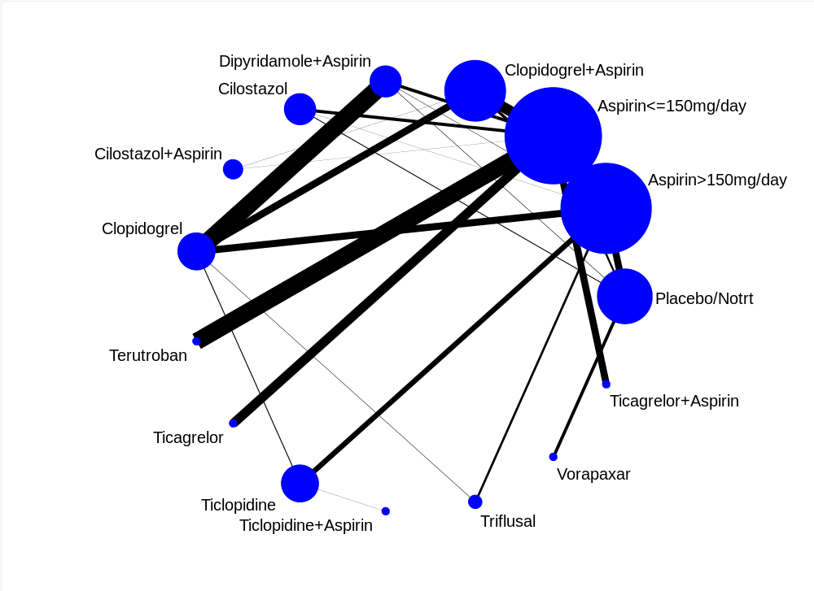

Ischemic stroke or transient ischemic attack
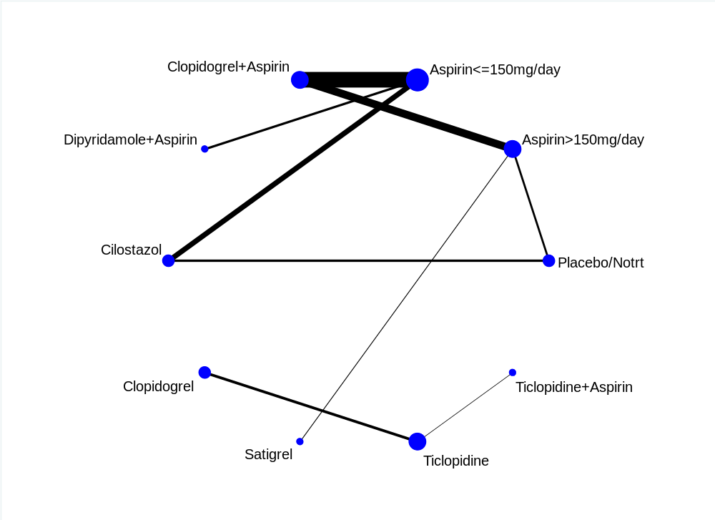

Cardiovascular event
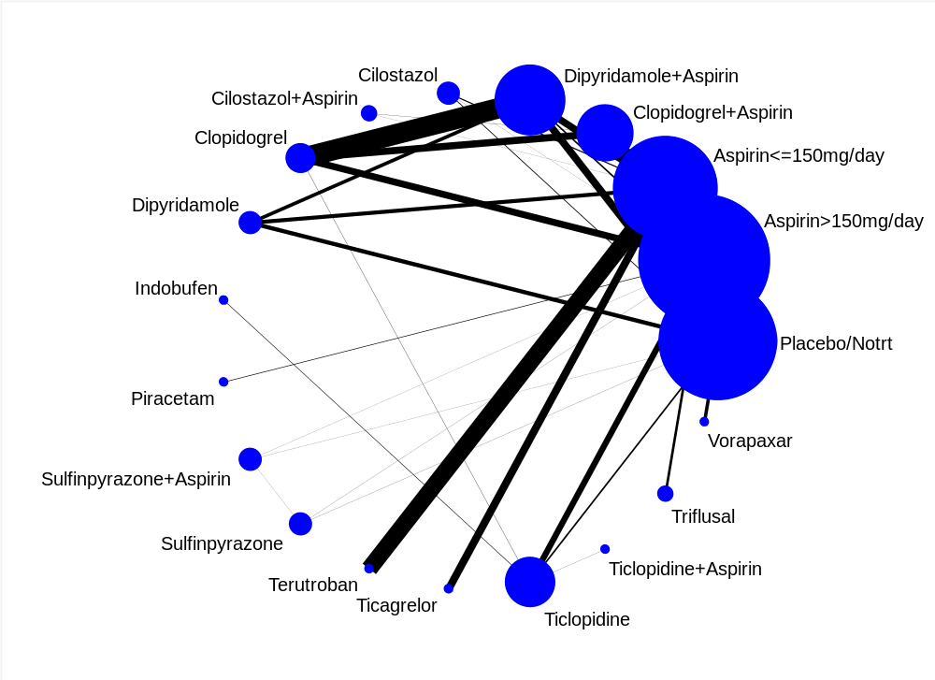

Hemorrhagic stroke
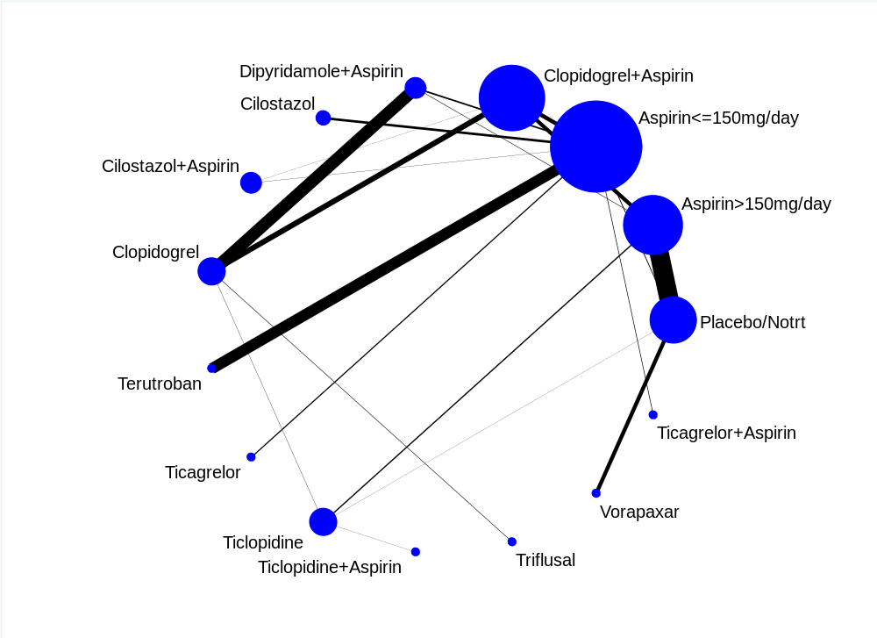

Intracranial haemorrhage
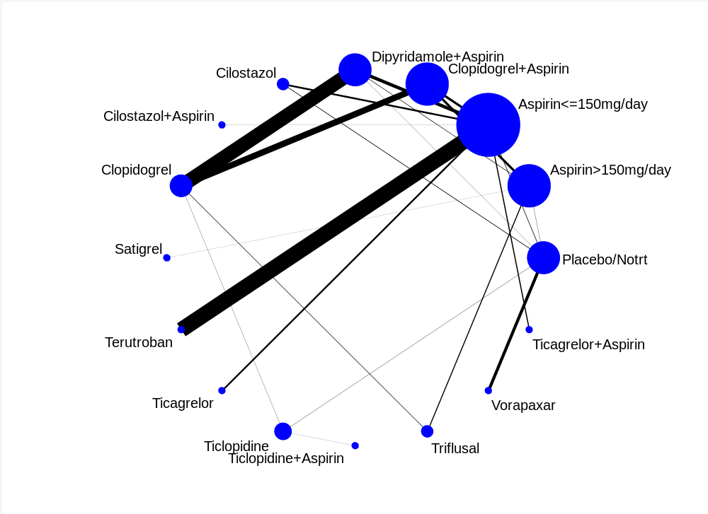

Major bleeding
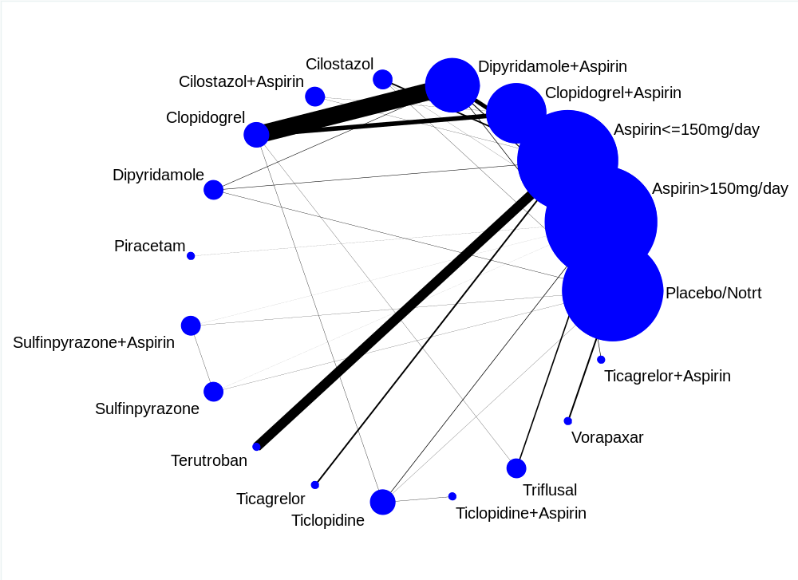

Supplementary 6. Results of the pairwise meta-analyses for primary and secondary outcomes

All strokes
Legend: 01=Placebo / No treatment; 02=Aspirin>150 mg; 03=Aspirin≤150 mg; 04=Clopidogrel 75 mg + Aspirin; 05=Dipyridamole + Aspirin; 06=Cilostazol 200 mg; 07=Cilostazol 200 mg + Aspirin; 08=Clopidogrel 75 mg; 09=Dipyridamole>200 mg; 10=Indobufen 200 mg; 11=Piracetam 4800 mg; 12=Sulfinpyrazone 800 mg + Aspirin>150 mg; 13=Sulfinpyrazone 800 mg; 14=Terutroban 30 mg; 15=Ticagrelor 180 mg; 16=Ticlopidine≤500 mg; 17=Ticlopidine<500 mg + Aspirin≤150 mg; 18=Triflusal 600 mg; 19=Vorapaxar 2.5 mg; 20=Ticagrelor 180 mg + Aspirin≤150 mg.
Study | Odds Ratio [95% Conf. Interval]
---------------------+---------------------------------------------------
02 - 01
CANADIAN CS 1978 | 1.073 0.557 2.068
SWEDISH CS 1987 | 0.995 0.589 1.682
EAFT 1993 | 0.891 0.638 1.245
CAST 1997 | 0.951 0.817 1.108
AICLA 1983 | 0.550 0.301 1.004
DANISH CS 1983 | 1.674 0.742 3.780
UK-TIA 1991 | 0.827 0.648 1.055
Sub-total |
D+L pooled ES | 0.913 0.813 1.026
---------------------+---------------------------------------------------
12 - 01
CANADIAN CS 1978 | 0.631 0.305 1.305
Sub-total |
D+L pooled ES | 0.631 0.305 1.305
---------------------+---------------------------------------------------
13 - 01
CANADIAN CS 1978 | 1.359 0.729 2.531
Sub-total |
D+L pooled ES | 1.359 0.729 2.531
---------------------+---------------------------------------------------
12 - 02
CANADIAN CS 1978 | 0.588 0.288 1.201
Sub-total |
D+L pooled ES | 0.588 0.288 1.201
---------------------+---------------------------------------------------
13 - 02
CANADIAN CS 1978 | 1.266 0.690 2.324
Sub-total |
D+L pooled ES | 1.266 0.690 2.324
---------------------+---------------------------------------------------
13 - 12
CANADIAN CS 1978 | 2.153 1.088 4.262
Sub-total |
D+L pooled ES | 2.153 1.088 4.262
---------------------+---------------------------------------------------
05 - 02
PERSANTIN ASPIRIN TR | 0.854 0.575 1.268
AICLA 1983 | 0.978 0.501 1.909
Sub-total |
D+L pooled ES | 0.885 0.630 1.243
---------------------+---------------------------------------------------
05 - 01
ESPS 1987 | 0.581 0.454 0.745
AICLA 1983 | 0.538 0.295 0.982
ESPS2 1996 | 0.588 0.476 0.728
Sub-total |
D+L pooled ES | 0.582 0.498 0.680
---------------------+---------------------------------------------------
03 - 01
SALT 1991 | 0.815 0.605 1.098
ESPS2 1996 | 0.799 0.655 0.974
Sub-total |
D+L pooled ES | 0.804 0.681 0.948
---------------------+---------------------------------------------------
04 - 03
COMPRESS 2016 | 0.593 0.139 2.521
POINT 2018 | 0.736 0.575 0.943
CHARISMA 2011 | 0.794 0.610 1.033
CHANCE 2013 | 0.673 0.560 0.810
Sub-total |
D+L pooled ES | 0.717 0.630 0.815
---------------------+---------------------------------------------------
04 - 02
SPS3 2012 | 0.888 0.689 1.144
WANG 2015 | 0.303 0.119 0.771
Sub-total |
D+L pooled ES | 0.572 0.203 1.612
---------------------+---------------------------------------------------
16 - 10
TISS 1997 | 0.570 0.311 1.046
Sub-total |
D+L pooled ES | 0.570 0.311 1.046
---------------------+---------------------------------------------------
14 - 03
PERFORM 2011 | 1.017 0.920 1.125
Sub-total |
D+L pooled ES | 1.017 0.920 1.125
---------------------+---------------------------------------------------
08 - 04
MATCH 2004 | 1.024 0.876 1.199
Sub-total |
D+L pooled ES | 1.024 0.876 1.199
---------------------+---------------------------------------------------
09 - 01
ESPS2 1996 | 0.818 0.672 0.997
Sub-total |
D+L pooled ES | 0.818 0.672 0.997
---------------------+---------------------------------------------------
05 - 03
ESPS2 1996 | 0.737 0.591 0.918
JASAP 2011 | 1.474 0.966 2.249
Sub-total |
D+L pooled ES | 1.017 0.516 2.003
---------------------+---------------------------------------------------
09 - 03
ESPS2 1996 | 1.024 0.834 1.258
Sub-total |
D+L pooled ES | 1.024 0.834 1.258
---------------------+---------------------------------------------------
09 - 05
ESPS2 1996 | 1.391 1.117 1.731
Sub-total |
D+L pooled ES | 1.391 1.117 1.731
---------------------+---------------------------------------------------
16 - 01
CATS 1989 | 0.561 0.390 0.809
Sub-total |
D+L pooled ES | 0.561 0.390 0.809
---------------------+---------------------------------------------------
16 - 02
AAASPS 2003 | 1.274 0.942 1.723
TASS 1989 | 0.794 0.640 0.984
Sub-total |
D+L pooled ES | 0.993 0.625 1.578
---------------------+---------------------------------------------------
11 - 02
GROTEMEYER 2000 | 1.396 0.776 2.511
Sub-total |
D+L pooled ES | 1.396 0.776 2.511
---------------------+---------------------------------------------------
18 - 08
MAESTRO 2017 | 1.328 0.729 2.422
Sub-total |
D+L pooled ES | 1.328 0.729 2.422
---------------------+---------------------------------------------------
06 - 03
CASISP 2008 | 0.584 0.281 1.214
CSPS2 2010 | 0.668 0.499 0.894
PICASSO 2018 | 0.636 0.435 0.929
Sub-total |
D+L pooled ES | 0.649 0.520 0.809
---------------------+---------------------------------------------------
17 - 16
TOPALS 2003 | 1.369 0.495 3.790
Sub-total |
D+L pooled ES | 1.369 0.495 3.790
---------------------+---------------------------------------------------
15 - 03
SOCRATES 2016 | 0.861 0.749 0.991
Sub-total |
D+L pooled ES | 0.861 0.749 0.991
---------------------+---------------------------------------------------
07 - 04
TOSS-2 2011 | 1.817 0.660 4.999
Sub-total |
D+L pooled ES | 1.817 0.660 4.999
---------------------+---------------------------------------------------
19 - 01
TIMI-50 2013 | 1.129 0.898 1.419
Sub-total |
D+L pooled ES | 1.129 0.898 1.419
---------------------+---------------------------------------------------
08 - 05
PRoFESS 2008 | 0.982 0.891 1.081
Sub-total |
D+L pooled ES | 0.982 0.891 1.081
---------------------+---------------------------------------------------
07 - 03
CATHARSIS 2015 | 0.456 0.132 1.578
ECLIPSE 2013 | 1.030 0.064 16.700
Sub-total |
D+L pooled ES | 0.522 0.168 1.622
---------------------+---------------------------------------------------
20 - 03
THALES 2019 | 0.804 0.684 0.945
Sub-total |
D+L pooled ES | 0.804 0.684 0.945
---------------------+---------------------------------------------------

Test(s) of heterogeneity:
Heterogeneity degrees of
statistic freedom P I-squared** Tau-squared

02 - 01 6.13 6 0.409 2.0% 0.0006
12 - 01 0.00 0 . .% 0.0000
13 - 01 0.00 0 . .% 0.0000
12 - 02 0.00 0 . .% 0.0000
13 - 02 0.00 0 . .% 0.0000
13 - 12 0.00 0 . .% 0.0000
05 - 02 0.12 1 0.733 0.0% 0.0000
05 - 01 0.08 2 0.963 0.0% 0.0000
03 - 01 0.01 1 0.915 0.0% 0.0000
04 - 03 1.12 3 0.772 0.0% 0.0000
04 - 02 4.74 1 0.029 78.9% 0.4556
16 - 10 0.00 0 . .% 0.0000
14 - 03 0.00 0 . .% 0.0000
08 - 04 0.00 0 . .% 0.0000
09 - 01 0.00 0 . .% 0.0000
05 - 03 8.14 1 0.004 87.7% 0.2109
09 - 03 0.00 0 . .% 0.0000
09 - 05 0.00 0 . .% 0.0000
16 - 01 0.00 0 . .% 0.0000
16 - 02 6.25 1 0.012 84.0% 0.0939
11 - 02 0.00 0 . .% 0.0000
18 - 08 0.00 0 . .% 0.0000
06 - 03 0.13 2 0.939 0.0% 0.0000
17 - 16 0.00 0 . .% 0.0000
15 - 03 0.00 0 . .% 0.0000
07 - 04 0.00 0 . .% 0.0000
19 - 01 0.00 0 . .% 0.0000
08 - 05 0.00 0 . .% 0.0000
07 - 03 0.27 1 0.600 0.0% 0.0000
20 - 03 0.00 0 . .% 0.0000
** I-squared: the variation in ES attributable to heterogeneity

Significance test(s) of ES=1

02 - 01 z= 1.53 p = 0.125
12 - 01 z= 1.24 p = 0.214
13 - 01 z= 0.97 p = 0.334
12 - 02 z= 1.46 p = 0.145
13 - 02 z= 0.76 p = 0.446
13 - 12 z= 2.20 p = 0.028
05 - 02 z= 0.71 p = 0.481
05 - 01 z= 6.80 p = 0.000
03 - 01 z= 2.59 p = 0.010
04 - 03 z= 5.08 p = 0.000
04 - 02 z= 1.06 p = 0.291
16 - 10 z= 1.81 p = 0.070
14 - 03 z= 0.33 p = 0.740
08 - 04 z= 0.30 p = 0.763
09 - 01 z= 1.99 p = 0.046
05 - 03 z= 0.05 p = 0.962
09 - 03 z= 0.23 p = 0.819
09 - 05 z= 2.95 p = 0.003
16 - 01 z= 3.10 p = 0.002
16 - 02 z= 0.03 p = 0.977
11 - 02 z= 1.11 p = 0.266
18 - 08 z= 0.93 p = 0.354
06 - 03 z= 3.84 p = 0.000
17 - 16 z= 0.61 p = 0.545
15 - 03 z= 2.09 p = 0.037
07 - 04 z= 1.16 p = 0.248
19 - 01 z= 1.04 p = 0.299
08 - 05 z= 0.38 p = 0.706
07 - 03 z= 1.12 p = 0.261
20 - 03 z= 2.65 p = 0.008

All-cause mortality
Legend: 01=Placebo / No treatment; 02=Aspirin>150 mg; 03=Aspirin≤150 mg; 04=Clopidogrel 75 mg + Aspirin; 05=Dipyridamole + Aspirin; 06=Cilostazol 200 mg; 07=Cilostazol 200 mg + Aspirin; 08=Clopidogrel 75 mg; 09=Dipyridamole>200 mg; 10=Indobufen 200 mg; 11=Piracetam 4800 mg; 12=Sulfinpyrazone 800 mg + Aspirin>150 mg; 13=Sulfinpyrazone 800 mg; 14=Terutroban 30 mg; 15=Ticagrelor 180 mg; 16=Ticlopidine≤500 mg; 17=Triflusal 600 mg; 18=Vorapaxar 2.5 mg; 19=Ticagrelor 180 mg + Aspirin≤150 mg.
Study | Odds Ratio [95% Conf. Interval]
---------------------+---------------------------------------------------
02 - 01
CANADIAN CS 1978 | 0.646 0.267 1.564
SWEDISH CS 1987 | 0.995 0.593 1.670
EAFT 1993 | 0.952 0.691 1.312
CAST 1997 | 0.858 0.746 0.988
AICLA 1983 | 1.497 0.558 4.014
DANISH CS 1983 | 1.011 0.341 2.993
UK-TIA 1991 | 0.895 0.705 1.137
MAST-I 1995 | 0.794 0.395 1.597
Sub-total |
D+L pooled ES | 0.883 0.793 0.983
---------------------+---------------------------------------------------
12 - 01
CANADIAN CS 1978 | 0.562 0.225 1.400
Sub-total |
D+L pooled ES | 0.562 0.225 1.400
---------------------+---------------------------------------------------
13 - 01
CANADIAN CS 1978 | 0.808 0.356 1.834
Sub-total |
D+L pooled ES | 0.808 0.356 1.834
---------------------+---------------------------------------------------
12 - 02
CANADIAN CS 1978 | 0.870 0.326 2.320
Sub-total |
D+L pooled ES | 0.870 0.326 2.320
---------------------+---------------------------------------------------
13 - 02
CANADIAN CS 1978 | 1.250 0.510 3.061
Sub-total |
D+L pooled ES | 1.250 0.510 3.061
---------------------+---------------------------------------------------
13 - 12
CANADIAN CS 1978 | 1.438 0.570 3.624
Sub-total |
D+L pooled ES | 1.438 0.570 3.624
---------------------+---------------------------------------------------
05 - 02
PERSANTIN ASPIRIN TR | 1.217 0.775 1.910
AICLA 1983 | 0.775 0.299 2.007
Sub-total |
D+L pooled ES | 1.120 0.745 1.684
---------------------+---------------------------------------------------
05 - 01
ESPS 1987 | 0.663 0.512 0.859
AICLA 1983 | 1.161 0.413 3.262
ESPS2 1996 | 0.905 0.732 1.119
Sub-total |
D+L pooled ES | 0.802 0.616 1.045
---------------------+---------------------------------------------------
03 - 01
SALT 1991 | 0.884 0.615 1.270
ESPS2 1996 | 0.889 0.718 1.100
Sub-total |
D+L pooled ES | 0.888 0.739 1.066
---------------------+---------------------------------------------------
04 - 03
COMPRESS 2016 | 7.128 0.365 139.069
POINT 2018 | 1.514 0.728 3.150
CARESS 2005 | 1.097 0.021 56.302
CHARISMA 2011 | 0.774 0.543 1.103
CHANCE 2013 | 1.001 0.416 2.408
Sub-total |
D+L pooled ES | 0.968 0.667 1.405
---------------------+---------------------------------------------------
04 - 02
SPS3 2012 | 1.491 1.105 2.010
WANG 2015 | 1.007 0.141 7.199
YI 2014 | 1.007 0.141 7.199
Sub-total |
D+L pooled ES | 1.465 1.094 1.962
---------------------+---------------------------------------------------
16 - 10
TISS 1997 | 0.448 0.224 0.894
Sub-total |
D+L pooled ES | 0.448 0.224 0.894
---------------------+---------------------------------------------------
14 - 03
PERFORM 2011 | 1.011 0.899 1.138
Sub-total |
D+L pooled ES | 1.011 0.899 1.138
---------------------+---------------------------------------------------
17 - 02
TAPIRSS 2004 | 0.453 0.169 1.214
TACIP 2003 | 1.203 0.837 1.729
Sub-total |
D+L pooled ES | 0.825 0.325 2.096
---------------------+---------------------------------------------------
08 - 04
MATCH 2004 | 0.999 0.817 1.221
Sub-total |
D+L pooled ES | 0.999 0.817 1.221
---------------------+---------------------------------------------------
09 - 01
ESPS2 1996 | 0.919 0.744 1.135
Sub-total |
D+L pooled ES | 0.919 0.744 1.135
---------------------+---------------------------------------------------
05 - 03
ESPS2 1996 | 1.018 0.819 1.265
ESPRIT 2006 | 0.868 0.651 1.159
JASAP 2011 | 0.388 0.121 1.244
Sub-total |
D+L pooled ES | 0.916 0.717 1.169
---------------------+---------------------------------------------------
09 - 03
ESPS2 1996 | 1.034 0.833 1.283
Sub-total |
D+L pooled ES | 1.034 0.833 1.283
---------------------+---------------------------------------------------
09 - 05
ESPS2 1996 | 1.016 0.819 1.260
Sub-total |
D+L pooled ES | 1.016 0.819 1.260
---------------------+---------------------------------------------------
16 - 01
CATS 1989 | 1.007 0.695 1.457
Sub-total |
D+L pooled ES | 1.007 0.695 1.457
---------------------+---------------------------------------------------
16 - 02
AAASPS 2003 | 1.138 0.736 1.761
TASS 1989 | 0.886 0.713 1.101
Sub-total |
D+L pooled ES | 0.932 0.766 1.135
---------------------+---------------------------------------------------
06 - 01
GOTOH 2000 | 0.900 0.363 2.233
Sub-total |
D+L pooled ES | 0.900 0.363 2.233
---------------------+---------------------------------------------------
11 - 02
GROTEMEYER 2000 | 1.362 0.518 3.582
Sub-total |
D+L pooled ES | 1.362 0.518 3.582
---------------------+---------------------------------------------------
06 - 03
CASISP 2008 | 0.595 0.141 2.508
CSPS2 2010 | 0.998 0.461 2.162
PICASSO 2018 | 0.902 0.536 1.519
Sub-total |
D+L pooled ES | 0.897 0.593 1.357
---------------------+---------------------------------------------------
15 - 03
SOCRATES 2016 | 1.178 0.828 1.675
Sub-total |
D+L pooled ES | 1.178 0.828 1.675
---------------------+---------------------------------------------------
07 - 04
TOSS-2 2011 | 0.483 0.043 5.361
Sub-total |
D+L pooled ES | 0.483 0.043 5.361
---------------------+---------------------------------------------------
18 - 01
TIMI-50 2013 | 1.186 0.877 1.604
Sub-total |
D+L pooled ES | 1.186 0.877 1.604
---------------------+---------------------------------------------------
08 - 05
PRoFESS 2008 | 1.028 0.925 1.142
Sub-total |
D+L pooled ES | 1.028 0.925 1.142
---------------------+---------------------------------------------------
07 - 03
CATHARSIS 2015 | 0.964 0.019 49.170
ECLIPSE 2013 | 1.030 0.020 52.402
Sub-total |
D+L pooled ES | 0.996 0.062 16.052
---------------------+---------------------------------------------------
19 - 03
THALES 2019 | 1.328 0.805 2.191
Sub-total |
D+L pooled ES | 1.328 0.805 2.191
---------------------+---------------------------------------------------

Test(s) of heterogeneity:
Heterogeneity degrees of
statistic freedom P I-squared** Tau-squared

02 - 01 2.31 7 0.940 0.0% 0.0000
12 - 01 0.00 0 . .% 0.0000
13 - 01 0.00 0 . .% 0.0000
12 - 02 0.00 0 . .% 0.0000
13 - 02 0.00 0 . .% 0.0000
13 - 12 0.00 0 . .% 0.0000
05 - 02 0.70 1 0.402 0.0% 0.0000
05 - 01 3.79 2 0.150 47.2% 0.0243
03 - 01 0.00 1 0.980 0.0% 0.0000
04 - 03 4.55 4 0.336 12.2% 0.0276
04 - 02 0.29 2 0.864 0.0% 0.0000
16 - 10 0.00 0 . .% 0.0000
14 - 03 0.00 0 . .% 0.0000
17 - 02 3.32 1 0.068 69.9% 0.3337
08 - 04 0.00 0 . .% 0.0000
09 - 01 0.00 0 . .% 0.0000
05 - 03 3.02 2 0.221 33.7% 0.0161
09 - 03 0.00 0 . .% 0.0000
09 - 05 0.00 0 . .% 0.0000
16 - 01 0.00 0 . .% 0.0000
16 - 02 1.01 1 0.315 1.2% 0.0004
06 - 01 0.00 0 . .% 0.0000
11 - 02 0.00 0 . .% 0.0000
06 - 03 0.39 2 0.824 0.0% 0.0000
15 - 03 0.00 0 . .% 0.0000
07 - 04 0.00 0 . .% 0.0000
18 - 01 0.00 0 . .% 0.0000
08 - 05 0.00 0 . .% 0.0000
07 - 03 0.00 1 0.981 0.0% 0.0000
19 - 03 0.00 0 . .% 0.0000
** I-squared: the variation in ES attributable to heterogeneity
Significance test(s) of ES=1

02 - 01 z= 2.27 p = 0.023
12 - 01 z= 1.24 p = 0.216
13 - 01 z= 0.51 p = 0.610
12 - 02 z= 0.28 p = 0.780
13 - 02 z= 0.49 p = 0.625
13 - 12 z= 0.77 p = 0.442
05 - 02 z= 0.54 p = 0.586
05 - 01 z= 1.64 p = 0.102
03 - 01 z= 1.27 p = 0.203
04 - 03 z= 0.17 p = 0.864
04 - 02 z= 2.56 p = 0.010
16 - 10 z= 2.28 p = 0.023
14 - 03 z= 0.19 p = 0.851
17 - 02 z= 0.40 p = 0.686
08 - 04 z= 0.01 p = 0.989
09 - 01 z= 0.79 p = 0.432
05 - 03 z= 0.71 p = 0.480
09 - 03 z= 0.30 p = 0.764
09 - 05 z= 0.14 p = 0.889
16 - 01 z= 0.03 p = 0.973
16 - 02 z= 0.70 p = 0.485
06 - 01 z= 0.23 p = 0.820
11 - 02 z= 0.63 p = 0.531
06 - 03 z= 0.51 p = 0.608
15 - 03 z= 0.91 p = 0.362
07 - 04 z= 0.59 p = 0.553
18 - 01 z= 1.11 p = 0.267
08 - 05 z= 0.52 p = 0.606
07 - 03 z= 0.00 p = 0.998
19 - 03 z= 1.11 p = 0.266

Ischemic stroke
Legend: 01=Placebo / No treatment; 02=Aspirin>150 mg; 03=Aspirin≤150 mg; 04=Clopidogrel 75 mg + Aspirin; 05=Dipyridamole + Aspirin; 06=Cilostazol 200 mg; 07=Cilostazol 200 mg + Aspirin; 08=Clopidogrel 75 mg; 09=Terutroban 30 mg; 10=Ticagrelor 180 mg; 11=Ticlopidine≤500 mg; 12=Ticlopidine<500 mg + Aspirin≤150 mg; 13=Triflusal 600 mg; 14=Vorapaxar 2.5 mg; 15=Ticagrelor 180 mg + Aspirin≤150 mg.
Study | Odds Ratio [95% Conf. Interval]
---------------------+---------------------------------------------------
02 - 01
SWEDISH CS 1987 | 0.958 0.557 1.649
EAFT 1993 | 0.786 0.544 1.138
CAST 1997 | 0.772 0.629 0.947
AICLA 1983 | 0.524 0.280 0.981
MAST-I 1995 | 3.079 0.124 76.163
Sub-total |
D+L pooled ES | 0.772 0.656 0.910
---------------------+---------------------------------------------------
03 - 01
SALT 1991 | 0.761 0.558 1.039
Sub-total |
D+L pooled ES | 0.761 0.558 1.039
---------------------+---------------------------------------------------
08 - 02
CAPRIE 1996 | 0.913 0.777 1.074
Sub-total |
D+L pooled ES | 0.913 0.777 1.074
---------------------+---------------------------------------------------
04 - 03
COMPRESS 2016 | 0.393 0.075 2.053
POINT 2018 | 0.714 0.557 0.917
CARESS 2005 | 0.113 0.006 2.157
CHARISMA 2011 | 0.792 0.597 1.050
CHANCE 2013 | 0.666 0.552 0.803
Sub-total |
D+L pooled ES | 0.700 0.614 0.799
---------------------+---------------------------------------------------
04 - 02
SPS3 2012 | 0.785 0.597 1.032
WANG 2015 | 0.267 0.098 0.729
YI 2014 | 0.267 0.098 0.729
Sub-total |
D+L pooled ES | 0.428 0.182 1.007
---------------------+---------------------------------------------------
09 - 03
PERFORM 2011 | 1.024 0.923 1.137
Sub-total |
D+L pooled ES | 1.024 0.923 1.137
---------------------+---------------------------------------------------
05 - 01
AICLA 1983 | 0.546 0.295 1.012
Sub-total |
D+L pooled ES | 0.546 0.295 1.012
---------------------+---------------------------------------------------
05 - 02
AICLA 1983 | 1.042 0.520 2.085
Sub-total |
D+L pooled ES | 1.042 0.520 2.085
---------------------+---------------------------------------------------
08 - 04
MATCH 2004 | 1.084 0.922 1.274
Sub-total |
D+L pooled ES | 1.084 0.922 1.274
---------------------+---------------------------------------------------
11 - 02
AAASPS 2003 | 1.274 0.942 1.723
TASS 1989 | 0.743 0.584 0.945
THOGI 1984 | 0.333 0.066 1.676
Sub-total |
D+L pooled ES | 0.882 0.528 1.473
---------------------+---------------------------------------------------
06 - 01
GOTOH 2000 | 0.499 0.315 0.790
Sub-total |
D+L pooled ES | 0.499 0.315 0.790
---------------------+---------------------------------------------------
05 - 03
ESPRIT 2006 | 0.823 0.621 1.091
JASAP 2011 | 1.406 0.882 2.243
Sub-total |
D+L pooled ES | 1.040 0.618 1.751
---------------------+---------------------------------------------------
13 - 08
MAESTRO 2017 | 1.648 0.851 3.191
Sub-total |
D+L pooled ES | 1.648 0.851 3.191
---------------------+---------------------------------------------------
06 - 03
CASISP 2008 | 0.723 0.327 1.596
CSPS2 2010 | 0.807 0.585 1.112
PICASSO 2018 | 0.714 0.469 1.087
Sub-total |
D+L pooled ES | 0.766 0.601 0.977
---------------------+---------------------------------------------------
12 - 11
TOPALS 2003 | 1.048 0.357 3.073
Sub-total |
D+L pooled ES | 1.048 0.357 3.073
---------------------+---------------------------------------------------
10 - 03
SOCRATES 2016 | 0.868 0.754 1.000
Sub-total |
D+L pooled ES | 0.868 0.754 1.000
---------------------+---------------------------------------------------
07 - 04
TOSS-2 2011 | 1.644 0.587 4.602
Sub-total |
D+L pooled ES | 1.644 0.587 4.602
---------------------+---------------------------------------------------
13 - 02
TACIP 2003 | 1.008 0.755 1.346
Sub-total |
D+L pooled ES | 1.008 0.755 1.346
---------------------+---------------------------------------------------
14 - 01
TIMI-50 2013 | 0.983 0.771 1.253
Sub-total |
D+L pooled ES | 0.983 0.771 1.253
---------------------+---------------------------------------------------
08 - 05
PRoFESS 2008 | 1.028 0.928 1.139
Sub-total |
D+L pooled ES | 1.028 0.928 1.139
---------------------+---------------------------------------------------
11 - 08
UCHIYAMA 2008 | 0.974 0.546 1.739
FUKUUCHI 2008 | 0.871 0.431 1.762
Sub-total |
D+L pooled ES | 0.931 0.595 1.457
---------------------+---------------------------------------------------
06 - 02
CAIST 2011 | 0.536 0.177 1.624
Sub-total |
D+L pooled ES | 0.536 0.177 1.624
---------------------+---------------------------------------------------
07 - 03
CATHARSIS 2015 | 0.624 0.169 2.301
ECLIPSE 2013 | 1.030 0.064 16.700
Sub-total |
D+L pooled ES | 0.683 0.210 2.226
---------------------+---------------------------------------------------
15 - 03
THALES 2019 | 0.785 0.667 0.924
Sub-total |
D+L pooled ES | 0.785 0.667 0.924
---------------------+---------------------------------------------------

Test(s) of heterogeneity:
Heterogeneity degrees of
statistic freedom P I-squared** Tau-squared

02 - 01 2.80 4 0.593 0.0% 0.0000
03 - 01 0.00 0 . .% 0.0000
08 - 02 0.00 0 . .% 0.0000
04 - 03 2.97 4 0.563 0.0% 0.0000
04 - 02 7.71 2 0.021 74.1% 0.4156
09 - 03 0.00 0 . .% 0.0000
05 - 01 0.00 0 . .% 0.0000
05 - 02 0.00 0 . .% 0.0000
08 - 04 0.00 0 . .% 0.0000
11 - 02 8.99 2 0.011 77.7% 0.1301
06 - 01 0.00 0 . .% 0.0000
05 - 03 3.71 1 0.054 73.0% 0.1048
13 - 08 0.00 0 . .% 0.0000
06 - 03 0.23 2 0.893 0.0% 0.0000
12 - 11 0.00 0 . .% 0.0000
10 - 03 0.00 0 . .% 0.0000
07 - 04 0.00 0 . .% 0.0000
13 - 02 0.00 0 . .% 0.0000
14 - 01 0.00 0 . .% 0.0000
08 - 05 0.00 0 . .% 0.0000
11 - 08 0.06 1 0.810 0.0% 0.0000
06 - 02 0.00 0 . .% 0.0000
07 - 03 0.10 1 0.750 0.0% 0.0000
15 - 03 0.00 0 . .% 0.0000
** I-squared: the variation in ES attributable to heterogeneity

Significance test(s) of ES=1

02 - 01 z= 3.10 p = 0.002
03 - 01 z= 1.72 p = 0.085
08 - 02 z= 1.10 p = 0.273
04 - 03 z= 5.30 p = 0.000
04 - 02 z= 1.94 p = 0.052
09 - 03 z= 0.45 p = 0.651
05 - 01 z= 1.92 p = 0.054
05 - 02 z= 0.12 p = 0.908
08 - 04 z= 0.97 p = 0.331
11 - 02 z= 0.48 p = 0.632
06 - 01 z= 2.96 p = 0.003
05 - 03 z= 0.15 p = 0.882
13 - 08 z= 1.48 p = 0.138
06 - 03 z= 2.15 p = 0.032
12 - 11 z= 0.09 p = 0.932
10 - 03 z= 1.96 p = 0.050
07 - 04 z= 0.95 p = 0.344
13 - 02 z= 0.05 p = 0.958
14 - 01 z= 0.14 p = 0.889
08 - 05 z= 0.53 p = 0.596
11 - 08 z= 0.31 p = 0.755
06 - 02 z= 1.10 p = 0.270
07 - 03 z= 0.63 p = 0.527
15 - 03 z= 2.91 p = 0.004

Ischemic stroke or transient ischemic attack
Legend: 01=Placebo / No treatment; 02=Aspirin>150 mg; 03=Aspirin≤150 mg; 04=Clopidogrel 75 mg + Aspirin; 05=Dipyridamole + Aspirin; 06=Cilostazol 200 mg; 07=Clopidogrel 75 mg; 08=Satigrel; 09=Ticlopidine≤500 mg; 10=Ticlopidine<500 mg + Aspirin≤150 mg.
Study | Odds Ratio [95% Conf. Interval]
---------------------+---------------------------------------------------
02 - 01
SWEDISH CS 1987 | 0.995 0.614 1.613
Sub-total |
D+L pooled ES | 0.995 0.614 1.613
---------------------+---------------------------------------------------
04 - 02
SPS3 2012 | 0.758 0.594 0.966
Sub-total |
D+L pooled ES | 0.758 0.594 0.966
---------------------+---------------------------------------------------
06 - 01
GOTOH 2000 | 0.502 0.323 0.781
Sub-total |
D+L pooled ES | 0.502 0.323 0.781
---------------------+---------------------------------------------------
10 - 09
TOPALS 2003 | 0.946 0.388 2.308
Sub-total |
D+L pooled ES | 0.946 0.388 2.308
---------------------+---------------------------------------------------
04 - 03
CARESS 2005 | 0.399 0.130 1.224
CHANCE 2013 | 0.681 0.572 0.811
Sub-total |
D+L pooled ES | 0.673 0.566 0.799
---------------------+---------------------------------------------------
08 - 02
JETS-1 1995 | 0.411 0.193 0.877
Sub-total |
D+L pooled ES | 0.411 0.193 0.877
---------------------+---------------------------------------------------
06 - 03
CSPS2 2010 | 0.822 0.611 1.107
Sub-total |
D+L pooled ES | 0.822 0.611 1.107
---------------------+---------------------------------------------------
09 - 07
UCHIYAMA 2008 | 1.057 0.618 1.807
FUKUUCHI 2008 | 0.991 0.519 1.892
Sub-total |
D+L pooled ES | 1.029 0.681 1.556
---------------------+---------------------------------------------------
05 - 03
JASAP 2011 | 1.371 0.874 2.151
Sub-total |
D+L pooled ES | 1.371 0.874 2.151
---------------------+---------------------------------------------------

Test(s) of heterogeneity:
Heterogeneity degrees of
statistic freedom P I-squared** Tau-squared

02 - 01 0.00 0 . .% 0.0000
04 - 02 0.00 0 . .% 0.0000
06 - 01 0.00 0 . .% 0.0000
10 - 09 0.00 0 . .% 0.0000
04 - 03 0.86 1 0.355 0.0% 0.0000
08 - 02 0.00 0 . .% 0.0000
06 - 03 0.00 0 . .% 0.0000
09 - 07 0.02 1 0.881 0.0% 0.0000
05 - 03 0.00 0 . .% 0.0000
** I-squared: the variation in ES attributable to heterogeneity

Significance test(s) of ES=1

02 - 01 z= 0.02 p = 0.985
04 - 02 z= 2.24 p = 0.025
06 - 01 z= 3.06 p = 0.002
10 - 09 z= 0.12 p = 0.904
04 - 03 z= 4.51 p = 0.000
08 - 02 z= 2.30 p = 0.021
06 - 03 z= 1.29 p = 0.196
09 - 07 z= 0.14 p = 0.890
05 - 03 z= 1.38 p = 0.169

Cardiovascular event
Legend: 01=Placebo / No treatment; 02=Aspirin>150 mg; 03=Aspirin≤150 mg; 04=Clopidogrel 75 mg + Aspirin; 05=Dipyridamole + Aspirin; 06=Cilostazol 200 mg; 07=Cilostazol 200 mg + Aspirin; 08=Clopidogrel 75 mg; 09=Dipyridamole>200 mg; 10=Indobufen 200 mg; 11=Piracetam 4800 mg; 12=Sulfinpyrazone 800 mg + Aspirin>150 mg; 13=Sulfinpyrazone 800 mg; 14=Terutroban 30 mg; 15=Ticagrelor 180 mg; 16=Ticlopidine≤500 mg; 17=Ticlopidine<500 mg + Aspirin≤150 mg; 18=Triflusal 600 mg; 19=Vorapaxar 2.5 mg.
Study | Odds Ratio [95% Conf. Interval]
---------------------+---------------------------------------------------
02 - 01
CANADIAN CS 1978 | 0.776 0.311 1.934
EAFT 1993 | 0.844 0.628 1.135
CAST 1997 | 0.892 0.760 1.047
AICLA 1983 | 0.483 0.284 0.821
UK-TIA 1991 | 0.843 0.688 1.034
MAST-I 1995 | 4.161 0.460 37.660
Sub-total |
D+L pooled ES | 0.832 0.714 0.969
---------------------+---------------------------------------------------
12 - 01
CANADIAN CS 1978 | 0.499 0.179 1.387
Sub-total |
D+L pooled ES | 0.499 0.179 1.387
---------------------+---------------------------------------------------
13 - 01
CANADIAN CS 1978 | 0.712 0.286 1.774
Sub-total |
D+L pooled ES | 0.712 0.286 1.774
---------------------+---------------------------------------------------
12 - 02
CANADIAN CS 1978 | 0.643 0.223 1.855
Sub-total |
D+L pooled ES | 0.643 0.223 1.855
---------------------+---------------------------------------------------
13 - 02
CANADIAN CS 1978 | 0.918 0.354 2.382
Sub-total |
D+L pooled ES | 0.918 0.354 2.382
---------------------+---------------------------------------------------
13 - 12
CANADIAN CS 1978 | 1.429 0.496 4.118
Sub-total |
D+L pooled ES | 1.429 0.496 4.118
---------------------+---------------------------------------------------
05 - 02
PERSANTIN ASPIRIN TR | 0.912 0.648 1.283
AICLA 1983 | 0.977 0.540 1.768
Sub-total |
D+L pooled ES | 0.928 0.690 1.247
---------------------+---------------------------------------------------
05 - 01
ESPS 1987 | 0.602 0.490 0.740
AICLA 1983 | 0.472 0.278 0.802
ESPS2 1996 | 0.624 0.515 0.755
Sub-total |
D+L pooled ES | 0.603 0.527 0.691
---------------------+---------------------------------------------------
03 - 01
SALT 1991 | 0.818 0.641 1.044
ESPS2 1996 | 0.841 0.702 1.007
Sub-total |
D+L pooled ES | 0.833 0.720 0.963
---------------------+---------------------------------------------------
08 - 02
CAPRIE 1996 | 0.918 0.797 1.058
Sub-total |
D+L pooled ES | 0.918 0.797 1.058
---------------------+---------------------------------------------------
04 - 03
COMPRESS 2016 | 0.658 0.182 2.377
POINT 2018 | 0.782 0.617 0.991
CARESS 2005 | 0.260 0.028 2.407
CHARISMA 2011 | 0.829 0.671 1.024
CHANCE 2013 | 0.677 0.564 0.813
Sub-total |
D+L pooled ES | 0.746 0.663 0.841
---------------------+---------------------------------------------------
04 - 02
SPS3 2012 | 0.857 0.681 1.078
Sub-total |
D+L pooled ES | 0.857 0.681 1.078
---------------------+---------------------------------------------------
16 - 10
TISS 1997 | 0.489 0.296 0.808
Sub-total |
D+L pooled ES | 0.489 0.296 0.808
---------------------+---------------------------------------------------
14 - 03
PERFORM 2011 | 1.029 0.941 1.126
Sub-total |
D+L pooled ES | 1.029 0.941 1.126
---------------------+---------------------------------------------------
18 - 02
TAPIRSS 2004 | 0.941 0.545 1.624
TACIP 2003 | 1.067 0.826 1.379
Sub-total |
D+L pooled ES | 1.043 0.827 1.316
---------------------+---------------------------------------------------
08 - 04
MATCH 2004 | 1.070 0.932 1.229
Sub-total |
D+L pooled ES | 1.070 0.932 1.229
---------------------+---------------------------------------------------
09 - 01
ESPS2 1996 | 0.857 0.716 1.025
Sub-total |
D+L pooled ES | 0.857 0.716 1.025
---------------------+---------------------------------------------------
05 - 03
ESPS2 1996 | 0.742 0.610 0.903
ESPRIT 2006 | 0.791 0.624 1.002
JASAP 2011 | 1.085 0.753 1.564
Sub-total |
D+L pooled ES | 0.819 0.680 0.987
---------------------+---------------------------------------------------
09 - 03
ESPS2 1996 | 1.019 0.847 1.226
Sub-total |
D+L pooled ES | 1.019 0.847 1.226
---------------------+---------------------------------------------------
09 - 05
ESPS2 1996 | 1.374 1.130 1.670
Sub-total |
D+L pooled ES | 1.374 1.130 1.670
---------------------+---------------------------------------------------
16 - 01
CATS 1989 | 0.744 0.557 0.994
Sub-total |
D+L pooled ES | 0.744 0.557 0.994
---------------------+---------------------------------------------------
16 - 02
AAASPS 2003 | 1.280 0.980 1.672
TASS 1989 | 0.887 0.738 1.067
THOGI 1984 | 0.523 0.216 1.269
Sub-total |
D+L pooled ES | 0.966 0.679 1.376
---------------------+---------------------------------------------------
06 - 01
GOTOH 2000 | 0.646 0.427 0.979
Sub-total |
D+L pooled ES | 0.646 0.427 0.979
---------------------+---------------------------------------------------
11 - 02
GROTEMEYER 2000 | 1.469 0.918 2.350
Sub-total |
D+L pooled ES | 1.469 0.918 2.350
---------------------+---------------------------------------------------
17 - 16
TOPALS 2003 | 1.049 0.403 2.729
Sub-total |
D+L pooled ES | 1.049 0.403 2.729
---------------------+---------------------------------------------------
15 - 03
SOCRATES 2016 | 0.884 0.774 1.010
Sub-total |
D+L pooled ES | 0.884 0.774 1.010
---------------------+---------------------------------------------------
07 - 04
TOSS-2 2011 | 1.486 0.653 3.381
Sub-total |
D+L pooled ES | 1.486 0.653 3.381
---------------------+---------------------------------------------------
19 - 01
TIMI-50 2013 | 1.027 0.841 1.255
Sub-total |
D+L pooled ES | 1.027 0.841 1.255
---------------------+---------------------------------------------------
08 - 05
PRoFESS 2008 | 1.003 0.925 1.089
Sub-total |
D+L pooled ES | 1.003 0.925 1.089
---------------------+---------------------------------------------------
06 - 03
PICASSO 2018 | 0.770 0.545 1.090
Sub-total |
D+L pooled ES | 0.770 0.545 1.090
---------------------+---------------------------------------------------
16 - 08
FUKUUCHI 2008 | 0.871 0.431 1.762
Sub-total |
D+L pooled ES | 0.871 0.431 1.762
---------------------+---------------------------------------------------
06 - 02
CAIST 2011 | 0.646 0.226 1.845
Sub-total |
D+L pooled ES | 0.646 0.226 1.845
---------------------+---------------------------------------------------
07 - 03
CATHARSIS 2015 | 0.402 0.133 1.215
Sub-total |
D+L pooled ES | 0.402 0.133 1.215
---------------------+---------------------------------------------------

Test(s) of heterogeneity:
Heterogeneity degrees of
statistic freedom P I-squared** Tau-squared

02 - 01 6.75 5 0.240 25.9% 0.0089
12 - 01 0.00 0 . .% 0.0000
13 - 01 0.00 0 . .% 0.0000
12 - 02 0.00 0 . .% 0.0000
13 - 02 0.00 0 . .% 0.0000
13 - 12 0.00 0 . .% 0.0000
05 - 02 0.04 1 0.842 0.0% 0.0000
05 - 01 0.94 2 0.625 0.0% 0.0000
03 - 01 0.03 1 0.860 0.0% 0.0000
08 - 02 0.00 0 . .% 0.0000
04 - 03 3.08 4 0.544 0.0% 0.0000
04 - 02 0.00 0 . .% 0.0000
16 - 10 0.00 0 . .% 0.0000
14 - 03 0.00 0 . .% 0.0000
18 - 02 0.17 1 0.681 0.0% 0.0000
08 - 04 0.00 0 . .% 0.0000
09 - 01 0.00 0 . .% 0.0000
05 - 03 3.25 2 0.197 38.5% 0.0106
09 - 03 0.00 0 . .% 0.0000
09 - 05 0.00 0 . .% 0.0000
16 - 01 0.00 0 . .% 0.0000
16 - 02 6.87 2 0.032 70.9% 0.0608
06 - 01 0.00 0 . .% 0.0000
11 - 02 0.00 0 . .% 0.0000
17 - 16 0.00 0 . .% 0.0000
15 - 03 0.00 0 . .% 0.0000
07 - 04 0.00 0 . .% 0.0000
19 - 01 0.00 0 . .% 0.0000
08 - 05 0.00 0 . .% 0.0000
06 - 03 0.00 0 . .% 0.0000
16 - 08 0.00 0 . .% 0.0000
06 - 02 0.00 0 . .% 0.0000
07 - 03 0.00 0 . .% 0.0000
** I-squared: the variation in ES attributable to heterogeneity)

Significance test(s) of ES=1

02 - 01 z= 2.36 p = 0.018
12 - 01 z= 1.33 p = 0.183
13 - 01 z= 0.73 p = 0.466
12 - 02 z= 0.82 p = 0.414
13 - 02 z= 0.18 p = 0.861
13 - 12 z= 0.66 p = 0.509
05 - 02 z= 0.50 p = 0.619
05 - 01 z= 7.31 p = 0.000
03 - 01 z= 2.47 p = 0.013
08 - 02 z= 1.18 p = 0.236
04 - 03 z= 4.83 p = 0.000
04 - 02 z= 1.32 p = 0.188
16 - 10 z= 2.79 p = 0.005
14 - 03 z= 0.63 p = 0.527
18 - 02 z= 0.36 p = 0.721
08 - 04 z= 0.96 p = 0.335
09 - 01 z= 1.69 p = 0.091
05 - 03 z= 2.10 p = 0.036
09 - 03 z= 0.20 p = 0.843
09 - 05 z= 3.18 p = 0.001
16 - 01 z= 2.00 p = 0.045
16 - 02 z= 0.19 p = 0.850
06 - 01 z= 2.06 p = 0.039
11 - 02 z= 1.60 p = 0.109
17 - 16 z= 0.10 p = 0.922
15 - 03 z= 1.81 p = 0.070
07 - 04 z= 0.94 p = 0.345
19 - 01 z= 0.26 p = 0.794
08 - 05 z= 0.08 p = 0.935
06 - 03 z= 1.47 p = 0.140
16 - 08 z= 0.38 p = 0.702
06 - 02 z= 0.82 p = 0.414
07 - 03 z= 1.62 p = 0.106

Hemorrhagic stroke
Legend: 01=Placebo / No treatment; 02=Aspirin>150 mg; 03=Aspirin≤150 mg; 04=Clopidogrel 75 mg + Aspirin; 05=Dipyridamole + Aspirin; 06=Cilostazol 200 mg; 07=Cilostazol 200 mg + Aspirin; 08=Clopidogrel 75 mg; 09=Terutroban 30 mg; 10=Ticagrelor 180 mg; 11=Ticlopidine≤500 mg; 12=Ticlopidine<500 mg + Aspirin≤150 mg; 13=Triflusal 600 mg; 14=Vorapaxar 2.5 mg; 15=Ticagrelor 180 mg + Aspirin≤150 mg.
Study | ES [95% Conf. Interval]
---------------------+---------------------------------------------------
05 - 02
PERSANTIN ASPIRIN TR | 0.491 0.089 2.695
Sub-total |
D+L pooled ES | 0.491 0.089 2.695
---------------------+---------------------------------------------------
02 - 01
SWEDISH CS 1987 | 1.500 0.249 9.054
EAFT 1993 | 2.814 0.114 69.292
CAST 1997 | 1.237 0.940 1.629
MAST-I 1995 | 3.100 0.319 30.135
Sub-total |
D+L pooled ES | 1.266 0.968 1.656
---------------------+---------------------------------------------------
03 - 01
SALT 1991 | 3.408 0.934 12.439
Sub-total |
D+L pooled ES | 3.408 0.934 12.439
---------------------+---------------------------------------------------
04 - 03
COMPRESS 2016 | 3.018 0.122 74.618
POINT 2018 | 1.680 0.401 7.036
CARESS 2005 | 1.097 0.021 56.302
CHARISMA 2011 | 1.115 0.452 2.749
CHANCE 2013 | 1.001 0.375 2.671
Sub-total |
D+L pooled ES | 1.187 0.661 2.133
---------------------+---------------------------------------------------
04 - 02
SPS3 2012 | 0.526 0.222 1.244
WANG 2015 | 1.007 0.063 16.179
YI 2014 | 0.912 0.381 2.183
Sub-total |
D+L pooled ES | 0.702 0.386 1.278
---------------------+---------------------------------------------------
09 - 03
PERFORM 2011 | 1.155 0.812 1.643
Sub-total |
D+L pooled ES | 1.155 0.812 1.643
---------------------+---------------------------------------------------
08 - 04
MATCH 2004 | 0.622 0.376 1.027
Sub-total |
D+L pooled ES | 0.622 0.376 1.027
---------------------+---------------------------------------------------
11 - 01
CATS 1989 | 5.048 0.242 105.395
Sub-total |
D+L pooled ES | 5.048 0.242 105.395
---------------------+---------------------------------------------------
13 - 08
MAESTRO 2017 | 0.399 0.077 2.069
Sub-total |
D+L pooled ES | 0.399 0.077 2.069
---------------------+---------------------------------------------------
11 - 02
TASS 1989 | 1.007 0.352 2.878
Sub-total |
D+L pooled ES | 1.007 0.352 2.878
---------------------+---------------------------------------------------
06 - 03
CASISP 2008 | 0.140 0.017 1.144
PICASSO 2018 | 0.495 0.221 1.110
Sub-total |
D+L pooled ES | 0.388 0.146 1.031
---------------------+---------------------------------------------------
12 - 11
TOPALS 2003 | 5.307 0.252 111.575
Sub-total |
D+L pooled ES | 5.307 0.252 111.575
---------------------+---------------------------------------------------
10 - 03
SOCRATES 2016 | 0.557 0.187 1.663
Sub-total |
D+L pooled ES | 0.557 0.187 1.663
---------------------+---------------------------------------------------
07 - 04
TOSS-2 2011 | 2.922 0.118 72.111
Sub-total |
D+L pooled ES | 2.922 0.118 72.111
---------------------+---------------------------------------------------
14 - 01
TIMI-50 2013 | 2.847 1.575 5.147
Sub-total |
D+L pooled ES | 2.847 1.575 5.147
---------------------+---------------------------------------------------
08 - 05
PRoFESS 2008 | 0.611 0.436 0.855
Sub-total |
D+L pooled ES | 0.611 0.436 0.855
---------------------+---------------------------------------------------
05 - 03
JASAP 2011 | 1.479 0.600 3.642
Sub-total |
D+L pooled ES | 1.479 0.600 3.642
---------------------+---------------------------------------------------
11 - 08
FUKUUCHI 2008 | 0.329 0.034 3.175
Sub-total |
D+L pooled ES | 0.329 0.034 3.175
---------------------+---------------------------------------------------
07 - 03
CATHARSIS 2015 | 0.317 0.013 7.906
ECLIPSE 2013 | 1.030 0.020 52.402
Sub-total |
D+L pooled ES | 0.509 0.042 6.128
---------------------+---------------------------------------------------
15 - 03
THALES 2019 | 4.980 1.091 22.739
Sub-total |
D+L pooled ES | 4.980 1.091 22.739
---------------------+---------------------------------------------------

Test(s) of heterogeneity:
Heterogeneity degrees of
statistic freedom P I-squared** Tau-squared

05 - 02 0.00 0 . .% 0.0000
02 - 01 0.90 3 0.827 0.0% 0.0000
03 - 01 0.00 0 . .% 0.0000
04 - 03 0.69 4 0.953 0.0% 0.0000
04 - 02 0.84 2 0.656 0.0% 0.0000
09 - 03 0.00 0 . .% 0.0000
08 - 04 0.00 0 . .% 0.0000
11 - 01 0.00 0 . .% 0.0000
13 - 08 0.00 0 . .% 0.0000
11 - 02 0.00 0 . .% 0.0000
06 - 03 1.21 1 0.271 17.4% 0.1387
12 - 11 0.00 0 . .% 0.0000
10 - 03 0.00 0 . .% 0.0000
07 - 04 0.00 0 . .% 0.0000
14 - 01 0.00 0 . .% 0.0000
08 - 05 0.00 0 . .% 0.0000
05 - 03 0.00 0 . .% 0.0000
11 - 08 0.00 0 . .% 0.0000
07 - 03 0.21 1 0.650 0.0% 0.0000
15 - 03 0.00 0 . .% 0.0000
** I-squared: the variation in ES attributable to heterogeneity)

Significance test(s) of ES=1

05 - 02 z= 0.82 p = 0.413
02 - 01 z= 1.72 p = 0.085
03 - 01 z= 1.86 p = 0.063
04 - 03 z= 0.57 p = 0.566
04 - 02 z= 1.16 p = 0.247
09 - 03 z= 0.80 p = 0.424
08 - 04 z= 1.86 p = 0.063
11 - 01 z= 1.04 p = 0.296
13 - 08 z= 1.09 p = 0.274
11 - 02 z= 0.01 p = 0.989
06 - 03 z= 1.90 p = 0.058
12 - 11 z= 1.07 p = 0.283
10 - 03 z= 1.05 p = 0.294
07 - 04 z= 0.66 p = 0.512
14 - 01 z= 3.46 p = 0.001
08 - 05 z= 2.87 p = 0.004
05 - 03 z= 0.85 p = 0.395
11 - 08 z= 0.96 p = 0.337
07 - 03 z= 0.53 p = 0.595
15 - 03 z= 2.07 p = 0.038
-------------------------------------------------------------------------

Intracranial haemorrhage
Legend: 01=Placebo / No treatment; 02=Aspirin>150 mg; 03=Aspirin≤150 mg; 04=Clopidogrel 75 mg + Aspirin; 05=Dipyridamole + Aspirin; 06=Cilostazol 200 mg; 07=Cilostazol 200 mg + Aspirin; 08=Clopidogrel 75 mg; 09=Satigrel; 10=Terutroban 30 mg; 11=Ticagrelor 180 mg; 12=Ticlopidine≤500 mg; 13=Ticlopidine<500 mg + Aspirin≤150 mg; 14=Triflusal 600 mg; 15=Vorapaxar 2.5 mg; 16=Ticagrelor 180 mg + Aspirin≤150 mg.
Study | Odds Ratio [95% Conf. Interval]
---------------------+---------------------------------------------------
05 - 02
PERSANTIN ASPIRIN TR | 0.392 0.076 2.031
AICLA 1983 | 0.488 0.044 5.420
Sub-total |
D+L pooled ES | 0.420 0.108 1.634
---------------------+---------------------------------------------------
03 - 01
SALT 1991 | 3.408 0.934 12.439
Sub-total |
D+L pooled ES | 3.408 0.934 12.439
---------------------+---------------------------------------------------
04 - 03
COMPRESS 2016 | 5.060 0.241 106.208
POINT 2018 | 1.816 0.608 5.425
CARESS 2005 | 1.097 0.021 56.302
CHARISMA 2011 | 1.186 0.530 2.654
Sub-total |
D+L pooled ES | 1.447 0.774 2.707
---------------------+---------------------------------------------------
04 - 02
SPS3 2012 | 0.672 0.347 1.301
WANG 2015 | 1.007 0.063 16.179
YI 2014 | 1.007 0.063 16.179
Sub-total |
D+L pooled ES | 0.700 0.375 1.310
---------------------+---------------------------------------------------
10 - 03
PERFORM 2011 | 1.208 0.948 1.540
Sub-total |
D+L pooled ES | 1.208 0.948 1.540
---------------------+---------------------------------------------------
02 - 01
AICLA 1983 | 1.031 0.144 7.389
Sub-total |
D+L pooled ES | 1.031 0.144 7.389
---------------------+---------------------------------------------------
05 - 01
AICLA 1983 | 0.502 0.045 5.586
Sub-total |
D+L pooled ES | 0.502 0.045 5.586
---------------------+---------------------------------------------------
08 - 04
MATCH 2004 | 0.578 0.394 0.848
Sub-total |
D+L pooled ES | 0.578 0.394 0.848
---------------------+---------------------------------------------------
12 - 01
CATS 1989 | 1.006 0.141 7.166
Sub-total |
D+L pooled ES | 1.006 0.141 7.166
---------------------+---------------------------------------------------
06 - 01
GOTOH 2000 | 0.569 0.166 1.956
Sub-total |
D+L pooled ES | 0.569 0.166 1.956
---------------------+---------------------------------------------------
05 - 03
ESPRIT 2006 | 0.573 0.281 1.170
JASAP 2011 | 0.980 0.451 2.130
Sub-total |
D+L pooled ES | 0.732 0.433 1.239
---------------------+---------------------------------------------------
14 - 08
MAESTRO 2017 | 0.426 0.109 1.661
Sub-total |
D+L pooled ES | 0.426 0.109 1.661
---------------------+---------------------------------------------------
13 - 12
TOPALS 2003 | 5.307 0.252 111.575
Sub-total |
D+L pooled ES | 5.307 0.252 111.575
---------------------+---------------------------------------------------
11 - 03
SOCRATES 2016 | 0.668 0.322 1.388
Sub-total |
D+L pooled ES | 0.668 0.322 1.388
---------------------+---------------------------------------------------
09 - 02
JETS-1 1995 | 0.176 0.007 4.376
Sub-total |
D+L pooled ES | 0.176 0.007 4.376
---------------------+---------------------------------------------------
14 - 02
TACIP 2003 | 0.632 0.244 1.637
Sub-total |
D+L pooled ES | 0.632 0.244 1.637
---------------------+---------------------------------------------------
15 - 01
TIMI-50 2013 | 2.542 1.467 4.404
Sub-total |
D+L pooled ES | 2.542 1.467 4.404
---------------------+---------------------------------------------------
08 - 05
PRoFESS 2008 | 0.700 0.543 0.901
Sub-total |
D+L pooled ES | 0.700 0.543 0.901
---------------------+---------------------------------------------------
06 - 03
CSPS2 2010 | 0.317 0.155 0.649
Sub-total |
D+L pooled ES | 0.317 0.155 0.649
---------------------+---------------------------------------------------
12 - 08
FUKUUCHI 2008 | 0.247 0.027 2.212
Sub-total |
D+L pooled ES | 0.247 0.027 2.212
---------------------+---------------------------------------------------
07 - 03
CATHARSIS 2015 | 0.188 0.009 3.978
Sub-total |
D+L pooled ES | 0.188 0.009 3.978
---------------------+---------------------------------------------------
16 - 03
THALES 2019 | 3.324 1.334 8.282
Sub-total |
D+L pooled ES | 3.324 1.334 8.282
---------------------+---------------------------------------------------

Test(s) of heterogeneity:
Heterogeneity degrees of
statistic freedom P I-squared** Tau-squared

05 - 02 0.02 1 0.883 0.0% 0.0000
03 - 01 0.00 0 . .% 0.0000
04 - 03 1.07 3 0.785 0.0% 0.0000
04 - 02 0.15 2 0.930 0.0% 0.0000
10 - 03 0.00 0 . .% 0.0000
02 - 01 0.00 0 . .% 0.0000
05 - 01 0.00 0 . .% 0.0000
08 - 04 0.00 0 . .% 0.0000
12 - 01 0.00 0 . .% 0.0000
06 - 01 0.00 0 . .% 0.0000
05 - 03 0.99 1 0.319 0.0% 0.0000
14 - 08 0.00 0 . .% 0.0000
13 - 12 0.00 0 . .% 0.0000
11 - 03 0.00 0 . .% 0.0000
09 - 02 0.00 0 . .% 0.0000
14 - 02 0.00 0 . .% 0.0000
15 - 01 0.00 0 . .% 0.0000
08 - 05 0.00 0 . .% 0.0000
06 - 03 0.00 0 . .% 0.0000
12 - 08 0.00 0 . .% 0.0000
07 - 03 0.00 0 . .% 0.0000
16 - 03 0.00 0 . .% 0.0000
** I-squared: the variation in ES attributable to heterogeneity)

Significance test(s) of ES=1

05 - 02 z= 1.25 p = 0.211
03 - 01 z= 1.86 p = 0.063
04 - 03 z= 1.16 p = 0.247
04 - 02 z= 1.12 p = 0.265
10 - 03 z= 1.53 p = 0.126
02 - 01 z= 0.03 p = 0.976
05 - 01 z= 0.56 p = 0.575
08 - 04 z= 2.80 p = 0.005
12 - 01 z= 0.01 p = 0.995
06 - 01 z= 0.89 p = 0.371
05 - 03 z= 1.16 p = 0.245
14 - 08 z= 1.23 p = 0.219
13 - 12 z= 1.07 p = 0.283
11 - 03 z= 1.08 p = 0.280
09 - 02 z= 1.06 p = 0.289
14 - 02 z= 0.94 p = 0.345
15 - 01 z= 3.33 p = 0.001
08 - 05 z= 2.76 p = 0.006
06 - 03 z= 3.14 p = 0.002
12 - 08 z= 1.25 p = 0.211
07 - 03 z= 1.07 p = 0.283
16 - 03 z= 2.58 p = 0.010

Major bleeding
Legend: 01=Placebo / No treatment; 02=Aspirin>150 mg; 03=Aspirin≤150 mg; 04=Clopidogrel 75 mg + Aspirin; 05=Dipyridamole + Aspirin; 06=Cilostazol 200 mg; 07=Cilostazol 200 mg + Aspirin; 08=Clopidogrel 75 mg; 09=Dipyridamole>200 mg; 10=Piracetam 4800 mg; 11=Sulfinpyrazone 800 mg + Aspirin>150 mg; 12=Sulfinpyrazone 800 mg; 13=Terutroban 30 mg; 14=Ticagrelor 180 mg; 15=Ticlopidine≤500 mg; 16=Ticlopidine<500 mg + Aspirin≤150 mg; 17=Triflusal 600 mg; 18=Vorapaxar 2.5 mg; 19=Ticagrelor 180 mg + Aspirin≤150 mg.
Study | Odds Ratio [95% Conf. Interval]
---------------------+---------------------------------------------------
02 - 01
CANADIAN CS 1978 | 0.190 0.009 4.000
SWEDISH CS 1987 | 1.500 0.249 9.054
EAFT 1993 | 1.410 0.395 5.034
CAST 1997 | 1.336 1.080 1.653
AICLA 1983 | 5.372 1.162 24.838
UK-TIA 1991 | 6.573 0.858 50.332
MAST-I 1995 | 4.161 0.460 37.660
Sub-total |
D+L pooled ES | 1.752 1.009 3.042
---------------------+---------------------------------------------------
11 - 01
CANADIAN CS 1978 | 2.544 0.581 11.149
Sub-total |
D+L pooled ES | 2.544 0.581 11.149
---------------------+---------------------------------------------------
12 - 01
CANADIAN CS 1978 | 1.623 0.340 7.748
Sub-total |
D+L pooled ES | 1.623 0.340 7.748
---------------------+---------------------------------------------------
11 - 02
CANADIAN CS 1978 | 13.370 0.746 239.564
Sub-total |
D+L pooled ES | 13.370 0.746 239.564
---------------------+---------------------------------------------------
12 - 02
CANADIAN CS 1978 | 8.528 0.455 159.801
Sub-total |
D+L pooled ES | 8.528 0.455 159.801
---------------------+---------------------------------------------------
12 - 11
CANADIAN CS 1978 | 0.638 0.188 2.168
Sub-total |
D+L pooled ES | 0.638 0.188 2.168
---------------------+---------------------------------------------------
05 - 02
PERSANTIN ASPIRIN TR | 0.631 0.325 1.226
AICLA 1983 | 0.094 0.012 0.738
Sub-total |
D+L pooled ES | 0.315 0.052 1.907
---------------------+---------------------------------------------------
03 - 01
SALT 1991 | 2.287 1.034 5.058
ESPS2 1996 | 2.880 1.214 6.829
Sub-total |
D+L pooled ES | 2.542 1.417 4.560
---------------------+---------------------------------------------------
04 - 03
COMPRESS 2016 | 3.689 0.755 18.010
POINT 2018 | 2.329 1.106 4.903
CARESS 2005 | 1.097 0.021 56.302
CHARISMA 2011 | 1.113 0.711 1.743
CHANCE 2013 | 1.001 0.250 4.006
Sub-total |
D+L pooled ES | 1.457 0.955 2.224
---------------------+---------------------------------------------------
04 - 02
SPS3 2012 | 1.921 1.378 2.679
WANG 2015 | 1.522 0.425 5.450
YI 2014 | 1.007 0.063 16.179
Sub-total |
D+L pooled ES | 1.877 1.364 2.584
---------------------+---------------------------------------------------
13 - 03
PERFORM 2011 | 1.003 0.827 1.217
Sub-total |
D+L pooled ES | 1.003 0.827 1.217
---------------------+---------------------------------------------------
05 - 01
AICLA 1983 | 0.502 0.045 5.586
ESPS2 1996 | 3.902 1.695 8.986
Sub-total |
D+L pooled ES | 1.936 0.288 13.019
---------------------+---------------------------------------------------
17 - 02
TAPIRSS 2004 | 0.140 0.017 1.149
TACIP 2003 | 0.465 0.271 0.797
Sub-total |
D+L pooled ES | 0.400 0.184 0.870
---------------------+---------------------------------------------------
08 - 04
MATCH 2004 | 0.407 0.307 0.538
Sub-total |
D+L pooled ES | 0.407 0.307 0.538
---------------------+---------------------------------------------------
09 - 01
ESPS2 1996 | 0.854 0.286 2.547
Sub-total |
D+L pooled ES | 0.854 0.286 2.547
---------------------+---------------------------------------------------
05 - 03
ESPS2 1996 | 1.355 0.757 2.426
ESPRIT 2006 | 0.658 0.426 1.015
JASAP 2011 | 1.059 0.602 1.865
Sub-total |
D+L pooled ES | 0.946 0.610 1.468
---------------------+---------------------------------------------------
09 - 03
ESPS2 1996 | 0.297 0.119 0.740
Sub-total |
D+L pooled ES | 0.297 0.119 0.740
---------------------+---------------------------------------------------
09 - 05
ESPS2 1996 | 0.219 0.090 0.531
Sub-total |
D+L pooled ES | 0.219 0.090 0.531
---------------------+---------------------------------------------------
15 - 01
CATS 1989 | 1.344 0.299 6.033
Sub-total |
D+L pooled ES | 1.344 0.299 6.033
---------------------+---------------------------------------------------
15 - 02
AAASPS 2003 | 0.524 0.242 1.133
Sub-total |
D+L pooled ES | 0.524 0.242 1.133
---------------------+---------------------------------------------------
06 - 01
GOTOH 2000 | 0.570 0.166 1.960
Sub-total |
D+L pooled ES | 0.570 0.166 1.960
---------------------+---------------------------------------------------
10 - 02
GROTEMEYER 2000 | 0.147 0.018 1.180
Sub-total |
D+L pooled ES | 0.147 0.018 1.180
---------------------+---------------------------------------------------
17 - 08
MAESTRO 2017 | 0.426 0.109 1.661
Sub-total |
D+L pooled ES | 0.426 0.109 1.661
---------------------+---------------------------------------------------
16 - 15
TOPALS 2003 | 1.048 0.329 3.334
Sub-total |
D+L pooled ES | 1.048 0.329 3.334
---------------------+---------------------------------------------------
14 - 03
SOCRATES 2016 | 0.818 0.508 1.315
Sub-total |
D+L pooled ES | 0.818 0.508 1.315
---------------------+---------------------------------------------------
07 - 04
TOSS-2 2011 | 0.317 0.063 1.589
Sub-total |
D+L pooled ES | 0.317 0.063 1.589
---------------------+---------------------------------------------------
18 - 01
TIMI-50 2013 | 2.114 1.319 3.386
Sub-total |
D+L pooled ES | 2.114 1.319 3.386
---------------------+---------------------------------------------------
08 - 05
PRoFESS 2008 | 0.869 0.753 1.003
Sub-total |
D+L pooled ES | 0.869 0.753 1.003
---------------------+---------------------------------------------------
06 - 03
CSPS2 2010 | 0.392 0.240 0.641
Sub-total |
D+L pooled ES | 0.392 0.240 0.641
---------------------+---------------------------------------------------
15 - 08
FUKUUCHI 2008 | 0.616 0.200 1.895
Sub-total |
D+L pooled ES | 0.616 0.200 1.895
---------------------+---------------------------------------------------
06 - 02
CAIST 2011 | 0.388 0.074 2.019
Sub-total |
D+L pooled ES | 0.388 0.074 2.019
---------------------+---------------------------------------------------
07 - 03
CATHARSIS 2015 | 1.300 0.282 5.999
ECLIPSE 2013 | 1.030 0.020 52.402
Sub-total |
D+L pooled ES | 1.260 0.303 5.242
---------------------+---------------------------------------------------
19 - 03
THALES 2019 | 3.993 1.743 9.150
Sub-total |
D+L pooled ES | 3.993 1.743 9.150
---------------------+---------------------------------------------------

Test(s) of heterogeneity:
Heterogeneity degrees of
statistic freedom P I-squared** Tau-squared

02 - 01 7.96 6 0.241 24.6% 0.1406
11 - 01 0.00 0 . .% 0.0000
12 - 01 0.00 0 . .% 0.0000
11 - 02 0.00 0 . .% 0.0000
12 - 02 0.00 0 . .% 0.0000
12 - 11 0.00 0 . .% 0.0000
05 - 02 2.98 1 0.085 66.4% 1.2098
03 - 01 0.15 1 0.700 0.0% 0.0000
04 - 03 4.47 4 0.346 10.5% 0.0299
04 - 02 0.32 2 0.854 0.0% 0.0000
13 - 03 0.00 0 . .% 0.0000
05 - 01 2.48 1 0.115 59.8% 1.2552
17 - 02 1.17 1 0.279 14.5% 0.1041
08 - 04 0.00 0 . .% 0.0000
09 - 01 0.00 0 . .% 0.0000
05 - 03 4.22 2 0.121 52.6% 0.0793
09 - 03 0.00 0 . .% 0.0000
09 - 05 0.00 0 . .% 0.0000
15 - 01 0.00 0 . .% 0.0000
15 - 02 0.00 0 . .% 0.0000
06 - 01 0.00 0 . .% 0.0000
10 - 02 0.00 0 . .% 0.0000
17 - 08 0.00 0 . .% 0.0000
16 - 15 0.00 0 . .% 0.0000
14 - 03 0.00 0 . .% 0.0000
07 - 04 0.00 0 . .% 0.0000
18 - 01 0.00 0 . .% 0.0000
08 - 05 0.00 0 . .% 0.0000
06 - 03 0.00 0 . .% 0.0000
15 - 08 0.00 0 . .% 0.0000
06 - 02 0.00 0 . .% 0.0000
07 - 03 0.01 1 0.914 0.0% 0.0000
19 - 03 0.00 0 . .% 0.0000
** I-squared: the variation in ES attributable to heterogeneity)

Significance test(s) of ES=1

02 - 01 z= 1.99 p = 0.046
11 - 01 z= 1.24 p = 0.215
12 - 01 z= 0.61 p = 0.544
11 - 02 z= 1.76 p = 0.078
12 - 02 z= 1.43 p = 0.152
12 - 11 z= 0.72 p = 0.471
05 - 02 z= 1.26 p = 0.209
03 - 01 z= 3.13 p = 0.002
04 - 03 z= 1.75 p = 0.081
04 - 02 z= 3.86 p = 0.000
13 - 03 z= 0.04 p = 0.972
05 - 01 z= 0.68 p = 0.497
17 - 02 z= 2.31 p = 0.021
08 - 04 z= 6.28 p = 0.000
09 - 01 z= 0.28 p = 0.777
05 - 03 z= 0.25 p = 0.806
09 - 03 z= 2.60 p = 0.009
09 - 05 z= 3.36 p = 0.001
15 - 01 z= 0.39 p = 0.700
15 - 02 z= 1.64 p = 0.101
06 - 01 z= 0.89 p = 0.373
10 - 02 z= 1.80 p = 0.071
17 - 08 z= 1.23 p = 0.219
16 - 15 z= 0.08 p = 0.937
14 - 03 z= 0.83 p = 0.406
07 - 04 z= 1.40 p = 0.163
18 - 01 z= 3.11 p = 0.002
08 - 05 z= 1.92 p = 0.054
06 - 03 z= 3.74 p = 0.000
15 - 08 z= 0.84 p = 0.398
06 - 02 z= 1.13 p = 0.261
07 - 03 z= 0.32 p = 0.750
19 - 03 z= 3.27 p = 0.001

Supplementary 7. Assessment of the confidence in the network estimates by outcome

Legend for treatments: 1=Placebo/No treatment; 2=Aspirin>150 mg; 3=Aspirin≤150 mg; 4=Clopidogrel 75 mg + Aspirin; 5=Dipyridamole + Aspirin; 6=Cilostazol 200 mg; 7=Cilostazol 200 mg + Aspirin; 8=Clopidogrel 75 mg; 9=Dipyridamole>200 mg; 10=Indobufen 200 mg; 11= Picotamide 600 mg; 12=Piracetam 4800 mg; 13=Satigrel; 14=Sulfinpyrazone 800 mg + Aspirin>150 mg; 15=Sulfinpyrazone 800 mg; 16=Terutroban 30 mg; 17=Ticagrelor 180 mg; 18=Ticlopidine≤500 mg; 19=Ticlopidine<500 mg + Aspirin≤150 mg; 20=Triflusal 600 mg; 21=Vorapaxar 1-2.5 mg + Aspirin≤150 mg; 22=Vorapaxar 2.5 mg; 23=Ticagrelor 180 mg + Aspirin≤150 mg

Confidence in the estimates for each drug by outcome (a: versus placebo/no treatment; b: versus aspirin ≤150 mg/day)

All strokes
Risk of bias bar chart
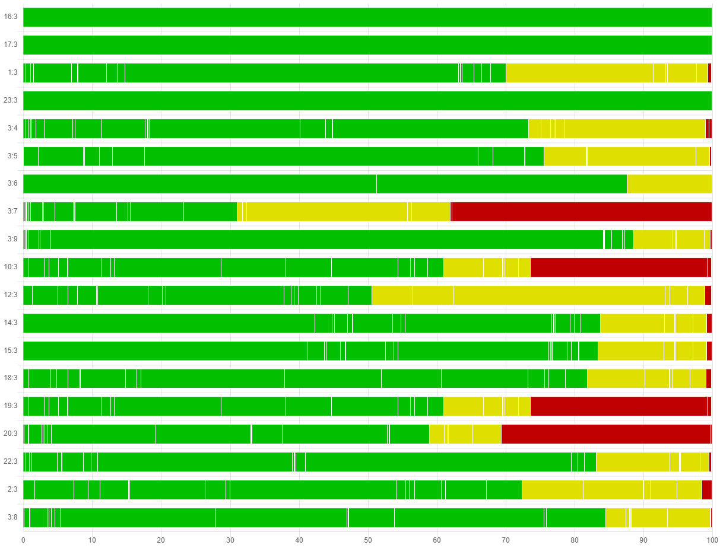
b) versus aspirin ≤150 mg/day

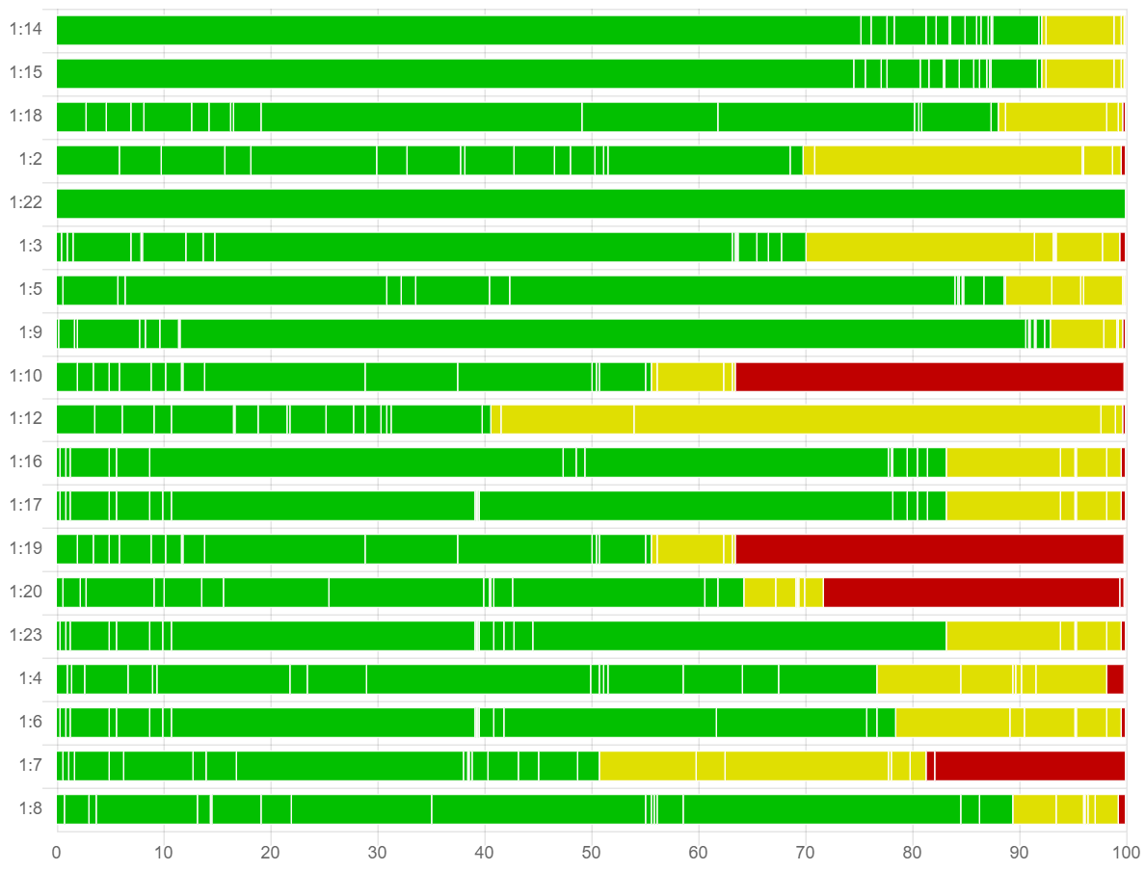
a) versus placebo/no treatment
Forest plot with network estimates and relative prediction intervals
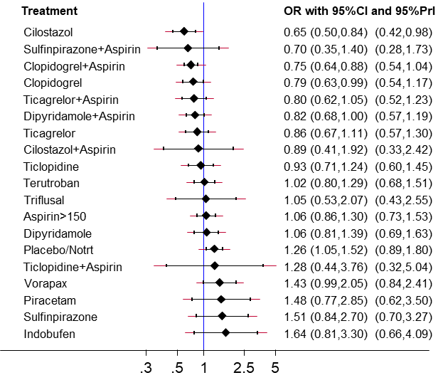
b) versus aspirin ≤150 mg/day

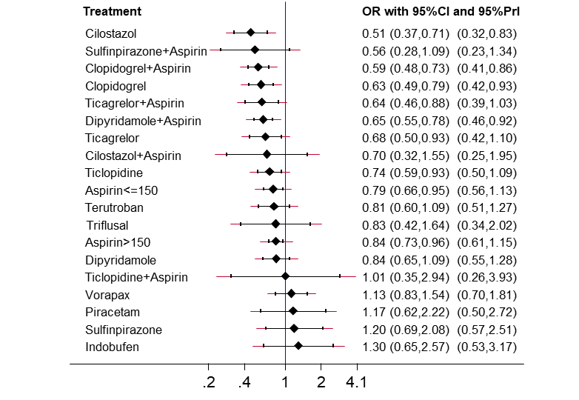
a) versus placebo/no treatment
Rating of the confidence in the network estimates
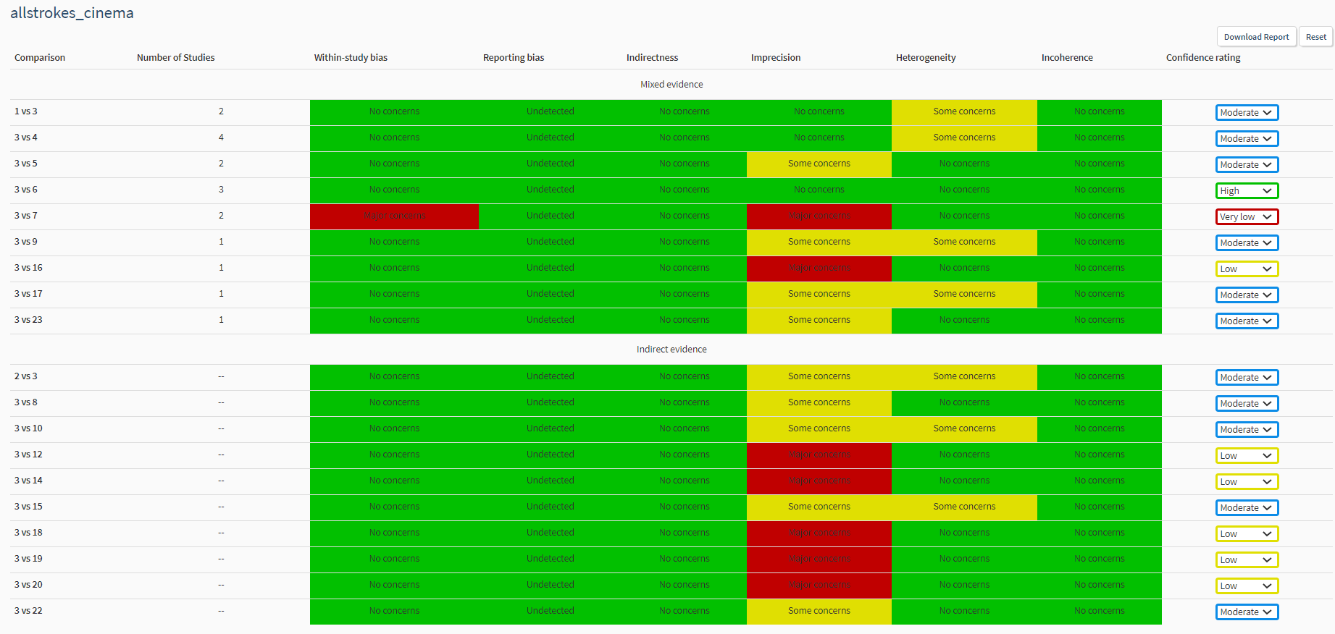 b) versus aspirin ≤150 mg/day

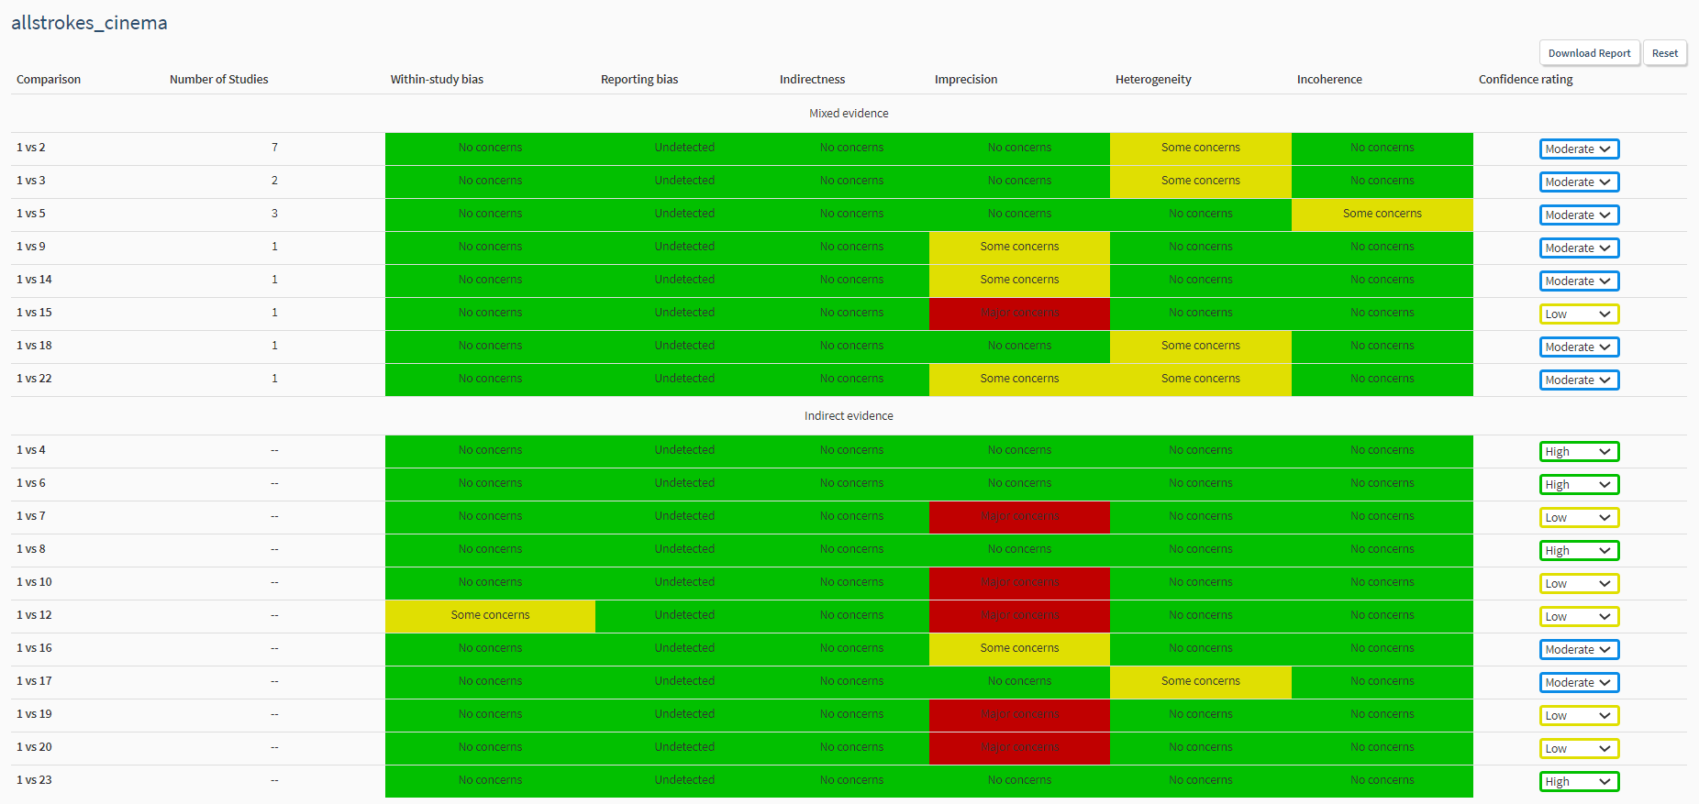a) versus placebo/no treatment

All-cause mortality
Risk of bias bar chart
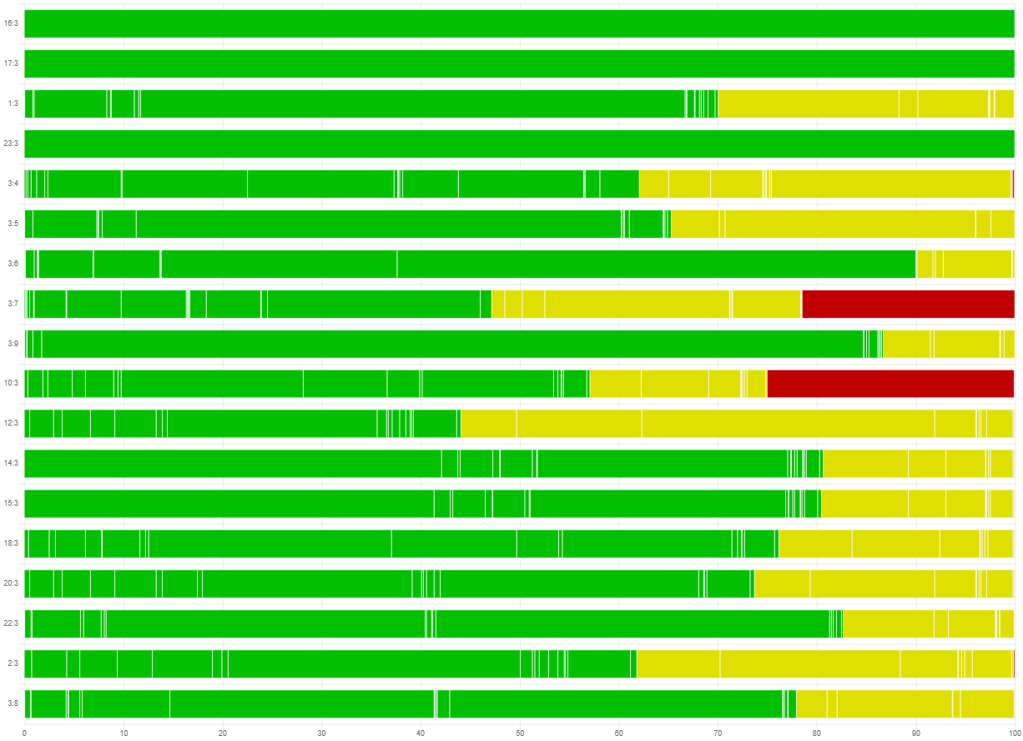
b) versus aspirin ≤150 mg/day

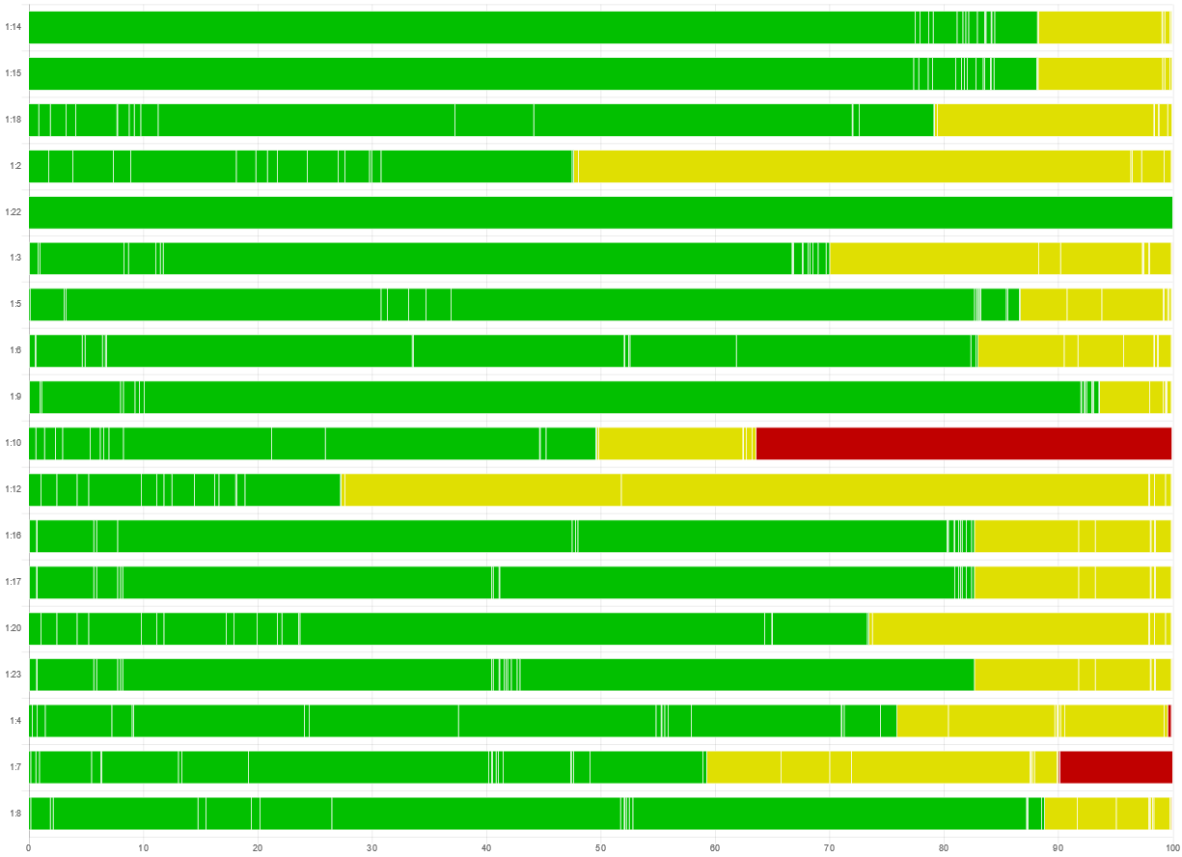
a) versus placebo/no treatment

Forest plot with network estimates and relative prediction intervals
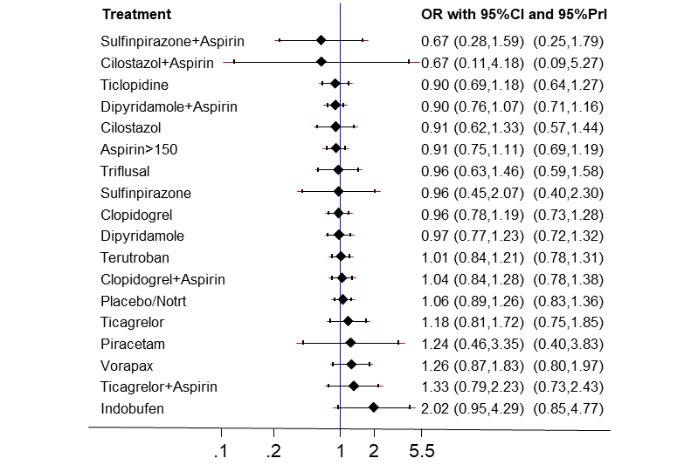
b) versus aspirin ≤150 mg/day

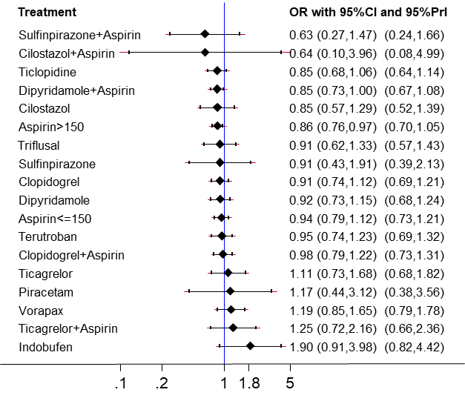
a) versus placebo/no treatment

Rating of the confidence in the network estimates
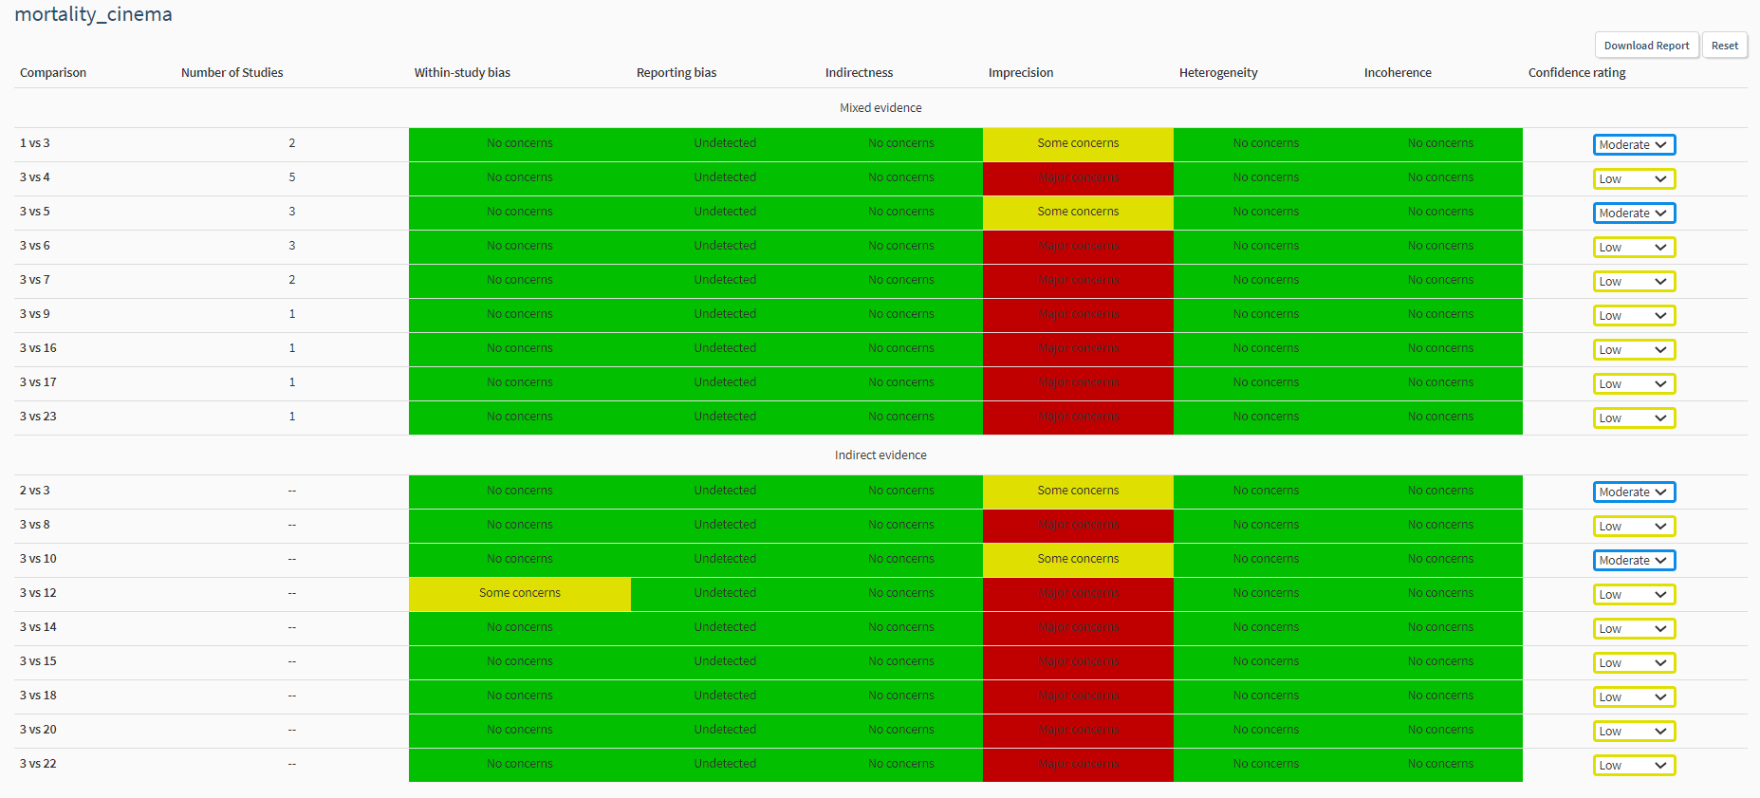 b) versus aspirin ≤150 mg/day

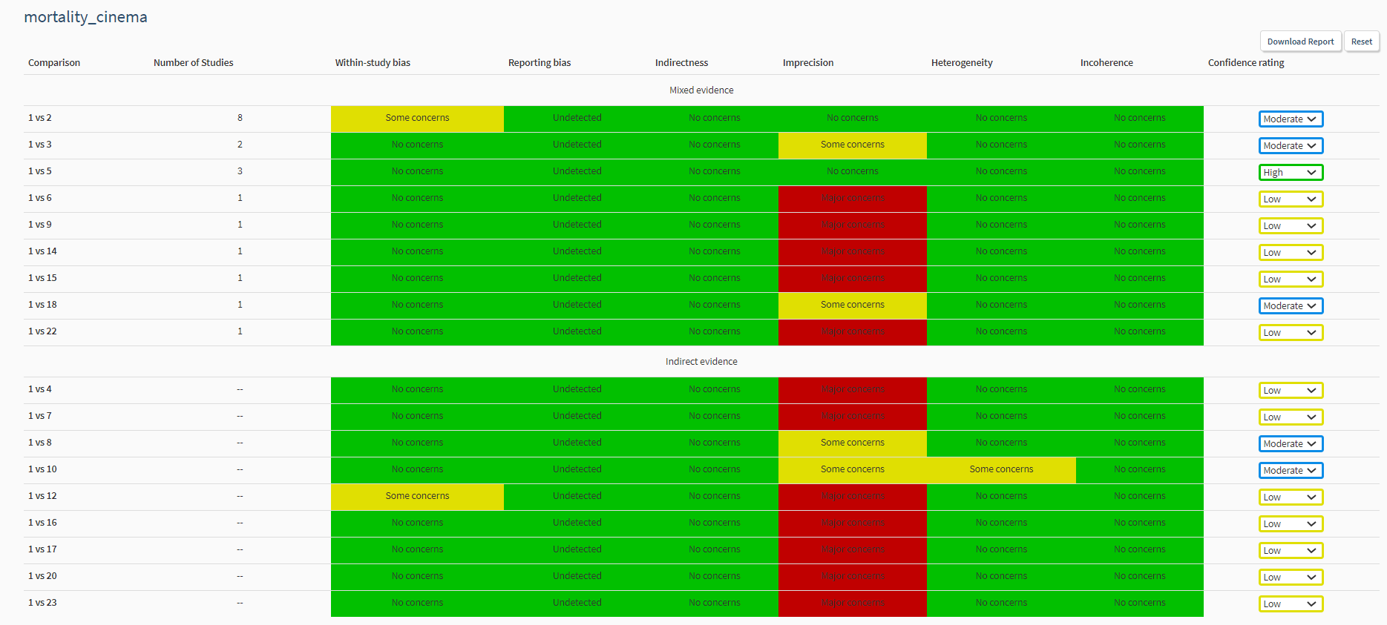 a) versus placebo/no treatment

Ischemic stroke
Risk of bias bar chart
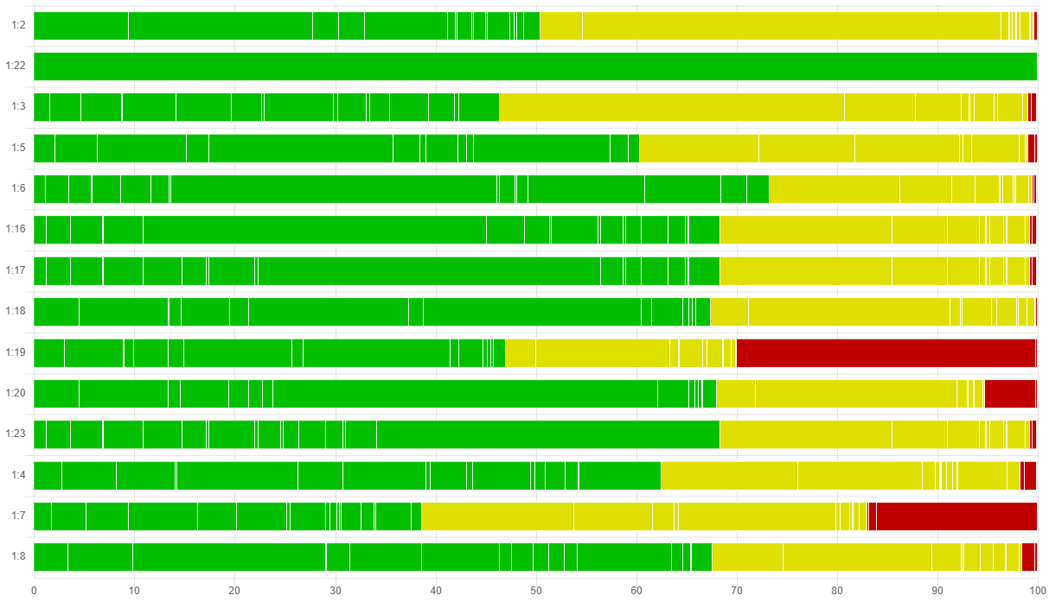
a) versus placebo/no treatment
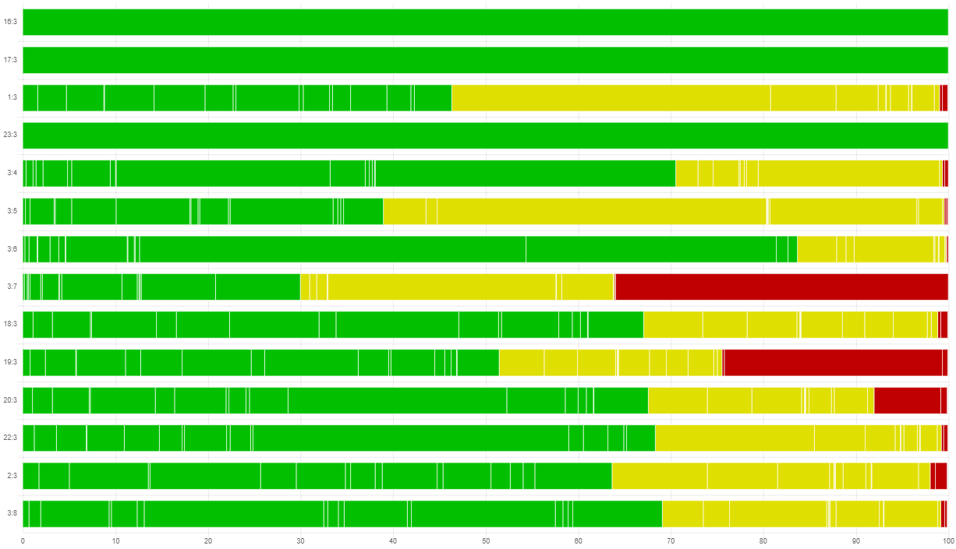
b) versus aspirin ≤150 mg/day

Forest plot with network estimates and relative prediction intervals
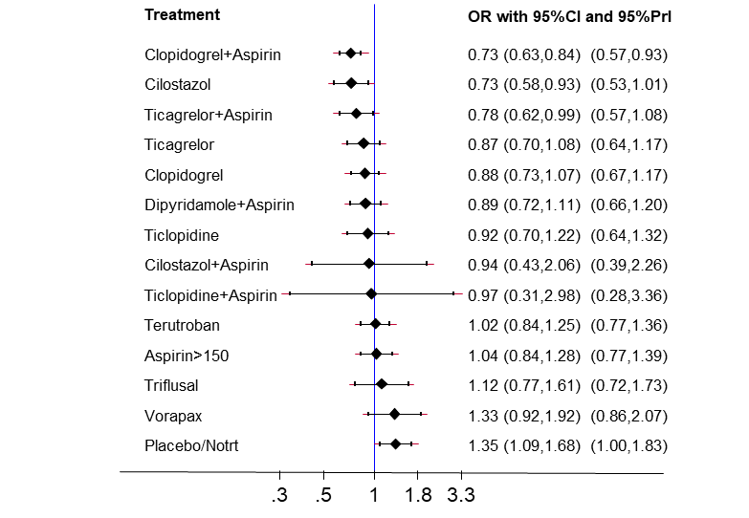
b) versus aspirin ≤150 mg/day
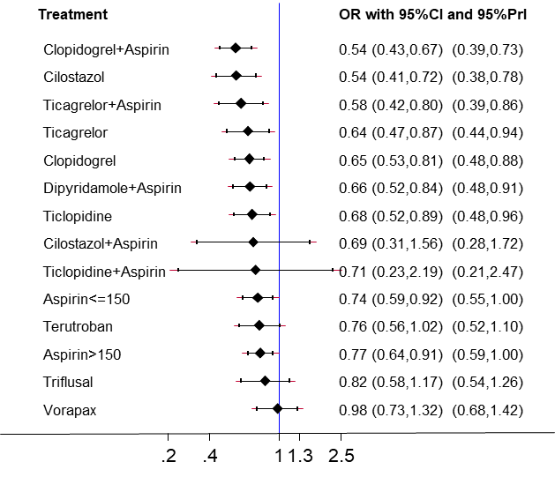
a) versus placebo/no treatment

Rating of the confidence in the network estimates
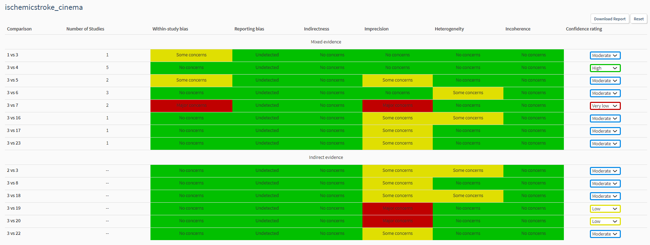b) versus aspirin ≤150 mg/day
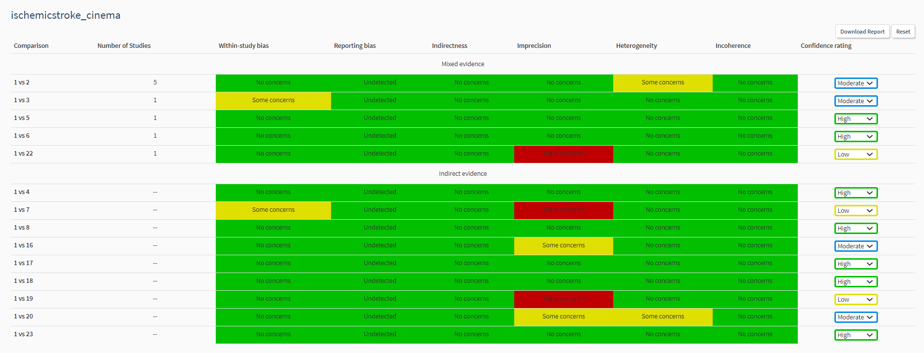a) versus placebo/no treatment

Cardiovascular event
Risk of bias bar chart
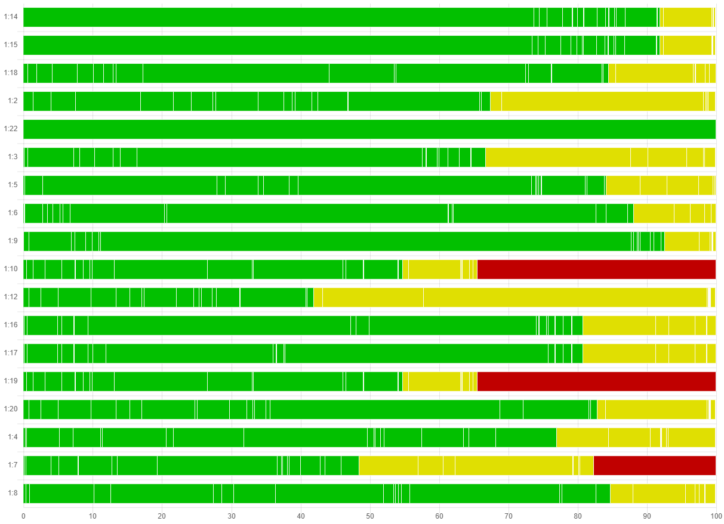a) versus placebo/no treatment
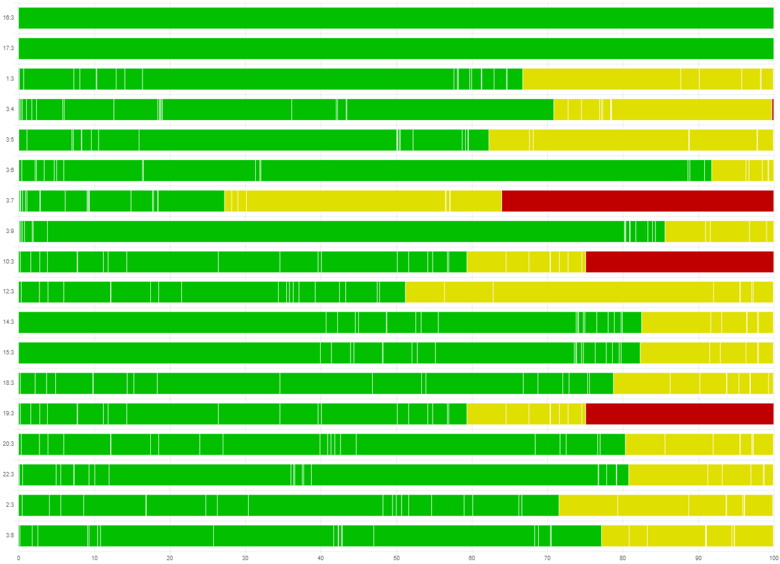b) versus aspirin ≤150 mg/day

Forest plot with network estimates and relative prediction intervals
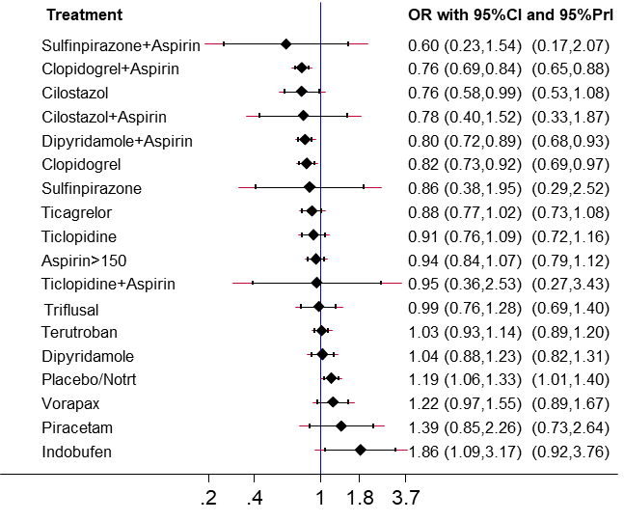
b) versus aspirin ≤150 mg/day
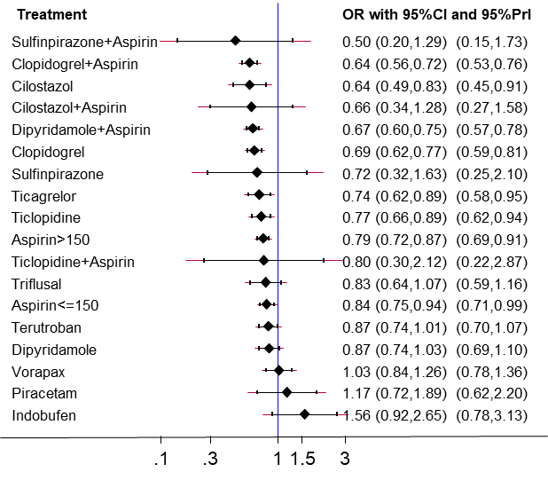
a) versus placebo/no treatment

Rating of the confidence in the network estimates
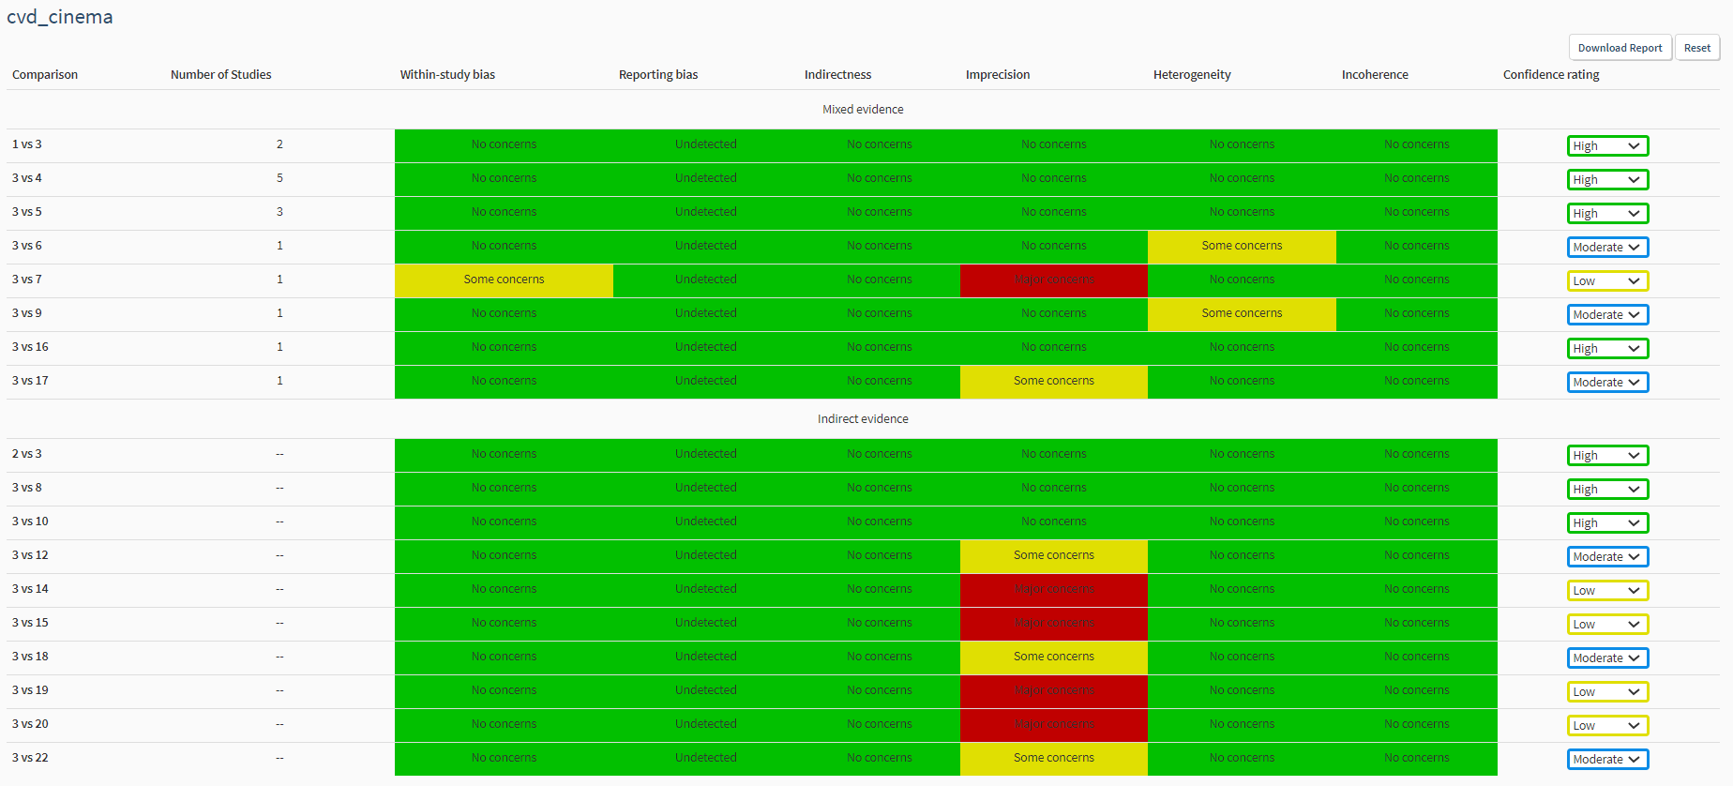
b) versus aspirin ≤150 mg/day

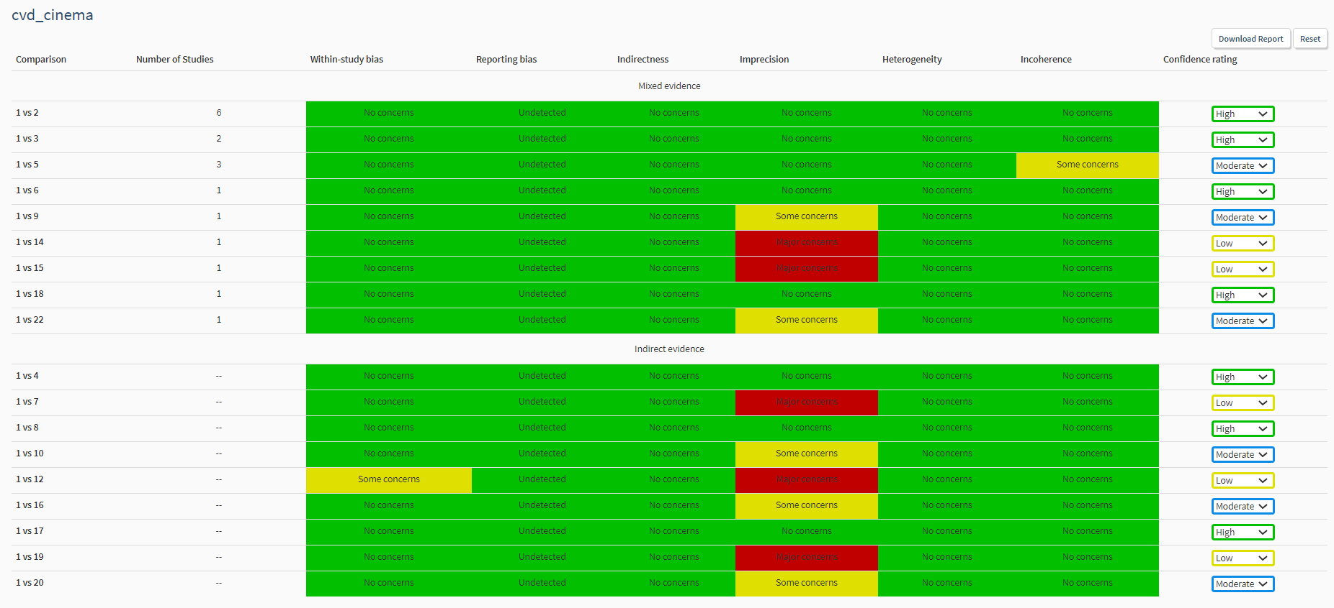
a) versus placebo/no treatment

Hemorrhagic stroke
Risk of bias bar chart
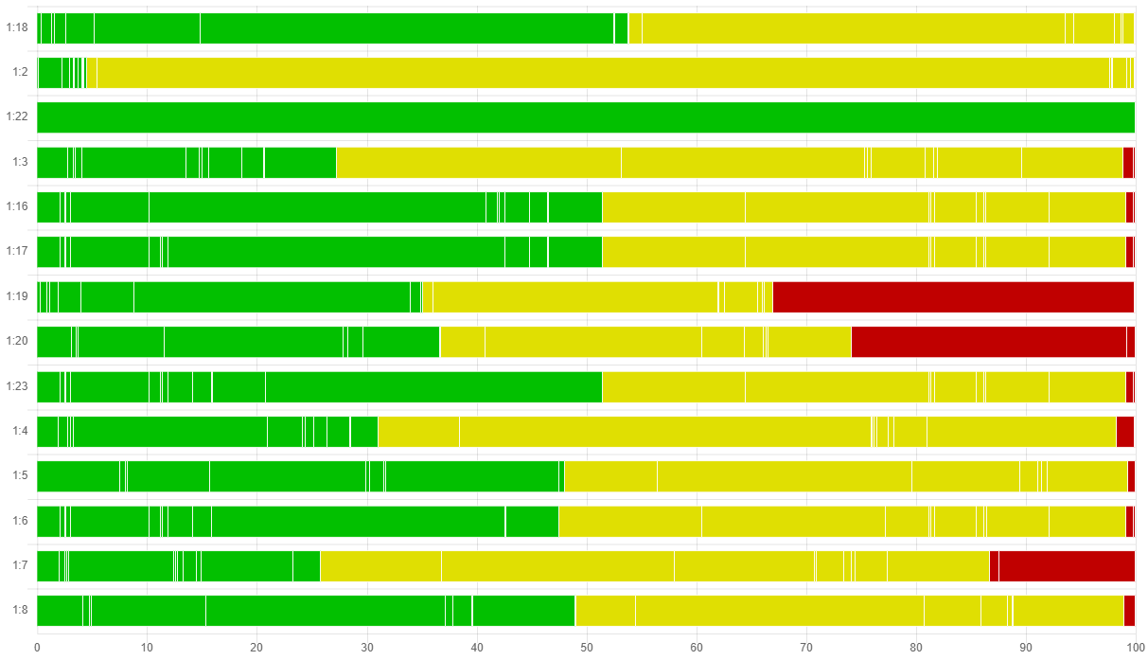
a) versus placebo/no treatment
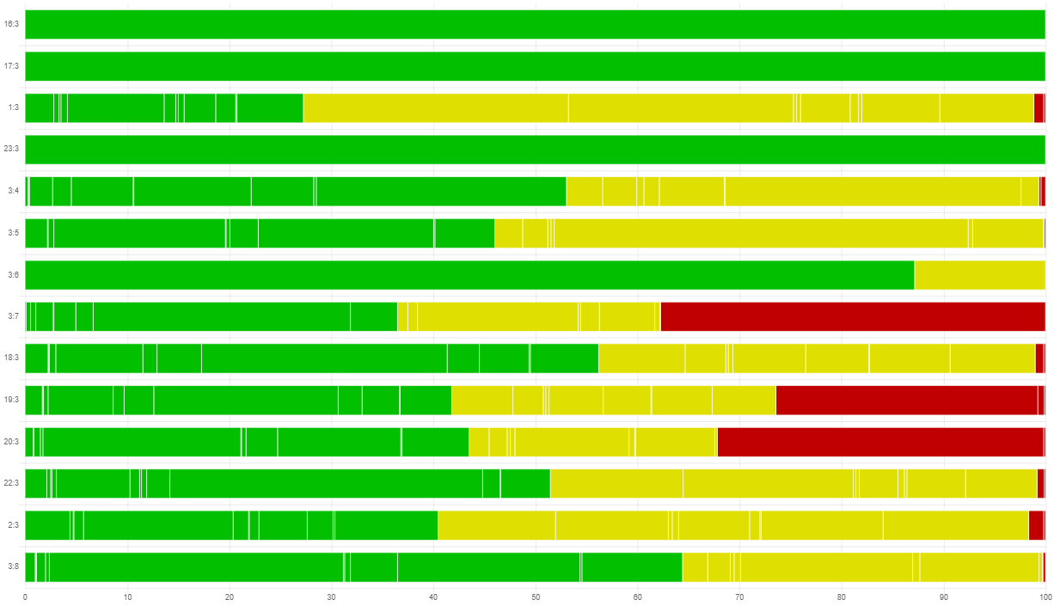
b) versus aspirin ≤150 mg/day

Forest plot with network estimates and relative prediction intervals

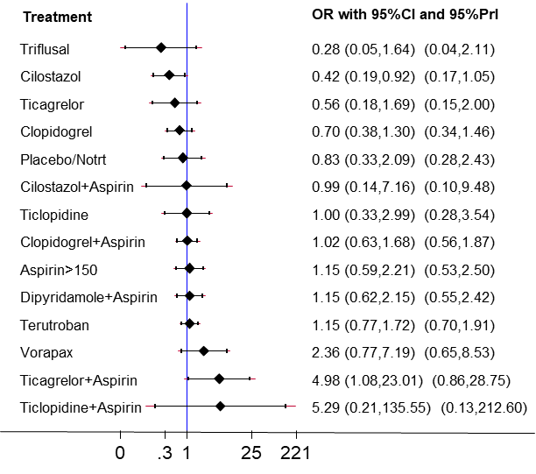
b) versus aspirin ≤150 mg/day
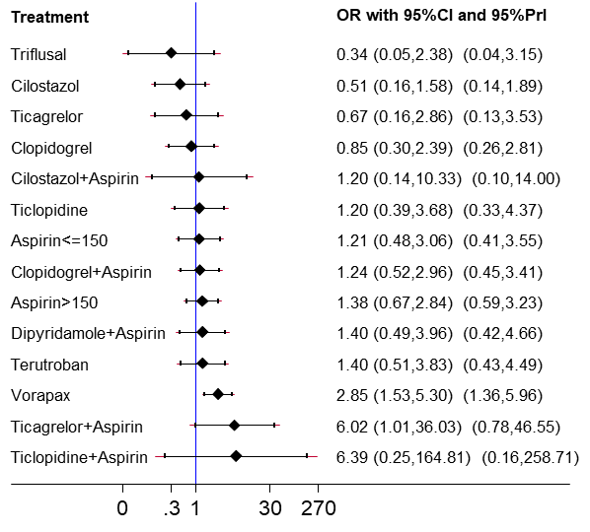
a) versus placebo/no treatment
Rating of the confidence in the network estimates
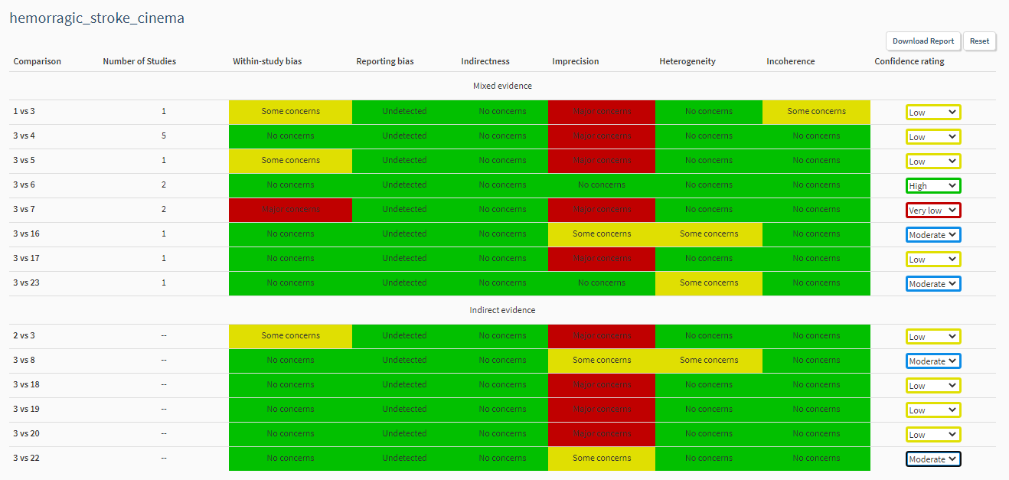
b) versus aspirin ≤150 mg/day
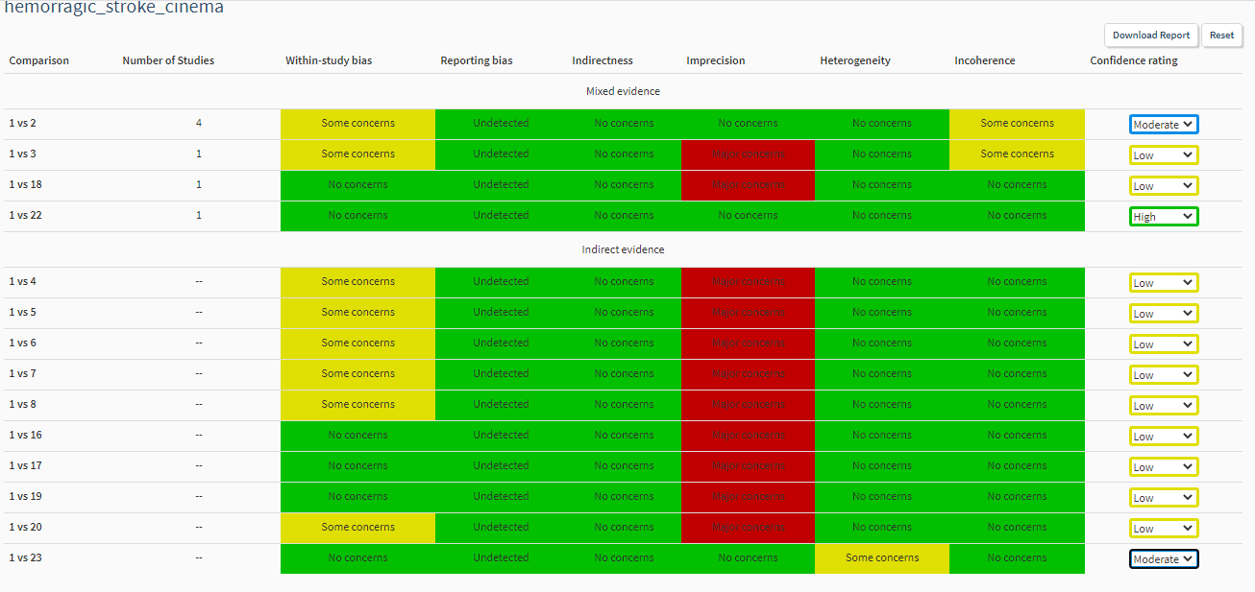
a) versus placebo/no treatment

Intracranial haemorrhage
Risk of bias bar chart
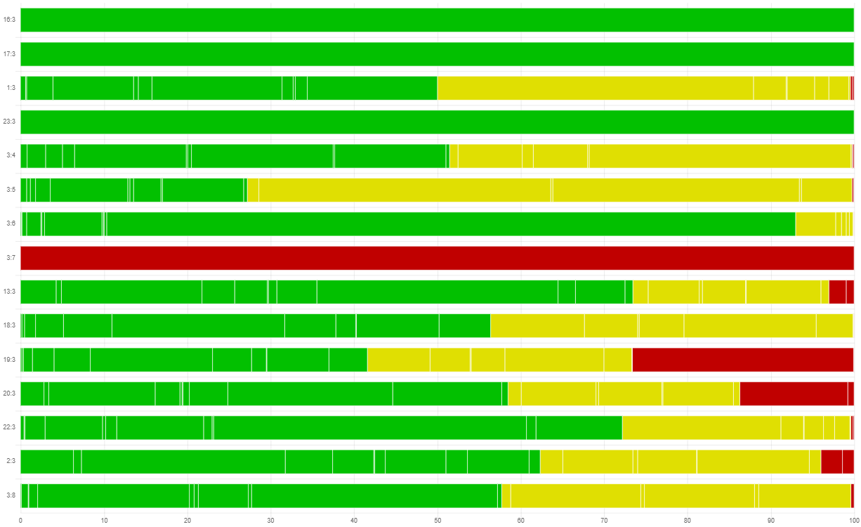
b) versus aspirin ≤150 mg/day
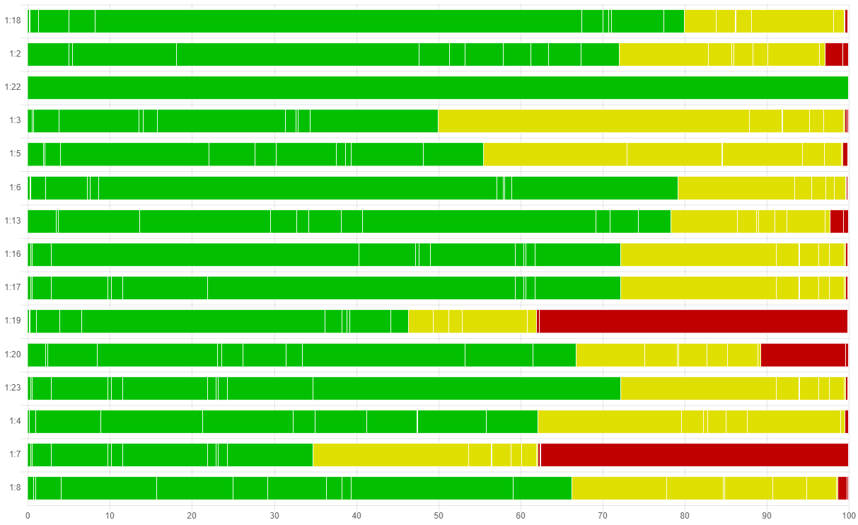
a) versus placebo/no treatment

Forest plot with network estimates and relative prediction intervals
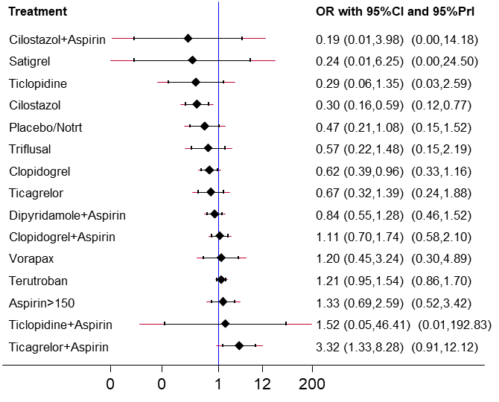b) versus aspirin ≤150 mg/day
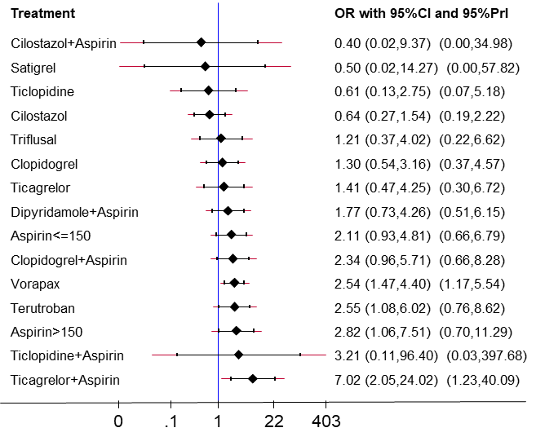
a) versus placebo/no treatment

Rating of the confidence in the network estimates
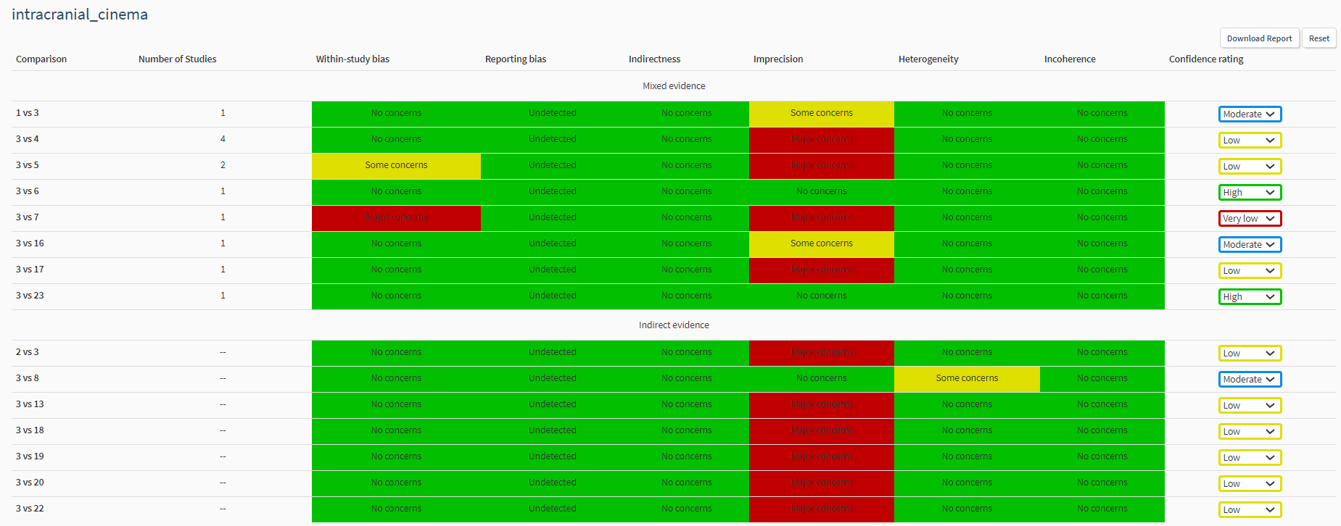
b) versus aspirin ≤150 mg/day
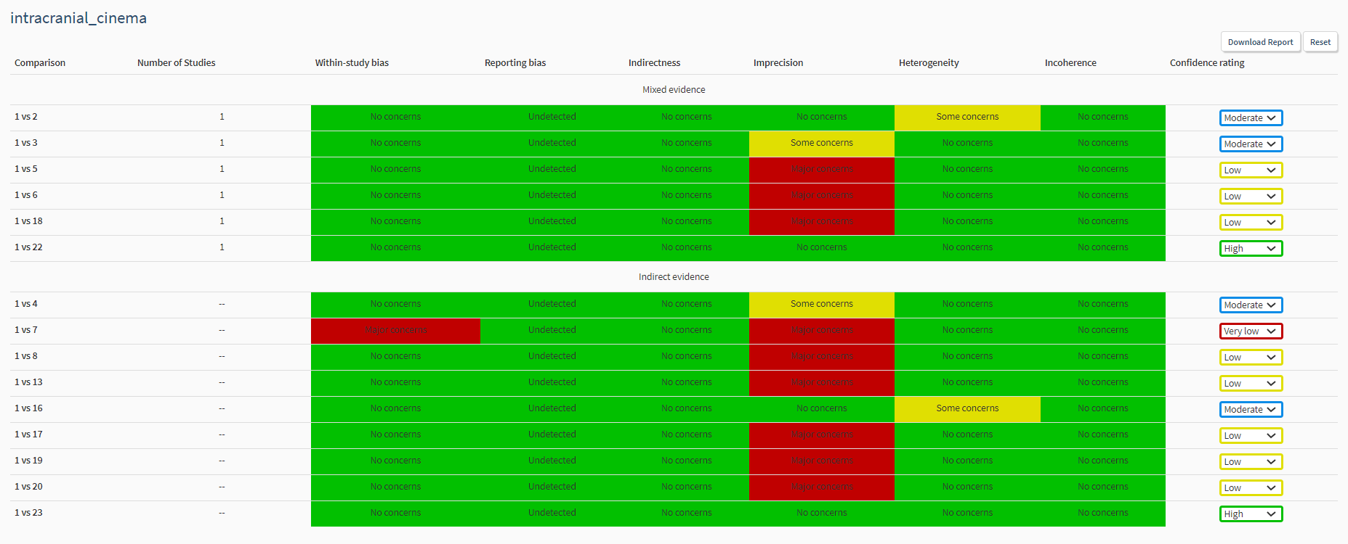
a) versus placebo/no treatment

Major bleeding
Risk of bias bar chart
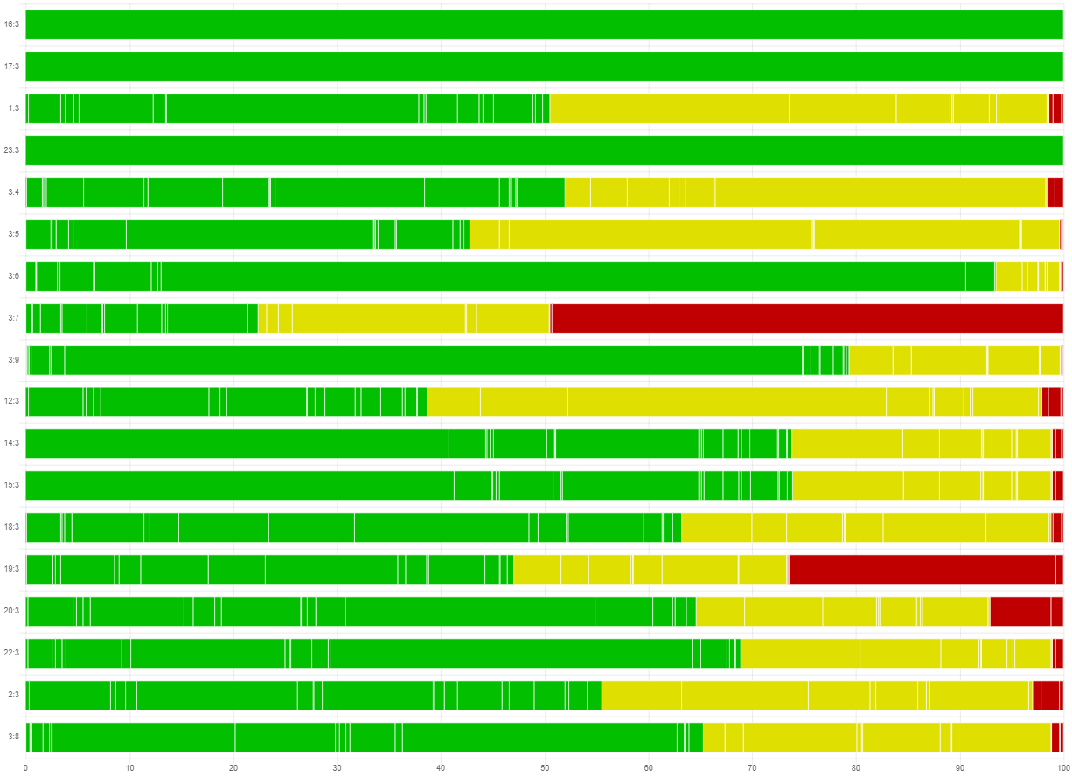
b) versus aspirin ≤150 mg/day
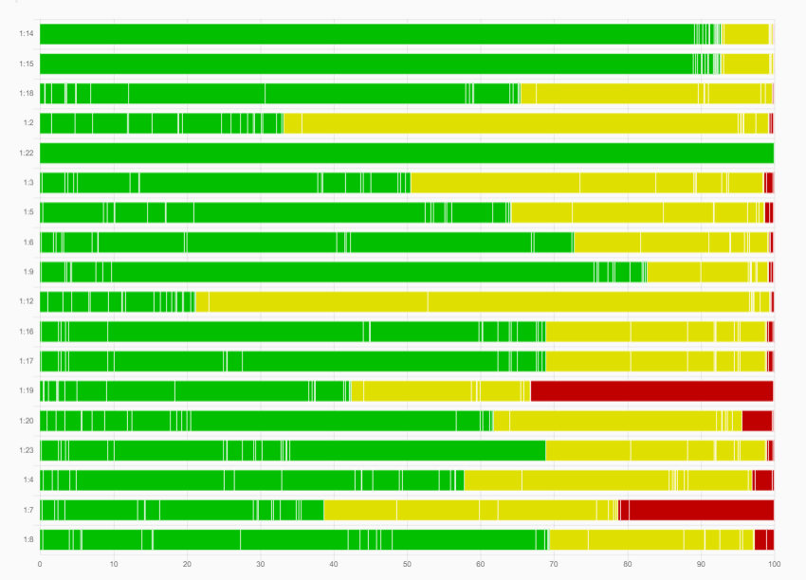
a) versus placebo/no treatment

Forest plot with network estimates and relative prediction intervals
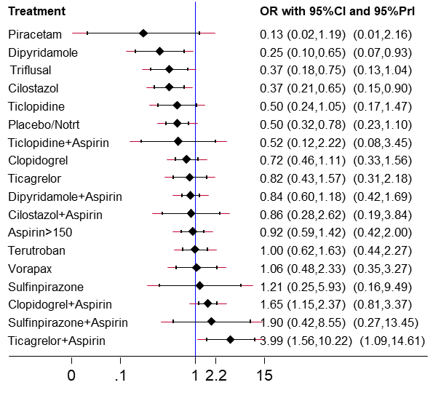
b) versus aspirin ≤150 mg/day

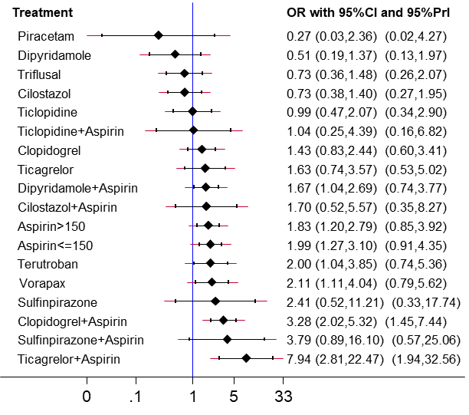
a) versus placebo/no treatment

b) versus aspirin ≤150 mg/day

Rating of the confidence in the network estimates
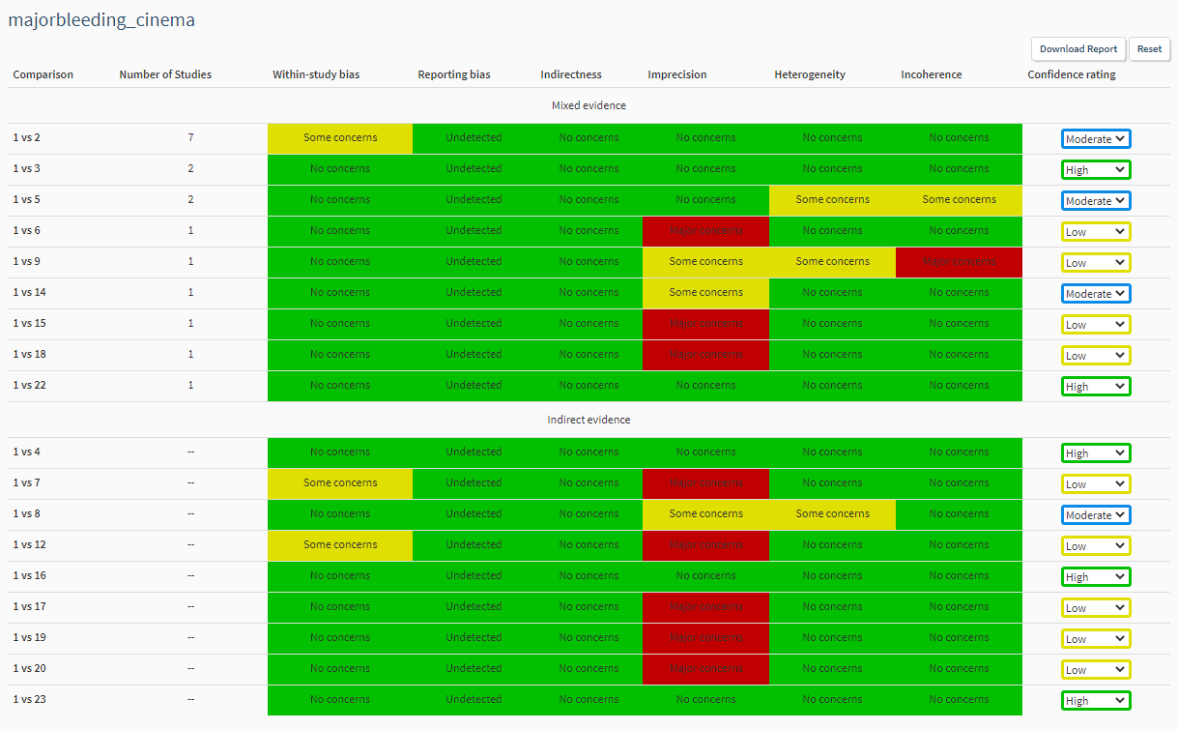
a) versus placebo/no treatment
/
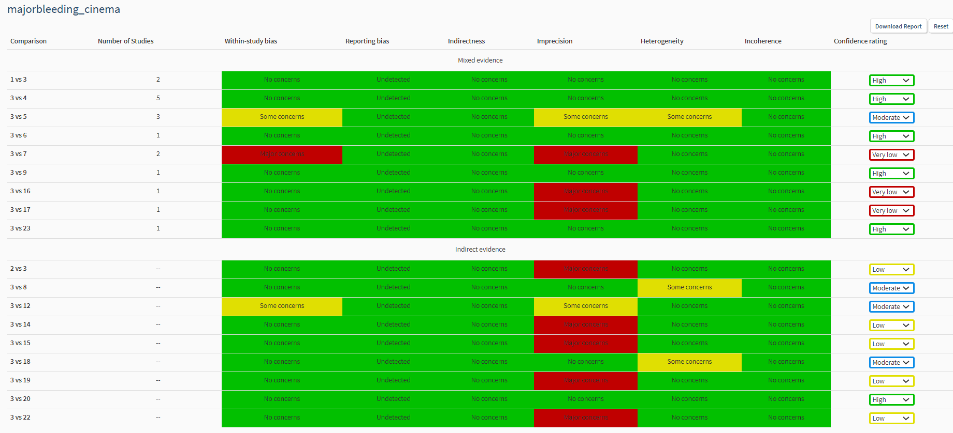
b) versus aspirin ≤150 mg/day

Supplementary 8. SUCRA, probability to be the best and mean rank by outcome

Legend: Notrt means No treatment

All strokes
+----------------------------------------------------+
| Treatment | SUCRA | PrBest | MeanRank |
|------------------------+-------+--------+----------|
| Placebo/Notrt | 22.0 | 0.0 | 15.8 |
| Aspirin>150 mg | 40.3 | 0.0 | 12.3 |
| Aspirin<=150 mg | 46.8 | 0.0 | 11.1 |
| Clopidogrel+Aspirin | 83.1 | 2.2 | 4.2 |
| Dipyridamole+Aspirin | 71.9 | 0.4 | 6.3 |
| Cilostazol | 92.2 | 33.3 | 2.5 |
| Cilostazol+Aspirin | 59.3 | 14.0 | 8.7 |
| Clopidogrel | 76.4 | 1.6 | 5.5 |
| Dipyridamole | 40.6 | 0.0 | 12.3 |
| Indobufen | 14.5 | 0.2 | 17.2 |
| Piracetam | 19.4 | 0.3 | 16.3 |
| Sulfinpyrazone+Aspirin | 79.0 | 32.3 | 5.0 |
| Sulfinpyrazone | 16.6 | 0.0 | 16.8 |
| Terutroban | 45.6 | 0.0 | 11.3 |
| Ticagrelor | 65.6 | 1.2 | 7.5 |
| Ticlopidine | 57.1 | 0.2 | 9.1 |
| Ticlopidine+Aspirin | 34.4 | 6.7 | 13.5 |
| Triflusal | 45.5 | 4.2 | 11.4 |
| Vorapaxar | 15.8 | 0.0 | 17.0 |
| Ticagrelor+Aspirin | 73.8 | 3.3 | 6.0 |
+----------------------------------------------------+

All-cause mortality
+----------------------------------------------------+
| Treatment | SUCRA | PrBest | MeanRank |
|------------------------+-------+--------+----------|
| Placebo/Notrt | 38.2 | 0.0 | 12.1 |
| Aspirin>150 mg | 70.1 | 0.4 | 6.4 |
| Aspirin<=150 mg | 50.7 | 0.0 | 9.9 |
| Clopidogrel+Aspirin | 42.9 | 0.0 | 11.3 |
| Dipyridamole+Aspirin | 71.6 | 0.9 | 6.1 |
| Cilostazol | 64.8 | 4.8 | 7.3 |
| Cilostazol+Aspirin | 66.7 | 42.8 | 7.0 |
| Clopidogrel | 57.7 | 0.3 | 8.6 |
| Dipyridamole | 55.8 | 0.5 | 9.0 |
| Indobufen | 6.6 | 0.1 | 17.8 |
| Piracetam | 36.7 | 5.5 | 12.4 |
| Sulfinpyrazone+Aspirin | 80.3 | 32.7 | 4.5 |
| Sulfinpyrazone | 55.3 | 6.5 | 9.1 |
| Terutroban | 49.4 | 0.2 | 10.1 |
| Ticagrelor | 30.6 | 0.3 | 13.5 |
| Ticlopidine | 68.9 | 1.9 | 6.6 |
| Triflusal | 57.7 | 2.5 | 8.6 |
| Vorapaxar | 22.8 | 0.0 | 14.9 |
| Ticagrelor+Aspirin | 23.1 | 0.5 | 14.8 |
+----------------------------------------------------+

Ischemic stroke
+--------------------------------------------------+
| Treatment | SUCRA | PrBest | MeanRank |
|----------------------+-------+--------+----------|
| Placebo/Notrt | 8.0 | 0.0 | 13.9 |
| Aspirin>150 mg | 33.5 | 0.0 | 10.3 |
| Aspirin<=150 mg | 39.1 | 0.0 | 9.5 |
| Clopidogrel+Aspirin | 89.2 | 21.3 | 2.5 |
| Dipyridamole+Aspirin | 59.9 | 0.6 | 6.6 |
| Cilostazol | 85.6 | 22.9 | 3.0 |
| Cilostazol+Aspirin | 51.6 | 17.4 | 7.8 |
| Clopidogrel | 61.9 | 0.1 | 6.3 |
| Terutroban | 36.7 | 0.0 | 9.9 |
| Ticagrelor | 63.9 | 2.1 | 6.1 |
| Ticlopidine | 54.5 | 0.8 | 7.4 |
| Ticlopidine+Aspirin | 49.2 | 24.4 | 8.1 |
| Triflusal | 27.5 | 0.2 | 11.2 |
| Vorapaxar | 11.8 | 0.0 | 13.3 |
| Ticagrelor+Aspirin | 77.6 | 10.1 | 4.1 |
+--------------------------------------------------+

Cardiovascular event
+----------------------------------------------------+
| Treatment | SUCRA | PrBest | MeanRank |
|------------------------+-------+--------+----------|
| Placebo/Notrt | 17.7 | 0.0 | 15.8 |
| Aspirin>150 mg | 50.3 | 0.0 | 10.0 |
| Aspirin<=150 mg | 40.5 | 0.0 | 11.7 |
| Clopidogrel+Aspirin | 84.8 | 4.1 | 3.7 |
| Dipyridamole+Aspirin | 77.6 | 0.6 | 5.0 |
| Cilostazol | 80.1 | 7.5 | 4.6 |
| Cilostazol+Aspirin | 68.5 | 17.1 | 6.7 |
| Clopidogrel | 72.9 | 0.1 | 5.9 |
| Dipyridamole | 34.9 | 0.0 | 12.7 |
| Indobufen | 3.5 | 0.0 | 18.4 |
| Piracetam | 14.1 | 0.0 | 16.5 |
| Sulfinpyrazone+Aspirin | 81.5 | 46.7 | 4.3 |
| Sulfinpyrazone | 58.5 | 10.7 | 8.5 |
| Terutroban | 35.5 | 0.0 | 12.6 |
| Ticagrelor | 61.5 | 0.2 | 7.9 |
| Ticlopidine | 56.5 | 0.0 | 8.8 |
| Ticlopidine+Aspirin | 50.0 | 12.8 | 10.0 |
| Triflusal | 44.1 | 0.2 | 11.1 |
| Vorapaxar | 17.4 | 0.0 | 15.9 |
+----------------------------------------------------+

Hemorrhagic stroke
+--------------------------------------------------+
| Treatment | SUCRA | PrBest | MeanRank |
|----------------------+-------+--------+----------|
| Placebo/Notrt | 61.6 | 1.5 | 6.4 |
| Aspirin>150mg/day | 41.6 | 0.0 | 9.2 |
| Aspirin<=150mg/day | 50.5 | 0.0 | 7.9 |
| Clopidogrel+Aspirin | 48.5 | 0.0 | 8.2 |
| Dipyridamole+Aspirin | 40.0 | 0.0 | 9.4 |
| Cilostazol | 87.2 | 19.6 | 2.8 |
| Cilostazol+Aspirin | 50.9 | 8.5 | 7.9 |
| Clopidogrel | 72.4 | 0.8 | 4.9 |
| Terutroban | 40.0 | 0.0 | 9.4 |
| Ticagrelor | 75.2 | 11.3 | 4.5 |
| Ticlopidine | 51.2 | 1.0 | 7.8 |
| Ticlopidine+Aspirin | 17.8 | 3.0 | 12.5 |
| Triflusal | 88.9 | 54.3 | 2.6 |
| Vorapaxar | 16.5 | 0.0 | 12.7 |
| Ticagrelor+Aspirin | 7.7 | 0.0 | 13.9 |
+--------------------------------------------------+

Intracranial haemorrhage
+--------------------------------------------------+
| Treatment | SUCRA | PrBest | MeanRank |
|----------------------+-------+--------+----------|
| Placebo/Notrt | 71.4 | 0.8 | 5.3 |
| Aspirin>150 mg | 21.4 | 0.0 | 12.8 |
| Aspirin<=150 mg | 37.1 | 0.0 | 10.4 |
| Clopidogrel+Aspirin | 29.9 | 0.0 | 11.5 |
| Dipyridamole+Aspirin | 47.1 | 0.0 | 8.9 |
| Cilostazol | 84.8 | 7.4 | 3.3 |
| Cilostazol+Aspirin | 78.8 | 38.5 | 4.2 |
| Clopidogrel | 63.7 | 0.0 | 6.4 |
| Satigrel | 73.5 | 33.0 | 5.0 |
| Terutroban | 24.1 | 0.0 | 12.4 |
| Ticagrelor | 57.1 | 0.3 | 7.4 |
| Ticlopidine | 80.7 | 13.7 | 3.9 |
| Ticlopidine+Aspirin | 33.8 | 5.3 | 10.9 |
| Triflusal | 63.4 | 0.9 | 6.5 |
| Vorapaxar | 29.3 | 0.0 | 11.6 |
| Ticagrelor+Aspirin | 4.1 | 0.0 | 15.4 |
+--------------------------------------------------+

Major bleeding
+----------------------------------------------------+
| Treatment | SUCRA | PrBest | MeanRank |
|------------------------+-------+--------+----------|
| Placebo/Notrt | 72.2 | 0.1 | 6.0 |
| Aspirin>150 mg | 38.7 | 0.0 | 12.0 |
| Aspirin<=150 mg | 33.1 | 0.0 | 13.0 |
| Clopidogrel+Aspirin | 12.9 | 0.0 | 16.7 |
| Dipyridamole+Aspirin | 44.9 | 0.0 | 10.9 |
| Cilostazol | 82.9 | 3.3 | 4.1 |
| Cilostazol+Aspirin | 44.5 | 0.5 | 11.0 |
| Clopidogrel | 54.7 | 0.0 | 9.2 |
| Dipyridamole | 90.0 | 20.9 | 2.8 |
| Piracetam | 91.0 | 64.5 | 2.6 |
| Sulfinpyrazone+Aspirin | 17.7 | 0.1 | 15.8 |
| Sulfinpyrazone | 32.7 | 0.7 | 13.1 |
| Terutroban | 34.8 | 0.0 | 12.7 |
| Ticagrelor | 46.4 | 0.0 | 10.7 |
| Ticlopidine | 71.0 | 0.6 | 6.2 |
| Ticlopidine+Aspirin | 64.6 | 5.5 | 7.4 |
| Triflusal | 82.5 | 3.7 | 4.2 |
| Vorapaxar | 33.1 | 0.0 | 13.0 |
| Ticagrelor+Aspirin | 2.4 | 0.0 | 18.6 |
+----------------------------------------------------+

Supplementary 9. Results from the assessment of incoherence by using global and local (side-split method) approaches for primary and secondary outcomes

All strokes
Design-by-treatment interaction test
P-value = 0.092
Side-splitting model
Legend: 01=Placebo / No treatment; 02=Aspirin>150 mg; 03=Aspirin≤150 mg; 04=Clopidogrel 75 mg + Aspirin; 05=Dipyridamole + Aspirin; 06=Cilostazol 200 mg; 07=Cilostazol 200 mg + Aspirin; 08=Clopidogrel 75 mg; 09=Dipyridamole>200 mg; 10=Indobufen 200 mg; 11=Piracetam 4800 mg; 12=Sulfinpyrazone 800 mg + Aspirin>150 mg; 13=Sulfinpyrazone 800 mg; 14=Terutroban 30 mg; 15=Ticagrelor 180 mg; 16=Ticlopidine≤500 mg; 17=Ticlopidine<500 mg + Aspirin≤150 mg; 18=Triflusal 600 mg; 19=Vorapaxar 2.5 mg; 20=Ticagrelor 180 mg + Aspirin≤150 mg.
Side Direct Indirect Difference
Coef. Std. Err. Coef. Std. Err. Coef. Std. Err. P>|z|
01 02 * -.0921363 .0625563 -.4071492 .1128243 .315013 .129003 0.015
01 03 * -.2180151 .1255995 -.2763202 .1702102 .0583051 .2117996 0.783
01 05 * -.5450663 .1005869 -.1869755 .1499086 -.3580908 .1806864 0.047
01 09 * -.2005694 .1576387 -.071763 .3025859 -.1288064 .3390768 0.704
01 12 * -.4603534 .3871015 -.9756916 .6405918 .5153382 .720419 0.474
01 13 * .3065 .3364517 -.2088396 .6113179 .5153395 .7204183 0.474
01 16 -.5772492 .2127662 -.1882003 .1387728 -.3890489 .2540223 0.126
01 19 . . . . . . .
02 04 -.2275626 .1614962 -.42615 .1326122 .1985874 .2072954 0.338
02 05 -.118018 .1940644 -.2978568 .1165204 .1798388 .2262472 0.427
02 11 * .3334973 .3188411 .3607595 224.264 -.0272622 224.2643 1.000
02 12 * -.530766 .3809137 -.0154266 .6516239 -.5153394 .7204185 0.474
02 13 * .2360873 .329314 .7514267 .6228692 -.5153394 .7204185 0.474
02 16 -.0428815 .1188571 -.4319272 .2244421 .3890457 .2540217 0.126
03 04 -.3244795 .091806 -.1796177 .1580942 -.1448619 .183217 0.429
03 05 * -.0931052 .1422014 -.3009019 .1468593 .2077967 .2021447 0.304
03 06 * -.4370749 .1333687 .4230187 145.5078 -.8600936 145.5078 0.995
03 07 -.648031 .5860313 .3190335 .5335728 -.9670645 .7925336 0.222
03 09 * .023982 .1651709 .2348672 .3382324 -.2108852 .376713 0.576
03 14 * .0169963 .1203154 .4675506 223.6691 -.4505542 223.6692 0.998
03 15 * -.1494121 .130234 .4626862 256.4915 -.6120983 256.4915 0.998
03 20 * -.2182615 .1365251 .4579383 263.6327 -.6761997 263.6327 0.998
04 07 .5970457 .5276411 -.3700086 .5913593 .9670543 .7925348 0.222
04 08 .0241925 .1531486 .1143089 .1981539 -.0901164 .2504385 0.719
05 08 -.0185503 .1395187 -.1086622 .2079757 .0901119 .2504383 0.719
05 09 * .3296755 .1635501 -.0052864 .3095323 .3349619 .3546444 0.345
08 18 * .2840453 .3251663 .9204079 269.1141 -.6363626 269.1144 0.998
10 16 * -.561827 .3281459 -.5346913 382.964 -.0271357 382.9642 1.000
12 13 . . . . . . .
16 17 * .3143274 .5306438 .5897171 267.4167 -.2753897 267.4173 0.999

* Warning: all the evidence about these contrasts comes from the trials which directly compare them.

All-cause mortality
Design-by-treatment interaction test
P-value = 0.292
Side-splitting model
Legend: 01=Placebo / No treatment; 02=Aspirin>150 mg; 03=Aspirin≤150 mg; 04=Clopidogrel 75 mg + Aspirin; 05=Dipyridamole + Aspirin; 06=Cilostazol 200 mg; 07=Cilostazol 200 mg + Aspirin; 08=Clopidogrel 75 mg; 09=Dipyridamole>200 mg; 10=Indobufen 200 mg; 11=Piracetam 4800 mg; 12=Sulfinpyrazone 800 mg + Aspirin>150 mg; 13=Sulfinpyrazone 800 mg; 14=Terutroban 30 mg; 15=Ticagrelor 180 mg; 16=Ticlopidine≤500 mg; 17=Triflusal 600 mg; 18=Vorapaxar 2.5 mg; 19=Ticagrelor 180 mg + Aspirin≤150 mg.
Side Direct Indirect Difference
Coef. Std. Err. Coef. Std. Err. Coef. Std. Err. P>|z|
01 02 * -.1161833 .0678946 -.3163801 .136127 .2001968 .1513381 0.186
01 03 * -.1183699 .1126886 .0531124 .1523753 -.1714823 .1895761 0.366
01 05 * -.2207263 .0917148 -.0227688 .1375948 -.1979574 .1645622 0.229
01 06 -.1053605 .4693224 -.1698778 .2351047 .0645173 .5249169 0.902
01 09 * -.0848709 .140107 -.0821507 .2818809 -.0027202 .3136358 0.993
01 12 * -.5764796 .4715681 -.001134 .85011 -.5753456 .9221117 0.533
01 13 * -.2135741 .4247449 .3617716 .8250574 -.5753457 .9221126 0.533
01 16 .0064865 .1993831 -.2329817 .1295788 .2394682 .2377904 0.314
01 18 . . . . . . .
02 04 .3818267 .1490769 -.059802 .1224723 .4416286 .1929336 0.022
02 05 .1022769 .2179272 -.0301633 .1036281 .1324402 .2405976 0.582
02 11 * .3088383 .4984912 .3143986 369.8705 -.0055603 369.8709 1.000
02 12 * -.1397619 .5059998 -.7151077 .7884868 .5753457 .9221125 0.533
02 13 * .2231436 .462674 -.3522022 .7614086 .5753457 .9221126 0.533
02 16 -.0620295 .1140647 .1774393 .2088134 -.2394687 .2377898 0.314
02 17 * .0556169 .186377 .3737049 202.9274 -.318088 202.9275 0.999
03 04 -.0767518 .163088 .132455 .1475797 -.2092068 .2159169 0.333
03 05 * -.0725341 .1058091 -.1719824 .1568414 .0994483 .1888134 0.598
03 06 -.10938 .2171561 -.044862 .4779515 -.0645181 .5249162 0.902
03 07 -.0035682 1.418978 -.6914323 1.234995 .6878642 1.881146 0.715
03 09 * .0331172 .1328895 -.2879156 .279379 .3210327 .3099388 0.300
03 14 * .0112965 .0927339 .1210501 261.4816 -.1097536 261.4817 1.000
03 15 * .1638073 .1929832 .0598392 606.8868 .1039681 606.8869 1.000
03 19 * .2838474 .2648948 .1061178 849.8326 .1777296 849.8327 1.000
04 07 -.7283931 1.230367 -.040524 1.422988 -.6878691 1.881142 0.715
04 08 -.0013894 .126655 -.2031516 .1670371 .2017623 .2096256 0.336
05 08 .027732 .0917804 .2294965 .1884648 -.2017645 .209625 0.336
05 09 * .0154037 .133467 .2988909 .2593457 -.2834872 .2919711 0.332
10 16 * -.8033051 .3595749 -.1910754 418.1288 -.6122296 418.1291 0.999
12 13 . . . . . . .

* Warning: all the evidence about these contrasts comes from the trials which directly compare them.

Ischemic stroke
Design-by-treatment interaction test
P-value = 0.200
Side-splitting model
Legend: 01=Placebo / No treatment; 02=Aspirin>150 mg; 03=Aspirin≤150 mg; 04=Clopidogrel 75 mg + Aspirin; 05=Dipyridamole + Aspirin; 06=Cilostazol 200 mg; 07=Cilostazol 200 mg + Aspirin; 08=Clopidogrel 75 mg; 09=Terutroban 30 mg; 10=Ticagrelor 180 mg; 11=Ticlopidine≤500 mg; 12=Ticlopidine<500 mg + Aspirin≤150 mg; 13=Triflusal 600 mg; 14=Vorapaxar 2.5 mg; 15=Ticagrelor 180 mg + Aspirin≤150 mg.
Side Direct Indirect Difference
Coef. Std. Err. Coef. Std. Err. Coef. Std. Err. P>|z|
01 02 -.2597601 .1041697 -.2804537 .2038709 .0206935 .2298211 0.928
01 03 -.2728179 .1880737 -.3302225 .1474457 .0574046 .2389811 0.810
01 05 -.6391881 .3259181 -.3763484 .1386183 -.2628397 .3531218 0.457
01 06 -.6949276 .2506579 -.5744286 .1792318 -.120499 .3081451 0.696
01 14 . . . . . . .
02 04 -.4357921 .1700334 -.3244258 .1314287 -.1113663 .2038538 0.585
02 05 .034502 .3652623 -.1678587 .1154181 .2023607 .3833177 0.598
02 06 -.6238285 .572117 -.3272235 .1522567 -.2966051 .5920302 0.616
02 08 -.0905502 .1265614 -.2276562 .1226931 .137106 .1762707 0.437
02 11 -.0891407 .1174928 -.2511997 .2578664 .162059 .2843112 0.569
02 13 .0077514 .1706353 .3572181 .3584897 -.3494668 .3970279 0.379
03 04 -.3527755 .0811147 -.2092234 .1537362 -.1435521 .1747887 0.411
03 05 -.0298126 .1444159 -.1974605 .1519032 .1676479 .2055648 0.415
03 06 -.2692866 .1362139 -.4493037 .2549289 .1800171 .2895315 0.534
03 07 -.3798606 .6069566 .1819127 .5372389 -.5617733 .8105717 0.488
03 09 * .0240006 .1007741 .6280236 199.9111 -.604023 199.9111 0.998
03 10 * -.1414591 .1119138 .4632533 202.8916 -.6047123 202.8916 0.998
03 15 * -.2421917 .1193445 .3627783 209.7211 -.60497 209.7211 0.998
04 07 .4972076 .5320823 -.0645346 .6114987 .5617421 .8105783 0.488
04 08 .0802632 .1120311 .3248976 .126354 -.2446344 .1688677 0.147
05 08 .0276811 .1101255 -.1074248 .1699233 .1351059 .2024884 0.505
08 11 -.0719412 .2384874 .0901289 .1545176 -.1620701 .2843132 0.569
08 13 .4995326 .3478706 .1500712 .1913567 .3494615 .397028 0.379
11 12 * .0468836 .5555938 .8125416 200.1181 -.765658 200.1174 0.997

* Warning: all the evidence about these contrasts comes from the trials which directly compare them.

Cardiovascular event
Design-by-treatment interaction test
P-value = 0.424
Side-splitting model
Legend: 01=Placebo / No treatment; 02=Aspirin>150 mg; 03=Aspirin≤150 mg; 04=Clopidogrel 75 mg + Aspirin; 05=Dipyridamole + Aspirin; 06=Cilostazol 200 mg; 07=Cilostazol 200 mg + Aspirin; 08=Clopidogrel 75 mg; 09=Dipyridamole>200 mg; 10=Indobufen 200 mg; 11=Piracetam 4800 mg; 12=Sulfinpyrazone 800 mg + Aspirin>150 mg; 13=Sulfinpyrazone 800 mg; 14=Terutroban 30 mg; 15=Ticagrelor 180 mg; 16=Ticlopidine≤500 mg; 17=Ticlopidine<500 mg + Aspirin≤150 mg; 18=Triflusal 600 mg; 19=Vorapaxar 2.5 mg.
Side Direct Indirect Difference
Coef. Std. Err. Coef. Std. Err. Coef. Std. Err. P>|z|
01 02 * -.1657426 .0571844 -.3435112 .0764129 .1777686 .095427 0.062
01 03 * -.1847315 .0781792 -.1620472 .0896147 -.0226843 .1188049 0.849
01 05 * -.5071074 .0690385 -.2646671 .0757037 -.2424403 .1026388 0.018
01 06 -.4366851 .2140202 -.4589594 .1789701 .0222743 .2789891 0.936
01 09 * -.1548229 .0969977 -.0600204 .1885273 -.0948025 .2100711 0.652
01 12 * -.695748 .52272 -.6477365 .8705842 -.0480115 .9386039 0.959
01 13 * -.339073 .466198 -.2910615 .8378671 -.0480115 .9386039 0.959
01 16 -.2959207 .1513354 -.2566954 .0925568 -.0392254 .1773955 0.825
01 19 . . . . . . .
02 04 -.1546123 .1221105 -.2443079 .0757404 .0896956 .1436927 0.532
02 05 -.074821 .1532723 -.1860964 .0635733 .1112755 .1660366 0.503
02 06 -.4370721 .536194 -.2032753 .145734 -.2337968 .5556457 0.674
02 08 -.0854174 .0721192 -.1994604 .0702167 .114043 .1006556 0.257
02 11 * .3847286 .2411327 .8449986 199.4988 -.4602701 199.4987 0.998
02 12 * -.4418328 .5413254 -.4898442 .8357787 .0480115 .9386039 0.959
02 13 * -.0851578 .4869678 -.1331693 .8016428 .0480115 .9386044 0.959
02 16 -.0168884 .0806359 -.104145 .1471876 .0872567 .1678884 0.603
02 18 * .041747 .1204089 .5020179 137.0766 -.4602708 137.0765 0.997
03 04 -.291266 .0648798 -.2381573 .0988311 -.0531088 .117918 0.652
03 05 * -.2150626 .0766008 -.2435833 .0921268 .0285207 .1217744 0.815
03 06 -.2608069 .1792949 -.296038 .2068568 .0352311 .2737451 0.898
03 07 -.9110542 .5647205 .1256818 .4235268 -1.036736 .7058905 0.142
03 09 * .0186225 .1014814 .1140303 .1923166 -.0954078 .2177679 0.661
03 14 * .028947 .0525507 .375647 200.787 -.3467 200.787 0.999
03 15 * -.1228265 .0725852 .2071964 198.3316 -.3300229 198.3316 0.999
04 07 .3961973 .4202555 -.6405232 .5671591 1.036721 .7058904 0.142
04 08 .0679062 .0829926 .0931395 .0905661 -.0252333 .1228413 0.837
05 08 .0033963 .0443537 .0981288 .0826348 -.0947325 .0937856 0.312
05 09 * .3174046 .1019669 .1212657 .1751505 .1961389 .2081887 0.346
08 16 -.1376761 .3602669 .1189821 .0865185 -.2566581 .37051 0.488
10 16 * -.7143807 .2572437 .1794241 200.4165 -.8938048 200.417 0.996
12 13 . . . . . . .
16 17 * .047628 .4886427 .582574 199.7868 -.534946 199.7862 0.998
* Warning: all the evidence about these contrasts comes from the trials which directly compare them.

Hemorrhagic stroke
Design-by-treatment interaction test
P-value = 0.462
Side-splitting model
Legend: 01=Placebo / No treatment; 02=Aspirin>150 mg; 03=Aspirin≤150 mg; 04=Clopidogrel 75 mg + Aspirin; 05=Dipyridamole + Aspirin; 06=Cilostazol 200 mg; 07=Cilostazol 200 mg + Aspirin; 08=Clopidogrel 75 mg; 09=Terutroban 30 mg; 10=Ticagrelor 180 mg; 11=Ticlopidine≤500 mg; 12=Ticlopidine<500 mg + Aspirin≤150 mg; 13=Triflusal 600 mg; 14=Vorapaxar 2.5 mg; 15=Ticagrelor 180 mg + Aspirin≤150 mg.
Side Direct Indirect Difference
Coef. Std. Err. Coef. Std. Err. Coef. Std. Err. P>|z|
01 02 .2359134 .137087 1.756207 .6921748 -1.520294 .7056194 0.031
01 03 1.226245 .6605326 -.2342707 .4010278 1.460516 .7727396 0.059
01 11 1.618944 1.55042 .0025051 .506795 1.616439 1.631148 0.322
01 14 . . . . . . .
02 04 -.3532492 .3053511 .6256315 .5320723 -.9788806 .6134657 0.111
02 05 -.7112468 .8839004 .1723748 .4359921 -.8836216 .9855804 0.370
02 11 .0072013 .5542601 -.6004948 .9672049 .6076962 1.11476 0.586
03 04 .1801473 .319261 -.3237781 .4910107 .5039253 .5891841 0.392
03 05 .3913027 .4923247 -.0493245 .4569974 .4406272 .6717368 0.512
03 06 * -.8714481 .3997253 -.490414 374.8189 -.3810341 374.8188 0.999
03 07 -.6752721 1.271835 1.123462 1.658675 -1.798735 2.090117 0.389
03 09 * .1439337 .2042541 -.370989 809.6212 .5149227 809.6212 0.999
03 10 * -.585208 .5663473 -.4686075 1897.926 -.1166004 1897.927 1.000
03 15 * 1.605439 .780835 -.9802198 1926.397 2.585659 1926.398 0.999
04 07 1.072353 1.63895 -.7264097 1.2971 1.798762 2.090127 0.389
04 08 -.4753129 .3256944 -.0688544 .5327603 -.4064585 .6244281 0.515
05 08 -.4929708 .2928565 -.4708169 .6479367 -.022154 .7110464 0.975
08 11 -1.110818 1.157704 .7689517 .6119259 -1.87977 1.309478 0.151
08 13 * -.9188647 .8452726 .13021 672.9367 -1.049075 672.9368 0.999
11 12 * 1.668935 1.556992 -.9593425 606.1473 2.628277 606.1519 0.997
* Warning: all the evidence about these contrasts comes from the trials which directly compare them.

Intracranial haemorrhage
Design-by-treatment interaction test
P-value = 1.000
Side-splitting model
Legend: 01=Placebo / No treatment; 02=Aspirin>150 mg; 03=Aspirin≤150 mg; 04=Clopidogrel 75 mg + Aspirin; 05=Dipyridamole + Aspirin; 06=Cilostazol 200 mg; 07=Cilostazol 200 mg + Aspirin; 08=Clopidogrel 75 mg; 09=Satigrel; 10=Terutroban 30 mg; 11=Ticagrelor 180 mg; 12=Ticlopidine≤500 mg; 13=Ticlopidine<500 mg + Aspirin≤150 mg; 14=Triflusal 600 mg; 15=Vorapaxar 2.5 mg; 16=Ticagrelor 180 mg + Aspirin≤150 mg.
Side Direct Indirect Difference
Coef. Std. Err. Coef. Std. Err. Coef. Std. Err. P>|z|
01 02 .0301034 1.005014 1.366709 .5760656 -1.336606 1.15841 0.249
01 03 1.226245 .6605326 .422659 .5447622 .8035865 .8561946 0.348
01 05 -.8315796 1.204062 .8262665 .4938988 -1.657846 1.322606 0.210
01 06 -.5634037 .6297976 -.319795 .6313349 -.2436086 .891756 0.785
01 12 .0057197 1.001905 -1.250424 1.215781 1.256143 1.575417 0.425
01 15 . . . . . . .
02 04 -.3560243 .3192755 .2895476 .5363642 -.6455719 .6241982 0.301
02 05 -.7627463 .6890497 -.3902818 .3487029 -.3724645 .7765053 0.631
02 09 * -1.736099 1.638945 -2.260114 679.344 .5240153 679.344 0.999
02 14 -.4586869 .4854699 -1.792658 .7644333 1.333971 .9055602 0.141
03 04 .3695415 .3195431 -.1929602 .3344188 .5625016 .4625405 0.224
03 05 -.3113686 .2680261 .0684087 .3669206 -.3797774 .4543883 0.403
03 06 -1.148886 .3657574 -1.3925 .8132969 .2436136 .8917568 0.785
03 07 * -1.671186 1.55715 -2.08278 473.2339 .4115939 473.2331 0.999
03 10 * .1891966 .1237989 -1.507602 522.6318 1.696799 522.6318 0.997
03 11 * -.403187 .3730853 -1.537235 1315.46 1.134048 1315.46 0.999
03 16 * 1.201061 .4658655 -1.835304 1301.272 3.036366 1301.272 0.998
04 08 -.5483486 .2174598 -.6985112 .4171524 .1501626 .470431 0.750
05 08 -.3570979 .1292697 .1999969 .4033668 -.5570947 .4235746 0.188
08 12 -1.400256 1.119594 -.1441231 1.108359 -1.256133 1.57542 0.425
08 14 -.8524652 .6937999 .481503 .5819632 -1.333968 .9055602 0.141
12 13 * 1.668935 1.553989 .4178629 606.0841 1.251072 606.0887 0.998

* Warning: all the evidence about these contrasts comes from the trials which directly compare them.

Major bleeding
Design-by-treatment interaction test
P-value = 0.085
Side-splitting model
Legend: 01=Placebo / No treatment; 02=Aspirin>150 mg; 03=Aspirin≤150 mg; 04=Clopidogrel 75 mg + Aspirin; 05=Dipyridamole + Aspirin; 06=Cilostazol 200 mg; 07=Cilostazol 200 mg + Aspirin; 08=Clopidogrel 75 mg; 09=Dipyridamole>200 mg; 10=Piracetam 4800 mg; 11=Sulfinpyrazone 800 mg + Aspirin>150 mg; 12=Sulfinpyrazone 800 mg; 13=Terutroban 30 mg; 14=Ticagrelor 180 mg; 15=Ticlopidine≤500 mg; 16=Ticlopidine<500 mg + Aspirin≤150 mg; 17=Triflusal 600 mg; 18=Vorapaxar 2.5 mg; 19=Ticagrelor 180 mg + Aspirin≤150 mg.
Side Direct Indirect Difference
Coef. Std. Err. Coef. Std. Err. Coef. Std. Err. P>|z|
01 02 * .4526523 .2252794 .9300946 .3406432 -.4774423 .3931099 0.225
01 03 * .8236462 .3438548 .5928899 .3016755 .2307563 .4488105 0.607
01 05 * 1.268312 .3749669 .1757498 .1793255 1.092562 .4069571 0.007
01 06 -.5615151 .6733328 -.2292709 .3917891 -.3322443 .7790223 0.670
01 09 * -.1577981 .5850584 -1.822072 .821365 1.664273 .9845401 0.091
01 11 * .9339279 .7904863 5.547475 2.994825 -4.613547 3.175919 0.146
01 12 * .484246 .8322768 5.097794 3.006125 -4.613548 3.175918 0.146
01 15 .2953303 .7989693 -.0882485 .4223261 .3835788 .9037208 0.671
01 18 . . . . . . .
02 04 .5938116 .2751551 .5512038 .3144555 .0426078 .4151292 0.918
02 05 -.7275257 .3620691 .2055665 .236223 -.9330923 .431326 0.031
02 06 -.9473348 .8734139 -.9197643 .3739992 -.0275704 .9501195 0.977
02 10 * -1.920262 1.087783 -2.130281 504.4939 .2100197 504.4934 1.000
02 11 * 2.593021 1.491481 -2.020522 2.042062 4.613544 3.175917 0.146
02 12 * 2.143339 1.514045 -2.470209 2.058601 4.613549 3.175917 0.146
02 15 -.6463481 .4595225 -.5745095 .5281238 -.0718387 .700054 0.918
02 17 -.8841055 .3468456 -1.123936 .7756859 .2398308 .847625 0.777
03 04 .4027456 .2441009 .6617141 .3013911 -.2589685 .3815199 0.497
03 05 * -.0586502 .201261 -.4746297 .3244502 .4159795 .3811838 0.275
03 06 -.9353365 .3444179 -1.194151 .574851 .2588148 .6701323 0.699
03 07 .2295986 .7533989 -.6706824 .8721378 .9002811 1.152544 0.435
03 09 * -1.215569 .5158486 -1.83492 .7609831 .6193515 .782225 0.428
03 13 * .003455 .2464195 -1.384424 424.8963 1.387879 424.8964 0.997
03 14 * -.2014664 .3314873 -1.384228 887.3576 1.182762 887.3576 0.999
03 19 * 1.384655 .4795216 -1.824043 1166.618 3.208698 1166.618 0.998
04 07 -1.147616 .8521677 -.2473653 .7759948 -.9002511 1.152543 0.435
04 08 -.9000984 .2936814 -.7408712 .3335379 -.1592272 .4444055 0.720
05 08 -.1404291 .2704545 -.1723535 .3616965 .0319245 .4516305 0.944
05 09 * -1.519364 .4624312 .0397016 .6755591 -1.559065 .6410789 0.015
08 15 -.4840635 .620746 -.2956264 .4703104 -.1884372 .7787923 0.809
08 17 -.8524657 .7329298 -.6126359 .4257772 -.2398298 .8476274 0.777
11 12 . . . . . . .
15 16 * .04652 .6323381 .0180461 307.0145 .0284739 307.0151 1.000

* Warning: all the evidence about these contrasts comes from the trials which directly compare them.

Supplementary 10. Comparison-adjusted funnel plot for a network of interventions by outcome

In the horizontal axis it is reported the difference of each study estimate from the pooled effect from the simple pairwise meta-analysis for the respective comparison. Studies that lie symmetrically around the zero suggest absence of small-study effects (lie symmetrically around the zero line).¹

All strokes
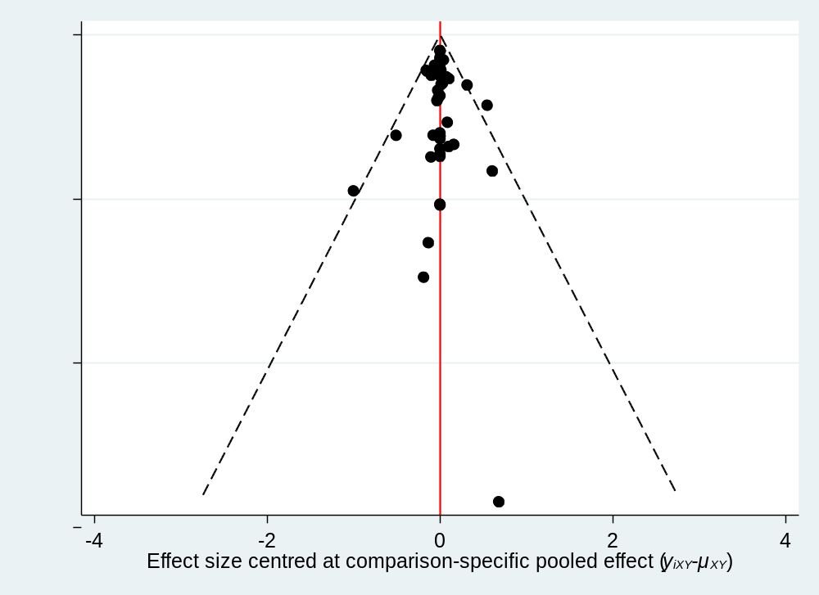

All-cause mortality
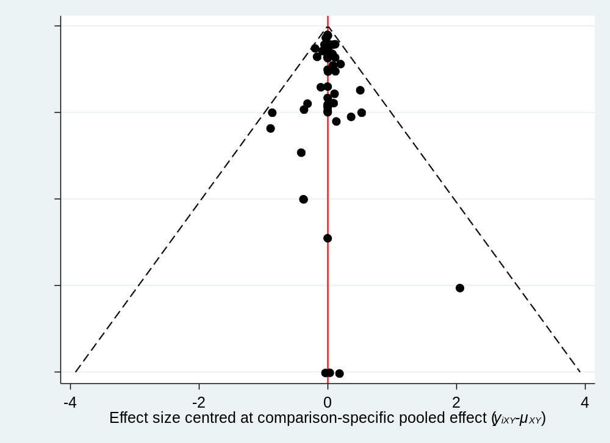

Ischemic stroke
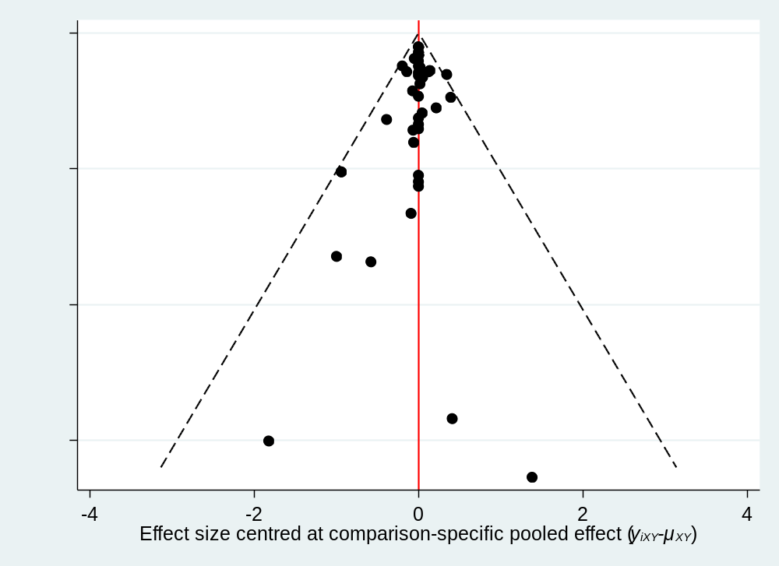

Cardiovascular event
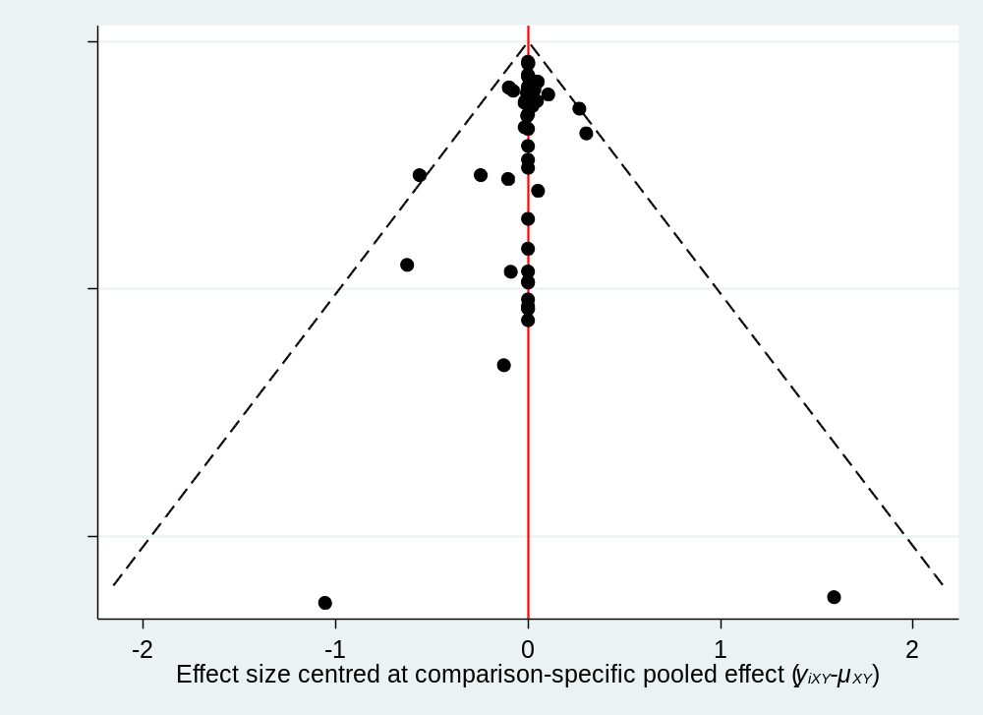

Hemorrhagic stroke
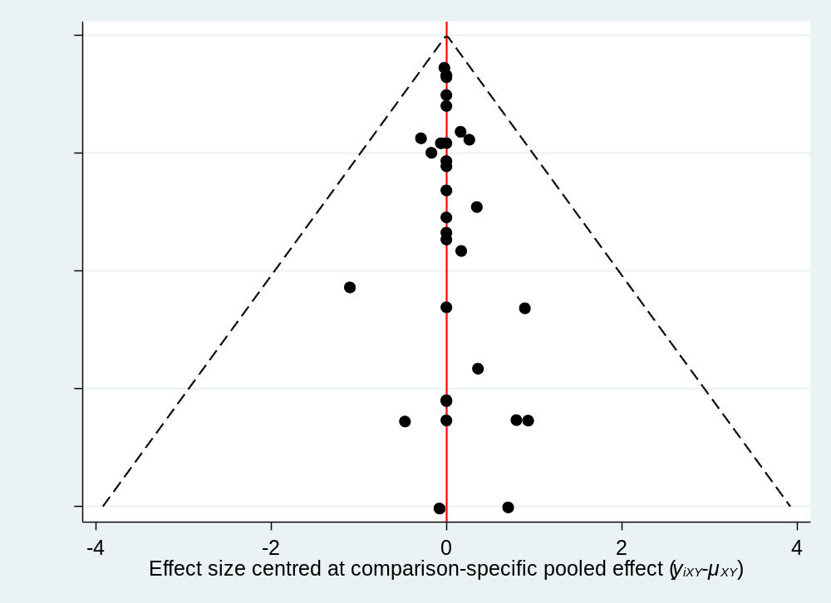

Intracranial haemorrhage
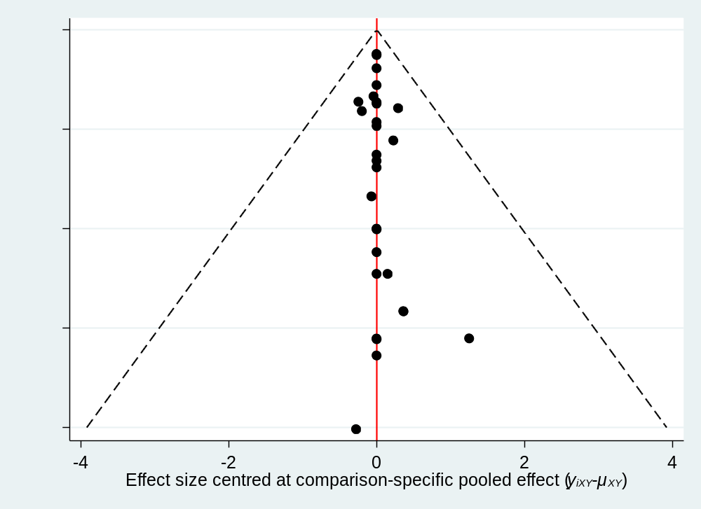

Major bleeding
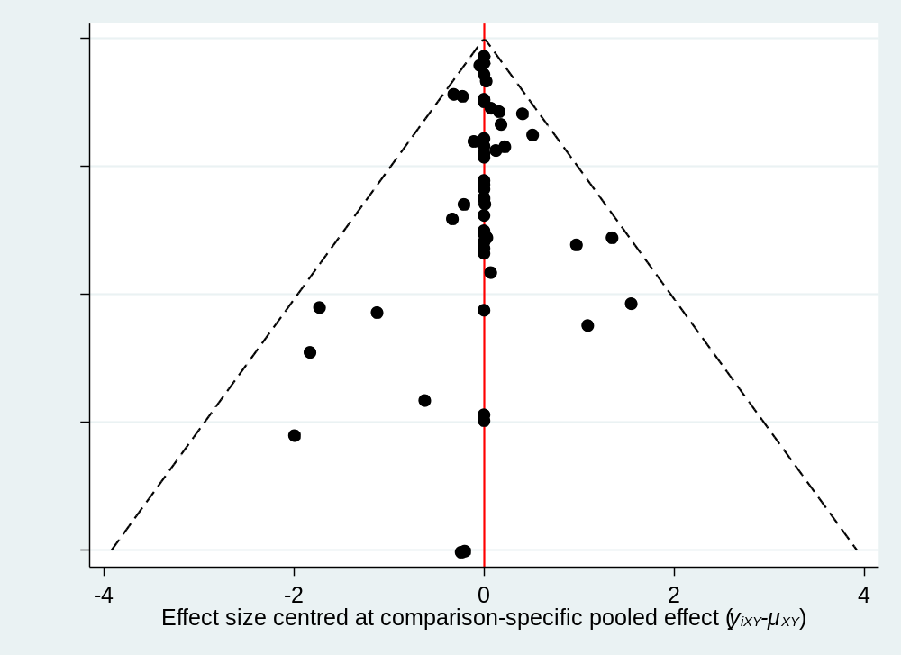

Reference
¹Chaimani A, Salanti G. Using network meta-analysis to evaluate the existence of small-study effects in a network of interventions. Research Synthesis Methods 2012;3: 161-176.

