Supplements table 1. The correlation between clinical characteristics and severity of CSVD.
Variables | LDL-C | LDL-C1 | LDL-C2 | LDL-C3 | LDL-C4 | LDL-C5 | LDL-C6 | LDL-C7
severity of CSVD, r | 0.151 | -0.207 | 0.056 | 0.367 | 0.405 | 0.385 | 0.201 | 0.061
P | 0.000 | 0.000 | 0.163 | 0.000 | 0.000 | 0.000 | 0.000 | 0.126
r, Spearman correlation coefficient.

Supplements figure 1. The level of LDL subtypes between different total CSVD scores.
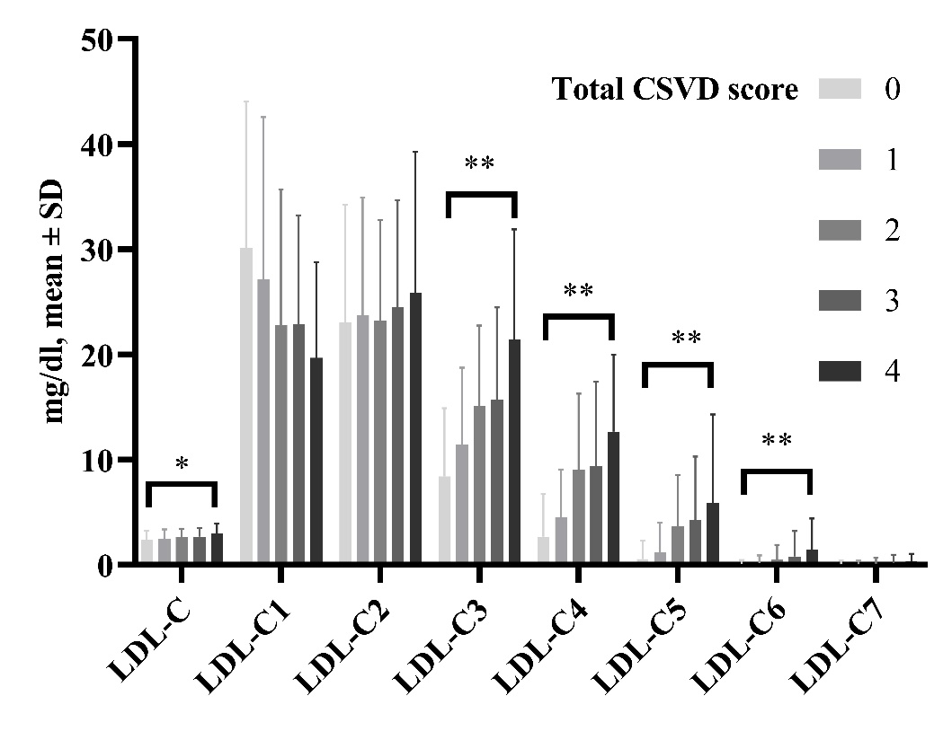
* P<0.05, ** P<0.01.
Supplements figure 2. The distribution of each component (WMH, CMBs, EPVS, and lacunes) of CSVD.
