Supplementary Materials

Duanlu Hou¹, MS, Ping Zhong², MD, Xiaofei Ye³, PhD, Danhong Wu¹*, MD
1. Department of Neurology, Shanghai Fifth People’s Hospital, Fudan University, Shanghai, China
2. Department of Neurology, Shidong Hospital of Yangpu District, Shanghai, China
3. Department of Health Statistics, Second Military Medical University, Shanghai, China

Supplemental file 1, Searching strategy
Pubmed
#1 (persistent hyperglycemia) OR (persistent hyperglycemia[MeSH Terms])
(("persist"[All Fields] OR "persistance"[All Fields] OR "persistant"[All Fields] OR "persisted"[All Fields] OR "persistence"[All Fields] OR "persistences"[All Fields] OR "persistencies"[All Fields] OR "persistency"[All Fields] OR "persistent"[All Fields] OR "persistently"[All Fields] OR "persistents"[All Fields] OR "persister"[All Fields] OR "persisters"[All Fields] OR "persisting"[All Fields] OR "persists"[All Fields]) AND ("hyperglycaemia"[All Fields] OR "hyperglycemia"[MeSH Terms] OR "hyperglycemia"[All Fields] OR "hyperglycaemias"[All Fields] OR "hyperglycemias"[All Fields] OR "hyperglycemia s"[All Fields])) OR (("persist"[All Fields] OR "persistance"[All Fields] OR "persistant"[All Fields] OR "persisted"[All Fields] OR "persistence"[All Fields] OR "persistences"[All Fields] OR "persistencies"[All Fields] OR "persistency"[All Fields] OR "persistent"[All Fields] OR "persistently"[All Fields] OR "persistents"[All Fields] OR "persister"[All Fields] OR "persisters"[All Fields] OR "persisting"[All Fields] OR "persists"[All Fields]) AND "hyperglycemia"[MeSH Terms])
#2 ((stroke outcome) OR (stroke outcome[MeSH Terms])) AND ((stroke[MeSH Terms])OR (stroke))
("stroke"[MeSH Terms] OR "stroke"[All Fields] OR "strokes"[All Fields] OR "stroke s"[All Fields]) AND ("outcome"[All Fields] OR "outcomes"[All Fields]) AND ("stroke"[MeSH Terms] OR ("stroke"[MeSH Terms] OR "stroke"[All Fields] OR "strokes"[All Fields] OR "stroke s"[All Fields]))
#3 ((stroke[MeSH Terms])OR (stroke)) AND ((persistent hyperglycemia) OR (persistent hyperglycemia[MeSH Terms]))
("stroke"[MeSH Terms] OR ("stroke"[MeSH Terms] OR "stroke"[All Fields] OR "strokes"[All Fields] OR "stroke s"[All Fields])) AND ((("persist"[All Fields] OR "persistance"[All Fields] OR "persistant"[All Fields] OR "persisted"[All Fields] OR "persistence"[All Fields] OR "persistences"[All Fields] OR "persistencies"[All Fields] OR "persistency"[All Fields] OR "persistent"[All Fields] OR "persistently"[All Fields] OR "persistents"[All Fields] OR "persister"[All Fields] OR "persisters"[All Fields] OR "persisting"[All Fields] OR "persists"[All Fields]) AND ("hyperglycaemia"[All Fields] OR "hyperglycemia"[MeSH Terms] OR "hyperglycemia"[All Fields] OR "hyperglycaemias"[All Fields] OR "hyperglycemias"[All Fields] OR "hyperglycemia s"[All Fields])) OR (("persist"[All Fields] OR "persistance"[All Fields] OR "persistant"[All Fields] OR "persisted"[All Fields] OR "persistence"[All Fields] OR "persistences"[All Fields] OR "persistencies"[All Fields] OR "persistency"[All Fields] OR "persistent"[All Fields] OR "persistently"[All Fields] OR "persistents"[All Fields] OR "persister"[All Fields] OR "persisters"[All Fields] OR "persisting"[All Fields] OR "persists"[All Fields]) AND "hyperglycemia"[MeSH Terms]))
#4 (admission hyperglycemia) AND (((stroke outcome) OR (stroke outcome[MeSH Terms])) AND ((stroke[MeSH Terms])OR (stroke)))
("admission"[All Fields] OR "admissions"[All Fields]) AND ("hyperglycaemia"[All Fields] OR "hyperglycemia"[MeSH Terms] OR "hyperglycemia"[All Fields] OR "hyperglycaemias"[All Fields] OR "hyperglycemias"[All Fields] OR "hyperglycemia s"[All Fields]) AND (("stroke"[MeSH Terms] OR "stroke"[All Fields] OR "strokes"[All Fields] OR "stroke s"[All Fields]) AND ("outcome"[All Fields] OR "outcomes"[All Fields]) AND ("stroke"[MeSH Terms] OR ("stroke"[MeSH Terms] OR "stroke"[All Fields] OR "strokes"[All Fields] OR "stroke s"[All Fields])))

Web of science
#1 TS=(persistent hyperglycemia) OR TI=(persistent hyperglycemia)
#2 (TS=(stroke) OR TI=(stroke)) AND (TS=(stroke outcome) OR TI=(stroke outcome))
#3 #2 AND #1
# 4 TS=(admission hyperglycemia) AND TS=(stroke)

Ovid MEDLINE(R) <1946 to March 1, 2021>
1 ..nlpx "query=persistent hyperglycemia","desiredResults=10000","minHitsDivisor=7","permitHyponyms=NO","lowestVocabularySearchLevel=none","phrasesBroken=NO","speedWanted=NoHypos","comment=Including Related Terms","elimEnable=NO","constraintMinTerms=2"
2 ..nlpx "query=stroke","desiredResults=10000","minHitsDivisor=7","permitHyponyms=NO","lowestVocabularySearchLevel=none","phrasesBroken=NO","speedWanted=NoHypos","comment=Including Related Terms","elimEnable=NO","constraintMinTerms=2"
3 ..nlpx "query=admission hyperglycemia","desiredResults=10000","minHitsDivisor=7","permitHyponyms=NO","lowestVocabularySearchLevel=none","phrasesBroken=NO","speedWanted=NoHypos","comment=Including Related Terms","elimEnable=NO","constraintMinTerms=2"
4 ..nlpx "query=persistent hyperglycemia AND stroke AND admission hyperglycemia","desiredResults=10000","minHitsDivisor=7","permitHyponyms=NO","lowestVocabularySearchLevel=none","phrasesBroken=NO","speedWanted=NoHypos","comment=Including Related Terms","elimEnable=NO","constraintMinTerms=2"

CNKI
In this database we searched in Chinese for the terms persistent hyperglycaemia, stroke.
An article was found LI G, Wang C: [Predictive value of hyperglycaemia in the prognosis of ischaemic cerebrovascular disease]. Journal of Shandong university (health science) 2010, 48(4):1-4.

Approvals, Registrations, and Patient Consents of the Cohort Study in Shanghai (or Shanghai Study) (Hou et al.)
Consecutive patients with either ischemic or hemorrhagic stroke were screened and selected from the Stroke Unit of Shanghai Fifth People’s Hospital between April 1, 2017, and February 1, 2020. Written informed consent was obtained from all patients or their families. This study was approved by the Ethical Review Board of Shanghai Fifth People’s Hospital before recruiting patients. The inclusion and exclusion criteria were the same as those reported in a previous study [1].

- Hou D, Wang C, Ye X, Zhong P, Wu D: Persistent inflammation worsens short-term outcomes in massive stroke patients. BMC Neurol 2021, 21(1):62.

Figure S1
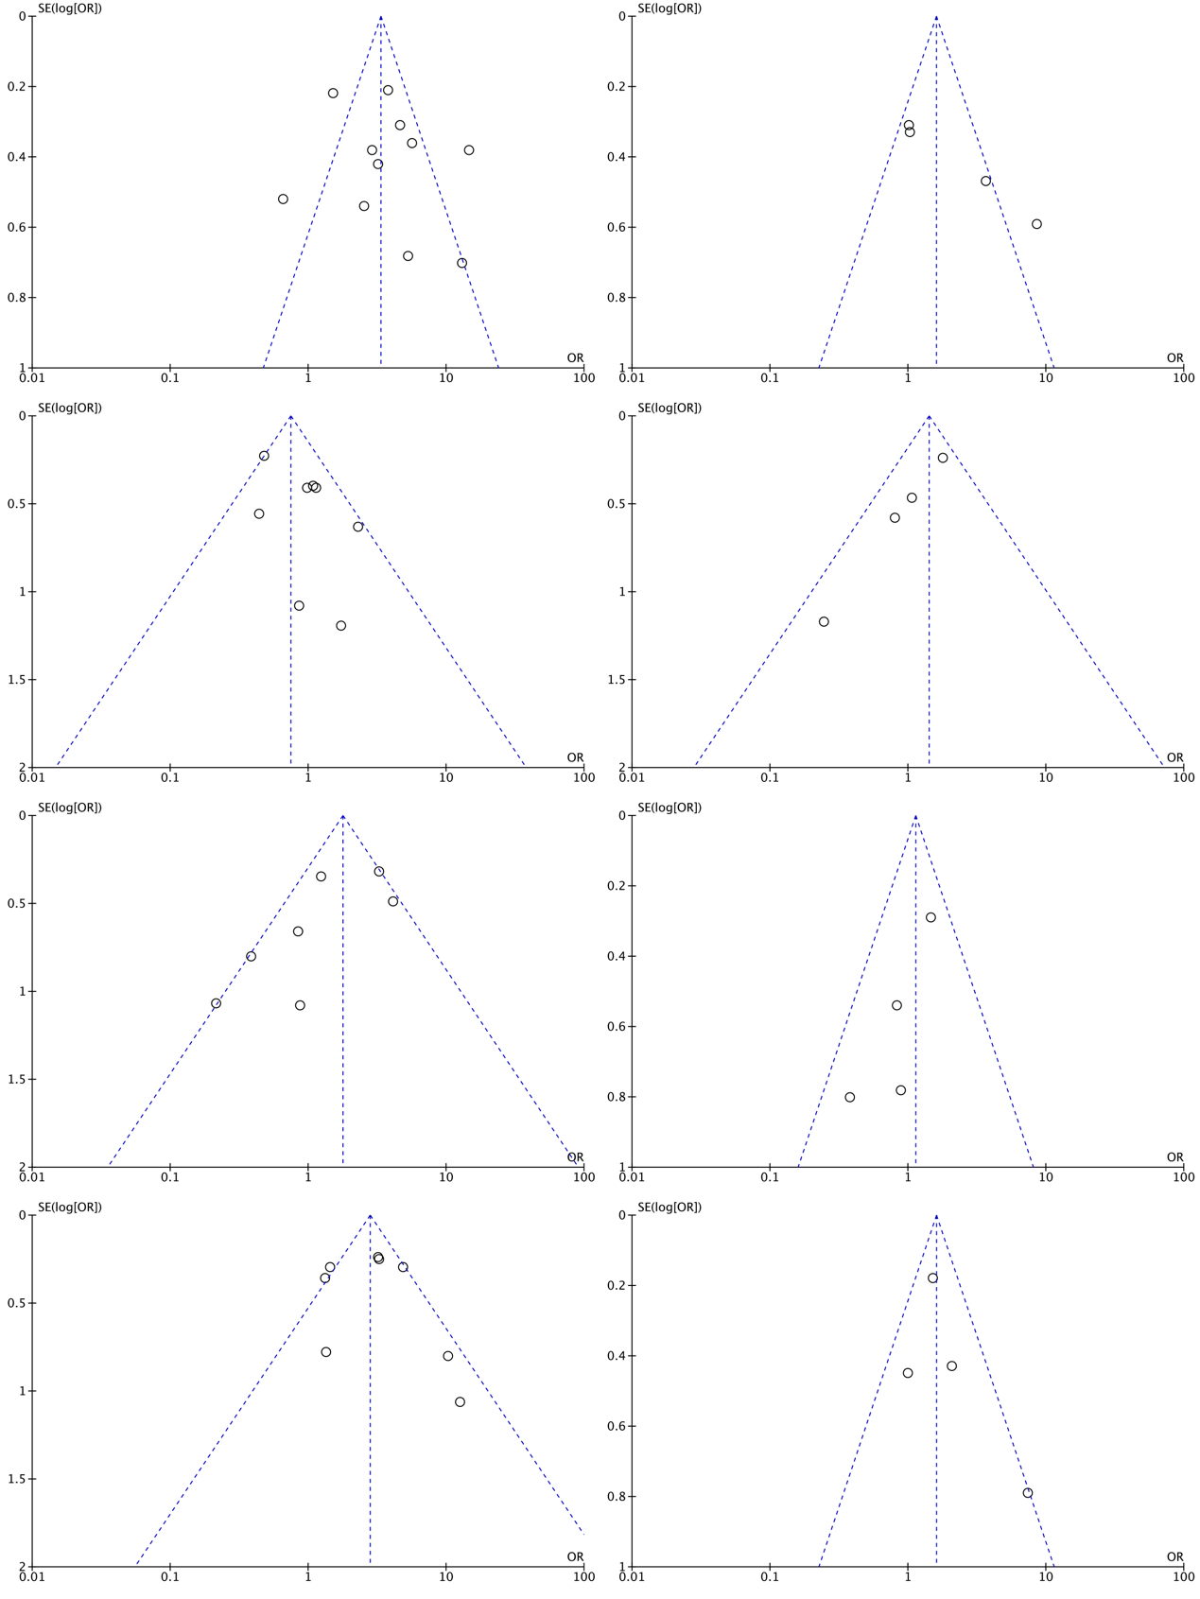
Figure S2 see next page
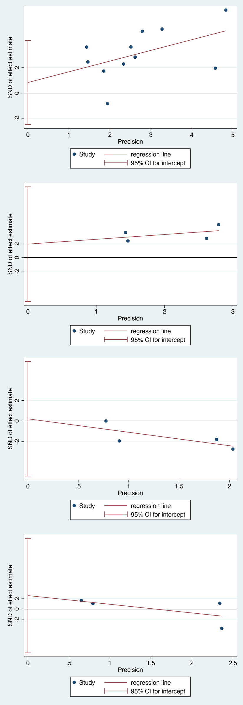
Figure S3

Figure S4

Table S1-5 Hou et al
Table S1. Baseline characteristics of the study population and bivariate comparisons between patients with favorable and unfavorable outcomes
 | Favorable functional outcome (n=102) | Unfavorable functional outcome (n=98) | p Value
Demographic data
Male | 56 (56.1) | 49 (50) | 0.512
Age † | 82 (13) | 81 (11) | 0.931
Smoker | 22 (22) | 17 (17.3) | 0.526
Alcohol drinker | 7 (7) | 12 (12.2) | 0.553
Medical history
Arterial hypertension | 83 (82.9) | 72 (73.4) | 0.232
Diabetes mellitus | 24 (24.4) | 39 (39.8) | 0.083
Atrial fibrillation | 22 (22.0) | 29 (39.8) | 0.357
Coronary artery disease | 2 (2.4) | 7 (7) | 0.436
Liver disease | 3 (4.9) | 8 (8.2) | 0.723
Kidney disease | 2 (2.4) | 7 (7.1) | 0.436
Clinical characteristics
Systolic BP, mmHg‡ | 150 (132-162) | 147 (138-164) | 0.992
Blood glucose, mg/dl‡ | 5.4 (4.6-6.3) | 6.6 (5.3-8.2) | 0.005*
Laboratory data
HbA1c, % | 5.9 (5.5-6.6) | 6 (5.5-6.7) | 0.992
Insulin, mmol/L | 59.5 (42-87) | 60.8 (42-78) | 0.834
Insulin resistance | 5.8 (0-16) | 9.2 (0-20) | 0.215
C peptide, ng/dl‡ | 0.7 (0.6-1) | 0.7 (0.6-1) | 0.611
Sodium, mmol/L‡ | 141 (139-143) | 140 (139-142) | 0.084
Potassium, mmol/L‡ | 4.0 (3.7-4.2) | 3.8 (3.5-4.1) | 0.144
NLR at admission‡ | 3.3 (2.3-4.9) | 5.1 (4.0-8.3) | 0.002*
NLR at discharge‡ | 3.4 (2.0-5.2) | 4.3 (2.7-6.3) | 0.028*
Platelet, 10⁹/L‡ | 202 (155-239) | 193 (157-237) | 0.900
LDL, mmol/L‡ | 2.5 (2.1-3.3) | 2.7 (1.9-3.4) | 0.837
Total bilirubin, μmol/L‡ | 12.1 (9.6-15.9) | 15.2 (10.7-18.9) | 0.080
Cystatin C, mg/L‡ | 1.0 (1.1-1.2) | 1.1 (1.0-1.3) | 0.922
Homocysteine, μmol/L‡ | 14.8 (11.5-19.3) | 13.9 (11.1-19.9) | 0.990
Imaging data
Cerebral ischemia | 89(87.8) | 81 (82.7) | 0.448
Hemisphere | 14 (16.6) | 40 (49.3) | 0.001*
Lobes | 22 (25) | 20 (24.6) | 0.972
Brainstem/cerebellum | 29 (33.3) | 13 (16) | 0.035*
Lacunes | 20 (22.2) | 5 (6) | 0.022*
Cerebral hemorrhage | 10 (9.8) | 18 (18.4) | 0.205
Basal ganglia | 5 (50) | 5 (28) | 0.565
Lobes | 2 (25) | 12 (66) | 0.264
Brainstem/cerebellum | 2 (25) | 1 (5) | 0.338
Medication
rtPA | 10 (9.7) | 11 (11.2) | 0.799
Intervention | 7 (7) | 5 (5.1) | 0.693
In-hospital infections
Lung infection | 32 (31.7) | 59 (60.2) | 0.002*
Urinary tract infection | 0 (0) | 14 (14.3) | 0.011*
Abbreviations: NLR = neutrophil-to-lymphocyte ratio; BP = blood pressure; HbA1c = glycated hemoglobin 1c; LDL = low density lipoprotein; rtPA = Recombinant Human Tissue Plasminogen A.
Unless specified, values are numbers of patients (%).
†Mean (standard deviation).
‡Median (interquartile range).
*Statistically significant.

Table S3. Baseline characteristics and bivariate comparisons between short-duration and long-duration persistent hyperglycemia groups
 | Persistent hyperglycemia (1-7d) (n=102) | Persistent hyperglycemia (>= 7d) (n=98) | p Value
Demographic data
Male | 59 (58) | 45 (45) | 0.30
Age | 81 (70-85) | 83 (73-87) | 0.55
Smoker | 12 (12) | 7 (29) | 0.68
Alcohol drinker | 15 (15) | 0 (0) | 0.02*
Medical history
Arterial hypertension | 74 (73) | 72 (76) | 0.78
Diabetes mellitus | 25 (24.4) | 39 (39.8) | 0.002*
Atrial fibrillation | 22 (22.0) | 29 (39.8) | 0.99
Coronary artery disease | 2 (2.4) | 7 (7) | 0.98
Liver disease | 5 (4.9) | 8 (8.2) | 0.72
Kidney disease | 2 (2.4) | 7 (7.1) | 0.43
Clinical characteristics
Systolic BP, mmHg‡ | 145 (138-160) | 152 (140-175) | 0.23
Blood glucose, mg/dl‡ | 7.0 (6-8) | 8.8 (7.6-12.1) | 0.005*
Laboratory data
Fasting blood glucose, mg/dl | 7.08 (5.78-8.08) | 8.57 (6.73-11.92) | 0.02*
HbA1C, % | 6.2 (5.8-7.3) | 7.3 (6.4-8.9) | 0.01*
Insulin, mmol/L | 63 (43-106) | 63 (42-250) | 0.75
Insulin resistance | 11.8 (0-21.6) | 5.7 (0-28.8) | 0.68
C peptide, | 0.73 (0.67-1.85) | 0.69 (0.47-1.91) | 0.66
Sodium, mmol/L‡ | 140 (139-142) | 140 (138-141) | 0.36
Potassium, mmol/L‡ | 3.8 (3.5-4.2) | 4.0 (3.6-4.2) | 0.39
NLR at admission‡ | 4.7 (3-6 | 4.7 (3-12) | 0.59
NLR at discharge‡ | 4.3 (3.7-5.6) | 4.7 (3.-11.3) | 0.21
LDL, mmol/L‡ | 2.7 (1.9-3.4) | 2.8 (2.2-3.5) | 0.74
Total bilirubin, μmol/L‡ | 12.7 (11.1-16.4) | 11.8 (8.3-16.8) | 0.29
Cystatin C, ng/dl‡ | 1.2 (1-1.4) | 1.2 (0.9-1.8) | 0.68
Homocysteine, μmol/L‡ | 14.4 (11.9-18.5) | 11.8 (9.5-17.8) | 0.19
Imaging data
Cerebral ischemia | 97 (97) | 80 (82) | 0.01
Hemisphere | 37 (39) | 40 (48) | 0.30
Lobes | 6 (6) | 10 (13) | 0.33
Brainstem/cerebellum | 25 (26) | 7 (9) | 0.16
Lacunes | 9 (9) | 7 (9) | 0.82
Basal ganglia | 19 (19) | 17 (21) | 0.87
Hemorrhagic transformation | 13(13) | 18(22) | 0.32
Cerebral hemorrhage | 3 (3) | 18 (18) | -
Basal ganglia | 3 (100) | 10 (60) | -
Lobes | - | 8 (40) | -
Abbreviations: NLR = neutrophil-to-lymphocyte ratio; BP = blood pressure; LDL = low density lipoprotein; HbA1c = glycated hemoglobin 1c.Unless specified, values are numbers of patients (%).‡Median (interquartile range).*Statistically significant.
Table S4. Comparisons of short-term outcomes between patients with short- and long-duration persistent hyperglycemia
Short-term outcomes | Persistent hyperglycemia |  | p value | OR | AR
Short-term outcomes | Short-duration | Long-duration | p value | OR | AR
Pulmonary infection | 27 (66) | 51 (52) | 0.27 | 1.3 | 14
Urinary tract infection | 7 (16) | 24 (24) | 0.40 | 0.7 | -8
1-month mortality | 7 (16) | 21 (21) | 0.61 | 0.8 | -5
1-month mRS | 4 (4-9)† | 4 (4-9)† | 0.87 | - | -
Abbreviations: mRS = modified Rankin scale; RR = relative ratio; AR = attributable ratio.
Unless specified, values are p value in non-parametric tests and values are numbers of patients (%).
†Median (interquartile range).
*Statistically significant.
Table S5. Comparisons of short-term outcomes between persistent hyperglycemia patients with HbA1c<7% and HbA1c>=7%
Short-term outcomes | Persistent hyperglycemia |  | p value | OR | AR
Short-term outcomes | HbA1C<7% | HbA1C>=7% | p value | OR | AR
Pulmonary infection | 17 (57) | 15 (58) | 0.90 | 0.9 | -1
Urinary tract infection | 5 (17) | 5 (17) | 1.0 | 1 | 0
1-month mortality | 3 (10) | 5 (17) | 0.69 | 0.6 | -7
1-month mRS | 4 (4-9)† | 4 (4-9)† | 0.95 | - | -
Abbreviations: HbA1C = glycated hemoglobin 1c; mRS = modified Rankin scale; RR = relative ratio; AR = attributable ratio.
Unless specified, values are p value in non-parametric tests and values are numbers of patients (%).
†Median (interquartile range).
*Statistically significant.

Table NOS

