Table S1 Number of FoG patients identified by MDS-UPDRS2 or MDS-UPDRS3.
Visit Year | n (MDS-UPDRS2) | n (MDS-UPDRS3) | n (BOTH) | n (MDS-UPDRS3 DOSE ON) | n (MDS-UPDRS3 DOSE OFF) | n  (IN TOTAL)
1 | 16 | 7 | 1 | 0 | 7 | 22
2 | 27 | 12 | 3 | 2 | 10 | 36
3 | 32 | 18 | 7 | 6 | 14 | 43
4 | 44 | 21 | 8 | 7 | 18 | 57
5 | 57 | 32 | 21 | 15 | 23 | 68
Figure S1 Number of FoG patients identified by MDS-UPDRS2 or MDS-UPDRS3.
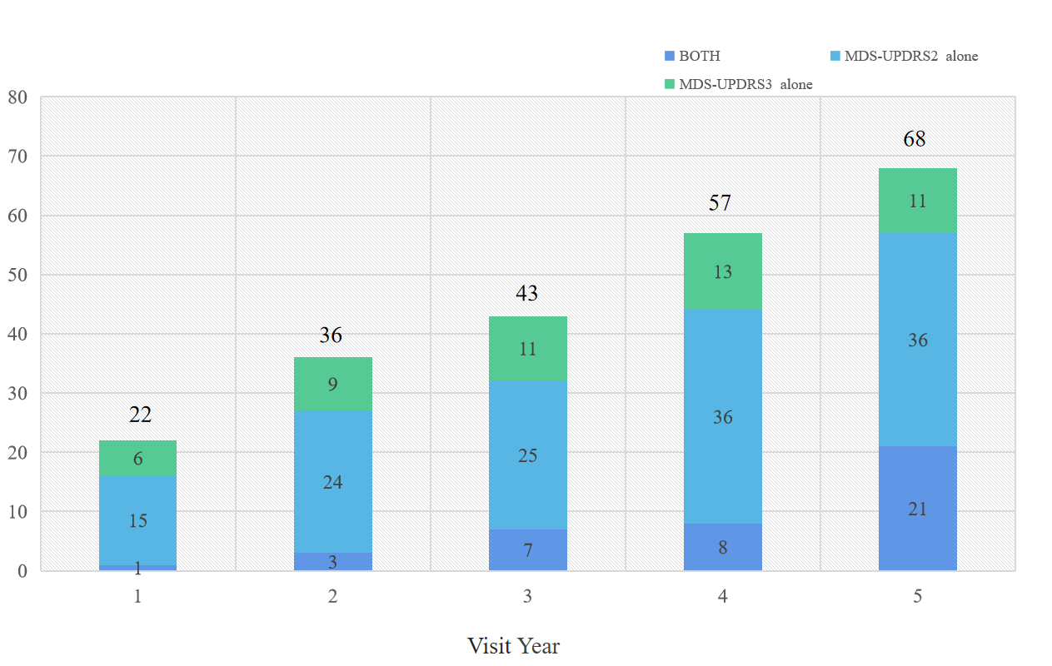

Table S2 Baseline characteristics of TD, PIGD and indeterminate patients.
 | TD  (n=127) | PIGD  (n=33) | Indeterminate  (n=23) | P  (TD VS PIGD) |  | - Overall |  | P
Demographic information
Age (years) | 62.0 [54.7;68.9] | 61.4 [53.1;68.5] | 59.6 [51.2;69.7] | 0.868 |  | 0.632
Age at Symptom Onset (years) | 60.3 [52.6;66.4] | 60.1 [52.0;66.8] | 58.6 [49.3;69.2] | 0.994 |  | 0.958
Duration of Disease since Diagnosis (Months) | 4.23 [2.18;7.70] | 3.30 [2.30;5.67] | 4.80 [2.77;6.17] | 0.469 |  | 0.319
Gender, female | 38 (29.9%) | 9 (27.3%) | 6 (26.1%) | 0.907 |  | 0.934
Years of education | 16.0 [15.0;18.0] | 14.0 [12.0;18.0] | 16.0 [14.0;17.5] | 0.033* |  | 0.015*
Categorical Education |  |  |  | 0.002* |  | <0.001*
<13 yrs | 13 (10.2%) | 12 (36.4%) | 4 (17.4%)
13-23 yrs | 113 (89.0%) | 20 (60.6%) | 19 (82.6%)
>23 yrs | 1 (0.79%) | 1 (3.03%) | 0 (0.00%)
Family members with PD (any) | 27 (21.3%) | 12 (36.4%) | 7 (30.4%) | 0.168 |  | 0.116
Disease characteristics
Side most affected at PD onset |  |  |  | 0.411 |  | 0.331
Left | 55 (43.3%) | 16 (48.5%) | 11 (47.8%)
Right | 71 (55.9%) | 16 (48.5%) | 11 (47.8%)
Symmetric | 1 (0.79%) | 1 (3.03%) | 1 (4.35%)
SPECT-DAT
Mean caudate DAT uptake | 2.10 (0.51) | 1.93 (0.56) | 1.90 (0.44) | 0.096 |  | 0.126
Mean putamen DAT uptake | 0.84 [0.69;0.99] | 0.74 [0.62;1.00] | 0.72 [0.59;0.84] | 0.179 |  | 0.334
Mean striatum DAT uptake | 1.47 (0.36) | 1.37 (0.40) | 1.35 (0.38) | 0.185 |  | 0.182
CSF biomarkers
Abeta | 893 [692;1140] | 961 [695;1251] | 898 [658;1174] | 0.814 |  | 0.569
aSyn | 1468 [1121;1798] | 1459 [1160;1866] | 1310 [1049;1539] | 0.415 |  | 0.918
Tau | 161 [138;209] | 172 [142;210] | 160 [128;182] | 0.541 |  | 0.795
pTau | 13.6 [11.2;17.2] | 14.2 [11.4;17.7] | 12.9 [10.7;15.5] | 0.588 |  | 0.711
Genetic Pattern
APOE |  |  |  | 0.434 |  | 0.520
APOE Genotype - number of e4 alleles | 0.31 (0.51) | 0.15 (0.36) | 0.43 (0.59) | 0.100 |  | 0.040*
SNCA_rs356181 |  |  |  | 0.276 |  | 0.081
SNCA_rs3910105 |  |  |  | 0.072 |  | 0.079
MAPT |  |  |  | 0.113 |  | 0.403
Motor assessments
Categorical Hoehn & Yahr |  |  |  | 0.149 |  | 0.236
Stage 1 | 61 (48.0%) | 16 (48.5%) | 7 (30.4%)
Stage 2 | 66 (52.0%) | 16 (48.5%) | 16 (69.6%)
Stages 3-5 | 0 (0.00%) | 1 (3.03%) | 0 (0.00%)
Total Rigidity Score | 3.00 [2.00;5.00] | 4.00 [2.00;5.00] | 4.00 [2.50;5.00] | 0.694 |  | 0.488
Tremor Score | 5.00 [3.00;7.00] | 0.00 [0.00;1.00] | 1.00 [1.00;3.50] | <0.001* |  | <0.001*
Modified Schwab & England ADL Score | 95.0 [90.0;100] | 90.0 [90.0;100] | 90.0 [90.0;100] | 0.471 |  | 0.778
MDS-UPDRS Part II Score | 4.00 [2.00;7.00] | 6.00 [3.00;9.00] | 7.00 [4.00;11.5] | 0.013* |  | 0.145
MDS-UPDRS Part III Score | 20.0 [14.0;24.5] | 20.0 [14.0;26.0] | 19.0 [11.5;24.5] | 0.778 |  | 0.798
MDS-UPDRS Total Score | 29.0 [22.0;37.5] | 30.0 [21.0;38.0] | 31.0 [21.0;41.5] | 0.825 |  | 0.775
Non-motor assessments
MDS-UPDRS Part I Score | 5.00 [2.00;7.00] | 5.00 [2.00;7.00] | 6.00 [3.00;7.00] | 0.667 |  | 0.835
MDS-UPDRS Part I Features of Dopamine Dysregulation Syndrome |  |  |  | 0.757 |  | 0.057
0 | 123 (96.9%) | 33 (100%) | 23 (100%)
1 | 4 (3.15%) | 0 (0.00%) | 0 (0.00%)
MDS-UPDRS Part I Fatigue |  |  |  | 0.044* |  | 0.175
0 | 72 (56.7%) | 15 (45.5%) | 8 (34.8%)
1 | 48 (37.8%) | 15 (45.5%) | 10 (43.5%)
2 | 6 (4.72%) | 1 (3.03%) | 4 (17.4%)
3 | 1 (0.79%) | 2 (6.06%) | 1 (4.35%)
MDS-UPDRS Part I Anxious Mood |  |  |  | 0.822 |  | 0.892
0 | 81 (63.8%) | 23 (69.7%) | 13 (56.5%)
1 | 41 (32.3%) | 9 (27.3%) | 10 (43.5%)
2 | 4 (3.15%) | 1 (3.03%) | 0 (0.00%)
3 | 1 (0.79%) | 0 (0.00%) | 0 (0.00%)
MDS-UPDRS Part I Apathy |  |  |  | 0.048* |  | 0.385
0 | 112 (88.2%) | 27 (81.8%) | 16 (69.6%)
1 | 15 (11.8%) | 6 (18.2%) | 6 (26.1%)
2 | 0 (0.00%) | 0 (0.00%) | 1 (4.35%)
MDS-UPDRS Part I Depressed Mood |  |  |  | 0.066 |  | 0.057
0 | 100 (78.7%) | 20 (60.6%) | 17 (73.9%)
1 | 25 (19.7%) | 11 (33.3%) | 4 (17.4%)
2 | 2 (1.57%) | 2 (6.06%) | 2 (8.70%)
MDS-UPDRS Part I Cognitive Impairment |  |  |  | 0.203 |  | 0.178
0 | 97 (76.4%) | 24 (72.7%) | 15 (65.2%)
1 | 29 (22.8%) | 7 (21.2%) | 8 (34.8%)
2 | 1 (0.79%) | 2 (6.06%) | 0 (0.00%)
MDS-UPDRS Part I Hallucinations and Psychosis |  |  |  | 1.000 |  | 1.000
0 | 121 (95.3%) | 32 (97.0%) | 22 (95.7%)
1 | 6 (4.72%) | 1 (3.03%) | 1 (4.35%)
MOCA Score (adjusted for education) | 28.0 [26.0;29.0] | 28.0 [26.0;28.0] | 28.0 [27.0;29.0] | 0.889 |  | 0.778
UPSIT Score | 22.0 [15.0;27.0] | 23.0 [17.0;31.0] | 22.0 [15.0;28.5] | 0.660 |  | 0.446
Benton Judgement of Line Orientation Score | 14.0 [13.0;15.0] | 13.0 [12.0;14.0] | 14.0 [13.0;15.0] | 0.158 |  | 0.084
Epworth Sleepiness Scale Score | 5.00 [3.00;7.00] | 6.00 [4.00;9.00] | 8.00 [4.00;8.50] | 0.074 |  | 0.098
REM Sleep Behavior Disorder Questionnaire Score | 3.00 [2.00;5.00] | 3.00 [2.00;6.00] | 3.00 [2.00;5.00] | 0.825 |  | 0.556
Geriatric Depression Scale Score | 1.00 [1.00;2.00] | 3.00 [2.00;3.00] | 2.00 [1.00;3.50] | 0.006* |  | 0.002*
STAI Total Score | 58.0 [50.0;71.5] | 65.0 [52.0;78.0] | 68.0 [60.0;79.0] | 0.119 |  | 0.243
Any QUIP disorder | 31(24.4%) | 4(12.1%) | 5(21.7%) | 0.651 |  | 0.412
SDMT Score | 42.0 [34.0;48.0] | 42.0 [32.0;46.0] | 43.0 [36.0;49.5] | 0.653 |  | 0.734
HVLT Immediate/Total Recall | 25.0 [21.0;28.5] | 25.0 [21.0;28.0] | 25.0 [22.5;27.5] | 0.955 |  | 0.848
HVLT Discrimination Recognition | 10.0 [9.00;11.0] | 10.0 [9.00;11.0] | 10.0 [9.50;11.0] | 0.701 |  | 0.447
HVLT Retention | 0.90 [0.79;1.00] | 0.80 [0.67;1.00] | 0.83 [0.73;1.00] | 0.022* |  | 0.009*
SCOPA-AUT Total Score | 7.00 [5.00;11.0] | 6.00 [5.00;12.0] | 8.00 [7.50;14.0] | 0.181 |  | 0.604
Semantic Fluency Total Score | 48.0 [42.0;57.5] | 49.0 [44.0;62.0] | 49.0 [45.0;58.0] | 0.638 |  | 0.530
Letter Number Sequencing Score | 11.0 [9.00;13.0] | 11.0 [9.00;13.0] | 11.0 [9.00;12.0] | 0.892 |  | 0.914
MCI test score (= 1) | 0.12 (0.32) | 0.18 (0.39) | 0.13 (0.34) |  | 0.631 | 0.394

Table S3 Correlations of PIGD score, SDMT score, fatigue and CSF Abeta in PD patients.
 |  | PIGD score | Fatigue | SDMT score | Abeta
PIGD score | Pearson's r | 1 | 0.221 | -0.201 | 0.041
PIGD score | P |  | 0.003* | 0.006* | 0.580
Fatigue | Pearson's r | 0.221 | 1 | 0.019 | 0.077
Fatigue | P | 0.003* |  | 0.795 | 0.299
SDMT score | Pearson's r | -0.201 | 0.019 | 1 | 0.016
SDMT score | P | 0.006* | 0.795 |  | 0.826
Abeta | Pearson's r | -0.018 | 0.077 | 0.016 | 1
Abeta | P | 0.808 | 0.299 | 0.826

Table S4 Percentage of missing data
 | Total Number | Missing  Number | Percentage（%)
bjlot | 250 | 1 | 0.4
fampd_new | 250 | 1 | 0.4
hvlt_immediaterecall | 250 | 1 | 0.4
hvlt_discrimination | 249 | 2 | 0.8
hvlt_retention | 250 | 1 | 0.4
lns | 250 | 1 | 0.4
scopa_gi | 250 | 1 | 0.4
scopa_sex | 249 | 2 | 0.8
scopa | 248 | 3 | 1.2
VLTANIM | 250 | 1 | 0.4
VLTVEG | 250 | 1 | 0.4
VLTFRUIT | 250 | 1 | 0.4
sft | 250 | 1 | 0.4
SDMTOTAL | 250 | 1 | 0.4
abeta | 244 | 7 | 2.9
asyn | 246 | 5 | 2
tau | 239 | 12 | 4.8
ptau | 226 | 25 | 10
mean_caudate | 248 | 3 | 1.2
mean_putamen | 248 | 3 | 1.2
mean_striatum | 248 | 3 | 1.2
APOE | 224 | 27 | 12.1
SNCA_rs356181 | 230 | 21 | 18.4
SNCA_rs3910105 | 230 | 21 | 18.4
APOE_e4 | 224 | 27 | 12.1
MAPT | 230 | 21 | 9.1

Table S5 Multivariate analysis adjusted for age, disease duration and gender for the onset of FoG during the 5-year follow up.
Index | OR | 95% CI: |  | P
PIGD score | 1.83 | 1.38 | 2.48 | <0.001*
MDS-UPDRS Part I Fatigue | 1.99 | 1.20 | 3.43 | 0.010*
SDMT score | 0.95 | 0.91 | 0.98 | 0.008*
Abeta | 1.00 | 1.00 | 1.00 | 0.008*
Age | 0.99 | 0.95 | 1.03 | 0.520
Duration of Disease since Diagnosis (Months) | 0.98 | 0.92 | 1.04 | 0.528
Gender | 1.50 | 0.68 | 3.33 | 0.320
Abeta: OR 0.999, 95% CI: 0.998-1.000.
R² = 0.234 (Cox & Snell), R² =0.320 (Nagelkerke). Homer and Lemeshow Goodness of fitχ² = 5.812, p=0.668.

Figure S2 ROC curve analysis for the onset of FoG during the 5-year follow up adjusted for age, gender and disease duration.
