Optimal therapeutic conditions for the neural stem cell-based management of ischemic stroke: a systematic review and network meta-analysis based on animal studies

Table 1: Search strategies
Web of science
(TS= (neural stem cells or neural precursor cell or neural progenitor cell or NSPC)) AND ((TS= (ischemic stroke OR brain ischemia OR brain infarction OR cerebral infarction OR cerebral ischemic stroke OR intracranial ischemia OR cerebral arterial thrombosis)) 6816
PUBMED
#1: "Neural Stem Cells"[MeSH Major Topic] 8992
#2: "neural stem cells"[Title/Abstract] OR "neural precursor cell"[Title/Abstract] OR "neural progenitor cell"[Title/Abstract] OR "NSPC"[Title/Abstract] 13230
#3: #1 OR #2 17606
#4: "Ischemic Stroke"[MeSH Major Topic] OR "Brain Ischemia"[MeSH Terms] OR "Brain Infarction"[MeSH Major Topic] OR "Cerebral Infarction"[MeSH Terms] 117522
#5: "ischemic stroke"[Title/Abstract] OR "brain ischemia"[Title/Abstract] OR "brain infarction"[Title/Abstract] OR "cerebral infarction"[Title/Abstract] OR "cerebral ischemic stroke"[Title/Abstract] OR "intracranial ischemia"[Title/Abstract] OR "cerebral arterial thrombosis"[Title/Abstract] 72865
#6: #4 OR #5 152248
#7: #3 AND #6 754
EMBASE
#1: (neural stem cells or neural precursor cell or neural progenitor cell or NSPC).mp. [mp=title, abstract, heading word, drug trade name, original title, device manufacturer, drug manufacturer, device trade name, keyword heading word, floating subheading word, candidate term word] 18358
#2: exp *neural stem cell/ 11566
#3: 1 or 2 22628
#4: (ischemic stroke or brain ischemia or brain infarction or cerebral infarction or cerebral ischemic stroke or intracranial ischemia or cerebral arterial thrombosis).mp. [mp=title, abstract, heading word, drug trade name, original title, device manufacturer, drug manufacturer, device trade name, keyword heading word, floating subheading word, candidate term word] 208467
#5: exp *brain ischemia/ or exp *ischemic stroke/ 89426
#6: exp *brain infarction/ 21388
#7: 4 or 5 or 6 225740
#8: 3 and 7 1230

Table 2: Basic information of included studies
NO. | Author (year) | Country | Type of study | Characteristics of animals |  |  |  | Sample size (E/C) | Modeling method | Characteristics of NSCs |  | Transplantation way | Transplanting time (After modeling/days) | Intervention
 |  |  |  | Species | Gender | Weight | Age |  |  | Type | Sources |  |  | Experience | Control
1 | Abeysinghe 2015 | Australia | RCT | Wistar rats | Male | 300-360g | Adult | 7/7 | Focal cerebral ischemia was induced i by constriction of the right MCA with perivascular administration of endothelin-1. | NSCs | Subventricular zone of human fetal brain tissues | Striatum and cortex | 7 | 8×10⁵ | Vehicle
2 | Chen 2009 | China | RCT | Wistar rats | Both male and female | 250-300g | Adult | 5/5 | A nylon monofilament was inserted from the lumen of the ECA to the lumen of ICA to occlude the origin of the right middle cerebral artery for two hours. | NSCs (GDNF) | The cerebral cortex of Wistar rats | Ventricle | 3 | 5×10⁵ | Normal saline
3 | Shen 2010 | China | RCT | Wistar rats | Male | / | Adult | 12/12 | A 3-0 nylon monofilament suture was gently inserted (approximately 18 mm) into the internal carotid artery. After 60 min of MCAO, the nylon surgical thread was removed. | NSCs | Wistar rat fetal forebrain | Femoral vein | 0 |  | Vehicle
4 | Cheng 2015 | China | RCT | SD rats | Male | 270-300g | Adult | 18/18 | Transient focal cerebral ischemia was induced using the intraluminal thread occlusion of middle cerebral artery (MCA) for 120 min | NSCs | The neonatal mouse cerebellum | Caudal vein | 1 | 5×10⁶ | PBS
5 | Doeppner 2014 | India | RCT | C57BL6/J mice | Male | 23-25g | 10-12 weeks | 6/6 | Mice were subjected to middle cerebral artery occlusion (MCAO) for 30 min under 1% isoflurane plus 69% N2O and 30% O2 anesthesia | NSCs | C57BL6/J mice | Caudal vein | 0 | 1×10⁶ | PBS
6 | Gomi 2012 | Japan | RCT | C57BL6/J mice | Male | 20-25g | 6-8 weeks | 8/8 | A silicon-coated No. 8-0 nylon monofilament was placed into the internal carotid artery to confirm rCBF dropping to 80% of its former value for 30min. | NSCs | Human iPS cells | Striatum | 7 |  | Medium
7 | Hicks 2008 | Canada | RCT | SD rats | Male | 320-350g | 12 weeks | 6/6 | The vasoconstrictive peptide endothelin-1 was injected adjacent to the right middle cerebral artery over 10 min as routinely done. | NSCs | GFP mice | Sensory motor cortex and Striatum | 7 | 1×10⁶ | DMEM
8 | Hosseini 2015 | Iran | RCT | SD rats | Male | 200-250g | / | 10/10 | The flow was coated with 4.0 nylon head thread with silicone and inserted into the total carotid artery to block blood flow for 60 min | NSCs | Ganglion of SD rat embryo | Ventricle | 7 | 1×10⁵ | PBS
9 | Hou 2016 | China | RCT | Kunming mice | Both male and female | 22-25g | 12 weeks | 10/10 | After drilling the skull to 50-μm in thickness, Rose Bengal dye pre-injected to the mice was illuminated by epifluorescence microscope to introduce photothrombotic ischemia. | NSCs | The hippocampus, olfactory bulb, and cerebral cortex of newborn Kunming mice | Cerebral cortex | 0 | 2.5×10⁵ | PBS
10 | Huang 2014 | USA | RCT | C57BL6/J mice | Male | 24-26g | / | 14/14 | A 6-0 nylon monofilament coated with silicon rubber was introduced into the left internal carotid artery occlude the origin of the MCA for 60min. | NSCs | The intraventricular area of the dead fetus | Hippocampus | 1 | 1×10⁵ | PBS
11 | Ishibashi 2004 | Japan | RCT | Mongolian gerbils | Male | 60-72g | 16-22 weeks | 7/7 | The left common carotid artery was occluded with a mini vascular clip for 10 min | NSCs | Forebrain tissues of human fetus | Caudate nucleus | 4 | 5×10⁵ | Medium
12 | Jin 2010 | USA | RCT | Fisher 344 rats | Male | / | 3 months | 6/6 | The left MCA was occluded by electrocoagulation without damaging the brain surface | NSCs | hESC line BG01 | Infarcted area | 21 | 1.8×10⁶ | Vehicle
13 | Kim 2014 | Korea | RCT | SD rats | Male | 250-300g | 2 months | 10/10 | A nylon thread was inserted into the left internal carotid artery and advanced to the Circle of Willis (permanent middle cerebral artery occlusion: pMCAo). | NSCs (PSA-NCAM+) | embryoid bodies (EBs) derived from hESCs | Striatum | 2 | 5×10⁵ | PBS
14 | Song 2015 | Korea | RCT | SD rats | Male | 250-300g | / | 9/9 | Transient focal cerebral ischemia was induced using intraluminal thread occlusion of the left middle cerebral artery (MCAO) | NSCs | Fetal human brain | Caudal vein | 1 | 4×10⁶ | PBS
15 | Ryu 2016 | Korea | RCT | SD rats | Male | 270-300g | / | 7/7 | By intraluminal thread occlusion of the left middle cerebral artery (MCAo) for 2 hours followed by reperfusion | NSCs | Immortalized human neural stem cell | Ventricle | 1 | 6×10⁵ | PBS
16 | Kim 2019 | Korea | RCT | SD rats | Male | 260-280g | 7 weeks | 10/10 | The middle cerebral artery was blocked with silicone thread for 2 hours | NSCs (over-expressing choline acetyltransferase) | Human | Caudal vein | / | 1×10⁶ | Normal saline
17 | Kim 2020 | Korea | RCT | ICR mice | / | / | 1 week | 10/10 | ICR mice were subjected to permanent right common carotid artery occlusion under isoflurane anesthesia | NSCs | Human fetal brain tissue | Infarcted area | 3 | 8×10⁵ | Vehicle
18 | Lacza 2003 | USA | RCT | Wistar rats | Male | / | Adult | 12/11 | A nickel coated brass stamp with a footprint of 3 mm in diameter was precooled to -60°C with a mixture of dry ice and acetone and was lowered by a micromanipulator to touch the exposed dura for 3 min | NSCs (PARP) | E14 rat embryos | Infarcted area | 6 | 1.5×10⁵ | PBS
19 | Chang 2013 | Korea | RCT | SD rats | Male | 270-300g | Adult | 8/6 | A blunt-ended monofilament was inserted into the internal carotid artery from the bifurcation to occlude the middle cerebral artery for 90min. | NSCs | H9 hESCs | Striatum | 7 | 2×10⁵ | Medium
20 | Lei 2012 | China | RCT | SD rats | Male | 200-240g | / | 18/6 | The middle cerebral artery was isolated, occluded with a nylon monofilament suture with a rounded tip using an intraluminal vascular occlusion method. | NSCs | Cortex and ganglionic eminence of SD fetal rats | Ventricle | 3 | 2×10⁵ | PBS
21 | Zhang 2009 | China | RCT | SD rats | Male | 250-300g | / | 30/30 | A 3-0 surgical monofilament nylon suture with a rounded tip was introduced into the left internal carotid through the arteriotomy and advanced 16.5–17.5mm past the carotid bifurcation. | NSCs | Embryonic human brains | Cerebral cortex | 1 | 5×10⁴ | Medium
22 | Li 2013 | China | RCT | SD rats | Male | 300g | Adult | 6/6 | / | NSCs | Forebrain tissue of embryonic SD rats | Cerebral cortex | 3 | 5×10⁵ | PBS
23 | Lu 2017 | China | RCT | ICR mice | Male | / | Adult | 7/7 | The middle cerebral artery (MCA) was occluded by a 6–0 suture with a silicone-coated round tip. | NSCs | Cortex of E14 transgenic mice | Striatum | 4 | 3×10⁵ | PBS
24 | Zhu 2017 | China | RCT | Wistar rats | Male | 250-280g | 12-16weeks | 20/20 | Closure of middle cerebral artery with nylon suture for 120 minutes | NSCs | cortex of newborn Wistar rats | Striatum | 3 | 5×10⁵ | PBS
25 | Ma 2015 | China | RCT | C57BL6/J mice | Male | 20-25g | Adult | 6/6 | The cortical micro vessels of the thinned region were illuminated with a beam of green light for 3 min. | NSCs | Hippocampus tissue of mice | Hippocampus | 2 | 1×10⁶ | PBS
26 | Mochizuki 2008 | Japna | RCT | Wistar rats | Male | 220-260g | / | 7/7 | / | NSCs | Brain of fetal rats | Cerebral cortex | 0 | 1×10⁵ | Vehicle
27 | MOCHIZUKI 2011 | Japna | RCT | Wistar rats | Male | 220-260g | / | 8/8 | / | NSCs | Brain of fetal rats | Hippocampus | 7 | 1×10⁵ | Vehicle
28 | Noh 2020 | Korea | RCT | SD rats | Male | 270-300g | Adult | 10/10 | A blunt-ended silicon-coated monofilament was inserted to occlude the middle cerebral artery (MCA) for 90 minutes before it was removed. | NSCs | Human-induced pluripotent stem cells | Striatum | 7 | 2×10⁵ | Medium
29 | Zhu 2004 | China | RCT | SD rats | Male | 250-300g | Adult | 10/10 | 120 min occlusion of middle cerebral artery by suture | NSCs | hippocampus of Day E14 fetal SD rats | Infarcted area | 3 | 2×10⁵ | PBS
30 | Rehni 2007 | China | RCT | Albino mice | Both male and female | 25±2g | / | 6/6 | The suture was allowed to remain at the origin of middle cerebral artery to produce partial occlusion of cerebral artery for 1h. | NSCs | Brain tissue of the pregnant mouse fetus | Ventricle | 3 | 5×10⁵; 1×10⁶ | PBS
31 | Saraiva 2018 | Portuga | RCT | C57BL6/J mice | Male | / | 9 weeks | 11/16 | Unilateral photothrombotic cortical ischemia in the right primary motor cortex | NSCs | C57BL6/J mice | Caudal vein | 0 |  | Normal saline
32 | Song 2010 | Korea | RCT | SD rats | Male | 250-300g | / | 12/10 | Transient focal cerebral ischemia was induced by intralumenal thread occlusion of the left middle cerebral artery. | NSCs | Fetal human brain cell | Caudal vein | 1 | 4×10⁶ | PBS
33 | Song 2011 | Korea | RCT | SD rats | Male | 250-300g | / | 6/6 | Transient focal cerebral ischemia was induced by intralumenal thread occlusion of the left middle cerebral artery. | NSCs | human neural stem cell | Caudal vein | 1/7 | 4×10⁶ | PBS
34 | Song 2015 | Korea | RCT | SD rats | Male | 250-300g | / | 12/10 | Transient focal cerebral ischemia was induced by intralumenal thread occlusion of the left middle cerebral artery. | NSCs | human neural stem cell | Caudal vein | 1 | 4×10⁶ | PBS
35 | Ryu 2015 | Korea | RCT | SD rats | Male | 270-300g | / | 7/7 | By intraluminal thread occlusion of the left middle cerebral artery (MCAo) for 2 hours followed by reperfusion | NSCs | Human | Ventricle | 1 | 6×10⁵ | PBS
36 | Takahashi 2008 | Japan | RCT | Wistar rats | Male | 250-280g | Adult | 8/8 | A 4-0 monofilament nylon suture with the tip polysiloxane-coated was advanced from the CCA bifurcation until it blocked the origin of the MCA for 90min | NSCs | Neural crest of Wistar rat embryos | Infarcted area | 1h | 1×10⁵ | Vehicle
37 | Tang 2014 | China | RCT | SD rats | Male | / | 24 months | 17/16 | A 4-0 round tip and silicon coated suture was inserted from the left external carotid artery into the internal carotid artery for 2h. | NSCs | GFP mice | Striatum | 1 | 1×10⁶ | PBS
38 | Ziaee 2017 | Iran | RCT | SD rats | Male | 250-300g | 10-12 weeks | 15/15 | 30 min occlusion of middle cerebral artery with nylon thread | NSCs | embryo rat ganglion eminence | Ventricle | 1/3/7 | 2×10⁵ | PBS
39 | Tian 2019 | China | RCT | SD rats | Male | 280-300g | / | 10/10 | The rats were subjected to transient (2 h) MCAo via right intraluminal vascular occlusion | NSCs (Leukemia inhibitory factor) | The cortex of embryonic mouse brains | Caudal vein | 6h | 5×10⁶ | Blank
40 | Wang 2019 | China | RCT | SD rats | Male | / | / | 12/12 | The 0.25 mm nylon suture was inserted into the arterial origin through ICA until resistance was encountered. Fixed nylon suture, suture incision. | NSCs | Fetuses were harvested from 15-d-pregnant Sprague-Dawley rat | Striatum | 1 | 1×10⁶ | Blank
41 | Watanabe 2015 | Japan | RCT | Wistar rats | Male | 250-300g | Adult | 5/5 | 4 – 0 monofilament nylon sutures (20 mm) were used to block the origin of middle cerebral artery for 60 min. | NSCs (BRCA1) | human fetal telencephalonn | Jugular vein | 6h | 3×10⁶ | PBS
42 | Xu 2019 | China | RCT | C57BL6/J mice | Male | 20-25g | Adult | 8/8 | A 6-0 siliconcoated monofilament nylon suture was introduced into the ICA through the ECA until mild resistance was felt for 90min. | NSCs | embryonic C57BL/6J mouse brain | Cerebral cortex | 7h | 1×10⁶ | PBS
43 | Yamashita 2017 | Japan | RCT | C57BL6/J mice | Male | 23-27g | 8-10 weeks | 19/19 | A silicone-coated 6-0 filament was inserted and gently advanced (9.0–10.0 mm) to occlude the middle cerebral artery for 35min. | NSCs | C57BL6/J mice | Striatum and cortex | 1 | 5×10⁵ | Normal saline
44 | Yao 2015 | China | RCT | SD rats | Male | 270-300g | / | 12/12 | / | NSCs (human neurotrophin-3) | embryos of C57BL6/J mice | Cerebral cortex | 2 | 1×10⁶ | PBS
45 | Zhang 2008 | China | RCT | SD rats | Male | 230-250g | Adult | 12/12 | A 3–0 monofilament nylon suture with a round tip was introduced into the CCA lumen and gently advanced to the ICA until slight resistance was left for 120min. | NSCs | Embryonic hippocampus of SD rats | Striatum | 7 | 2×10⁵ | Normal saline
46 | Zhang 2017 | China | RCT | SD rats | Male | 270-300g | Adult | 16/16 | A 5-0 monofilament nylon suture was advanced from the ECA into the lumen of the ICA until a slight resistance was exerted (18.5–19.5 mm) for 120min. | NSCs (bFGF) | mice | Caudal vein | 1 | 5×10⁶ | PBS
47 | Zhang 2018 | China | RCT | SD rats | Male | 240-280g | Adult | 15/15 | Nylon thread was introduced into the CCA. The insertion depth was approximately 18 mm ± 0.5 mm above the CCA bifurcation for 90min. | NSCs | hippocampus of fetal rats | Striatum | 3 | 8×10⁵ | PBS
48 | Zhang 2017 | China | RCT | SD rats | Male | 250-280g | Adult | 6/6 | The insertion length of the sutures was 2 cm. After 120 min of occlusion, the suture was withdrawn to restore blood supply to the MCA territory | NSCs | newborn SD rat | Striatum | 1 | 5×10⁵ | PBS
49 | Zhang 2017 | China | RCT | ICR mice | Male | 25-30g | Adult | 8/8 | The middle cerebral arteries were closed with a suture for 2 hours | NSCs | The cortex of GFP mice | Striatum | 1 | 1×10⁶ | PBS
50 | Zhang 2018 | China | RCT | SD rats | Male | 250-300g | Adult | 24/24 | Closure of middle cerebral artery with nylon suture for 90 minutes | NSCs | hippocampus of fetal rats | Striatum | 0 | 8×10⁵ | PBS
51 | Zhu 2005 | China | RCT | SD rats | Male | 250-300g | Adult | 10/10 | Closure of middle cerebral artery with nylon suture for 120 minutes | NSCs | hippocampus of E14 fetal SD rats | Striatum | 3 | 2×10⁵ | PBS
52 | Zhu 2011 | China | RCT | SD rats | Male | 250-300g | Adult | 10/10 | Closure of middle cerebral artery with nylon suture for 120 minutes | NSCs | hippocampus of E14 fetal SD rats | Striatum | 3 | 1×10⁶ | PBS
Table 3: Results of network meta-analysis among neural stem cells with different transplantation doses in rats
1×10⁵ | 27.83 (-24.37, 80.61) | 28.92 (-46.43, 104.60) | -3.19 (-64.82, 57.54) | 21.82 (-37.12, 82.41) | 40.99 (-32.40, 116.86) | 35.71 (-26.70, 96.56) | 37.14 (-17.83, 93.99) | 24.94 (-35.82, 86.18) | 36.58 (-23.69, 97.17) | 43.21 (0.23, 86.34)
-27.83 (-80.61, 24.37) | 1×10⁶ | 1.25 (-68.60, 70.63) | -31.00 (-86.06, 22.84) | -6.47 (-56.60, 46.82) | 13.23 (-54.67, 80.60) | 7.64 (-45.99, 60.07) | 9.67 (-36.61, 56.36) | -2.95 (-54.93, 51.01) | 9.48 (-44.13, 61.35) | 15.29 (-15.23, 45.72)
-28.92 (-104.60, 46.43) | -1.25 (-70.63, 68.60) | 1.8×10⁶ | -32.11 (-108.81, 41.74) | -7.34 (-81.30, 69.23) | 12.31 (-75.34, 100.51) | 7.09 (-68.88, 81.60) | 8.82 (-62.71, 78.88) | -3.95 (-78.85, 71.04) | 8.17 (-67.98, 84.21) | 14.13 (-48.52, 76.49)
3.19 (-57.54, 64.82) | 31.00 (-22.84, 86.06) | 32.11 (-41.74, 108.81) | 2×10⁵ | 24.89 (-34.20, 87.43) | 44.42 (-29.94, 121.40) | 38.59 (-23.21, 100.40) | 40.83 (-14.99, 96.46) | 27.95 (-32.46, 90.09) | 40.25 (-21.86, 103.15) | 46.40 (2.15, 91.35)
-21.82 (-82.41, 37.12) | 6.47 (-46.82, 56.60) | 7.34 (-69.23, 81.30) | -24.89 (-87.43, 34.20) | 4×10⁶ | 19.44 (-55.95, 92.55) | 14.05 (-48.68, 74.20) | 15.70 (-40.36, 70.22) | 3.32 (-56.30, 62.41) | 15.01 (-46.34, 74.82) | 21.43 (-21.88, 62.37)
-40.99 (-116.86, 32.40) | -13.23 (-80.60, 54.67) | -12.31 (-100.51, 75.34) | -44.42 (-121.40, 29.94) | -19.44 (-92.55, 55.95) | 5×10⁴ | -5.70 (-82.68, 70.30) | -3.54 (-74.09, 65.43) | -16.43 (-90.24, 58.59) | -4.28 (-79.42, 70.07) | 2.18 (-59.64, 63.00)
-35.71 (-96.56, 26.70) | -7.64 (-60.07, 45.99) | -7.09 (-81.60, 68.88) | -38.59 (-100.40, 23.21) | -14.05 (-74.20, 48.68) | 5.70 (-70.30, 82.68) | 5×10⁵ | 1.72 (-54.06, 59.38) | -10.57 (-70.98, 50.82) | 1.30 (-58.74, 63.18) | 7.66 (-35.23, 51.87)
-37.14 (-93.99, 17.83) | -9.67 (-56.36, 36.61) | -8.82 (-78.88, 62.71) | -40.83 (-96.46, 14.99) | -15.70 (-70.22, 40.36) | 3.54 (-65.43, 74.09) | -1.72 (-59.38, 54.06) | 5×10⁶ | -12.39 (-67.90, 43.54) | -0.00 (-56.62, 54.15) | 5.60 (-28.83, 40.37)
-24.94 (-86.18, 35.82) | 2.95 (-51.01, 54.93) | 3.95 (-71.04, 78.85) | -27.95 (-90.09, 32.46) | -3.32 (-62.41, 56.30) | 16.43 (-58.59, 90.24) | 10.57 (-50.82, 70.98) | 12.39 (-43.54, 67.90) | 6×10⁵ | 11.77 (-49.78, 72.66) | 18.03 (-26.33, 60.81)
-36.58 (-97.17, 23.69) | -9.48 (-61.35, 44.13) | -8.17 (-84.21, 67.98) | -40.25 (-103.15, 21.86) | -15.01 (-74.82, 46.34) | 4.28 (-70.07, 79.42) | -1.30 (-63.18, 58.74) | 0.00 (-54.15, 56.62) | -11.77 (-72.66, 49.78) | 8×10⁵ | 6.36 (-35.66, 49.76)
-43.21 (-86.34, -0.23) | -15.29 (-45.72, 15.23) | -14.13 (-76.49, 48.52) | -46.40 (-91.35, -2.15) | -21.43 (-62.37, 21.88) | -2.18 (-63.00, 59.64) | -7.66 (-51.87, 35.23) | -5.60 (-40.37, 28.83) | -18.03 (-60.81, 26.33) | -6.36 (-49.76, 35.66) | Placebo

Table 4: Results of network meta-analysis among neural stem cells with different transplantation doses in mice
1×10⁵ | 13.67 (-2.19, 20.75) | 6.21 (-0.69, 8.52) | 11.55 (-5.82, 12.04) | 2.72 (-0.07, 10.58) | 9.54 (-1.96, 15.17) | 13.13 (-8.91, 14.36)
-13.67 (-20.75, 2.19) | 1×10⁶ | -8.49 (-14.22, 1.17) | -2.54 (-8.92, 4.68) | -7.80 (-16.46, 2.12) | -1.93 (-18.03, 7.82) | -0.20 (-7.38, 7.01)
-6.21 (-8.52, 0.69) | 8.49 (-1.17, 14.22) | 2.5×10⁵ | 5.34 (-3.51, 6.51) | -0.80 (-6.59, 4.05) | 6.25 (-3.93, 7.38) | 6.92 (-5.84, 9.60)
-11.55 (-12.04, 5.82) | 2.54 (-4.68, 8.92) | -5.34 (-6.51, 3.51) | 3×10⁵ | -6.65 (-10.11, 1.46) | 0.61 (-9.11, 3.14) | 2.07 (-1.33, 3.09)
-2.72 (-10.58, 0.07) | 7.80 (-2.12, 16.46) | 0.80 (-4.05, 6.59) | 6.65 (-1.46, 10.11) | 5×10⁵ | 4.21 (-1.56, 13.25) | 9.10 (-2.79, 12.44)
-9.54 (-15.17, 1.96) | 1.93 (-7.82, 18.03) | -6.25 (-7.38, 3.93) | -0.61 (-3.14, 9.11) | -4.21 (-13.25, 1.56) | 8×10⁵ | 1.60 (-0.81, 10.92)
-13.13 (-14.36, 8.91) | 0.20 (-7.01, 7.38) | -6.92 (-9.60, 5.84) | -2.07 (-3.09, 1.33) | -9.10 (-12.44, 2.79) | -1.60 (-10.92, 0.81) | Placebo

Table 5: Ranking results between different doses of neural stem cells transplantation in rats
Drug | Rank 1 | Rank 2 | Rank 3 | Rank 4 | Rank 5 | Rank 6 | Rank 7 | Rank 8 | Rank 9 | Rank 10 | Rank 11
1×10⁵ | 0.03 | 0.01 | 0.01 | 0.01 | 0.03 | 0.04 | 0.06 | 0.09 | 0.16 | 0.27 | 0.32
1×10⁶ | 0.00 | 0.05 | 0.07 | 0.10 | 0.14 | 0.15 | 0.17 | 0.14 | 0.10 | 0.05 | 0.01
1.8×10⁶ | 0.00 | 0.10 | 0.07 | 0.06 | 0.08 | 0.09 | 0.09 | 0.10 | 0.11 | 0.09 | 0.08
2×10⁵ | 0.14 | 0.01 | 0.01 | 0.01 | 0.02 | 0.03 | 0.05 | 0.08 | 0.14 | 0.25 | 0.41
4×10⁶ | 0.04 | 0.04 | 0.06 | 0.07 | 0.09 | 0.10 | 0.13 | 0.14 | 0.15 | 0.11 | 0.06
5×10⁴ | 0.28 | 0.13 | 0.08 | 0.07 | 0.08 | 0.07 | 0.07 | 0.07 | 0.06 | 0.05 | 0.04
5×10⁵ | 0.13 | 0.12 | 0.11 | 0.11 | 0.11 | 0.11 | 0.10 | 0.09 | 0.06 | 0.04 | 0.02
5×10⁶ | 0.12 | 0.14 | 0.13 | 0.13 | 0.13 | 0.13 | 0.10 | 0.07 | 0.04 | 0.02 | 0.01
6×10⁵ | 0.05 | 0.06 | 0.07 | 0.09 | 0.09 | 0.12 | 0.12 | 0.13 | 0.13 | 0.09 | 0.05
8×10⁵ | 0.15 | 0.14 | 0.11 | 0.10 | 0.10 | 0.11 | 0.10 | 0.08 | 0.06 | 0.03 | 0.01
Placebo | 0.06 | 0.21 | 0.29 | 0.25 | 0.13 | 0.05 | 0.01 | 0.00 | 0.00 | 0.00 | 0.00

Table 6: Ranking results between different doses of neural stem cells transplantation in mice
Drug | Rank 1 | Rank 2 | Rank 3 | Rank 4 | Rank 5 | Rank 6 | Rank 7
1×10⁵ | 0.00 | 0.00 | 0.00 | 0.00 | 0.00 | 0.25 | 0.75
1×10⁶ | 0.50 | 0.00 | 0.00 | 0.25 | 0.25 | 0.00 | 0.00
2.5×10⁵ | 0.00 | 0.00 | 0.00 | 0.50 | 0.00 | 0.25 | 0.25
3×10⁵ | 0.00 | 0.00 | 0.75 | 0.25 | 0.00 | 0.00 | 0.00
5×10⁵ | 0.00 | 0.00 | 0.00 | 0.00 | 0.75 | 0.25 | 0.00
8×10⁵ | 0.25 | 0.25 | 0.25 | 0.00 | 0.00 | 0.25 | 0.00
Placebo | 0.25 | 0.75 | 0.00 | 0.00 | 0.00 | 0.00 | 0.00

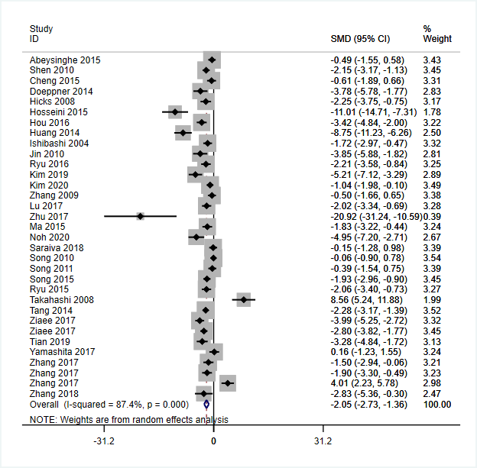
Figure 1: Traditional meta-analysis results of cerebral infarction volume
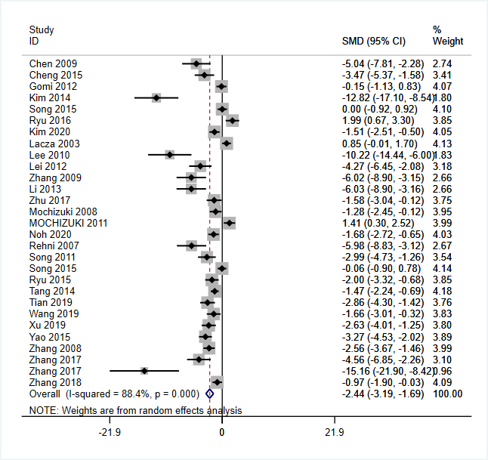
Figure 2: Traditional meta-analysis results of the first week of mNSS
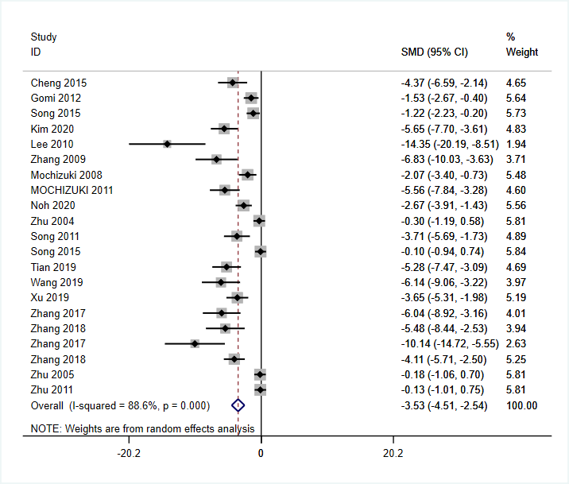
Figure 3: Traditional meta-analysis results of the fourth week of mNSS

