Supplementary Material

Supplemental figure 1: Sample Size Calculation using two-stage optimum design of Simon for Phase II trials (performed by nQuery Sample Size Software)
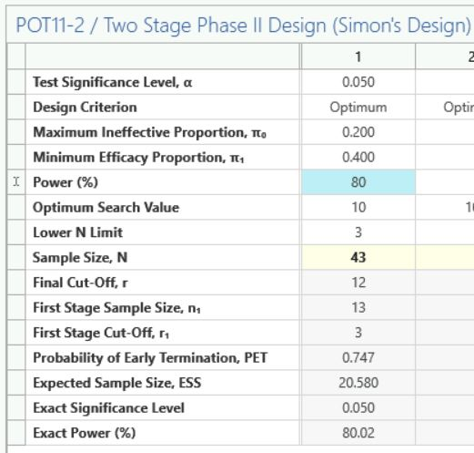

Supplemental figure 2: The Simon two-stage optimum design algorithm of the study

