Supplementary Materials
Supplementary Table 1. PRISMA checklist
Section and Topic | Item # | Checklist item | Location where item is reported
TITLE
Title | 1 | Identify the report as a systematic review. | Title
ABSTRACT
Abstract | 2 | See the PRISMA 2020 for Abstracts checklist. | N/A
INTRODUCTION
Rationale | 3 | Describe the rationale for the review in the context of existing knowledge. | Background: P1, 2
Objectives | 4 | Provide an explicit statement of the objective(s) or question(s) the review addresses. | Background: P3
METHODS
Eligibility criteria | 5 | Specify the inclusion and exclusion criteria for the review and how studies were grouped for the syntheses. | Methods 2.2
Information sources | 6 | Specify all databases, registers, websites, organisations, reference lists and other sources searched or consulted to identify studies. Specify the date when each source was last searched or consulted. | Methods 2.1
Search strategy | 7 | Present the full search strategies for all databases, registers and websites, including any filters and limits used. | Methods 2.1
Selection process | 8 | Specify the methods used to decide whether a study met the inclusion criteria of the review, including how many reviewers screened each record and each report retrieved, whether they worked independently, and if applicable, details of automation tools used in the process. | Methods 2.2
Data collection process | 9 | Specify the methods used to collect data from reports, including how many reviewers collected data from each report, whether they worked independently, any processes for obtaining or confirming data from study investigators, and if applicable, details of automation tools used in the process. | Methods 2.3
Data items | 10a | List and define all outcomes for which data were sought. Specify whether all results that were compatible with each outcome domain in each study were sought (e.g. for all measures, time points, analyses), and if not, the methods used to decide which results to collect. | Methods 2.3
Data items | 10b | List and define all other variables for which data were sought (e.g. participant and intervention characteristics, funding sources). Describe any assumptions made about any missing or unclear information. | Methods 2.3
Study risk of bias assessment | 11 | Specify the methods used to assess risk of bias in the included studies, including details of the tool(s) used, how many reviewers assessed each study and whether they worked independently, and if applicable, details of automation tools used in the process. | Methods 2.3
Effect measures | 12 | Specify for each outcome the effect measure(s) (e.g. risk ratio, mean difference) used in the synthesis or presentation of results. | Methods 2.4
Synthesis methods | 13a | Describe the processes used to decide which studies were eligible for each synthesis (e.g. tabulating the study intervention characteristics and comparing against the planned groups for each synthesis (item #5)). | Methods 2.4
Synthesis methods | 13b | Describe any methods required to prepare the data for presentation or synthesis, such as handling of missing summary statistics, or data conversions. | Methods 2.4
Synthesis methods | 13c | Describe any methods used to tabulate or visually display results of individual studies and syntheses. | Methods 2.4
Synthesis methods | 13d | Describe any methods used to synthesize results and provide a rationale for the choice(s). If meta-analysis was performed, describe the model(s), method(s) to identify the presence and extent of statistical heterogeneity, and software package(s) used. | Methods 2.4
Synthesis methods | 13e | Describe any methods used to explore possible causes of heterogeneity among study results (e.g. subgroup analysis, meta-regression). | Methods 2.4
Synthesis methods | 13f | Describe any sensitivity analyses conducted to assess robustness of the synthesized results. | Methods 2.4
Reporting bias assessment | 14 | Describe any methods used to assess risk of bias due to missing results in a synthesis (arising from reporting biases). | Methods 2.4
Certainty assessment | 15 | Describe any methods used to assess certainty (or confidence) in the body of evidence for an outcome. | Methods 2.4
RESULTS
Study selection | 16a | Describe the results of the search and selection process, from the number of records identified in the search to the number of studies included in the review, ideally using a flow diagram. | Results 3.1
Study selection | 16b | Cite studies that might appear to meet the inclusion criteria, but which were excluded, and explain why they were excluded. | Results 3.1
Study characteristics | 17 | Cite each included study and present its characteristics. | Results 3.1
Risk of bias in studies | 18 | Present assessments of risk of bias for each included study. | Results 3.1
Results of individual studies | 19 | For all outcomes, present, for each study: (a) summary statistics for each group (where appropriate) and (b) an effect estimate and its precision (e.g. confidence/credible interval), ideally using structured tables or plots. | Results 3.2-3.3
Results of syntheses | 20a | For each synthesis, briefly summarise the characteristics and risk of bias among contributing studies. | Results 3.2-3.3
Results of syntheses | 20b | Present results of all statistical syntheses conducted. If meta-analysis was done, present for each the summary estimate and its precision (e.g. confidence/credible interval) and measures of statistical heterogeneity. If comparing groups, describe the direction of the effect. | Results 3.2-3.3
Results of syntheses | 20c | Present results of all investigations of possible causes of heterogeneity among study results. | Results 3.2-3.3
Results of syntheses | 20d | Present results of all sensitivity analyses conducted to assess the robustness of the synthesized results. | Results 3.2-3.3
Reporting biases | 21 | Present assessments of risk of bias due to missing results (arising from reporting biases) for each synthesis assessed. | Results 3.2-3.3
Certainty of evidence | 22 | Present assessments of certainty (or confidence) in the body of evidence for each outcome assessed. | Results 3.2-3.3
DISCUSSION
Discussion | 23a | Provide a general interpretation of the results in the context of other evidence. | Discussion P1
Discussion | 23b | Discuss any limitations of the evidence included in the review. | Discussion P15
Discussion | 23c | Discuss any limitations of the review processes used. | Discussion P15
Discussion | 23d | Discuss implications of the results for practice, policy, and future research. | Discussion P2-14
OTHER INFORMATION
Registration and protocol | 24a | Provide registration information for the review, including register name and registration number, or state that the review was not registered. | Methods 2.1
Registration and protocol | 24b | Indicate where the review protocol can be accessed, or state that a protocol was not prepared. | Methods 2.1
Registration and protocol | 24c | Describe and explain any amendments to information provided at registration or in the protocol. | Methods 2.1
Support | 25 | Describe sources of financial or non-financial support for the review, and the role of the funders or sponsors in the review. | No funding
Competing interests | 26 | Declare any competing interests of review authors. | No competing interests
Availability of data, code and other materials | 27 | Report which of the following are publicly available and where they can be found: template data collection forms; data extracted from included studies; data used for all analyses; analytic code; any other materials used in the review. | Data availability statement

Supplementary Table 2. Search strategy for each database
Query |  | Results  (27 November, 2023)
PubMed
#1 | ("Cerebrovascular Disorders"[Mesh] OR "Brain Ischemia"[Mesh] OR "Hypoxia-Ischemia, Brain"[Mesh] OR "Ischemic Attack, Transient"[Mesh] OR "Stroke"[Mesh] OR "Stroke, Lacunar"[Mesh] OR "Infarction, Posterior Cerebral Artery"[Mesh] OR "Brain Stem Infarctions"[Mesh] OR "Infarction, Middle Cerebral Artery"[Mesh] OR "Infarction, Anterior Cerebral Artery"[Mesh] OR Stroke[TIAB] OR “cerebrovascular infarct*”[Tiab] OR “cerebrovascular event*”[Tiab] OR “cerebrovascular event*”[Tiab] OR CVA[Tiab] OR “transient ischemic attack*”[Tiab] OR TIA[Tiab]) | 589,636
#2 | ("Thrombolytic Therapy"[Mesh] OR thromboly* therap*[Tiab] OR "Fibrinolysis"[MesH] OR fibrinoly*[Tiab] OR "Plasminogen Activators"[MesH] OR plasminogen* activator*[Tiab] OR "fibrinolytic agents"[MesH] OR fibrinoly* agent*[Tiab] OR "fibrinolysin"[MesH] OR plasmin*[Tiab] OR plasminogen*[Tiab] OR thromboly*[Tiab] OR clot ly*[Tiab] OR "Antithrombins"[MesH] OR “tissue plasminogen activator”[TIAB] OR “tissue plasminogen activators”[TIAB] OR “intravenous tissue plasminogen activator”[TIAB] OR “intra-venous tissue plasminogen activator”[TIAB] OR “IV tissue plasminogen activator”[TIAB] OR “IV plasminogen activator”[TIAB] OR “recombinant tissue plasminogen activator”[TIAB] OR “intravenous recombinant tissue plasminogen activator”[TIAB] OR “intra-venous recombinant tissue plasminogen activator”[TIAB] OR “IV recombinant tissue plasminogen activator”[TIAB] OR “Recombinant human tissue-type plasminogen activator”[TIAB] OR “Tissue plasminogen activator (recombinant human)”[TIAB] OR “tPA”[TIAB] OR “t-PA”[TIAB] OR “rtPA”[TIAB] OR “rt-PA”[TIAB] OR “IV-tPA”[TIAB] OR “IV rt-PA” [TIAB] OR “alteplase”[TIAB] OR “actilyse”[TIAB] OR “activase”[TIAB] OR “alteplasi”[TIAB] OR “alteplasum”[TIAB] OR “alteplasum” [TIAB] OR “cathflo activase”[TIAB] OR “GRTPA”[TIAB] OR “SRT-PA”[TIAB] OR “UNII1RXS4UE564”[TIAB] OR “CAS Registry Number 105857-23-6”[TIAB] OR “RN: 105857-23-6”[TIAB]) | 188,695
#3 | ("Factor Xa Inhibitor*"[tiab] OR "Factor Xa Inhibitor"[Mesh] OR “Rivaroxaban”[tiab] OR “Rivaroxaban”[Mesh] OR “Xarelto”[tiab] OR "apixaban" [Supplementary Concept] OR "apixaban" [tiab] OR “Eliquis”[tiab] OR “eliques”[tiab] OR "edoxaban" [Supplementary Concept] OR "edoxaban" [tiab] “Savaysa”[tiab] OR "Dabigatran"[Mesh] OR "Dabigatran"[tiab] OR “Pradaxa”[tiab] OR "betrixaban" [Supplementary Concept] OR "betrixaban" [tiab] OR “Direct oral anticoagul*”[tiab] OR “DOAC*”[ti] OR “Direct Acting Oral Anticoagulant*”[tiab] OR “Novel Oral anticoagul*”[tiab] OR “NOAC*”[tiab] OR “non-vitamin K oral anticoagul*”[tiab]) | 15,163
#4 | (“vitamin K antagonist*”[tiab] OR “warfarin”[tiab] OR “warfarin”[Mesh] OR “Aldocumar”[tiab] OR “Warfant”[tiab] OR “Coumadin*”[tiab] OR “Marevan”[tiab] OR “Tedicumar”[tiab]) | 40,313
#5 | (“intravenous*”[tiab] OR “IVT”[tiab]) | 387,689
#6 | #1 AND #2 AND (#3 OR #4) AND #5 | 240
Scopus
#1 | TITLE-ABS-KEY("Cerebrovascular Disorders" OR "Brain Ischemia" OR "Hypoxia-Ischemia, Brain" OR "Ischemic Attack, Transient" OR "Stroke" OR "Stroke, Lacunar" OR "Infarction, Posterior Cerebral Artery" OR "Brain Stem Infarctions" OR "Infarction, Middle Cerebral Artery" OR "Infarction, Anterior Cerebral Artery" OR Stroke OR “cerebrovascular infarct*” OR “cerebrovascular event*” OR “cerebrovascular event*” OR CVA OR “transient ischemic attack*” OR TIA) | 662,119
#2 | TITLE-ABS-KEY("Thrombolytic Therapy" OR thromboly* therap* OR "Fibrinolysis" OR fibrinoly* OR "Plasminogen Activators" OR plasminogen* activator* OR "fibrinolytic agents" OR fibrinoly* agent* OR "fibrinolysin" OR plasmin* OR plasminogen* OR thromboly* OR "Antithrombins" OR “tissue plasminogen activator” OR “tissue plasminogen activators” OR “intravenous tissue plasminogen activator” OR “intra-venous tissue plasminogen activator” OR “IV tissue plasminogen activator” OR “IV plasminogen activator” OR “recombinant tissue plasminogen activator” OR “intravenous recombinant tissue plasminogen activator” OR “intra-venous recombinant tissue plasminogen activator” OR “IV recombinant tissue plasminogen activator” OR “Recombinant human tissue-type plasminogen activator” OR “Tissue plasminogen activator (recombinant human)” OR “tPA” OR “t-PA” OR “rtPA” OR “rt-PA” OR “IV-tPA” OR “IV rt-PA” OR “alteplase” OR “actilyse” OR “activase” OR “alteplasi” OR “alteplasum” OR “alteplasum” OR “cathflo activase” OR “GRTPA” OR “SRT-PA” OR “UNII1RXS4UE564” OR “CAS Registry Number 105857-23-6” OR “RN: 105857-23-6”) | 39,399
#3 | TITLE-ABS-KEY("Factor Xa Inhibitor*" OR "Factor Xa Inhibitor" OR “Rivaroxaban” OR “Rivaroxaban” OR “Xarelto” OR "apixaban" OR "apixaban" OR “Eliquis” OR “eliques” OR "edoxaban" OR "edoxaban" “Savaysa” OR "Dabigatran" OR "Dabigatran" OR “Pradaxa” OR "betrixaban" OR “Direct oral anticoagul*” OR “DOAC*” OR “Direct Acting Oral Anticoagulant*” OR “Novel Oral anticoagul*” OR “NOAC*” OR “non-vitamin K oral anticoagul*”) | 14,289
#4 | TITLE-ABS-KEY(“vitamin K antagonist*” OR “warfarin” OR “Aldocumar” OR “Warfant” OR “Coumadin*” OR “Marevan” OR “Tedicumar”) | 102,448
#5 | TITLE-ABS-KEY(“intravenous*” OR “IVT”) | 784,517
#6 | #1 AND #2 AND (#3 OR #4) AND #5 | 293
Embase
#1 | ("Cerebrovascular Disorders" OR "Brain Ischemia" OR "Hypoxia-Ischemia, Brain" OR "Ischemic Attack, Transient" OR "Stroke" OR "Stroke, Lacunar" OR "Infarction, Posterior Cerebral Artery" OR "Brain Stem Infarctions" OR "Infarction, Middle Cerebral Artery" OR "Infarction, Anterior Cerebral Artery" OR Stroke OR “cerebrovascular infarct*” OR “cerebrovascular event*” OR “cerebrovascular event*” OR CVA OR “transient ischemic attack*” OR TIA) | 1,094,792
#2 | ("Thrombolytic Therapy" OR thromboly* therap* OR "Fibrinolysis" OR fibrinoly* OR "Plasminogen Activators" OR plasminogen* activator* OR "fibrinolytic agents" OR fibrinoly* agent* OR "fibrinolysin" OR plasmin* OR plasminogen* OR thromboly* OR "Antithrombins" OR “tissue plasminogen activator” OR “tissue plasminogen activators” OR “intravenous tissue plasminogen activator” OR “intra-venous tissue plasminogen activator” OR “IV tissue plasminogen activator” OR “IV plasminogen activator” OR “recombinant tissue plasminogen activator” OR “intravenous recombinant tissue plasminogen activator” OR “intra-venous recombinant tissue plasminogen activator” OR “IV recombinant tissue plasminogen activator” OR “Recombinant human tissue-type plasminogen activator” OR “Tissue plasminogen activator (recombinant human)” OR “tPA” OR “t-PA” OR “rtPA” OR “rt-PA” OR “IV-tPA” OR “IV rt-PA” OR “alteplase” OR “actilyse” OR “activase” OR “alteplasi” OR “alteplasum” OR “alteplasum” OR “cathflo activase” OR “GRTPA” OR “SRT-PA” OR “UNII1RXS4UE564” OR “CAS Registry Number 105857-23-6” OR “RN: 105857-23-6”) | 236,974
#3 | ("Factor Xa Inhibitor*" OR "Factor Xa Inhibitor" OR “Rivaroxaban” OR “Rivaroxaban” OR “Xarelto” OR "apixaban" OR "apixaban" OR “Eliquis” OR “eliques” OR "edoxaban" OR "edoxaban" “Savaysa” OR "Dabigatran" OR "Dabigatran" OR “Pradaxa” OR "betrixaban" OR “Direct oral anticoagul*” OR “DOAC*” OR “Direct Acting Oral Anticoagulant*” OR “Novel Oral anticoagul*” OR “NOAC*” OR “non-vitamin K oral anticoagul*”) | 41,818
#4 | (“vitamin K antagonist*” OR “warfarin” OR “Aldocumar” OR “Warfant” OR “Coumadin*” OR “Marevan” OR “Tedicumar”) | 122,090
#5 | (‘intravenous’:ti,ab,kw OR ‘IVT’:ti,ab,kw) | 459,222
#6 | #1 AND #2 AND (#3 OR #4) AND #5 | 589
Web of Science
#1 | TS=("Cerebrovascular Disorders" OR "Brain Ischemia" OR "Hypoxia-Ischemia, Brain" OR "Ischemic Attack, Transient" OR "Stroke" OR "Stroke, Lacunar" OR "Infarction, Posterior Cerebral Artery" OR "Brain Stem Infarctions" OR "Infarction, Middle Cerebral Artery" OR "Infarction, Anterior Cerebral Artery" OR Stroke OR “cerebrovascular infarct*” OR “cerebrovascular event*” OR “cerebrovascular event*” OR CVA OR “transient ischemic attack*” OR TIA) | 427,876
#2 | TS=("Thrombolytic Therapy" OR thromboly* therap* OR "Fibrinolysis" OR fibrinoly* OR "Plasminogen Activators" OR plasminogen* activator* OR "fibrinolytic agents" OR fibrinoly* agent* OR "fibrinolysin" OR plasmin* OR plasminogen* OR thromboly* OR "Antithrombins" OR “tissue plasminogen activator” OR “tissue plasminogen activators” OR “intravenous tissue plasminogen activator” OR “intra-venous tissue plasminogen activator” OR “IV tissue plasminogen activator” OR “IV plasminogen activator” OR “recombinant tissue plasminogen activator” OR “intravenous recombinant tissue plasminogen activator” OR “intra-venous recombinant tissue plasminogen activator” OR “IV recombinant tissue plasminogen activator” OR “Recombinant human tissue-type plasminogen activator” OR “Tissue plasminogen activator (recombinant human)” OR “tPA” OR “t-PA” OR “rtPA” OR “rt-PA” OR “IV-tPA” OR “IV rt-PA” OR “alteplase” OR “actilyse” OR “activase” OR “alteplasi” OR “alteplasum” OR “alteplasum” OR “cathflo activase” OR “GRTPA” OR “SRT-PA” OR “UNII1RXS4UE564” OR “CAS Registry Number 105857-23-6” OR “RN: 105857-23-6”) | 161,298
#3 | TS=("Factor Xa Inhibitor*" OR "Factor Xa Inhibitor" OR “Rivaroxaban” OR “Rivaroxaban” OR “Xarelto” OR "apixaban" OR "apixaban" OR “Eliquis” OR “eliques” OR "edoxaban" OR "edoxaban" “Savaysa” OR "Dabigatran" OR "Dabigatran" OR “Pradaxa” OR "betrixaban" OR “Direct oral anticoagul*” OR “DOAC*” OR “Direct Acting Oral Anticoagulant*” OR “Novel Oral anticoagul*” OR “NOAC*” OR “non-vitamin K oral anticoagul*”) | 25,792
#4 | TS=(“vitamin K antagonist*” OR “warfarin” OR “Aldocumar” OR “Warfant” OR “Coumadin*” OR “Marevan” OR “Tedicumar”) | 42,222
#5 | TS=(“intravenous*” OR “IVT”) | 320,827
#6 | #1 AND #2 AND (#3 OR #4) AND #5 | 266
Total |  | 1,388
Total without duplicates |  | 868

Supplementary Table 3. Qualities of included studies based on NOS

Study | Selection |  |  |  | Comparability | Outcome |  |  | Overall  Score
Study | Representation of exposed cohort | Selection of the non-exposed cohort | Ascertainment of exposure | Outcome of interest presence | Comparability | Assessment of outcome | Sufficient length of follow-up | Loss to follow-up | Overall  Score
Kam et al. (2022) | * | * | * | * | - | * | *  (In-hospital) | * | 7
Meinel et al. (2023) | * | * | * | * | - | * | *  (90-days) | * | 7
Okada et al. (2022) | * | * | * | * | - | * | *  (90-days) | * | 7
Seiffge et al. (2015) | * | * | * | * | - | * | *  (90-days) | * | 7
Xian et al. (2017) | * | * | * | * | ** | * | *  (In-hospital) | * | 9
Tsai et al. (2017) | * | * | * | * | ** | * | *  (30-days) | * | 9

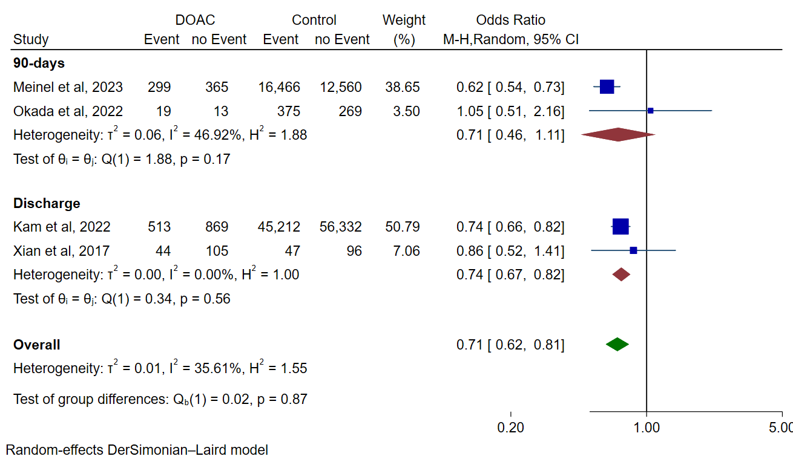

Supplementary Figure 1. Forest plot for meta-analysis of modified Rankin Score 0-2 in patients on DOACs vs. controls

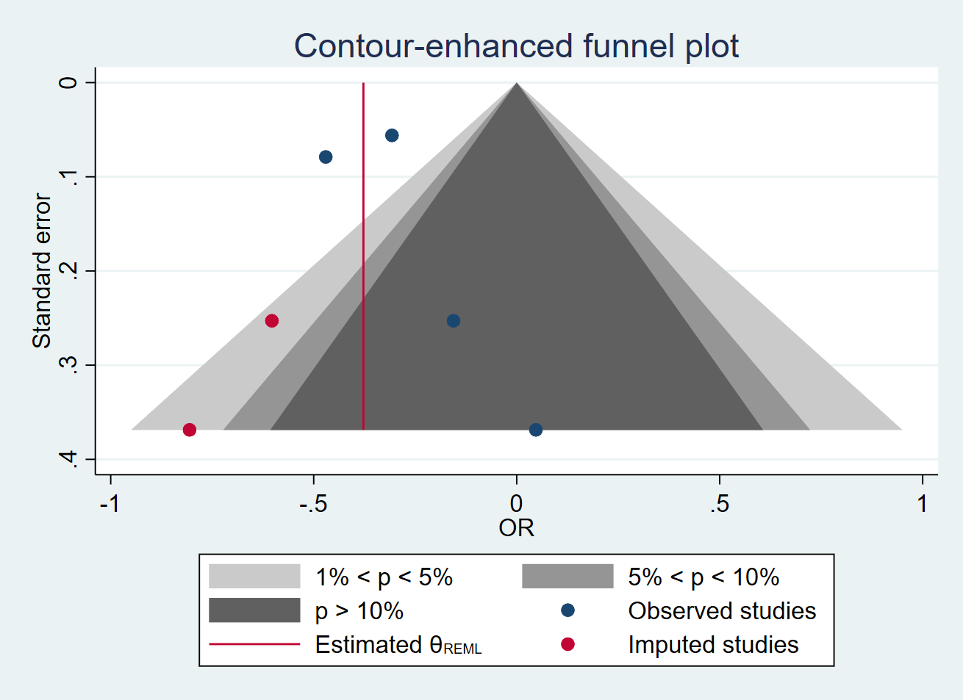

Supplementary Figure 2. Funnel plot for meta-analysis of modified Rankin Score 0-2 in patients on DOACs vs. controls

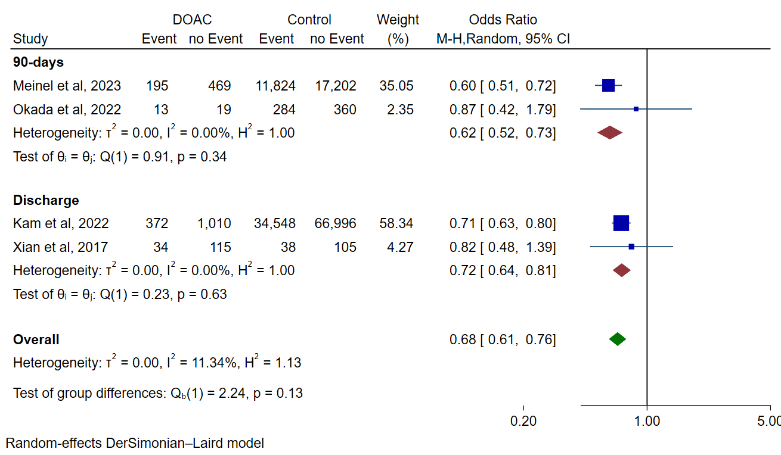

Supplementary Figure 3. Forest plot for meta-analysis of modified Rankin Score 0-1 in patients on DOACs vs. controls

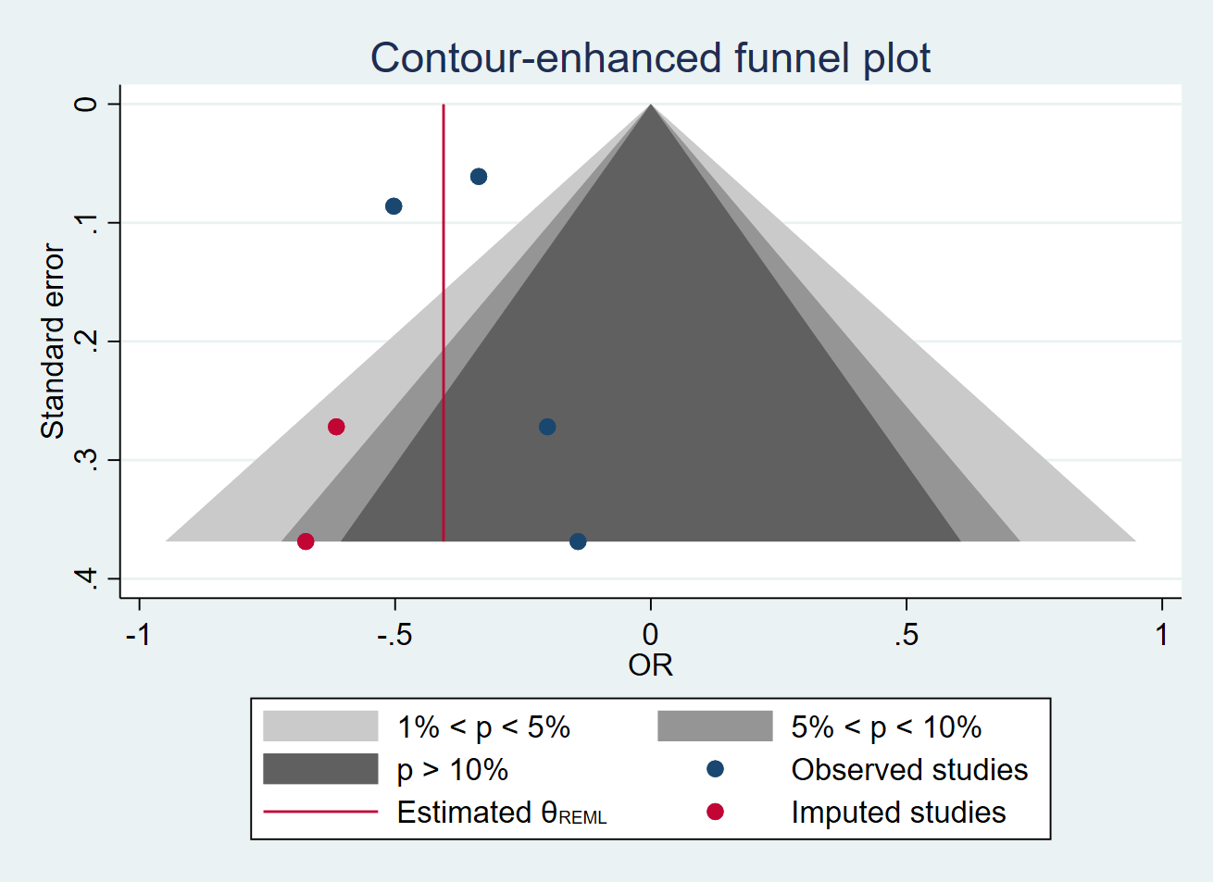

Supplementary Figure 4. Funnel plot for meta-analysis of modified Rankin Score 0-1 in patients on DOACs vs. controls

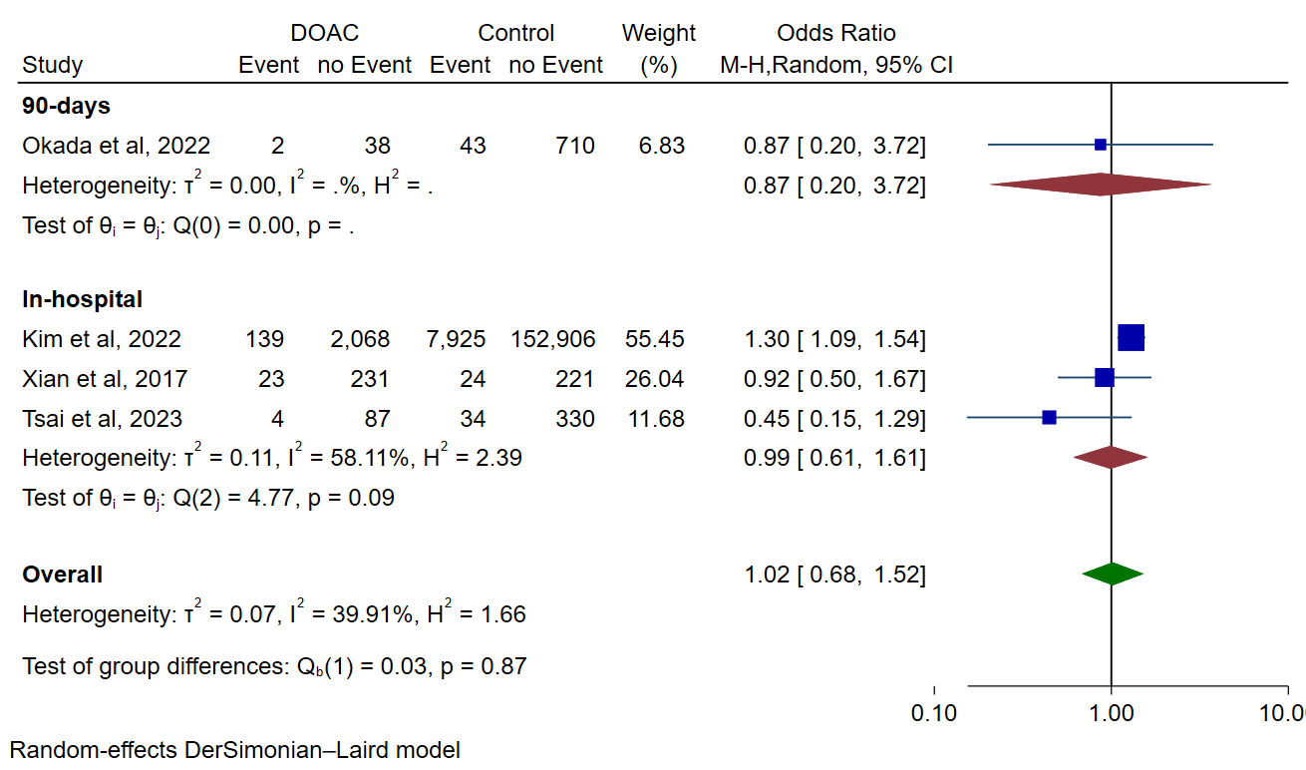

Supplementary Figure 5. Forest plot for meta-analysis of all-cause mortality in patients on DOACs vs. controls

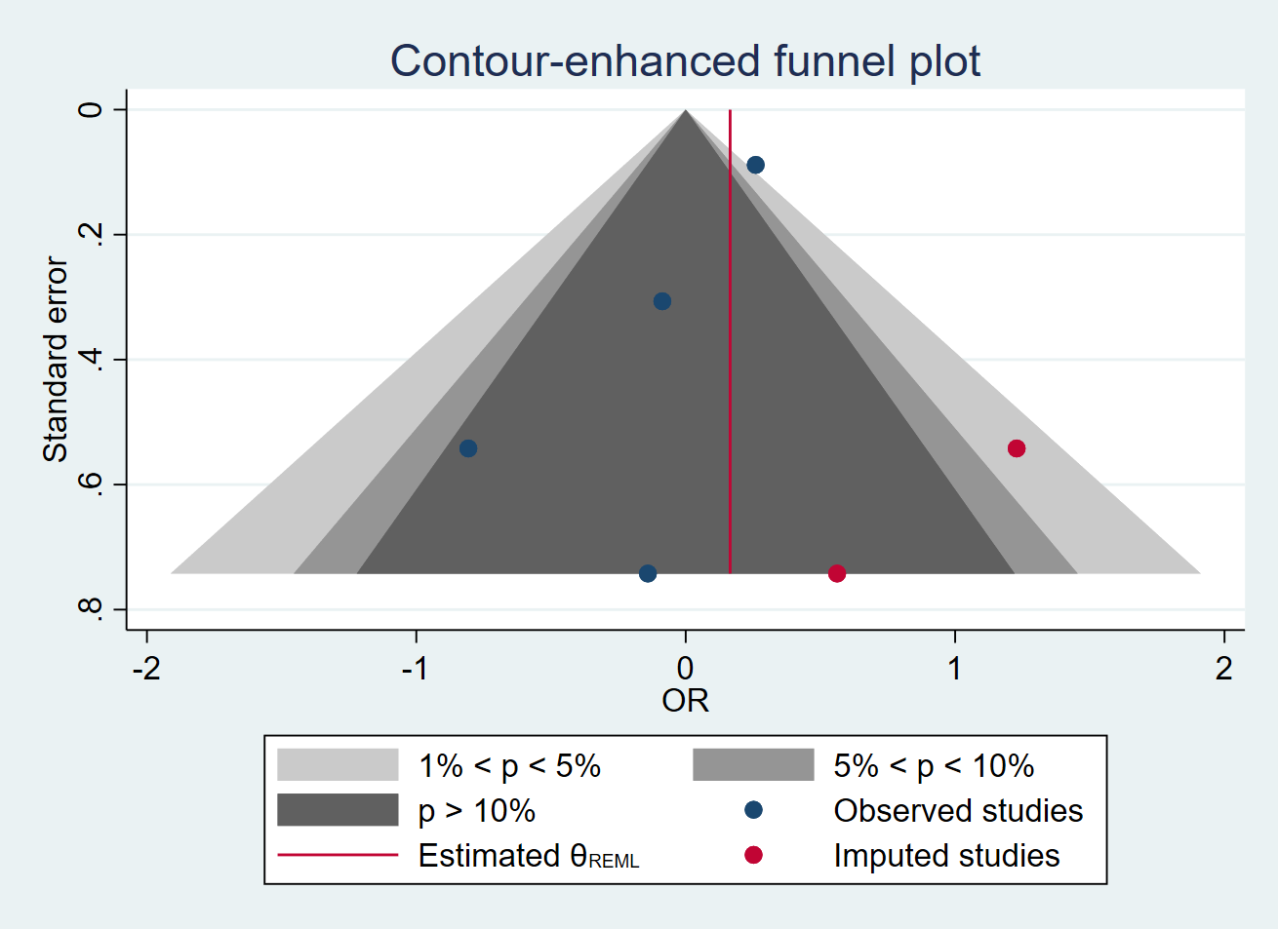

Supplementary Figure 6. Funnel plot for meta-analysis of all-cause mortality in patients on DOACs vs. controls

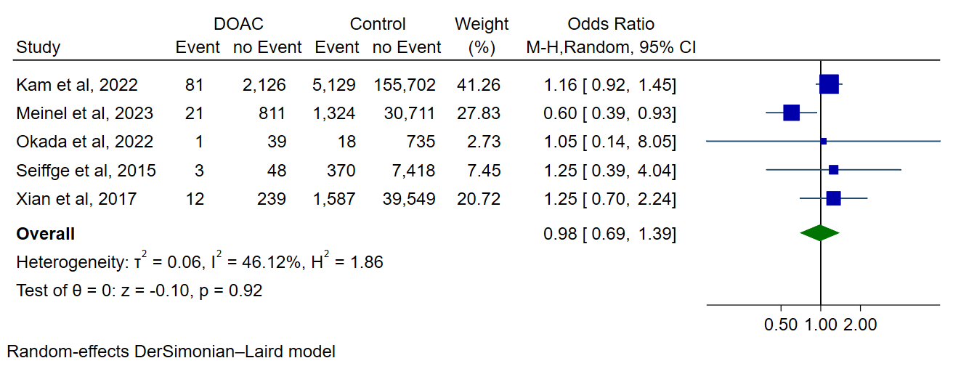

Supplementary Figure 7. Forest plot for meta-analysis of symptomatic ICH in patients on DOACs vs. controls

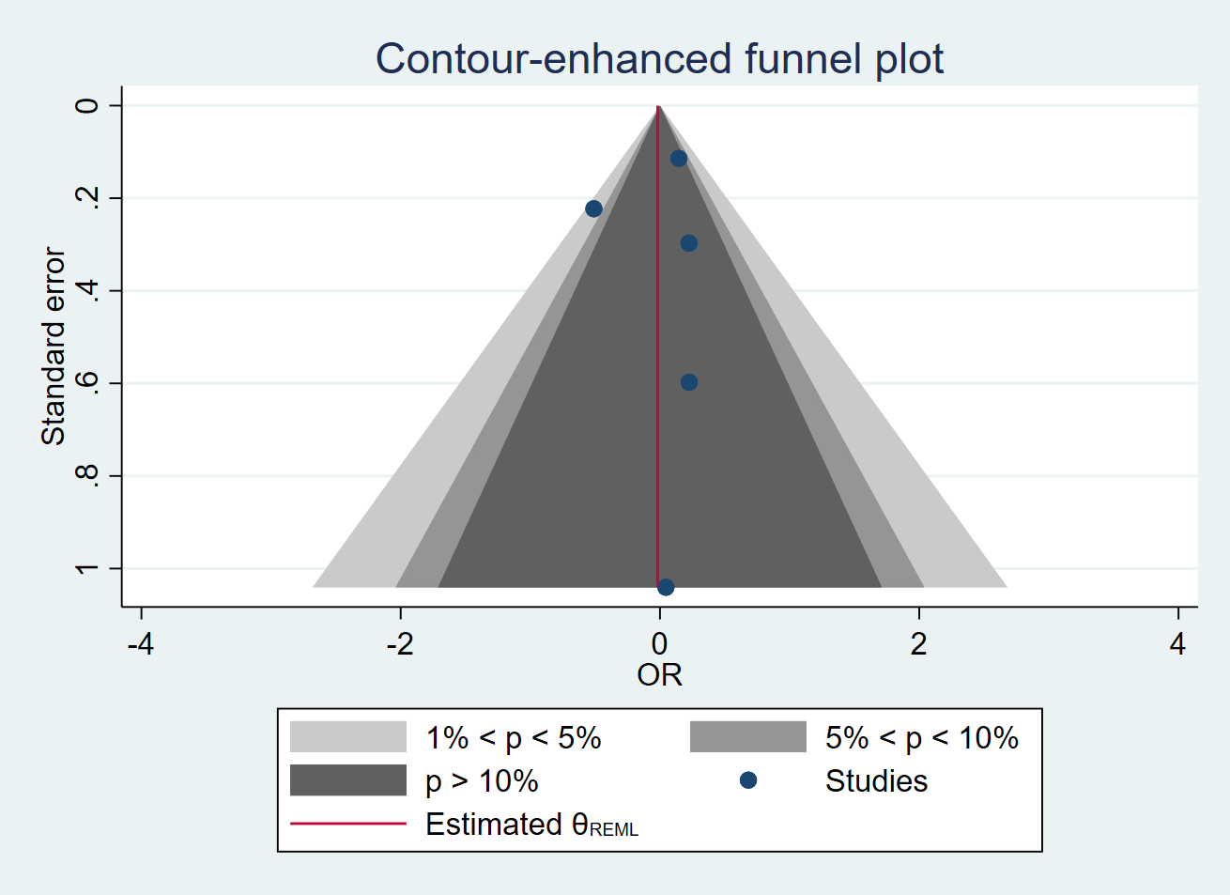

Supplementary Figure 8. Funnel plot for meta-analysis of symptomatic ICH in patients on DOACs vs. controls

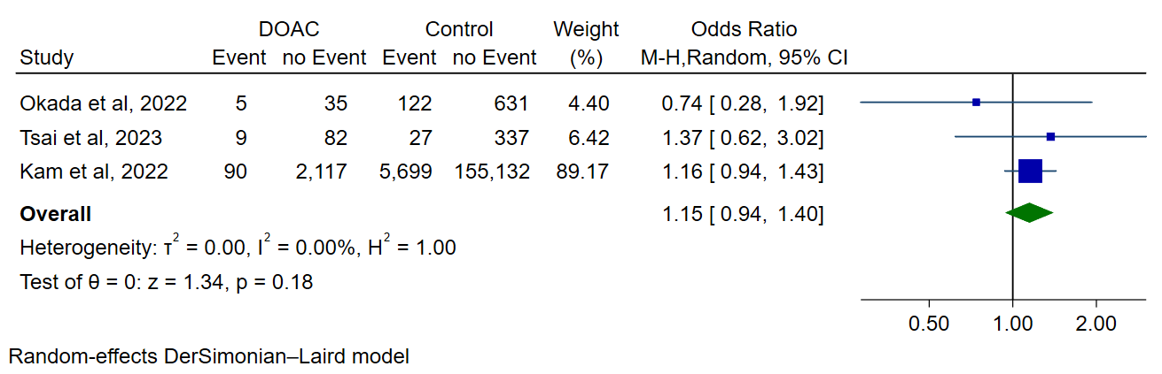

Supplementary Figure 9. Forest plot for meta-analysis of any ICH in patients on DOACs vs. controls

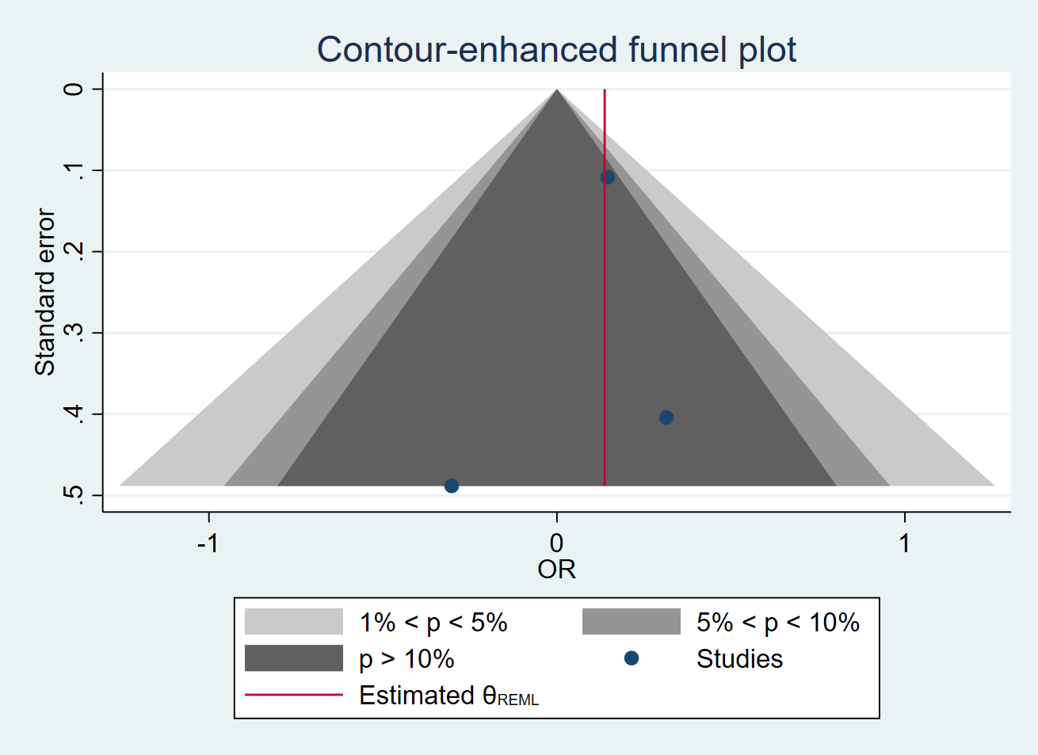

Supplementary Figure 10. Funnel plot for meta-analysis of symptomatic ICH in patients on DOACs vs. controls

