Supplementary Materials

Title: The SNP rs6859 in NECTIN2 gene is associated with underlying heterogenous trajectories of cognitive changes in older adults
Aravind Lathika Rajendrakumar¹, Konstantin G. Arbeev¶, Olivia Bagley¹, Anatoliy I. Yashin¹, Svetlana Ukraintseva¹, for the Alzheimer’s Disease Neuroimaging Initiative§
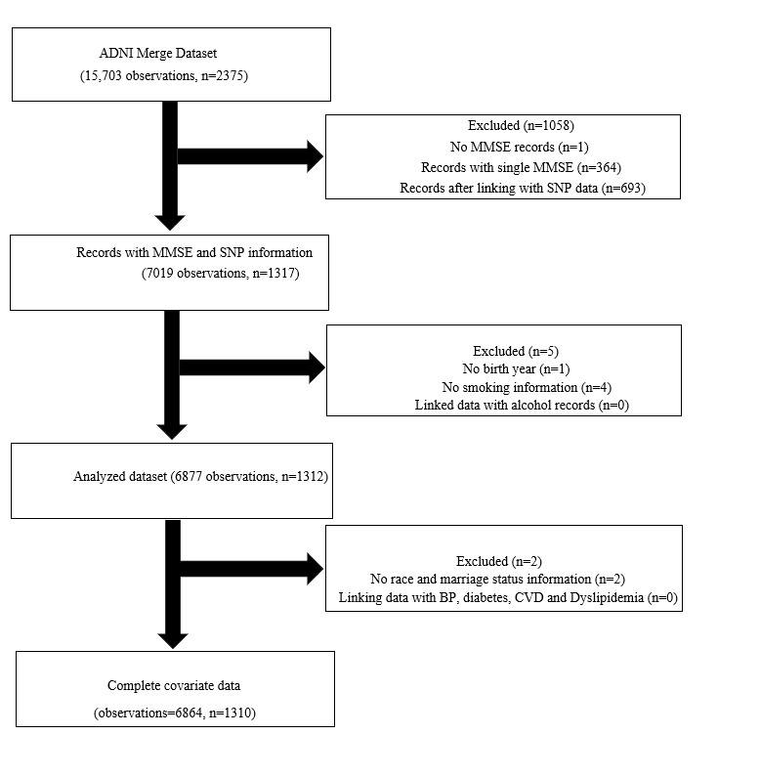
Supplementary Figure S1. Flow chart showing the sample selection for the association analysis

Supplementary Figure S2. Histogram showing the interval between adjacent MMSE measurements in the analyzed sample (observations=6864)

Supplementary Figure S3. Distribution of MMSE and normalized MMSE and their relationship in the analyzed sample in the cross-sectional analysis

Supplementary Figure S4. Class wise distribution of posterior probabilities from the latent class regression model

Supplementary Table S1. Participant characteristics in the analyzed sample from the ADNI cohort in the cross-sectional analysis
Characteristics | Mean (Frequency) | SD | Range
Age, years | 73.74 | 7.00 | 55.00 - 90.90
Sex, Male, n (%) | 723 (55.19%)
Education, years | 15.97 | 2.84 | 4-20
MMSE† | 25.00 | 21-28 | 0-30
Visits† | 4 | 3-6 | 2-16
Marriage Status
Ever | 1262 (96.33%)
Never | 48 (3.66%)
Race
White | 1219 (93.05%)
Black | 54 (4.12%)
Asian | 21 (1.60%)
Others | 16 (1.22%)
Smoking
Ever | 390 (29.77%)
Alcohol
Ever | 55 (4.19%)
SNP rs6859$$
GG | 347 (26.48%)
GA | 661 (50.45%)
AA | 302 (23.05%)
Hypertension, Yes, n (%) | 779 (59.46%)
Diabetes, Yes, n (%) | 140 (10.68%)
CVD, Yes, n (%) | 526 (40.15%)
Dyslipidemia, Yes, n (%) | 758 (57.86%)
Note. Data are presented as mean ± standard deviation (SD) or percentage (%) for continuous and categorical variables, respectively; †MMSE and Visits was presented as median and IQR due to skewed distribution. $$Allele frequencies of SNP rs6859 alleles in the sample.

Supplementary Table S2. Model selection parameters corresponding to the linear mixed models tested to determine the most informative model

Model | AIC | Deviance | p
Model 1 | 55939 | 55909
Model 2 | 55860 | 55830
Model 3 | 55854 | 55820 | <0.01**
Note. Model 1 adjusted for rs6859, age, sex, visits smoking, alcohol, hypertension, diabetes, CVD, dyslipidemia, and random effects (1+visit | participant ID). Model 2 adjusted for rs6859, age, sex, race, education, visits, hypertension, diabetes, CVD, dyslipidemia, and random effects (1+visit | participant ID). Model 3 adjusted for rs6859, age, sex, race, education, visits, smoking, marriage, hypertension, diabetes, CVD, dyslipidemia, and random effects (1+visit | participant ID). **p<0.01.

R code used for deriving model parameters from a homogenous mixed model and estimating covariate effects for the optimal 3 latent class model
## for replicability
set.seed (1234)
## homogenous mixed model
train=hlme(MMSE_norm~rs6959+Age+Gender+Education+Race+Visit+Smoking+Dyslipidemia_medication + Hypertension_medication +Diabetes_medication + CVD_medication, random=1+Visit | RID, subject= “RID”, data=mmse_valsorted_ordered)
## run the latent 3 class mixed model regression
test=hlme(MMSE_norm~rs6959+Age+Gender+Education+Race+Visit+Smoking+ Dyslipidemia_medication + Hypertension_medication+Diabetes_medication +CVD_medication, mixture =~rs6859, subject= “RID”, ng=3, maxiter=100000, B=train, data=mmse_valsorted_ordered, nwg=T)

