Table S1. Diagnostic codes used to identify analyzed comorbidities
Type of Comorbidity | Detail of Comorbidity | ICD-9 codes
Cardiovascular | Acute pulmonary heart diseases | 415-417
Cardiovascular | Chronic cardiac rheumatic disease | 393 - 398
Cardiovascular | Hypertensive Disease | 401-405
Cardiovascular | Ischemic Disease (AMI/AP) | 410-414
Cardiovascular | Other CV diseases | 420-429
Cardiovascular | Peripheral CV Disease | 440-449
Stroke | Stroke | 430-438
Digestive | Gastrointestinal diseases type 1 | 530 - 539, 569
Digestive | Gastrointestinal diseases type 2 | 555, 556, 558, 579
Metabolic | Dyslipidaemia | 272
Metabolic | Patients with 30Kg/m2 will be classified as obese* | 278.0, 278.00, 278.01
Metabolic | Diabetes (Type 1 / Type 2) | 250
Metabolic | Hypothyroidism | 244
Neurologic | Epilepsy | 345
Neuropsychiatric | Anxiety, Dissociative and Somatoform Disorders | 300
Neuropsychiatric | Bipolar Disorder | 296
Neuropsychiatric | Depression | 311
Neuropsychiatric | Drug abuse | 305
Neuropsychiatric | Drug dependency | 304
Neuropsychiatric | Other syndromes | 307 (*except 307.4)
Neuropsychiatric | Stress syndromes | 308
Neuropsychiatric | ADHD | 314
Pain | Chronic Pain, Fibromyalgia, Generalised Pain | 338.2, 338.4, 729.1, 780.96
Pain | Dorsopathies | 720-724
Pain | Chronic Fatigue Syndrome | 780.71
Pain | Disorders of the peripheral nervous system | 350-359, 729.2, 337.0, 337.1, 337.9
Pain | Osteoarthrosis and related disorders | 715
Pain | Temporomandibular joint disorders | 524.6
Respiratory | Asthma / COPD | 493
Respiratory | Sinusitis | 473
Rheumatologic | Arthritis | 714
Sleep | Organic Sleep disorders | 327
Sleep | Sleep disorders | 307.4
Sleep | Sleep disorders | 780

Table S2. List of pharmacologic treatments included in the analysis
Class of treatment | ATC code | Included molecules | Type of use
Ergot alkaloids | N02CA | Ergotamine, Dihydroergotamine | Acute
Antiemetics | A03F | Metoclopramide, Other Antiemetics (Alizaprida, Cinitapride…) | Acute
Benzodiazepines | N05BA | Diazepam, Other Benzodiazepines (Alprazolam, Lorazepam…) | Migraine associated
Antivertigo preparations | N07C | Flunarizine, Other Antivertig (Betahistine, Cinnarizine) | Preventive
Opioids | N02A | Morphine, Other Opioids (Codeine, Oxycodone…) | Acute
Serotonin agonists (Triptans) | N02CC | Almotritptan, Eletriptan, Frovatriptan, Naratriptan, Rizatriptan, Sumatriptan, Zolmitriptan | Acute
Calcitonin gene-related peptide antagonists | N02CD | Erenumab, Galcanezumab, Fremanezumab | Preventive
Analgesics | N02BA | AAS, Diflunisal, Etersalato, Fosfosal, Salicyloysalicylic acid | Acute
Analgesics | N02BB | Metamizol, Phenazone, Propyphenazone | Acute
Analgesics | N02BE | Paracetamol | Acute
Analgesics | N02BG | Clonixinato de Lisina , Nabiximols | Acute
Analgesics | B01AC91 | AAS | Acute
Analgesics | B01AC06 | AAS | Acute
Non-steroidal anti-inflammatory drugs (NSAIDs) | M01A | Ibuprofen, Naproxen, Dexketoprofen, Other NSAIDs (Acemetacin,Flurbiprofen, Glucosamine…) | Acute
Antiepileptics | N03A | Topiramate, Other Antiepileptic (Beclamide, Cannabidiolo, Valproic acid…) | Preventive
Antidepressants | N06A | Amitriptyline, Other Antidepressant (Agomelatine, Nortriptyline…) | Preventive
Beta blocking agents | C07A | Propranolol, Other Beta - Blockers (Acebutolol, Bisoprolol, Carvedilol…) | Preventive
Beta blocking agents | C07B | Beta blocking agents with Thiazides | Preventive
Beta blocking agents | C07C | Beta blocking agents with Diuretics | Preventive
Beta blocking agents | C07D | Beta blocking agents with Thiazides and Diuretics | Preventive
Beta blocking agents | C07EA | Other combinations | Preventive
Beta blocking agents | C07F | Other combinations | Preventive

Figure S1. Lines of therapy analysis definitions

Figure S2. Lines of therapy analysis per molecule: focus on triptan treatments
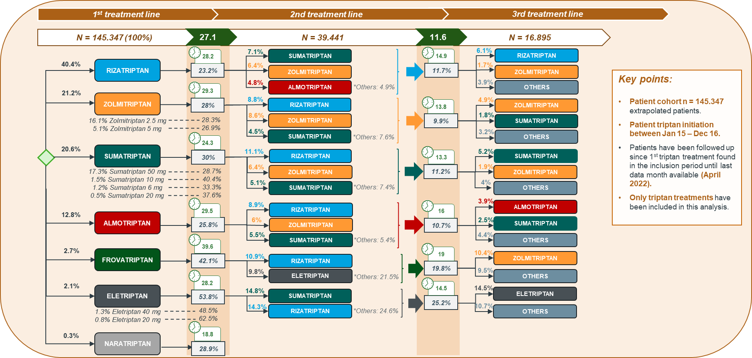

Figure S3. Lines of therapy analysis per molecule: focus on preventive treatments
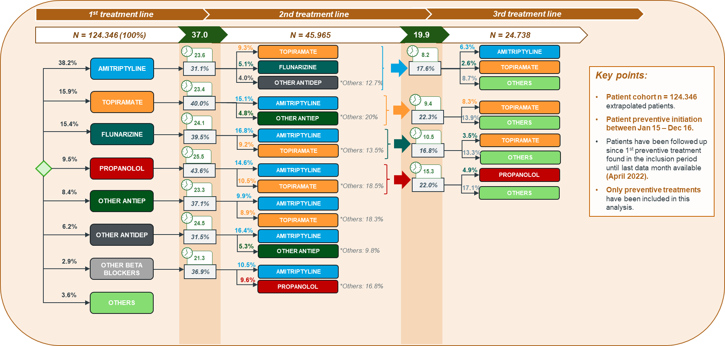

Figure S4. Detailed patient pathway: focus on triptan treatments
- All patients who initiated a triptan between January 2015 and December 2016
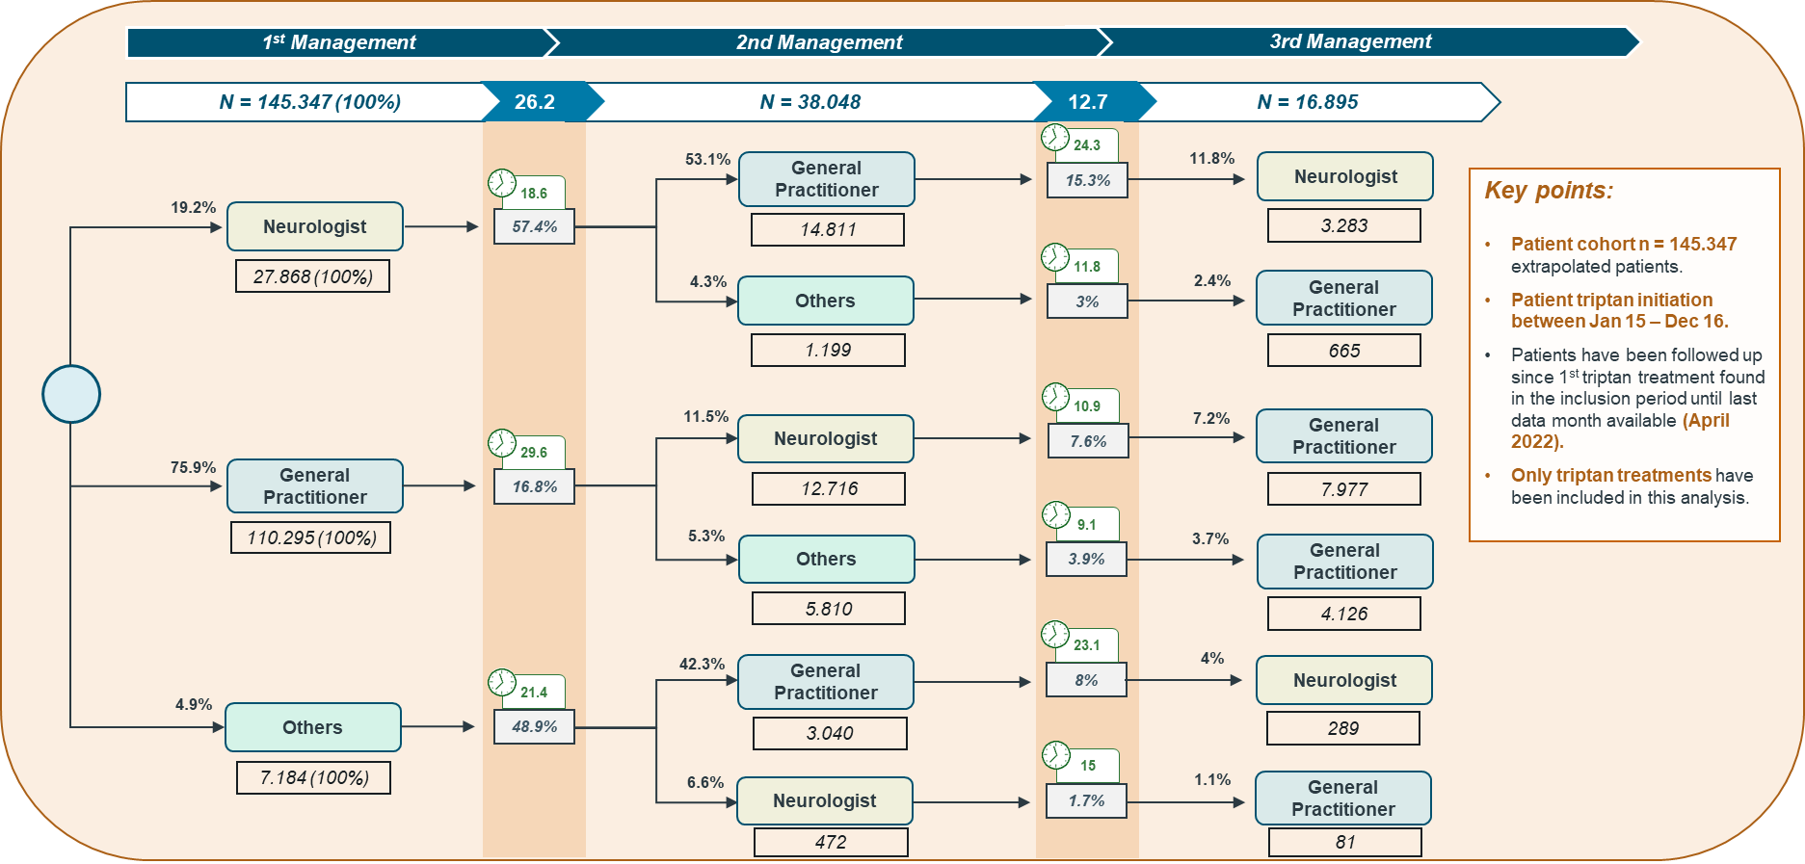

- Patients who initiated a triptan between January 2015 and December 2016 and with more than two different triptan molecules in their historical record
