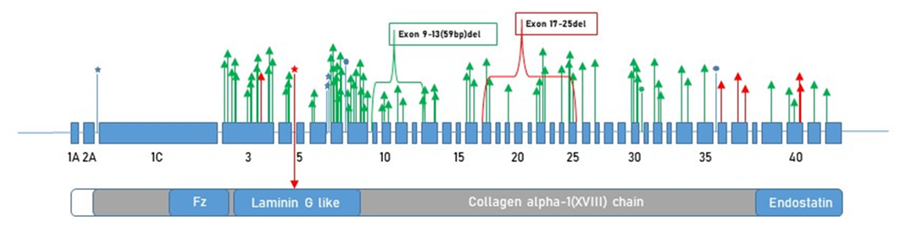
Figure: The systematic diagram illustrates the exons and domains of COL18A1, with variants highlighted:

Splice donor site variants.

A splice acceptor site variant identified in current study.

Splice acceptor site variants.

Epilepsy and associated conditions

Knobloch syndrome

