SUPPLEMENTARY FIGURES

Supplementary Figure 1. Potential adverse effects participants would like to avoid the most if prescribed a new medication for urinary problems (n=4460*)
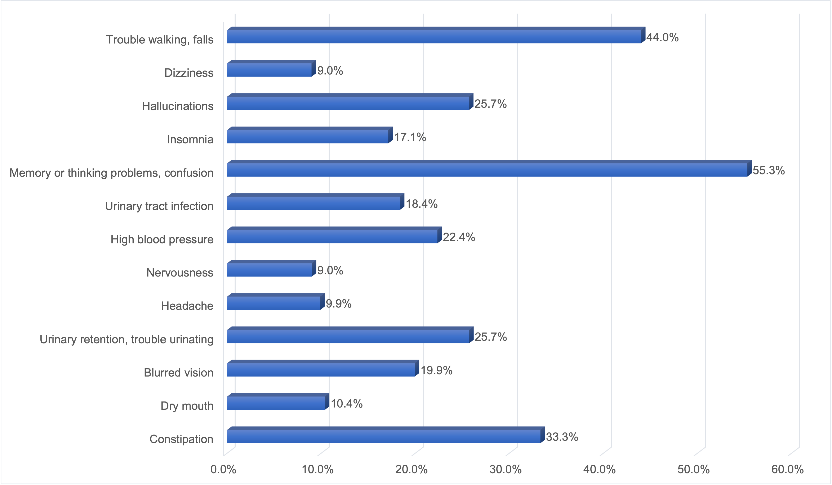
*485/4945 (9.81%) did not respond to this question
Supplementary Figure 2. Potential adverse effects participants would like to avoid the most if prescribed a new medication for mood (n=4413*)
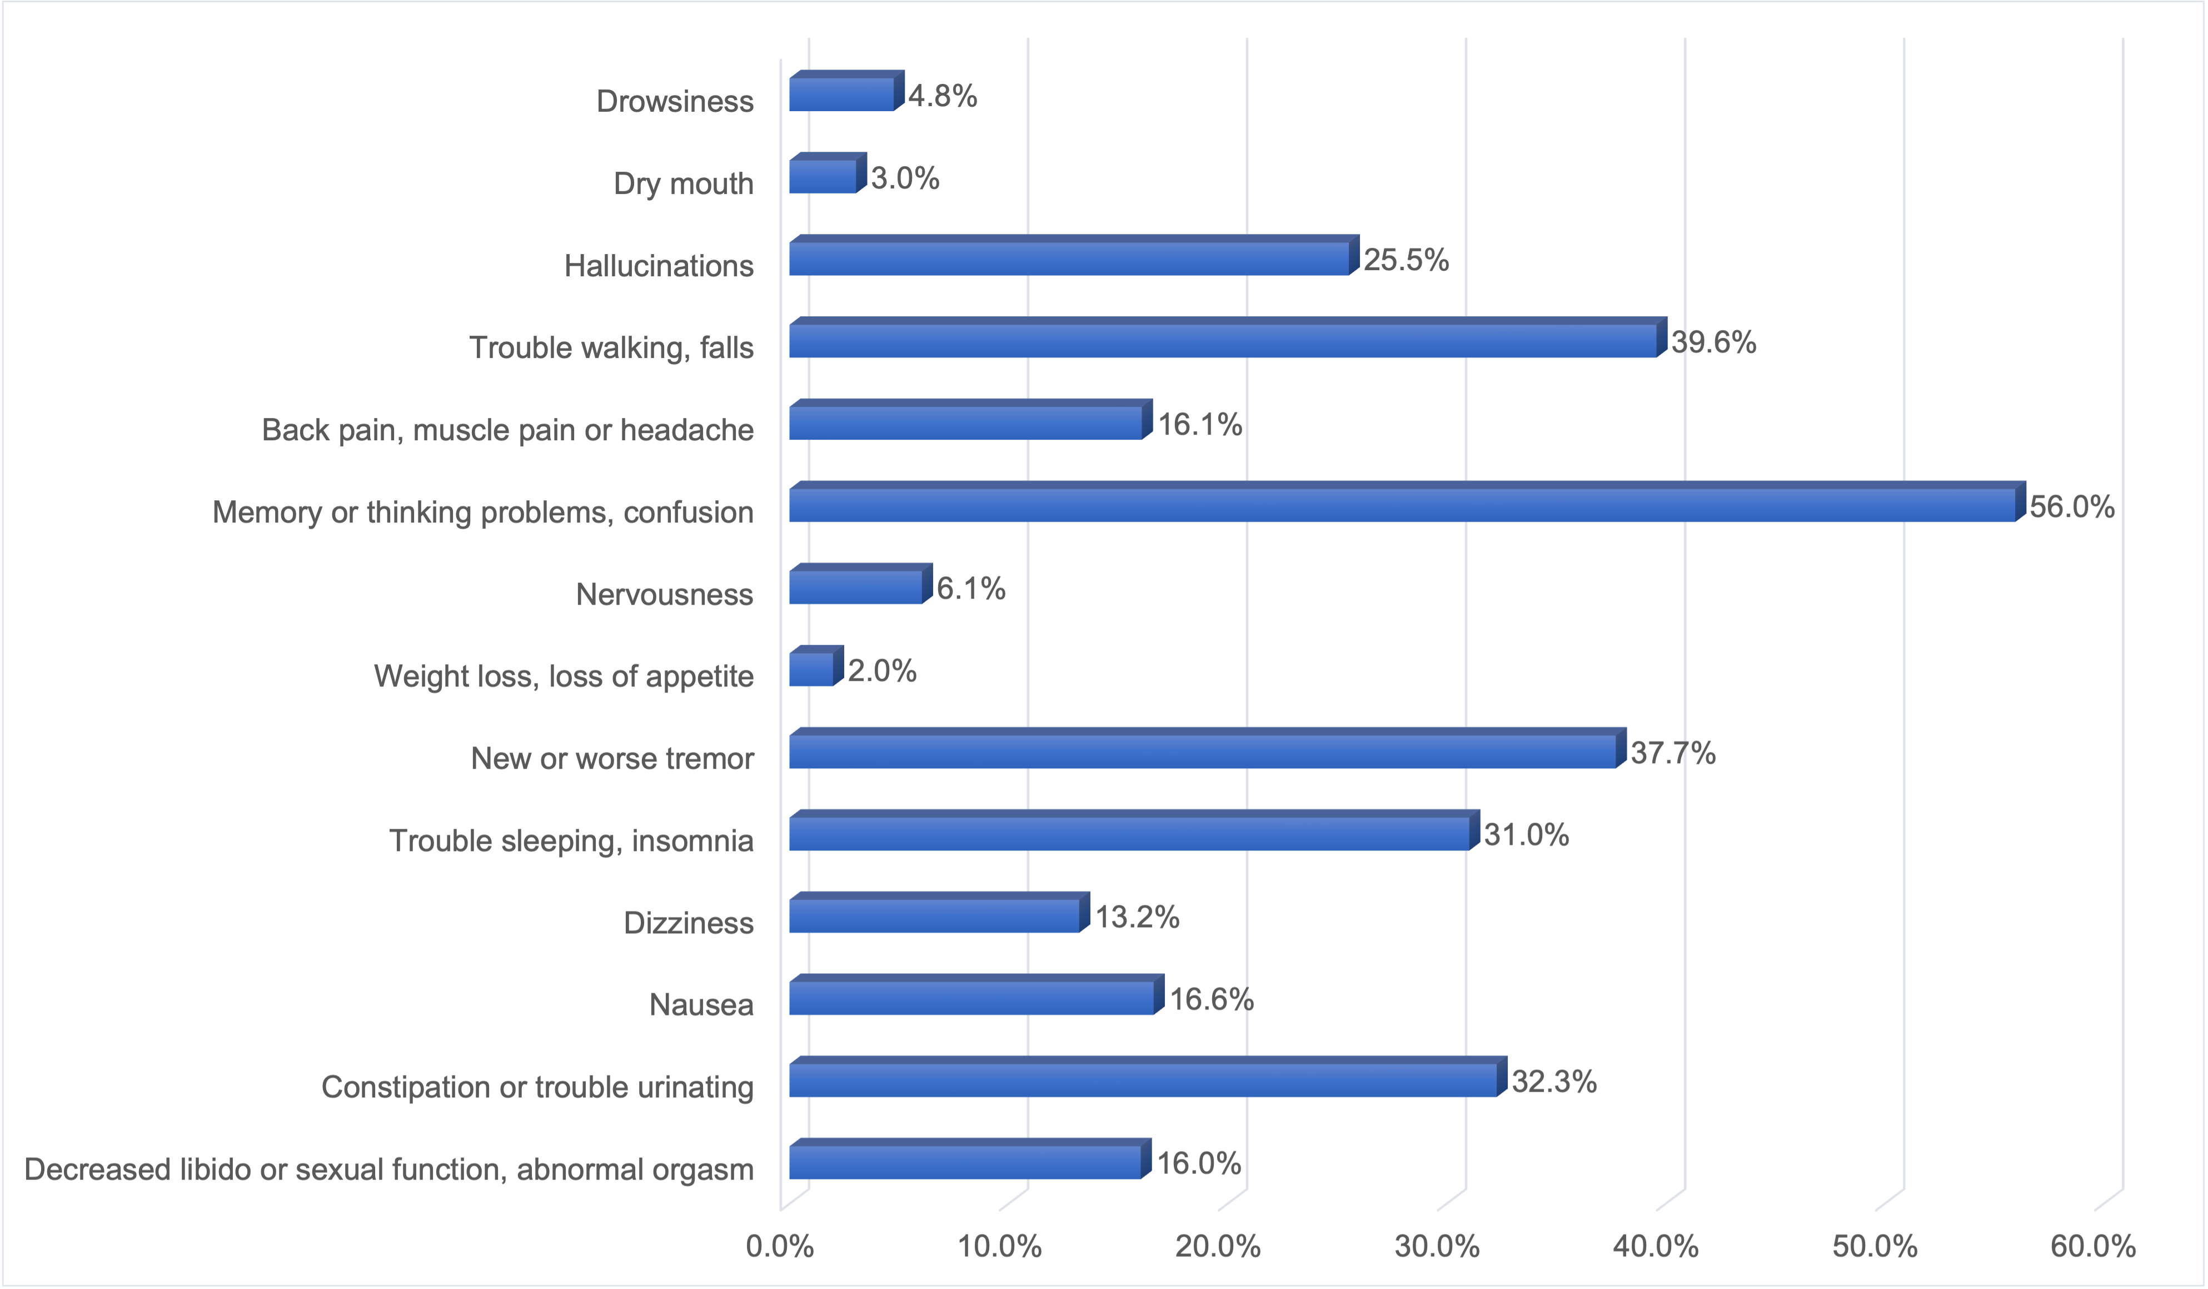
*532/4945 (10.76%) did not respond to this question

Supplementary Figure 3. Potential adverse effects participants would like to avoid the most if prescribed a new medication for hallucinations (n=4386*)
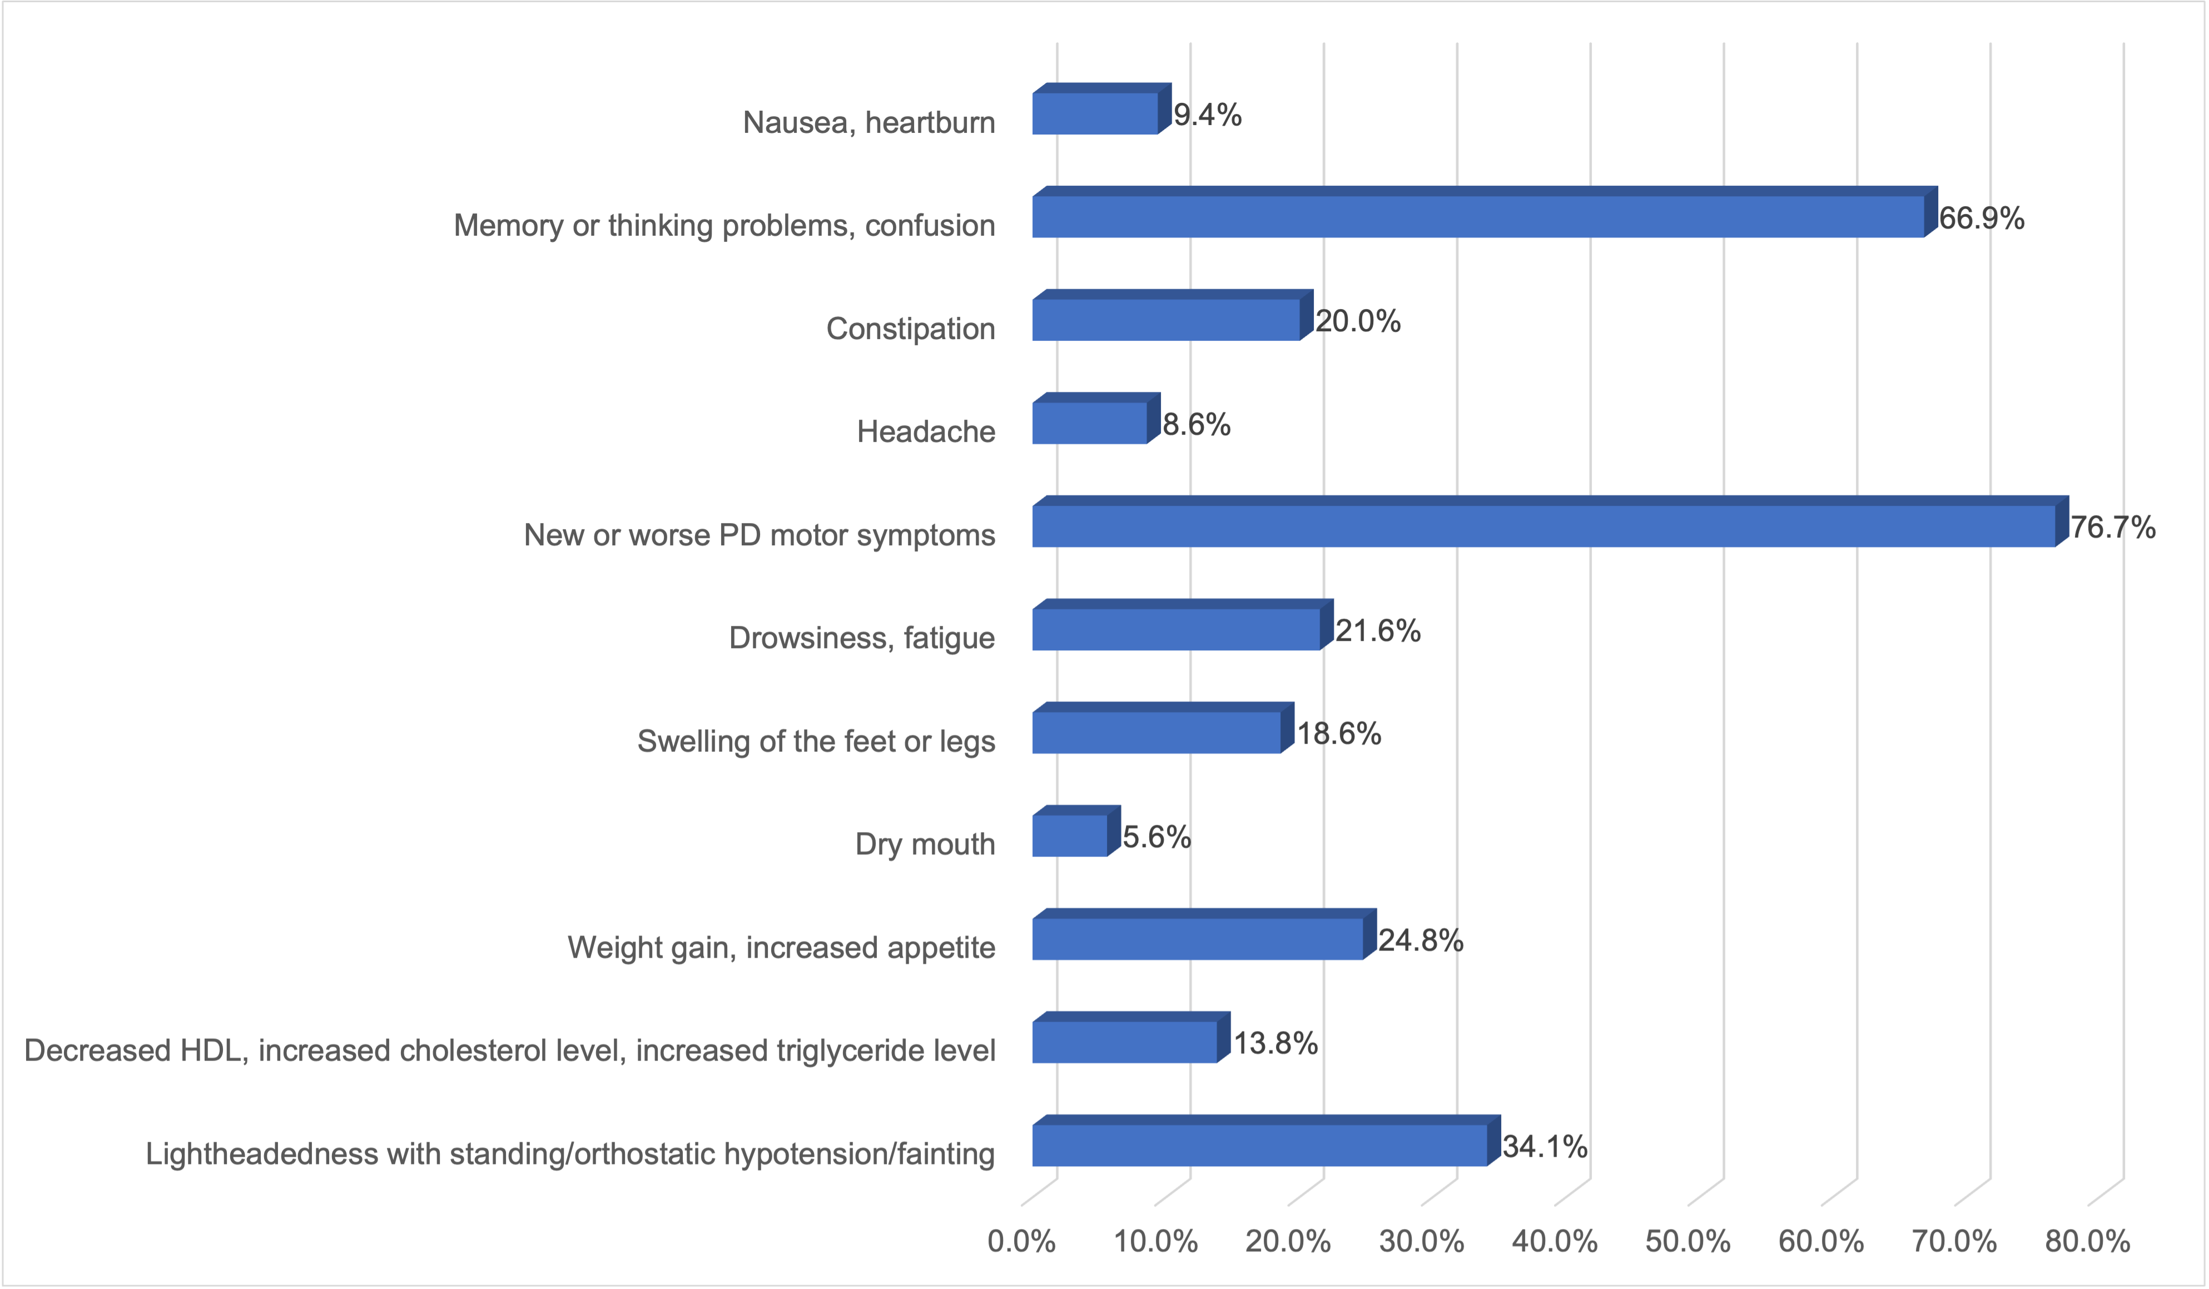
*559/4945 (11.30%) did not respond to this question

