A Systematic Review and Meta-Analysis Show a Decreasing Prevalence of Post-Stroke Infections
Aaron Awere-Duodu¹, Samuel Darkwah¹, Abdul-Halim Osman¹, Eric S. Donkor¹*

¹Department of Medical Microbiology, University of Ghana Medical School, Accra, Ghana

*Author to whom correspondence should be addressed; esampane-donkor@ug.edu.gh

Supplementary Materials
Table of Contents
Supplementary Table 1: Search Strategy
Supplementary Table 2: Characteristics of Included Studies
Supplementary Table 3: Sensitivity Analysis of Pooled Prevalence
Supplementary Table 4: STROBE Checklist Assessment of Included Studies
Supplementary Table 5: Main Reasons for Exclusion of Eligible Studies
Supplementary Figure 1: Funnel Plot for Publications on Post-Stroke Infections
Supplementary Figure 2: Continental Prevalence of Post-Stroke Infections
Supplementary Figure 3: Prevalences of post-stroke infections according to the World Bank Classification of countries.

Supplementary Table 1. Search Strategy
DATABASE | SEARCH PHRASE
SCOPUS | (stroke OR cerebral OR ischemic OR hemorrhagic) AND (infection OR infections OR post-stroke infection) AND (respiratory tract infection OR respiratory infection OR pneumonia) AND (urinary tract infection OR UTI OR urinary infection)
PubMed and Web of Science | (stroke OR cerebral OR ischemic OR hemorrhagic) AND (infection OR infections OR post-stroke infection) AND (respiratory tract infection OR respiratory infection OR pneumonia) AND (urinary tract infection OR UTI OR urinary infection) NOT REVIEW [Publication Type]

Supplementary Table 2. Characteristics of Included Studies
Study | Duration of Study | Study Design | Location | Age of Patients (years) | Type of Stroke | NIHSS (Mean or Median) | Post-Stroke Infections | Clinical Variables | Etiologic Agents | Prescribed Antibiotics
Adoukonou et al. | Jan 2013 – Dec 2019 | Retrospective | Benin | 16-97 | Ischemic, Hemorrhagic, Unspecified | 9.4 | Pneumonia, UTI | NA | NA | NA
Ahmed et al. 2022 | Dec 2019 – May 2021 | Prospective | India | 67.48±11.29 | Ischemic | 10.59 | Pneumonia, UTI | NA | NA | NA
Ahmed et al. | 2017 - 2019 | Prospective | United States | 18-≥80 | Ischemic | 6.7 | Pneumonia, UTI | Dysphagia (13.4%) | NA | NA
Akimoto et al. | Oct 2015 - Oct 2017 | Retrospective | Japan | 39-99 | Ischemic | 2 | Pneumonia | NA | Enterobacter aerogenes, methicillin-sensitive Staphylococcus aureus (MSSA), Klebsiella pneumoniae, Streptococcus agalactiae, Serratia marcescens, Stenotrophomonas maltophilia | Ampicillin/Sulbactam (57%), Cefmetazole (3%), Ceftriaxone (6%), Gentamicin (3%), Meropenem (11%), Sulfamethoxazole/Trimethoprim (3%), Tazobactam/Piperacillin (14%), Vancomycin (3%)
Ali et al. | Oct 2021 – Dec 2022 | Prospective | Pakistan | 36-99 | Ischemic, Hemorrhagic, Unspecified | NA | Pneumonia, UTI | NA | Staphylococcus aureus, Pseudomonas aeruginosa, K. pneumoniae, E. coli, S. agalactiae, S. pneumonia, Neisseria meningitidis | Ceftriaxone (79%), Piperacillin tazobactam (52%), Cefixime (48%), Meropenem (42%), Vancomycin (39%), Ciprofloxacin (10%), Levofloxacin (10%), Metronidazole (22%), Gentamicin (10%), Cefoperazone-sulbactum (4%), Amikacin (12%), Moxifloxacin (14%), Linezolid (2%), Co-amoxiclav (3.2%), Azithromycin (20%)
Ashour et al. | - | Prospective | Egypt | 62-77 | Ischemic | 8.23-17.06 | UTI | Urine retention (36.7%), Lowered consciousness (56.6%) | NA | NA
Bhowmik et al. | Jan 2011 – Feb 2013 | Prospective | Bangladesh | 30-90 | Unspecified | 9.1->14 | Pneumonia, UTI | NA | NA | NA
Biscetti et al. | Jan 2018 – Dec 2021 | Retrospective | Italy | ≥65 | Unspecified | NA | Pneumonia, UTI | NA | NA | NA
Boehme et al. | Jan 2013 – Dec 2013 | Retrospective | United States | ≥18 | Ischemic | NA | Pneumonia, UTI | NA | NA | NA
Boehme et al. 2013 | Jul 2008 – Dec 2010 | Retrospective | United States | 19-97 | Ischemic | 6-17 | Pneumonia, UTI | NA | NA | NA
Brogan et al. | 2010 | Retrospective | Australia | <60->80 | Ischemic, Hemorrhagic, Unspecified | NA | UTI | Dysphagia (61.5%), Urine incontinence (36%) | NA | NA
Chapman et al. | 2009 – 2013 | Retrospective | Australia | ≥18 | Ischemic, Hemorrhagic, Unspecified | NA | UTI | NA | NA | NA
Cisse et al. | Jan – Dec 2017 & Jan – Dec 2018 | Mixed | Guinea | 60±14.8 | Ischemic, Unspecified | 11 | UTI | NA | NA | NA
Di Carlo et al. | Nov 2012 – Feb 2013 | Prospective | Italy | 76 (65.9-82.9) | Ischemic, Hemorrhagic, Unspecified | NA | Pneumonia, UTI | Dysphagia (29.7%), Urine incontinence (10.8%) | NA | NA
Duan et al. | Aug 2015 – Jul 2019 | Retrospective | China | 66±12 | Ischemic | 3-4 | Pneumonia, UTI | NA | NA | NA
Erlebach et al. | Jul 2017 – Dec 2018 | Retrospective | Switzerland | 67-85 | Ischemic, Hemorrhagic | 2-3 | Pneumonia, UTI | NA | NA | NA
Fluck et al. 2023 | 2014 – 2016 | Retrospective | United Kingdom | 69.4-77.1 | Unspecified | ≥16 | Pneumonia, UTI | NA | NA | NA
Fluck et al. | 2014 – 2016 | Retrospective | United Kingdom | <70-≥80 | Unspecified | NA | Pneumonia, UTI | NA | NA | NA
Fluri et al. | Nov 2006 – Nov 2007 | Prospective | Switzerland | 70.5±14.1 | Unspecified | NA | Pneumonia, UTI | NA | NA | NA
Fry et al. | 2014 – 2016 | Retrospective | United Kingdom | 76.8±13.3 | Ischemic, Unspecified | NA | Pneumonia, UTI | NA | NA | NA
Gardener et al. | 2010 - 2013 | Retrospective | United States | ≥18 | Ischemic | NA | Pneumonia | NA | NA | NA
Gaspari et al. | Oct 2012 – Sep 2015 | Retrospective | Brazil | 64.1±13.7 | Ischemic | NA | Pneumonia, UTI | NA | NA | NA
Gu et al. | Aug 2015 – Jul 2019 | Prospective | China | 51-75 | Ischemic | NA | Pneumonia, UTI | NA | NA | NA
Han et al. | Jan 2014 – Feb 2016 | Retrospective | United Kingdom | 65-89 | Unspecified | NA | Pneumonia, UTI | NA | NA | NA
Han et al. (Pred) | Jan 2014 – Feb 2016 | Retrospective | United Kingdom | 60-92 | Unspecified | NA | Pneumonia, UTI | NA | NA | NA
Hasse et al. | Aug 2014 – Nov 2018 | Prospective | Germany | 74 (64-81) | Ischemic | 5 | Pneumonia | Dysphagia (34.08%) | NA | NA
Huang et al. | Apr 2012 – Jan 2016 | Retrospective | China | 62-78 | Ischemic | 4 | Pneumonia, UTI | NA | NA | NA
Huang et al. 2019 | 2002 – 2009 | Retrospective | Taiwan | 40-≥80 | Unspecified | NA | Pneumonia, UTI | NA | NA | NA
Ingeman et al. | Jan 2003 – Dec 2011 | Retrospective | Denmark | ≥18 | Unspecified | NA | Pneumonia, UTI | NA | NA | NA
Ji et al. | 2007 – 2008 | Prospective | China | 64.1±12.9 | Ischemic, Hemorrhagic | 5 | Pneumonia, UTI | NA | NA | NA
Jitpratoom and Boonyasiri 2 | Jul 2019 – Jul 2020 | Retrospective | Thailand | 65±15 | Ischemic | NA | Pneumonia | Dysphagia (2%) | K. pneumoniae (41.5%), MRSA (9.8-15.4%), Haemophilus influenzae (7.3%), Moraxella catarrhalis (2.4%), Carbapenem- resistant Acinetobacter baumannii (38.5%), Carbapenem- resistant K. pneumoniae (15.4%), Stenotrophomonas maltophilia (7.7%) | Piperacillin -tazobactam (27.8%), Ceftriaxone (27.8%), Ceftazidime (13%), Meropenem (3.7%)
Kasemsap et al. 2022 | Oct 2004 – Sep 2017 | Retrospective | Thailand | ≥18 | Ischemic, Hemorrhagic | NA | Pneumonia, UTI | NA | NA | NA
Kasemsap et al. | Oct 2015 – Aug 2016 | Retrospective | Thailand | 58 (67-75) | Ischemic | 8 | Pneumonia, UTI | NA | NA | NA
Kim et al. | Aug 2012 – June 2015 | Prospective | South Korea | 65.63±13.49 | Ischemic, Hemorrhagic | 4.89 | Pneumonia, UTI | NA | NA | NA
Kortazar-Zubizarreta et al. | Jan 2010 – Dec 2011 | Prospective | Spain | ≤55->80 | Ischemic | 10 | UTI | NA | NA | NA
Lan et al. | Aug 2018 – Jun 2019 | Retrospective | China | ≥18 | Ischemic | 2-7 | Pneumonia, UTI | Dysphagia (20.6%) | NA | NA
Leangpanich et al. | Jan 2014 – Oct 2018 | Retrospective | Thailand | ≤40-≥80 | Unspecified | NA | Pneumonia | NA | NA | NA
Lei et al. | Jan 2016 – Dec 2019 | Retrospective | China | 68.85±12.96 | Ischemic | 17.5 | UTI | NA | NA | NA
Li et al. | Jan 2018 – Jan 2020 | Retrospective | China | 26-92 | Ischemic | NA | UTI | NA | NA | NA
Liao et al. | 2000 - 2009 | Retrospective | Taiwan | 20-≥70 | Unspecified | NA | Pneumonia, UTI | NA | NA | NA
Lin et al. | Jan 2015 – Sep 2015 | Prospective | China | ≥18 | Ischemic | 4-8 | UTI | NA | NA | NA
Lu et al. | Aug 2015 – Jul 2019 | Retrospective | China | ≥18 | Hemorrhagic | 7.5-9.0 | Pneumonia, UTI | NA | NA | NA
Maier et al. | 2011 – 2017 | Retrospective | Germany | 72±13 | Unspecified | 15-17 | Pneumonia, UTI | Dysphagia (73.9%) | NA | NA
Maier et al. 2015 | 2011 – 2013 | Retrospective | Germany | 72±14 | Ischemic, Hemorrhagic | 8 | Pneumonia, UTI | NA | NA | NA
Mao et al. | Jan 2014 – Dec 2016 | Prospective | China | 72±10.8 | Ischemic | 5.6 | Pneumonia, UTI | Dysphagia | Streptococcus viridans (4.7%), Staphylococcus aureus (15%), Staphylococcus saprophyticus (1.9%), Staphylococcus hominis (1.9%), Staphylococcus epidermidis (0.9%), Klebsiella pneumoniae (31.8%), Pseudomonas aeruginosa (11.2%), Acinetobacter baumannii (16.8%), Lofel acinetobacter (3.7%) Haemophilus parainfluenza (1.9%), Escherichia coli (1.9%), Candida albicans (9.3%) | NA
Matz et al. | Jan 2003 – Dec 2013 | Retrospective | Austria | ≤55-≥80 | Ischemic | 3-14 | Pneumonia, UTI | NA | NA | NA
Melmed et al. | 2009 – 2018 | Retrospective | United States | 65±16 | Hemorrhagic | NA | Pneumonia, UTI | NA | NA | NA
Mezuki et al. | Jul 2007 – Sep 2019 | Retrospective | Japan | 70.6±12.3 | Ischemic | 0-3 | UTI | NA | NA | NA
Milosevich et al. | Jan 2015 – Sep 2019 | Prospective | United Kingdom | 73.9±12.6 | Ischemic, Hemorrhagic, Mixed | 5 | Pneumonia, UTI | Dysphagia (40.4%), Urine incontinence (10.6%) | NA | NA
Morotti et al. | 1994 – 2015 | Retrospective | United States | 74 (64-82) | Hemorrhagic | NA | Pneumonia, UTI | NA | NA | NA
Muscari et al. | Jan 2011 – Dec 2015 | Retrospective | Italy | 73.7±13.1 | Ischemic, Hemorrhagic | 6-12 | Pneumonia, UTI | NA | NA | NA
Nazir et al. | Jan – Dec 2019 | Prospective | Pakistan | ≥70 | Ischemic, Hemorrhagic | NA | UTI | NA | NA | NA
Odiase and Lofor | Jul 2018 – Jun 2022 | Retrospective | Nigeria | 45-95 | Ischemic, Hemorrhagic | NA | UTI | NA | Enterococcus faecalis (18.5%), Klebsiella oxotyca (12.9%), Proteus mirabilis (12.9%), Staphylococcus aureus (11.5%), Escherichia coli (11.2%), Enterobacter aerogenes (9.3%), Klebsiella pneumoniae (8.5%), Citobacter freundii (6.8%), Proteus vulgaris (6.6%), Candida albicans (1.7%) | NA
Ornello et al. | Mar 2020 – Feb 2021 & Mar 2019 – Feb 2020 | Retrospective | Italy | >18 | Ischemic Hemorrhagic | NA | Pneumonia, UTI | NA | NA | NA
Panda et al. | Oct 2021 – Mar 2023 | Retrospective | India | 57.1±15.7 | Ischemic, Hemorrhagic | 10 | Pneumonia, UTI | Dysphagia (85.2%) | NA | NA
Rofes et al. | May 2010 – Sep 2014 | Prospective | Spain | 73.2±13.3 | Ischemic, Hemorrhagic, Unspecified | 3 | UTI | NA | NA | NA
Rumalla and Mittal | 2002 – 2011 | Retrospective | United States | ≥18 | Ischemic | NA | Pneumonia, UTI | NA | NA | NA
Sawczynska et al. | Aug – Dec 2020 | Retrospective | Poland | 49-97 | Unspecified | NA | Pneumonia, UTI | NA | NA | NA
Seystahl et al. | 2014 – 2016 | Retrospective | Switzerland | 19-100 | Ischemic | 5-6 | Pneumonia, UTI | Dysphagia (84.8%), Urine retention (76.6) | NA | NA
Stenzelius et al. | Jun 2012 – Jun 2013 | Prospective | Sweden | ≥18 | Unspecified | NA | Pneumonia, UTI | Urine retention | NA | NA
Stösser et al. | 2016 – 2020 | Retrospective | Germany | 80 (71-86) | Ischemic | 10 | Pneumonia, UTI | NA | NA | NA
Stösser et al. 2022 | Jun 2016 – Dec 2019 | Retrospective | Germany | ≥18 | Unspecified | 13-14 | Pneumonia, UTI | Dysphagia (48.1%) | NA | NA
Sung et al. | 2010 – 2017 | Retrospective | Taiwan | 20-≥80 | Unspecified |  | Pneumonia, UTI | NA | NA | NA
Szylińska et al. | Jun 2015 – Mar 2018 | Retrospective | Poland | 72.08±12.32 | Ischemic | 11.22-12.72 | Pneumonia, UTI | NA | NA | NA
Tornes et al. | Oct 2009 – Sep 2011 | Prospective | United Kingdom | ≥18 | Unspecified | NA | Pneumonia, UTI | NA | NA | NA
Tworek et al. | Jun 2016 – Jun 2017 | Prospective | Poland | 40-96 | Ischemic | 8-10 | Pneumonia, UTI | NA | NA | NA
Vahdati et al. | Mar 2019 – Mar 2020 | Retrospective | Iran | ≤55-≥80 | Ischemic, Hemorrhagic, Unspecified | NA | Pneumonia, UTI | NA | NA | NA
van Gemmeren et al. | 2015 – 2017 | Prospective | Germany | ≥18 | Ischemic | 5-11 | UTI | Dysphagia, Urine retention, Lowered consciousness | NA | NA
Wei et al. | Aug 2015 – Jul 2019 | Retrospective | China | 66 (59-74) | Ischemic | 3 | Pneumonia, UTI | NA | NA | NA
Westendorp et al. | Jul 2010 – Mar 2014 | Prospective | Netherlands | ≤60-≥80 | Ischemic, Hemorrhagic | 5 | Pneumonia, UTI | Dysphagia (26.3%), Urine retention (17.9%) | NA | NA
Xu et al. | Aug 2015 – Jul 2019 | Retrospective | China | 67 (58-75) | Ischemic | 3-7 | Pneumonia, UTI | NA | NA | NA
Youkee et al. | May 2019 – Apr 2020 | Prospective | Sierra Leone | 59.2±13.8 | Ischemic, Hemorrhagic, Unspecified | 17 | Pneumonia, UTI | Dysphagia (0.8%) | NA | NA
Zhao et al. | Aug 2015 – Jul 2018 | Retrospective | China | 67.9±11.6 | Unspecified | 3.4-5.2 | Pneumonia, UTI | NA | NA | NA

Supplementary Table 3. Sensitivity Analysis of Pooled Prevalence
Excluded Study | Prevalence (%) | Lower CI | Upper CI
Adoukonou et al. | 9.14 | 8.23 | 10.10
Di Carlo et al. | 9.15 | 8.23 | 10.11
Ji et al. | 9.10 | 8.19 | 10.06
Kim et al. | 9.16 | 8.24 | 10.12
Lu et al. | 9.07 | 8.16 | 10.02
Melmed et al. | 9.07 | 8.16 | 10.03
Morotti et al. | 9.09 | 8.18 | 10.05
Panda et al. | 9.05 | 8.14 | 10.01
Youkee et al. | 9.10 | 8.18 | 10.05
Adoukonou et al. | 9.15 | 8.23 | 10.11
Di Carlo et al. | 9.14 | 8.23 | 10.10
Ji et al. | 9.17 | 8.25 | 10.13
Kim et al. | 9.17 | 8.25 | 10.13
Lu et al. | 9.20 | 8.28 | 10.16
Melmed et al. | 9.08 | 8.17 | 10.04
Morotti et al. | 9.11 | 8.20 | 10.07
Panda et al. | 9.12 | 8.21 | 10.08
Youkee et al. | 9.14 | 8.23 | 10.10
Melmed et al. | 9.17 | 8.25 | 10.13
Morotti et al. | 9.19 | 8.27 | 10.15
Adoukonou et al. | 9.14 | 8.22 | 10.09
Ahmed et al. 2023 | 9.20 | 8.22 | 10.23
Boehme et al. | 9.20 | 8.27 | 10.16
Boehme et al. | 9.18 | 8.26 | 10.15
Boehme et al. 2013 | 9.15 | 8.23 | 10.11
Di Carlo et al. | 9.15 | 8.23 | 10.11
Duan et al. | 9.15 | 8.22 | 10.12
Gardener et al. | 9.15 | 8.23 | 10.11
Gu et al. | 9.15 | 8.22 | 10.11
Ahmed et al. 2022 | 9.16 | 8.25 | 10.12
Huang et al. | 9.13 | 8.21 | 10.09
Ingeman et al. | 9.15 | 8.23 | 10.11
Ji et al. | 9.13 | 8.21 | 10.09
Jitpratoom and Boonyasiri 2 | 9.11 | 8.19 | 10.07
Kasemsap et al. | 9.08 | 8.17 | 10.04
Kim et al. | 9.19 | 8.27 | 10.15
Lan et al. | 9.12 | 8.20 | 10.07
Matz et al. | 9.17 | 8.25 | 10.13
Panda et al. | 9.16 | 8.24 | 10.12
Seystahl et al. | 9.14 | 8.23 | 10.10
Youkee et al. | 9.09 | 8.17 | 10.04
Stösser et al. | 8.99 | 8.08 | 9.95
Zhao et al. | 9.16 | 8.24 | 10.12
Xu et al. | 9.15 | 8.22 | 10.12
Xu et al. | 9.17 | 8.25 | 10.13
Szylińska et al. | 9.08 | 8.16 | 10.04
Tworek et al. | 9.12 | 8.21 | 10.08
Mao et al. | 9.03 | 8.12 | 9.98
Rumalla and Mittal | 9.20 | 8.22 | 10.22
Adoukonou et al. | 9.13 | 8.21 | 10.09
Ahmed et al. 2023 | 9.11 | 8.28 | 10.01
Akimoto et al. | 9.15 | 8.23 | 10.11
Boehme et al. | 9.13 | 8.22 | 10.10
Boehme et al. | 9.13 | 8.21 | 10.09
Boehme et al. 2013 | 9.11 | 8.20 | 10.07
Cisse et al. | 9.16 | 8.24 | 10.12
Di Carlo et al. | 9.14 | 8.23 | 10.10
Duan et al. | 9.21 | 8.30 | 10.17
Gu et al. | 9.21 | 8.29 | 10.17
Hasse et al. | 9.15 | 8.23 | 10.11
Ahmed et al. 2022 | 9.19 | 8.27 | 10.15
Huang et al. | 9.14 | 8.23 | 10.10
Ingeman et al. | 9.12 | 8.21 | 10.08
Ji et al. | 9.19 | 8.27 | 10.15
Jitpratoom and Boonyasiri 2 | 9.14 | 8.23 | 10.10
Kasemsap et al. | 9.17 | 8.25 | 10.13
Kim et al. | 9.20 | 8.28 | 10.16
Kortazar-Zubizarreta et al. | 9.19 | 8.27 | 10.15
Lan et al. | 9.17 | 8.26 | 10.14
Li et al. | 9.17 | 8.26 | 10.14
Matz et al. | 9.18 | 8.26 | 10.14
Mezuki et al. | 9.18 | 8.26 | 10.15
Ashour et al. | 9.12 | 8.20 | 10.07
Panda et al. | 9.16 | 8.24 | 10.12
Seystahl et al. | 9.16 | 8.24 | 10.12
Youkee et al. | 9.14 | 8.22 | 10.10
Stösser et al. | 9.01 | 8.10 | 9.96
Zhao et al. | 9.17 | 8.25 | 10.13
Xu et al. | 9.21 | 8.30 | 10.17
Xu et al. | 9.21 | 8.29 | 10.17
van Gemmeren et al | 9.15 | 8.23 | 10.11
Szylińska et al. | 9.16 | 8.24 | 10.12
Tworek et al. | 9.07 | 8.16 | 10.03
Lei et al. | 9.16 | 8.24 | 10.12
Lin et al. | 9.18 | 8.26 | 10.14
Mao et al | 9.18 | 8.26 | 10.14
Rumalla and Mittal | 9.11 | 8.24 | 10.02
Boehme et al. 2013 | 9.16 | 8.25 | 10.13
Rumalla and Mittal | 9.20 | 8.34 | 10.09
Seystahl et al. | 9.21 | 8.29 | 10.17
Mao et al. | 9.19 | 8.27 | 10.15
Matz et al. | 9.23 | 8.31 | 10.19
Boehme et al. | 9.21 | 8.30 | 10.17
Kasemsap et al. | 9.18 | 8.26 | 10.14
Mezuki et al. | 9.23 | 8.31 | 10.19
van Gemmeren et al. | 9.20 | 8.28 | 10.16
Mao et al. | 9.20 | 8.28 | 10.16
Adoukonou et al. | 9.15 | 8.24 | 10.11
Ali et al. | 9.02 | 8.11 | 9.97
Bhowmik et al. | 9.15 | 8.23 | 10.10
Biscetti et al. | 9.11 | 8.19 | 10.07
Cisse et al. | 9.14 | 8.23 | 10.10
Erlebach et al. | 9.15 | 8.23 | 10.11
Fluck et al. 2023 | 9.13 | 8.21 | 10.09
Fluck et al. | 9.13 | 8.22 | 10.09
Fry et al. | 9.13 | 8.21 | 10.09
Gaspari et al. | 9.12 | 8.20 | 10.08
Han et al. | 9.13 | 8.21 | 10.09
Han et al. (Pred) | 9.15 | 8.23 | 10.11
Huang et al. 2019 | 9.14 | 8.23 | 10.10
Leangpanich et al. | 9.04 | 8.13 | 10.00
Liao et al. | 9.16 | 8.24 | 10.13
Maier et al. | 9.06 | 8.15 | 10.02
Maier et al. 2015 | 9.02 | 8.11 | 9.98
Ingeman et al. | 9.15 | 8.23 | 10.11
Milosevich et al. | 9.10 | 8.18 | 10.06
Muscari et al. | 9.17 | 8.25 | 10.13
Ornello et al. | 9.16 | 8.24 | 10.12
Ornello et al. | 9.19 | 8.27 | 10.15
Sawczynska et al. | 9.07 | 8.16 | 10.03
Youkee et al. | 9.03 | 8.12 | 9.98
Stösser et al. 2022 | 9.04 | 8.13 | 10.00
Sung et al. | 9.15 | 8.23 | 10.11
Westendorp et al. | 9.16 | 8.24 | 10.12
Wei et al. | 9.14 | 8.22 | 10.10
Tornes et al. | 9.13 | 8.22 | 10.09
Vahdati et al. | 9.11 | 8.20 | 10.07
Fluri et al | 9.17 | 8.25 | 10.13
Kasemsap et al. 2022 | 9.13 | 8.21 | 10.09
Stenzelius et al. | 9.09 | 8.18 | 10.05
Adoukonou et al. | 9.18 | 8.26 | 10.14
Ali et al. | 9.08 | 8.17 | 10.04
Bhowmik et al. | 9.15 | 8.23 | 10.11
Biscetti et al. | 9.12 | 8.20 | 10.07
Cisse et al. | 9.19 | 8.27 | 10.15
Erlebach et al. | 9.17 | 8.25 | 10.13
Fluck et al. 2023 | 9.15 | 8.24 | 10.11
Fluck et al. | 9.11 | 8.20 | 10.07
Fry et al. | 9.15 | 8.24 | 10.11
Gaspari et al. | 9.17 | 8.25 | 10.13
Han et al. | 9.13 | 8.21 | 10.09
Han et al. (Pred) | 9.15 | 8.24 | 10.12
Huang et al. 2019 | 9.12 | 8.20 | 10.08
Liao et al. | 9.15 | 8.23 | 10.11
Maier et al. | 9.07 | 8.16 | 10.03
Maier et al. 2015 | 9.11 | 8.19 | 10.07
Ingeman et al. | 9.12 | 8.21 | 10.08
Milosevich et al. | 9.11 | 8.20 | 10.07
Muscari et al. | 9.15 | 8.23 | 10.11
Odiase and Lofor | 9.11 | 8.19 | 10.06
Ornello et al. | 9.18 | 8.26 | 10.15
Ornello et al. | 9.20 | 8.28 | 10.16
Sawczynska et al. | 9.15 | 8.23 | 10.11
Youkee et al. | 9.18 | 8.27 | 10.15
Stösser et al. 2022 | 9.14 | 8.22 | 10.09
Sung et al. | 9.14 | 8.22 | 10.10
Westendorp et al. | 9.16 | 8.24 | 10.12
Wei et al. | 9.20 | 8.28 | 10.17
Tornes et al. | 9.15 | 8.24 | 10.11
Vahdati et al. | 9.04 | 8.13 | 9.99
Brogan et al. | 9.16 | 8.24 | 10.12
Chapman et al. | 9.15 | 8.23 | 10.11
Fluri et al | 9.16 | 8.24 | 10.12
Kasemsap et al. 2022 | 9.17 | 8.25 | 10.13
Nazir et al. | 9.13 | 8.21 | 10.09
Rofes et al. | 9.18 | 8.26 | 10.14
Stenzelius et al. | 9.08 | 8.16 | 10.03
Nazir et al. | 9.21 | 8.29 | 10.17
Biscetti et al. | 9.21 | 8.29 | 10.18
Sung et al. | 9.19 | 8.27 | 10.15
Kasemsap et al. 2022 | 9.18 | 8.26 | 10.14
Leangpanich et al. | 9.14 | 8.23 | 10.10
Maier et al. | 9.12 | 8.21 | 10.08
Muscari et al. | 9.18 | 8.26 | 10.15
Vahdati et al. | 9.10 | 8.19 | 10.06
Cisse et al. | 9.18 | 8.26 | 10.15
Odiase and Lofor | 9.16 | 8.24 | 10.12

Supplementary Table 4. STROBE checklist assessment of included studies
Study | Background | Objectives | Study Design | Setting | Participants | Data Sources | Study Size | Bias | Descriptive data | Outcome Data | Main results | Interpretation | Grading
Adoukonou et al. | Yes | Yes | Yes | Yes | Yes | Yes | Yes | No | Yes | Yes | Yes | Yes | High
Ahmed et al. 2022 | Yes | Yes | Yes | Yes | Yes | No | No | No | No | Yes | Yes | Yes | Moderate
Ahmed et al. | Yes | Yes | Yes | No | Yes | Yes | No | No | Yes | No | Yes | Yes | Moderate
Akimoto et al. | Yes | Yes | No | No | Yes | Yes | No | No | Yes | Yes | Yes | Yes | Moderate
Ali et al. | Yes | Yes | Yes | Yes | Yes | Yes | No | No | No | Yes | Yes | Yes | High
Ashour et al. | Yes | Yes | No | Yes | Yes | No | No | No | Yes | No | Yes | Yes | Moderate
Bhowmik et al. | Yes | Yes | No | Yes | Yes | Yes | Yes | No | No | No | Yes | Yes | Moderate
Biscetti et al. | Yes | Yes | Yes | No | Yes | Yes | No | No | No | Yes | Yes | Yes | Moderate
Boehme et al. | Yes | Yes | No | No | Yes | Yes | No | No | Yes | No | Yes | Yes | Moderate
Boehme et al. 2013 | Yes | Yes | Yes | No | Yes | Yes | No | No | Yes | Yes | Yes | Yes | High
Brogan et al. | Yes | Yes | No | Yes | Yes | Yes | No | No | Yes | No | Yes | Yes | Moderate
Chapman et al. | Yes | Yes | Yes | No | Yes | Yes | No | No | No | No | Yes | Yes | Moderate
Cisse et al. | Yes | Yes | No | Yes | Yes | No | No | No | Yes | No | Yes | Yes | Moderate
Di Carlo et al. | Yes | Yes | Yes | Yes | Yes | Yes | No | No | Yes | Yes | Yes | Yes | High
Duan et al. | Yes | Yes | No | No | Yes | Yes | Yes | No | Yes | Yes | Yes | Yes | High
Erlebach et al. | Yes | Yes | No | Yes | Yes | Yes | No | No | Yes | No | Yes | Yes | Moderate
Fluck et al. 2023 | Yes | Yes | No | Yes | No | No | No | No | Yes | Yes | Yes | Yes | Moderate
Fluck et al. | Yes | Yes | No | Yes | No | Yes | No | No | Yes | No | Yes | Yes | Moderate
Fluri et al. | Yes | Yes | Yes | Yes | Yes | No | No | No | Yes | No | Yes | Yes | Moderate
Fry et al. | Yes | Yes | No | Yes | No | No | No | No | Yes | Yes | Yes | Yes | Moderate
Gardener et al. | Yes | Yes | No | Yes | Yes | Yes | Yes | No | Yes | Yes | Yes | Yes | High
Gaspari et al. | Yes | Yes | Yes | Yes | Yes | Yes | No | No | No | No | Yes | Yes | Moderate
Gu et al. | Yes | Yes | No | Yes | Yes | No | No | No | Yes | Yes | Yes | Yes | Moderate
Han et al. | Yes | Yes | Yes | Yes | Yes | Yes | No | No | Yes | No | Yes | Yes | High
Han et al. (Pred) | Yes | Yes | No | Yes | No | Yes | No | No | Yes | Yes | Yes | Yes | Moderate
Hasse et al. | Yes | Yes | No | Yes | Yes | Yes | Yes | No | Yes | Yes | Yes | Yes | High
Huang et al. | Yes | Yes | No | Yes | Yes | No | Yes | No | Yes | Yes | Yes | Yes | High
Huang et al. 2019 | Yes | Yes | Yes | Yes | Yes | Yes | No | No | Yes | Yes | Yes | Yes | High
Ingeman et al. | Yes | Yes | Yes | No | No | Yes | No | No | Yes | Yes | Yes | Yes | Moderate
Ji et al. | Yes | Yes | Yes | Yes | Yes | Yes | No | No | Yes | Yes | Yes | Yes | High
Jitpratoom and Boonyasiri | Yes | Yes | Yes | Yes | Yes | Yes | No | No | Yes | Yes | Yes | Yes | High
Kasemsap et al. 2022 | Yes | Yes | Yes | No | Yes | Yes | Yes | No | Yes | No | Yes | Yes | High
Kasemsap et al. | Yes | Yes | No | Yes | Yes | Yes | No | No | Yes | No | Yes | Yes | Moderate
Kim et al. | Yes | Yes | Yes | Yes | Yes | Yes | No | No | Yes | Yes | Yes | Yes | High
Kortazar-Zubizarreta et al. | Yes | Yes | No | Yes | Yes | Yes | No | No | Yes | No | Yes | Yes | Moderate
Lan et al. | Yes | Yes | No | Yes | Yes | No | Yes | No | Yes | No | Yes | Yes | Moderate
Leangpanich et al. | Yes | Yes | Yes | Yes | Yes | Yes | No | No | Yes | Yes | Yes | Yes | High
Lei et al. | Yes | Yes | No | Yes | Yes | Yes | No | No | Yes | Yes | Yes | Yes | High
Li et al. | Yes | Yes | No | Yes | No | No | No | No | No | No | Yes | Yes | Moderate
Liao et al. | Yes | Yes | Yes | Yes | Yes | Yes | No | No | Yes | Yes | Yes | Yes | High
Lin et al. | Yes | Yes | No | Yes | Yes | Yes | No | No | Yes | No | Yes | Yes | Moderate
Lu et al. | Yes | Yes | Yes | Yes | Yes | No | Yes | No | Yes | Yes | Yes | Yes | High
Maier et al. | Yes | Yes | No | Yes | Yes | Yes | No | No | Yes | No | Yes | Yes | Moderate
Maier et al. 2015 | Yes | Yes | Yes | Yes | Yes | No | No | No | Yes | Yes | Yes | Yes | High
Mao et al. | Yes | Yes | No | No | Yes | Yes | No | No | Yes | Yes | Yes | Yes | Moderate
Matz et al. | Yes | Yes | Yes | Yes | No | Yes | No | No | Yes | No | Yes | Yes | Moderate
Melmed et al. | Yes | Yes | Yes | Yes | Yes | Yes | Yes | No | Yes | No | Yes | Yes | High
Mezuki et al. | Yes | Yes | Yes | Yes | Yes | Yes | No | No | Yes | Yes | Yes | Yes | High
Milosevich et al. | Yes | Yes | No | Yes | Yes | Yes | Yes | No | Yes | No | Yes | Yes | High
Morotti et al. | Yes | Yes | No | Yes | Yes | Yes | No | No | Yes | No | Yes | Yes | Moderate
Muscari et al. | Yes | Yes | Yes | Yes | No | No | No | No | Yes | Yes | Yes | Yes | Moderate
Nazir et al. | Yes | Yes | Yes | Yes | No | Yes | No | No | Yes | No | Yes | Yes | Moderate
Odiase and Lofor | Yes | Yes | No | No | No | No | No | No | Yes | No | Yes | Yes | Moderate
Ornello et al. | Yes | Yes | Yes | Yes | No | No | No | No | Yes | No | Yes | Yes | Moderate
Panda et al. | Yes | Yes | Yes | Yes | Yes | No | No | No | Yes | Yes | Yes | Yes | High
Rofes et al. | Yes | Yes | Yes | No | Yes | Yes | No | No | Yes | No | Yes | Yes | Moderate
Rumalla and Mittal | Yes | Yes | No | No | Yes | Yes | No | No | No | Yes | Yes | Yes | Moderate
Sawczynska et al. | Yes | Yes | Yes | Yes | Yes | No | No | No | Yes | No | Yes | Yes | Moderate
Seystahl et al. | Yes | Yes | No | No | Yes | Yes | Yes | No | Yes | Yes | Yes | Yes | High
Stenzelius et al. | Yes | Yes | Yes | Yes | Yes | Yes | Yes | No | Yes | No | Yes | Yes | High
Stösser et al. | Yes | Yes | Yes | Yes | Yes | Yes | No | No | Yes | Yes | Yes | Yes | High
Stösser et al. 2022 | Yes | Yes | No | Yes | No | Yes | No | No | Yes | Yes | Yes | Yes | Moderate
Sung et al. | Yes | Yes | No | Yes | No | Yes | No | No | Yes | Yes | Yes | Yes | Moderate
Szylińska et al. | Yes | Yes | No | Yes | Yes | Yes | No | No | Yes | No | Yes | Yes | Moderate
Tornes et al. | Yes | Yes | Yes | Yes | Yes | No | Yes | No | Yes | No | Yes | Yes | High
Tworek et al. | Yes | Yes | No | Yes | Yes | Yes | No | No | Yes | No | Yes | Yes | Moderate
Vahdati et al. | Yes | Yes | Yes | No | No | Yes | No | No | Yes | Yes | Yes | Yes | Moderate
van Gemmeren et al. | Yes | Yes | No | Yes | Yes | No | No | No | Yes | No | Yes | Yes | Moderate
Wei et al. | Yes | Yes | No | Yes | Yes | Yes | Yes | No | Yes | Yes | Yes | Yes | High
Westendorp et al. | Yes | Yes | No | No | Yes | Yes | No | No | Yes | Yes | Yes | Yes | Moderate
Xu et al. | Yes | Yes | Yes | No | Yes | Yes | Yes | No | Yes | Yes | Yes | Yes | High
Youkee et al. | Yes | Yes | Yes | No | No | Yes | Yes | No | Yes | No | Yes | Yes | Moderate
Zhao et al. | Yes | Yes | No | Yes | Yes | Yes | Yes | No | Yes | Yes | Yes | Yes | High

Supplementary Table 5. Main reasons for exclusion of eligible studies
No | Author, Year | Title | Reason for exclusion
1 | Akano, 2019 | Alcohol withdrawal is associated with poorer outcome in acute ischemic stroke. | No infection rates
2 | Akhtar, 2016 | Frequency of medical complications in hospitalized stroke patients at Bahawal Victoria Hospital, Bahawalpur | Not accessible
3 | Altas, 2020 | Post-stroke complex regional pain syndrome and related factors: Experiences from a tertiary rehabilitation center | Rehabilitation setting
4 | Brogan, 2015 | Can't swallow, can't transfer, can't toilet: Factors predicting infections in the first week post stroke | Same population as an included stud
5 | Filipov, 2021 | Skin Autofluorescence is an Independent Predictor of Post Stroke Infection in Diabetes | Infection undefined
6 | Ghaith, 2023 | Impact of the pandemic and concomitant COVID-19 on the management and outcomes of middle cerebral artery strokes: A nationwide registry-based study | Subgroup of stroke patients
7 | Han, 2022 | Adverse consequences of immediate thrombolysis-related complications: a multi-centre registry-based cohort study of acute stroke. | Subgroup of stroke patients
8 | Han, 2020 | Prestroke Disability Predicts Adverse Poststroke Outcome A Registry-Based Prospective Cohort Study of Acute Stroke | Same population as an included study
9 | Janus-Laszuk, 2017 | Effect of medical complications on the after-stroke rehabilitation outcome | Rehabilitation setting
10 | Jitpratoom, 2023 | Determinants of urinary tract infection in hospitalized patients with acute ischemic stroke | Same population as an included study
11 | Jung, 2023 | Post-Stroke Infections: Insights from Big Data Using Clinical Data Warehouse (CDW). | Infection undefined
12 | Karthika, 2015 | An observation into the incidence of in-hospital complications of ischemic stroke patients | Not accessible
13 | Krishnan, 2022 | Pressure Injury on Poststroke Admission Assessment to Skilled Nursing Facilities: Risk Factors, Management, and Impact on Rehabilitation | Rehabilitation setting
14 | Li, 2019 | AND score: a simple tool for predicting infection in acute ischemic stroke patients without a ventilator in the Chinese population | No infection rates
15 | Lin, 2023 | Differences in risk factors and outcome after acute stroke in patients with tandem occlusion and those with isolated intracranial occlusion after endovascular treatment | Not accessible
16 | Liu, 2020 | Argatroban increased the basal vein drainage and improved outcomes in acute paraventricular ischemic stroke patients | No infection rates
17 | Lord, 2016 | The majority of 30-Day Readmissions After Intracerebral Hemorrhage Are Related to Infections. | Readmitted patients
18 | Mi, 2018 | The effects of infection on severe stroke patients in the neurological intensive care unit in China | Not accessible
19 | Miller, 2018 | Infections and risk of peripartum stroke during delivery admissions | Subgroup of stroke patients
20 | Morton, 2020 | Association between common infections and incident post-stroke dementia: A cohort study using the clinical practice research datalink | No infection rates
21 | Roquer, 2012 | Previous infection and stroke: A prospective study | Pre-stroke infections
22 | Sebastian, 2019 | Infection as a Stroke Trigger: Associations between Different Organ System Infection Admissions and Stroke Subtypes | No infection rates
23 | Sluis, 2023 | Timing and causes of death after endovascular thrombectomy in patients with acute ischemic stroke | No infection rates
24 | Wang, 2020 | Dynamic change of neutrophil to lymphocyte ratios and infection in patients with acute ischemic stroke | Not accessible
25 | Yu, 2019 | In-hospital recurrence in a Chinese large cohort with acute ischemic stroke. | Infection undefined

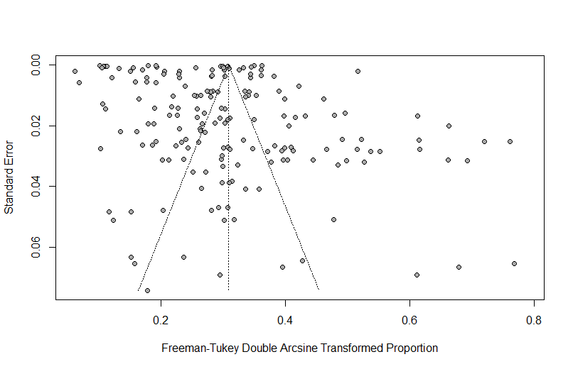
Egger’s regression had a p-value of 0.621 indicating no publication bias.
Supplementary Figure 1. Funnel plot for publications on post-stroke infections
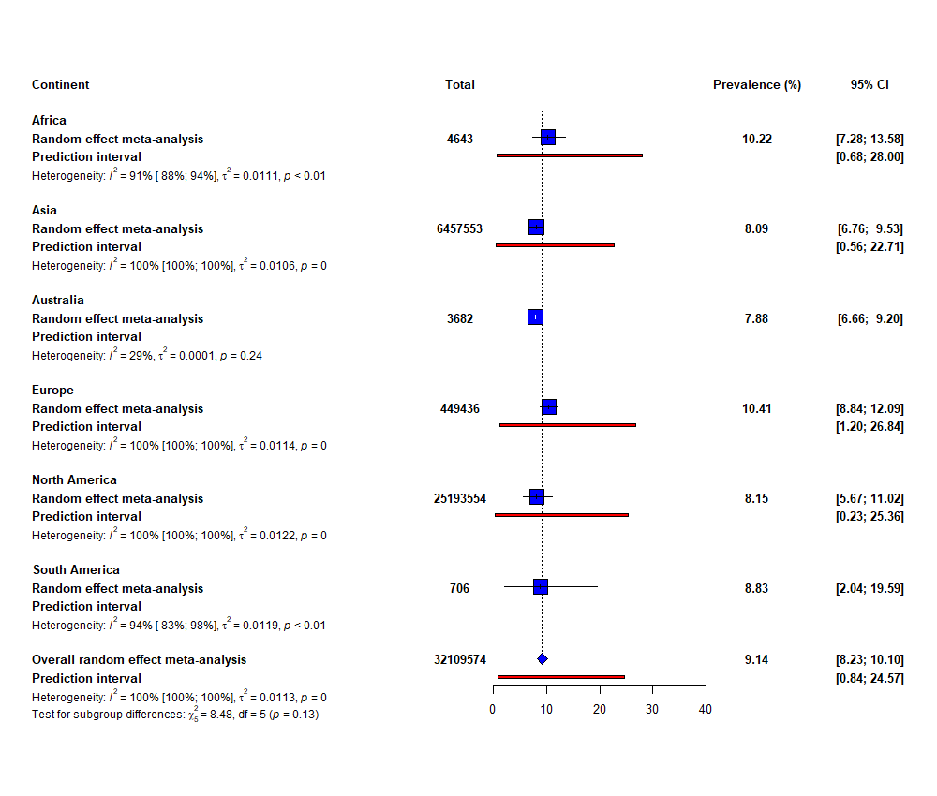
Supplementary Figure 2. Continental prevalences of post-stroke infections.
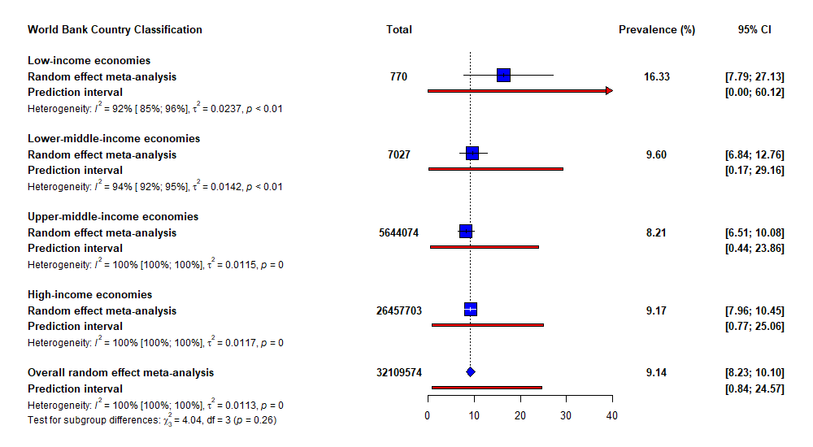

Supplementary Figure 3. Prevalences of post-stroke infections according to the World Bank Classification of countries.

