Supplementary table 1: Search strategy applied in the study
Search strategy | ((Thrombolytic therapy) OR (IVT) OR (rtpa) OR (recombinant tissue plasminogen activator) OR (Actilysis) OR (Fibrinolytic Therapy) OR (Fibrinolysis) OR (intravenous thrombolysis) OR (tissue plasminogen activator) OR (Activase) OR (Clot Buster) OR (Streptokinase) OR (tPA) OR (PLAT) OR (Retaplase) OR (Alteplase) OR (Tenecteplase) OR (Urokinase) OR (Anistreplase) OR (urinary-type plasminogen activator) OR (uPA) OR (Anistreplase) OR (fibrinolysin) OR (IV thrombolysis)) AND ((minor) AND ((stroke) OR (ischemic stroke) OR (Cerebrovascular Accident) OR (Cerebrovascular Apoplexy) OR (Brain Vascular Accident) OR (CVA) OR (CVAs) OR (Cerebrovascular Stroke) OR (brain attack) OR (cerebral infarction) OR (brain infarction)))

Supplementary table 2: Quality assessment of the included cohort studies using New Castle Ottawa Scale
Study ID | Selection |  |  |  | Comparability | Exposure |  |  | Score | Quality
Study ID | Is the case definition adequate? | Representativeness of the cases | Selection of Controls | Definition of Controls | Comparability of cases and controls on the basis of the design or analysis | Ascertainment of exposure | Same method of ascertainment for cases and controls | Non-Response rate | Score | Quality
Zhong 2021 | * | * | _ | * | * | * | * | * | 7 | High
Huisa 2011 | _ | * | _ | _ | ** | * | * | * | 6 | Moderate
Hsia 2021 | * | * | * | _ | * | * | * | * | 7 | High
Laurencin 2015 | * | * | _ | _ | ** | * | * | _ | 6 | Moderate
Li 2019 | * | * | _ | _ | _ | * | * | * | 5 | Moderate
Sykora 2021 | * | * | _ | _ | ** | * | * | * | 7 | High
Duan 2023 | * | * | * | * | * | * | * | * | 8 | High
Villringer 2014 | _ | * | _ | _ | _ | * | * | * | 4 | Moderate
Mengel 2022 | * | * | _ | _ | ** | * | * | _ | 6 | Moderate
Sharma 2018 | * | * | _ | _ | ** | * | * | _ | 6 | Moderate
Han 2021 | * | * | _ | _ | _ | * | * | _ | 4 | Moderate
Choi 2015 | * | * | _ | _ | ** | * | * | * | 7 | High
Ng 2016 | * | * | _ | _ | * | * | * | _ | 5 | Moderate
Greisenegger 2014 | * | * | _ | _ | ** | * | * | _ | 6 | Moderate
Logallo 2014 | * | * | _ | _ | ** | * | * | _ | 6 | Moderate
Urra 2013 | * | * | _ | _ | * | * | * | _ | 5 | Moderate
Chen 2017 | * | * | _ | _ | ** | * | * | _ | 6 | Moderate
Luo 2024 | * | * | _ | _ | ** | * | * | _ | 6 | Moderate
Yaghi 2018 | * | * | * | _ | * | * | * | _ | 6 | Moderate
Pitaksuteepong 2020 | * | * | * | _ | * | * | * | * | 7 | High

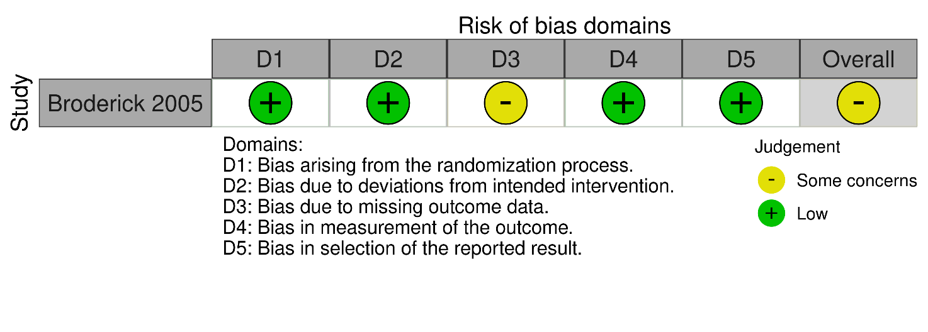
Supplementary figure 1: Risk of bias assessment of the included randomized controlled trial using RoB 2.0 tool
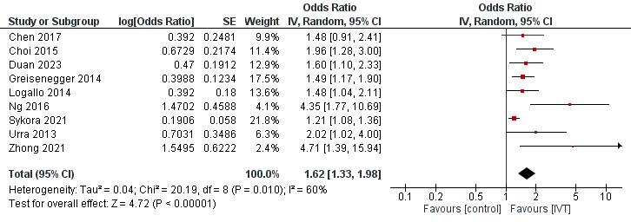
Supplementary figure 2: Prediction of 90-day mRs 0-1 after using intravenous thrombolysis vs control
The diamond shape represents the overall forest plot, the blue region is the OR of each study and the two lines merging from it represent the confidence intervals

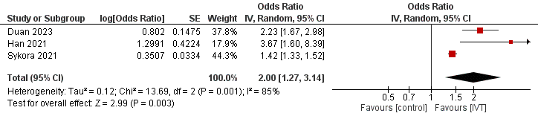
Supplementary figure 3: Prediction of NIHSS improvement after using intravenous thrombolysis vs control
The diamond shape represents the overall forest plot, the blue region is the OR of each study and the two lines merging from it represent the confidence intervals
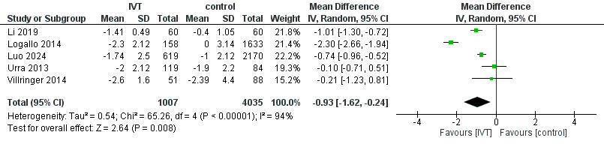
Supplementary figure 4: Comparison between intravenous thrombolysis and control regarding the change in NIHSS
The diamond shape represents the overall forest plot, the blue region is the MD of each study and the two lines merging from it represent the confidence intervals

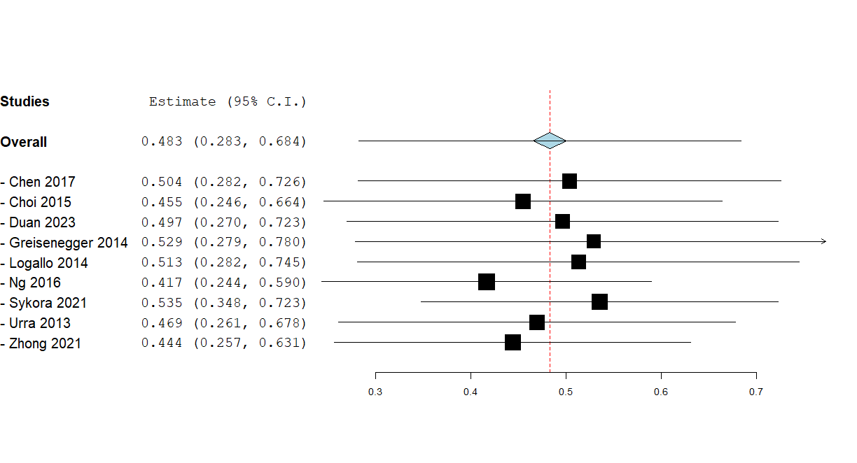
Supplementary figure 5: Leave-one-out for the prediction of 90-day mRs 0-1 in intravenous thrombolysis vs control using odds ratio
The diamond shape represents the overall forest plot, the black region is the OR of each study and the two lines merging from it represent the confidence intervals

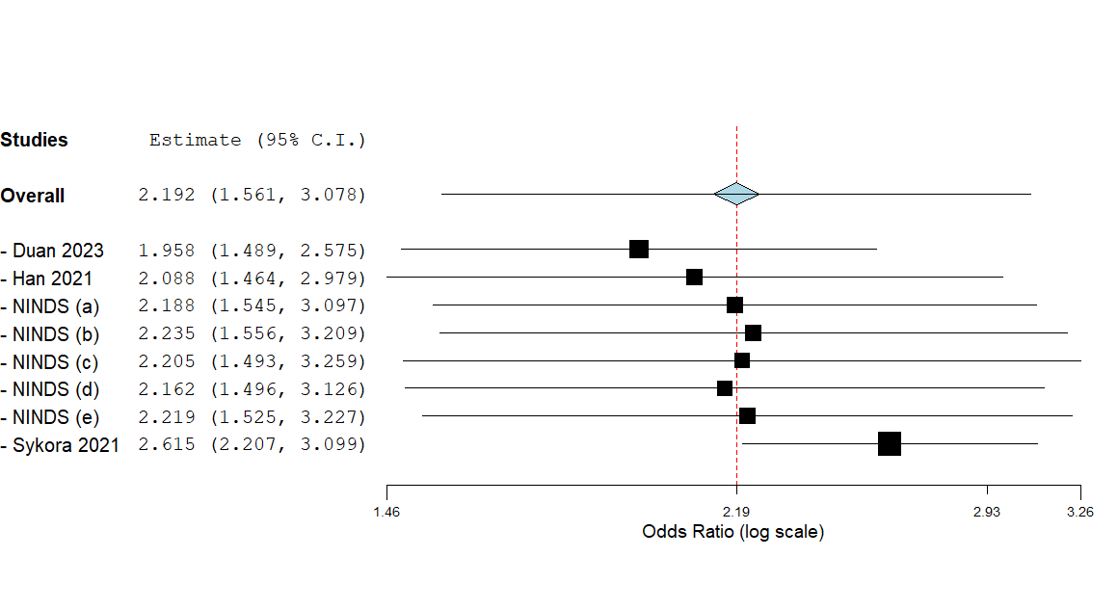
Supplementary figure 6: Leave-one-out analysis for the improvement of NIHSS in intravenous thrombolysis vs control
The diamond shape represents the overall forest plot, the black region is the OR of each study and the two lines merging from it represent the confidence intervals

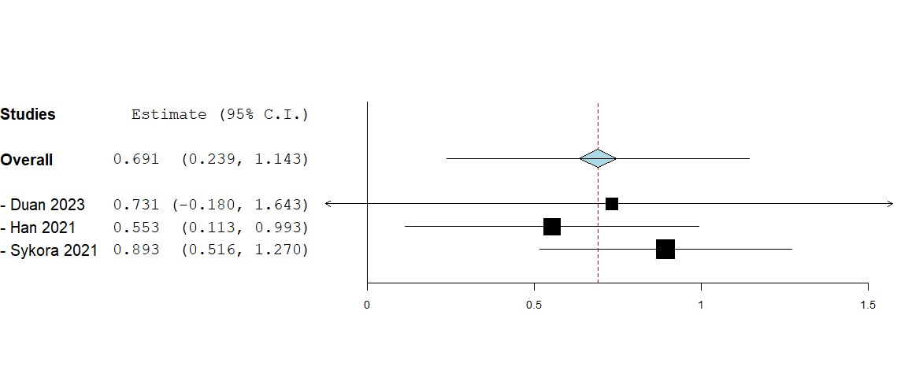
Supplementary figure 7: Leave-one-out for the prediction of NIHSS improvement in intravenous thrombolysis vs control using odds ratio
The diamond shape represents the overall forest plot, the black region is the OR of each study and the two lines merging from it represent the confidence intervals

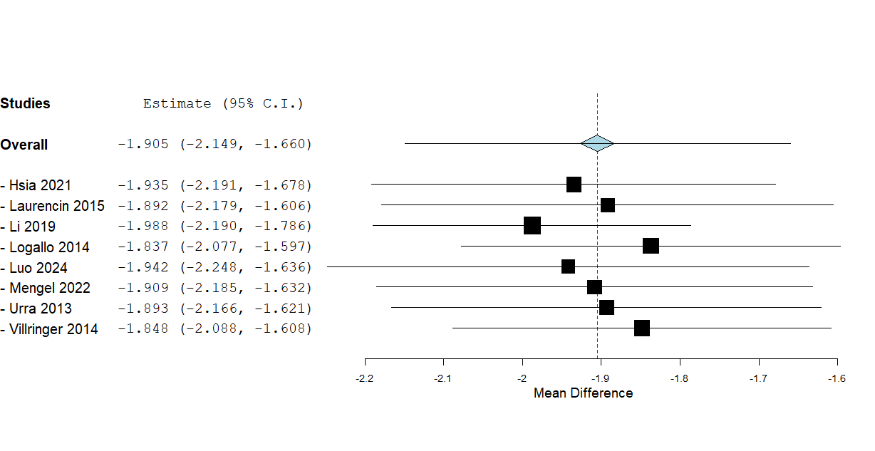
Supplementary figure 8: Leave-one-out for the effect of NIHSS after and before treatment with intravenous thrombolysis
The diamond shape represents the overall forest plot, the black region is the MD of each study and the two lines merging from it represent the confidence intervals

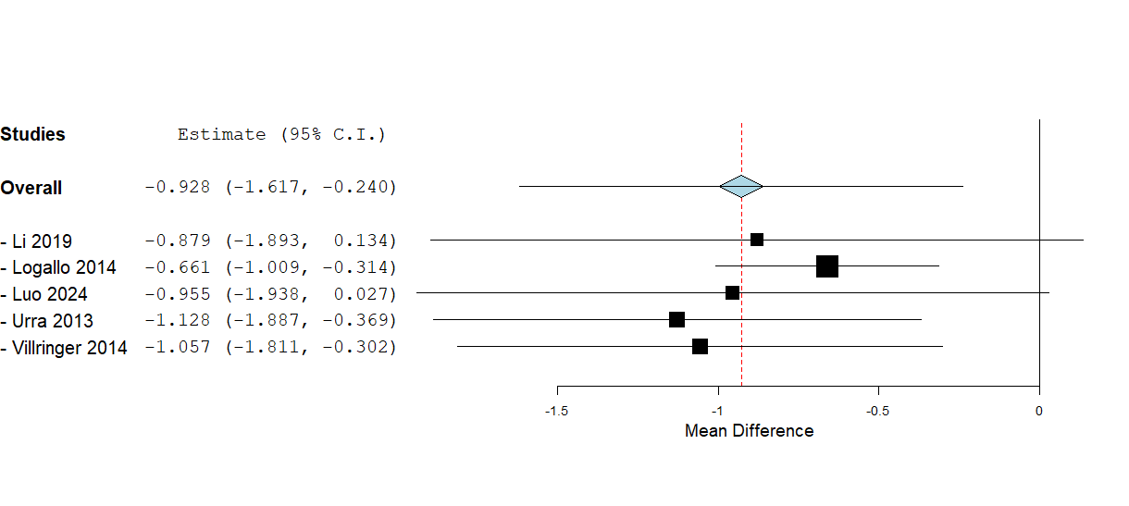
Supplementary figure 9: Leave-one-out analysis for the comparison between intravenous thrombolysis and control groups regarding the change in NIHSS
The diamond shape represents the overall forest plot, the black region is the MD of each study and the two lines merging from it represent the confidence intervals

