Supplement Material

Figure 1: ROC curve of GCS
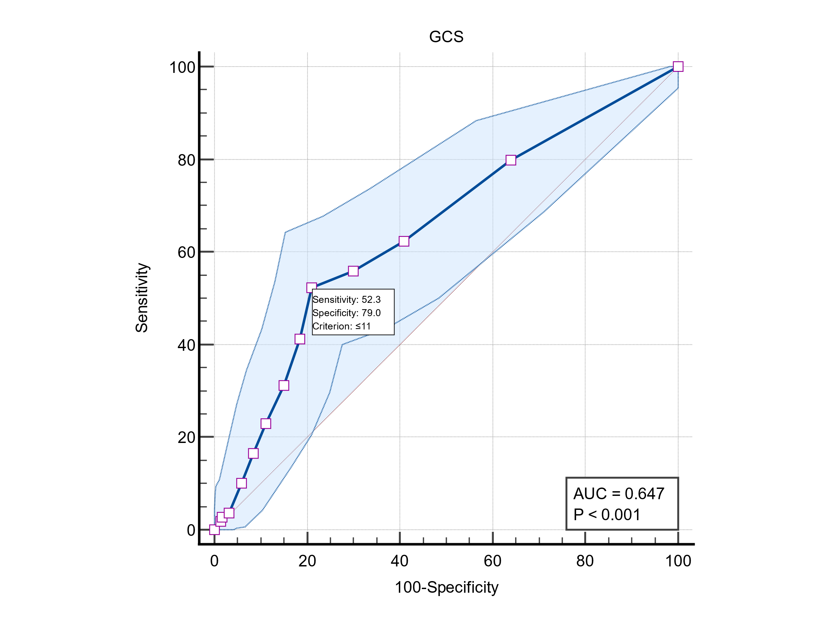
GCS: Glasgow Coma Scale; AUC: Area under Curve

Figure 2: ROC curve of Time elapse from onset to NCCT
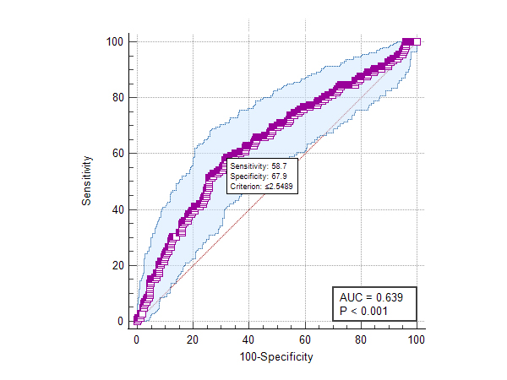
AUC: Area under Curve

