Supplement Figure 3: Leave-one-out plots for the causal association between gut microbiota and INPH.
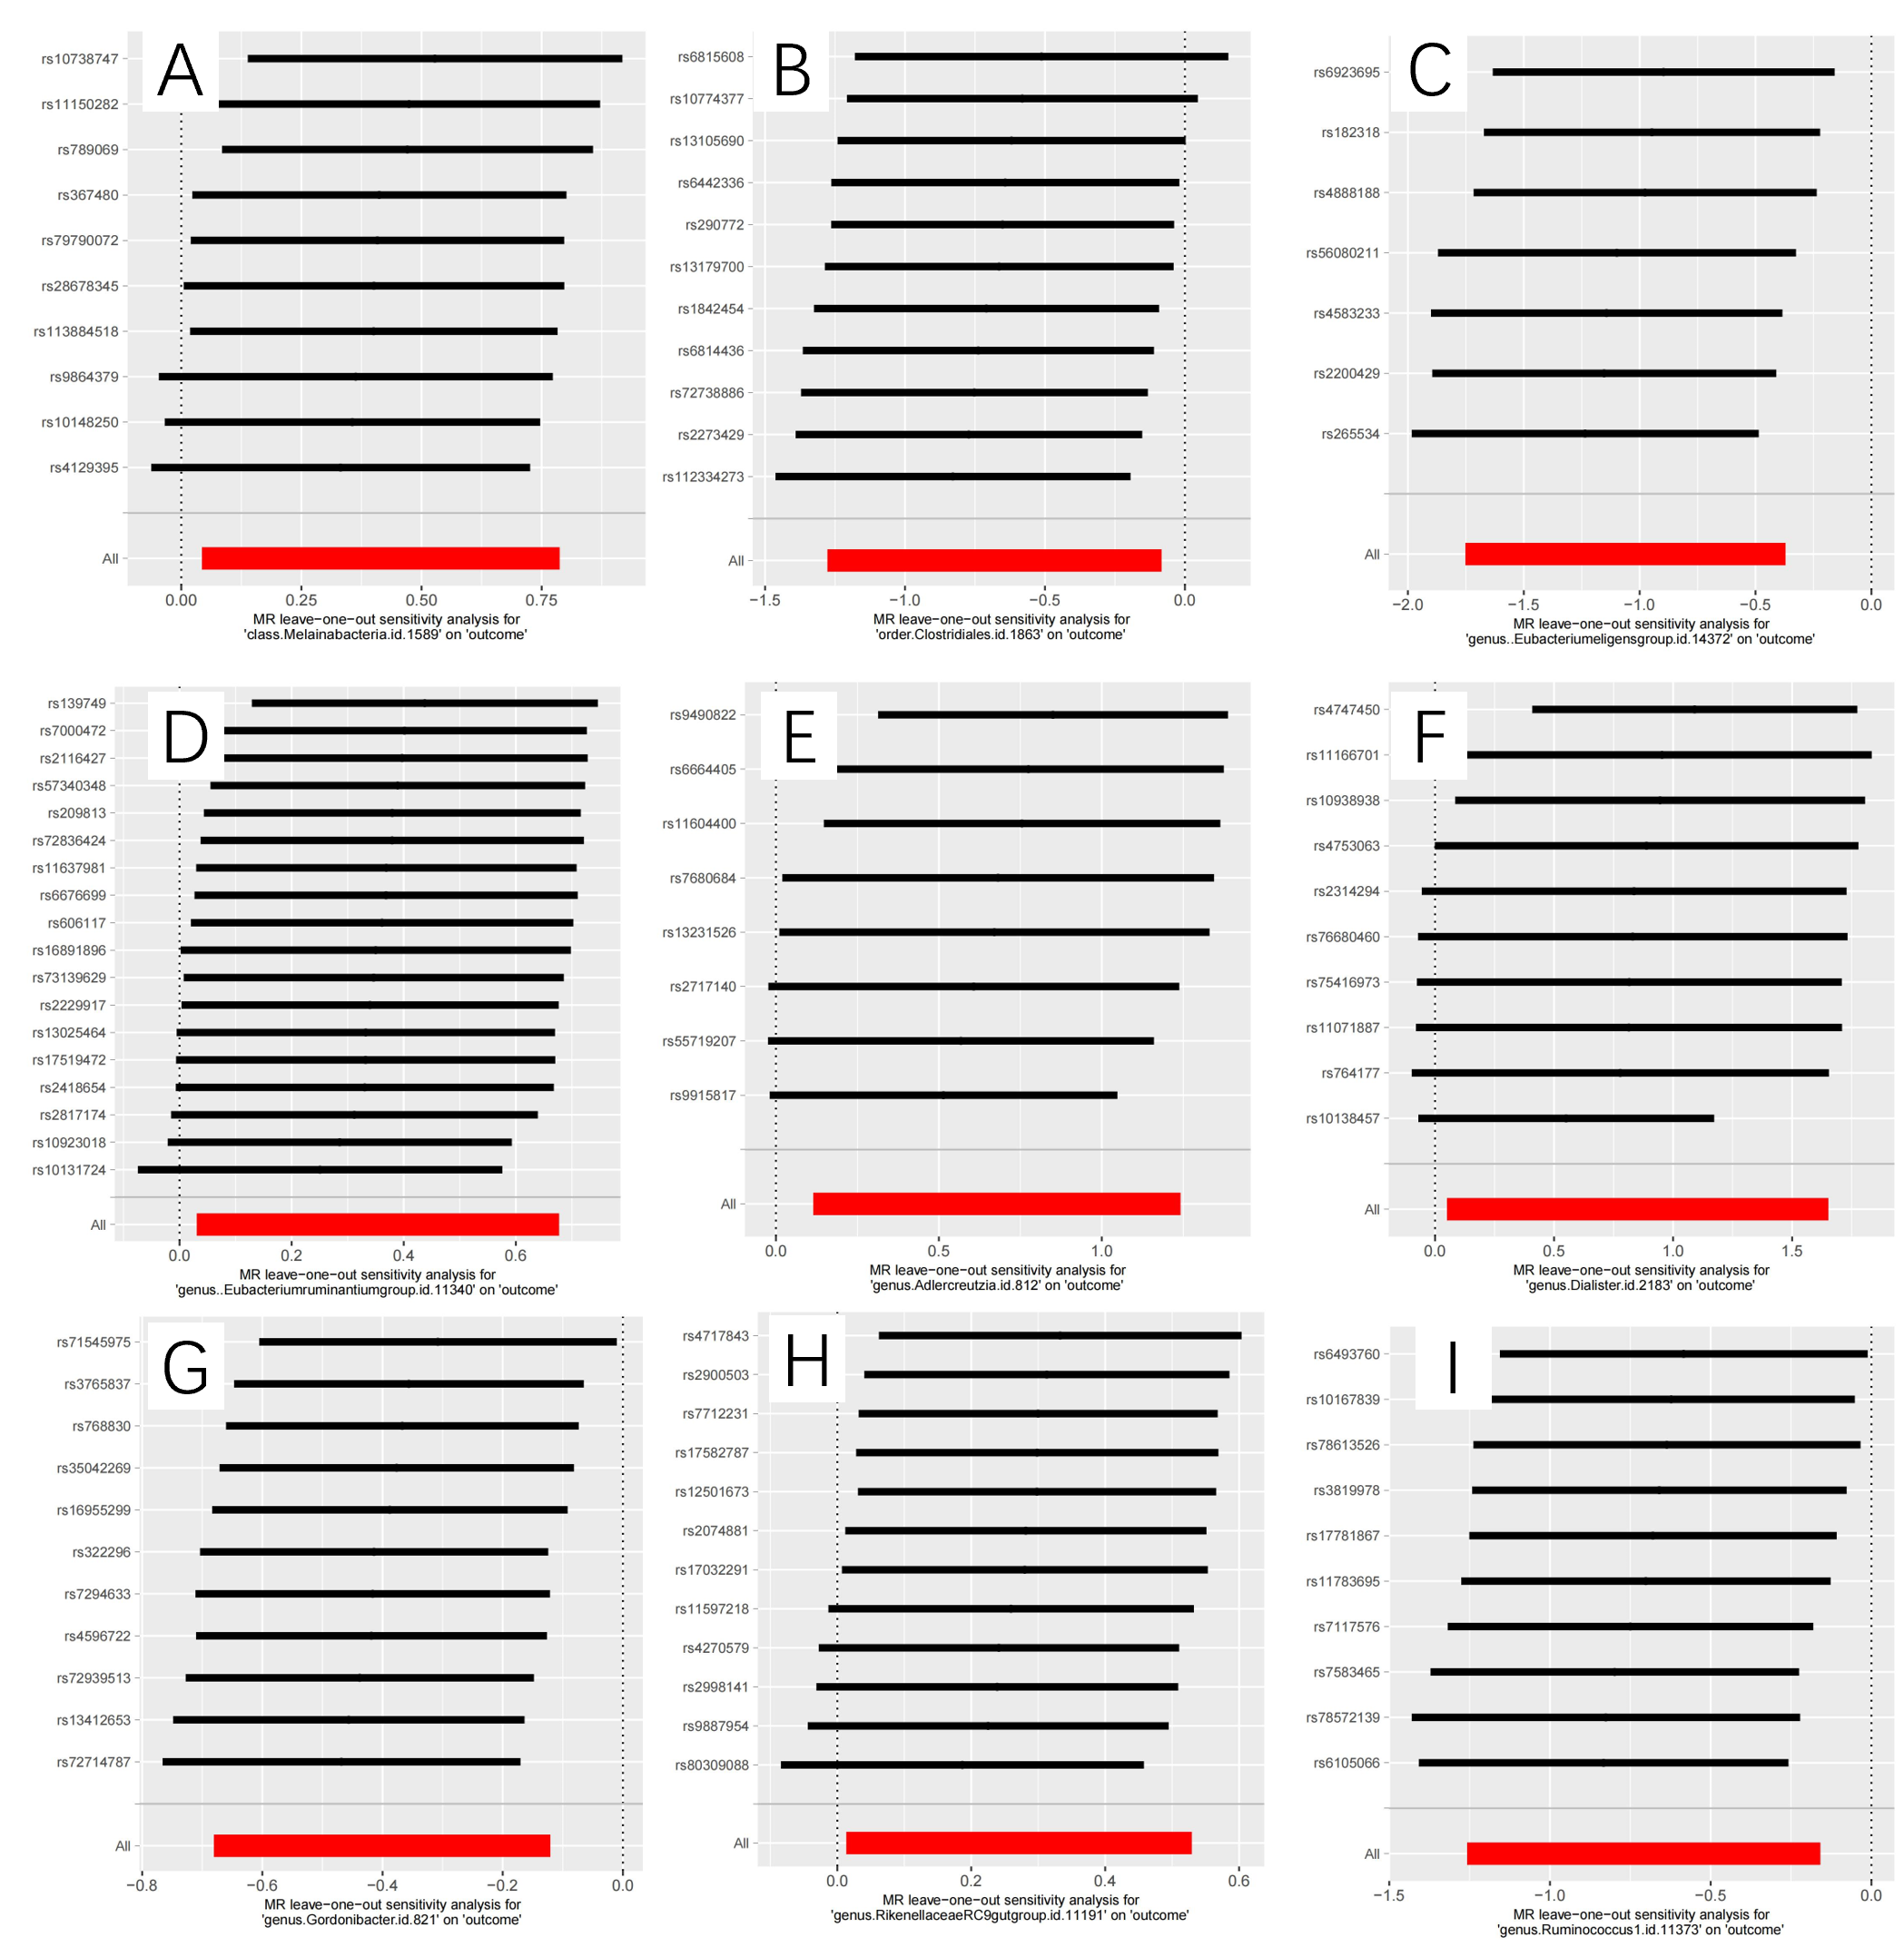
A class.Melainabacteria B order.Clostridiales C genus.Eubacteriumeligensgroup D genus.Eubacteriumruminantiumgroup E genus.Adlercreutzia F genus.Dialister G genus.Gordonibacter H genus.RikenellaceaeRC9gutgroup I genus.Ruminococcus1

