Supplementary Material

eTable 1 PRISMA 2020 Checklist
Section and Topic | Item # | Checklist item | Location where item is reported
TITLE
Title | 1 | Identify the report as a systematic review. | P1
ABSTRACT
Abstract | 2 | See the PRISMA 2020 for Abstracts checklist. | P1
INTRODUCTION
Rationale | 3 | Describe the rationale for the review in the context of existing knowledge. | P2-3
Objectives | 4 | Provide an explicit statement of the objective(s) or question(s) the review addresses. | P3
METHODS
Eligibility criteria | 5 | Specify the inclusion and exclusion criteria for the review and how studies were grouped for the syntheses. | P3-4
Information sources | 6 | Specify all databases, registers, websites, organisations, reference lists and other sources searched or consulted to identify studies. Specify the date when each source was last searched or consulted. | P4-5
Search strategy | 7 | Present the full search strategies for all databases, registers and websites, including any filters and limits used. | P3-4
Selection process | 8 | Specify the methods used to decide whether a study met the inclusion criteria of the review, including how many reviewers screened each record and each report retrieved, whether they worked independently, and if applicable, details of automation tools used in the process. | P4-5
Data collection process | 9 | Specify the methods used to collect data from reports, including how many reviewers collected data from each report, whether they worked independently, any processes for obtaining or confirming data from study investigators, and if applicable, details of automation tools used in the process. | P4-5
Data items | 10a | List and define all outcomes for which data were sought. Specify whether all results that were compatible with each outcome domain in each study were sought (e.g. for all measures, time points, analyses), and if not, the methods used to decide which results to collect. | P5
Data items | 10b | List and define all other variables for which data were sought (e.g. participant and intervention characteristics, funding sources). Describe any assumptions made about any missing or unclear information. | P5
Study risk of bias assessment | 11 | Specify the methods used to assess risk of bias in the included studies, including details of the tool(s) used, how many reviewers assessed each study and whether they worked independently, and if applicable, details of automation tools used in the process. | P5
Effect measures | 12 | Specify for each outcome the effect measure(s) (e.g. risk ratio, mean difference) used in the synthesis or presentation of results. | P4
Synthesis methods | 13a | Describe the processes used to decide which studies were eligible for each synthesis (e.g. tabulating the study intervention characteristics and comparing against the planned groups for each synthesis (item #5)). | P7-9
Synthesis methods | 13b | Describe any methods required to prepare the data for presentation or synthesis, such as handling of missing summary statistics, or data conversions. | P5
Synthesis methods | 13c | Describe any methods used to tabulate or visually display results of individual studies and syntheses. | P5-9
Synthesis methods | 13d | Describe any methods used to synthesize results and provide a rationale for the choice(s). If meta-analysis was performed, describe the model(s), method(s) to identify the presence and extent of statistical heterogeneity, and software package(s) used. | P5
Synthesis methods | 13e | Describe any methods used to explore possible causes of heterogeneity among study results (e.g. subgroup analysis, meta-regression). | P5
Synthesis methods | 13f | Describe any sensitivity analyses conducted to assess robustness of the synthesized results. | P5
Reporting bias assessment | 14 | Describe any methods used to assess risk of bias due to missing results in a synthesis (arising from reporting biases). | P5
Certainty assessment | 15 | Describe any methods used to assess certainty (or confidence) in the body of evidence for an outcome. | P5
RESULTS
Study selection | 16a | Describe the results of the search and selection process, from the number of records identified in the search to the number of studies included in the review, ideally using a flow diagram. | P6
Study selection | 16b | Cite studies that might appear to meet the inclusion criteria, but which were excluded, and explain why they were excluded. | P6
Study characteristics | 17 | Cite each included study and present its characteristics. | P11-12
Risk of bias in studies | 18 | Present assessments of risk of bias for each included study. | P11-12
Results of individual studies | 19 | For all outcomes, present, for each study: (a) summary statistics for each group (where appropriate) and (b) an effect estimate and its precision (e.g. confidence/credible interval), ideally using structured tables or plots. | P12-16
Results of syntheses | 20a | For each synthesis, briefly summarise the characteristics and risk of bias among contributing studies. | P11-12
Results of syntheses | 20b | Present results of all statistical syntheses conducted. If meta-analysis was done, present for each the summary estimate and its precision (e.g. confidence/credible interval) and measures of statistical heterogeneity. If comparing groups, describe the direction of the effect. | P12-16
Results of syntheses | 20c | Present results of all investigations of possible causes of heterogeneity among study results. | P15-16
Results of syntheses | 20d | Present results of all sensitivity analyses conducted to assess the robustness of the synthesized results. | P16
Reporting biases | 21 | Present assessments of risk of bias due to missing results (arising from reporting biases) for each synthesis assessed. | nr
Certainty of evidence | 22 | Present assessments of certainty (or confidence) in the body of evidence for each outcome assessed. | nr
DISCUSSION
Discussion | 23a | Provide a general interpretation of the results in the context of other evidence. | P16-18
Discussion | 23b | Discuss any limitations of the evidence included in the review. | P16-18
Discussion | 23c | Discuss any limitations of the review processes used. | P16-18
Discussion | 23d | Discuss implications of the results for practice, policy, and future research. | P16-18
OTHER INFORMATION
Registration and protocol | 24a | Provide registration information for the review, including register name and registration number, or state that the review was not registered. | P3
Registration and protocol | 24b | Indicate where the review protocol can be accessed, or state that a protocol was not prepared. | nr
Registration and protocol | 24c | Describe and explain any amendments to information provided at registration or in the protocol. | nr
Support | 25 | Describe sources of financial or non-financial support for the review, and the role of the funders or sponsors in the review. | P19
Competing interests | 26 | Declare any competing interests of review authors. | P19
Availability of data, code and other materials | 27 | Report which of the following are publicly available and where they can be found: template data collection forms; data extracted from included studies; data used for all analyses; analytic code; any other materials used in the review. | P19

The complete search strategies
Cochrane

Search Name: Neurodegenerative Disease
Date Run: 13/06/2024 01:36:31
Comment:

ID Search Hits
#1 MeSH descriptor: [Neurodegenerative Diseases] explode all trees 14923
#2 (Degenerative Diseases):ti,ab kw OR (Neurologic Degenerative Condition):ti,ab kw OR (Neurodegenerative Disorders):ti,ab kw 5
#3 #1 OR #2 14926
#4 MeSH descriptor: [Parkinson Disease] explode all trees 6108
#5 (Lewy Body Parkinson Disease):ti,ab kw OR (Parkinson's Disease):ti,ab kw OR (Parkinsonism):ti,ab kw 68
#6 #4 OR #5 6140
#7 MeSH descriptor: [Alzheimer Disease] explode all trees 5337
#8 (Familial Alzheimer Disease):ti,ab kw OR (Alzheimer's Disease):ti,ab kw OR (Senile Dementia):ti,ab kw OR (Dementia):ti,ab kw 100
#9 #7 OR #8 5409
#10 #3 OR #6 OR #9 15028
#11 MeSH descriptor: [Transcranial Magnetic Stimulation] explode all trees 2625
#12 (Magnetic Stimulation):ti,ab kw OR (repetitive transcranial magnetic stimulation):ti,ab kw 12
#13 #11 OR #12 2634
#14 #10 AND #13 195
Embase
Session Results
.......................................................
No. Query Results Results Date
#19. #15 AND #18 571 13 Jun 2024
#18. #16 OR #17 1,199,658 13 Jun 2024
#17. 'randomized controlled':ab,kw,ti OR 'clinic 376,184 13 Jun 2024
trial':ab,kw,ti OR 'rct':ab,kw,ti
#16. 'randomized controlled trial'/exp OR 'randomized 1,120,383 13 Jun 2024
controlled trial'
#15. #12 AND #13 3,693 13 Jun 2024
#14. #12 AND #13 3,693 13 Jun 2024
#13. #3 OR #6 OR #9 969,501 13 Jun 2024
#12. #10 OR #11 39,337 13 Jun 2024
#11. 'repetitive transcranial magnetic 31,525 13 Jun 2024
stimulation':ab,kw,ti OR 'magnetic
stimulation':ab,kw,ti
#10. 'transcranial magnetic stimulation'/exp OR 36,793 13 Jun 2024
'transcranial magnetic stimulation'
#9. #7 OR #8 408,013 13 Jun 2024
#8. 'familial alzheimer disease':ab,kw,ti OR 'senile 218,335 13 Jun 2024
dementia':ab,kw,ti OR 'dementia':ab,kw,ti
#7. 'alzheimer disease'/exp OR 'alzheimer disease' 268,705 13 Jun 2024
#6. #4 OR #5 227,340 13 Jun 2024
#5. 'lewy body parkinson disease':ab,kw,ti OR 31,199 13 Jun 2024
'parkinsonism':ab,kw,ti
#4. 'parkinson disease'/exp OR 'parkinson disease' 211,519 13 Jun 2024
#3. #1 OR #2 838,350 13 Jun 2024
#2. 'degenerative diseases':ab,kw,ti OR 'neurologic 45,020 13 Jun 2024
degenerative condition':ab,kw,ti OR
'neurodegenerative disorders':ab,kw,ti
#1. 'degenerative disease'/exp OR 'degenerative 820,353 13 Jun 2024
disease'
.......................................................
Pubmed

Query Sort By Filters Search Details Results Time
((((Transcranial Magnetic Stimulation) OR (repetitive transcranial magnetic stimulation)) OR (magnetic stimulation)) AND (((randomized controlled trial) OR (Controlled Clinical Trial)) OR (Clinical Trial))) AND ((((((Neurodegenerative Diseases) OR (Neurodegenerative Disorders)) OR (Nervous System Degenerative Diseases)) OR (Neurologic Degenerative Diseases)) OR ((((Parkinson Disease) OR (Parkinson's Disease)) OR (Parkinsonism)) OR (Lewy Body Parkinson's Disease))) OR ((((Alzheimer's Disease) OR (Dementia)) OR (Senile Dementia)) OR (Alzheimer Syndrome))) ("transcranial magnetic stimulation"[MeSH Terms] OR ("transcranial"[All Fields] AND "magnetic"[All Fields] AND "stimulation"[All Fields]) OR "transcranial magnetic stimulation"[All Fields] OR ("transcranial magnetic stimulation"[MeSH Terms] OR ("transcranial"[All Fields] AND "magnetic"[All Fields] AND "stimulation"[All Fields]) OR "transcranial magnetic stimulation"[All Fields] OR ("repetitive"[All Fields] AND "transcranial"[All Fields] AND "magnetic"[All Fields] AND "stimulation"[All Fields]) OR "repetitive transcranial magnetic stimulation"[All Fields]) OR (("magnet s"[All Fields] OR "magnetical"[All Fields] OR "magnetically"[All Fields] OR "magnetics"[MeSH Terms] OR "magnetics"[All Fields] OR "magnetic"[All Fields] OR "magnetisation"[All Fields] OR "magnetisations"[All Fields] OR "magnetised"[All Fields] OR "magnetism"[All Fields] OR "magnetisms"[All Fields] OR "magnetization"[All Fields] OR "magnetizations"[All Fields] OR "magnetize"[All Fields] OR "magnetized"[All Fields] OR "magnetizing"[All Fields] OR "magnets"[MeSH Terms] OR "magnets"[All Fields] OR "magnet"[All Fields]) AND ("stimulate"[All Fields] OR "stimulated"[All Fields] OR "stimulates"[All Fields] OR "stimulating"[All Fields] OR "stimulation"[All Fields] OR "stimulations"[All Fields] OR "stimulative"[All Fields] OR "stimulator"[All Fields] OR "stimulator s"[All Fields] OR "stimulators"[All Fields]))) AND ("randomized controlled trial"[Publication Type] OR "randomized controlled trials as topic"[MeSH Terms] OR "randomized controlled trial"[All Fields] OR "randomised controlled trial"[All Fields] OR ("controlled clinical trial"[Publication Type] OR "controlled clinical trials as topic"[MeSH Terms] OR "controlled clinical trial"[All Fields]) OR ("clinical trial"[Publication Type] OR "clinical trials as topic"[MeSH Terms] OR "clinical trial"[All Fields])) AND ("neurodegenerative diseases"[MeSH Terms] OR ("neurodegenerative"[All Fields] AND "diseases"[All Fields]) OR "neurodegenerative diseases"[All Fields] OR ("neurodegenerative diseases"[MeSH Terms] OR ("neurodegenerative"[All Fields] AND "diseases"[All Fields]) OR "neurodegenerative diseases"[All Fields] OR ("neurodegenerative"[All Fields] AND "disorders"[All Fields]) OR "neurodegenerative disorders"[All Fields]) OR ("neurodegenerative diseases"[MeSH Terms] OR ("neurodegenerative"[All Fields] AND "diseases"[All Fields]) OR "neurodegenerative diseases"[All Fields] OR ("nervous"[All Fields] AND "system"[All Fields] AND "degenerative"[All Fields] AND "diseases"[All Fields]) OR "nervous system degenerative diseases"[All Fields]) OR ("neurodegenerative diseases"[MeSH Terms] OR ("neurodegenerative"[All Fields] AND "diseases"[All Fields]) OR "neurodegenerative diseases"[All Fields] OR ("neurologic"[All Fields] AND "degenerative"[All Fields] AND "diseases"[All Fields]) OR "neurologic degenerative diseases"[All Fields]) OR ("parkinson disease"[MeSH Terms] OR ("parkinson"[All Fields] AND "disease"[All Fields]) OR "parkinson disease"[All Fields] OR ("parkinson disease"[MeSH Terms] OR ("parkinson"[All Fields] AND "disease"[All Fields]) OR "parkinson disease"[All Fields] OR "parkinson s disease"[All Fields]) OR ("parkinson disease"[MeSH Terms] OR ("parkinson"[All Fields] AND "disease"[All Fields]) OR "parkinson disease"[All Fields] OR "parkinsons"[All Fields] OR "parkinson"[All Fields] OR "parkinson s"[All Fields] OR "parkinsonian disorders"[MeSH Terms] OR ("parkinsonian"[All Fields] AND "disorders"[All Fields]) OR "parkinsonian disorders"[All Fields] OR "parkinsonism"[All Fields] OR "parkinsonisms"[All Fields] OR "parkinsons s"[All Fields]) OR ("parkinson disease"[MeSH Terms] OR ("parkinson"[All Fields] AND "disease"[All Fields]) OR "parkinson disease"[All Fields] OR ("lewy"[All Fields] AND "body"[All Fields] AND "parkinson s"[All Fields] AND "disease"[All Fields]) OR "lewy body parkinson s disease"[All Fields])) OR ("alzheimer disease"[MeSH Terms] OR ("alzheimer"[All Fields] AND "disease"[All Fields]) OR "alzheimer disease"[All Fields] OR ("alzheimer s"[All Fields] AND "disease"[All Fields]) OR "alzheimer s disease"[All Fields] OR ("dementia"[MeSH Terms] OR "dementia"[All Fields] OR "dementias"[All Fields] OR "dementia s"[All Fields]) OR ("alzheimer disease"[MeSH Terms] OR ("alzheimer"[All Fields] AND "disease"[All Fields]) OR "alzheimer disease"[All Fields] OR ("senile"[All Fields] AND "dementia"[All Fields]) OR "senile dementia"[All Fields]) OR ("alzheimer disease"[MeSH Terms] OR ("alzheimer"[All Fields] AND "disease"[All Fields]) OR "alzheimer disease"[All Fields] OR ("alzheimer"[All Fields] AND "syndrome"[All Fields]) OR "alzheimer syndrome"[All Fields]))) 628 11:59:36
(((((Neurodegenerative Diseases) OR (Neurodegenerative Disorders)) OR (Nervous System Degenerative Diseases)) OR (Neurologic Degenerative Diseases)) OR ((((Parkinson Disease) OR (Parkinson's Disease)) OR (Parkinsonism)) OR (Lewy Body Parkinson's Disease))) OR ((((Alzheimer's Disease) OR (Dementia)) OR (Senile Dementia)) OR (Alzheimer Syndrome)) "neurodegenerative diseases"[MeSH Terms] OR ("neurodegenerative"[All Fields] AND "diseases"[All Fields]) OR "neurodegenerative diseases"[All Fields] OR ("neurodegenerative diseases"[MeSH Terms] OR ("neurodegenerative"[All Fields] AND "diseases"[All Fields]) OR "neurodegenerative diseases"[All Fields] OR ("neurodegenerative"[All Fields] AND "disorders"[All Fields]) OR "neurodegenerative disorders"[All Fields]) OR ("neurodegenerative diseases"[MeSH Terms] OR ("neurodegenerative"[All Fields] AND "diseases"[All Fields]) OR "neurodegenerative diseases"[All Fields] OR ("nervous"[All Fields] AND "system"[All Fields] AND "degenerative"[All Fields] AND "diseases"[All Fields]) OR "nervous system degenerative diseases"[All Fields]) OR ("neurodegenerative diseases"[MeSH Terms] OR ("neurodegenerative"[All Fields] AND "diseases"[All Fields]) OR "neurodegenerative diseases"[All Fields] OR ("neurologic"[All Fields] AND "degenerative"[All Fields] AND "diseases"[All Fields]) OR "neurologic degenerative diseases"[All Fields]) OR ("parkinson disease"[MeSH Terms] OR ("parkinson"[All Fields] AND "disease"[All Fields]) OR "parkinson disease"[All Fields] OR ("parkinson disease"[MeSH Terms] OR ("parkinson"[All Fields] AND "disease"[All Fields]) OR "parkinson disease"[All Fields] OR "parkinson s disease"[All Fields]) OR ("parkinson disease"[MeSH Terms] OR ("parkinson"[All Fields] AND "disease"[All Fields]) OR "parkinson disease"[All Fields] OR "parkinsons"[All Fields] OR "parkinson"[All Fields] OR "parkinson s"[All Fields] OR "parkinsonian disorders"[MeSH Terms] OR ("parkinsonian"[All Fields] AND "disorders"[All Fields]) OR "parkinsonian disorders"[All Fields] OR "parkinsonism"[All Fields] OR "parkinsonisms"[All Fields] OR "parkinsons s"[All Fields]) OR ("parkinson disease"[MeSH Terms] OR ("parkinson"[All Fields] AND "disease"[All Fields]) OR "parkinson disease"[All Fields] OR ("lewy"[All Fields] AND "body"[All Fields] AND "parkinson s"[All Fields] AND "disease"[All Fields]) OR "lewy body parkinson s disease"[All Fields])) OR ("alzheimer disease"[MeSH Terms] OR ("alzheimer"[All Fields] AND "disease"[All Fields]) OR "alzheimer disease"[All Fields] OR ("alzheimer s"[All Fields] AND "disease"[All Fields]) OR "alzheimer s disease"[All Fields] OR ("dementia"[MeSH Terms] OR "dementia"[All Fields] OR "dementias"[All Fields] OR "dementia s"[All Fields]) OR ("alzheimer disease"[MeSH Terms] OR ("alzheimer"[All Fields] AND "disease"[All Fields]) OR "alzheimer disease"[All Fields] OR ("senile"[All Fields] AND "dementia"[All Fields]) OR "senile dementia"[All Fields]) OR ("alzheimer disease"[MeSH Terms] OR ("alzheimer"[All Fields] AND "disease"[All Fields]) OR "alzheimer disease"[All Fields] OR ("alzheimer"[All Fields] AND "syndrome"[All Fields]) OR "alzheimer syndrome"[All Fields])) 678,790 11:59:12
((randomized controlled trial) OR (Controlled Clinical Trial)) OR (Clinical Trial) "randomized controlled trial"[Publication Type] OR "randomized controlled trials as topic"[MeSH Terms] OR "randomized controlled trial"[All Fields] OR "randomised controlled trial"[All Fields] OR "controlled clinical trial"[Publication Type] OR "controlled clinical trials as topic"[MeSH Terms] OR "controlled clinical trial"[All Fields] OR "clinical trial"[Publication Type] OR "clinical trials as topic"[MeSH Terms] OR "clinical trial"[All Fields] 1,455,549 11:58:31
((Transcranial Magnetic Stimulation) OR (repetitive transcranial magnetic stimulation)) OR (magnetic stimulation) "transcranial magnetic stimulation"[MeSH Terms] OR ("transcranial"[All Fields] AND "magnetic"[All Fields] AND "stimulation"[All Fields]) OR "transcranial magnetic stimulation"[All Fields] OR ("transcranial magnetic stimulation"[MeSH Terms] OR ("transcranial"[All Fields] AND "magnetic"[All Fields] AND "stimulation"[All Fields]) OR "transcranial magnetic stimulation"[All Fields] OR ("repetitive"[All Fields] AND "transcranial"[All Fields] AND "magnetic"[All Fields] AND "stimulation"[All Fields]) OR "repetitive transcranial magnetic stimulation"[All Fields]) OR (("magnet s"[All Fields] OR "magnetical"[All Fields] OR "magnetically"[All Fields] OR "magnetics"[MeSH Terms] OR "magnetics"[All Fields] OR "magnetic"[All Fields] OR "magnetisation"[All Fields] OR "magnetisations"[All Fields] OR "magnetised"[All Fields] OR "magnetism"[All Fields] OR "magnetisms"[All Fields] OR "magnetization"[All Fields] OR "magnetizations"[All Fields] OR "magnetize"[All Fields] OR "magnetized"[All Fields] OR "magnetizing"[All Fields] OR "magnets"[MeSH Terms] OR "magnets"[All Fields] OR "magnet"[All Fields]) AND ("stimulate"[All Fields] OR "stimulated"[All Fields] OR "stimulates"[All Fields] OR "stimulating"[All Fields] OR "stimulation"[All Fields] OR "stimulations"[All Fields] OR "stimulative"[All Fields] OR "stimulator"[All Fields] OR "stimulator s"[All Fields] OR "stimulators"[All Fields])) 64,382 11:55:16
(((Alzheimer's Disease) OR (Dementia)) OR (Senile Dementia)) OR (Alzheimer Syndrome) "alzheimer disease"[MeSH Terms] OR ("alzheimer"[All Fields] AND "disease"[All Fields]) OR "alzheimer disease"[All Fields] OR ("alzheimer s"[All Fields] AND "disease"[All Fields]) OR "alzheimer s disease"[All Fields] OR ("dementia"[MeSH Terms] OR "dementia"[All Fields] OR "dementias"[All Fields] OR "dementia s"[All Fields]) OR ("alzheimer disease"[MeSH Terms] OR ("alzheimer"[All Fields] AND "disease"[All Fields]) OR "alzheimer disease"[All Fields] OR ("senile"[All Fields] AND "dementia"[All Fields]) OR "senile dementia"[All Fields]) OR ("alzheimer disease"[MeSH Terms] OR ("alzheimer"[All Fields] AND "disease"[All Fields]) OR "alzheimer disease"[All Fields] OR ("alzheimer"[All Fields] AND "syndrome"[All Fields]) OR "alzheimer syndrome"[All Fields]) 348,481 11:52:50
(((Parkinson Disease) OR (Parkinson's Disease)) OR (Parkinsonism)) OR (Lewy Body Parkinson's Disease) "parkinson disease"[MeSH Terms] OR ("parkinson"[All Fields] AND "disease"[All Fields]) OR "parkinson disease"[All Fields] OR ("parkinson disease"[MeSH Terms] OR ("parkinson"[All Fields] AND "disease"[All Fields]) OR "parkinson disease"[All Fields] OR "parkinson s disease"[All Fields]) OR ("parkinson disease"[MeSH Terms] OR ("parkinson"[All Fields] AND "disease"[All Fields]) OR "parkinson disease"[All Fields] OR "parkinsons"[All Fields] OR "parkinson"[All Fields] OR "parkinson s"[All Fields] OR "parkinsonian disorders"[MeSH Terms] OR ("parkinsonian"[All Fields] AND "disorders"[All Fields]) OR "parkinsonian disorders"[All Fields] OR "parkinsonism"[All Fields] OR "parkinsonisms"[All Fields] OR "parkinsons s"[All Fields]) OR ("parkinson disease"[MeSH Terms] OR ("parkinson"[All Fields] AND "disease"[All Fields]) OR "parkinson disease"[All Fields] OR ("lewy"[All Fields] AND "body"[All Fields] AND "parkinson s"[All Fields] AND "disease"[All Fields]) OR "lewy body parkinson s disease"[All Fields]) 178,559 11:46:24
(((Neurodegenerative Diseases) OR (Neurodegenerative Disorders)) OR (Nervous System Degenerative Diseases)) OR (Neurologic Degenerative Diseases) "neurodegenerative diseases"[MeSH Terms] OR ("neurodegenerative"[All Fields] AND "diseases"[All Fields]) OR "neurodegenerative diseases"[All Fields] OR ("neurodegenerative diseases"[MeSH Terms] OR ("neurodegenerative"[All Fields] AND "diseases"[All Fields]) OR "neurodegenerative diseases"[All Fields] OR ("neurodegenerative"[All Fields] AND "disorders"[All Fields]) OR "neurodegenerative disorders"[All Fields]) OR ("neurodegenerative diseases"[MeSH Terms] OR ("neurodegenerative"[All Fields] AND "diseases"[All Fields]) OR "neurodegenerative diseases"[All Fields] OR ("nervous"[All Fields] AND "system"[All Fields] AND "degenerative"[All Fields] AND "diseases"[All Fields]) OR "nervous system degenerative diseases"[All Fields]) OR ("neurodegenerative diseases"[MeSH Terms] OR ("neurodegenerative"[All Fields] AND "diseases"[All Fields]) OR "neurodegenerative diseases"[All Fields] OR ("neurologic"[All Fields] AND "degenerative"[All Fields] AND "diseases"[All Fields]) OR "neurologic degenerative diseases"[All Fields]) 454,208 11:42:33
Scopus

# | Query | Result
Neurodegenerative Disease
1 | TITLE-ABS-KEY("Neurodegenerative Disease" OR "Degenerative Diseases" OR "Neurologic Degenerative Condition" OR "Neurodegenerative Disorders" ) | 193,005
Parkinson Disease
2 | TITLE-ABS-KEY("Parkinson Disease" OR "Parkinson's Disease  " OR "Parkinsonism" ) | 217,056
Alzheimer Disease
3 | TITLE-ABS-KEY("Alzheimer's Disease" OR "Familial Alzheimer Disease" OR "Senile Dementia" OR "Dementia") | 443,122
Transcranial Magnetic Stimulation
4 | TITLE-ABS-KEY("Magnetic Stimulation" OR "repetitive transcranial magnetic stimulation" OR "transcranial magnetic stimulation" ) | 35,599
Randomized Controlled Trial
5 | TITLE-ABS-KEY("Randomized Controlled Trial" OR "RCT" OR "Randomized Controlled" OR "clinical trial" ) | 2,320,702
6 | #1 OR #2 OR #3 | 706,722
7 | #4 AND #6 | 3,138
8 | #5 AND #7 | 760

Web of Science

# Web of Science Search Strategy (v0.1)

# Database: All Databases

# Entitlements:

- WOS: 1982 to 2024
- BCI: 1994 to 2024
- CSCD: 1989 to 2024
- DIIDW: 1966 to 2024
- GRANTS: 1953 to 2024
- INSPEC: 1969 to 2024
- KJD: 1980 to 2024
- MEDLINE: 1950 to 2024
- PPRN: 1991 to 2024
- PQDT: 1637 to 2024
- SCIELO: 2002 to 2024

# Searches:

1: AutoGluon (Topic) and Preprint Citation Index (Exclude – Database) Date Run: Thu Jul 13 2024 15:34:07 GMT+0800 (CST) Results: 107

2: AutoGluon (Topic) and Preprint Citation Index (Exclude – Database) and 2024 or 2023 or 2022 or 2021 (Publication Years) Date Run: Thu Jul 13 2024 15:34:26 GMT+0800 (CST) Results: 104

3: (((((((((((TS=(neurodegenerative disease)) OR TS=(Degenerative Diseases )) OR TS=(Degenerative; Neurologic Degenerative Condition)) OR TS=(Neurodegenerative Disorders)) OR TS=(Parkinson Disease)) OR TS=(Parkinson's Disease)) OR TS=(Parkinsonism)) OR TS=(Alzheimer Disease)) OR TS=(Familial Alzheimer Disease)) OR TS=(Alzheimer's Disease)) OR TS=(Senile Dementia)) OR TS=(Dementia) and Preprint Citation Index (Exclude – Database) Date Run: Thu Jul 13 2024 15:34:44 GMT+0800 (CST) Results: 1153670

4: ((TS=(transcranial magnetic stimulation)) OR TS=(Magnetic Stimulation)) OR TS=(repetitive transcranial magnetic stimulation) and Preprint Citation Index (Exclude – Database) Date Run: Thu Jul 13 2024 15:35:53 GMT+0800 (CST) Results: 131475

5: #3 AND #4 and Preprint Citation Index (Exclude – Database) Date Run: Thu Jul 13 2024 15:37:00 GMT+0800 (CST) Results: 8529

6: ((TS=(randomized controlled trial)) OR TS=(randomized controlled)) OR TS=(clinical trial) and Preprint Citation Index (Exclude – Database) Date Run: Thu Jul 13 2024 15:38:15 GMT+0800 (CST) Results: 2473290

7: #5 AND #6 and Preprint Citation Index (Exclude – Database) Date Run: Thu Jul 13 2024 15:38:25 GMT+0800 (CST) Results: 1313

Sensitivity Analysis
eFigure 1. shows the sensitivity analysis of MoCA.
eFigure 2. shows the sensitivity analysis of MMSE.
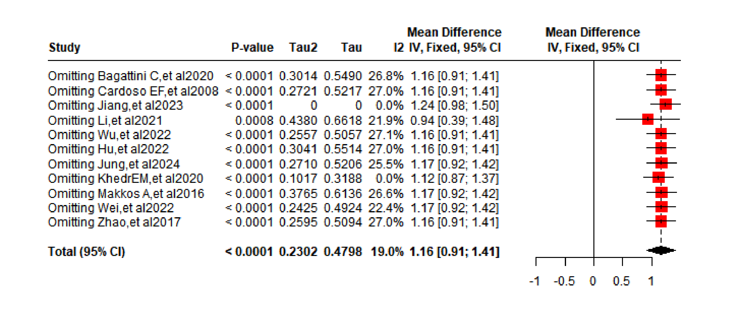
eFigure 3. shows the sensitivity analysis of HAMD.
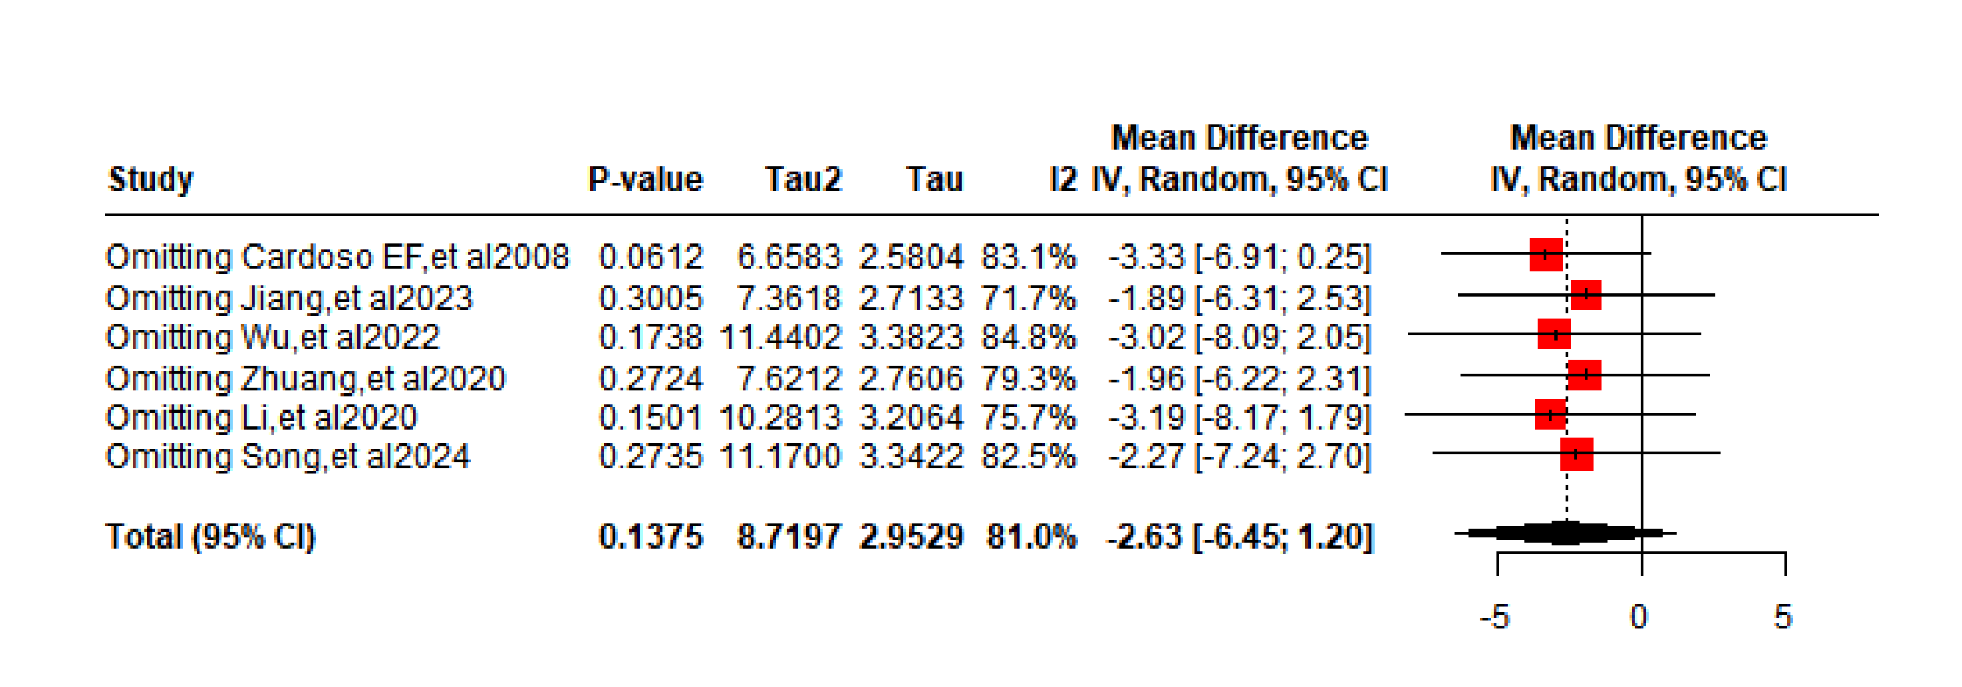

eFigure 4. shows the sensitivity analysis of HAMA.
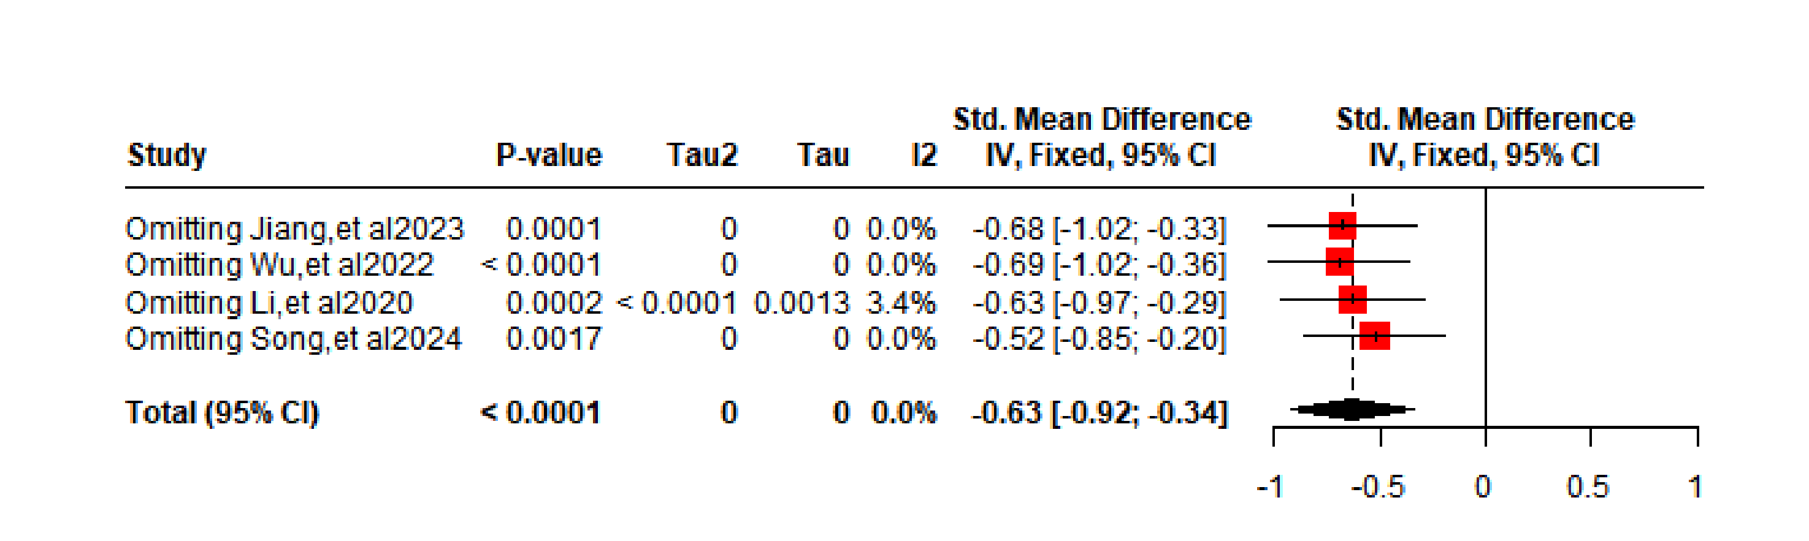
eFigure 5. shows the sensitivity analysis of ADL.
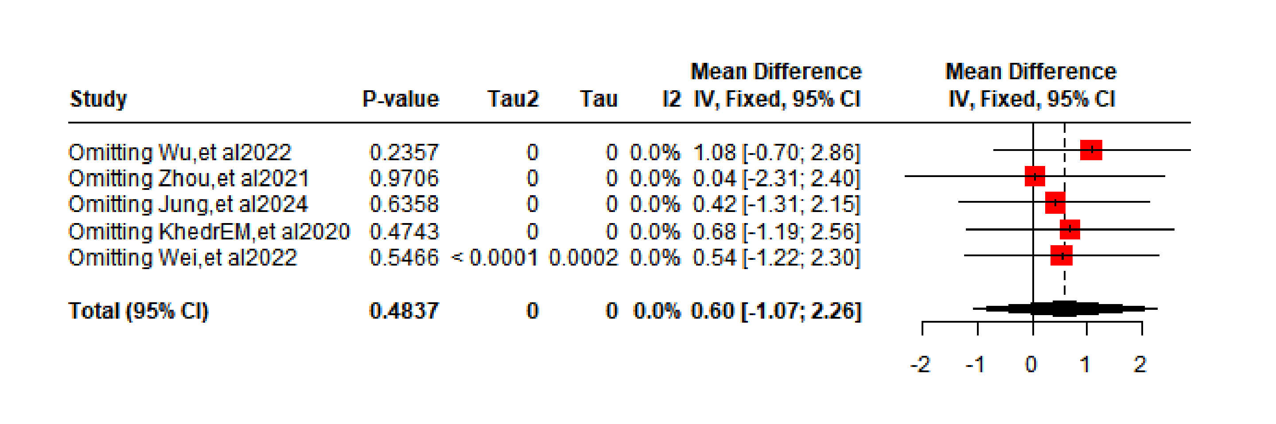

eTable 2. Grade Quality of evidence
Quality assessment |  |  |  |  |  |  | No of patients |  | Effect |  | Quality | Importance
No of studies | Design | Risk of bias | Inconsistency | Indirectness | Imprecision | Other considerations | MMSE | Control | Relative  (95% CI) | Absolute | Quality | Importance
11 | randomised trials | no serious risk of bias | no serious inconsistency | no serious indirectness | no serious imprecision | none | 252 | 233 | - | MD 1.16 higher (0.91 to 0.41 higher) | ⊕⊕⊕⊕  HIGH |  | MMSE
5 | randomised trials | serious | no serious inconsistency | no serious indirectness | no serious imprecision | none | 126 | 124 | - | MD 1.13 higher (0.87 to 1.40 higher) | ⊕⊕⊕Ο  MODERATE |  | MMSE - DLPFC
6 | randomised trials | no serious risk of bias | no serious inconsistency | no serious indirectness | no serious imprecision | none | 126 | 109 | - | MD 1.39 higher (0.64 to 2.14 higher) | ⊕⊕⊕⊕  HIGH |  | MMSE - Non-DLPFC
9 | randomised trials | no serious risk of bias | no serious inconsistency | no serious indirectness | no serious imprecision | none | 178 | 158 | - | MD 2.13 higher (0.75 to 3.52 higher) | ⊕⊕⊕⊕  HIGH |  | MoCA
5 | randomised trials | no serious risk of bias | no serious inconsistency | no serious indirectness | no serious imprecision | none | 102 | 97 | - | MD 2.73 higher (0.54 to 4.93 higher) | ⊕⊕⊕⊕  HIGH |  | MoCA - DLPFC
4 | randomised trials | no serious risk of bias | no serious inconsistency | serious | no serious imprecision | none | 76 | 61 | - | MD 0.98 higher (-1.51 lower to 3.47 higher) | ⊕⊕⊕Ο  MODERATE |  | MoCA - Non-DLPFC
5 | randomised trials | no serious risk of bias | serious | no serious indirectness | serious | none | 121 | 107 | - | MD 0.6 higher (1.07 lower to 2.26 higher) | ⊕⊕ΟΟ  LOW |  | ADL
2 | randomised trials | no serious risk of bias | serious | no serious indirectness | serious | none | 56 | 53 | - | MD 0.36 higher (1.76 lower to 2.48 higher) | ⊕⊕ΟΟ  LOW |  | ADL - DLPFC
3 | randomised trials | no serious risk of bias | serious | no serious indirectness | serious | none | 65 | 54 | - | MD 0.98 higher (1.73 lower to 3.68 higher) | ⊕⊕ΟΟ  LOW |  | ADL - Non-DLPEC
6 | randomised trials | serious | serious | no serious indirectness | no serious imprecision | none | 127 | 123 | - | MD -2.63 lower (-6.45 to 1.20 lower) | ⊕⊕ΟΟ  LOW |  | HAMD
4 | randomised trials | serious | serious | no serious indirectness | no serious imprecision | none | 81 | 77 | - | MD -2.77 lower (-10.20 to 4.66 lower) | ⊕⊕ΟΟ  LOW |  | HAMD - DLPEC
2 | randomised trials | no serious risk of bias | no serious inconsistency | no serious indirectness | no serious imprecision | none | 46 | 46 | - | MD -2.08 lower (-26.60 lower to 22.45 higher) | ⊕⊕⊕⊕  HIGH |  | HAMD - Non-DLPEC
4 | randomised trials | no serious risk of bias | no serious inconsistency | no serious indirectness | serious | none | 98 | 98 | - | MD -0.63 lower (-0.92 to 0.34 lower) | ⊕⊕⊕Ο  MODERATE |  | HAMA
2 | randomised trials | no serious risk of bias | no serious inconsistency | no serious indirectness | serious | none | 52 | 52 | - | MD -0.48 lower (-0.87 to -0.08 lower) | ⊕⊕⊕Ο  MODERATE |  | HAMA - DLPEC
2 | randomised trials | no serious risk of bias | no serious inconsistency | no serious indirectness | no serious imprecision | none | 46 | 46 | - | MD -0.80 lower (-1.23 lower to -0.38 higher) | ⊕⊕⊕⊕  HIGH |  | HAMA - Non-DLPEC

