Supplemental Materials

Supplemental Table 3 Optimal parameters of four ML models for 30-day mortality prediction

Model | Optimal parameter
LR | C=0.01, class_weight= {0:1,1:2}, max_iter=1000,solver=lbfgs,penalty=l2.fit_intercept=True
RF | criterion=entropy,max_depth=5, max_features=sqrt,n_estimators=25, random_state=1
XGBoost | objective=binary:logistic,verbosity=0, tree_method= approx,nthread=3, learning_rate=0.01,n_estimators=300,gamma=0.15,subsample=0.2,colsamlpe_bytree=0.85,max_depth-5,min_chid_weight=2
NB | var_smoothing=1e-09

Supplemental Table 4 Disease codes included in the study
Ischemic | ICD9 | 433.00,433.01,433.10,433.11,433.20,433.21,433.30,433.31,4
stroke | ICD9 | 33.80,433.81,433.90,433.91,434.00,434.01,434.10,434.11,43
 | ICD9 | 4.90,434.91
 | ICD10 | I63.41, I63.42, I63.43, I63.44, I63.5, I63.51, I63.519, I63.52,
 | ICD10 | I63.53, I63.54,
 | ICD10 | I65, I66, I63.40, I63.411, I63.412, I63.413, I63.419, I63.421,
 | ICD10 | I63.422, I63.423,
 | ICD10 | I63.429, I63.431, I63.432, I63.433, I63.439, I63.441,
 | ICD10 | I63.442, I63.443, I63.449,
 | ICD10 | I63.9, I63.50, I63.511, I63.512, I63.513, I63.521, I63.522,
 | ICD10 | I63.523, I63.529,
 | ICD10 | I63.531, I63.532, I63.533, I63.539, I63.541, I63.542,
 | ICD10 | I63.543, I63.549, I63.9,
 | ICD10 | I63.6, I63.8, I63.81, I63.89, I63.9

Supplemental Figure 1 Performance of a machine learning (ML) model in predicting 90-day mortality in ischemic stroke patients in the training and test set. ROC curve analysis (A), calibration curve analysis (B、C), parallel line plots of the evaluation indicators for each model (D), and DCA curves for each model (E)

A B
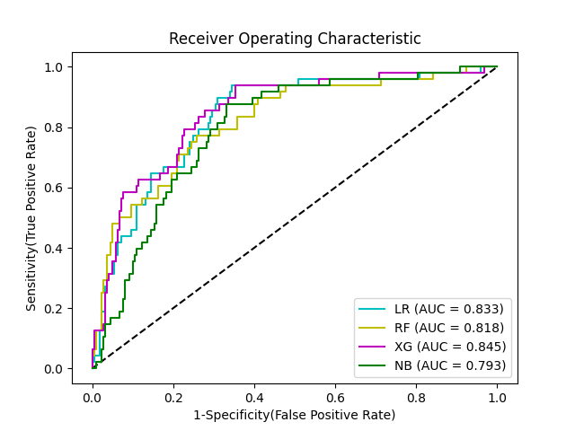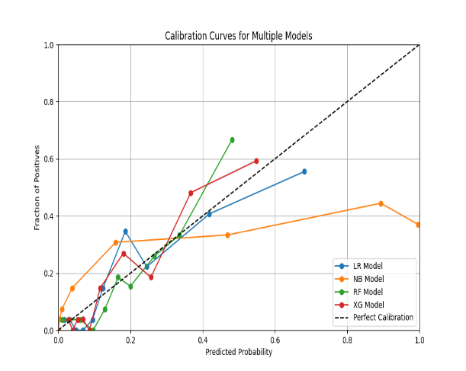
C D
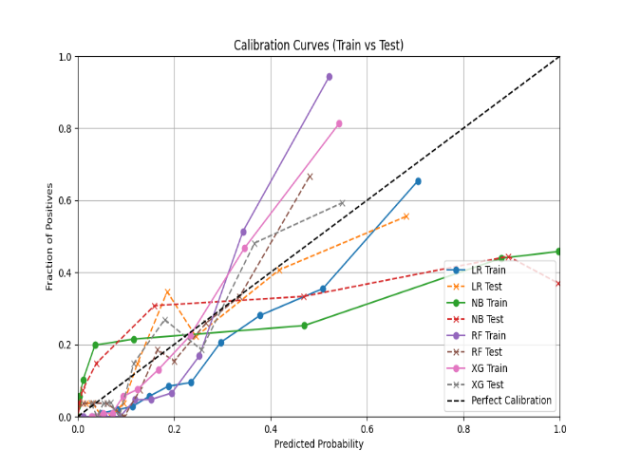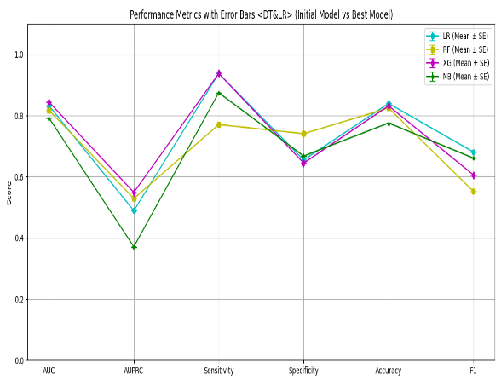

E
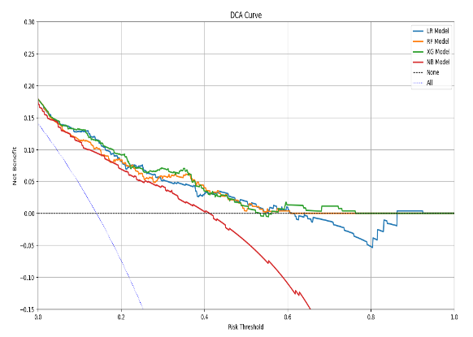
Supplemental Figure 2 (A) and (B) The top 20 risk predictors for predicting 90-day all-cause mortality in critically ill patients with ischemic stroke

A
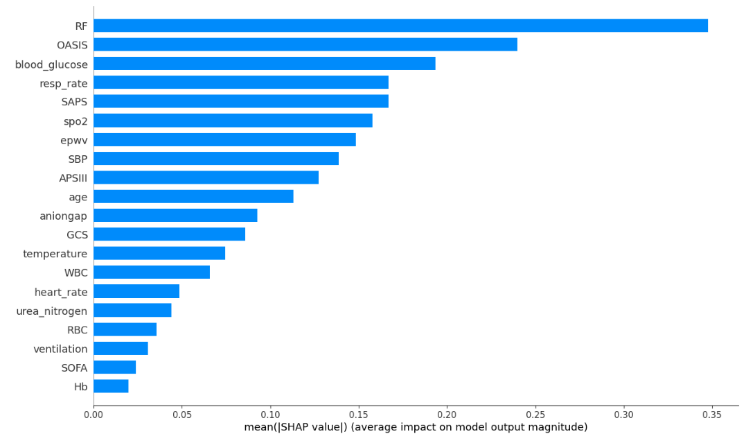

B
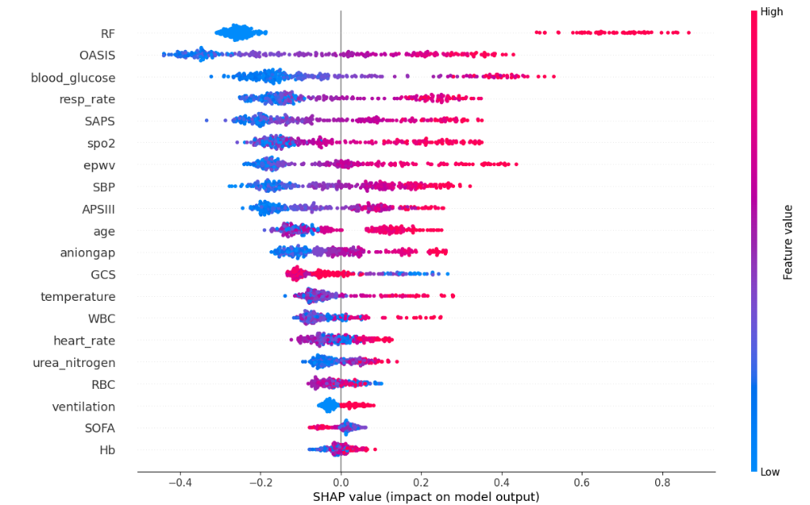

Supplemental Figure 3 Performance of a machine learning (ML) model in predicting one-year mortality in ischemic stroke patients in the training and test set. ROC curve analysis (A), calibration curve analysis (B、C), parallel line plots of the evaluation indicators for each model (D), and DCA curves for each model (E)

A B
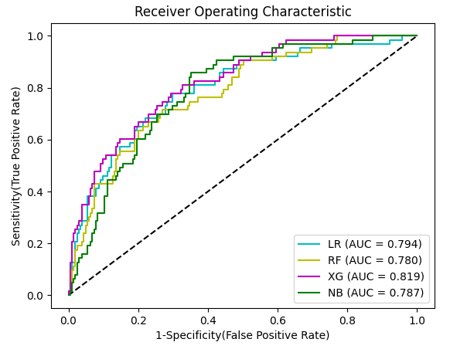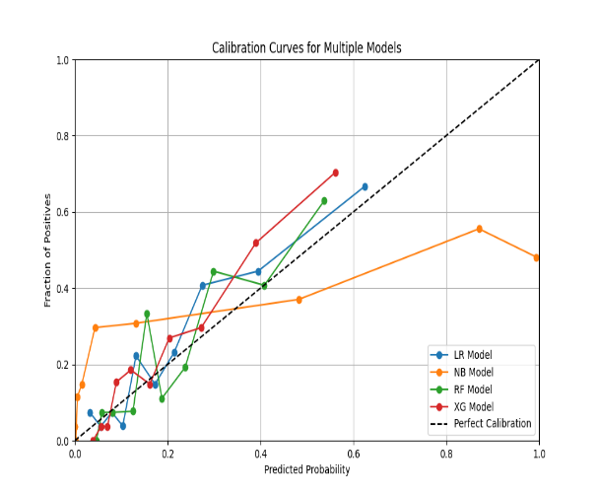
C D
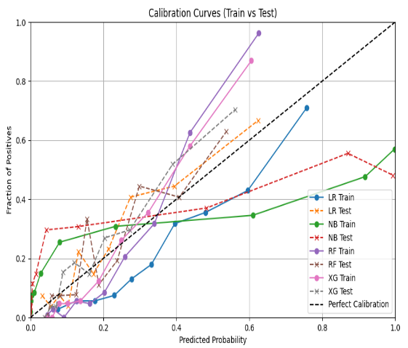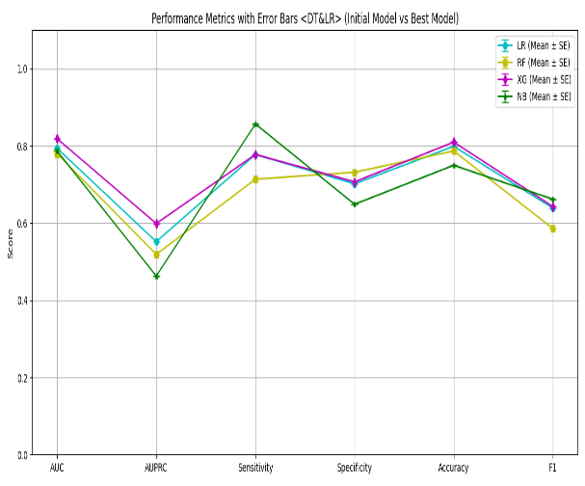
E
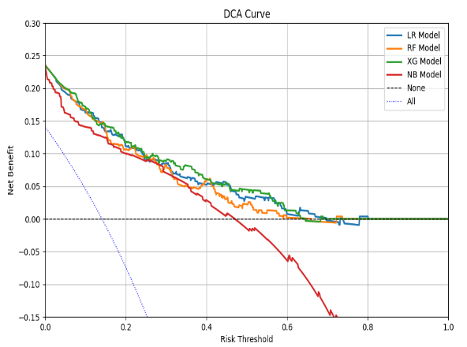

Supplemental Figure 4 (A) and (B) The top 20 risk predictors for predicting one-year all-cause mortality in critically ill patients with ischemic stroke

A
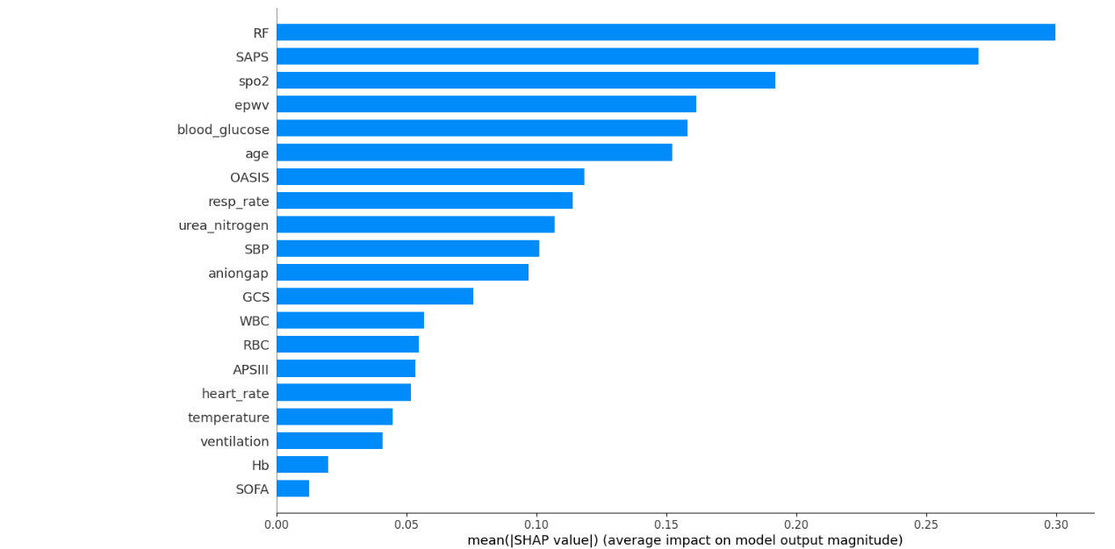
B
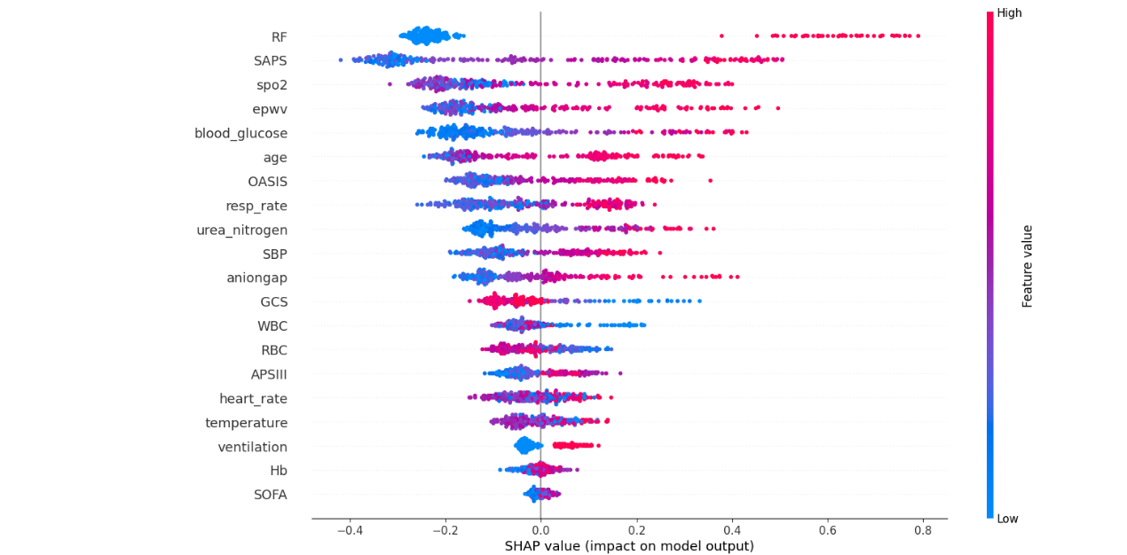

Supplemental Table 4 Comparison of performance metrics of four machine learning models in predicting 30-day, 90-day, and 1-year mortality

Models | AUC | AUPRC | Sensitivity | Specificity | Accuracy | F1
30-day mortality
LR | 0.829 | 0.475 | 0.789 | 0.735 | 0.881 | 0.691
RF | 0.826 | 0.476 | 0.763 | 0.778 | 0.858 | 0.487
XG Boost | 0.826 | 0.455 | 0.711 | 0.826 | 0.866 | 0.588
NB | 0.827 | 0.412 | 0.684 | 0.826 | 0.813 | 0.683
90-day mortality
LR | 0.833 | 0.489 | 0.938 | 0.655 | 0.84 | 0.681
RF | 0.818 | 0.529 | 0.771 | 0.741 | 0.825 | 0.552
XG Boost | 0.845 | 0.529 | 0.938 | 0.645 | 0.832 | 0.606
NB | 0.793 | 0.549 | 0.875 | 0.668 | 0.776 | 0.661
1-year mortality
LR | 0.794 | 0.552 | 0.778 | 0.702 | 0.799 | 0.639
RF | 0.78 | 0.519 | 0.714 | 0.732 | 0.797 | 0.586
XG Boost | 0.819 | 0.599 | 0.707 | 0.707 | 0.81 | 0.643
NB | 0.787 | 0.463 | 0.857 | 0.649 | 0.75 | 0.662

