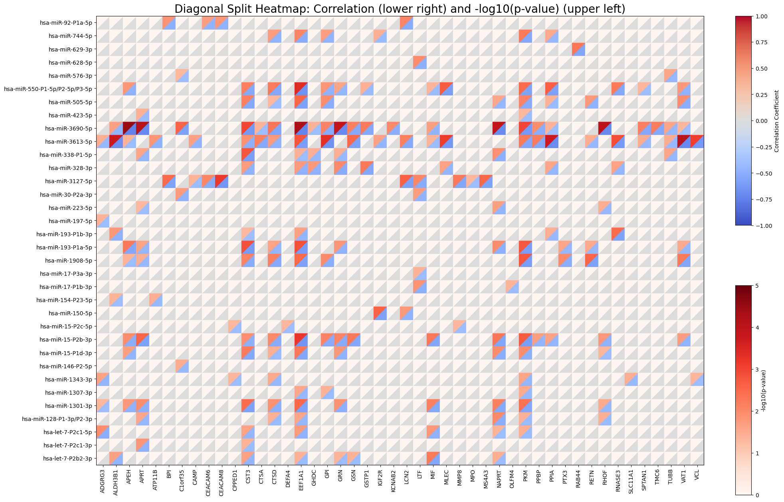

Supplemental Figure S1: Unclustered heatmap (X-axis alphabetized by gene name) for the combined Spearman correlation coefficients (r) and the -log10(p-values) between miRNA at 7 days and mRNA at 7 days from the neutrophil degranulation pathway. Each square on the heatmap is separated by a diagonal line with upper left showing the -log10(p-value) and the lower right showing the Spearman correlation coefficient. Colored boxes show results for Spearman correlation coefficient (r) < 0 and p-value <0.05. The focus on negative correlations is based on the biologic relationship between miRNA and mRNA expression.

