Supplementary Material 4
Figure S4. Screenshot of Head.AI platform
- 
- 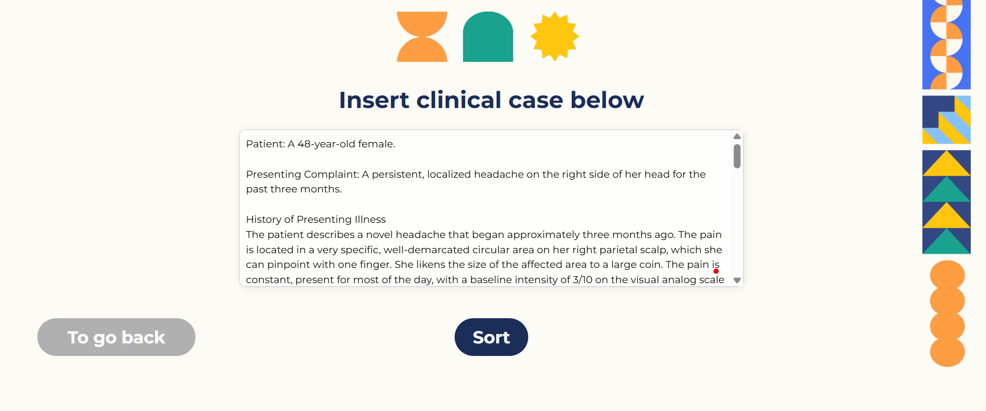
- 
- 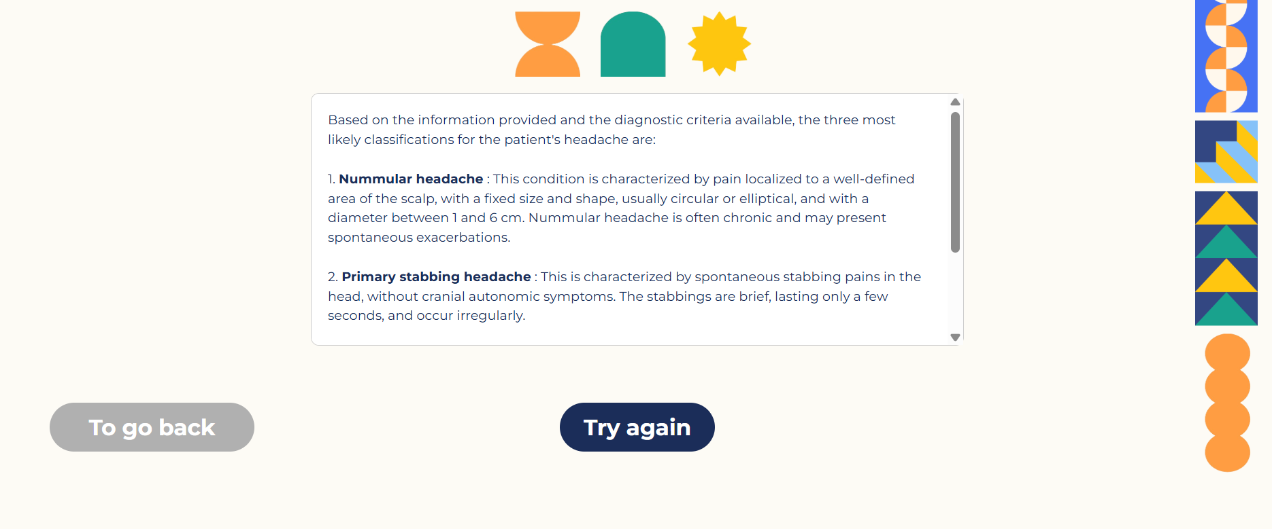
Legend. User interface of the Head.AI platform as accessed via desktop browser (A). The interface displays the input field for clinical vignette entry (B,C), the diagnostic output returned by the model (top-ranked hypothesis), and the structured explanation generated according to ICHD-3 criteria (D)

