Supplementary Materials

Comparative Effectiveness and Safety of Preventive Treatments for Vestibular Migraine: A Systematic Review and Network Meta-Analysis

Supplementary Table 1. Database Search Strategies and Results
Database | Search Strategy | Date | Results
Embase (Ovid) | (vestibular migraine or migrainous vertigo or migraine-associated vertigo).mp. and (prevention or prophylaxis or prophylactic or preventive).mp. and (randomized or randomised or RCT or placebo or trial or cohort or prospective).mp. | January 15, 2025 | 132
Scopus | TITLE-ABS-KEY("vestibular migraine" OR "migrainous vertigo" OR "migraine-associated vertigo") AND TITLE-ABS-KEY(prevention OR prophylaxis OR prophylactic OR preventive) AND TITLE-ABS-KEY(randomized OR randomised OR RCT OR placebo OR trial OR cohort OR prospective) | January 15, 2025 | 101
PubMed | ("vestibular migraine" OR "migrainous vertigo" OR "migraine-associated vertigo") AND (prevention OR prophylaxis OR prophylactic OR preventive) AND (randomized OR randomised OR RCT OR placebo OR trial OR cohort OR prospective) | January 15, 2025 | 75
Cochrane Library | ("vestibular migraine" OR "migrainous vertigo" OR "migraine-associated vertigo") AND (prevention OR prophylaxis OR prophylactic OR preventive) | January 15, 2025 | 32
Total |  |  | 340
After deduplication |  |  | 178

Additional Sources Searched:
- ClinicalTrials.gov: 48 records identified, 14 unique trials without published results
- WHO International Clinical Trials Registry Platform: 12 records identified, all duplicates
- Reference lists of included studies: 3 additional studies identified, all duplicates
- Conference abstracts (2023-2025): 4 identified, all preliminary results of included studies

Supplementary Table 2. Studies Excluded at Full-Text Review with Reasons (n=44)

Studies with Detailed Review (n=25)
Study | Primary Reason | Additional Reasons
Islam et al., 2023 | No control group | Duration <12 weeks (8 weeks)
Calandre et al., 2024 | Review article | Not primary study
Obermann & Strupp, 2014 | Review article | Not primary study
Kang et al., 2016 | Not intervention study | Prognostic study
Alghadir & Anwer, 2018 | Non-pharmacological | Vestibular rehabilitation
Hu et al., 2021 | Duration <12 weeks | Protocol only, 8-week duration
Hoskin & Fife, 2022 | Sample size <30 (n=28) | Retrospective design
Mallampalli et al., 2022 | Not primary study | Expert panel report
Oh et al., 2022 | Intervention not in protocol | Botulinum toxin, 8-week duration
Chu et al., 2023 | Network meta-analysis | Not primary study
Teelucksingh et al., 2023 | Review article | Pregnancy-specific
Hannigan et al., 2024 | No control group | Nutraceuticals not in protocol
Çelik et al., 2020 | No control group | Single-arm observational
Lovato et al., 2023 | Sample size <30 (n=23) | CGRP study, retrospective
Abu-Zaid et al., 2024 | Retrospective design | Supplements not in protocol
Karaaslan et al., 2020 | Not intervention study | Biomarker study
Çelebisoy et al., 2016 | Retrospective design | Used ICHD-3 beta criteria
Domínguez-Durán et al., 2020 | Duration <12 weeks | 5-week study, no control
Fotuhi et al., 2009 | Review article | Not primary study
Dieterich et al., 2016 | Review article | Not primary study
Teggi et al., 2015 | Intervention not in protocol | Fixed combination drug
Ceriani, 2024 | Review article | Not primary study
Beh et al., 2021 | Wrong population | MDDS not VM
Neuhauser et al., 2006 | Duration <12 weeks | 3-month open extension excluded
Yuan et al. 2016 | Sample size <30(23) | Prospective study, small sample size

Summary of Exclusion Reasons (n=44)
Exclusion Category | n (%)
Wrong study design | 14 (31.8%)
- Review/commentary | 10 (22.7%)
- Protocol only | 2 (4.5%)
- Not intervention study | 2 (4.5%)
No control group | 8 (18.2%)
Duration <12 weeks | 7 (15.9%)
Wrong intervention | 6 (13.6%)
Clinical trial registry (no results) | 14 (31.8%)
Conference abstract only | 3 (6.8%)
Retrospective design | 4 (9.1%)
Sample size <30 (CGRP) | 3 (6.8%)
Wrong population | 1 (2.3%)
*Note: Some studies had multiple exclusion reasons; primary reason listed

Supplementary Table 3. Risk of Bias Detailed Assessment

Randomized Controlled Trials (Cochrane RoB 2.0)
Study | D1: Randomization | D2: Deviations | D3: Missing Data | D4: Measurement | D5: Selection | Overall
Sharon 2024 | Low | Low | Low | Low | Low | Low
- | Computer-generated, centralized | Double-blind maintained | 5% missing, balanced | Validated VM-PATHI | Pre-specified protocol
Liu 2017 | Some concerns | High | Some concerns | Some concerns | Low | High
- | Quasi-randomization by admission | Single-blind, possible deviations | 13% missing, unclear handling | Self-reported diaries | All outcomes reported
Salviz 2015 | Low | Some concerns | Low | Some concerns | Low | Some concerns
- | Random number table | Open-label design | ITT analysis, 19% dropout | Patient-reported, unblinded | Protocol registered
Qi 2020 | Low | Low | Some concerns | Low | Low | Some concerns
- | Block randomization | Double-blind | 15% missing, per-protocol only | Standardized assessment | Pre-specified outcomes
Lepcha 2014 | Low | Some concerns | Low | Some concerns | Low | Some concerns
- | Computer-generated | Open-label | Complete follow-up | Categorical outcomes only | All outcomes reported
Bayer 2019 | Low | Low | High | Some concerns | Some concerns | High
- | Centralized IVRS | Double-blind | 37% dropout, early termination | Electronic diary | Terminated early
Maksoud Nassar 2023 | Some concerns | High | Low | Some concerns | Low | High
- | Method not described | Open-label | No dropouts | Unblinded assessment | Complete reporting

Observational Studies (ROBINS-I)
Study | Confounding | Selection | Classification | Deviations | Missing | Measurement | Reporting | Overall
Russo 2023 | Moderate | Low | Low | Low | Low | Moderate | Low | Moderate
- | Adjusted for baseline | Consecutive enrollment | Clear drug/dose | Protocol adherence | Complete data | Self-reported diary | All outcomes
Görür 2021 | Serious | Low | Low | Moderate | Moderate | Moderate | Low | Serious
- | Non-randomized allocation | All eligible included | Treatment documented | Variable adherence | 18% dropout | Unblinded | Complete

Supplementary Table 4. GRADE Evidence Profiles

Primary Outcome: Monthly Vertigo Frequency Reduction
Comparison | Studies (n) | Risk of Bias | Inconsistency | Indirectness | Imprecision | Other | MD (95% CI) | Certainty
Galcanezumab vs Control | 1 (40) | Not serious | Not assessable¹ | Not serious | Serious² | None | -5.80 (-10.61 to -0.99) | ⊕⊕⊕⊝ Moderate
Propranolol vs Control | 0 (0)³ | Serious⁴ | Not assessable¹ | Serious⁵ | Serious² | None | -7.04 (-12.77 to -1.31) | ⊕⊕⊝⊝ Low
Venlafaxine vs Control | 0 (0)³ | Serious⁴ | Not assessable¹ | Serious⁵ | Serious² | None | -5.94 (-8.98 to -2.90) | ⊕⊕⊝⊝ Low
Flunarizine vs Control | 1 (52) | Serious⁶ | Not assessable¹ | Not serious | Serious² | None | -4.00 (-6.54 to -1.46) | ⊕⊕⊝⊝ Low
Valproic acid vs Control | 0 (0)³ | Serious⁴ | Not assessable¹ | Serious⁵ | Very serious⁷ | None | -5.95 (-9.01 to -2.89) | ⊕⊝⊝⊝ Very low
LcS vs Control | 1 (247) | Serious⁶ | Not assessable¹ | Not serious | Not serious | None | -2.59 (-3.31 to -1.87) | ⊕⊕⊝⊝ Low
¹Single study per comparison or no closed loops in network ²Wide confidence intervals and/or small sample size ³Indirect evidence only through network ⁴High risk of bias in contributing studies ⁵All evidence indirect through network connections ⁶Some concerns in risk of bias assessment ⁷Very wide confidence intervals, smallest sample size

Secondary Outcomes
Outcome | Comparison | Studies | Participants | Effect Estimate | Certainty
DHI Score | Galcanezumab vs Control | 1 | 40 | MD -13.7 (-20.4 to -8.5) | ⊕⊕⊕⊝ Moderate
Responder Rate | Galcanezumab vs Control | 1 | 40 | RR 1.60 (0.92 to 2.79) | ⊕⊕⊝⊝ Low
Discontinuation | All treatments | 7 | 419 | Range 0-25% | ⊕⊕⊝⊝ Low

Supplementary Table 5. Sensitivity Analysis Results

SA1: Fixed-Effect Model
Treatment | Random-Effects MD | Fixed-Effect MD | Difference | Rank Change
Propranolol | -7.04 | -7.04 | 0.000 | 0
Valproic acid | -5.95 | -5.95 | 0.000 | 0
Venlafaxine | -5.94 | -5.94 | 0.000 | 0
Galcanezumab | -5.80 | -5.80 | 0.000 | 0
Flunarizine | -4.00 | -4.00 | 0.000 | 0
LcS | -2.59 | -2.59 | 0.000 | 0
Interpretation: Negligible heterogeneity (τ²<0.001) resulted in identical fixed and random-effects estimates

SA2: Threshold Analysis
Analysis | Current Value | Threshold | Change Needed | % Change
Propranolol to lose #1 rank | -7.04 | -5.95 | 1.09 | 15.5%
Galcanezumab to become #1 | -5.80 | -7.04 | 1.24 | 21.4%
Significance threshold (Propranolol) | -7.04 | -1.31 | 5.73 | 81.4%
Clinical threshold (2 attacks/month) | All treatments | >2.0 | 0.59-5.04 | Exceeded

SA3: Feasibility of Planned Sensitivity Analyses
Planned Analysis | Feasible | Result/Reason
Fixed-effect model | ✓ Yes | Completed - identical results
Include observational | ✓ Yes | Network disconnected (2 subnetworks)
Low RoB only | ✗ No | Only 1 study (network collapses)
≥6 months duration | ✗ No | No studies met criteria
3-month outcomes only | ✗ No | Would exclude key evidence
Drug class analysis | ✓ Yes | Each class n=1, no within-class comparison

Supplementary Table 6. Network Connectivity Matrix
 | Control | Propranolol | Valproic acid | Venlafaxine | Galcanezumab | Flunarizine | LcS
Control | - | 0 | 0 | 0 | 1 (Sharon) | 1 (Lepcha) | 1 (Qi)
Propranolol | 0 | - | 0 | 1 (Salviz) | 0 | 0 | 0
Valproic acid | 0 | 0 | - | 1 (Liu) | 0 | 0 | 0
Venlafaxine | 0 | 1 | 1 | - | 0 | 1 (Liu) | 0
Galcanezumab | 1 | 0 | 0 | 0 | - | 0 | 0
Flunarizine | 1 | 0 | 0 | 1 | 0 | - | 0
LcS | 1 | 0 | 0 | 0 | 0 | 0 | -
Numbers indicate direct comparisons; study names in parentheses

Supplementary Table 7. Outcome Harmonization Details
Study | Original Scale | Original Values | Converted to Monthly | Conversion Method
Sharon 2024 | Dizzy days/month | Direct | No conversion needed | -
Liu 2017 | Attacks/month | Direct | No conversion needed | -
Salviz 2015 | Attacks/month | Direct | No conversion needed | -
Qi 2020 | Episodes/month | Direct | No conversion needed | -
Lepcha 2014 | Categorical frequency | Low/High | Estimated means | Assumed distributions
Bayer 2019 | Attacks/30 days | IRR only | Could not convert | Excluded from NMA
Maksoud Nassar 2023 | Proportional change | -0.43 to -0.55 | Could not convert | Excluded from NMA
Russo 2023 | Vertigo days/month | Direct | No conversion needed | -
Görür 2021 | Attacks/3 months | 5.4±1.7 baseline | Divided by 3 | 1.8±0.57/month

Supplementary Table 8. Sample Size and Power Considerations
Comparison | Total N | Per Arm | Power for 3 attacks/month difference* | Actual Difference | Significant
Galcanezumab vs Control | 40 | 18/22 | 45% | 5.80 | Yes
Flunarizine vs Control | 52 | 25/27 | 52% | 4.00 | Yes
LcS vs Control | 247 | 103/144 | 99% | 2.59 | Yes
Propranolol vs Venlafaxine | 64 | 33/31 | 58% | 1.10 | No
Flunarizine vs Venlafaxine | 45 | 22/23 | 42% | 1.94 | Yes
Valproic acid vs Venlafaxine | 43 | 20/23 | 40% | 0.01 | No
*Assuming SD=3.5, α=0.05, two-tailed test

Supplementary Figure Legends
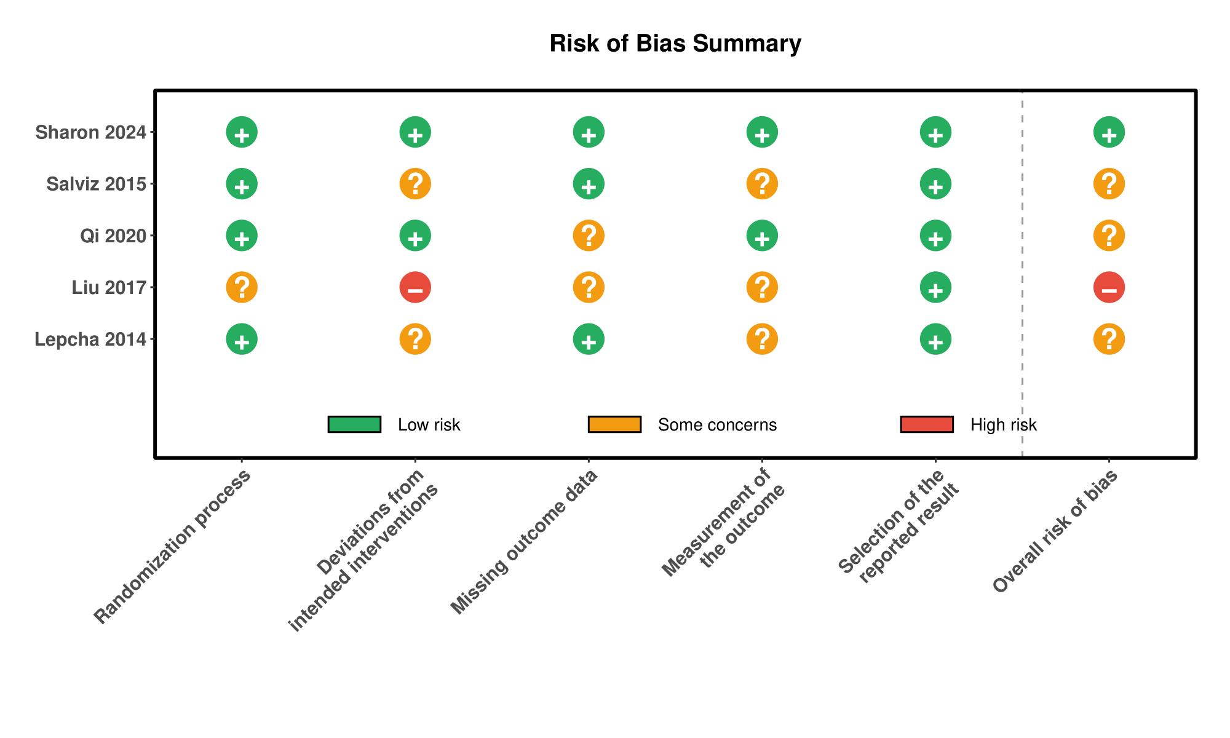
Supplementary Figure 1. Risk of Bias Summary Traffic light plot showing risk of bias assessments across five domains for each included randomized controlled trial. Green = low risk, yellow = some concerns, red = high risk.

