Supplemental Figure 3
A Scatter Plot Including Participants’ Age as the Moderator
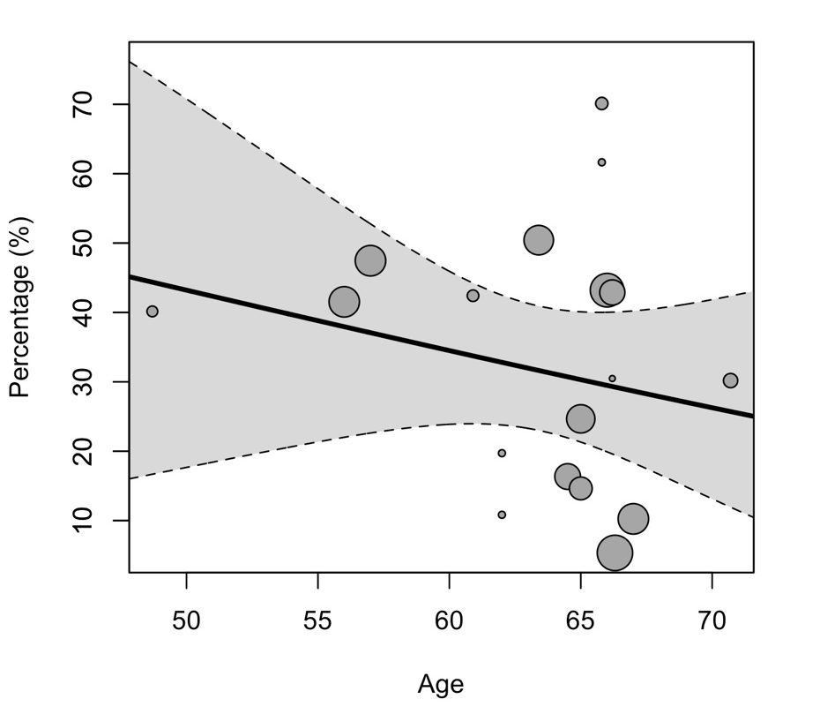
Note. Age (in years); Percentage = frequency of depression

