Supplementary Table 1. List of White Matter Tracts and Their Abbreviations
No. | Fiber | Abbreviation
1 | Left Thalamic Radiation | ATR_L
2 | Right Thalamic Radiation | ATR_R
3 | Left Corticospinal | CSF_L
4 | Right Corticospinal | CSF_R
5 | Left Cingulum Cingulate | CGC_L
6 | Right Cingulum Cingulate | CGC_R
7 | Left Cingulum Hippocampus | HCC_L
8 | Right Cingulum Hippocampus | HCC_R
9 | Callosum Forceps Major | FMa
10 | Callosum Forceps Minor | FMi
11 | Left IFOF | IFOF_L
12 | Right IFOF | IFOF_R
13 | Left ILF | ILF_L
14 | Right ILF | ILF_R
15 | Left SLF | SLF_L
16 | Right SLF | SLF_R
17 | Left Uncinate | UF_L
18 | Right Uncinate | UF_R
19 | Left Arcuate | AF_L
20 | Right Arcuate | AF_R
IFOF: Left Inferior Fronto-Occipital Fasciculus; ILF: Inferior Longitudinal Fasciculus;
SLF: Superior Longitudinal Fasciculus

Supplementary Table 2. Group Differences in MD Between NC and IE
Fiber | ROI | Start | End | Type | MeanSD_NC | MeanSD_IE | p | d | power
ATR_L | 1 | 1 | 32 | overlap | 0.801±0.034 | 0.844±0.042 | 0.000 | -1.121 | 0.988
ATR_R | 1 | 1 | 14 | overlap | 0.834±0.037 | 0.872±0.047 | 0.001 | -0.911 | 0.930
HCC_L | 1 | 70 | 100 | NC_IE | 0.837±0.031 | 0.874±0.029 | 0.000 | -1.224 | 0.996
FMa | 1 | 46 | 55 | NC_IE | 0.859±0.112 | 0.992±0.200 | 0.005 | -0.817 | 0.870
FMa | 2 | 81 | 96 | NC_IE | 0.914±0.105 | 0.836±0.047 | 0.001 | 0.949 | 0.948
FMi | 1 | 1 | 47 | overlap | 0.863±0.042 | 0.917±0.060 | 0.000 | -1.050 | 0.978
FMi | 2 | 65 | 100 | overlap | 0.878±0.041 | 0.926±0.054 | 0.000 | -1.006 | 0.967
IFOF_L | 1 | 37 | 65 | overlap | 0.848±0.026 | 0.881±0.035 | 0.000 | -1.070 | 0.981
IFOF_L | 2 | 71 | 100 | overlap | 0.821±0.035 | 0.863±0.035 | 0.000 | -1.224 | 0.996
ILF_L | 1 | 36 | 75 | overlap | 0.911±0.033 | 0.948±0.046 | 0.001 | -0.923 | 0.936
ILF_L | 2 | 82 | 94 | overlap | 0.902±0.041 | 0.929±0.037 | 0.010 | -0.697 | 0.750
ILF_R | 1 | 81 | 98 | overlap | 0.865±0.033 | 0.897±0.032 | 0.000 | -0.966 | 0.954
SLF_L | 1 | 2 | 44 | overlap | 0.777±0.027 | 0.804±0.050 | 0.015 | -0.660 | 0.703
SLF_L | 2 | 58 | 96 | overlap | 0.795±0.030 | 0.849±0.086 | 0.003 | -0.828 | 0.878
UF_R | 1 | 1 | 33 | overlap | 0.889±0.027 | 0.919±0.027 | 0.000 | -1.095 | 0.985
d: Cohen’s d (effect size); power: statistical power based on observed effect size; p: FDR-corrected p-value;
Overlap: ROI significant in both NC vs. IE and preoperative vs. postoperative comparisons;
Type: comparison type (NC vs. IE or preoperative vs. postoperative)

Supplementary Table 3. Group Differences in MD Between IE_preop and IE_postop
Fiber | ROI | Start | End | Type | MeanSD_IE1 | MeanSD_IE2 | p | d | power
ATR_L | 1 | 1 | 32 | overlap | 0.871±0.047 | 0.804±0.030 | 0.000 | 1.213 | 0.997
ATR_R | 1 | 1 | 14 | overlap | 0.898±0.049 | 0.829±0.029 | 0.000 | 1.124 | 0.991
CSF_L | 1 | 5 | 100 | IE1_IE2 | 0.818±0.030 | 0.764±0.020 | 0.000 | 1.386 | 1.000
CSF_R | 1 | 8 | 51 | IE1_IE2 | 0.836±0.032 | 0.790±0.032 | 0.001 | 0.956 | 0.959
CSF_R | 2 | 60 | 100 | IE1_IE2 | 0.791±0.031 | 0.756±0.024 | 0.004 | 0.817 | 0.885
CGC_R | 1 | 1 | 100 | IE1_IE2 | 0.899±0.039 | 0.829±0.024 | 0.000 | 1.834 | 1.000
FMi | 1 | 1 | 47 | overlap | 0.948±0.069 | 0.879±0.036 | 0.000 | 1.199 | 0.996
FMi | 2 | 65 | 100 | overlap | 0.957±0.061 | 0.888±0.030 | 0.000 | 1.502 | 1.000
IFOF_L | 1 | 37 | 65 | overlap | 0.904±0.034 | 0.845±0.025 | 0.000 | 1.597 | 1.000
IFOF_L | 2 | 71 | 100 | overlap | 0.887±0.035 | 0.819±0.028 | 0.000 | 1.542 | 1.000
IFOF_R | 1 | 25 | 100 | IE1_IE2 | 0.893±0.026 | 0.839±0.023 | 0.000 | 1.346 | 0.999
ILF_L | 1 | 36 | 75 | overlap | 0.974±0.040 | 0.897±0.036 | 0.000 | 1.982 | 1.000
ILF_L | 2 | 82 | 94 | overlap | 0.951±0.036 | 0.898±0.030 | 0.000 | 1.282 | 0.999
ILF_R | 1 | 81 | 98 | overlap | 0.916±0.027 | 0.867±0.034 | 0.000 | 1.113 | 0.990
SLF_L | 1 | 2 | 44 | overlap | 0.832±0.058 | 0.772±0.021 | 0.001 | 0.928 | 0.948
SLF_L | 2 | 58 | 96 | overlap | 0.884±0.109 | 0.803±0.019 | 0.014 | 0.668 | 0.734
SLF_R | 1 | 1 | 100 | IE1_IE2 | 0.842±0.047 | 0.775±0.018 | 0.000 | 1.168 | 0.995
UF_L | 1 | 6 | 56 | IE1_IE2 | 0.965±0.138 | 0.876±0.026 | 0.018 | 0.637 | 0.694
UF_L | 2 | 63 | 100 | IE1_IE2 | 0.880±0.119 | 0.800±0.028 | 0.011 | 0.701 | 0.774
UF_R | 1 | 1 | 33 | overlap | 0.937±0.022 | 0.893±0.032 | 0.000 | 1.153 | 0.994
d: Cohen’s d (effect size); power: statistical power based on observed effect size; p: FDR-corrected p-value;
Overlap: ROI significant in both NC vs. IE and preoperative vs. postoperative comparisons; IE1:IE_preop; IE2:IE_postop;
Type: comparison type (NC vs. IE or preoperative vs. postoperative)

Supplementary Table 4. Group Differences in FA Between NC and IE
Fiber | ROI | Start | End | Type | MeanSD_NC | MeanSD_IE | p | d | power
ATR_L | 1 | 32 | 41 | overlap | 0.465±0.041 | 0.429±0.043 | 0.003 | 0.846 | 0.891
ATR_L | 2 | 73 | 85 | overlap | 0.424±0.056 | 0.383±0.049 | 0.005 | 0.785 | 0.842
ATR_R | 1 | 9 | 17 | overlap | 0.327±0.033 | 0.362±0.041 | 0.001 | -0.937 | 0.942
CMa | 1 | 44 | 55 | NC_IE | 0.758±0.058 | 0.690±0.092 | 0.003 | 0.878 | 0.912
IFOF_R | 1 | 9 | 23 | NC_IE | 0.421±0.050 | 0.477±0.042 | 0.000 | -1.206 | 0.995
SLF_L | 1 | 4 | 61 | NC_IE | 0.400±0.045 | 0.451±0.078 | 0.003 | -0.805 | 0.860
SLF_R | 1 | 1 | 44 | NC_IE | 0.416±0.054 | 0.460±0.052 | 0.002 | -0.827 | 0.877
d: Cohen’s d (effect size); power: statistical power based on observed effect size; p: FDR-corrected p-value;
Overlap: ROI significant in both NC vs. IE and preoperative vs. postoperative comparisons;
Type: comparison type (NC vs. IE or preoperative vs. postoperative)

Supplementary Table 5. Group Differences in FA Between IE_preop and IE_postop
Fiber | ROI | Start | End | Type | MeanSD_IE1 | MeanSD_IE2 | p | d | power
ATR_L | 1 | 32 | 41 | overlap | 0.413±0.039 | 0.468±0.046 | 0.000 | -1.242 | 0.998
ATR_L | 2 | 73 | 85 | overlap | 0.371±0.042 | 0.423±0.058 | 0.015 | -0.715 | 0.791
ATR_R | 1 | 9 | 17 | overlap | 0.342±0.032 | 0.367±0.032 | 0.004 | -0.851 | 0.908
CSF_L | 1 | 1 | 8 | IE1_IE2 | 0.436±0.034 | 0.490±0.036 | 0.001 | -1.054 | 0.983
CGC_L | 1 | 6 | 18 | IE1_IE2 | 0.336±0.043 | 0.393±0.052 | 0.013 | -0.857 | 0.912
CGC_L | 2 | 52 | 89 | IE1_IE2 | 0.452±0.045 | 0.504±0.069 | 0.000 | -1.428 | 1.000
CGC_R | 1 | 14 | 31 | IE1_IE2 | 0.354±0.038 | 0.429±0.059 | 0.005 | -0.998 | 0.971
CGC_R | 2 | 54 | 90 | IE1_IE2 | 0.387±0.052 | 0.429±0.056 | 0.002 | -1.158 | 0.994
CMi | 1 | 34 | 46 | IE1_IE2 | 0.646±0.097 | 0.725±0.047 | 0.008 | -0.728 | 0.804
CMi | 2 | 53 | 90 | IE1_IE2 | 0.529±0.063 | 0.596±0.037 | 0.001 | -0.979 | 0.966
IFOF_R | 2 | 81 | 89 | IE1_IE2 | 0.367±0.032 | 0.421±0.036 | 0.000 | -1.176 | 0.995
ILF_L | 1 | 19 | 46 | IE1_IE2 | 0.426±0.040 | 0.474±0.033 | 0.000 | -1.135 | 0.992
ILF_L | 2 | 55 | 68 | IE1_IE2 | 0.336±0.038 | 0.384±0.038 | 0.004 | -0.840 | 0.902
ILF_L | 3 | 79 | 91 | IE1_IE2 | 0.327±0.025 | 0.364±0.036 | 0.001 | -1.034 | 0.979
ILF_R | 1 | 15 | 60 | IE1_IE2 | 0.412±0.043 | 0.456±0.033 | 0.000 | -1.311 | 0.999
SLF_R | 2 | 65 | 84 | IE1_IE2 | 0.401±0.050 | 0.445±0.047 | 0.000 | -1.103 | 0.989
UF_R | 1 | 69 | 100 | IE1_IE2 | 0.413±0.053 | 0.472±0.040 | 0.001 | -1.030 | 0.978
d: Cohen’s d (effect size); power: statistical power based on observed effect size; p: FDR-corrected p-value;
Overlap: ROI significant in both NC vs. IE and preoperative vs. postoperative comparisons; IE1:IE_preop; IE2:IE_postop;
Type: comparison type (NC vs. IE or preoperative vs. postoperative)

Supplementary Table 6. Optic Radiation MD and FA: Lateral and Longitudinal Comparisons
 |  | NC vs. IE |  |  | IE-preop vs. IE-postop
 |  | p | Cohen’s d | power | p | Cohen’s d | power
OR_L | MD | 0.0878 | -0.4841 | 0.4477 | 0.0819 | 0.5393 | 0.5372
OR_L | FA | 0.0878 | -0.5175 | 0.5083 | 0.9830 | -0.0053 | 0.0500
OR_R | MD | 0.0878 | 0.0721 | 0.0582 | 0.0634 | 0.6542 | 0.7166
OR_R | FA | 0.7812 | -0.5017 | 0.4779 | 0.9830 | -0.0646 | 0.0572
MD, mean diffusivity; FA, fractional anisotropy; p, FDR-corrected p-value;
d, Cohen’s d; power, statistical power.

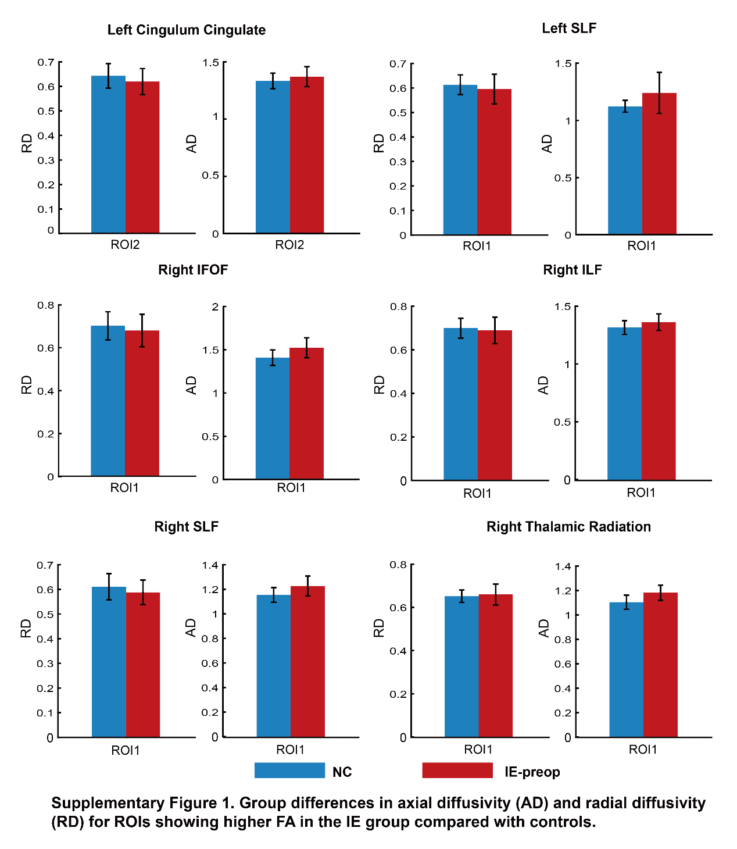

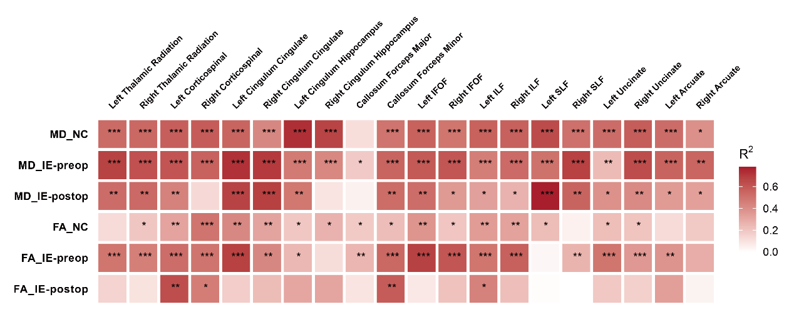
Supplementary Figure 2. Linear regression of age on MD and FA across three groups. R² represents the coefficient of determination. Significance levels after FDR correction are indicated as */**/***, corresponding to p < 0.05, p < 0.01, and p < 0.001, respectively.

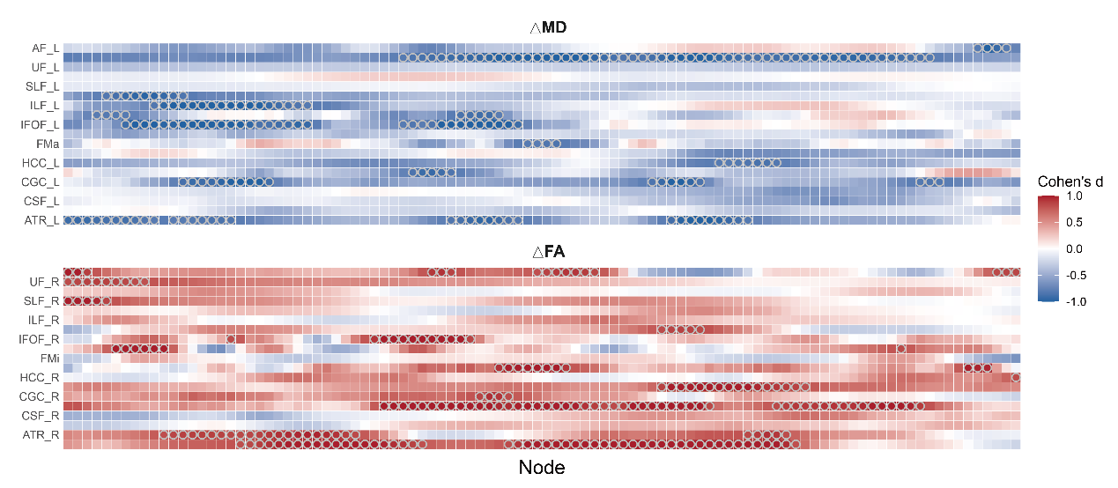
Supplementary Figure 3. Node-wise Cohen’s d of ΔMD and ΔFA between early and late surgery groups.

