APPENDIX
APPENDIX1. An overview of the walkway for FGA.
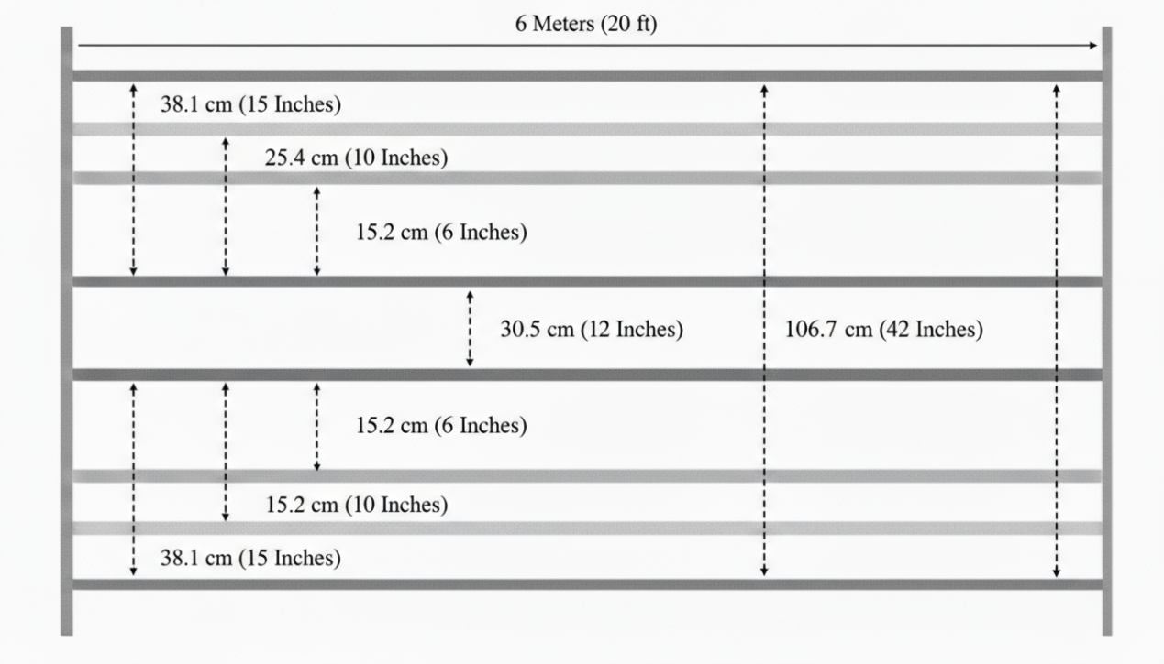
APPENDIX2. The FGA scoring form.


