Table S1: Baseline Characteristics of Included vs. Excluded Participants from the CHARLS Cohort.
 | Excluded Participants | Included Participants | Standardize diff. | P-value
N | 9392 | 8316
Age | 58.52 ± 10.91 | 59.27 ± 9.28 | 0.07 (0.04, 0.10) | <0.001
SBP | 130.47 ± 21.87 | 129.11 ± 21.38 | 0.06 (0.03, 0.10) | <0.001
DBP | 75.87 ± 12.30 | 75.25 ± 12.23 | 0.05 (0.02, 0.08) | 0.004
IS | 0.00 ± 1.56 | -0.00 ± 1.56 | 0.00 (-0.04, 0.04) | 0.924
TC | 191.59 ± 40.29 | 193.52 ± 38.31 | 0.05 (0.01, 0.09) | 0.016
LDL-c | 114.60 ± 35.32 | 116.61 ± 34.80 | 0.06 (0.02, 0.10) | 0.005
BUN | 15.80 ± 5.06 | 15.73 ± 4.47 | 0.02 (-0.02, 0.06) | 0.412
HbA1c | 5.46 ± 1.18 | 5.18 ± 0.60 | 0.30 (0.26, 0.34) | <0.001
SUA | 4.50 ± 1.34 | 4.45 ± 1.24 | 0.04 (0.00, 0.08) | 0.043
eGFR | 96.89 ± 17.90 | 97.01 ± 15.25 | 0.01 (-0.03, 0.05) | 0.718
HPCC | 8215.66 ± 25428.05 | 6531.92 ± 8541.38 | 0.09 (0.06, 0.12) | <0.001
Gender |  |  | 0.05 (0.02, 0.08) | 0.002
Female | 4792 (51.03%) | 4435 (53.33%)
Male | 4598 (48.97%) | 3881 (46.67%)
Hukou |  |  | 0.28 (0.25, 0.31) | <0.001
Urban | 2608 (27.89%) | 1362 (16.38%)
Rural | 6742 (72.11%) | 6954 (83.62%)
Marital status |  |  | 0.23 (0.20, 0.26) | <0.001
Married | 7215 (77.09%) | 6955 (83.63%)
Married, not cohabiting | 896 (9.57%) | 351 (4.22%)
Separate | 39 (0.42%) | 44 (0.53%)
Divorce | 94 (1.00%) | 53 (0.64%)
Widowed | 1015 (10.85%) | 854 (10.27%)
Never married | 100 (1.07%) | 59 (0.71%)
Drinking status |  |  | 0.03 (0.00, 0.06) | 0.074
Never | 5663 (61.35%) | 5060 (60.85%)
Ever | 791 (8.57%) | 652 (7.84%)
Current | 2776 (30.08%) | 2604 (31.31%)
Smoking status |  |  | 0.09 (0.06, 0.12) | <0.001
Never | 5585 (64.84%) | 5050 (60.73%)
Ever | 716 (8.31%) | 705 (8.48%)
Current | 2312 (26.84%) | 2561 (30.80%)
Hypertension |  |  | 0.09 (0.06, 0.12) | <0.001
No | 6624 (72.13%) | 6330 (76.12%)
Yes | 2559 (27.87%) | 1986 (23.88%)
Heart disease |  |  | 0.08 (0.05, 0.11) | <0.001
No | 7936 (86.53%) | 7420 (89.23%)
Yes | 1235 (13.47%) | 896 (10.77%)
Dyslipidemia |  |  | 0.12 (0.09, 0.15) | <0.001
No | 7962 (88.37%) | 7654 (92.04%)
Yes | 1048 (11.63%) | 662 (7.96%)
Continuous variables are presented as mean ± standard deviation; Categorical variables are presented as n (%). Standardized differences (Std. diff) were calculated for continuous variables. SBP, systolic blood pressure; DBP, diastolic blood pressure; TC, total cholesterol; LDL-c, low-density lipoprotein cholesterol; HbA1c, glycosylated hemoglobin; BUN, blood urea nitrogen; CREA, creatinine; eGFR, estimated glomerular filtration rate; SUA, serum uric acid; CRP, C-reactive protein; MAP, mean arterial pressure; IS inflammatory score; HPCC household per capita consumption.

Table S2 Independent variable collinearity stepwise screening
 | Step 1
Age | 1.9
Gender | 2.4
Hukou | 1.1
Marital status | 1.1
Drinking status | 1.4
Smoking status | 1.9
Hypertension | 1.3
Heart disease | 1.1
Dyslipidemia | 1.1
SBP | 2.8
DBP | 2.5
IS | 1.0
TC | 3.4
LDL-c | 3.3
BUN | 1.1
HbA1c | 1.1
SUA | 1.6
eGFR | 1.9
HPCC | 1.1
METS-IR | 1.3
Calculate the VIF of each variable, and if the maximum VIF value is > = 5, eliminate the variable with the maximum VIF value. Repeat the previous step until the VIF of all remaining variables is less than 5. SBP systolic blood pressure, DBP diastolic blood pressure, TC total cholesterol, LDL-c low-density lipoprotein cholesterol, HbA1c glycosylated hemoglobin, BUN blood urea nitrogen, CREA creatinine, eGFR estimated glomerular filtration rate, SUA serum uric acid, CRP C-reactive protein, MAP mean arterial pressure, HPCC household per capita consumption, IS inflammatory score, METS-IR the metabolic score for insulin resistance index.

Table S3. Predictive performance of clinical and metabolic markers for incident stroke
 | AUC | C-index (95% CI)
METS-IR | 0.573 | 0.575 (0.554–0.596)
HbA1c | 0.519 | 0.536 (0.515–0.557)
SUA | 0.510 | 0.525 (0.504–0.546)
TG | 0.549 | 0.555 (0.534–0.576)
BMI | 0.557 | 0.564 (0.543–0.585)
HDL-c | 0.454 | 0.547 (0.526–0.568)
IS | 0.535 | 0.543 (0.522–0.564)
TC | 0.516 | 0.523 (0.502–0.544)
LDL-c | 0.524 | 0.531 (0.510–0.552)
BUN | 0.486 | 0.503 (0.482–0.524)
eGFR | 0.452 | 0.569 (0.548–0.590)
HPCC | 0.491 | 0.492 (0.471–0.513)
METS-IR the metabolic score for insulin resistance index, HbA1c glycosylated hemoglobin, SUA serum uric acid, TG triglycerides, BMI body mass index, HDL-c high-density lipoprotein cholesterol, IS inflammatory score, TC total cholesterol, LDL-c low-density lipoprotein cholesterol, BUN blood urea nitrogen, eGFR estimated glomerular filtration rate, HPCC household per capita consumption.
AUC, Area Under the Curve，C-index, Concordance Index.

Table S4. Multivariable Fine–Gray competing risk regression for incident stroke
Outcome | Exposure | Model III  sHR (95% CI) | P-value
Stroke (Competing Event = 1) | METS-IR | 1.019 (1.010,1.030) | <0.001
 | METS-IR quartile
 | Q1 | Ref
 | Q2 | 1.35 (1.07,1.71) | 0.011
 | Q3 | 1.44 (1.14,1.81) | 0.002
 | Q4 | 1.71 (1.35,2.18) | <0.001
Non-Stroke Death (Event = 2) | METS-IR | 0.98 (0.97,0.99) | <0.001
 | METS-IR quartile
 | Q1 | Ref
 | Q2 | 0.78 (0.65,0.93) | 0.005
 | Q3 | 0.78 (0.64,0.94) | 0.010
 | Q4 | 0.60 (0.48,0.74) | <0.001
Age, sex, hukou, marital status, drinking status, smoking status, hypertension, dyslipidemia, heart disease, SBP, DBP, LDL-c, TC, BUN, CRP, HbA1c, SUA, eGFR，IS，and HPCC were adjusted.
sHR, sub distribution hazard ratio; CI, confidence interval.

Figure S1
A:

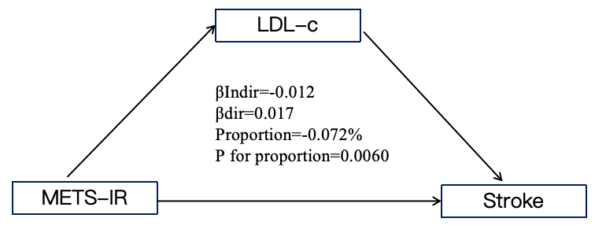
B:

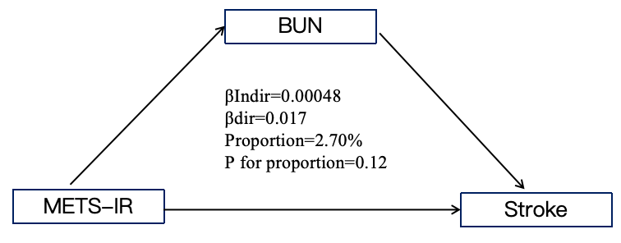
C:

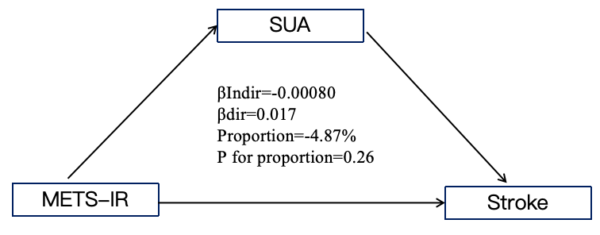
D:

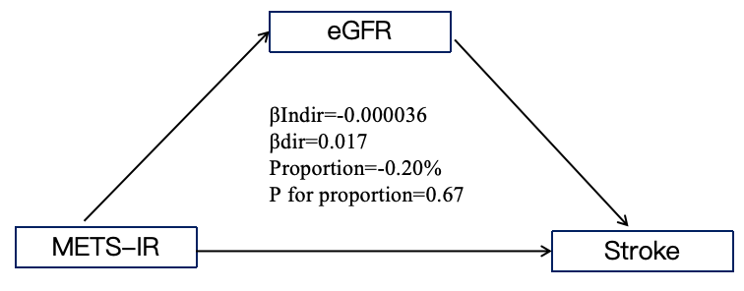
E:
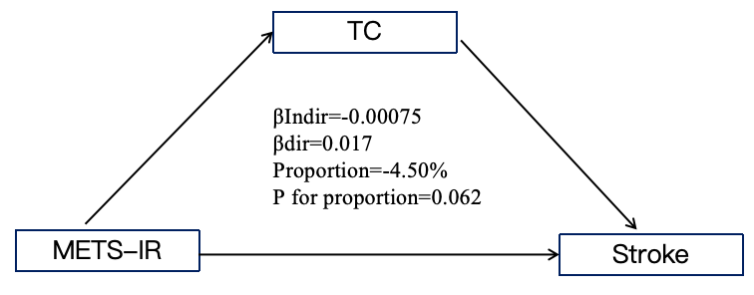
F:
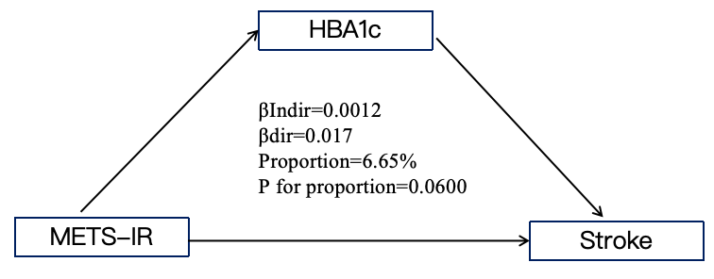
G:
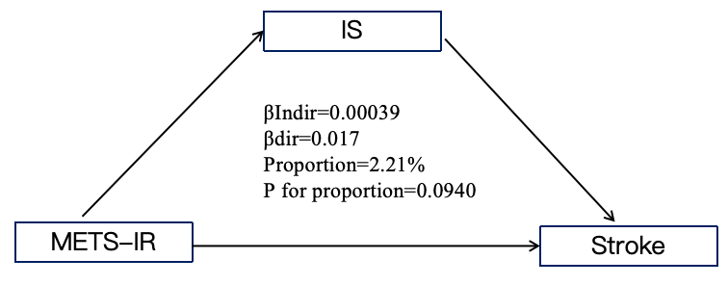
H:
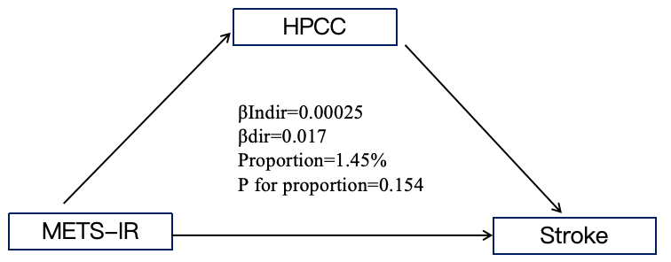
Adjusting for all other covariates except the mediator itself.
βdir, direct effect; βindir, indirect effect; Proportion, proportion mediated; P for proportion, P-value for the proportion mediated.

